Task01

1. Which devices did the current packet move from and to?

From: PC0

To: Hub

1. Click the “Capture / Forward” button a **second time**. Where did the packet move from and to?

From: Hub

To: Server0 and PC1

1. Click on the packet that has arrived at PC1, In the packet details, click “Layer 2” under the “In-Layers” to see what happens at the Data-link layer (layer-2) on PC1. If we realize that the MAC address is the Layer-2 address, what does PC1 do with this packet when it is received and why?

Drop it because the MAC address doesn’t not match. The program said: “The frame's destination MAC address does not match the receiving port's MAC address, the broadcast address, or any multicast address. The device drops the frame.”

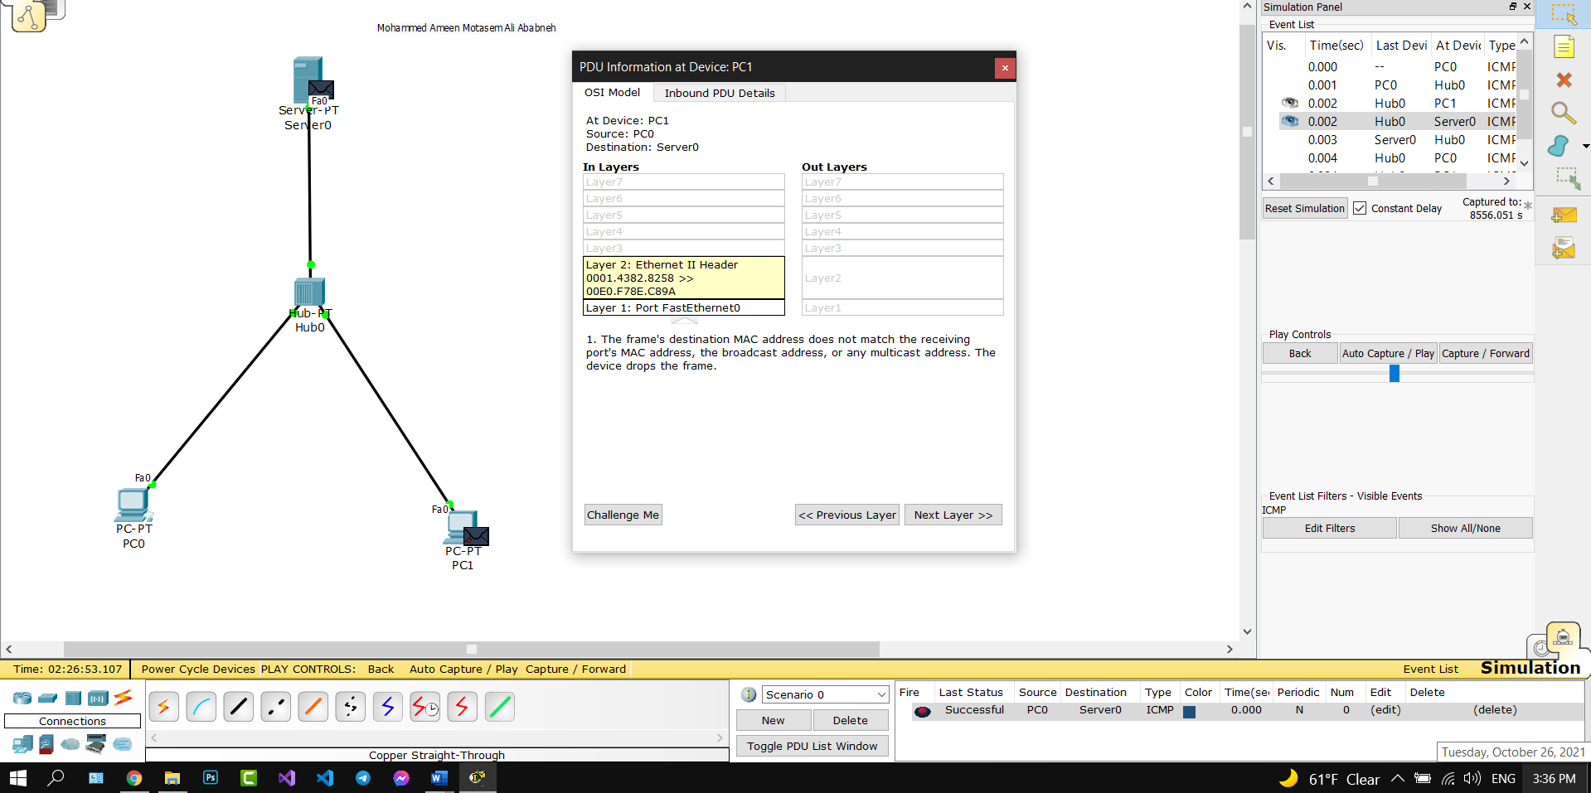

1. Click on the packet received by Server1. Look at what happens as the packet comes into Layer 2, moves up to layer 3, and then is sent out of layer 3 and through layer 2, follow the actions taken by Server1 at the various in-coming and out-going layers for this packet. What does it do and why (try to use your own words to describe what happens)?

It decapsulates the message removing layer 2 headers sending it to layer 3 and finds out that the IP addresses match, then the ICMP receives the echo request message and sends the reply and adds the needed encapsulation through layer 3 to 1. Then the device sends the next packet to the destination.

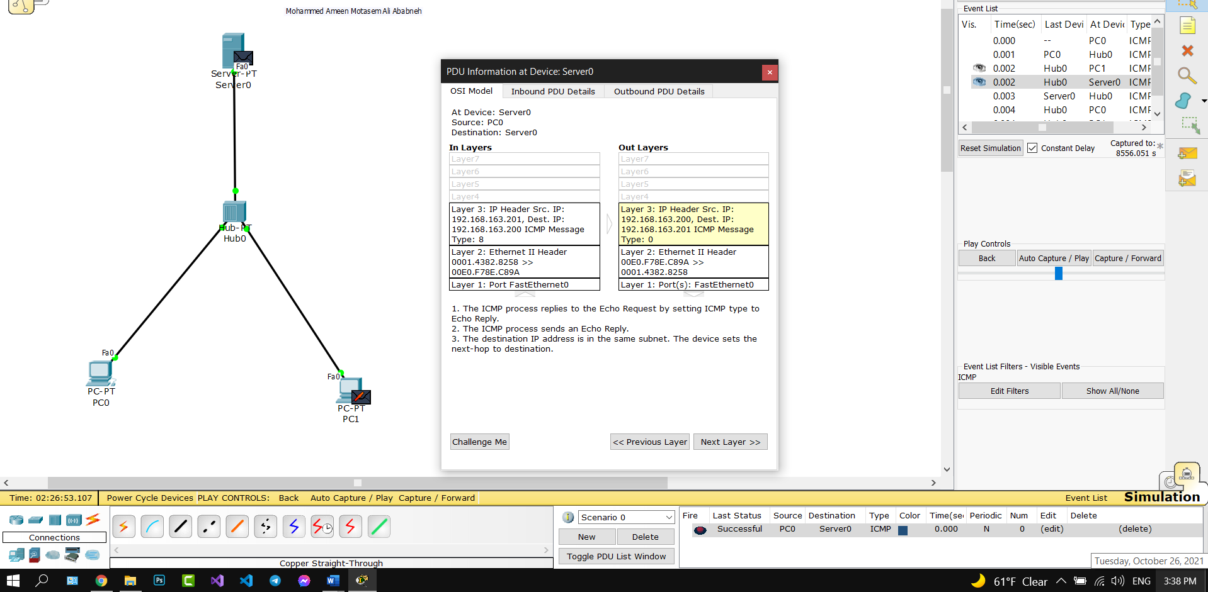

1. Play the rest of the simulation by clicking on the “Auto Capture/Play” button. What the Hub does every time it receives a packet?

It broadcasts it to all connected devices, except the receiver.

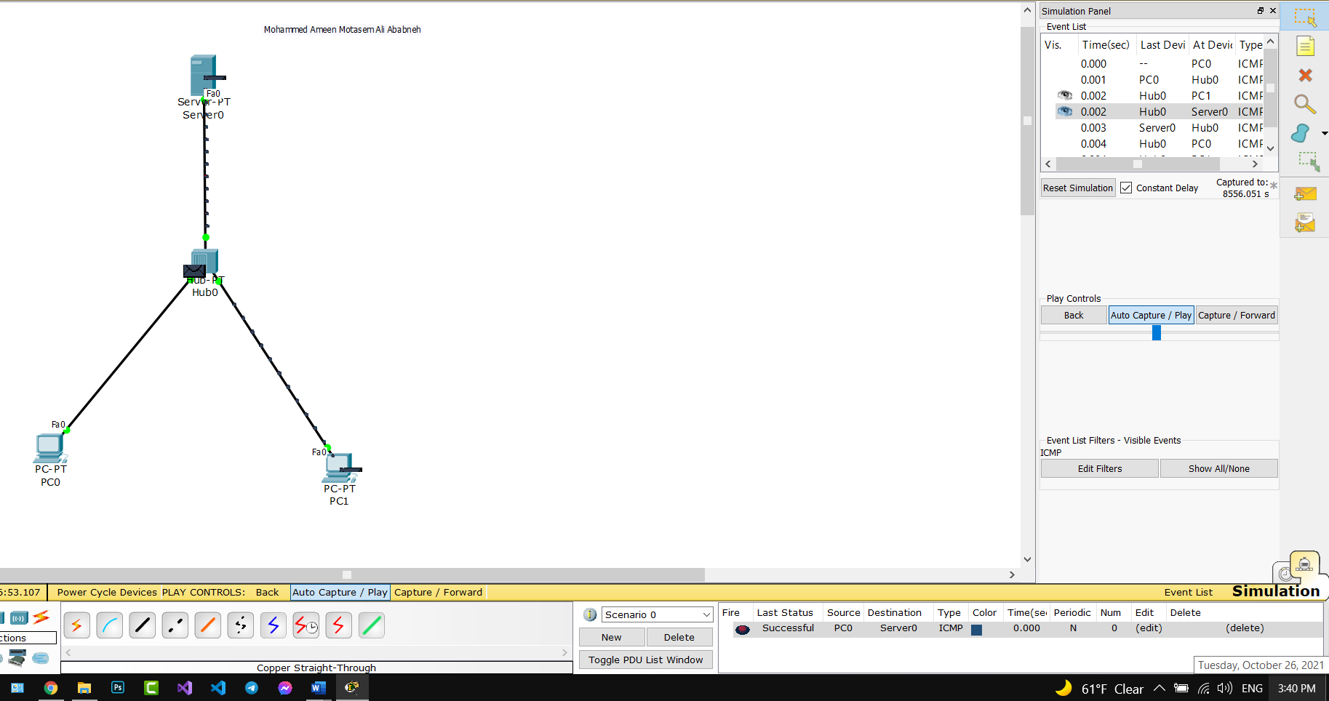

Task02

1. Briefly describe the path taken by a ping (ICMP) packet between PC2 and Server2 and back – that is, what devices does the packet go through. Be sure to include how much PC3 is involved in this communication.

PC2-> Switch -> Server 2

Server 2 -> Switch -> PC2

PC3 is NOT involved in anyway, as the switch has a table of connected devices MAC addresses it only sends the message to the wanted destination.

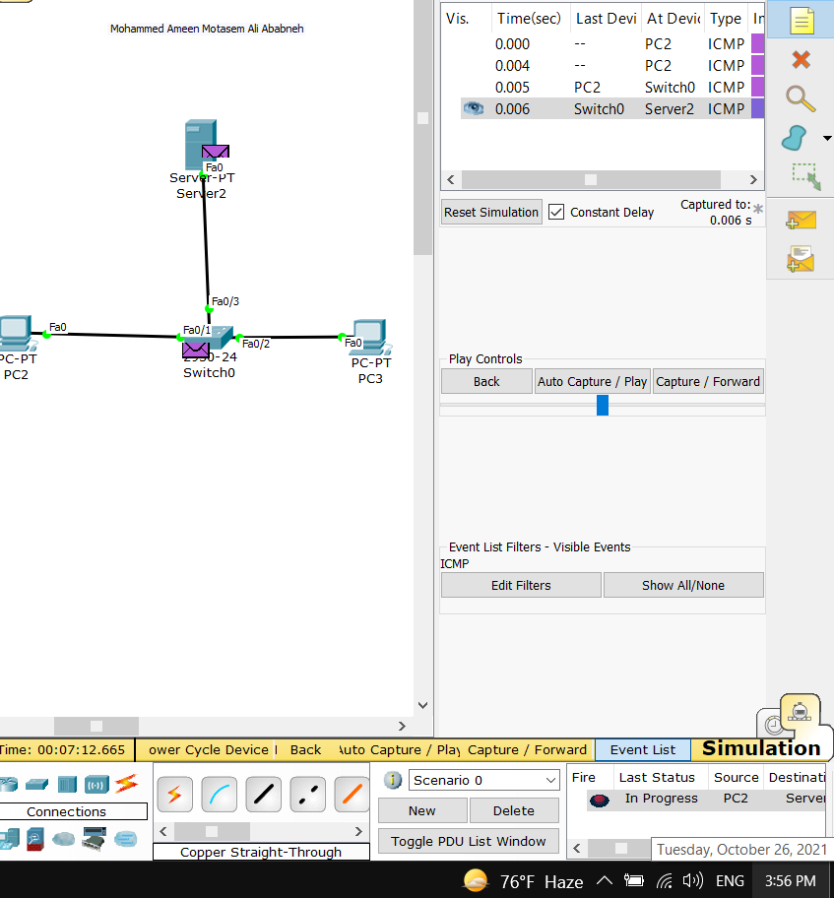

1. What effect would using a switch instead of a hub have in an environment with a large number of workstations?

Way less traffic and much more efficiency, as there will be no broadcast messages.

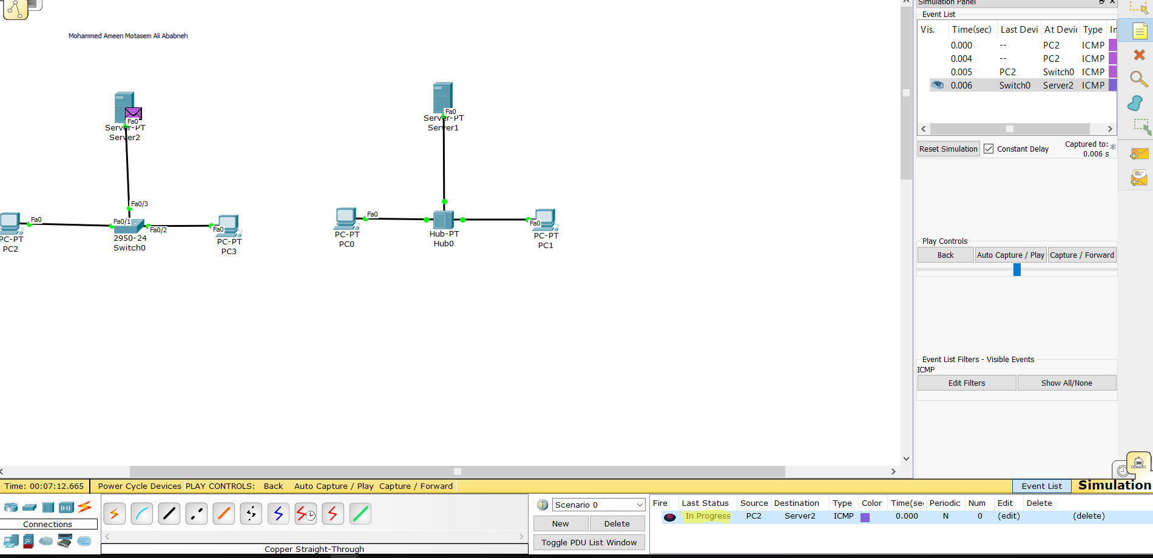

Task03

1. What does the Switch find in the destination address at Layer-2 of the packet it received?

It finds that the source MAC address is in the table, and the destination is broadcast.

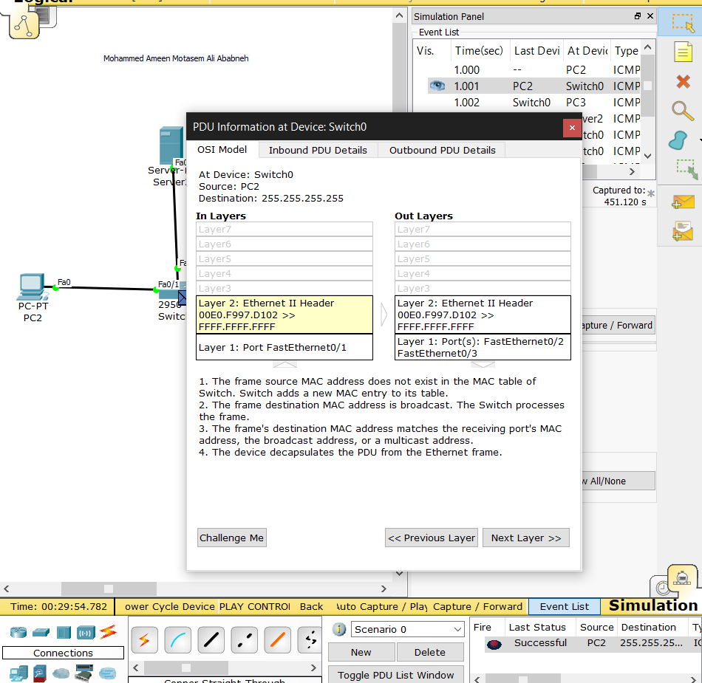

1. Under the Out-layers of the frame details, what will the switch do with the packet it received at Layer-2?

It will send it to all other connected devices(ports) except the source port, because the message was a broadcast message.

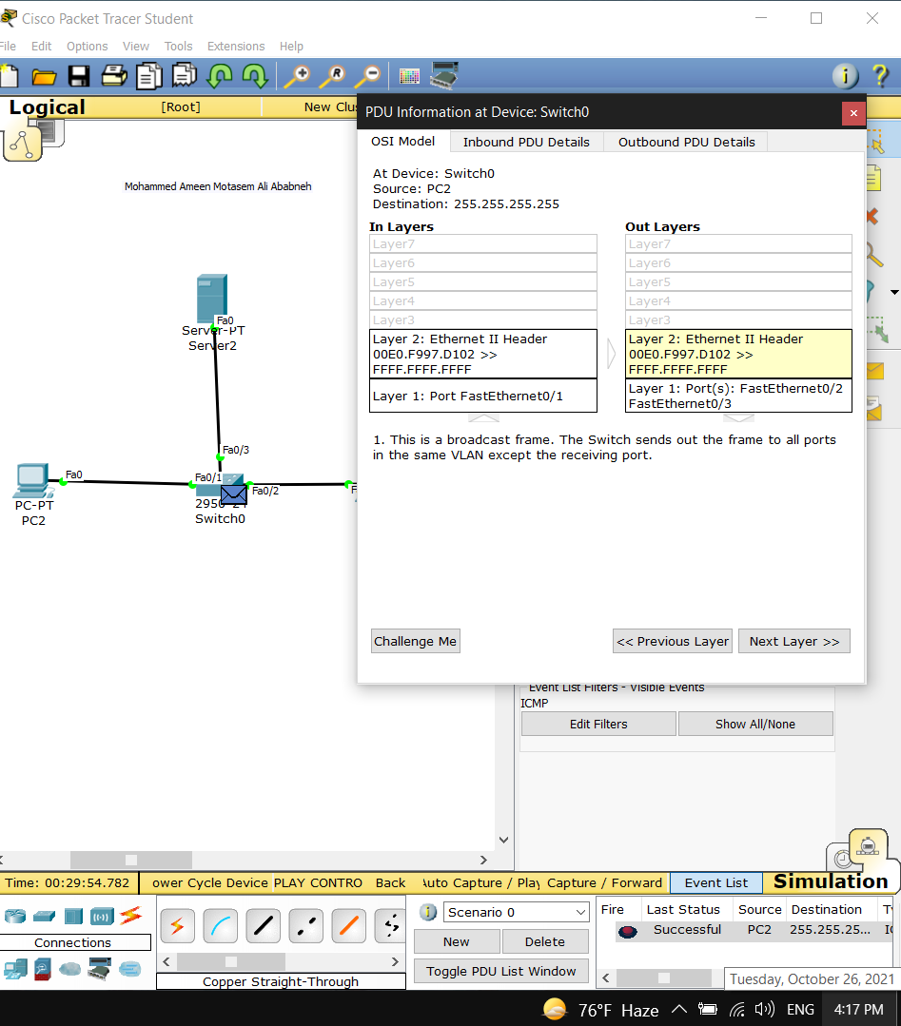

* + - 1. Where did the packet(s) move to? PC3 and Server2

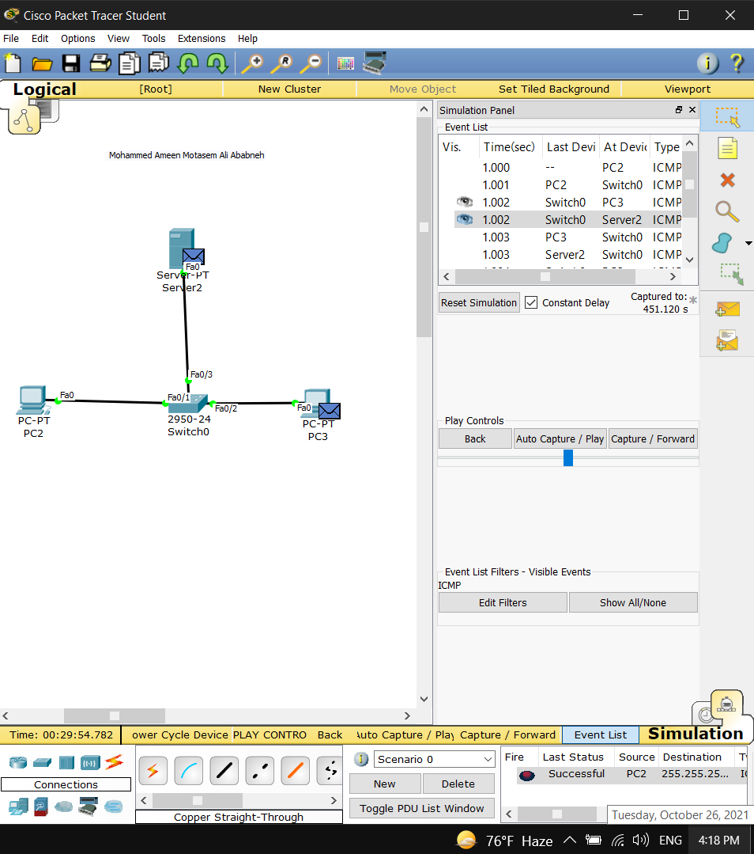

1. What will Server 2 do with the packet it received? What will PC3 do with the packet it received? If necessary, look at the details of the packets received by each of the machines.

Both PC3 and server will send an echo reply to the echo request they received to PC2

