1. If we “somehow” know that the first three octets (numbers) in our IP addresses are the network ID, why do the IP Address for Server 1 and the IP Address for PC1 and the configured Default Gateway need to have the same first three octets?

Because both the PC1 and the server1 are in the same network.

1. If we “somehow” know that the first three octets (numbers) in our IP addresses are the network ID, why do the IP Address for Server 1 and the IP Address for Server 2 have different numbers in at least one of the first three octets?

Because both the servers have different networks id.

1. Should the first three octets of the IP addresses assign the two interfaces on Router0 be the same or different? Why or why not?

They must have a different IP address, because both of the Router are in two different networks.

1. At the command prompt, type ipconfig and record the network configuration of PC1 below:

IP Address: 172.16.10.10

Subnet Mask: 255.255.0.0 But it supposed to be 255.255.255.0

Default Gateway: 172.16.10.1

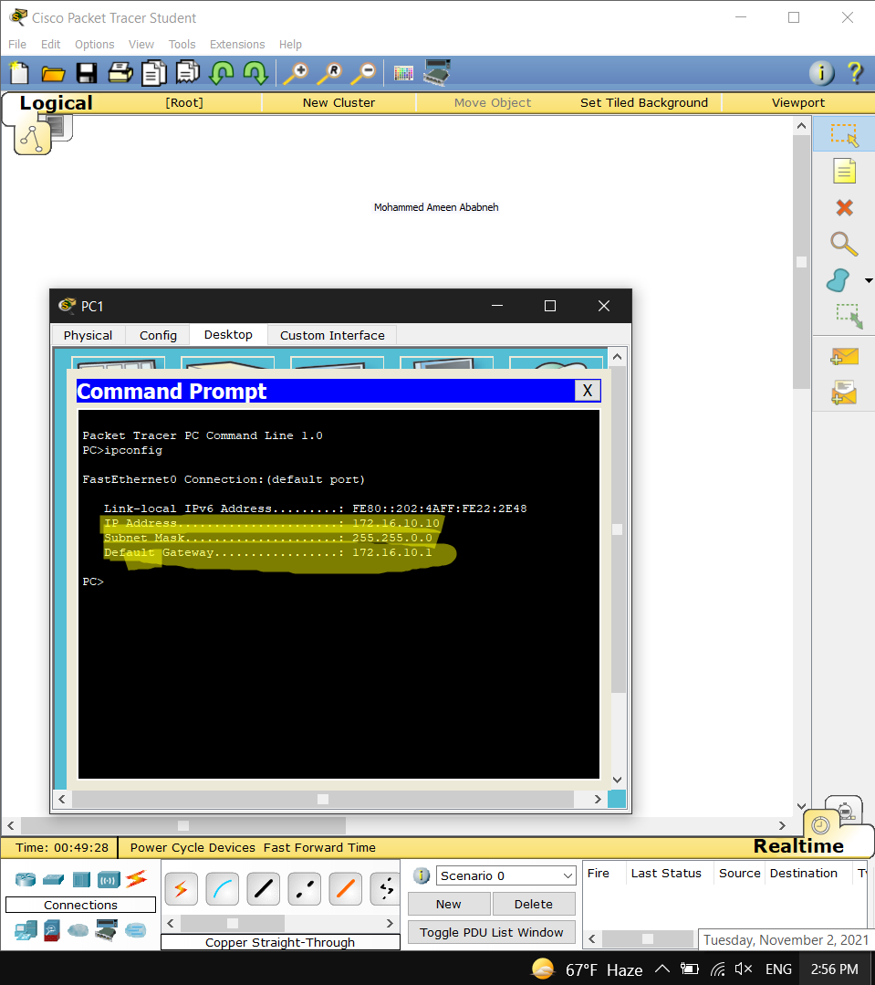

1. At the command prompt of PC1, use the ping command to send ping requests to the local PC1 address (e.g., ping 172.16.10.10) – Yes, you’re pinging yourself. What is the result of the command (e.g., did the ping succeed)?

The pint did succeed, there was no problem at all, four sent and four reserved.

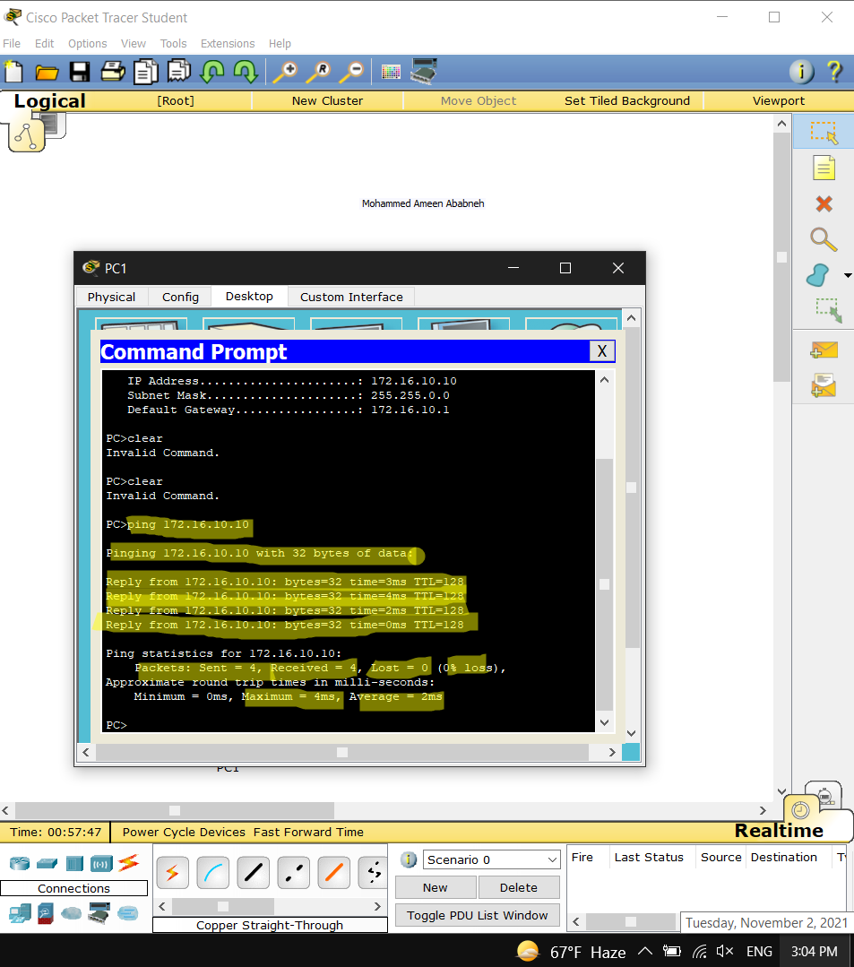

1. At the command prompt of PC1, use the ping command to send ping requests to Server1 and the FastEthernet0/0 interface of Router0 (use the Addressing Table if you need to recall the addresses for these interfaces). What is the result of these commands (e.g., did the ping succeed)?

Server1:

Router0-FastEthernet0/0:

Yes, the ping succeeds in both the Server and the Router

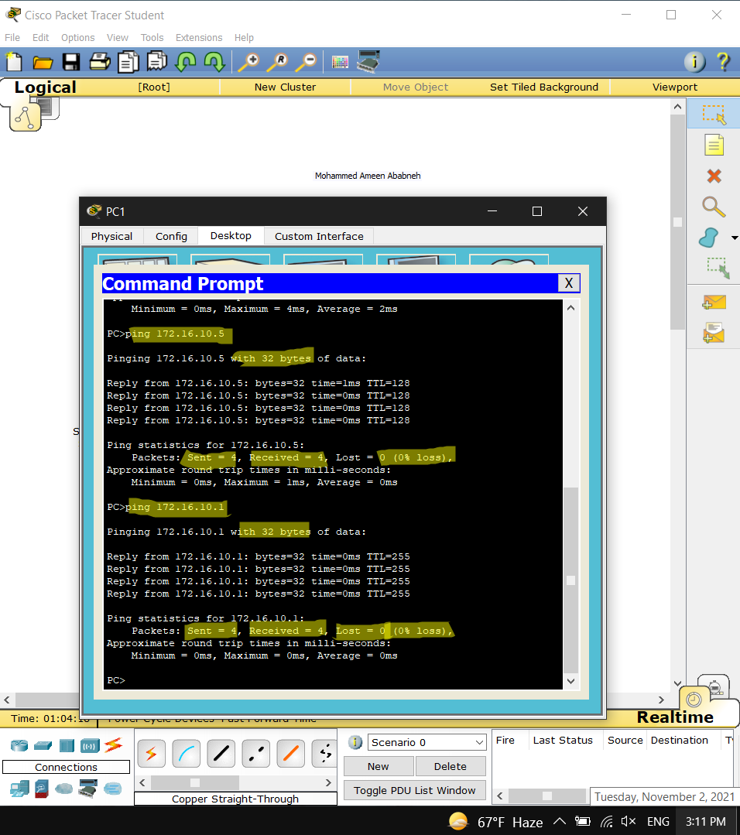

1. How was PC1 able to communicate with the interface on the router that is in the other network? In other words, what allowed the packets to reach a network that PC1 isn’t on?

Throughout the default Gateway that every network has, in order to communicate with the router, delivering the packet to the other network.

1. Fill in the following information about the inbound packet (PDU) at Switch0, also determine to which device belongs this address:

Source Ethernet (MAC) Address: 0002.4A22.2E48

Destination Ethernet (MAC) Address: 000D.BD91.1001

Source IP Address: 172.16.10.10

Destination IP Address: 172.16.20.5

The source is PC1 and the destination is server 2 as in the previous questions.

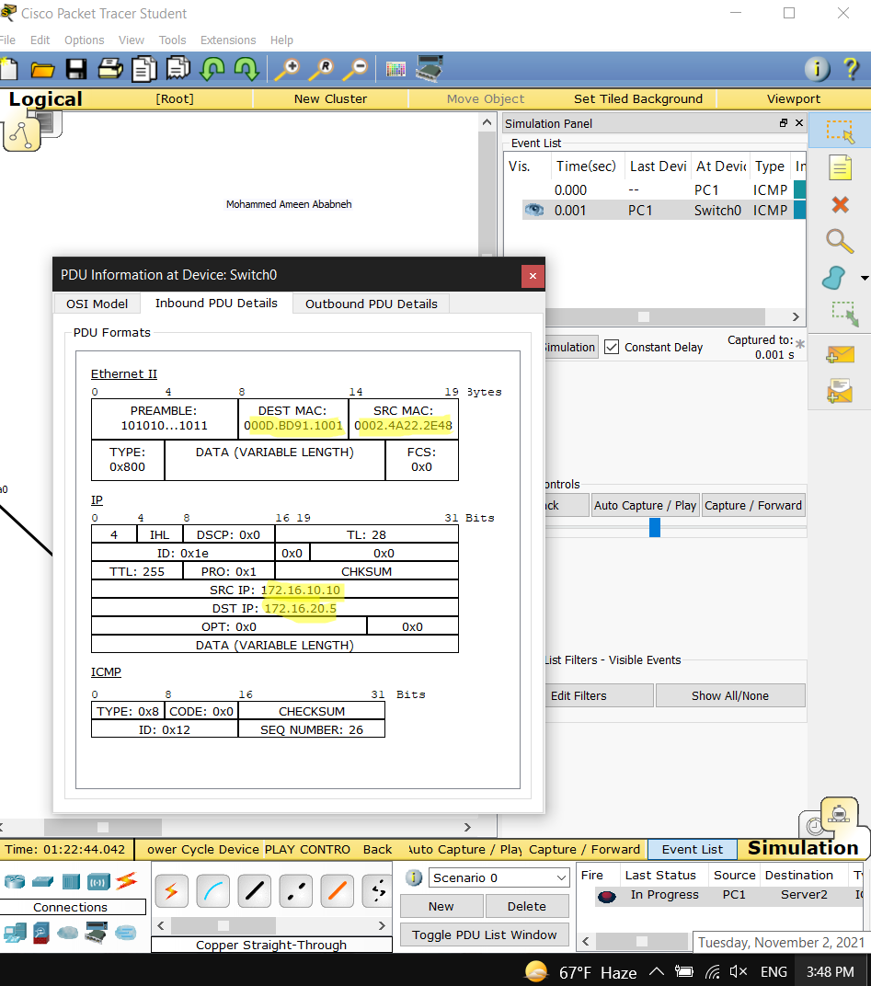

1. Record the addresses shown at Layer 3 in both the “In Layers” and “Out Layers”, also determine to which devices belong these addresses.

Source IP address in the “In Layers”: 172.16.10.10

Destination IP address in the “In Layers”:172.16.20.5

Source IP address in the “Out Layers”: 172.16.10.10

Destination IP address in the “Out Layers”: 172.16.20.5

The source is PC1 and the destination is server 2 as it not possible to see the layer 3 on the Router.

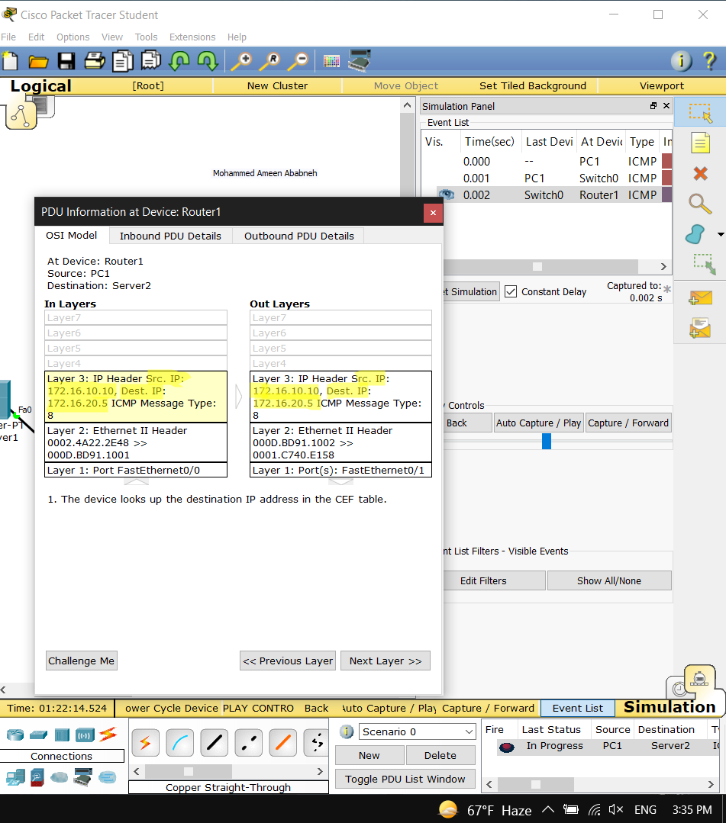

1. Why are the addresses at the IP layer (Layer 3) the same (In and out)?

The Source and the Destination must not be changed (same source and destination).

1. Record the addresses shown at Layer 2 in both the “In Layers” and “Out Layers”, also determine to which devices belong these addresses.

Source Ethernet address in the “In Layers”: 0002.4A22.2E48

Destination Ethernet address in the “In Layers”: 000D.BD91.1001

Source Ethernet address in the “Out Layers 000D.BD91.1002

Destination Ethernet address in the “Out Layers 0001.C740.E158

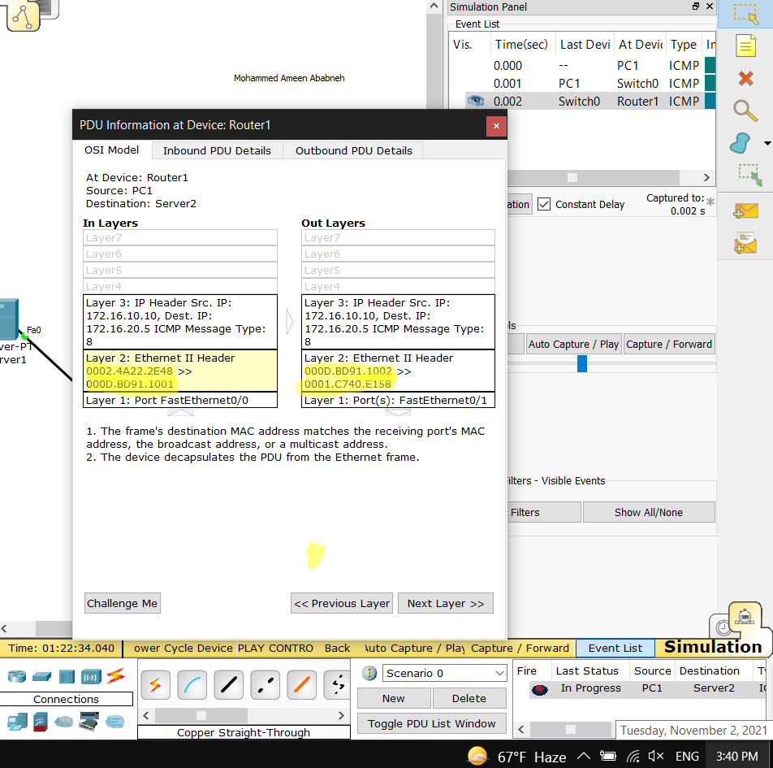

1. Why are the addresses at the Ethernet layer (Layer 2) different (In and Out)

The router connects two different networks, both should change because they communicate in Layer 2 which the MAC address change, So the address of the Ethernet changes in order to deliver the message.