**Part1:**

1. What version of HTTP is your browser running? What version is the server running?

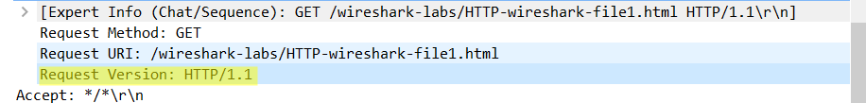



2.What languages (if any) does your browser indicate that it can accept to the server?

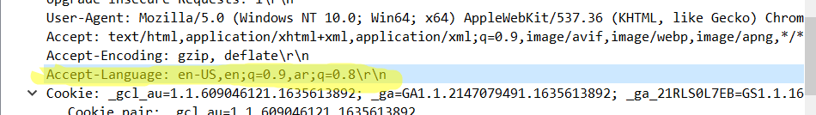

3. What is the IP address of your computer? What is the IP address of the gaia.cs.umass.edu server?

The client’s IP address is 192.168.172.84

The server’s destination IP address is 128.119.245.12



4. What is the status code returned from the server to your browser?



5. When the HTML file that you are retrieving was last modified at the server?



6. How many bytes of content are being returned to your browser?

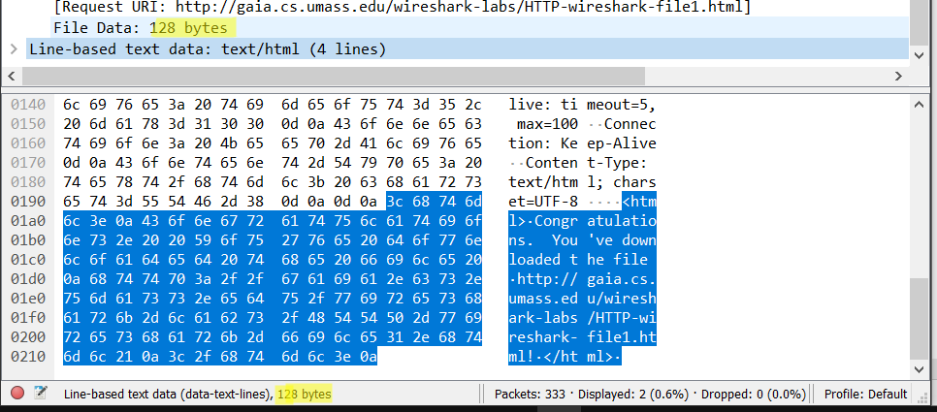

**Part2**

7. Inspect the contents of the first HTTP GET request from your browser to the server. Do you see an "IF-MODIFIED-SINCE" line in the HTTP GET? No, it shouldn’t have a if modified

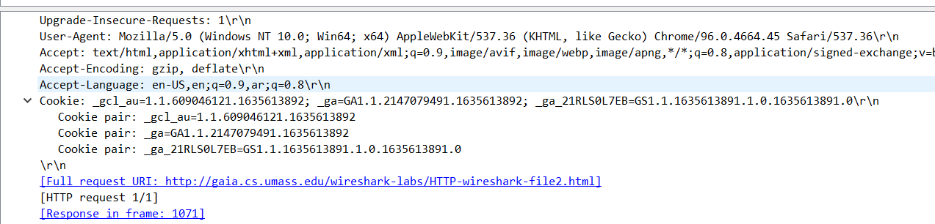

8. Inspect the contents of the server response. Did the server explicitly return the contents of the file? How can you tell? Yes, as shown below

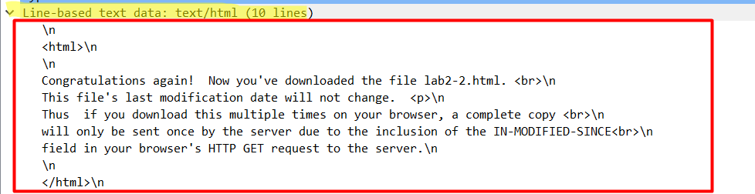

9. Now inspect the contents of the second HTTP GET request from your browser to the server. Do you see an "IF-MODIFIED-SINCE:" line in the HTTP GET? If so, what information follows the "IF-MODIFIED-SINCE:" header?



Yes, there is a line that indicates the modification date. The client is basically asking the server to send the needed file only if it has been modified since the last time it was received.

10. What is the HTTP status code and phrase returned from the server in response to this second HTTP GET? Did the server explicitly return the contents of the file? Explain.

The status code with the phrase is “304 Not Modified”. Which means that the server did not send the file back as it is not needed. This is because the file in the client’s cache is the same as the file that the server has, thus there is no reason to send it again to the client.



**Part3**:

11. How many HTTP GET request messages were sent by your browser?

Only one GET request message.



12. How many data-containing TCP segments were needed to carry the single HTTP response?

Four message TCP segments.

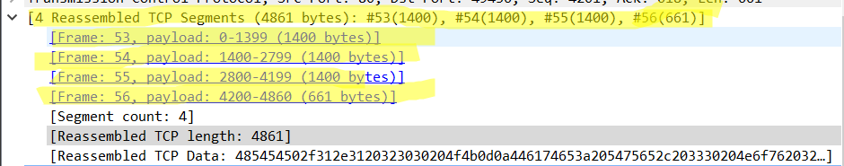

**Part4**:

13. How many HTTP GET request messages were sent by your browser? To which Internet addresses were these GET requests sent?

There were three GET request message send from the client at (192.168.172.84) to the servers at (128.119.245.12, 178.79.137.164)

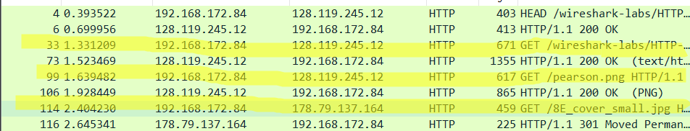

**Part5**:

14. What is the server’s response (status code and phrase) in response to the initial HTTP GET

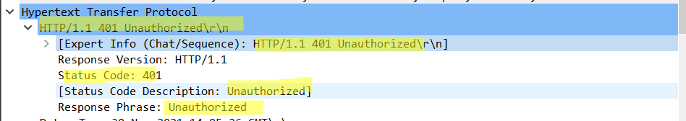

1. When your browser’s sends the HTTP GET message, what new field is included in the HTTP GET message?

