Answer the following questions:

* 1. What is the IP address and TCP port number used by the client computer (source) that is transferring the file to **gaia.cs.umass.edu**? To answer this question, it’s probably easiest to select an HTTP message and explore the details of the TCP packet used to carry this HTTP message, using the “details of the selected packet header window.

Answer: We can see that the IP address is 192.168.0.105 and the TCP source port number is 62376

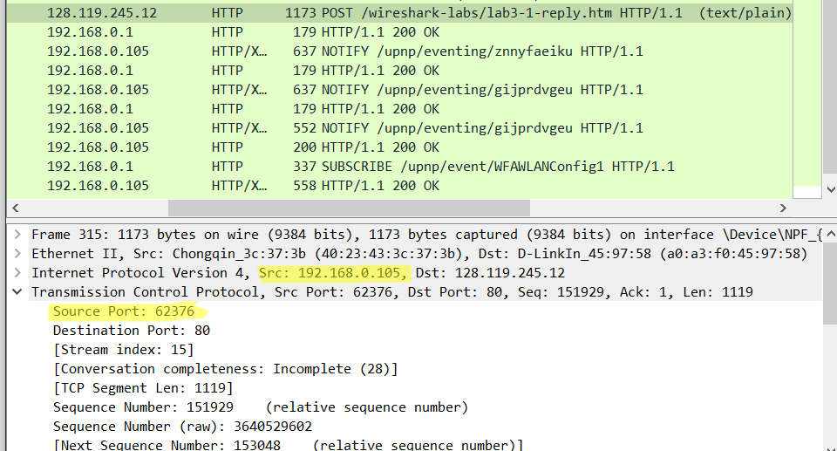

* 1. What is the IP address of **gaia.cs.umass.edu**? On what port number is it sending and receiving TCP segments for this connection?

Answer: The IP address is 128.119.245.12. This is the address of Gaia. It is sending and reciveving on port number 80.

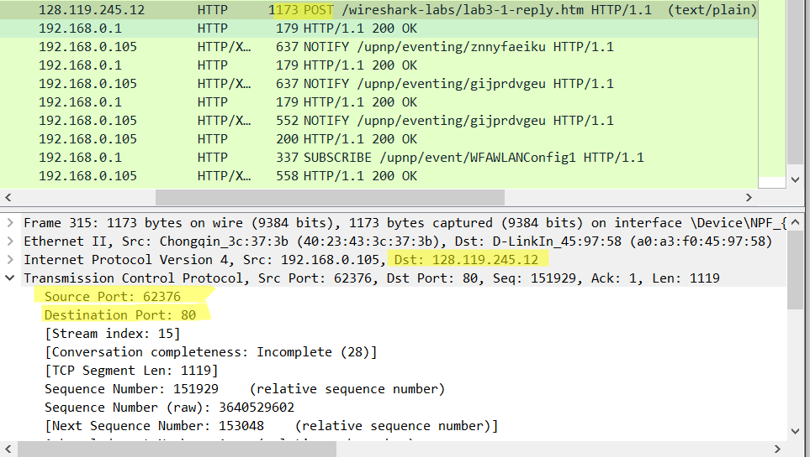

Answer the following questions for the TCP segments:

* 1. What is the sequence number of the TCP SYN segment that is used to initiate the TCP connection between the client computer and **gaia.cs.umass.edu**? What is it in the segment that identifies the segment as a SYN segment?

Answer: The sequence number of the TCP SYN segment is 0. And the flag bit is used to identify it as an SYN segment. This flag bit “Syn” is set to 1.

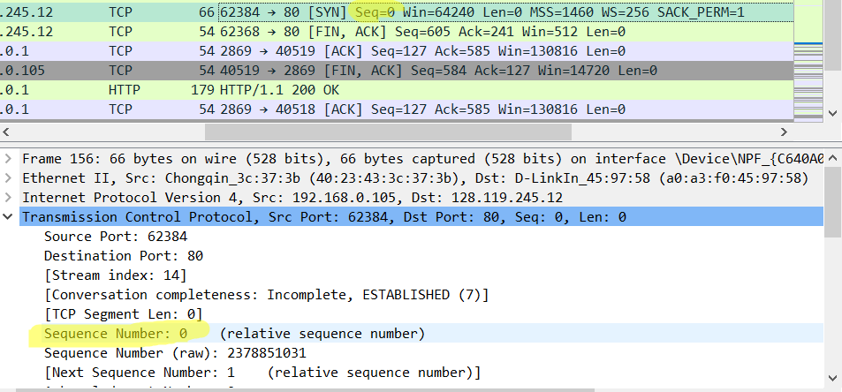

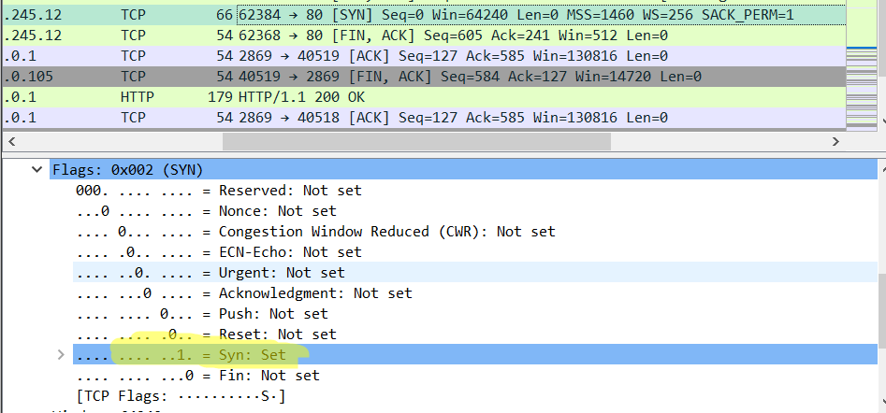

* 1. What is the sequence number of the SYNACK segment sent by **gaia.cs.umass.edu** to the client computer in reply to the SYN? What is the value of the Acknowledgement field in the SYNACK segment? What is it in the segment that identifies the segment as a SYNACK segment?

Answer: The sequence number is 0. The value of the Acknowledgement field is 1. The server determines this value according to the next byte it is expected to receive from the client in the next segment. The “Syn” and “ACK” flag bits are used to identify this segment an SYNCAK segment, and they are set to 1.

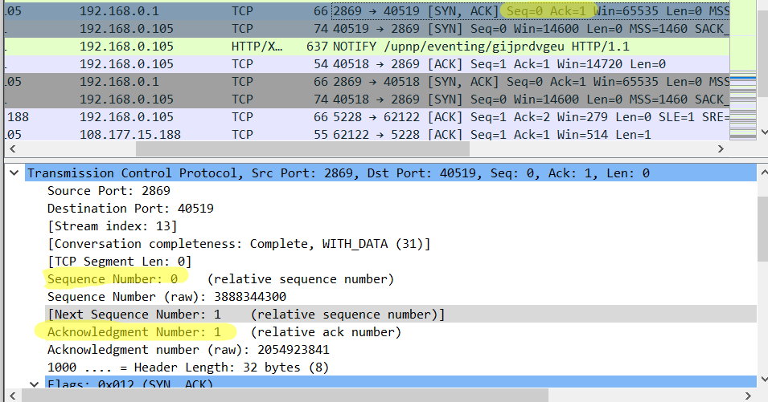

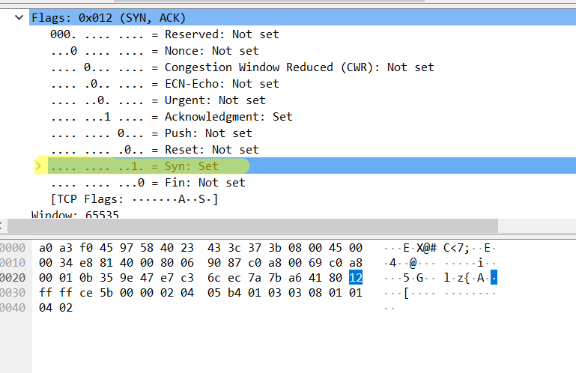

* 1. What is the sequence number of the TCP segment containing the HTTP POST command? Note that in order to find the POST command; you’ll need to dig into the packet content field at the bottom of the Wireshark window, looking for a segment with a “POST” within its DATA field.

Answer: The sequence number of this segment is 1.

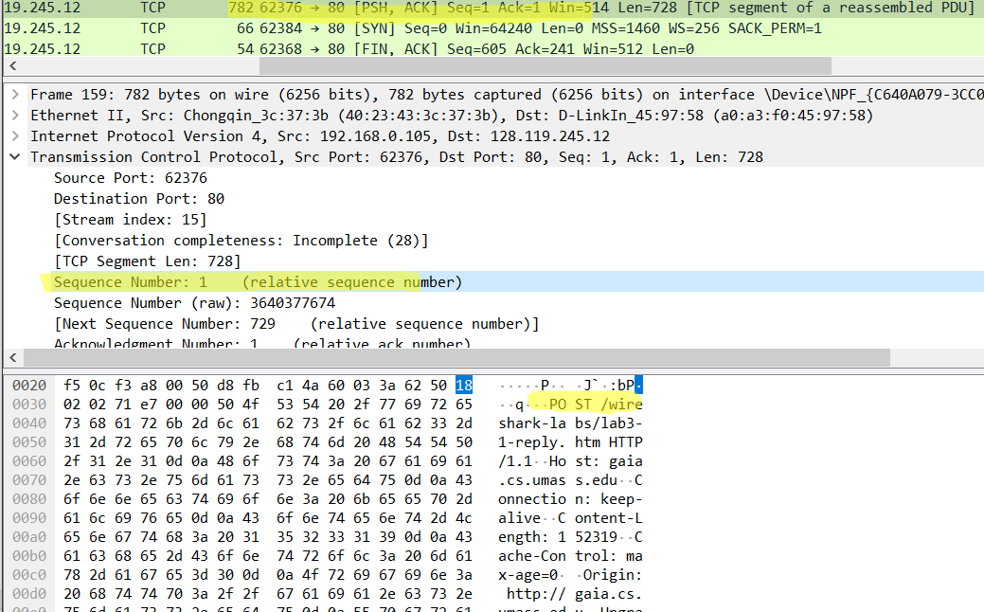

**UDP Procedure**

Start capturing packets in Wireshark and then do something that will cause your host to send and receive several UDP packets. After stopping packet capture, set your packet filter so that Wireshark only displays the UDP packets sent and received at your host. Pick one of these UDP packets and expand the UDP fields in the details window.

* 1. Select one packet. From this packet, determine how many fields there are in the UDP header. Name these fields. 4 Fields
  2. From the packet content field, determine the length (in bytes) of each of the UDP header fields.

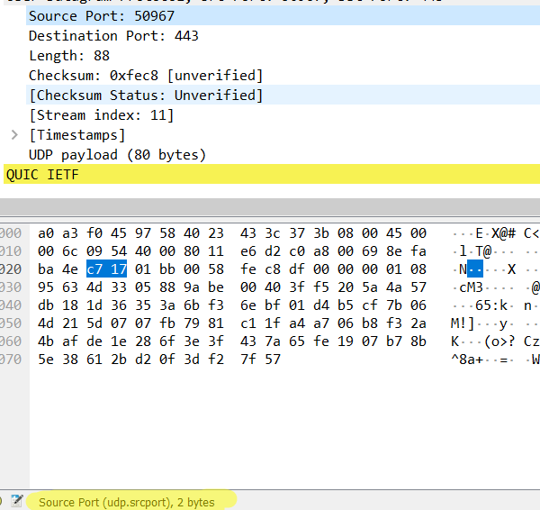

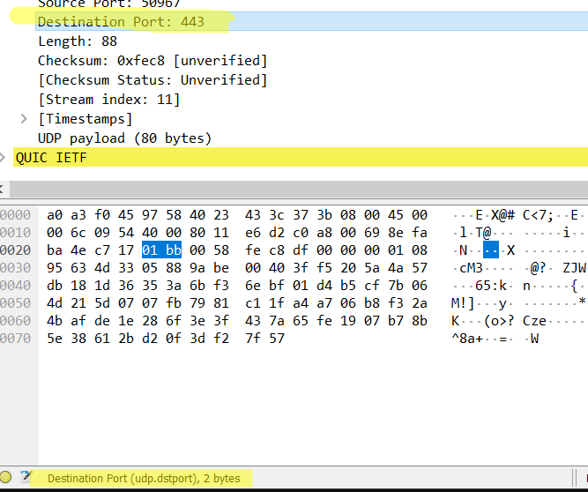

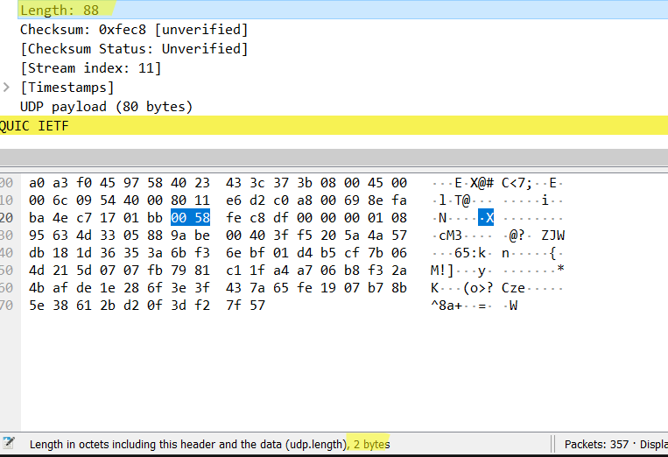

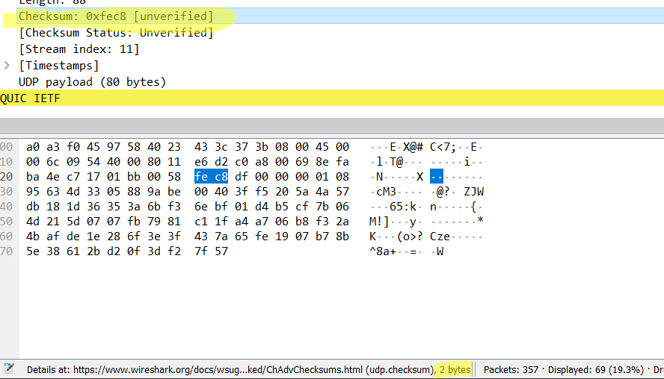

* 1. The value in the Length field is the length of what? Verify your claim with your captured UDP packet.

Answer: The is the length of the header + the payload, which is 8 byes + 80 bytes = 88 bytes

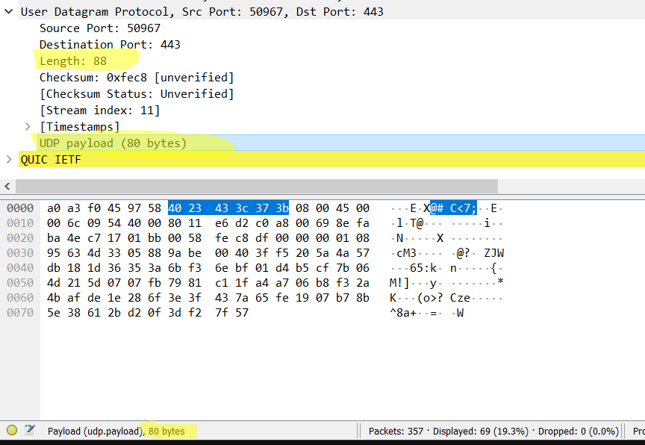

* 1. What is the largest possible source port number?

It is 216 – 1 = 65535

* 1. What is the protocol number for UDP? Give your answer in both hexadecimal and decimal. (To answer this question, you’ll need to investigate the IP header.)

Answer: In decimal it is 17 and in hexadecimal, it is 11.

