**Table of Contents**

List of Tables iv

List of Figures v

Abstract vi

Chapter 1: Introduction 1

Chapter 2: Background 4

Chapter 3: Design 7

Chapter 4: Implementation 21

Chapter 5: Results and Discussion 28

Chapter 6: Economical, Ethic, and Contemporary Issues 31

Chapter 7: Project Management 32

Chapter 8: Conclusion and Future Work 34

References 35

# List of Tables

Table 1: Design Considerations 20

# List of Figures

Figure 1:  system components 3

Figure 2: user account table 7

Figure 3: Address 7

Figure 4: Item table 8

Figure 5:Item category table 8

Figure 6: stock table 8

Figure 7: Shopping session table 9

Figure 8: Order table 9

Figure 9: City table 9

Figure 10: Delivery table 10

Figure 11: Trip table 10

Figure 12: use case 11

Figure 13: scenario 1 16

Figure 14: scenario 2 17

Figure 15: Agile Model 18

Figure 16: home page 21

Figure 17: login page 22

Figure 18: Sign up page 22

Figure 19: select region 23

Figure 20: branch section 23

Figure 21: branch section 24

Figure 22: physical services branch 24

Figure 23: branches section 25

Figure 24: feedback section 25

Figure 25: Trending 26

Figure 26: Trending 26

Figure 27: Delivery services branch 27

Figure 28: time management 32

# Abstract

Many people seek to increase their sources of income due to the difficult living conditions they suffer from for many reasons. That is why we wanted to make the RentU platform the first-of-its-kind to provide various services that will increase the sources of individual income and earn money. Through the RentU platform, anyone can rent or sell goods and tools that have accumulated without using them for years. In addition, RentU takes the freelance services to a whole new level by the physical services that the website offers, or by using their cars in their spare time to achieve an alternative source of income by delivering some orders. Except for the possibility of selling their accumulated waste and offering it for recycling, thus keeping the environment around them clean. Finally, RentU also offers some pet grooming services or offers it for adopt

The website will use Laravel web application framework applying Model-View-Controller software design pattern (MVC) and MySQL for the database.

**Keywords:**

Laravel, MVC, Website, SQL, Rent.

# Chapter 1: Introduction

**1.1 The Description of the problem**

With the emergence of so many challenges that individuals are going through these days that reduce their sources of income (COVID-19 for example) and the inflation we are experiencing, the outlook for emerging markets and developing economies will likely be dampened by the lasting legacies of the pandemic – the erosion of skills from lost work and schooling; a sharp drop in investment; higher debt burdens; and greater financial vulnerabilities [7]. Consequently, many people are seeking to find additional sources of income for their businesses. We decided to make RentU (which is a p2p website) as a platform that provides some interrelated services that would diversify the sources of income, for some people and sometimes increase them; To take advantage of unused items and rent them or sell them through the RentU platform instead of accumulating them for years without interest, or if the user of RentU owns a car, they can use their spare time and make money by applying for delivery requests available on RentU. Also, it is possible to take advantage of the waste that accumulates in it instead of feeding it to the environment, and offer it for recycling on RentU. Also, RentU cares not only for the environment, but even for pets so that it provides the service of showing pets for adoption, and taking care of them by showing some nearby care centers

**1.2 Background**

Few attempts have been made in the past for rental services, some of them were focusing on other things in conjunction with rental but they are limited with accommodation services such as: Amazon or eBay. However, the idea was fully implemented on other websites such as: Rentomojo [2] which succeeded on a local level in India. Therefore, it could be a leap if it was well presented in Jordan, creating new opportunities to explode and operate unused household appliances. Therefore, it may help many people to keep a constant money ratio out of items they rarely use.

**1.3 Aims and objectives**

The aim of the project is to apply E-commerce in different and useful ways, by create a rental and sale website, to save the customer’s energy and finding the product nearby, with high quality and for a short time, also this website will connect multiple service providers together, you will be able to make money from unused items, it is a great way to make people offer their services to a higher percentage of people around them, and at last increasing revenue for goods in case of sale or lease.

There are many projects in Jordan that aim to rent things, but they are specialized. For example, there are sites for renting cars or a site for renting apartments, but at the national level there are no sites for renting simple things like this project.

**1.4 How has the problem been solved till now?**

There were a few attempts in the industry in the Middle-East for used household appliances, such as websites like: Rentomojo [2] for rental services. Besides that, there are countless rental shops in the market. Yet, the only problem these fields have is that they only rent their products. They don’t target household appliances which solve a small amount of the problem only, which RentU offers.

**1.5 Main solution idea**

To keep pace with the rapid advancement of E-commerce, a website idea was created to offer rental or sale services for used or new items that are no longer in use.

RentU online store is an interactive website for people to sell, buy and rent things from each other with an acceptable price. It's a solution for all tools that people need from time to time and they don’t want to buy.

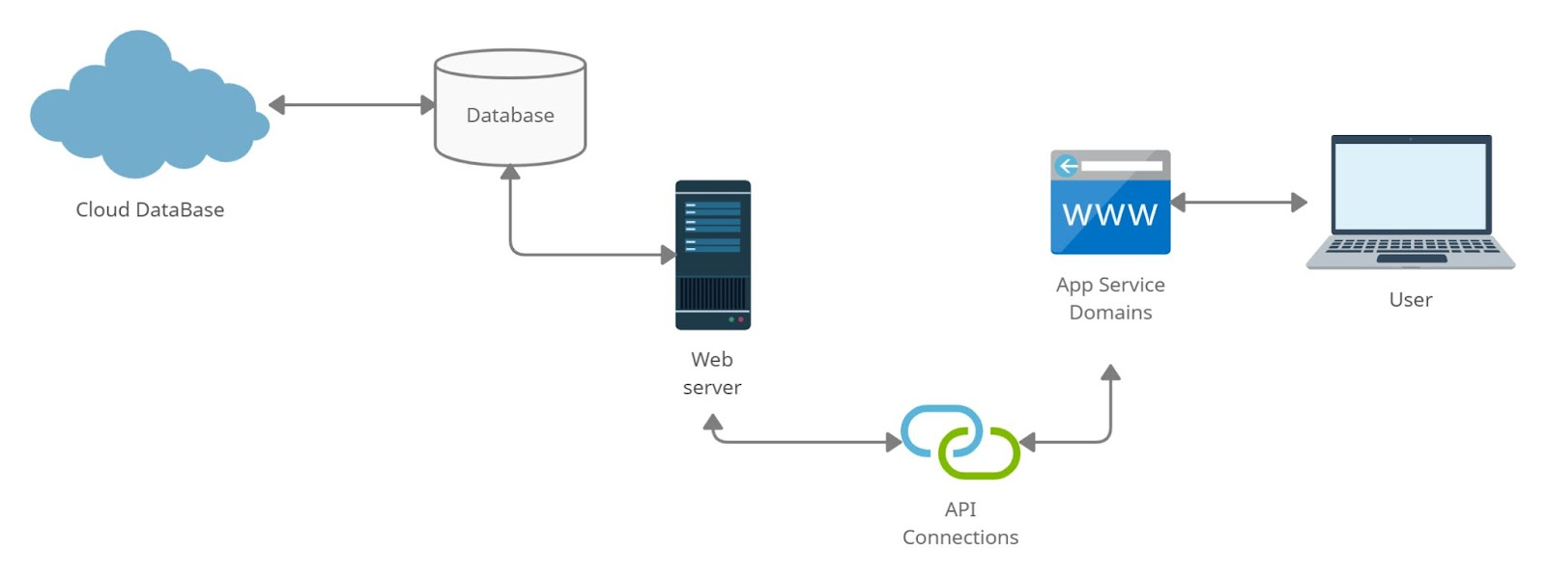

**Figure 1:  system components**

**1.9 Summary of report structure.**

The report consists of three main parts. The first part will describe the problem, leading to the solution. The motivations behind the project, a glimpse of the background, and how the project will contribute with the solution of the problem, at last a summary of the system. The second part provides a background of the problem and the target market and how it can affect them. The last part explains about methods used in construction and designing the project. The process describes the problem and how the solution addresses the problem statement.

# Chapter 2: Background

* 1. **Project Scope**

The project is not a huge site like Amazon, but it will present a good chance that will benefit a large group of people who do not have the capital to build warehouses to place goods or market them. It will provide a service for people who want to rent their products in a wider and more secure way.

* 1. **Context about the problem, and why it is important and where it is used**

E-commerce is an extremely important online purchase and sales process in our daily lives. In addition to social networks in E-commerce, the main reason for the growth of Internet users.

We spend a lot of time on the Internet every day to work, study, do marketing, do business and entertain ourselves. All these commercial and social activities are now connected to the Internet. Without E-commerce, the world of the Internet is impossible and will scare your imagination. That is why E-commerce is important in our daily life[3].

Due to what was previously presented and in line with the requirements of our era, we want to create this website as a p2p (peer-to-peer) website. that allows users to sell or buy items, rent other's items or rent what they own. provide a service or take advantage of other services provided onto the website. Also, it connects service providers themselves, as a broker website.

The website contains multi branches:

* Waste Management:  The website allows users to waste their disposal and recycle it by displaying it on their own store in this branch or take advantage of those that are existing in other branches by buying it, if the customer of this branch is a Recycle Waste Company for example.
* Pet Adoption: Pet centres for adoption can offer their services through their own store in this branch, and customers can browse this branch by searching for a specific pet or also specific pets offered for adoption located nearby. It is also possible to offer services for the care of these pets, such as vaccination and personal care (by specialists, of course). Customers can display lost pets they find somewhere and in return, other customers can search for their lost pet
* Physical Service: Customers in this branch can offer any physical service they can provide. Literally any service! Of course, they can take advantage of others' services offered in this branch.
* Rental Store: In this branch, the user can offer items that own for rent or leasing out other's items on this branch simply user can be lessor or lessee
* Sale Store: Traditionally buying or selling things online.
* Delivery Services: Usually, the shops that are physically located somewhere, contract with a delivery company for a rather heavy fee. where more than one order destined for a specific place is collected to be delivered on a specific day. It often takes time from days to weeks depending on the distance of destinations, but in this creative branch on this website, it offers a very fast delivery service for a simple fee. How? On this site, any store that is physically located somewhere can request a delivery service in order to deliver an instant order has already done on their website so that the other customer (which is a driver) available at that moment and nearby this store location, accepts this order on the website then delivers it to the specified place in return a little of hours. Thus, it means saving a lot of time and money for both the customer and the store, and it also saves the store some heavy fees for delivery companies.

Not only that, customers on the site for other branches of the rental or sales branch can request delivery service for one of the available drivers who are nearby to take advantage of this quick delivery service. Simply this branch connects service providers to each other!

* 1. **Target market**

Target market of this project will serve a large segment of people; Children (under parental supervision) or adults. Everyone that wants to shop or trade online, that want to make money by renting used or new things they own, some readers who are looking for books or novels or wish to publish their articles and novels through the site, pet show centres for adoption or centres that provide personal care for these pets and of course users who are interested in pets and are looking for a suitable pet for adoption or near their presence all of that as a peer to pee, Also delivery companies such as Uber, Careem, and others that want to offer delivery services through the website, companies that are interested in waste management and recycling or even people who want to get rid of or make money from recyclable waste.

* 1. **Potential ethical and/or environmental issues**

There will not be any major problem regarding ethical and environmental issues, no data trading, the privacy of the users will be preserved, and all the information that the website will take from the user will be used for the user benefit, and it will never be used for any other goal.

* 1. **Summarize the different approaches currently previously used to solve the problem.**

There are websites that offer each service on our website separately, but today we have collected more than one related service on one site, which makes it easier and faster.

Some people may throw unused items in the storehouse for years or throw some recyclables with trash without thinking that it may increase their income, but with a website that provides all these services in one place. It gets easier, faster and also money-generating. At the last the website takes the freelance services to a whole new level, it doesn't offer online services only, it offers physical services such as: construction workers, companies with services to offer in the real word, giving the option to rate such services in the website by previous customers as a feedback, which was done in OpenSooq [8] but with poor marketing to the service. And if we mention Jordan, our website will be the first-of-its-kind in the area that offers all these services to the users simply to make money from anything that they own.

# Chapter 3: Design

* 1. **Design Overview:**

RentU aims to achieve many goals, the aim and goals were mentioned above, However the Illustration of the design will be explained throughout the database which contain the tables shown in the figures below:

1. User_account table: contains a list of all lessees, lessors, customers or sellers, almost everyone login into RentU website. Each user can be a lessee and lessor, seller or buyer or all of them.

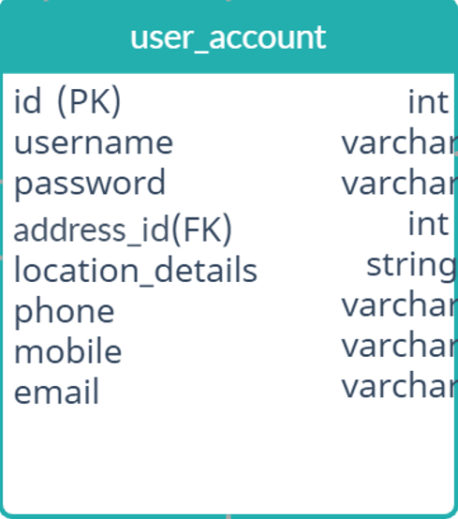

**Figure 2: user account tab****le**

1. Address table: contains the address of where all our users and items are located.

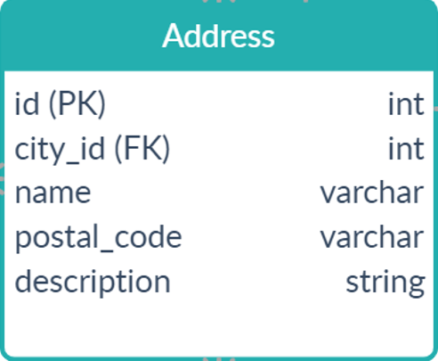

**Figure 3: Address**

1. Item table: contains all the elements that can be displayed on the site include : pets, waste, Physical Services, or any tool that may rent or sell.

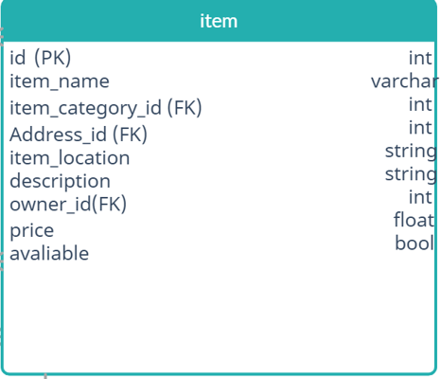

**Figure 4: Item table**

1. Item_Category table: Contains a description of an item, also it contains a specification the service provider and its recipient.

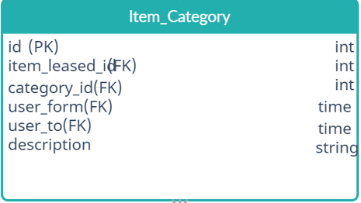

**Figure 5:Item category table**

1. Stock table: contains a group of items or services that people can sell or rent and these items belong to the same person.

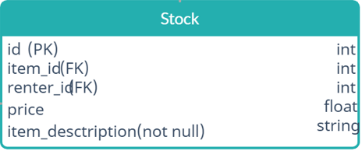

**Figure 6: stock table**

1. Shopping_session table: contains a set of items that have been purchased or rented with the total price of all items.

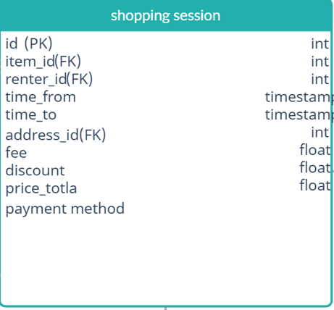

**Figure 7: Shopping session table**

1. Order table: contains one item that the customer wants to buy or rent, or it can be an adopted animal. This table is considered as a part of the shopping session.

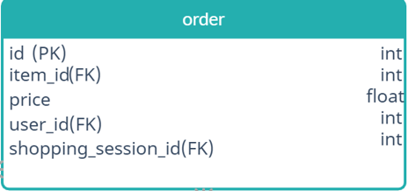

**Figure 8: Order table**

1. City table: contains the id of the city and its name. It's very important to know the location of the item in order to find it in a specific city.

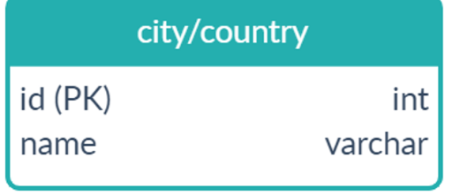

**Figure 9: City table**

1. Delivery table: contains information about the person who will do the delivery job and its trip.

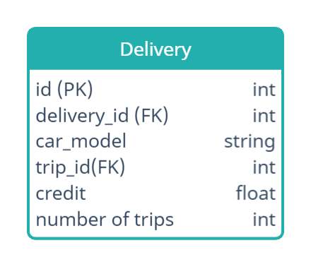

**Figure 10: Delivery table**

1. Trip table: contains the id of the trip and the delivery user which is the user id also, it has the id of the shopping session in order to know the location and the id of the renter and the price along with the distance.

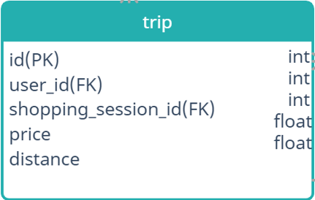

**Figure 11: Trip table**

* + 1. **Describe the design of our project to achieve the solution.**

The website has an easy GUI that includes a lot of features, a search bar which gives the users the ability to find the desired item side by side with the location bar for the users to choose from, in addition to the delivery company and the date of delivery. On the other hand, the website gives the lessors the choice to publish their items, in a fast forward way all it takes is: a location, name of the item, the condition and the category.

* + 1. **How we plan to address the problem statement.**

By creating a website that connects the users with each other giving them the ability to have a peer-to-peer relationship, this website allows the user to rent anything online, which is sustainable with the idea of getting the most of unused items.

* + 1. **Detailed figure of our solution, describing the interaction between the components in detail.**

In the figure below is a representative of the RentU system.

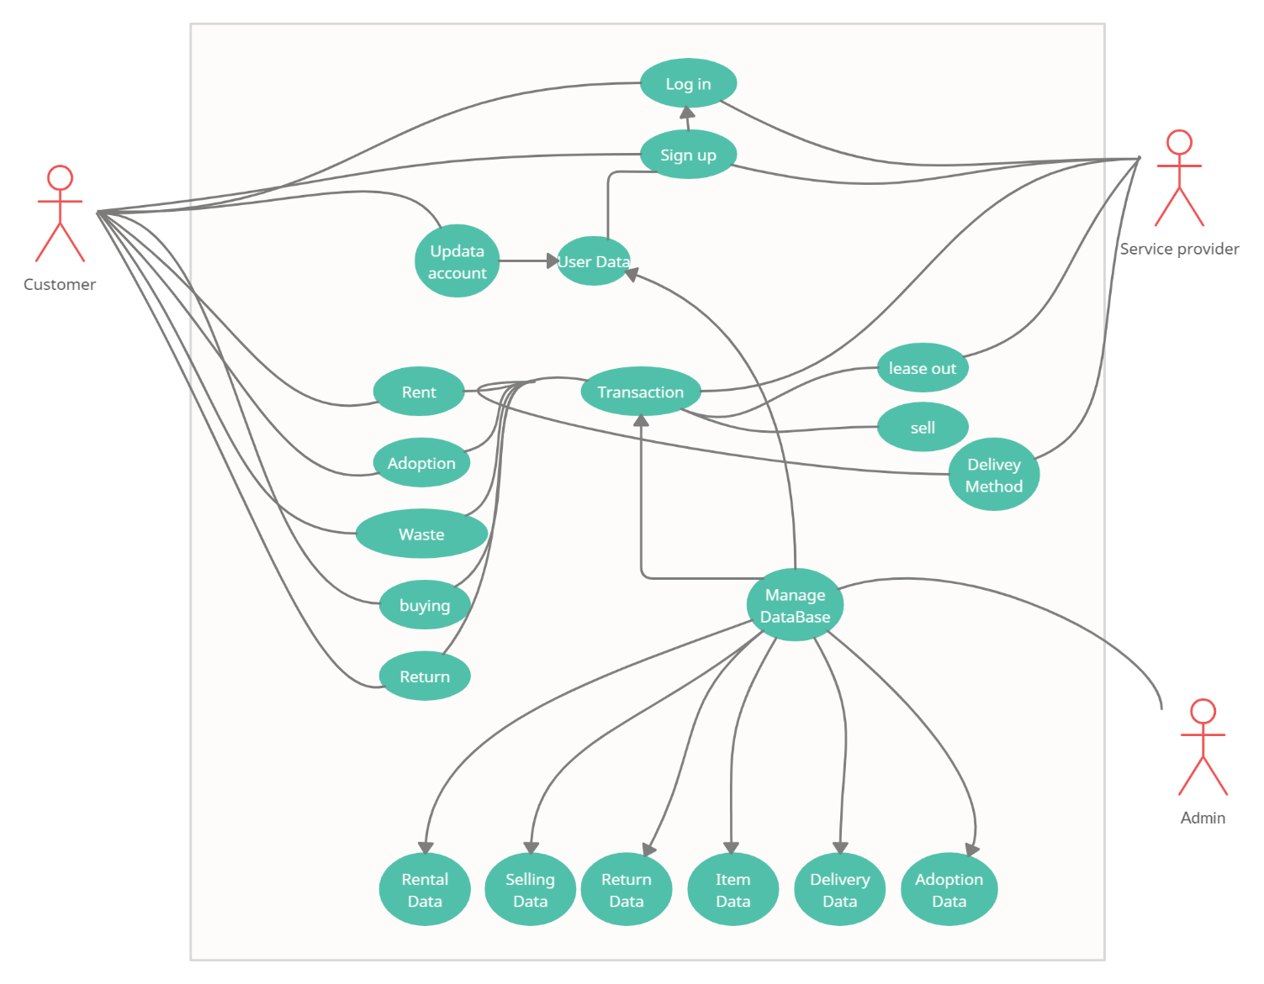

**Figure 12: use case**

**Use case description:**

**Use case 1: Sign Up.**

**Actor:** user

**Goal:** create an account on the website

**Main flow:**

* The customer shall click on “create account”.
* The customer shall fill in all the basic information such as his/her name.
* The customer shall click over the Register button.
* The database shall be updated by adding the new account.

**Pre-condition:** The customer must have an email and phone number.

**Use case 2: Sign In.**

**Actor:** user

**Goal:** Enter to the website

**Main flow:**

* The actor shall click over the sign in
* The actor shall enter the username, password.
* The actor shall click over sign in button
* Website shall check whether the username and password are correct or not.
* The website shall create a new session

**Pre-condition**: The actor must have an account

**Use case 3: rent an item**

**Actor:** customer

**Goal:** rent an item

**Main flow:**

* The customer login to the website by his account to rent an item, then he prints the name of the item with the location.
* The system shows the available item as he requested.
* The customer chooses the item he wants.
* The system displays the delivery method as it’s from a third-party company.
* The system offers the customer the payment method.
* The customer chooses the payment method.

**Pre-condition:** the customer must login from an account.

**Use case 4: sell an item**

**Actor:** customer

**Goal:** sell an item

**Main flow:**

* The customer login to the website by his account to sell an item, then he prints the name of the item with the location.
* The system shows the available item as he requested.
* The customer chooses the item he wants.
* The system displays the delivery method as it’s from a third-party company.
* The system offers the customer the payment method.
* The customer chooses the payment method.

**Pre-condition:** the customer must login from an account.

**Use case 5: buy an item**

**Actor:** customer

**Goal:** buy an item

**Main flow:**

* The customer login to the website by his account to buy an item, if he chooses to buy then he prints the name of the item with the location.
* The system shows the available item as he requested.
* The customer chooses the item he wants.
* The system displays the delivery method as it’s from a third-party company.
* The system offers the customer the payment method.
* The customer chooses the payment method.

**Pre-condition:** the customer must login from an account.

**Use case 6: lease out an item**

**Actor:** the leaser

**Goal:** lease an item

**Main flow:**

* The leaser login to the website by his account to lease out an item, if he chooses to lease out then he prints the name of the item with his location.
* The customer chooses the price of the item, and some info about the item.
* The system enrols the item into the system.

**Pre-condition:** the leaser must login from an account.

**Use case 7: Delivery Method**

**Actor:** Delivery

**Goal:** Deliver

**Main flow:**

* The Delivery login to the website by his account to see if there is any request in his area.
* If there is an offer, he has the option to accept it.
* If he accepts, the system will add the order to his delivery list.

**Pre-condition:** The delivery must login from an account.

**Use case 8: Sign out.**

**Actor:** user

**Goal:** log out from the website

**Main flow:**

* The actor shall click over the sign out button.
* The website shall end the session and logout the actor

**Pre-condition**: sign in.

**Use case 9: Contact for Support.**

**Actor:** user

**Goal:** solve problems.

**Main flow:**

* The customer shall click over the contact tab.
* The website shall display a new frame containing an empty box and send button.
* The customer shall write his/her message.
* The customer then clicks over the send button.
* The website shall send the message to the admin account.

**Pre-condition**: sign in.

**Use case 10: Pet adoption**

**Actor:** user

**Goal:** adopt an animal.

**Main flow:**

* The customer shall click on the pet adoption branch.
* A list of pets will be displayed.
* The user can adapt any pet.
* Request will send to the owner of the pet.
* If the owner accepts the request, then the customer can adopt the pet.

**Pre-condition**: login, also the customer should have a humanity.

* **scenarios:**

**Scenario 1: Order an item for rent.**

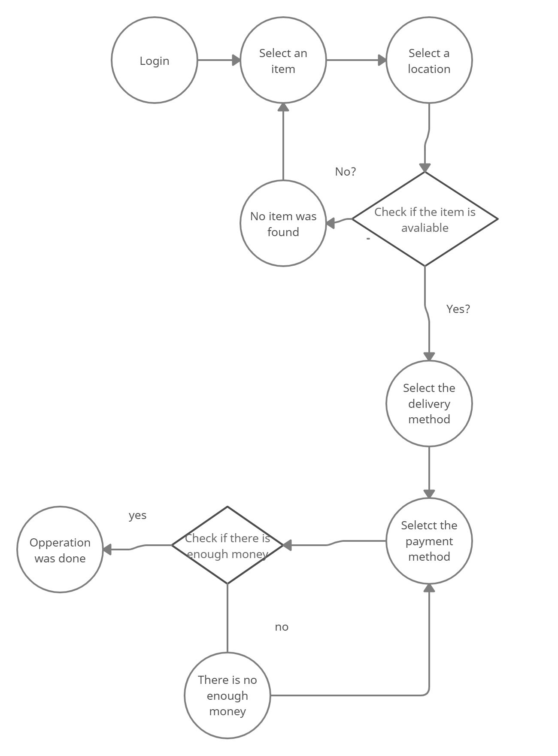

**Figure 13: scenario 1**

**Scenario 2: Put an item for rent.**

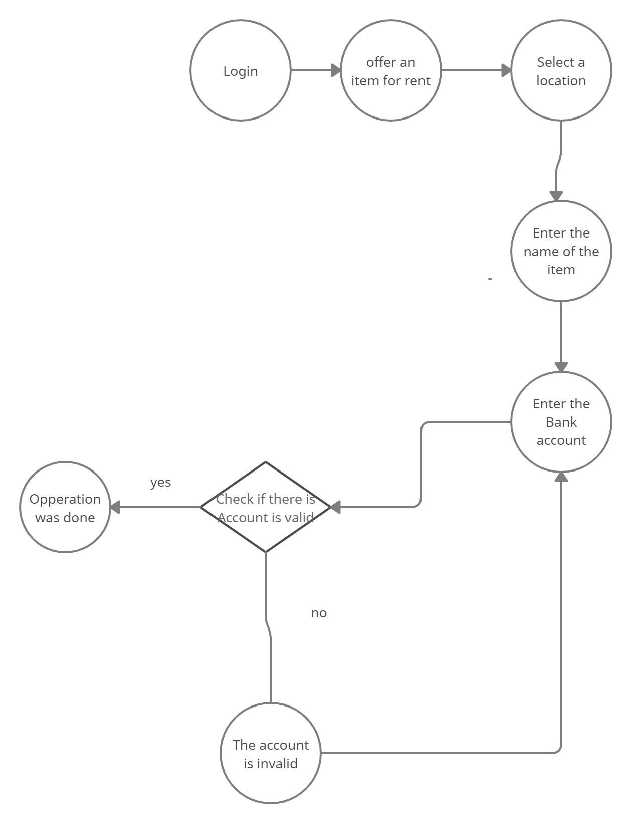

**Figure 14: scenario 2**

* 1. **Design Details:**
     1. **Design Specifications**

There will be multiple sections with items of the same category, therefore we added a search box to let people search for the items they need.

We estimated that the project completion period can be 4 months, after that the site will be complete and ready to use, anyone can take advantage of it, as it is clear and easy to use, also it is widely used for all segments of society and directly benefits them, so this system is expected to achieve great success.

* + 1. **Design Process**

The design process that is being used to make our website is the Agile software model which focuses on practices which range from choosing the right modelling approach for the thing to be modelled to the advantages of working in a group [4], it has 5 values: (Communication, simplicity, Feedback, Courage, Humility).

It is based on iterative and incremental development [5], as shown in the figure. 6, below.

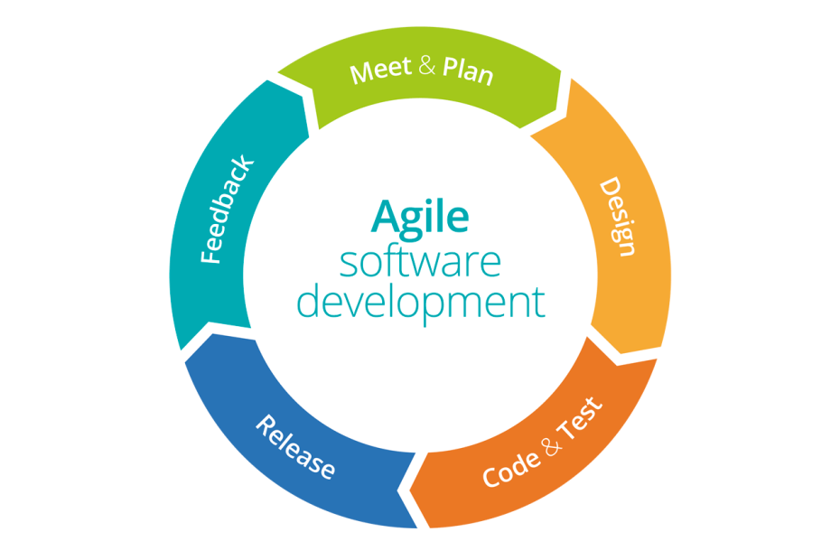

**Figure 15: Agile Model**

* + 1. **Legal Aspects**

This website applies the highest standards of privacy protection. Information about our customers is an important part of our business, and we are not in the business of selling our customers' personal information to others. The site does not have the right to show any of the user's personal information without obtaining their approval. In addition, the website never saves any credit card information which is used in the website to the payment. in accordance with the site’s policies and rules, each user who has been exposed to any form of fraud by other users of the site has the right to sue those who defrauded him or caused the damage or loss of any piece (if rented items) and the other party must comply with all legal procedures consequences.

* + 1. **Design Constraints**

The project is a website application, and it does not have any constraints, except knowledge.

* + 1. **Design Standards**

There were no design standards that were followed during the process of the design.

* + 1. **Design Alternatives**

An Alternative to the website will be a store to the customer relationship, not a peer-to-peer relationship, which is less efficient. So, the current design is more efficient which opens a new opportunity of getting the most of the market.

* + 1. **Safety Consideration**

The site does not assume any responsibility for the safety of drivers or the items that are rented or sold, or any responsibility for the safety and health of any of the animals displayed on the site

As we mentioned previously. Customers are fully responsible, once they accept the website's terms and policies.

* + 1. **Design considerations table.**

**Table 1: Design Considerations**

|  |  |  |
| --- | --- | --- |
| Design consideration | Project application | Relevant location in report |
| Performance | N/A | N/A |
| Serviceability | X | Section 1.1 |
| Economic | X | Section 2.3 |
| Environmental | X | Section 6.4 |
| Environmental Sustainability | X | Section 2.2 |
| Manufacturability | N/A | N/A |
| Ethical | X | Section 2.4 |
| Health and safety | N/A | N/A |
| Social | N/A | N/A |
| Political | N/A | N/A |

# Chapter 4: Implementation

* 1. **Description of the methods and tools.**

We use WebNode platform [8] to create the main interfaces of our website, so we add all types of content in just a few clicks, and moving it around or changing it up.

The website will use HTML, CSS and JavaScript along with libraries like: React Native and Bootstrap as (front-end) technologies. As for (back-end) technologies the website uses Laravel along with MVC and MySQL. In addition, as for the tools that have been used for the development of the website, for the front end the team used Visual Studio Code, following Visual Studio 2019 for the back-end.

* 1. **Infrastructure the solution depends on.**

The idea behind the website depends on the process of spreading between people, besides of how easy the accessibility to the services of the website is. This can be presented by the friendly GUI along with the clear instructor that’s being used in the website, which gives the user the easy-going experience.

**Home page:**

In the Figure. 16 below is the home page of the website.

* 1. **trade-offs**

The website’s main standards are: time and the design, with less time given to the design the quality will drop, so to balance everything the team traded-off time for design, but in a balanced way that makes the design as clean as possible.

* 1. **What are the dependencies/assumptions of your implementation?**

The user needs only an internet connection in order to access the website, a bank account to rent and an Email address in order to create an account.

# Chapter 5: Results and Discussion

* 1. **Results of our work and discusses them in detail.**

The website contains a homepage, that collects all of the trends items which are recently sold or rented and services that are done newly, places section so that the customer can select what country they from, so it makes easier for the customer to know their country price and the shipping fees etc., "About us" button which has some information, about us and what we deliver, "Contact" button to give help for a customer got into trouble, In addition to a “Branches” button which is collects six branches; each branch has several or one main sections inside it.

1. Waste Management branch that has one main section; materials and disposals that are recyclable. This section helps customers to get rid of scraps items and keeps their around-environment clean in addition to earning some money in return. In addition to makes easier for customers, to reach the companies that care by these types of business through this branch
2. Pet Adoption branch which contains three sections:

* Adoption section that Shows pets offered for adoption which makes it easier for pet lovers to find pets and reach a lot of kinds in a fast way without much physical effort.
* The care centres section shows the nearby which help customers to find pet care centres near their current locations
* The lost pits section, which helps customers to increases the chance of finding lost pets and makes it easier as well

1. Physical Services branch has one main section display some services provided by people with a certain skill or craft, which creates opportunities to increase the income of the service providers themselves and fill their free time with useful work
2. Rental Store branch, that has one main section inside, but it allows customers to

search for specific items like:

* Occasion’s wear
* Household items and furniture
* Commercial or industrial equipment
* Auto parts and cars
* Electronics and technical tools
* Homes or apartments or even lands’ plots

by this branch, the website offers an easy way to take advantage of items and tools that the consumers are not used at the current time, which helps some to generate money from what may be stored for years without any interest

1. Sales Store branch, that has one main section inside, but it allows customers to search for a specific item like:

* Occasions’ wear
* Household items and furniture
* Commercial or industrial equipment
* Auto parts and cars
* electronics and technical tools
* Homes or apartments or even lands’ plots

1. Delivery Services branch, lets small and midsize businesses owners get a very fast delivery service and get rid of the heavy fees that they pay for delivery companies that have somewhat pit slow delivery services. In addition to helping drivers to generate some money by accepting any delivery services offered on this branch, moreover, this branch makes it easier to reach those customers very fast without making any effort.

Also, there are reviews or feedback from customers that have tried some services or have rented items etc.

* 1. **Discuss the strengths and weaknesses of our solution/system.**

Of course, like any website, a website system may have strengths and weaknesses that we need to be conscious of.

* The strengths points:

The website is open-source so that the developers can modify the website and improve it as they need. In addition to the modifiability, the designers can modify the website and optimize it as technology develops based on the feedback that customers present it by the website in other words i.e., flexible design over time.

moreover that, the speed that website offers by allowing the customer to find a lot of items and tools even services offered on one website without the need to lose a lot of time and effort looking for some services or items

the security as we mentioned previously, the website has the highest security standard that can be applied on an E-commerce website

* The weaknesses points:

Maybe the website has not easy loading of the webpage on mobile devices, which is problematic as on older phones. Also, maybe the size doesn't adjust the mobile phone screen. Finally, the possibility of not being able to follow up on problems that may encounter both the developers and the customers, due to the large size of the website

# Chapter 6: Economical, Ethic, and Contemporary Issues

* 1. **Preliminary Cost Estimation and Justification**

There will be no costs to set up this website, not even capital, because the goods and services will be provided by the visitors to the website.

* 1. **Relevant Codes of Ethics and Moral Frameworks**

This website will make sure that information about individuals will be treated properly and equally, personal data will only be gathered for specified, accurate, and genuine reasons, also it will be sufficient and retained for no longer than is necessary.

* 1. **Ethical Dilemmas and Justification of Proposed Solution**

every person will be notified about any further procedures that his or her personal data may be exposed to, such as making decisions, being corrected, deleted, or blocked, or being revealed to other third parties.

Any activities that violate the norms of personal data privacy will be handled with appropriate security measures

* 1. **Relevant Environmental Considerations**

From an environmental point of view, the site will have a special part for waste management and recycling, so there will be no harm to the environment by establishing this site.

Since the site depends on renting things, not making new tools, this will save environmental resources and this is one of the positive features of the project.

* 1. **Relevance to Jordan and Region (Social, Cultural, and Political)**

The site will support all governorates of Jordan, and it is possible that we will later work on to develop it to include more areas. If we are lucky, our site will become available to all parts of the world.

# Chapter 7: Project Management

* 1. **Schedule and Time Management of our project** 

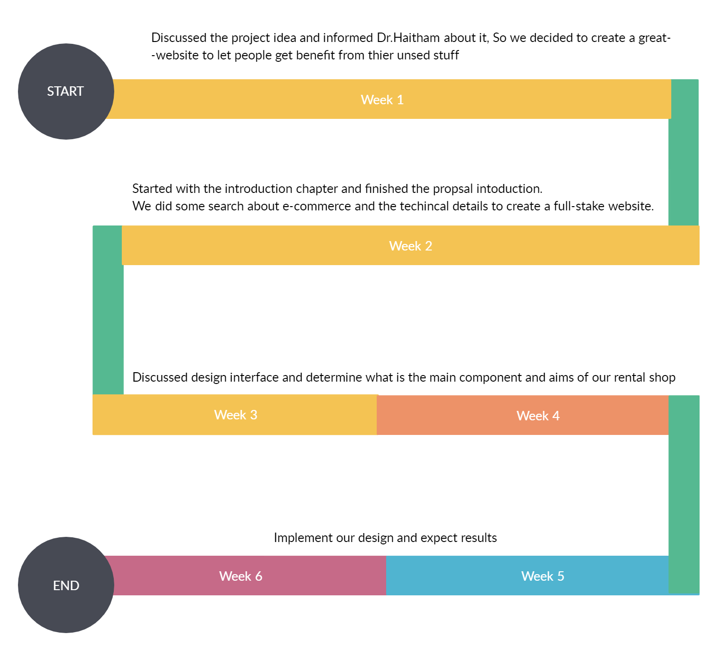

**Figure 28: time management**

* 1. **Resource and Cost Management**

In terms of resources, we did not use any tangible materials, but we used a set of tools and different websites to ensure that this project will complete correctly, completely and on time.

* 1. **Quality Management**

We will supervise all buying and selling activities to maintain the required level of excellence. This includes quality control and returning the product as leased.

* 1. **Risk Management**

The risks will be that each person will be responsible for the product he gives, and in the event that there are bad services or a bad customer, this will affect the evaluation of the site.

**7.5 project procurement**

For us, website hosting services costs are required purchases, but for customers, the cost of an item per day and delivery fee. For delivery and less they have about (5%) fees.

# Chapter 8: Conclusion and Future Work

* 1. **Summarize the main contributions of the work.**

The business process via the Internet has become no less important than trade in the traditional way until it has become beyond it, as our modern life is moving towards technology and reliance on automation greatly. As people are turning to trade through the Internet due to saving time and effort, whether they are business owners or customers.

RentU will provide the exciting services that people really and seriously need, one place that provides many services, and provides other sources to increase income, and because the website is a(p2p) website, here achieves mutual benefit, which enables it to serve a large segment of people. We hope that some of the parties that provide support for such projects take RentU into account. as a pioneering site that offers creative solutions by increasing sources of income, getting rid of unused materials in a beneficial way, and obtaining quick service in many services. We need time to develop the website better and of course, we need official support for RentU.

* 1. **Further future work someone should do to make the solution/system better.**

We are looking forward to making this website as an application that can be downloaded on Android and IOS devices.

We seek to add a lot of improvements, increase the number of services provided by the website, and work on developing each branch inside the site in particular furthermore we are looking to publish this website locally and in the Arab world as soon as possible.

* 1. **Lessons learned.**
* Speed and accuracy in completing tasks depend largely on the strength of teamwork in the group, Therefore, it is necessary to work in a one-team spirit.
* We exchanged many skills and experiences among members of a group themselves. Moreover, we gained many skills and information during the work of this report from the supervisor of this report.
* We got new skills whether it was in the way of writing this report or on the level of using a lot of tools and software that facilitated our task.
* Expand our awareness of programming and gain more experience in it.
* Our experience in many programming languages used in programming websites (such as JavaScript, Html etc.) has increased

# References

[1] Flores-Garcia, Monica, and Alfredo J. Mainar. "Environmental effects of production and consumption activities within an economy”

[2]<https://www.rentomojo.com/mysore>

[4]<https://www.klientsolutech.com/importance-of-ecommerce-in-our-daily-life/>

[5] Abrahamsson, P., Salo, O., Ronkainen, J., & Warsta, J. (2017). Agile software development methods: Review and analysis. *arXiv preprint arXiv:1709.08439*.

[6]<https://www.researchgate.net/publication/264626696_A_STUDY_OF_AGILE_SOFTWARE_DEVELOPMENT_MODEL>

[7]<https://www.worldbank.org/en/news/feature/2021/06/08/the-global-economy-on-track-for-strong-but-uneven-growth-as-covid-19-still-weighs>

[8] <https://jo.opensooq.com>