CSE480: Machine Vision — Lab Assignment Report — AIN SHAMS UNIVERSITY

AIN SHAMS UNIVERSITY
Faculty of Engineering
Mechatronics Engineering Department

CSE480: Machine Vision

Handwritten Digit Classification
Lab Assignment #06
Subject: K-Nearest Neighbors Digit Classification
Dataset: Scikit-Learn Digits Dataset
Implementation: Python, Scikit-Learn, Matplotlib
Model: KNN Classifier (k = 3)
Semester: Spring 2026
Prepared by: Mohammed Mahmoud AlJamal 2002612
May 14, 2026

1 Introduction
This lab demonstrates a supervised machine learning pipeline using the Scikit-Learn handwritten digits dataset. The objective is to classify handwritten digits using the K-Nearest Neighbors (KNN) algorithm.
The workflow includes:
- Loading the digits dataset
- Visualizing handwritten digit images
- Splitting the dataset into training and testing sets
- Standardizing the feature vectors
- Training a KNN classifier
- Evaluating classification performance
- Generating visual analysis plots

2 Dataset Description
The dataset used is the built-in load digits() dataset from Scikit-Learn.
Dataset properties:
- Total samples: 1797
- Image size: 8 × 8
- Number of classes: 10 digits (0–9)
- Feature vector size: 64 features

3 Methodology

3.1 Train-Test Split
The dataset was divided into training and testing sets using:
- Test size = 0.25
- Random state = 42

3.2 Standardization
Feature scaling was performed using StandardScaler() to normalize the data before training the KNN classifier.

3.3 KNN Classifier
The classifier used was:
- Algorithm: K-Nearest Neighbors
- Number of neighbors: k = 3

4 Results

4.1 First 50 Digits Visualization
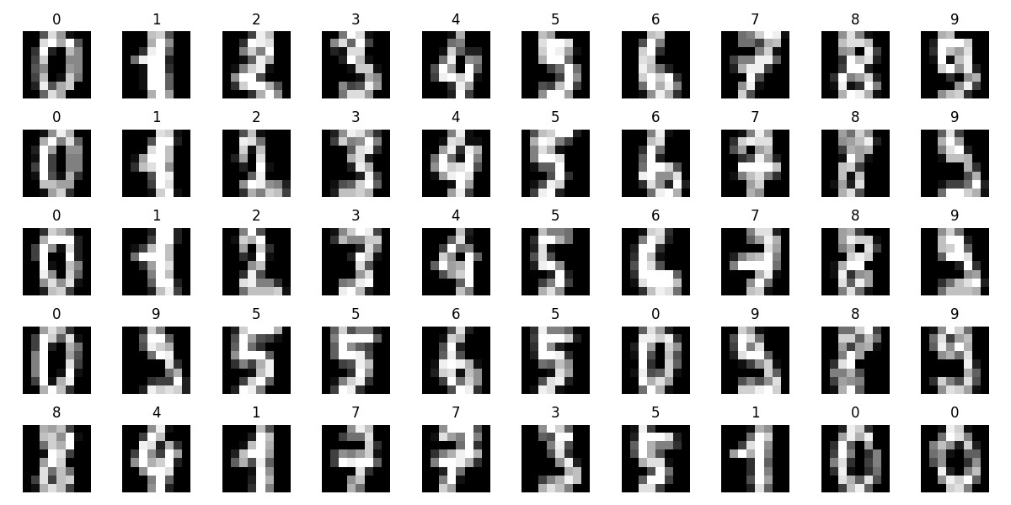
Figure 1: Visualization of the first 50 handwritten digit samples

4.2 Confusion Matrix
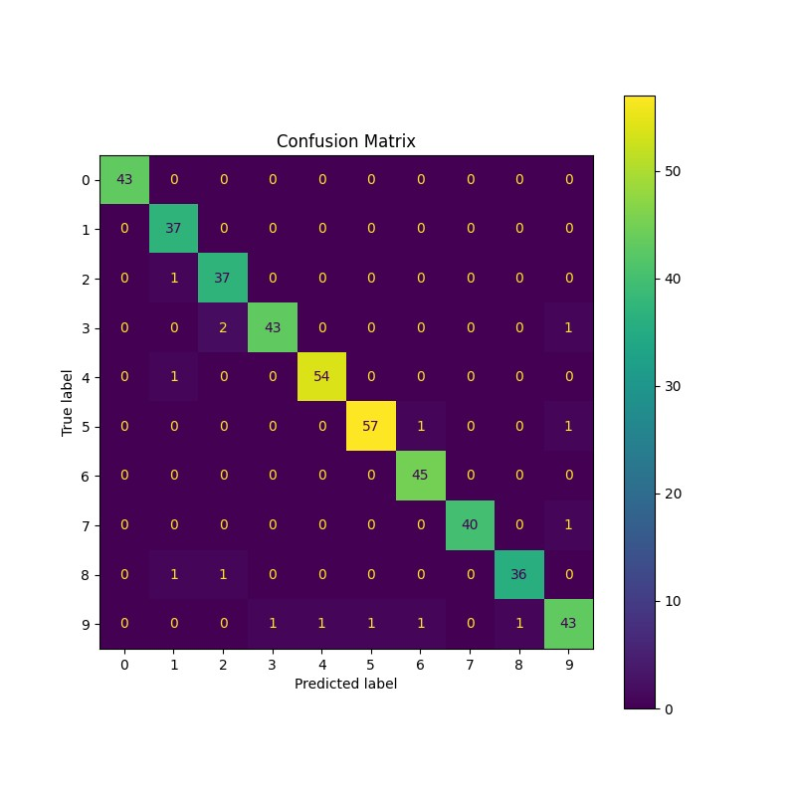
Figure 2: Confusion matrix of KNN classification results

4.3 Sample Predictions
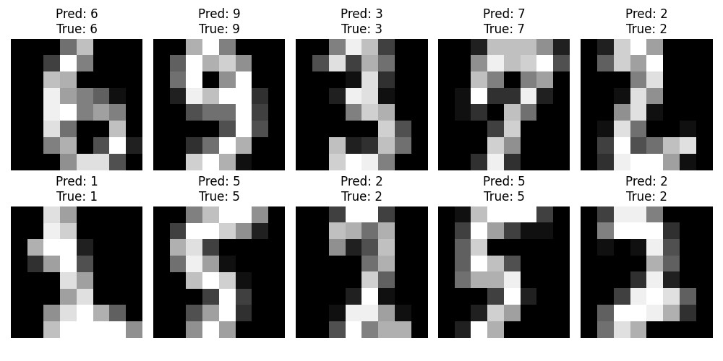
Figure 3: Example predictions from the testing dataset

4.4 Accuracy Graph
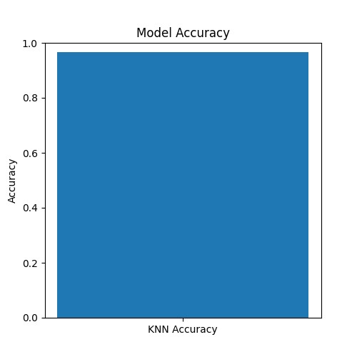
Figure 4: Model accuracy visualization

5 Performance Evaluation
The KNN classifier achieved very high classification accuracy on the test dataset, demonstrating the effectiveness of KNN for small image classification tasks.
The confusion matrix shows that most predictions lie on the main diagonal, indicating correct classifications with very few misclassified samples.

6 Conclusion
In this lab, a complete handwritten digit classification pipeline was implemented using Python and Scikit-Learn.
The implemented system successfully:
- Loaded and visualized digit images
- Performed preprocessing and standardization
- Trained a KNN classifier
- Evaluated model performance using multiple visualization tools
The achieved results demonstrate that KNN is highly effective for the classification of low-dimensional handwritten digit datasets.

GitHub Link for the Lab:

