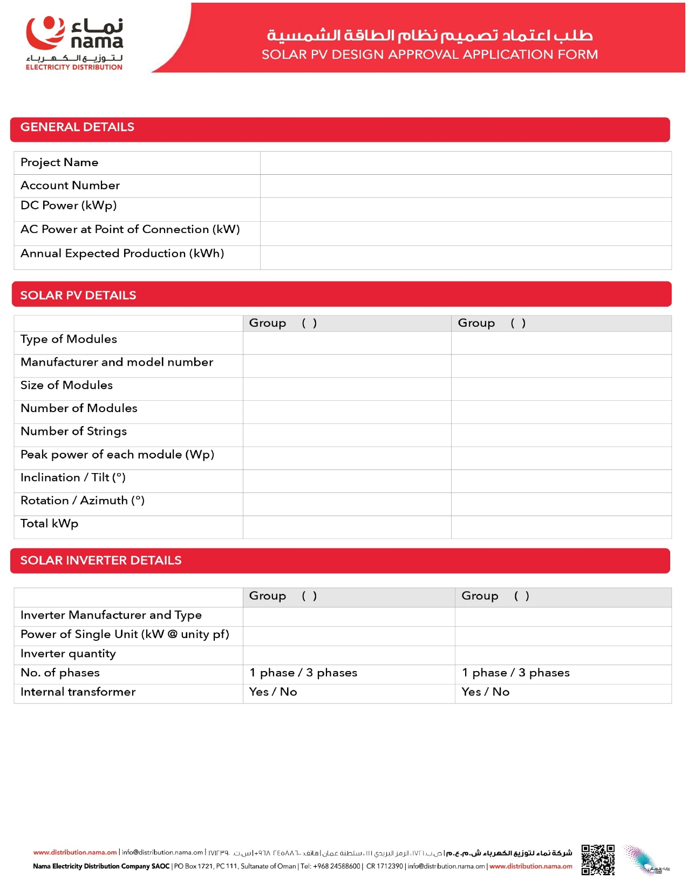
{{Capacity}}
{{Tilt}}
{{Azimuth}}
{{PanelCap}}
{{InverterMake}} {{InverterModel}}
{{InverterCap}}
{{InverterQty}}
{{PanelType}}
{{ModuleMake}} {{ModuleModel}}
{{ModuleDims}}
{{PanelNo}}
{{Strings}}
{{Capacity}}
{{Capacity}}
{{AccountNo}}
{{AnnualGenKWh}}
{{InverterCap}}
{{Name}}
