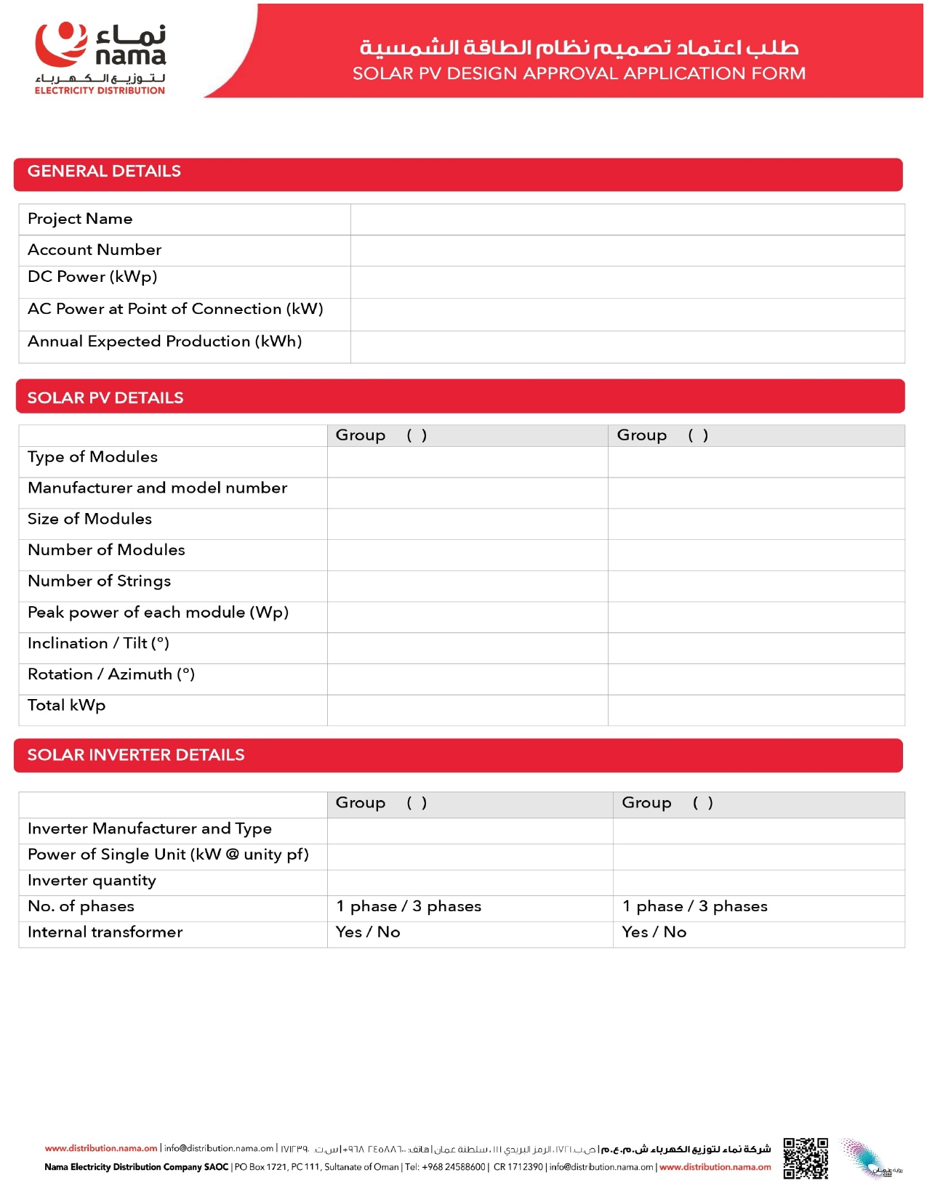
{{InverterMake}} {{InverterModel}}
{{InverterQty}}
{{InverterCap}}
{{Capacity}}
{{Azimuth}}
{{Tilt}}
{{PanelCap}}
{{Strings}}
{{PanelNo}}
{{ModuleDims}}
{{ModuleMake}} {{ModuleModel}}
{{PanelType}}
{{AnnualGenKWh}}
{{Capacity}}
{{InverterCap}}
{{AccountNo}}
{{Name}}
