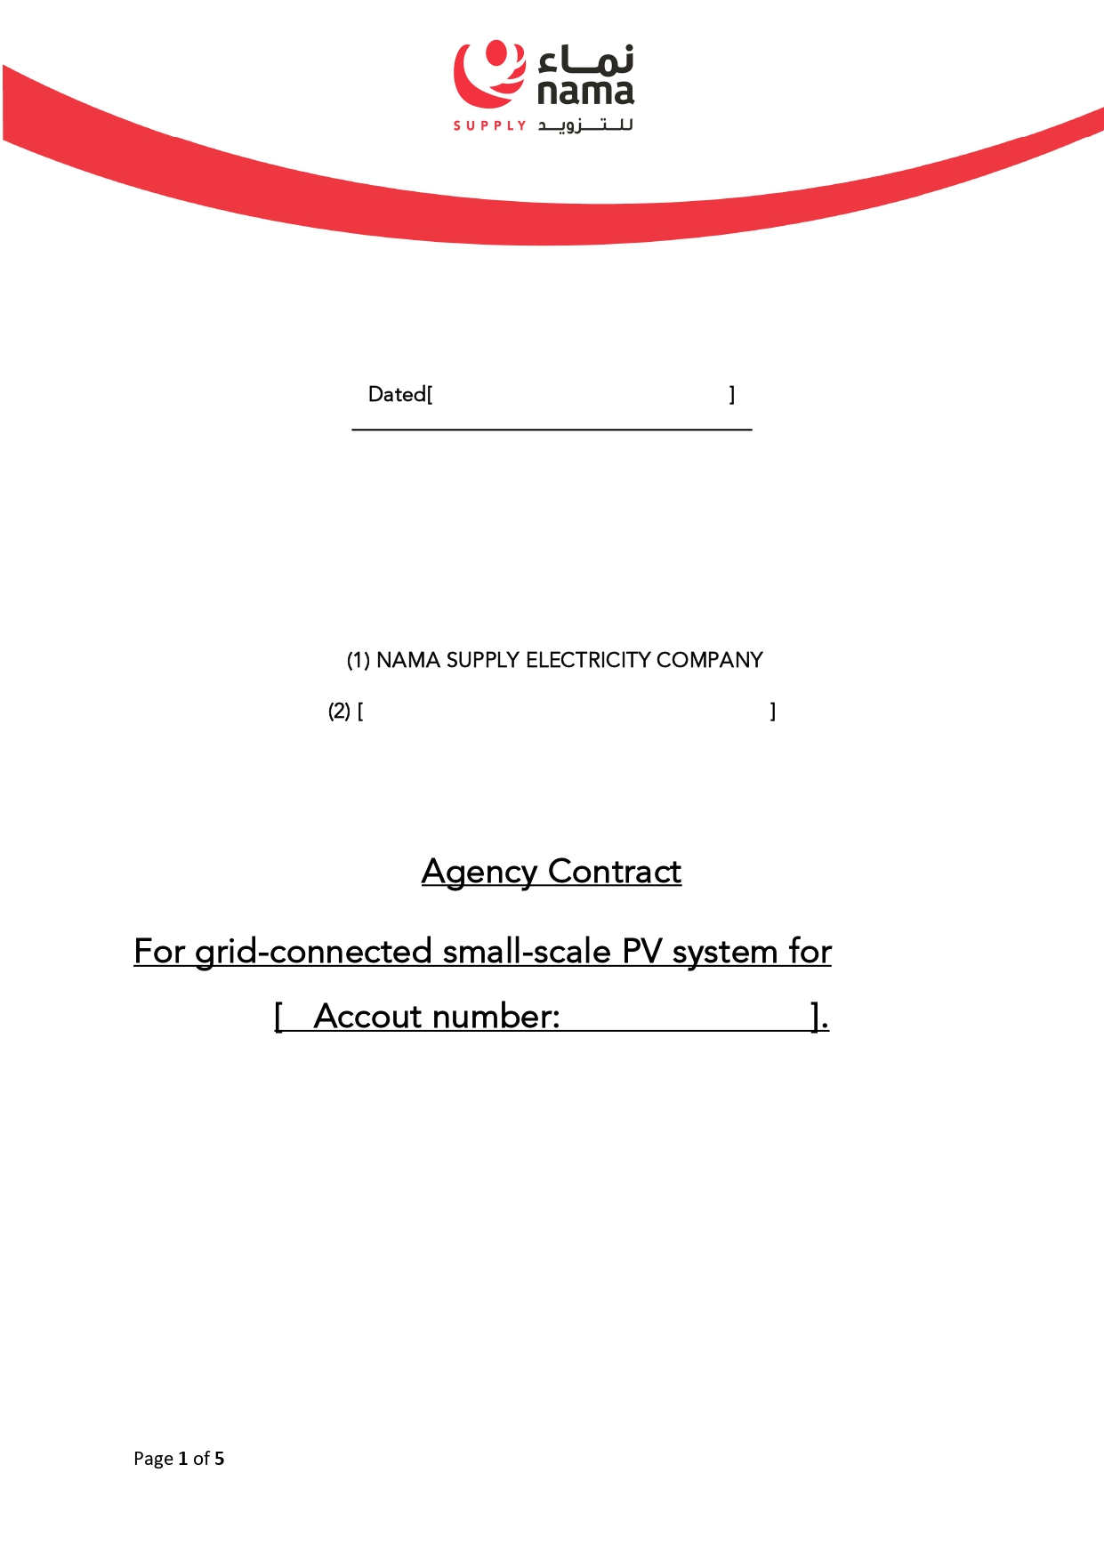
{{AccountNo}}
{{Name}}
{{ENdate}}

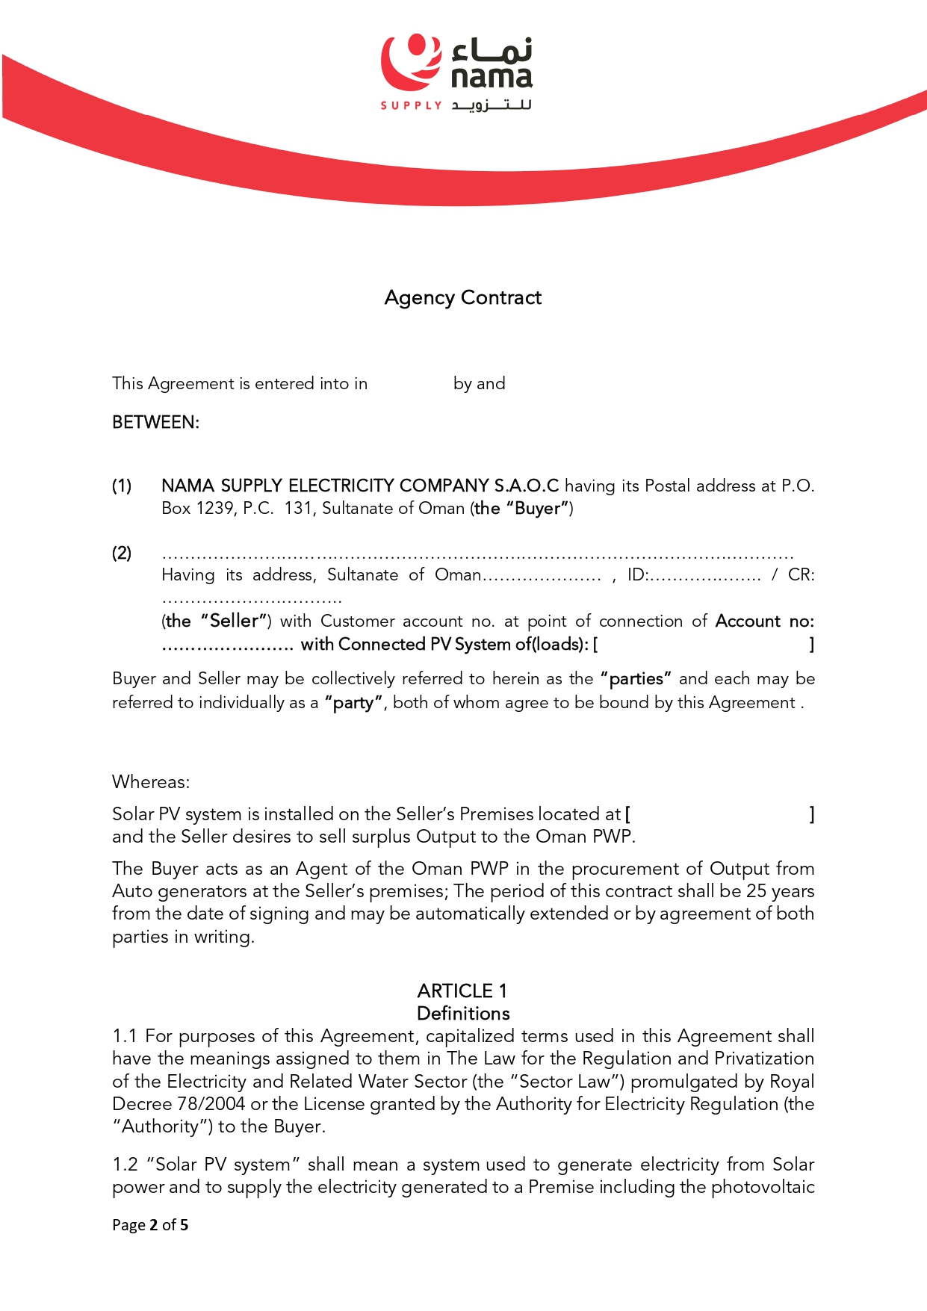
{{Wilaya}}
{{Capacity}} kWp
{{AccountNo}}
{{IDNo}}
{{Wilaya}}
{{Name}}
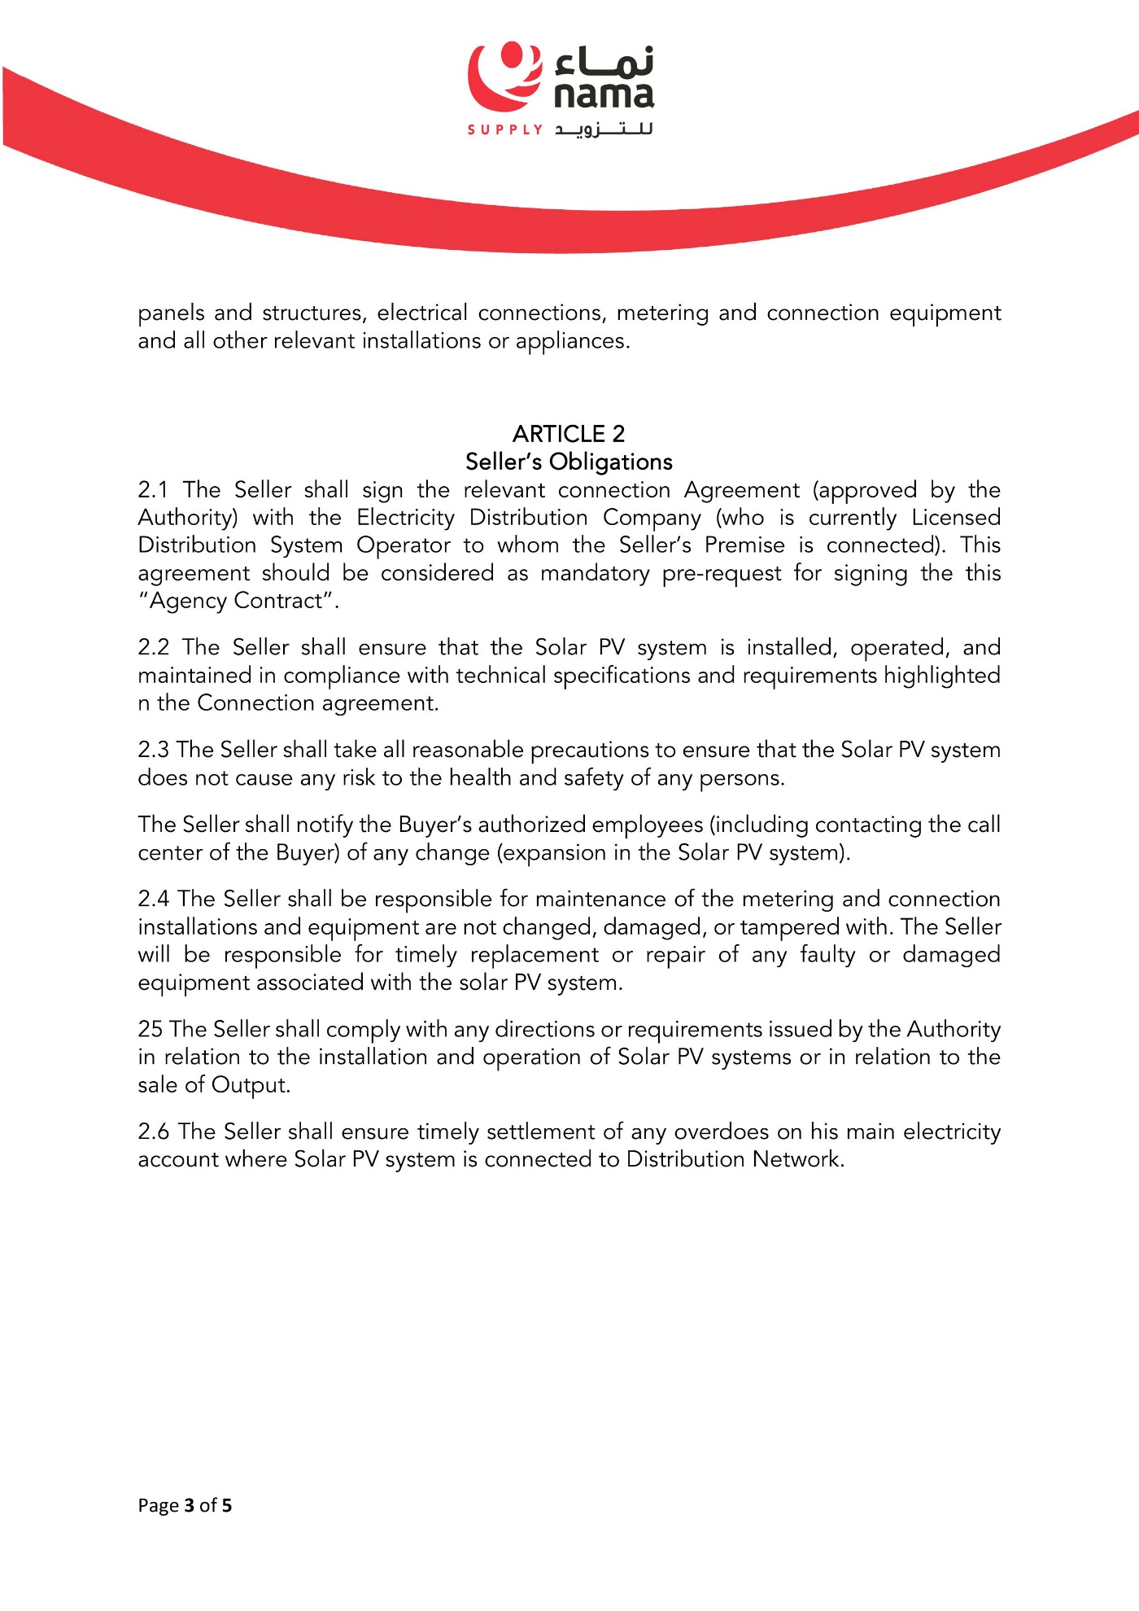
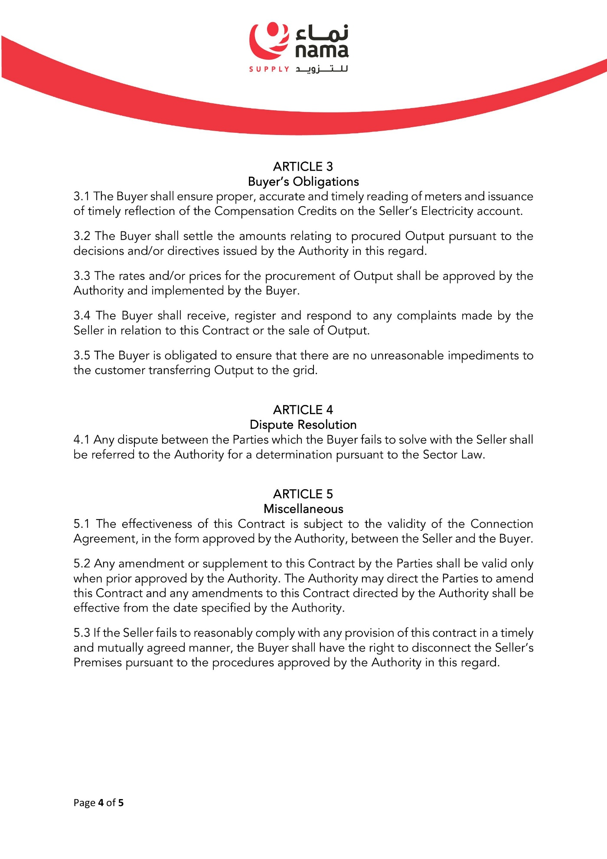
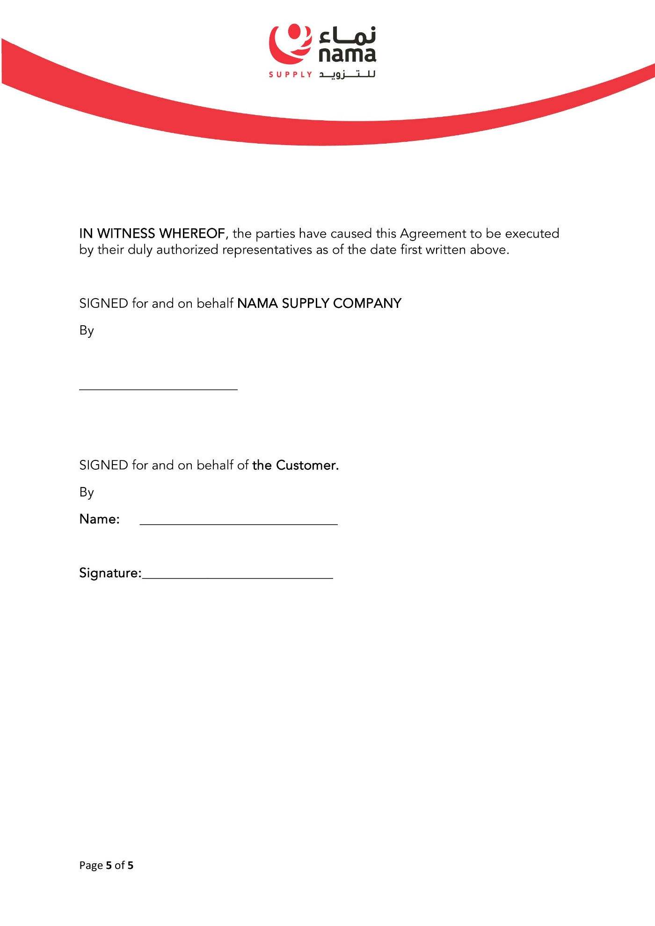
{{Name}}

