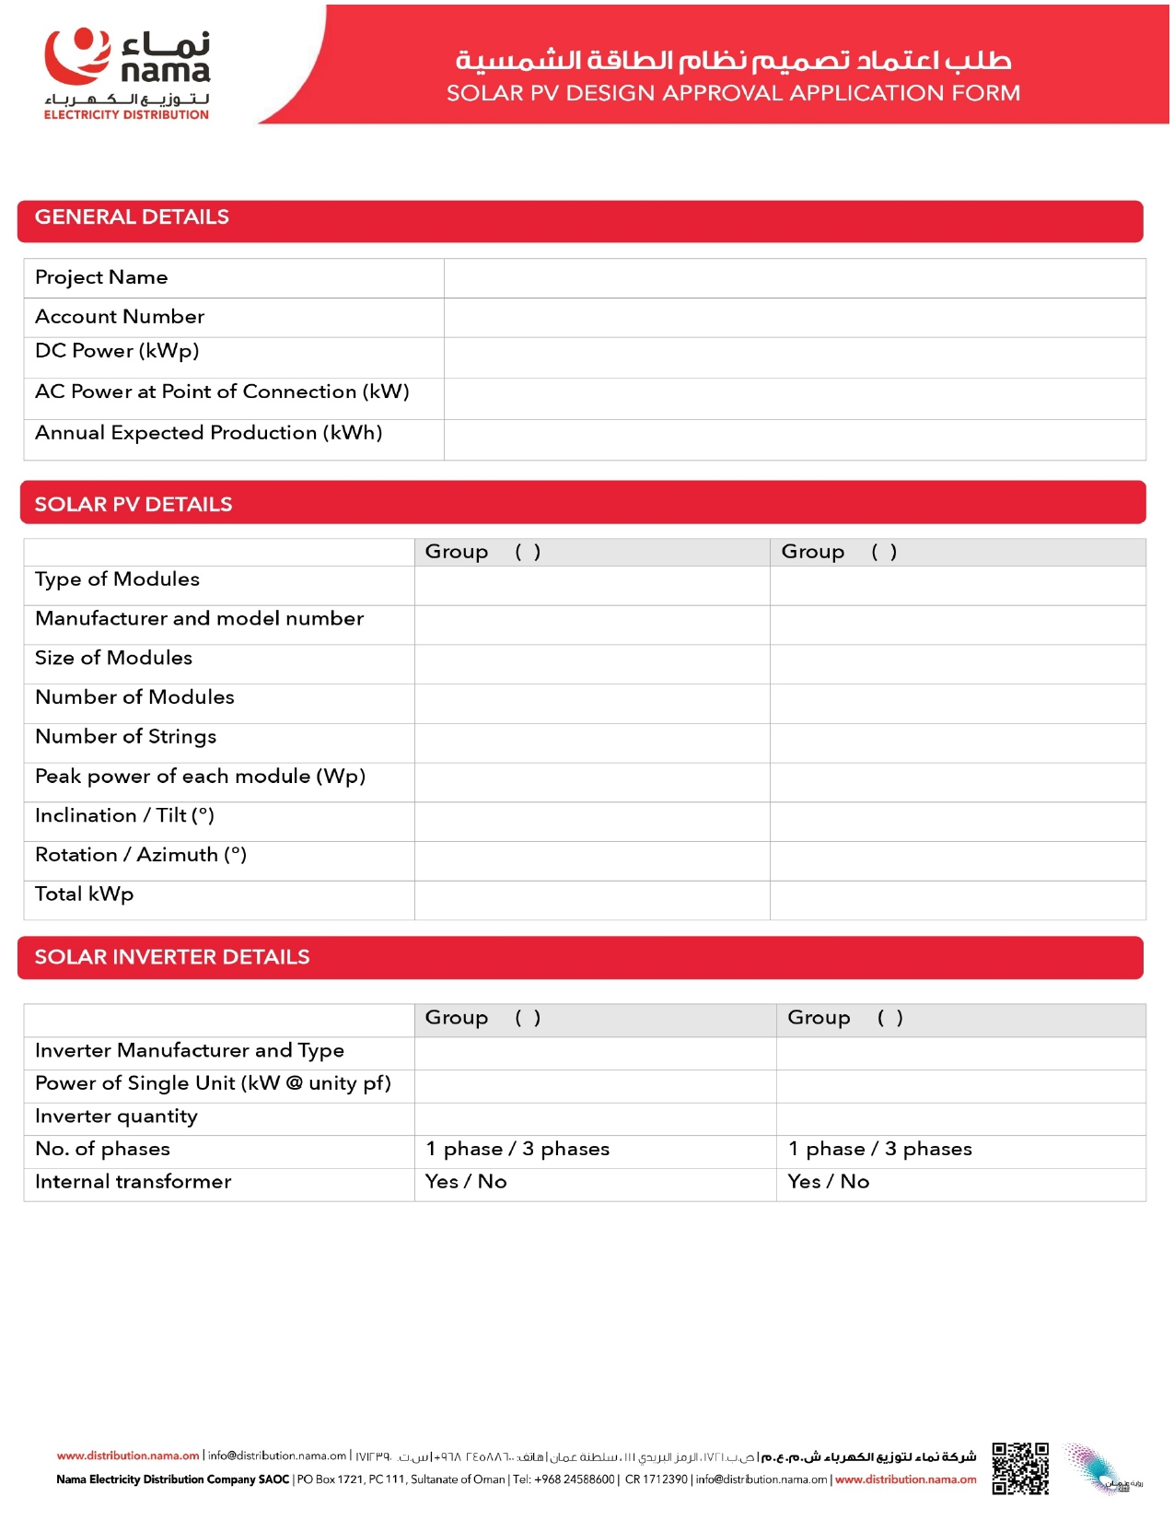
{{Capacity}}
5

{{PanelCap}}
{{InverterMake}} RT
RT
{{InverterCap}}

1
{{PanelType}}

JInko
2256 ×1133×35mm
{{PanelNo}}

2
{{Capacity}}

{{Capacity}}

{{AccountNo}}

{{AnnualGen}} MWh

{{InverterCap}}

{{Name}}

