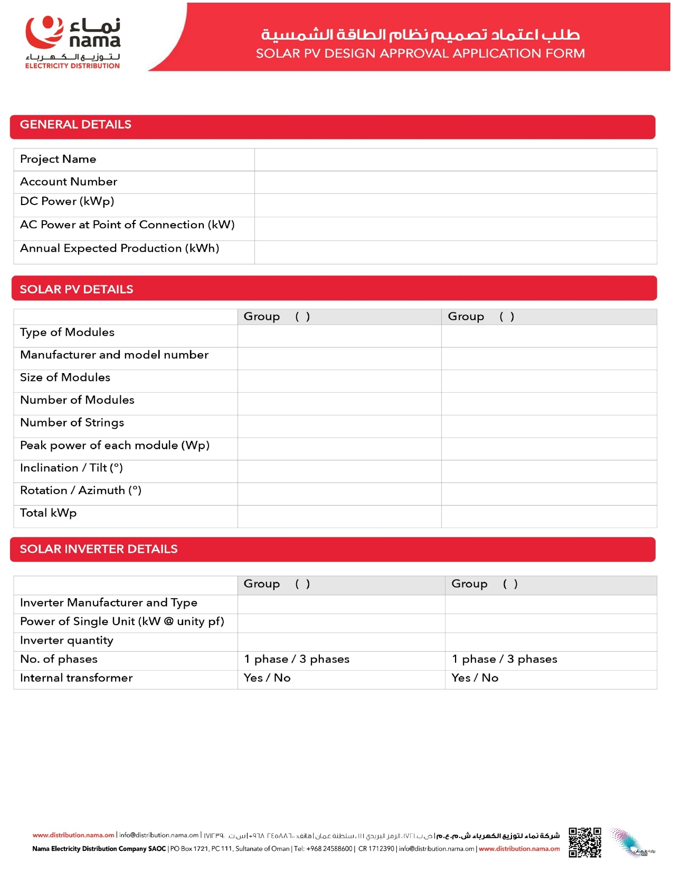
{{InverterMake}} RT

1
{{InverterCap}}

{{Capacity}}

208
5

545

2

{{PanelNo}}

2256 ×1133×35mm

JInko

{{PanelType}}

{{AnnualGen}},000

{{Capacity}}

{{InverterCap}}

{{AccountNo}}

{{Name}}

