

# Report for Football League Tables

## Introduction

Our goal for this project was to create a football live scores web app. Ultimately due to numerous complications and difficulties we moved away from that and created a web app that displays league tables for some of Europe’s top football leagues that includes the English Premier League, The Bundesliga, La Liga and Ligue 1.

We had initially wanted to use an API to collect our data and display footballing live scores, but we had many issues accessing our API Key and trying to implement it to our html. We then decided to create our own JSON to display our data. As it would be too hard to get that to work with a live score system, we moved to a league table display.

## phpMyAdmin

Here you can see the data stored on our php when data is entered into our localhost. As you can see below, we initially had some errors in our php code which lead to some data not being stored correctly. Eventually we managed to find the error which was a simple spelling mistake in our code. Once we solved this problem our php ran without any problems and was able to store the data in the manner we wanted.

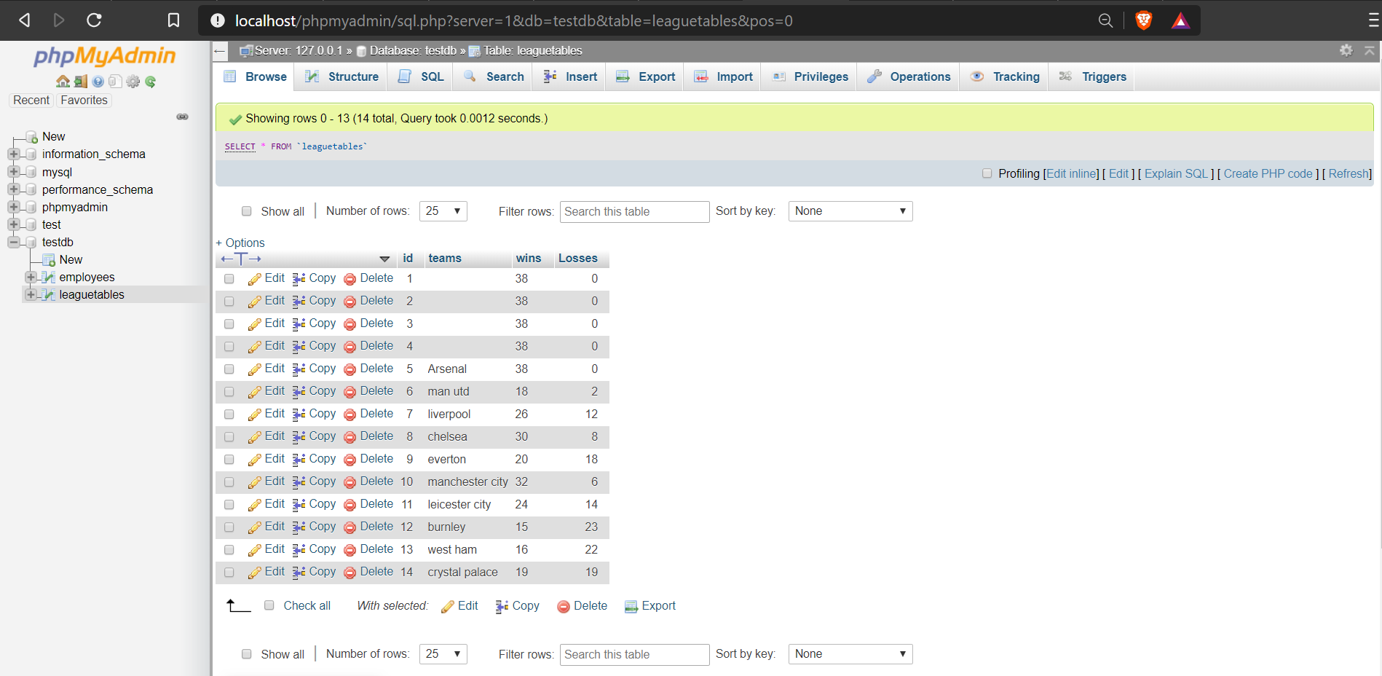

## Localhost

Here is our .php page that we created to link to our phpMyAdmin. On this page we have three boxes where data can be entered to, team, wins and losses. We also have a button to add the data when you have finished entering the data. This button will save the data to our php.

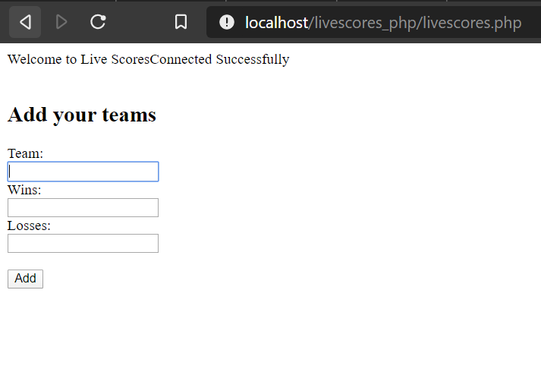

## League Table

Below you can see a screenshot of one of our 4 different league tables that we offer. This screenshot is of our premier league table. The data for this table was compiled in a JSON format and has been called to display this data using a construct table function

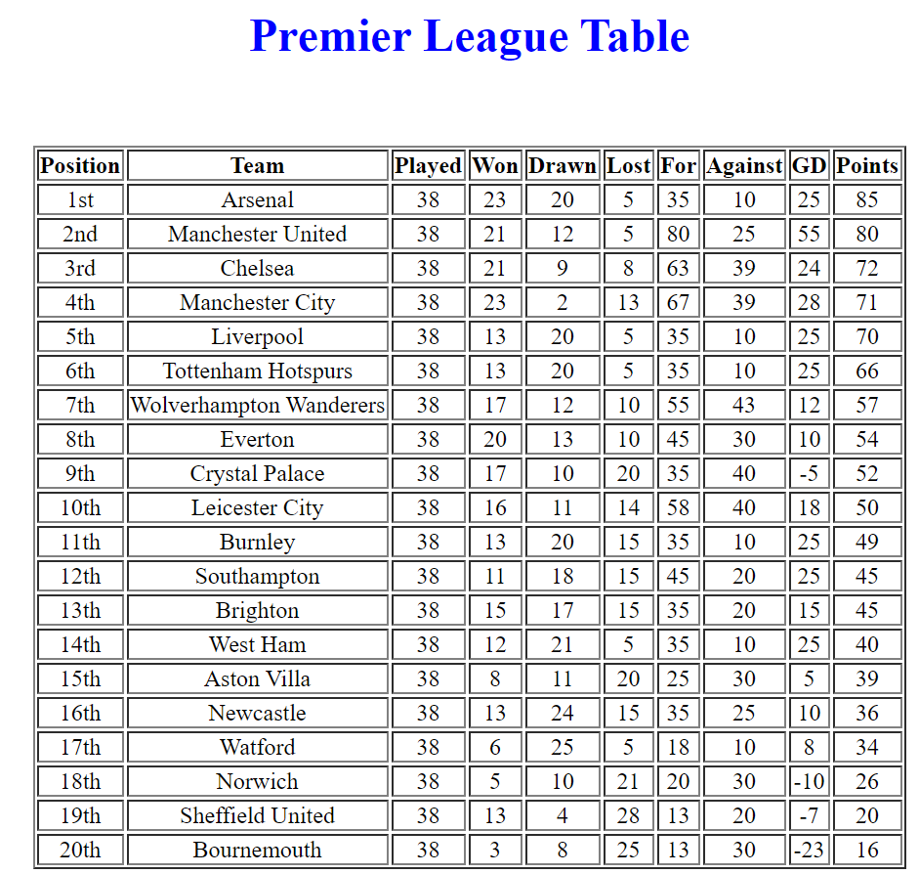

Here is the JSON code we made for our league table and has been added by script using a var list. It contains data such as the team name, the position they are currently in, how many games they have won drawn and lost, goals scored, goals against and their goal difference.

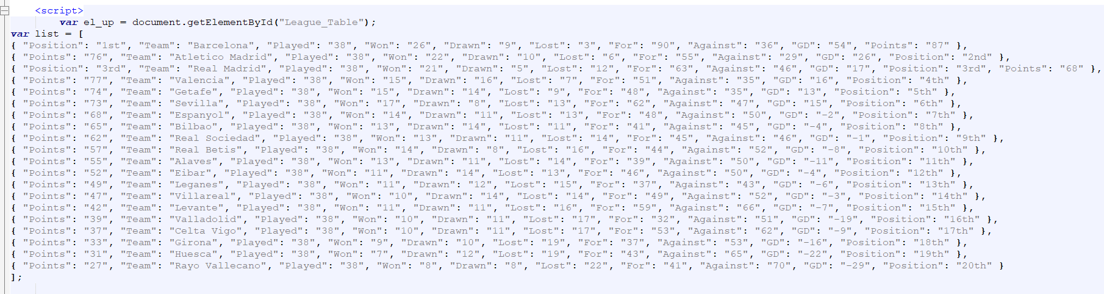

Here is the script we use to create the table that would display our data for our league tables.

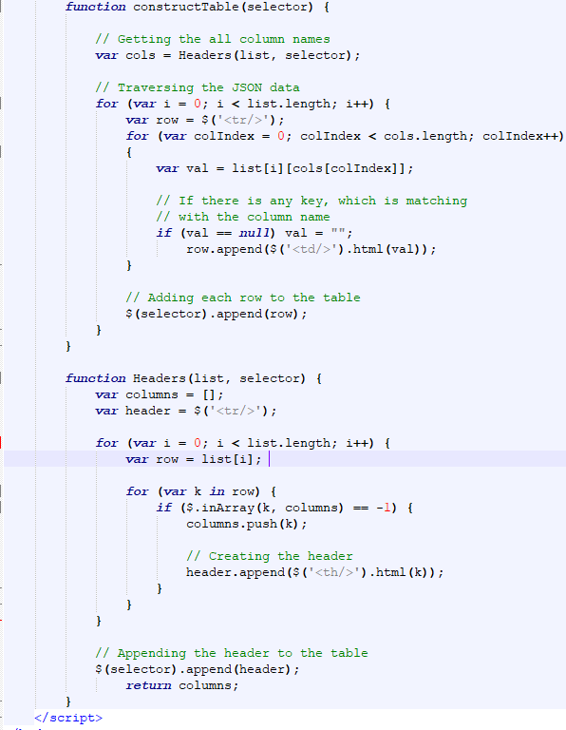

Here below you can see that our XAMPP controller is active and running.

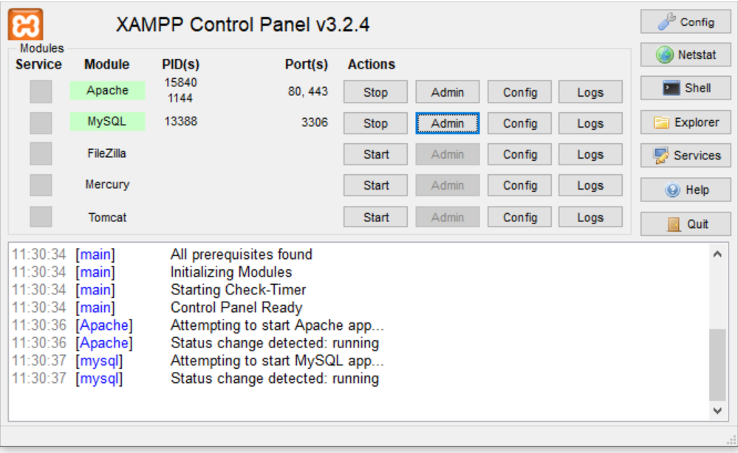

Here is a screenshot of the homepage of our website.

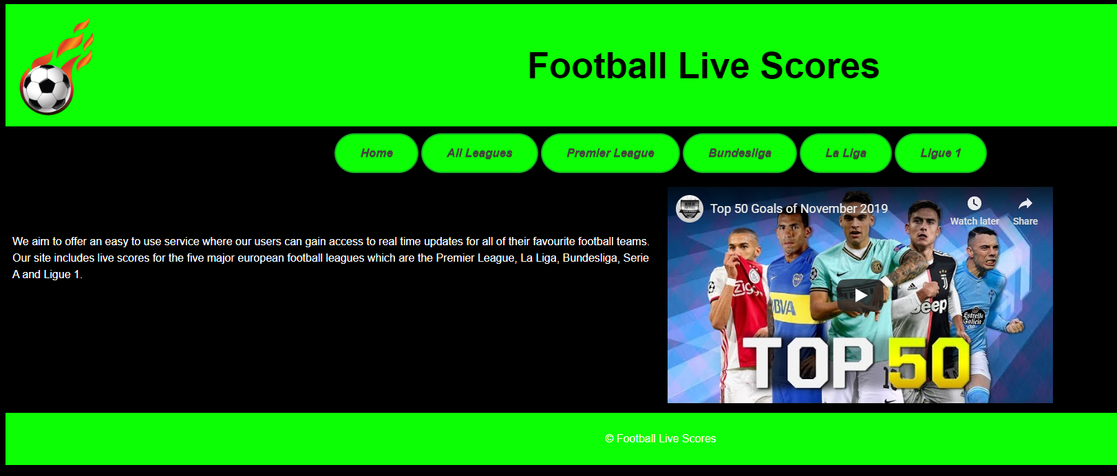

Here is a screenshot of one of our league pages. In order to view the league table for the league just have to click the “Click to View League” and you will be redirected to another html page that displays the league with an onload function. We initially had a click to display button but felt that was an extra step that was not needed.

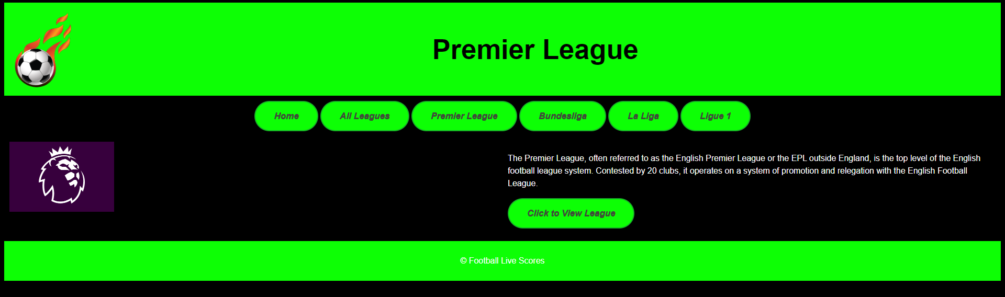

Here is a sample of the code from our index.html

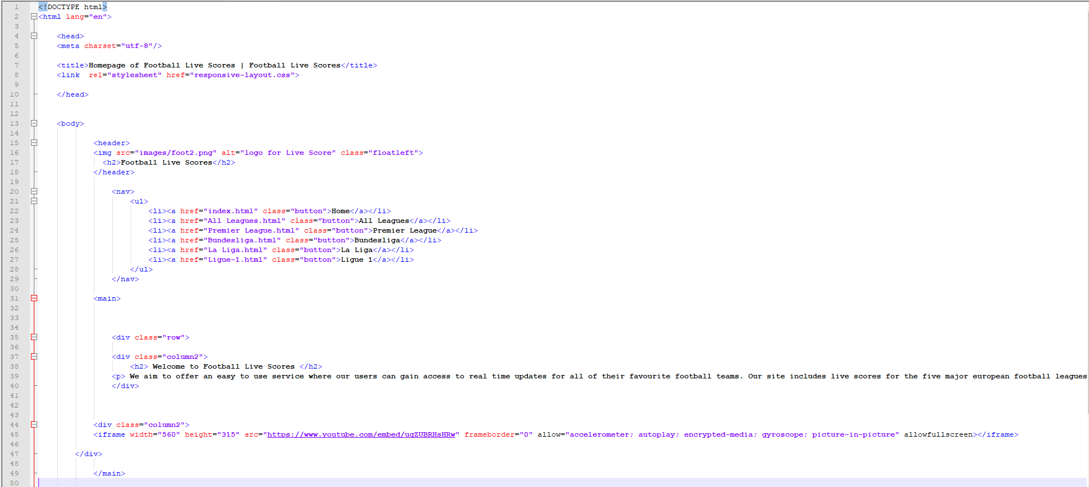

## Conclusion

We are very happy with the end result of our project and believe we built a good site that hits the requirements set out in the project brief. We had many hurdles in this project, mainly with attaining our data and then being able to display but with plenty of perseverance and research we ended up with something we are very happy with. Though challenging we all thoroughly enjoyed working on this project and were learn able to take some valuable lessons from it that we can apply to future projects, both individual and grouped.