1-Regularized Multivariate

Mohammed Alrezq

2023-11-23

#install.packages("seminr")  
library(seminr)

## Warning: package 'seminr' was built under R version 4.2.3

library(tidyverse)

## Warning: package 'tibble' was built under R version 4.2.3

## Warning: package 'dplyr' was built under R version 4.2.3

library(psych)

## Warning: package 'psych' was built under R version 4.2.3

library(lavaan)

## Warning: package 'lavaan' was built under R version 4.2.3

library(semPlot)  
library(regsem)

## Warning: package 'regsem' was built under R version 4.2.3

## Warning: package 'Rcpp' was built under R version 4.2.3

## Warning: package 'Rsolnp' was built under R version 4.2.3

library("here")

## Warning: package 'here' was built under R version 4.2.3

library(corrplot)# to plot the correlation matrix   
library(glmnet)

## Warning: package 'glmnet' was built under R version 4.2.3

## Warning: package 'Matrix' was built under R version 4.2.3

# Download data

sem_plsData <- read.csv("sem_plsData.csv")  
# remove extra column   
sem_plsData <- sem_plsData |>  
 select(-1)

# Adding itmes for outcoems variabels by averaging

names(sem_plsData)

## [1] "IMPL_SUCC_1" "BUDG_COMP_2" "TASK_COMP_3" "STAKEH_ACC_4" "DEPLOY_6"   
## [6] "ACT_INTG_7" "EMPL_SKI_8" "EMPL_SAT_9" "EMPL_BEL_10" "BUSI_IMP_11"   
## [11] "ORG_IMP_12" "DEC_IMP_13" "LD_SUP_1" "EMP_ATT_3" "RES_AVL_4"   
## [16] "LD_INV_5" "PRJ_SEL_6" "DEF_MEA_7" "LD_STL_9" "DAT_QLT_11"   
## [21] "EMP_ENG_12" "TOOL_AP_13" "CONTX_CUS_14" "EFT_REQ_15" "TRA_EDUC_18"   
## [26] "WKF_SKL_19" "EXP_CON_20" "UND_CNG_22" "PAT_RES_24" "CUS_IDEF_26"

# Group the three outcomes and take their means   
sem_plsData <- sem_plsData |>   
 rowwise() |>   
 mutate(Avg_Transform_Success = mean(c_across(c(IMPL_SUCC_1, EMPL_SAT_9, ORG_IMP_12, STAKEH_ACC_4, EMPL_SKI_8, DEC_IMP_13, BUSI_IMP_11, EMPL_BEL_10))),  
 Avg_Deploy_Success = mean(c_across(c(DEPLOY_6, ACT_INTG_7))),  
 Avg_Improv_Success = mean(c_across(c(BUDG_COMP_2, TASK_COMP_3)))  
 )  
  
# Removes the itmes related to outcomes   
sem_plsData <- sem_plsData |>   
 select(-c(IMPL_SUCC_1, BUDG_COMP_2, TASK_COMP_3, STAKEH_ACC_4, DEPLOY_6, ACT_INTG_7, EMPL_SKI_8, EMPL_SAT_9, EMPL_BEL_10, BUSI_IMP_11, ORG_IMP_12, DEC_IMP_13))

# Check for correlation

cor_matrix <- round(cor(sem_plsData, method = "spearman"), 2)  
#write.csv(cor_matrix_DVs, "DVs_correlation_Sperman.csv")  
# Plotting the correlation matrix  
corrplot(cor_matrix,   
 method = "number",   
 #order = "hclust", # arranges the variables in a way that those with the highest similarities are closer to each other.   
 tl.col = "black",   
 #tl.srt = 45,   
 addCoef.col = "black",  
 title = "Correlation",  
 line = -1)

## Warning in text.default(pos.xlabel[, 1], pos.xlabel[, 2], newcolnames, srt =  
## tl.srt, : "line" is not a graphical parameter

## Warning in text.default(pos.ylabel[, 1], pos.ylabel[, 2], newrownames, col =  
## tl.col, : "line" is not a graphical parameter

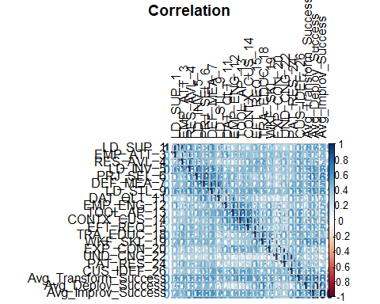

#Note: overall correlation is okay less than 70%

#names(sem_plsData)  
Y_Var <- sem_plsData[, c(19: 21)]  
X_Var <- sem_plsData[ ,c(1:18)]  
  
mutliv_lasso <- glmnet(   
 as.matrix(X_Var),  
 as.matrix(Y_Var),  
 alpha = 1,  
 family = "mgaussian",  
 nlambda = 100)  
  
par(mfrow = c(1,3))  
plot(mutliv_lasso, xvar = "lambda")

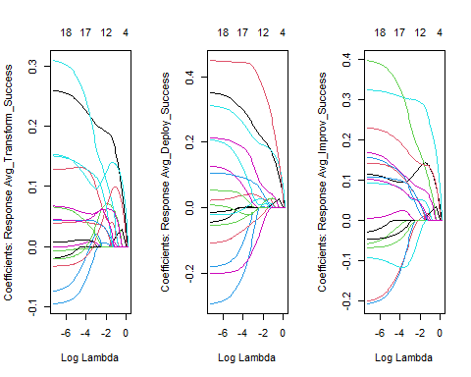

# Cross validation to determine optimal lambda   
mutliv_lasso_cv <- cv.glmnet(as.matrix(X_Var),  
 as.matrix(Y_Var),  
 family = "mgaussian",# mgaussian is used for multivariate outcomes   
 nfolds = 10,  
 type.measure = "mse")  
# optimla (min) lmbda   
mutliv_lasso_cv$lambda.min

## [1] 0.1130907

mutliv_lasso_cv$lambda.1se

## [1] 0.379035

# plot   
#par(mfrow = c(1,3))  
plot(mutliv_lasso_cv)# Finla  
  
# Finla model with optimal lmbda   
mutliv_lasso_optimla <- glmnet(   
 as.matrix(X_Var),  
 as.matrix(Y_Var),  
 alpha = 1, # lasso   
 family = "mgaussian",  
 lambda = mutliv_lasso_cv$lambda.min)  
  
coef(mutliv_lasso_optimla)

## $Avg_Transform_Success  
## 19 x 1 sparse Matrix of class "dgCMatrix"  
## s0  
## 0.748340370  
## LD_SUP_1 0.192884896  
## EMP_ATT_3 0.054060566  
## RES_AVL_4 .   
## LD_INV_5 0.006319923  
## PRJ_SEL_6 0.116456353  
## DEF_MEA_7 .   
## LD_STL_9 .   
## DAT_QLT_11 0.031367888  
## EMP_ENG_12 0.068323473  
## TOOL_AP_13 .   
## CONTX_CUS_14 0.120949457  
## EFT_REQ_15 0.062056359  
## TRA_EDUC_18 .   
## WKF_SKL_19 0.054319289  
## EXP_CON_20 .   
## UND_CNG_22 0.031446047  
## PAT_RES_24 0.079733548  
## CUS_IDEF_26 0.056819632  
##   
## $Avg_Deploy_Success  
## 19 x 1 sparse Matrix of class "dgCMatrix"  
## s0  
## 0.179958747  
## LD_SUP_1 0.215719260  
## EMP_ATT_3 0.030394637  
## RES_AVL_4 .   
## LD_INV_5 0.003051092  
## PRJ_SEL_6 0.193724641  
## DEF_MEA_7 .   
## LD_STL_9 .   
## DAT_QLT_11 -0.022756133  
## EMP_ENG_12 0.008225323  
## TOOL_AP_13 .   
## CONTX_CUS_14 0.009961197  
## EFT_REQ_15 0.071356165  
## TRA_EDUC_18 .   
## WKF_SKL_19 0.378899675  
## EXP_CON_20 .   
## UND_CNG_22 0.051971962  
## PAT_RES_24 0.027117745  
## CUS_IDEF_26 -0.062229101  
##   
## $Avg_Improv_Success  
## 19 x 1 sparse Matrix of class "dgCMatrix"  
## s0  
## 0.0425868973  
## LD_SUP_1 0.1286112344  
## EMP_ATT_3 0.0005517563  
## RES_AVL_4 .   
## LD_INV_5 0.0263325542  
## PRJ_SEL_6 0.2959052843  
## DEF_MEA_7 .   
## LD_STL_9 .   
## DAT_QLT_11 0.0509678860  
## EMP_ENG_12 0.1787489246  
## TOOL_AP_13 .   
## CONTX_CUS_14 0.0520610256  
## EFT_REQ_15 0.0824350699  
## TRA_EDUC_18 .   
## WKF_SKL_19 0.1441503023  
## EXP_CON_20 .   
## UND_CNG_22 0.0503902582  
## PAT_RES_24 -0.0432571431  
## CUS_IDEF_26 0.0478887216

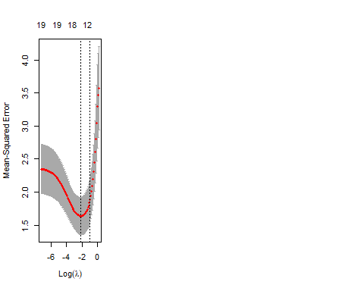

# 

# Transformational Success

names(sem_plsData)

## [1] "LD_SUP_1" "EMP_ATT_3" "RES_AVL_4"   
## [4] "LD_INV_5" "PRJ_SEL_6" "DEF_MEA_7"   
## [7] "LD_STL_9" "DAT_QLT_11" "EMP_ENG_12"   
## [10] "TOOL_AP_13" "CONTX_CUS_14" "EFT_REQ_15"   
## [13] "TRA_EDUC_18" "WKF_SKL_19" "EXP_CON_20"   
## [16] "UND_CNG_22" "PAT_RES_24" "CUS_IDEF_26"   
## [19] "Avg_Transform_Success" "Avg_Deploy_Success" "Avg_Improv_Success"

TS_Y <- sem_plsData[, 19]  
  
# Cross validation to determine optimal lambda   
TS_lasso_cv <- cv.glmnet(as.matrix(X_Var),  
 as.matrix(TS_Y),  
 family = "gaussian",# used for single outcome   
 nfolds = 10,  
 type.measure = "mse")  
# optimla (min) lmbda   
TS_lasso_cv$lambda.min

## [1] 0.02590946

TS_lasso_cv$lambda.1se

## [1] 0.1517522

# plot   
#par(mfrow = c(1,3))  
plot(TS_lasso_cv)# Finla

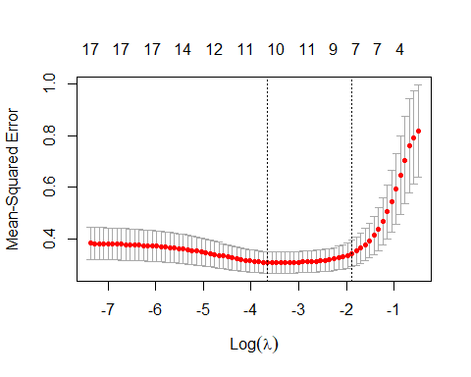

# Finla model with optimal lmbda   
TS_lasso_optimla <- glmnet(   
 as.matrix(X_Var),  
 as.matrix(TS_Y),  
 alpha = 1, # lasso   
 family = "gaussian",  
 lambda = TS_lasso_cv$lambda.min)  
  
coef(TS_lasso_optimla)

## 19 x 1 sparse Matrix of class "dgCMatrix"  
## s0  
## (Intercept) 0.37179213  
## LD_SUP_1 0.20320453  
## EMP_ATT_3 0.14930593  
## RES_AVL_4 .   
## LD_INV_5 .   
## PRJ_SEL_6 0.08243828  
## DEF_MEA_7 .   
## LD_STL_9 .   
## DAT_QLT_11 0.02963411  
## EMP_ENG_12 .   
## TOOL_AP_13 .   
## CONTX_CUS_14 0.23753815  
## EFT_REQ_15 0.02873174  
## TRA_EDUC_18 .   
## WKF_SKL_19 .   
## EXP_CON_20 0.02881962  
## UND_CNG_22 0.03039896  
## PAT_RES_24 0.12642027  
## CUS_IDEF_26 0.04335873

# Deployment Success

names(sem_plsData)

## [1] "LD_SUP_1" "EMP_ATT_3" "RES_AVL_4"   
## [4] "LD_INV_5" "PRJ_SEL_6" "DEF_MEA_7"   
## [7] "LD_STL_9" "DAT_QLT_11" "EMP_ENG_12"   
## [10] "TOOL_AP_13" "CONTX_CUS_14" "EFT_REQ_15"   
## [13] "TRA_EDUC_18" "WKF_SKL_19" "EXP_CON_20"   
## [16] "UND_CNG_22" "PAT_RES_24" "CUS_IDEF_26"   
## [19] "Avg_Transform_Success" "Avg_Deploy_Success" "Avg_Improv_Success"

DS_Y <- sem_plsData[, 20]  
  
# Cross validation to determine optimal lambda   
DS_lasso_cv <- cv.glmnet(as.matrix(X_Var),  
 as.matrix(DS_Y),  
 family = "gaussian",# used for single outcome   
 nfolds = 10,  
 type.measure = "mse")  
# optimla (min) lmbda   
DS_lasso_cv$lambda.min

## [1] 0.04533421

DS_lasso_cv$lambda.1se

## [1] 0.2914116

# plot   
#par(mfrow = c(1,3))  
plot(DS_lasso_cv)# Finla

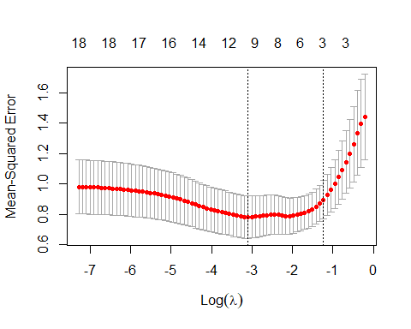

# Finla model with optimal lmbda   
DS_lasso_optimla <- glmnet(   
 as.matrix(X_Var),  
 as.matrix(DS_Y),  
 alpha = 1, # lasso   
 family = "gaussian",  
 lambda = DS_lasso_cv$lambda.min)  
  
coef(DS_lasso_optimla)

## 19 x 1 sparse Matrix of class "dgCMatrix"  
## s0  
## (Intercept) 0.16547377  
## LD_SUP_1 0.24175069  
## EMP_ATT_3 0.00713190  
## RES_AVL_4 0.01154336  
## LD_INV_5 .   
## PRJ_SEL_6 0.18242581  
## DEF_MEA_7 .   
## LD_STL_9 .   
## DAT_QLT_11 .   
## EMP_ENG_12 .   
## TOOL_AP_13 -0.06174686  
## CONTX_CUS_14 .   
## EFT_REQ_15 0.13089913  
## TRA_EDUC_18 .   
## WKF_SKL_19 0.45529715  
## EXP_CON_20 .   
## UND_CNG_22 0.08526264  
## PAT_RES_24 .   
## CUS_IDEF_26 -0.13175624

# Improvement Project Success

names(sem_plsData)

## [1] "LD_SUP_1" "EMP_ATT_3" "RES_AVL_4"   
## [4] "LD_INV_5" "PRJ_SEL_6" "DEF_MEA_7"   
## [7] "LD_STL_9" "DAT_QLT_11" "EMP_ENG_12"   
## [10] "TOOL_AP_13" "CONTX_CUS_14" "EFT_REQ_15"   
## [13] "TRA_EDUC_18" "WKF_SKL_19" "EXP_CON_20"   
## [16] "UND_CNG_22" "PAT_RES_24" "CUS_IDEF_26"   
## [19] "Avg_Transform_Success" "Avg_Deploy_Success" "Avg_Improv_Success"

IPS_Y <- sem_plsData[, 21]  
  
# Cross validation to determine optimal lambda   
IPS_lasso_cv <- cv.glmnet(as.matrix(X_Var),  
 as.matrix(IPS_Y),  
 family = "gaussian",# used for single outcome   
 nfolds = 10,  
 type.measure = "mse")  
# optimla (min) lmbda   
IPS_lasso_cv$lambda.min

## [1] 0.030297

IPS_lasso_cv$lambda.1se

## [1] 0.1947513

# plot   
#par(mfrow = c(1,3))  
plot(IPS_lasso_cv)# Finla

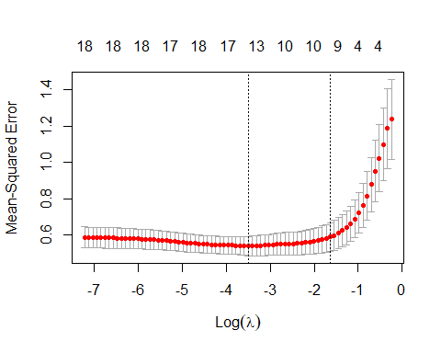

# Finla model with optimal lmbda   
IPS_lasso_optimla <- glmnet(   
 as.matrix(X_Var),  
 as.matrix(IPS_Y),  
 alpha = 1, # lasso   
 family = "gaussian",  
 lambda = IPS_lasso_cv$lambda.min)  
  
coef(IPS_lasso_optimla)

## 19 x 1 sparse Matrix of class "dgCMatrix"  
## s0  
## (Intercept) -0.27738721  
## LD_SUP_1 0.05043818  
## EMP_ATT_3 -0.03643762  
## RES_AVL_4 .   
## LD_INV_5 0.13694535  
## PRJ_SEL_6 0.26865673  
## DEF_MEA_7 .   
## LD_STL_9 0.01922011  
## DAT_QLT_11 0.11253966  
## EMP_ENG_12 0.28246430  
## TOOL_AP_13 .   
## CONTX_CUS_14 .   
## EFT_REQ_15 0.09074697  
## TRA_EDUC_18 .   
## WKF_SKL_19 0.15669114  
## EXP_CON_20 -0.02506850  
## UND_CNG_22 0.09150461  
## PAT_RES_24 -0.09977586  
## CUS_IDEF_26 0.03694313