Reading the modernbert Code — A Visual Brief
A short map of the modernbert package in modernbert-reimplementation: what each file does, how a batch flows through it, and the five ideas that make it ModernBERT rather than BERT. Every figure was generated from the package itself (the masks and RoPE curves come from calling your classes).
Status (November 3, 2026, after your comment clean-up): example → logits (2, 12, 64), loss 4.1183; pytest tests → 19 passed; compare_with_hf → MATCH (max error 1.2e-7); overfit on 10 sentences → loss 4.15 → 0.012 in 300 steps; masked_prediction gives the identical loss.

1. Reading order
Read the files in this order — each one only uses the files above it.
# | File | What it holds | Look for
1 | config.py | Every architectural number and switch (dataclass). | intermediate_size, sliding_window, is_global_layer(), rope_theta_for_layer(), tiny()
2 | embeddings.py | Token lookup → LayerNorm → dropout. No position table. | forward (3 lines)
3 | attention.py | RotaryEmbedding and ModernBertPaperSelfAttention. | RotaryEmbedding.forward, build_attention_mask, the scores lines
4 | mlp.py | GeGLU feed-forward. | the one-line forward
5 | block.py | One pre-norm Transformer layer. | the two residual lines; layer-0 Identity
6 | initialization.py | How weights start. | the stds dictionary
7 | model.py | Encoder stack + MLM head + loss. | weight tying; masked_prediction branch
8 | example.py, tests/, compare_with_hf.py | Proof that it works. | what each test asserts

2. The big picture
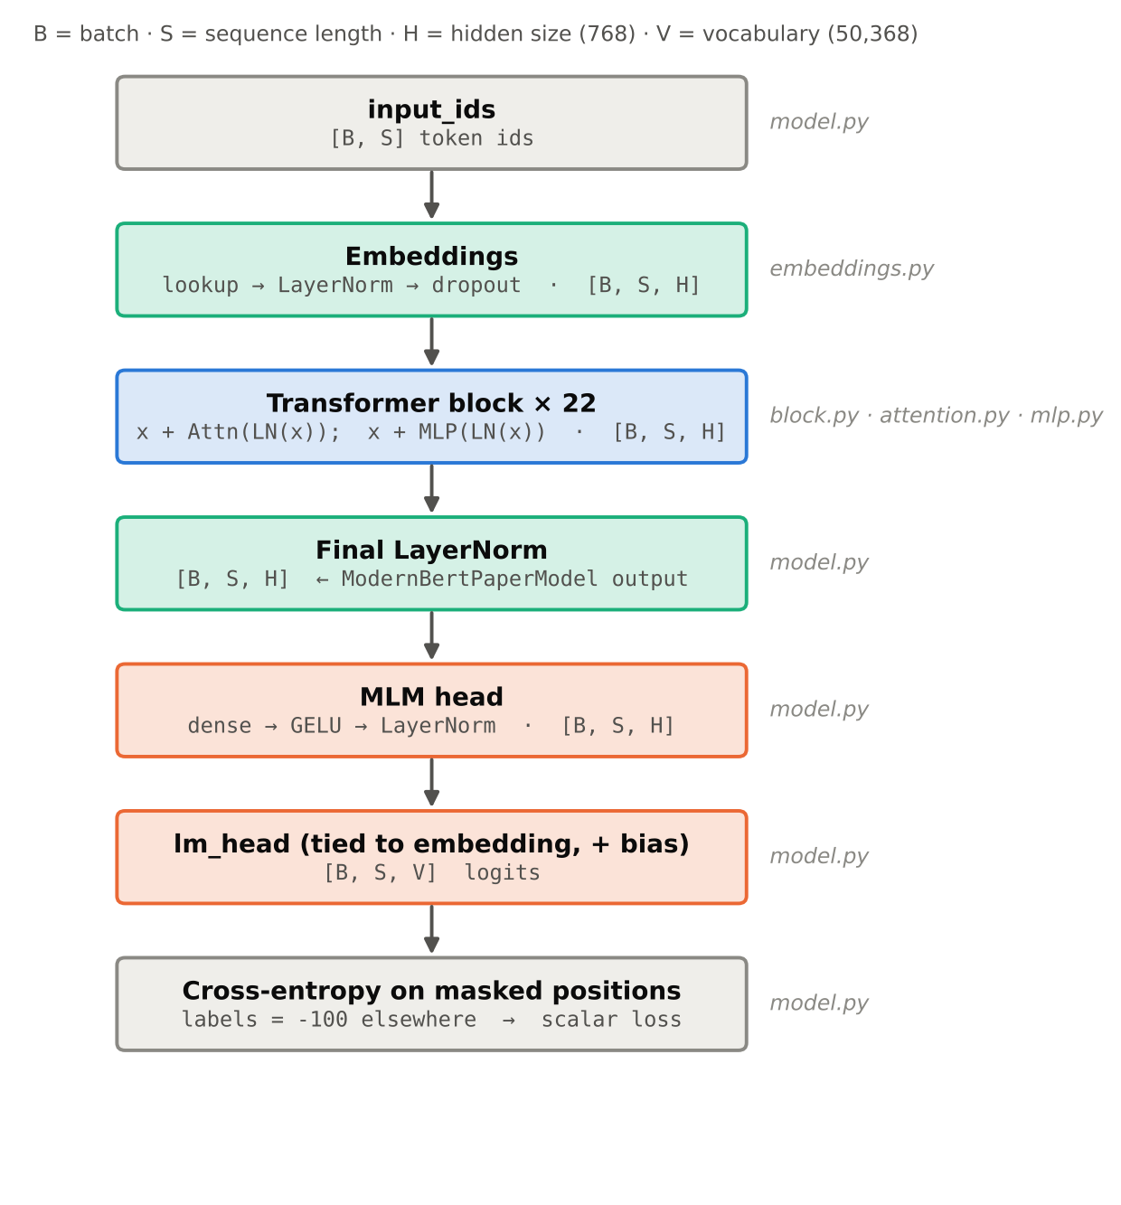
Figure 1 — One forward pass of ModernBertPaperForMaskedLM. The tensor shape stays [B, S, H] from the embeddings to the head; only the last projection widens it to the vocabulary.
ModernBertPaperModel is the encoder (everything down to the final LayerNorm). ModernBertPaperForMaskedLM wraps it with the head and the loss. For downstream tasks (GLUE) you will reuse the encoder and put a different head on top.

3. Config and the layer pattern
config.py is the single source of truth: change a number there and every module follows. The two helpers decide what each layer looks like:
is_global_layer(i) -> i % 3 == 0 # 0, 3, 6, ... 21
rope_theta_for_layer(i) -> 160_000 if global else 10_000
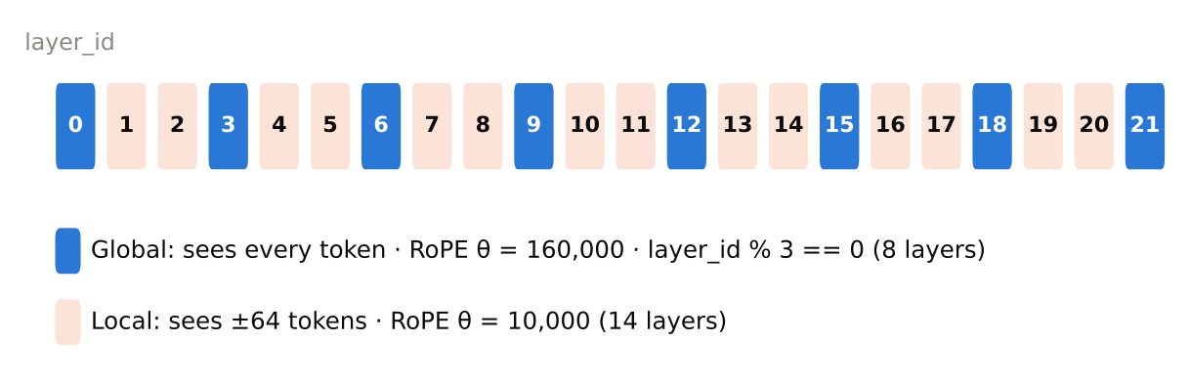
Figure 2 — ModernBERT-base: 22 layers, one global layer every three. Local layers are cheap (each token looks at 129 keys) and global layers keep the whole document connected.
intermediate_size = 1152 is the width of each GeGLU branch, so the MLP holds 3 × 768 × 1152 weights per layer. That choice is what makes the model 149.6M parameters, matching the paper.

4. The Transformer block (block.py)
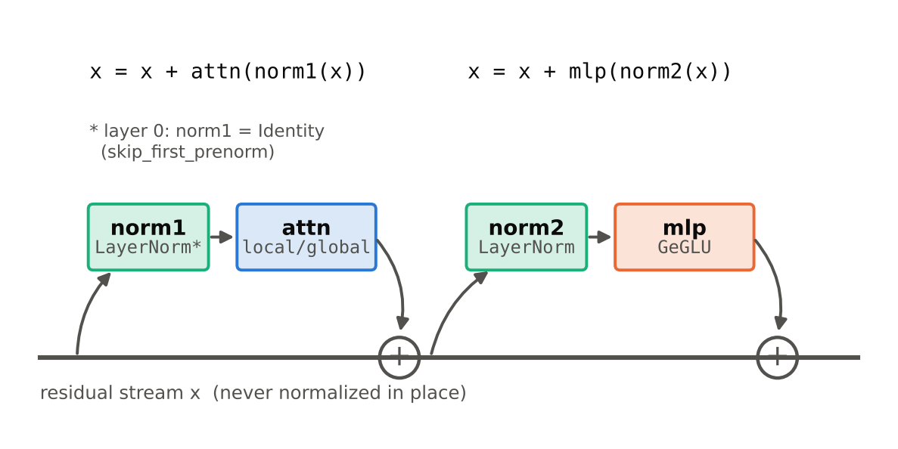
Figure 3 — Pre-LayerNorm: each sub-layer reads a normalized copy of x and adds its result back. The running sum x itself is only normalized once, at the very end (final LayerNorm).
- Pre-norm vs post-norm. BERT normalized after adding (LN(x + F(x))). ModernBERT normalizes before (x + F(LN(x))), which keeps gradients healthy in deep stacks.
- skip_first_prenorm. The embedding output was just normalized, so layer 0 uses nn.Identity() instead of a second LayerNorm.
- No biases. Every LayerNorm and Linear is bias-free, except the final vocabulary projection.

5. Attention (attention.py)
Step by step inside ModernBertPaperSelfAttention.forward:
- qkv_proj makes Q, K and V in one matrix multiply; chunk(3) splits them → 3 × [B, S, H].
- view + transpose splits H = 768 into 12 heads of 64 → [B, 12, S, 64].
- RoPE rotates Q and K (not V) according to position.
- scores = Q·Kᵀ / √64 → [B, 12, S, S]: how much each query wants each key.
- build_attention_mask blocks keys outside the window and padded keys.
- softmax → weights; weights × V → [B, 12, S, 64]; merge heads → [B, S, 768]; out_proj; dropout 0.1.

5.1 RoPE — positions as rotations
half = self.dim // 2
x1, x2 = xf[..., :half], xf[..., half:] # pair dim k with dim k + half
out = torch.cat([x1 * cos - x2 * sin, # rotate every pair by
x1 * sin + x2 * cos], dim=-1) # angle = position × inv_freq[k]
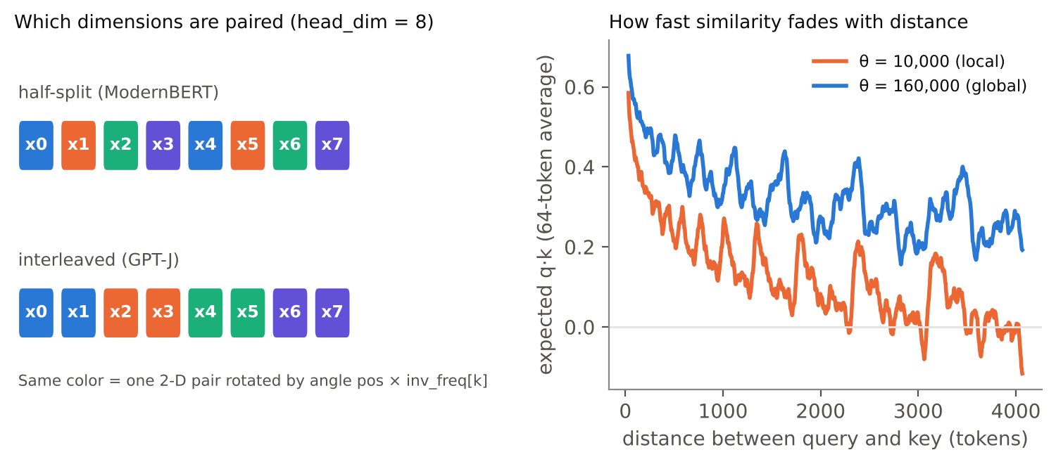
Figure 4 — Left: half-split pairing (used by ModernBERT and its weights) vs interleaved pairing; same math, different dimension order. Right: after RoPE, the similarity of a vector with itself fades with distance. The larger θ of global layers fades more slowly, so far-apart tokens remain distinguishable over long contexts.
- Each pair turns by an angle proportional to the token's position. Because both q and k are rotated, their dot product depends only on the distance between them — the model learns relative positions without a position table.
- Position 0 is never rotated (angle 0), and rotation never changes a vector's length — both are checked in test_stage1_rope_properties.

5.2 The attention mask — local, global, padding
distance = (idx.view(-1, 1) - idx.view(1, -1)).abs() # [S, S]: |i - j|
allowed = distance <= self.window_radius # local layers only
allowed = allowed & attention_mask.bool().view(B, 1, 1, S) # hide padded keys
scores = scores.masked_fill(~allowed, torch.finfo(scores.dtype).min)
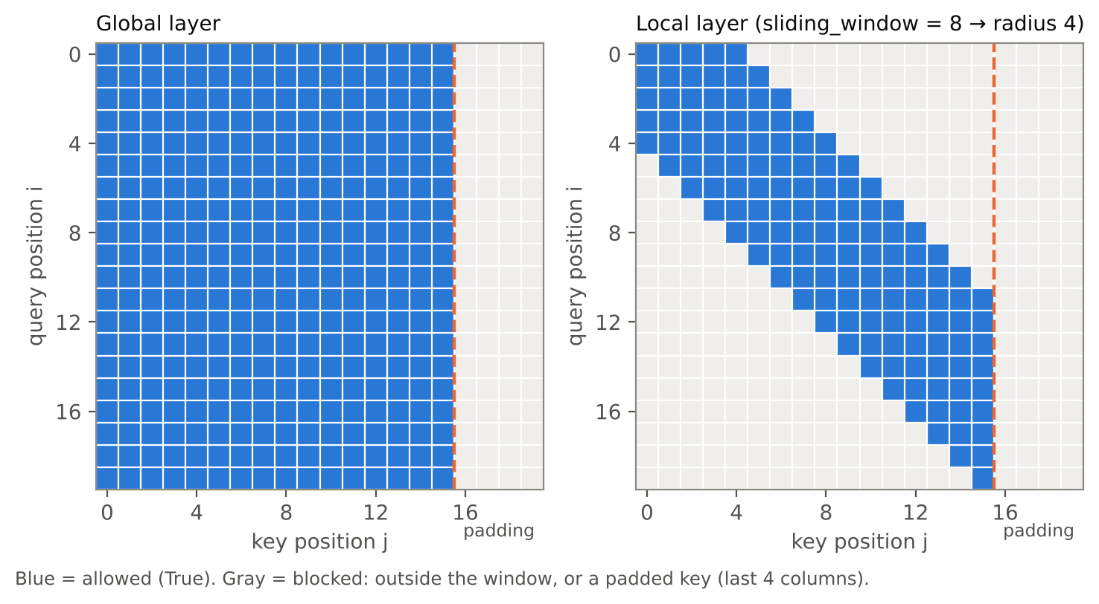
Figure 5 — Real output of build_attention_mask for 20 tokens, the last 4 being padding. Global: every query sees all 16 real keys. Local: a diagonal band of width 2×4+1 — the same rule as FlashAttention-2 window_size=(64, 64) in ModernBERT.
- finfo.min is used instead of -inf so a fully blocked row cannot produce NaN.
- Outputs at padded query positions are meaningless; tests and the loss never read them.

6. The GeGLU MLP (mlp.py)
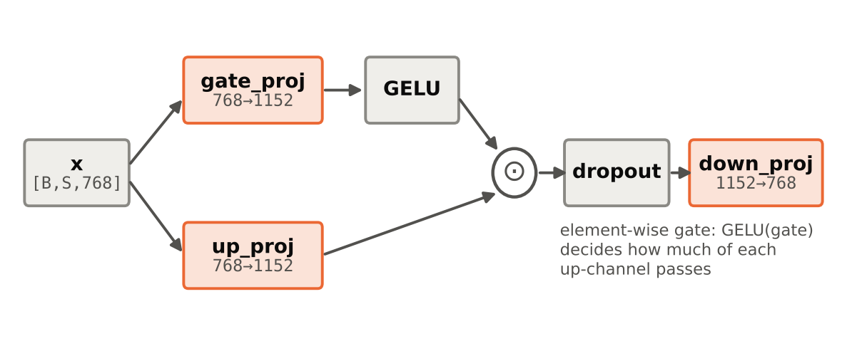
Figure 6 — Two parallel projections; GELU of one gates the other element by element. The reference stores gate_proj and up_proj stacked in one matrix Wi (first half / second half).
Attention mixes information between positions; the MLP transforms each position on its own. The gate lets the network switch individual channels on or off per token, which is why GLU variants train better than a plain GELU MLP of the same size.

7. MLM head, tying and the loss (model.py)
- Head: head_dense → GELU → head_norm keeps the shape [B, S, 768].
- Weight tying: lm_head.weight is the embedding matrix (self.lm_head.weight = ...token_embedding.weight). One 50,368 × 768 table is used to read tokens in and to score them out. The decoder bias is the one bias ModernBERT keeps.
- Labels: the true token id at masked positions, -100 everywhere else; cross_entropy(..., ignore_index=-100) averages only over masked positions.
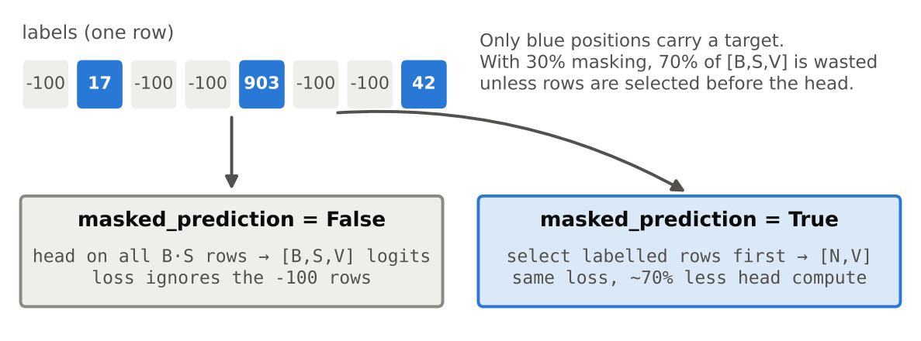
Figure 7 — masked_prediction=True selects the labelled rows before the head, so the 50k-wide projection is computed only where a target exists. The loss is identical (checked in the tests).

8. How weights start (initialization.py)
Module type | Layers | Std (base) | Why
in | qkv_proj, gate_proj, up_proj, head_dense | 0.02 | Standard small random start.
out | out_proj, down_proj | 0.02 / √(2·22) ≈ 0.003 | These write into the residual stream twice per layer; shrinking them keeps the sum of 44 additions at a stable scale.
emb | token_embedding | 0.02 | Shared with lm_head through tying.
LayerNorm | all norms | weight = 1 | Starts as plain normalization.

All draws are truncated at ±2σ, so no weight starts extreme (the measured std ends up ≈ 0.88σ — test_init_scales checks this).

9. Core concepts at a glance
Concept | One-line meaning | Where
Residual stream | The running sum x every layer reads from and adds to. | block.py
Pre-LayerNorm | Normalize the input of each sub-layer, not the sum. | block.py
Multi-head attention | 12 independent 64-dim attention patterns, merged back to 768. | attention.py
RoPE | Encode position by rotating Q/K pairs; scores depend on distance. | attention.py
Local / global attention | ±64-token window on 2 of every 3 layers; full attention on the rest. | attention.py, config.py
Padding mask | Padded keys are made invisible to every query. | attention.py
GeGLU | GELU(gate) ⊙ up, then down-projection. | mlp.py
Weight tying | Embedding matrix reused as the output projection. | model.py
MLM with -100 | Predict only masked tokens; ignore the rest in the loss. | model.py
Depth-scaled init | Output projections start 1/√(2L) smaller. | initialization.py

10. Check it yourself
From the modernbert-reimplementation folder (Colab/Kaggle cell: prefix with !; Codespaces/local: inside a venv with torch, pytest, transformers):
Command | Expected result
python -c "from modernbert import build_paper_reference_example as b; c,m,o=b(); print(tuple(o['logits'].shape), round(float(o['loss']),4))" | (2, 12, 64) 4.1183 (last digits may differ on GPU)
python -m pytest tests -v | 19 passed in ~20–30 s on CPU
python -m modernbert.compare_with_hf | missing: [], unexpected: [], max_abs ≈ 1e-7, MATCH
python -m modernbert.compare_with_hf --pretrained answerdotai/ModernBERT-base | Downloads ~600 MB; expect MATCH (errors ≲ 1e-5). Not yet run — needs Hugging Face access.

Learning exercise: break one detail on purpose — e.g. sliding_window // 2 + 1, rotary_emb_interleaved=True, or remove skip_first_prenorm — and watch which tests fail and how compare_with_hf reports MISMATCH. Revert with git checkout -- <file>.

Appendix — Pushing the repo to GitHub
Run these in Git Bash or PowerShell on your Windows machine, inside D:\AI_skill_dev\Repos_reconstruction\first\my_work\modernbert-reimplementation.
- Create an empty repo on GitHub (github.com → New repository → name modernbert-reimplementation, Private or Public). Do not tick "Add README", ".gitignore" or "license" — an empty remote avoids a merge on the first push.
- Identify yourself once per machine (skip if git config --global user.name already prints your name):
git config --global user.name "Your Name"
git config --global user.email "you@example.com" # same email as your GitHub account
- Fix line endings once (your editor saves CRLF, so every file looks fully changed):
git config core.autocrlf true
git add --renormalize .
- Add a .gitignore (create the file in the repo root with this content):
__pycache__/
*.pyc
.venv/
.pytest_cache/
checkpoints/
*.pt
*.safetensors
data/raw/
~$*.docx
- Keep the empty folders (git does not store empty directories): create an empty file named .gitkeep in configs, data, docs, evaluation and training.
- Commit your current work (the comment clean-up is not committed yet):
git status
git add .
git commit -m "Clean up comments, add .gitignore, normalize line endings"
- Rename the branch to main, connect the remote, push and set the upstream:
git branch -M main
git remote add origin https://github.com/<your-user>/modernbert-reimplementation.git
git push -u origin main
-u (--set-upstream) links your local main to origin/main, so from now on plain git push and git pull know where to go. On the first push, Git for Windows opens a browser window (Git Credential Manager) to sign in to GitHub — GitHub does not accept your account password on the command line.
- Check it worked: git remote -v lists origin twice (fetch/push); git status says "Your branch is up to date with 'origin/main'"; the files appear on GitHub.

Day-to-day loop
git checkout -b data-pipeline # one branch per milestone (optional but tidy)
# ... edit, run tests ...
git add -A && git commit -m "M2: MLM masking + tests"
git push -u origin data-pipeline # first push of a new branch; later just: git push
# on Colab/Kaggle: !git clone https://github.com/<your-user>/modernbert-reimplementation.git
# then !git pull after each push
Problem | Fix
remote origin already exists | git remote set-url origin <url>
rejected ... fetch first (remote has commits, e.g. a README) | git pull --rebase origin main, then git push
Authentication failed | Sign in again through the browser prompt, or use a Personal Access Token as the password.
src refspec main does not match any | Nothing committed yet, or branch still named master → commit, then git branch -M main.

