**Md. Aman Taiyab**

**6B, 1BM19CS089**

1. **CREATE DATABASE IN MONGODB.**

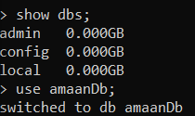

1. **CRUD (CREATE, READ, UPDATE, DELETE) OPERATIONS**
2. To create a collection by the name “Student”. Let us take a look at the collection list prior to the creation of the new collection “Student”.
3. To drop a collection by the name “Student”.

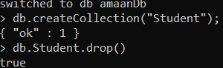

1. Create a collection by the name “Students” and store the following data in it.

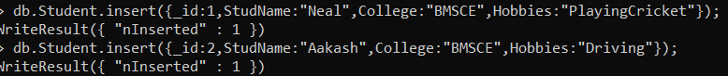

1. Update his Hobbies from “Skating” to “Chess”. ) Use “Update else insert” (if there is an existing document, it will attempt to update it, if there is no existing document then it will insert it



1. FIND METHOD

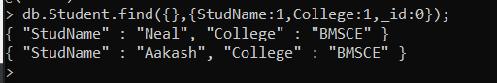

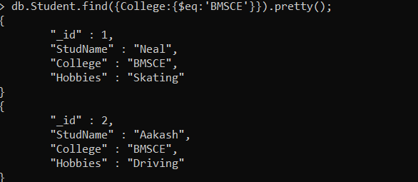

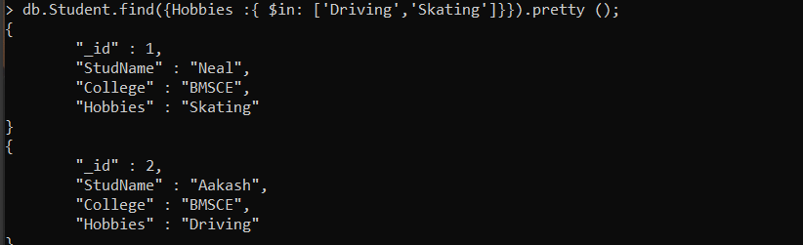

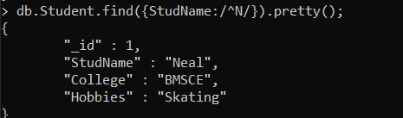

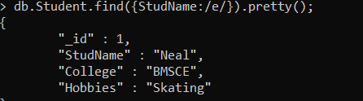



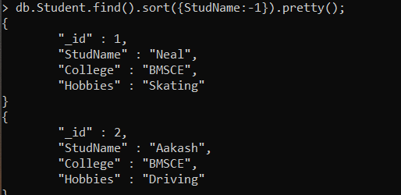

1. **Save Method :**

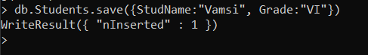

1. **Add a new field to existing Document:**



1. **Remove the field in an existing Document**



1. **Finding Document based on search criteria suppressing few fields**

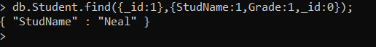

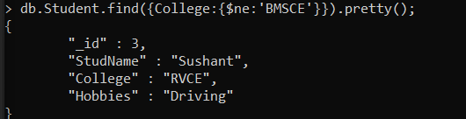

**To find documents from the Students collection where the StudName ends with s.**

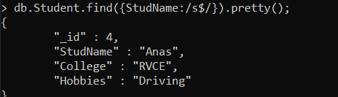

1. **to set a particular field value to NULL**



1. **Count the number of documents in Student Collections**



1. **Count the number of documents in Student Collections with grade :VII**



**retrieve first 3 documents**

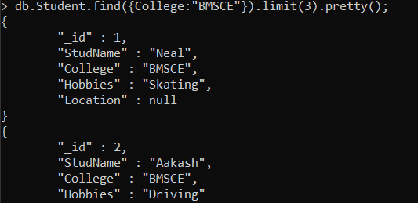

**Sort the document in Ascending order**

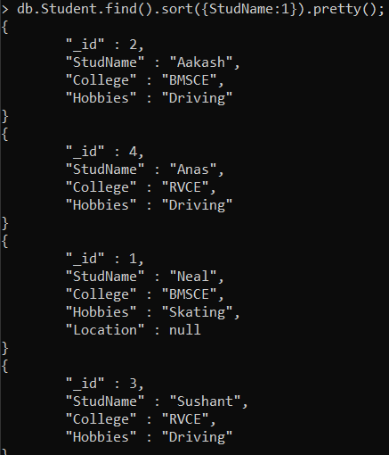

**for desending order :** 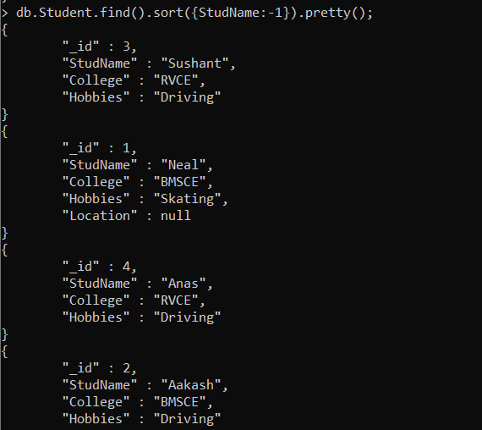

**to Skip the 1st two documents from the Students Collections**

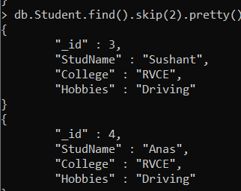

**To find those documents from the “food” collection which has the “fruits array” constitute of “grapes”, “mango” and “apple”.**



**To find in “fruits” array having “mango” in the first index position.**



**To find those documents from the “food” collection where the size of the array is two.**

db.food.find ( {“fruits”: {$size:2}} )

**To find the document with a particular id and display the first two elements from the array “fruits”**



**To find all the documets from the food collection which have elements mango and grapes in the array “fruits”**



**update on Array:**

**using particular id replace the element present in the 1st index position of the fruits array with apple**



insert new key value pairs in the fruits array



**XII. Aggregate Function :**

**Create a collection Customers with fields custID, AcctBal, AcctType.** 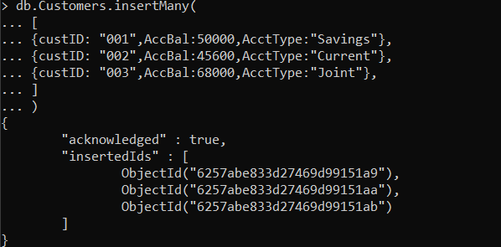

**Now group on “custID” and compute the sum of “AccBal”.**

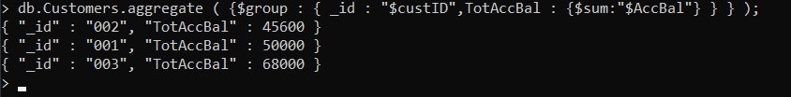

**match on AcctType:” Savings” then group on “CustID” and compute the sum of “AccBal”.**



**match on AcctType:”S” then group on “CustID” and compute the sum of “AccBal” and total balance greater than 1200.**



**Create Collection “Alphabets”**



**Insert Documents with fields “_id” and “alphabet”**

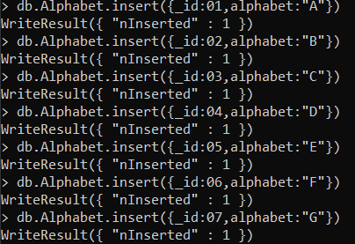

**use cursor to iterate through the “Alphabets” Collection.**

