DineSafe Food Hygiene Dataset Analysis

Mohammed Amir

March 01, 2017

## Load Dataset

## Convert NULL values to NA on data loading  
Dinesafe = read.csv("D:/CAPSTONE/data/DineSafe_02162017.csv", na.strings='NULL')  
Address = read.csv("D:/CAPSTONE/data/ADDRESS_02262017.csv", na.strings='NULL')

# Identify column names

colnames(Dinesafe)

## Review dimension of dataset (Row by column)

dim(Dinesafe)  
dim(Address)

## Review summary of dinesafe dataset

summary(Dinesafe)

## Review summary of Address dataset

summary(Address)

## Review structure of Dinesafe dataset

str(Dinesafe)

## Review structure of Address dataset

str(Address)

### Merge Dinesafe and Address dataset based on establishment id column

Dinesafe <- merge(Dinesafe,Address,by="ESTABLISHMENT_ID")

## Remove Columns from data set

### Remove COURT_OUTCOME and AMOUNT_FINED Columns from Dinesafe dataset  
Dinesafe <- subset(Dinesafe, select = -c(ROW_ID, COURT_OUTCOME,AMOUNT_FINED,LONG_ADDRESS) )  
  
### Remove Establishement Name from Address dataset to avoid duplicate rows   
Dinesafe <- subset(Dinesafe, select = -c(ESTABLISHMENT_NAME.y, ESTABLISHMENT_ADDRESS) )  
  
## Rename ESTABLISHMENT_NAME.x column name to ESTABLISHMENT_NAME  
colnames(Dinesafe)[colnames(Dinesafe) == 'ESTABLISHMENT_NAME.x'] <- 'ESTABLISHMENT_NAME'

## Convert VALUE from factor to numeric Data Structure

## use suppressWarnings to avoid getting "NAs introduced by coercion" message  
Dinesafe$VALUE <- suppressWarnings(as.numeric(as.character(Dinesafe$VALUE)))

## Convert INSPECTION_DATE from factor to Date Data Structure

Dinesafe$INSPECTION_DATE <- dmy(as.character(Dinesafe$INSPECTION_DATE))

## Convert INSPECTION_DATE from factor to Date Data Structure

Dinesafe$CUISINE_TYPE <- as.character(Dinesafe$CUISINE_TYPE)  
Dinesafe$ESTABLISHMENT_TYPE <- as.character(Dinesafe$ESTABLISHMENT_TYPE)  
Dinesafe$ESTABLISHMENT_STATUS <- as.character(Dinesafe$ESTABLISHMENT_STATUS)   
Dinesafe$SEVERITY <- as.character(Dinesafe$SEVERITY)  
Dinesafe$ACTION <- as.character(Dinesafe$ACTION)  
Dinesafe$ACTION <- as.character(Dinesafe$ACTION)  
Dinesafe$ACTION <- as.character(Dinesafe$ACTION)

str(Dinesafe)

## Complete Case Rows with no missing (NA) value

Complete_Dinesafe <- Dinesafe[complete.cases(Dinesafe),]  
nrow(Complete_Dinesafe)

## Rows with Missing (NA) value

Dinesafe_NA <- Dinesafe[!complete.cases(Dinesafe),]  
nrow(Dinesafe_NA)

## Show missingness in Dinesafe dataset

#Quantify missing values  
apply(Dinesafe, 2, function(x) sum(is.na(x)))  
   
# Plot missingness map  
missmap(Dinesafe, col = c("Red","Grey"), y.cex = 0.8, x.cex = 0.8, legend = TRUE, rank.order = "False" ,main = "Dinesafe missingness map", y.labels = NULL,y.at = NULL)

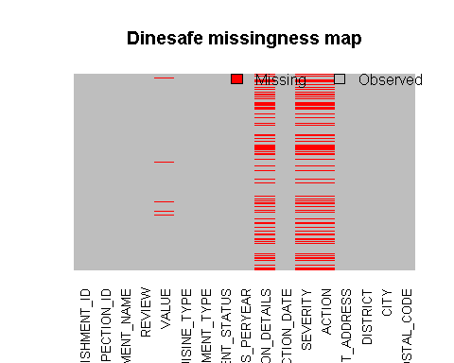

## Impute Dinesafe$REVIEW with Mean Review Value for each missing review value based cuisine type

Dinesafe$REVIEW[is.na(Dinesafe$REVIEW) & Dinesafe$CUISINE_TYPE=="African"] = mean(Dinesafe$REVIEW[Dinesafe$CUISINE_TYPE=="African"], na.rm=TRUE)  
Dinesafe$REVIEW[is.na(Dinesafe$REVIEW) & Dinesafe$CUISINE_TYPE=="Bakeries"] = mean(Dinesafe$REVIEW[Dinesafe$CUISINE_TYPE=="Bakeries"], na.rm=TRUE)  
Dinesafe$REVIEW[is.na(Dinesafe$REVIEW) & Dinesafe$CUISINE_TYPE=="Bar"] = mean(Dinesafe$REVIEW[Dinesafe$CUISINE_TYPE=="Bar"], na.rm=TRUE)  
Dinesafe$REVIEW[is.na(Dinesafe$REVIEW) & Dinesafe$CUISINE_TYPE=="Cafe"] = mean(Dinesafe$REVIEW[Dinesafe$CUISINE_TYPE=="Cafe"], na.rm=TRUE)  
Dinesafe$REVIEW[is.na(Dinesafe$REVIEW) & Dinesafe$CUISINE_TYPE=="Caribbean"] = mean(Dinesafe$REVIEW[Dinesafe$CUISINE_TYPE=="Caribbean"], na.rm=TRUE)  
Dinesafe$REVIEW[is.na(Dinesafe$REVIEW) & Dinesafe$CUISINE_TYPE=="Deli"] = mean(Dinesafe$REVIEW[Dinesafe$CUISINE_TYPE=="Deli"], na.rm=TRUE)  
Dinesafe$REVIEW[is.na(Dinesafe$REVIEW) & Dinesafe$CUISINE_TYPE=="Dessert"] = mean(Dinesafe$REVIEW[Dinesafe$CUISINE_TYPE=="Dessert"], na.rm=TRUE)  
Dinesafe$REVIEW[is.na(Dinesafe$REVIEW) & Dinesafe$CUISINE_TYPE=="European"] = mean(Dinesafe$REVIEW[Dinesafe$CUISINE_TYPE=="European"], na.rm=TRUE)  
Dinesafe$REVIEW[is.na(Dinesafe$REVIEW) & Dinesafe$CUISINE_TYPE=="Far Eastern"] = mean(Dinesafe$REVIEW[Dinesafe$CUISINE_TYPE=="Far Eastern"], na.rm=TRUE)  
Dinesafe$REVIEW[is.na(Dinesafe$REVIEW) & Dinesafe$CUISINE_TYPE=="Pastries"] = mean(Dinesafe$REVIEW[Dinesafe$CUISINE_TYPE=="Pastries"], na.rm=TRUE)  
Dinesafe$REVIEW[is.na(Dinesafe$REVIEW) & Dinesafe$CUISINE_TYPE=="South Asian"] = mean(Dinesafe$REVIEW[Dinesafe$CUISINE_TYPE=="South Asian"], na.rm=TRUE)  
Dinesafe$REVIEW[is.na(Dinesafe$REVIEW) & Dinesafe$CUISINE_TYPE=="South East Asian"] = mean(Dinesafe$REVIEW[Dinesafe$CUISINE_TYPE=="South East Asian"], na.rm=TRUE)  
Dinesafe$REVIEW[is.na(Dinesafe$REVIEW) & Dinesafe$CUISINE_TYPE=="Latin American"] = mean(Dinesafe$REVIEW[Dinesafe$CUISINE_TYPE=="Latin American"], na.rm=TRUE)  
Dinesafe$REVIEW[is.na(Dinesafe$REVIEW) & Dinesafe$CUISINE_TYPE=="Mediterranean"] = mean(Dinesafe$REVIEW[Dinesafe$CUISINE_TYPE=="Mediterranean"], na.rm=TRUE)  
Dinesafe$REVIEW[is.na(Dinesafe$REVIEW) & Dinesafe$CUISINE_TYPE=="Middle Eastern"] = mean(Dinesafe$REVIEW[Dinesafe$CUISINE_TYPE=="Middle Eastern"], na.rm=TRUE)  
Dinesafe$REVIEW[is.na(Dinesafe$REVIEW) & Dinesafe$CUISINE_TYPE=="North American"] = mean(Dinesafe$REVIEW[Dinesafe$CUISINE_TYPE=="North American"], na.rm=TRUE)  
Dinesafe$REVIEW[is.na(Dinesafe$REVIEW) & Dinesafe$CUISINE_TYPE=="Juicery & Smoothies"] = mean(Dinesafe$REVIEW[Dinesafe$CUISINE_TYPE=="Juicery & Smoothies"], na.rm=TRUE)

## Impute Dinesafe$VALUE with Mean Value for each missing value based cuisine type

Dinesafe$VALUE[is.na(Dinesafe$VALUE) & Dinesafe$CUISINE_TYPE=="African"] = mean(Dinesafe$VALUE[Dinesafe$CUISINE_TYPE=="African"], na.rm=TRUE)  
Dinesafe$VALUE[is.na(Dinesafe$VALUE) & Dinesafe$CUISINE_TYPE=="Bakeries"] = mean(Dinesafe$VALUE[Dinesafe$CUISINE_TYPE=="Bakeries"], na.rm=TRUE)  
Dinesafe$VALUE[is.na(Dinesafe$VALUE) & Dinesafe$CUISINE_TYPE=="Bar"] = mean(Dinesafe$VALUE[Dinesafe$CUISINE_TYPE=="Bar"], na.rm=TRUE)  
Dinesafe$VALUE[is.na(Dinesafe$VALUE) & Dinesafe$CUISINE_TYPE=="Cafe"] = mean(Dinesafe$VALUE[Dinesafe$CUISINE_TYPE=="Cafe"], na.rm=TRUE)  
Dinesafe$VALUE[is.na(Dinesafe$VALUE) & Dinesafe$CUISINE_TYPE=="Caribbean"] = mean(Dinesafe$VALUE[Dinesafe$CUISINE_TYPE=="Caribbean"], na.rm=TRUE)  
Dinesafe$VALUE[is.na(Dinesafe$VALUE) & Dinesafe$CUISINE_TYPE=="Deli"] = mean(Dinesafe$VALUE[Dinesafe$CUISINE_TYPE=="Deli"], na.rm=TRUE)  
Dinesafe$VALUE[is.na(Dinesafe$VALUE) & Dinesafe$CUISINE_TYPE=="Dessert"] = mean(Dinesafe$VALUE[Dinesafe$CUISINE_TYPE=="Dessert"], na.rm=TRUE)  
Dinesafe$VALUE[is.na(Dinesafe$VALUE) & Dinesafe$CUISINE_TYPE=="European"] = mean(Dinesafe$VALUE[Dinesafe$CUISINE_TYPE=="European"], na.rm=TRUE)  
Dinesafe$VALUE[is.na(Dinesafe$VALUE) & Dinesafe$CUISINE_TYPE=="Far Eastern"] = mean(Dinesafe$VALUE[Dinesafe$CUISINE_TYPE=="Far Eastern"], na.rm=TRUE)  
Dinesafe$VALUE[is.na(Dinesafe$VALUE) & Dinesafe$CUISINE_TYPE=="Pastries"] = mean(Dinesafe$VALUE[Dinesafe$CUISINE_TYPE=="Pastries"], na.rm=TRUE)  
Dinesafe$VALUE[is.na(Dinesafe$VALUE) & Dinesafe$CUISINE_TYPE=="South Asian"] = mean(Dinesafe$VALUE[Dinesafe$CUISINE_TYPE=="South Asian"], na.rm=TRUE)  
Dinesafe$VALUE[is.na(Dinesafe$VALUE) & Dinesafe$CUISINE_TYPE=="South East Asian"] = mean(Dinesafe$VALUE[Dinesafe$CUISINE_TYPE=="South East Asian"], na.rm=TRUE)  
Dinesafe$VALUE[is.na(Dinesafe$VALUE) & Dinesafe$CUISINE_TYPE=="Latin American"] = mean(Dinesafe$VALUE[Dinesafe$CUISINE_TYPE=="Latin American"], na.rm=TRUE)  
Dinesafe$VALUE[is.na(Dinesafe$VALUE) & Dinesafe$CUISINE_TYPE=="Mediterranean"] = mean(Dinesafe$VALUE[Dinesafe$CUISINE_TYPE=="Mediterranean"], na.rm=TRUE)  
Dinesafe$VALUE[is.na(Dinesafe$VALUE) & Dinesafe$CUISINE_TYPE=="Middle Eastern"] = mean(Dinesafe$VALUE[Dinesafe$CUISINE_TYPE=="Middle Eastern"], na.rm=TRUE)  
Dinesafe$VALUE[is.na(Dinesafe$VALUE) & Dinesafe$CUISINE_TYPE=="North American"] = mean(Dinesafe$VALUE[Dinesafe$CUISINE_TYPE=="North American"], na.rm=TRUE)  
Dinesafe$VALUE[is.na(Dinesafe$VALUE) & Dinesafe$CUISINE_TYPE=="Juicery & Smoothies"] = mean(Dinesafe$VALUE[Dinesafe$CUISINE_TYPE=="Juicery & Smoothies"], na.rm=TRUE)

## Impute Severity column if it is NA and Establishment Status is PASS  
Dinesafe$SEVERITY[is.na(Dinesafe$SEVERITY) & Dinesafe$ESTABLISHMENT_STATUS == "Pass"] = "N - No Action"  
  
## Impute Action column if it is NA and Establishment Status is PASS & Severity is No Action  
Dinesafe$ACTION[is.na(Dinesafe$ACTION) & Dinesafe$ESTABLISHMENT_STATUS == "Pass" & Dinesafe$SEVERITY == "N - No Action"] = "No Action Required"

## Double Check Rows with Missing (NA) value after imputation

Complete_Dinesafe_1 <- Dinesafe[complete.cases(Dinesafe),]  
Complete_Dinesafe_1  
nrow(Complete_Dinesafe_1)  
  
Dinesafe_NA1 <- Dinesafe[!complete.cases(Dinesafe),]  
Dinesafe_NA1  
nrow(Dinesafe_NA1)

### 

### Univariate Analysis & Visualization

hist(Dinesafe$REVIEW, xlab = "Review Rating", main="Histogram of Diner Review",   
 border="blue", col="GREEN", las=1, breaks=5,prob = TRUE)

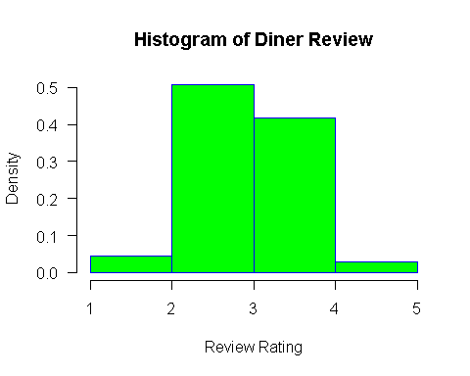

hist(Dinesafe$VALUE, xlab = "Dollar Value", main="Histogram of Diner Value",   
 border="blue", col="YELLOW", las=1, breaks=5,prob = TRUE)

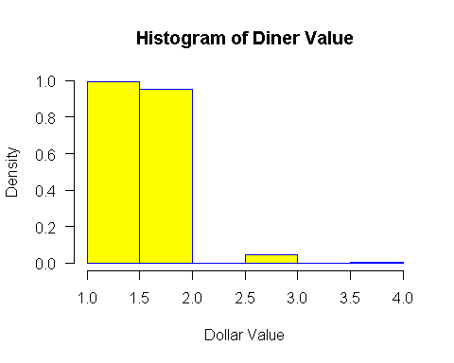

## CUISINE TYPE FREQUECY  
status <- table(Dinesafe$CUISINE_TYPE)  
barplot(status, main="Cuisine Type", ylab="Frequency", beside=TRUE, col = rainbow(17),las=2, horiz=FALSE)

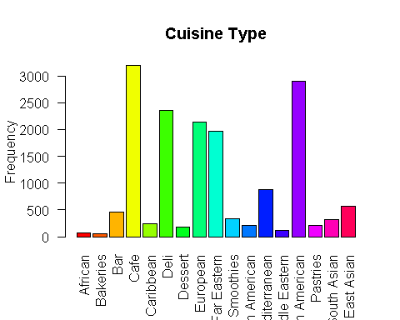

## Food Hygiene Inspection Result  
status <- table(Dinesafe$ESTABLISHMENT_STATUS)  
barplot(status, main="Food Hygiene Inspection Result", xlab="Inspection Result", ylab="Establishment Count", col=c("red","yellow","green"), beside=TRUE)

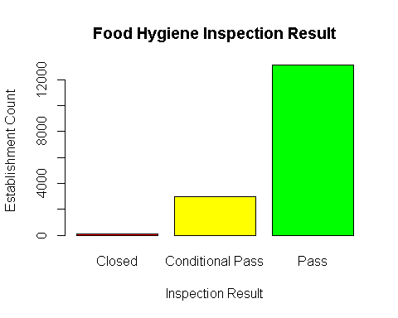

## Food Hygiene Inspection Result  
status1 <- table(Dinesafe$SEVERITY)  
barplot(status1, main="Food Hygiene Inspection Severity", xlab="", ylab="Count", col=c("red","yellow","green","White","Orange"), beside=TRUE,las=2)

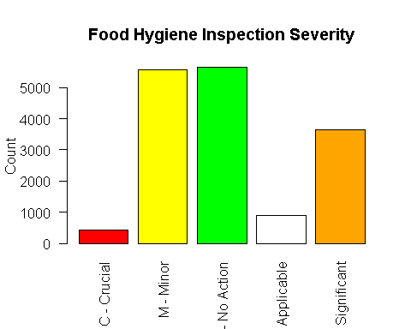

boxplot(Dinesafe$REVIEW,  
 main = toupper("Boxplot of Review"),  
 ylab = "Review Rating",  
 col = "blue")

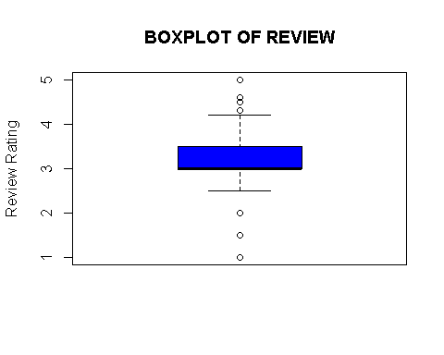

boxplot(Dinesafe$VALUE,  
 main = toupper("Boxplot of VALUE"),  
 ylab = "Value",  
 col = "green")

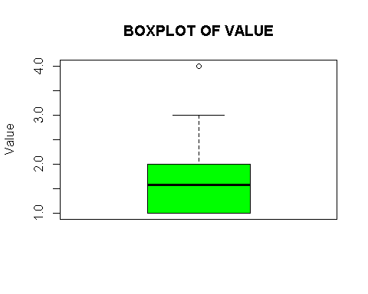

### Bivariate Analysis & Visualization

## Inspection outcome by Cuisine Stype  
Inspection_Status_By_Cuisine_Type <- table(Dinesafe$CUISINE_TYPE, Dinesafe$ESTABLISHMENT_STATUS)  
Inspection_Status_By_Cuisine_Type  
  
  
##Scatter plot of restaurant review rating vs value  
plot(Dinesafe$REVIEW, Dinesafe$VALUE, xlab="Review",ylab="Value",col=c("red","black"),cex=2)

