HANDICRAFTS OF INDIA
A Regional Exploration

Covering Four Regions of India:
North · South · East · West

24 Iconic Handicraft Traditions

Submitted By: ___________________________

College: ___________________________

Year / Semester: ___________________________

ACKNOWLEDGEMENT
I would like to express my sincere gratitude to all those who made this project possible. First and foremost, I thank my teacher and mentor for providing guidance and direction throughout the preparation of this project on 'Handicrafts of India.'
I am deeply grateful to my parents and family for their constant encouragement and support. I also thank my classmates and friends who shared valuable inputs during the research process.
I acknowledge the contributions of artisan communities across India whose extraordinary skill and dedication have kept these craft traditions alive for centuries. This project is a humble tribute to their craftsmanship and cultural heritage.
Finally, I thank the institutions and organisations — including the Crafts Council of India and the Development Commissioner (Handicrafts), Ministry of Textiles — whose published resources were invaluable references for this project.

________________________
(Signature)

TABLE OF CONTENTS
Cover Page ........ 1
Acknowledgement ........ 2
Table of Contents ........ 3
Introduction ........ 4
Part I — Handicrafts of North India ........ 5
Carpets & Durrie ........ 5
Wood Carvings ........ 5
Silver & Copper Ware ........ 6
Jootis & Footwear ........ 6
Stone Craft ........ 7
Embroidery of North India ........ 7
Part II — Handicrafts of South India ........ 8
Traditional Jewelry ........ 8
Leather Work ........ 8
Needlework (Kasuti) ........ 9
Tanjore Painting ........ 9
Clay & Bamboo Work ........ 10
Pottery ........ 10
Part III — Handicrafts of East India ........ 11
Pattachitra Painting ........ 11
Face Masks ........ 11
Shell Craft (Shankha) ........ 12
Terracotta Work ........ 12
Jute Craft ........ 13
Toy Making ........ 13
Part IV — Handicrafts of West India ........ 14
Glassware ........ 14
Bangle Making (Lac) ........ 14
Sikki Grass Craft ........ 15
Rajasthani Leather Craft ........ 15
Gujarat Wood Craft ........ 16
Kutch Embroidery ........ 16

INTRODUCTION
India is a land of extraordinary diversity — in geography, language, religion, and culture. Nowhere is this more vividly expressed than in its handicrafts. For thousands of years, Indian artisans have transformed natural materials — clay, metal, silk, stone, bamboo, lac, and wood — into objects of breathtaking beauty and functional elegance.
Indian handicrafts are not merely decorative objects; they are living encyclopaedias of history, mythology, ecology, and community identity. A Kashmiri carpet carries the aesthetic legacy of the Mughal court. An Odisha Pattachitra painting retells the story of Lord Jagannath in vivid natural colours. A Kutch embroidered blouse records the identity of a tribal community through its stitches. These crafts are inseparable from the lives of the people who make them.
India's handicraft sector employs over 70 lakh (7 million) artisans, making it the second largest employment sector after agriculture. The sector contributes significantly to India's export earnings, with handicraft exports exceeding USD 4 billion annually. India has received Geographical Indication (GI) tags for hundreds of craft traditions, protecting artisan communities from imitation and exploitation.
This project explores 24 iconic handicraft traditions, divided into four regional sections — North India, South India, East India, and West India. Each section highlights six crafts, presenting their historical origins, artistic techniques, cultural significance, and present-day status. Together, they offer a window into the astonishing creative wealth of the Indian subcontinent.
From the snow-capped mountains of Kashmir to the sun-baked plains of Rajasthan, from the lush deltas of Bengal to the tropical shores of Kerala — India's handicrafts mirror its landscapes. They are the country's greatest living heritage, and understanding them is to understand India itself.

PART I
NORTH INDIA HANDICRAFTS
States: Uttar Pradesh, Rajasthan, Punjab, Himachal Pradesh, Jammu & Kashmir

North India is the cradle of some of India's most celebrated handicraft traditions. From the intricate carpet weaving of Kashmir to the vibrant leather work of Agra, this region blends Mughal grandeur with folk artistry. The harsh terrain and royal patronage of empires shaped a rich legacy of craftsmanship that continues to thrive today.

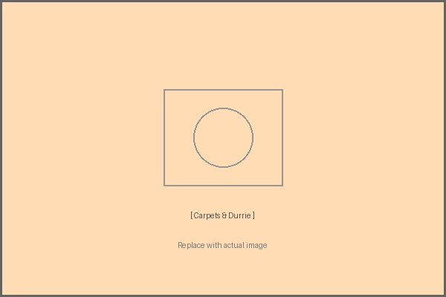  Carpets & Durrie  📍 Origin: Kashmir & Uttar Pradesh (especially Agra & Mirzapur)  📜 History  Carpet weaving was introduced to India by Mughal Emperor Akbar in the 16th century. Persian weavers brought the craft to India, and over centuries it evolved a uniquely Indian identity. Durries (flat-woven rugs) are even older, rooted in indigenous village traditions.  🌟 Today  India is now the world's largest carpet exporter. Kashmiri hand-knotted silk carpets and Agra woollen carpets fetch premium prices globally.  ✅ Key Facts  - Hand-knotted carpets can take months to years to complete  - GI Tag awarded to Kashmir Hand-knotted Carpet  - Mirzapur and Bhadohi form the 'Carpet City' cluster  - Durries are woven on pit looms with cotton or jute yarn | 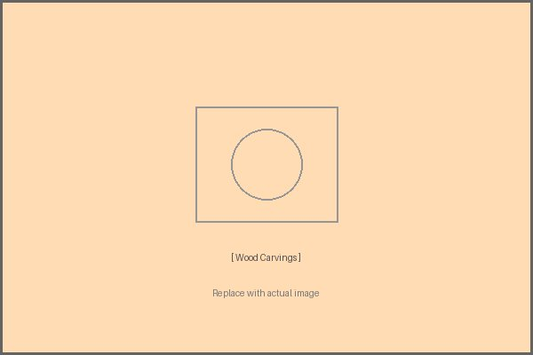  Wood Carvings  📍 Origin: Saharanpur (UP), Hoshiarpur (Punjab), Kashmir  📜 History  Wood carving in North India dates to ancient times, with temples and palaces showcasing intricate patterns. Saharanpur became a major hub during the Mughal era, when craftsmen carved furniture for royal courts. Kashmiri walnut wood carving is renowned for its fine floral motifs.  🌟 Today  Saharanpur remains the largest centre for carved wooden furniture in Asia. Kashmiri walnut carving is exported worldwide.  ✅ Key Facts  - Kashmiri walnut carving uses 3D deep-relief technique  - Saharanpur uses shisham (rosewood) and teak  - Traditional motifs include vine scrolls, chinar leaves, lotus  - GI Tag awarded to Saharanpur wood craft

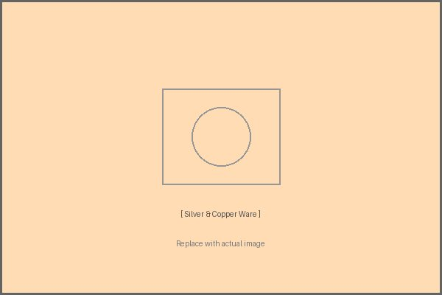  Silver & Copper Ware  📍 Origin: Moradabad (UP) — known as the 'Brass City'  📜 History  Metal craft in North India flourished under Mughal patronage. Moradabad developed as a major brass and copper ware hub from the 17th century. Bidriware from Bidar (which spread to Lucknow) blends zinc, copper, and silver inlay in stunning patterns.  🌟 Today  Moradabad exports metal handicrafts worth thousands of crores annually. The industry employs millions of artisans.  ✅ Key Facts  - Moradabad is called 'Peetal Nagari' (Brass City)  - Bidriware uses a black alloy inlaid with silver  - Traditional items: thalis, lotas, hookahs, decorative vases  - GI Tag awarded to Moradabad Metal Craft | 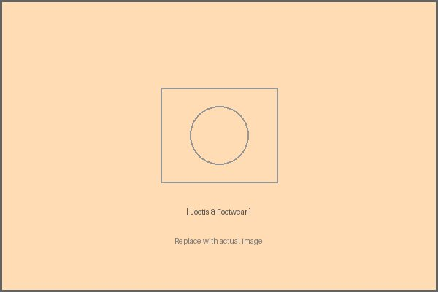  Jootis & Footwear  📍 Origin: Rajasthan (Jaipur, Jodhpur, Bikaner), Agra (UP)  📜 History  Mojaris (leather shoes) have been handcrafted in Rajasthan for centuries, traditionally worn by royals and nobles. The craft involves stretching leather over wooden lasts and hand-stitching intricate embroidery. Agra's leather craft tradition dates to the Mughal period.  🌟 Today  Jodhpuri jootis and Jaipur mojaris are popular fashion accessories exported worldwide. Agra remains India's largest shoe manufacturing hub.  ✅ Key Facts  - Traditional jootis have no left/right distinction initially  - Embroidery uses zari (gold/silver thread), beads, and mirrors  - Camel leather is used in many Rajasthani designs  - GI Tag awarded to Jodhpur Mojari

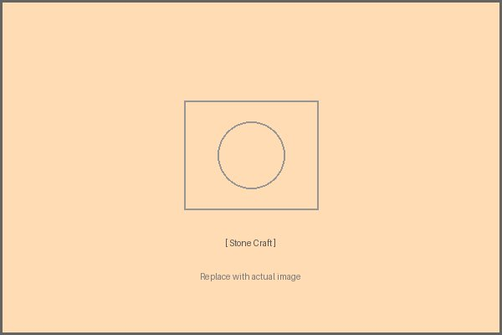  Stone Craft  📍 Origin: Agra (UP), Makrana (Rajasthan), Jaisalmer  📜 History  Stone carving reached its pinnacle in India with the construction of the Taj Mahal (1653), built using Makrana marble. Agra craftsmen carry on the pietra dura (stone inlay) tradition passed down from Mughal artisans. Jaisalmer is known for its yellow sandstone jali (lattice) work.  🌟 Today  Agra marble inlay work is a UNESCO-recognised craft. Makrana marble is exported globally, including for Italy's restoration projects.  ✅ Key Facts  - Pietra dura uses semi-precious stones inlaid in marble  - Jaisalmer jali screens are used in modern architecture  - Makrana marble was used in the Taj Mahal and Victoria Memorial  - GI Tag awarded to Agra Marble Inlay Work | 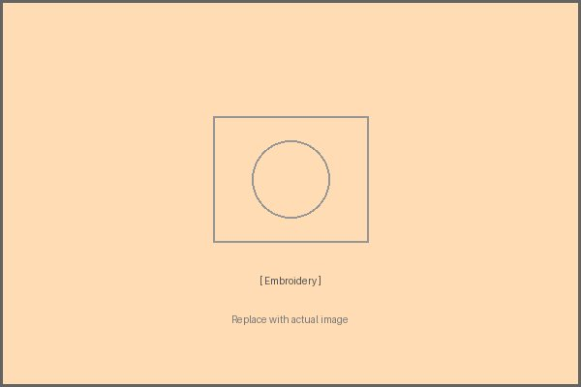  Embroidery of North India  📍 Origin: Punjab (Phulkari), Uttar Pradesh (Chikankari, Zardosi)  📜 History  Phulkari ('flower work') embroidery from Punjab is an ancient folk tradition, traditionally done by women for weddings. Lucknow's Chikankari (white-on-white embroidery) was refined under Nawabi patronage in the 18th century. Zardosi (gold thread embroidery) was a Mughal court craft.  🌟 Today  Chikankari employs over 2.5 lakh artisans in Lucknow alone. Phulkari has gained global recognition in high fashion.  ✅ Key Facts  - Phulkari uses darning stitch on khaddar cloth  - Chikankari has 32 distinct hand-embroidery stitches  - Zardosi work adorns bridal wear and ceremonial costumes  - GI Tags awarded to both Chikankari and Phulkari

PART II
SOUTH INDIA HANDICRAFTS
States: Tamil Nadu, Kerala, Karnataka, Andhra Pradesh, Telangana

South India's handicrafts are deeply intertwined with temple culture, classical arts, and ancient trade routes. From the dazzling Tanjore paintings of Tamil Nadu to the intricate Bidri metalwork of Karnataka, the South preserves craft traditions that are thousands of years old. The region's tropical resources — cane, bamboo, coconut, and silk — have shaped distinctive craft forms found nowhere else in India.

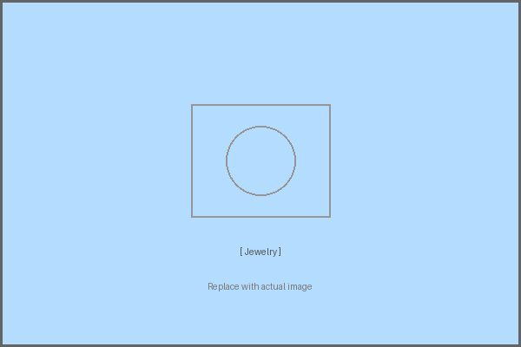  Traditional Jewelry  📍 Origin: Tamil Nadu (Temple Jewelry), Kerala (Palakkad Gold), Karnataka  📜 History  South Indian jewelry tradition is rooted in temple worship. 'Temple jewelry' was originally made for deities and later adopted for Bharatanatyam dancers. The craft dates back over 2,000 years, with gold working traditions documented in ancient Sangam literature.  🌟 Today  Temple jewelry from Chennai and Nagercoil is used in classical dance performances worldwide. Kerala's traditional gold ornaments like Kasumala and Nagapadam remain popular.  ✅ Key Facts  - Temple jewelry uses gold, rubies, emeralds, and white stones  - Kundan work uses gold foil with gemstone settings  - Traditional pieces: Maatal, Tikka, Vanki (armlet)  - Andhra Pradesh known for Nakshi and Filigree silverwork | 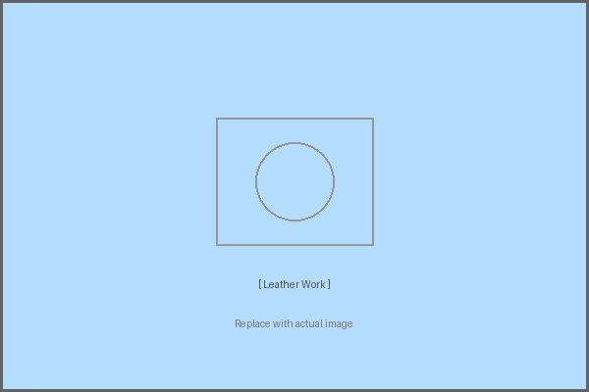  Leather Work  📍 Origin: Andhra Pradesh (Leather Puppets), Tamil Nadu (Vellore)  📜 History  The Tolubommalata (shadow puppet) tradition of Andhra Pradesh involves making large translucent leather puppets from deerskin, a craft over 1,000 years old. Vellore is historically known for leather tanning and export.  🌟 Today  Andhra leather puppets are UNESCO-recognised as an intangible cultural heritage craft. Modern artisans have diversified into leather bags and accessories.  ✅ Key Facts  - Andhra puppets can be up to 5 feet tall  - Made from deerskin treated with vegetable dyes  - Perforated designs allow light to pass through for shadow effects  - GI Tag awarded to Leather Shadow Puppets of AP

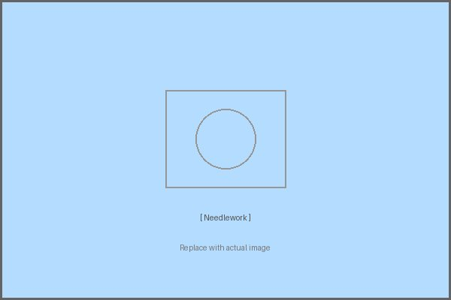  Needlework — Kasuti  📍 Origin: Karnataka (North Karnataka — Dharwad, Gadag, Bijapur)  📜 History  Kasuti is a traditional folk embroidery of North Karnataka, practised for over 1,000 years. Historically done by women on Ilkal sarees as part of their trousseau, it features geometric and mythological patterns worked entirely in running stitch, with no knots.  🌟 Today  Kasuti has been revived as a contemporary fashion element, appearing on salwar suits and home furnishings. GI Tag has helped protect artisan livelihoods.  ✅ Key Facts  - Uses four stitches: Gavanti, Murgi, Negi, and Menthi  - Patterns include temple gopurams, palanquins, elephants  - No thread is wasted — same pattern appears on both sides  - GI Tag awarded to Kasuti Embroidery of Karnataka | 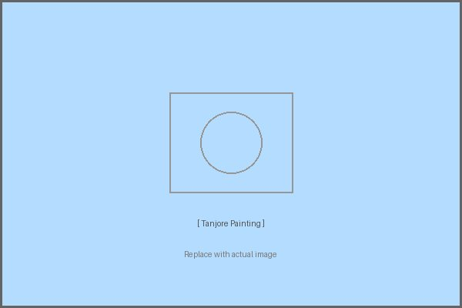  Tanjore (Thanjavur) Painting  📍 Origin: Thanjavur, Tamil Nadu  📜 History  Tanjore painting originated in the court of the Maratha ruler Serfoji II in the 16th–17th century. These panel paintings feature richly decorated Hindu deities, with surfaces encrusted with gold foil, semi-precious stones, and glass beads. The tradition flourished under Maratha and Nayaka royal patronage.  🌟 Today  Tanjore paintings are prized collectors' items globally. The GI Tag has protected the craft from imitations.  ✅ Key Facts  - Base is cloth pasted on wooden plank  - Raised surface (gold foil on chalk paste) is the signature feature  - Common subjects: Lord Krishna, Lakshmi, Ganesha  - GI Tag awarded to Thanjavur Painting

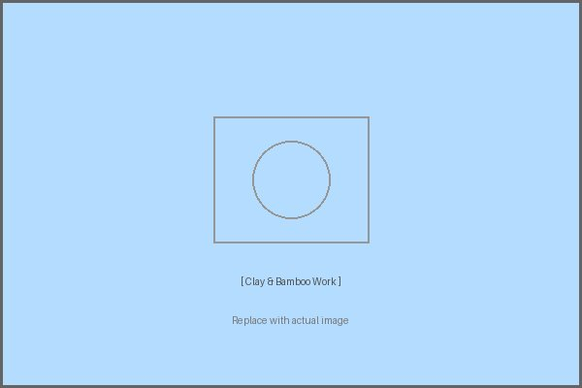  Clay & Bamboo Work  📍 Origin: Kerala (Bamboo), Andhra Pradesh & Tamil Nadu (Clay Toys)  📜 History  Bamboo craft in Kerala is an ancient tradition, with artisans weaving intricate baskets, mats, and furniture from forest bamboo. Kondapalli clay toys of Andhra Pradesh have a 400-year history, originally made for children during festivals.  🌟 Today  Kerala bamboo furniture is now exported to Europe as eco-friendly décor. Kondapalli toys received a GI Tag and are a major cottage industry.  ✅ Key Facts  - Kerala uses 15+ bamboo species for craft  - Kondapalli toys made from soft Tella Poniki wood  - Bamboo weaving involves no glue — only interlocking technique  - Kondapalli toys feature scenes from Hindu mythology | 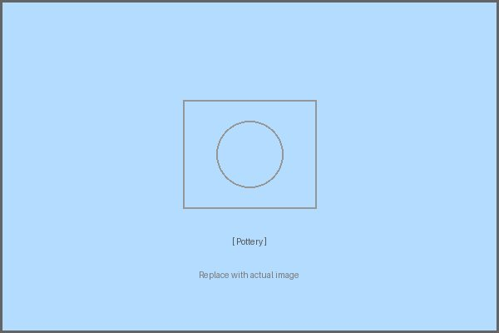  Pottery  📍 Origin: Tamil Nadu (Karigiri Blue Pottery), Andhra Pradesh (Nirmal), Karnataka  📜 History  Pottery is one of India's oldest crafts, with evidence dating to the Indus Valley Civilisation (3000 BCE). South Indian pottery traditions include black pottery of Kerakonam, terracotta votive figures, and Nirmal lacquerware objects that blend pottery with painting.  🌟 Today  Blue pottery from Karigiri is exported globally. Handmade terracotta water pots remain in daily use across rural South India.  ✅ Key Facts  - Traditional wheel-thrown pottery uses locally sourced red clay  - Nirmal craft involves wood or clay base with lacquer coating  - Sacred pottery (pots for temple rituals) follows strict ritual rules  - GI Tag awarded to Karigiri Blue Pottery

PART III
EAST INDIA HANDICRAFTS
States: West Bengal, Odisha, Assam, Jharkhand, Bihar

East India is home to some of the most spiritually rich and visually stunning craft traditions in the country. Odisha's Pattachitra paintings carry mythological stories in vivid colour; Bengal's terracotta temples inspired generations of potters; and Assam's bamboo and cane crafts reflect the abundance of the region's forests. These crafts are not merely decorative — they are living expressions of faith, community, and identity.

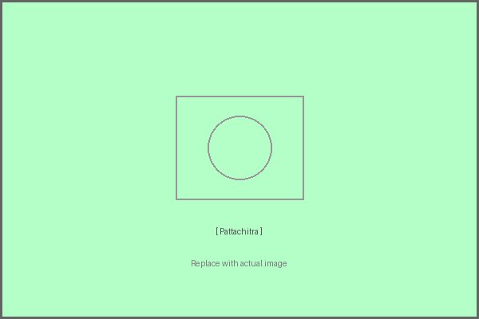  Pattachitra Painting  📍 Origin: Odisha (Puri, Raghurajpur) and West Bengal  📜 History  Pattachitra (meaning 'cloth picture') is one of India's oldest art forms, originating over 1,000 years ago in connection with the Jagannath temple in Puri. Traditionally made on cloth coated with chalk and tamarind paste, the paintings depict episodes from Hindu mythology in bold colours made from natural pigments.  🌟 Today  Raghurajpur village is a UNESCO-recognised heritage crafts village where every family practises Pattachitra. The craft is now also done on palm leaves (Tala Pattachitra).  ✅ Key Facts  - Colours derived from stone, flowers, conch shells, and lamp soot  - No pencil sketch — artists draw freehand from memory  - White border called 'Laccha' frames every composition  - GI Tag awarded to Odisha Pattachitra | 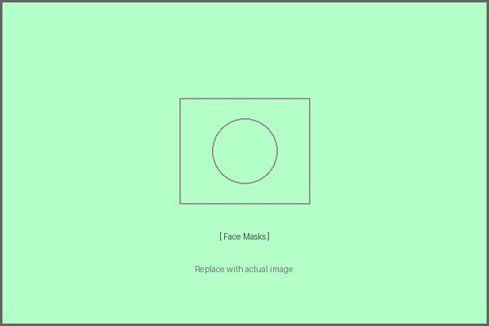  Face Masks — Chhau & Mukha  📍 Origin: West Bengal (Purulia), Odisha (Seraikela), Assam  📜 History  Chhau masks of Purulia are made for the Chhau dance, a martial folk dance tradition of the Jharkhand-Bengal-Odisha region. Assamese Mukha masks, used in Satriya theatre and Bihu celebrations, are crafted from bamboo and papier-mâché. Both traditions are over 300 years old.  🌟 Today  Chhau dance is listed under UNESCO's Intangible Cultural Heritage. Purulia mask-making families have organised into cooperatives to sustain the craft.  ✅ Key Facts  - Chhau masks depict gods, demons, and animals  - Made from clay mould, cloth, paper, and paint  - Assamese masks use bamboo strips woven over a clay base  - Some masks take up to 2 weeks to complete

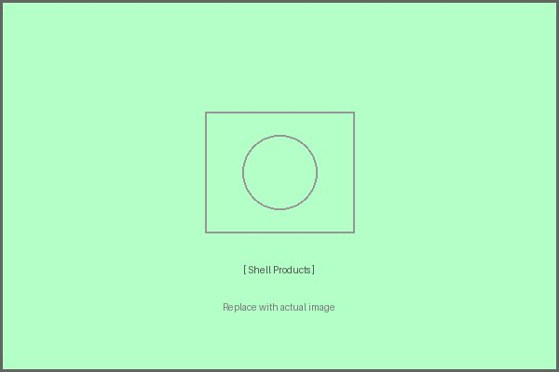  Shell Craft — Shankha Work  📍 Origin: West Bengal (Murshidabad, Kolkata), Odisha coast  📜 History  Shankha (conch shell) craft is a sacred tradition in Bengal, as the white conch is a holy symbol in Hinduism. The craft of cutting, carving, and polishing conch shells into bangles, ornaments, and ritual objects has been practised in Bengal for over 500 years. The Shankhari community has traditionally been the custodians of this craft.  🌟 Today  The GI Tag has been awarded to Bengal's Shankha craft. Conch shell bangles (Shankha) are an essential part of a Bengali Hindu married woman's ornaments.  ✅ Key Facts  - Conch shells are imported from the Andaman and Gulf regions  - Cutting is done on a vertical lathe with abrasive discs  - Ornamental carved conches are used in puja and weddings  - GI Tag awarded to West Bengal Shankha Craft | 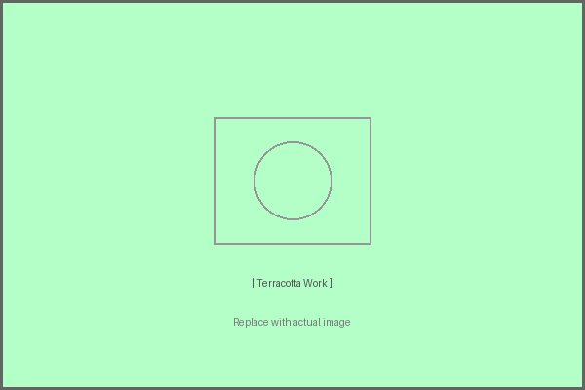  Terracotta Work  📍 Origin: West Bengal (Bishnupur, Bankura), Bihar (Bhagalpur)  📜 History  Bishnupur's terracotta temples, built by the Malla kings in the 17th–18th century, are masterpieces of brick and terracotta architecture. The Bankura horse — a stylised terracotta horse — is one of the most iconic Indian craft symbols. Bihar's Bhagalpur terracotta has roots in the ancient Mauryan period.  🌟 Today  The Bankura Horse is used as the logo of the All India Handicrafts Board. Bishnupur terracotta plaques are collector's items worldwide.  ✅ Key Facts  - Bankura horse is made in two halves and joined before firing  - Traditional kilns use wood fire, giving a distinctive reddish hue  - Bishnupur terracotta panels depict Ramayana and Mahabharata scenes  - GI Tag awarded to Bankura Terracotta Horse

  Jute Craft  📍 Origin: West Bengal (Kolkata, Nadia, North 24 Parganas)  📜 History  Bengal has been the world's jute capital since the 19th century. Jute weaving and craft — bags, baskets, floor mats, wall hangings — have long been a cottage industry in the Bengal delta. During the British era, Kolkata was known as the 'Jute Capital of the World.'  🌟 Today  India produces over 80% of the world's raw jute. Modern jute craft includes fashion accessories, eco-friendly packaging, and home décor exported globally.  ✅ Key Facts  - Jute is called the 'Golden Fibre' for its colour and value  - Naturally biodegradable and sustainable  - Products range from sacking cloth to fashion jewellery  - West Bengal has over 60 jute mills and thousands of artisans | 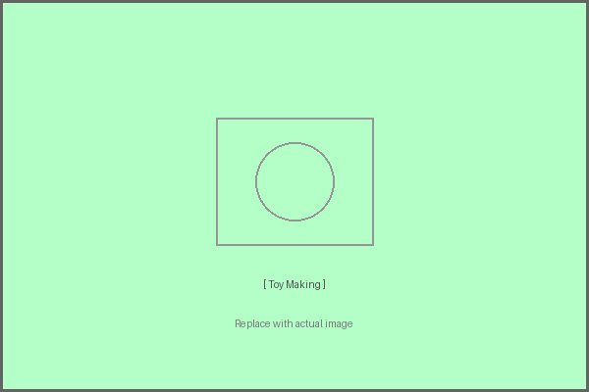  Toy Making  📍 Origin: West Bengal (Natungram), Assam (Dhemaji), Bihar  📜 History  Traditional toy-making in East India uses wood, clay, and cloth. Natungram in West Bengal is a village entirely dedicated to making wooden lacquerware toys and dolls. Bihar's papier-mâché toys have roots in the Madhubani art tradition. Assam makes bamboo and cane toys for children.  🌟 Today  Natungram toys are sold internationally and have received national recognition. The Indian government's vocal for local campaign has boosted demand for handmade toys.  ✅ Key Facts  - Natungram uses shisham wood and natural lacquer  - Traditional toys include animals, dolls, and mythological figures  - Bihar toys incorporate Madhubani painting on papier-mâché  - Movement for eco-toys has boosted traditional craft toys

PART IV
WEST INDIA HANDICRAFTS
States: Rajasthan, Gujarat, Maharashtra, Goa

West India dazzles with colour, geometry, and bold artistry. Rajasthan's block-printed textiles and lac bangles, Gujarat's Kutch embroidery and Patola silk, and Maharashtra's Paithani weaves — all represent a region where craft is a celebration of life itself. The desert and coastal landscapes have shaped these traditions profoundly, producing handicrafts that are as vibrant and resilient as the people who make them.

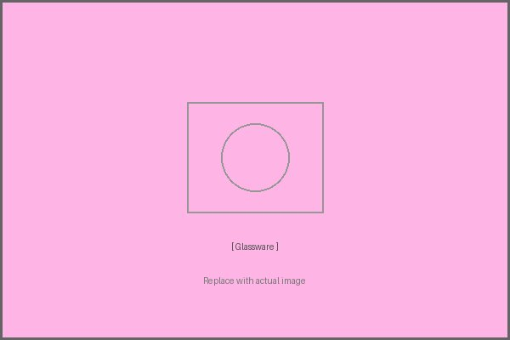  Glassware — Firozabad & Rajasthan  📍 Origin: Firozabad (Uttar Pradesh / West India corridor), Jaipur (Rajasthan)  📜 History  Firozabad, on the UP-Rajasthan border, has been a glassblowing centre since the Mughal era, known for its vibrant glass bangles and ornamental glass. Jaipur's blue pottery uses a glass-like glaze on a quartz and glass base (not clay), a technique introduced by Mongol/Persian craftsmen.  🌟 Today  Firozabad produces 70% of India's glass bangles. Jaipur blue pottery is sold in top stores worldwide and is a signature Rajasthan craft.  ✅ Key Facts  - Firozabad glass is mouth-blown and hand-shaped  - Jaipur Blue Pottery is fired at low temperature (800°C)  - Blue Pottery has no clay — uses quartz powder and glass  - GI Tag awarded to Jaipur Blue Pottery | 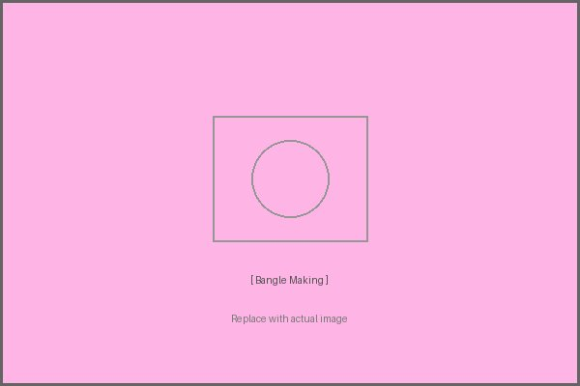  Bangle Making — Lac Bangles  📍 Origin: Rajasthan (Jaipur, Jodhpur, Bikaner, Udaipur)  📜 History  Lac bangles are traditional bangles made from lac resin, decorated with mirror work, stone, and beads. In Rajasthan, they are an essential part of a married woman's ornaments and are associated with auspiciousness. The Manihars (bangle-makers) have practised this craft for generations.  🌟 Today  Rajasthani lac bangles are exported globally as fashion accessories and cultural jewellery. The craft community has adapted to modern fashion trends while preserving traditional designs.  ✅ Key Facts  - Lac is a natural resin secreted by the lac insect  - Bangles are shaped on a rotating wooden stick over a flame  - Decorated with gold foil, stones, mirrors, and kundan  - A bride wears fresh lac bangles at her wedding — a sacred custom

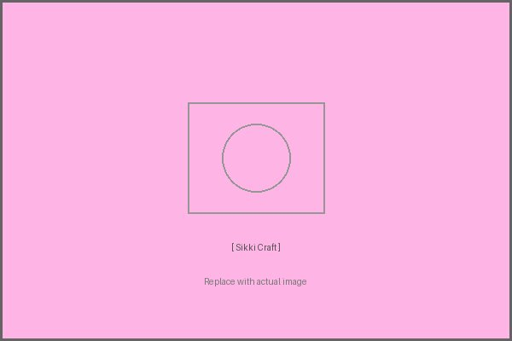  Sikki Grass Craft  📍 Origin: Bihar (Sitamarhi, Madhubani, Muzaffarpur) — Western Bihar corridor  📜 History  Sikki craft uses golden grass (Sikki) that grows along the Himalayan foothills of Bihar. Women have been weaving Sikki into decorative items — dolls, boxes, baskets, and wall hangings — for centuries. The craft is associated with the Madhubani art belt and has deep folk roots in the Mithila culture.  🌟 Today  Sikki craft has received national recognition and is exported as eco-friendly home décor. Women artisans have found economic empowerment through cooperative marketing.  ✅ Key Facts  - Sikki grass harvested in winter when it turns golden  - No dye needed — natural golden colour is the aesthetic  - Traditional items: Daura (wedding basket), dolls, flower vases  - GI Tag awarded to Bihar Sikki Grass Work | 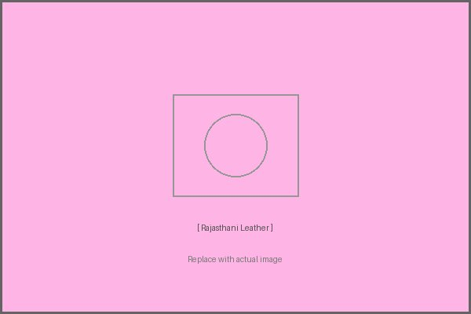  Rajasthani Leather Craft  📍 Origin: Jaipur, Jodhpur, Bikaner (Rajasthan)  📜 History  Rajasthan's leather craft tradition is one of India's oldest. The Mochis (cobbler community) have been crafting embroidered leather goods — jootis, bags, camel saddles, and water containers — for over 500 years. Camel leather is a Rajasthani speciality, tanned using traditional vegetable methods.  🌟 Today  Rajasthani embroidered leather goods are major export items in the handicrafts sector, sold in boutiques from Paris to Tokyo.  ✅ Key Facts  - Embroidery uses silk and zari thread on camel/goat leather  - Traditional items: jootis, potlis (pouches), camel decorations  - Jodhpur leather craft is known for equestrian accessories  - GI Tags protect multiple Rajasthani leather craft traditions

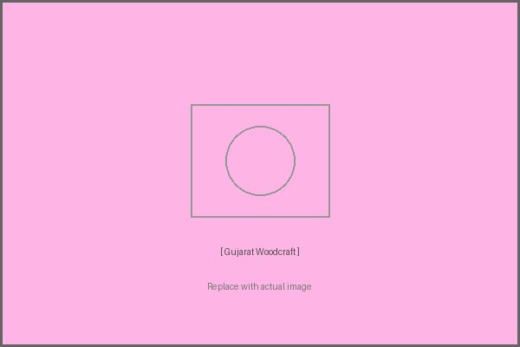  Gujarat Wood Craft  📍 Origin: Saurashtra, Kutch, Ahmedabad (Gujarat)  📜 History  Gujarat's wood carving tradition is ancient, visible in the ornate wooden havelis (mansions) of Ahmedabad and the carved doorways of Jaisalmer-influenced architecture in Saurashtra. Kutch and Saurashtra craftsmen carve intricate patterns on furniture, toys, and temple items, influenced by Hindu, Jain, and Islamic motifs.  🌟 Today  UNESCO has recognised the Historic City of Ahmedabad (with its wooden architecture) as a World Heritage Site. Gujarat wood craft is a key export in the home décor segment.  ✅ Key Facts  - Carved wooden doors called 'Toranas' are heirloom items  - Uses teak, rosewood, and local woods  - Motifs include peacocks, elephants, flowers, and geometric patterns  - Patan Patola silk weaving looms are also made from carved wood | 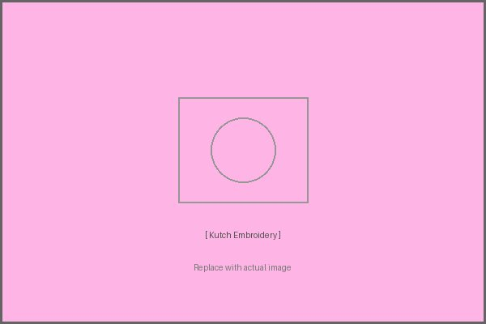  Kutch Embroidery  📍 Origin: Kutch district, Gujarat  📜 History  Kutch embroidery is among the most internationally celebrated Indian folk art forms. The region's arid landscape belies the extraordinary richness of its textiles — more than 16 distinct embroidery styles exist in Kutch alone, including Ahir, Rabari, Mutwa, and Soof styles. Each community has its own signature stitch and motif vocabulary.  🌟 Today  Kutch embroidery is sold in top fashion houses in Paris, New York, and London. The 2001 earthquake devastated the community, but craft revival NGOs helped rebuild the sector.  ✅ Key Facts  - Over 16 distinct styles from different communities of Kutch  - Uses mirrors (shisha work), silk thread, and gold zari  - Rabari embroidery is known for bold geometric patterns  - GI Tag awarded to Kutch Embroidery

