PYTHON
It is an interpreter oriented High Level programming language it is used for web development software development and scripting system
HISTORY
1980’s-Guido van Rossum @Netherland
Python is developed in the initial state of build an operating system called amoeba the name derived from Monty's Python circus series
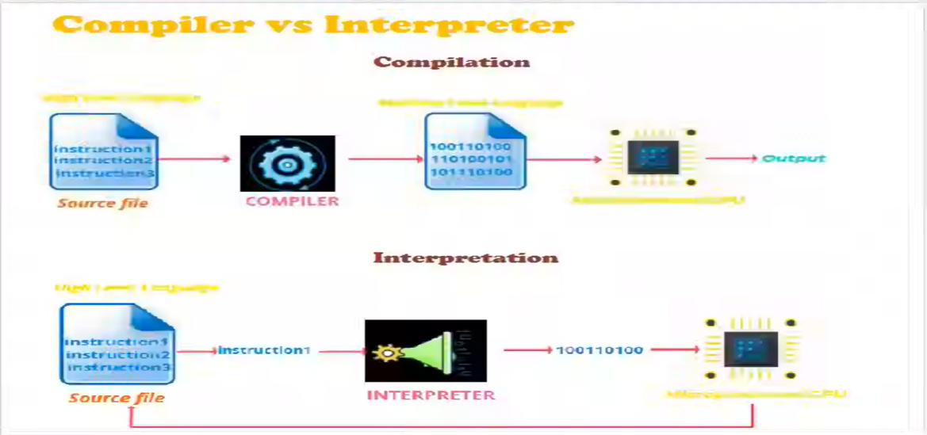
Logo was designed by two snakes colliding together.
Data Type
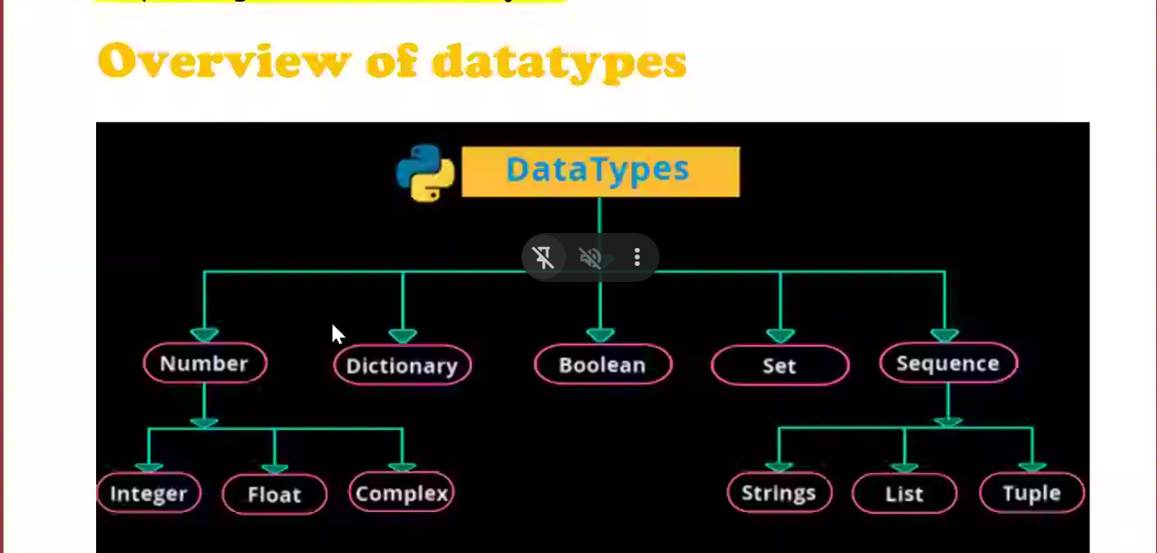
Data Type is a converted which converts real world data into machine code
Basic data type
Int float str Boolean
Advanced data type
List tuple set dictionary
program
a=5
print(type(a)) # <class 'int'>
Variable
variable is a container used to store data into it.
Ex:
a=10
command
- single line command
- multi line command
# this is used for single line command
‘’’ ‘’’ this is used for multi line command

a=int(input(“Enter value : ”)) #getting input from user
b=int(input(“Enter value : “ ))
‘’’c=a+b
print(c)’’’Multi line command
List
- List is an object and ordered collection of one or more items
- It is not necessary to follow same data type
- List declared using [] square brackets
- We can access the element using positive and negative indexing
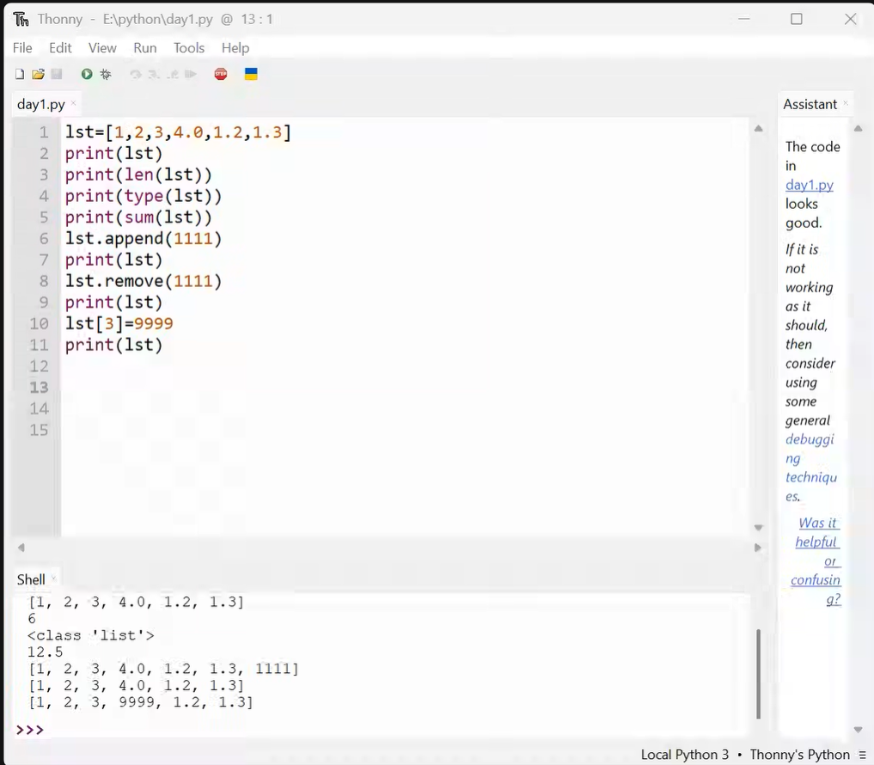
- List is Mutable datatype
Syntax:-
List=[int ,float ,str]
Tuple
- Tuple is an object and ordered collection of one or more items
- Tuple declared using () paratheses
- It also follows forward and backward indexing
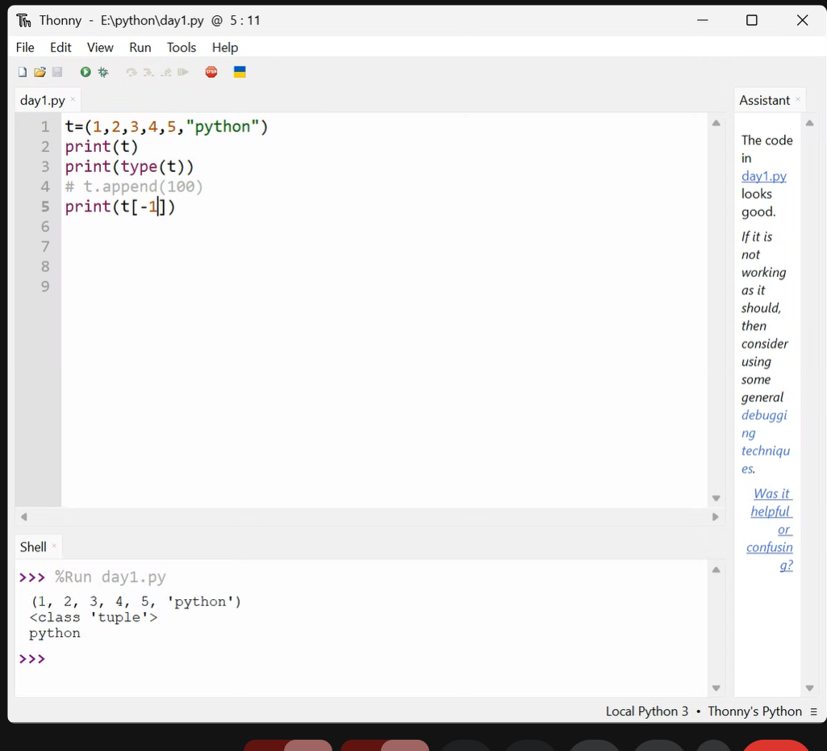
- Tuples are immutable
Syntax:-
Tuple=(int,float,str)
Set
- Set is a collection of unordered data
- Set declared using {} braces
- Set is mutable datatype
- Set doesn’t allow duplicate
- Set allow multiple datatypes
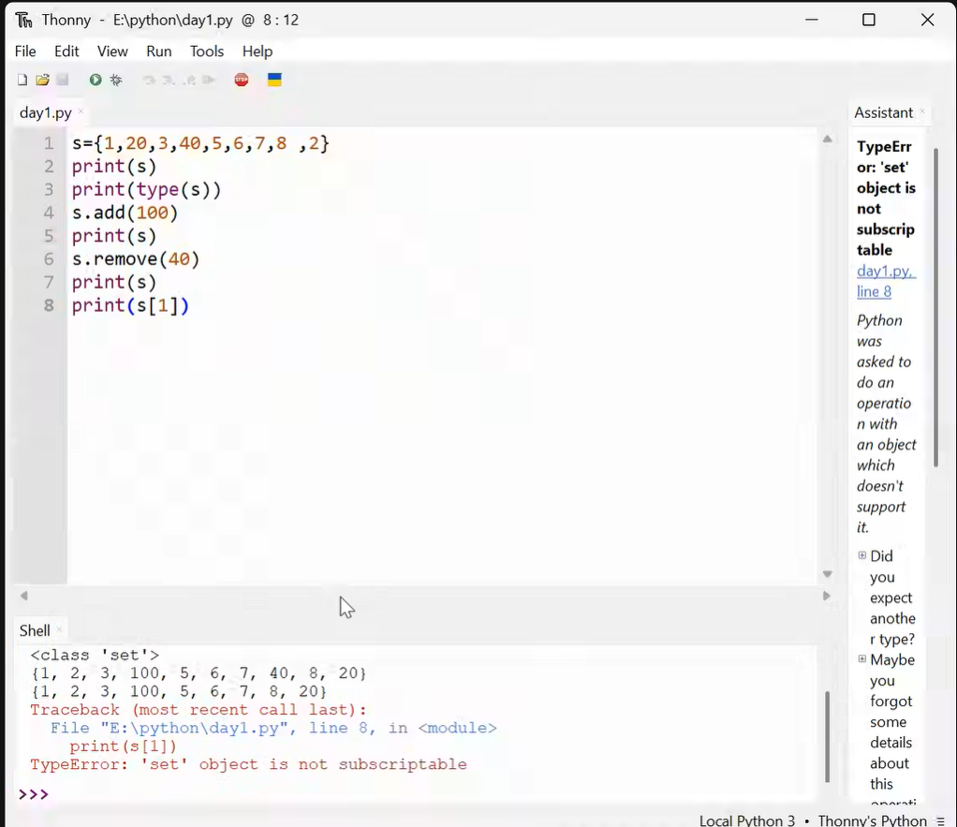
Syntax:-
Set={int,float,str}
Dictionary
- Dictionary declared using {} braces
- Key value pairs
- Dictionaries are mutable
- Key is immutable and value is mutable
- Key should not be duplicate
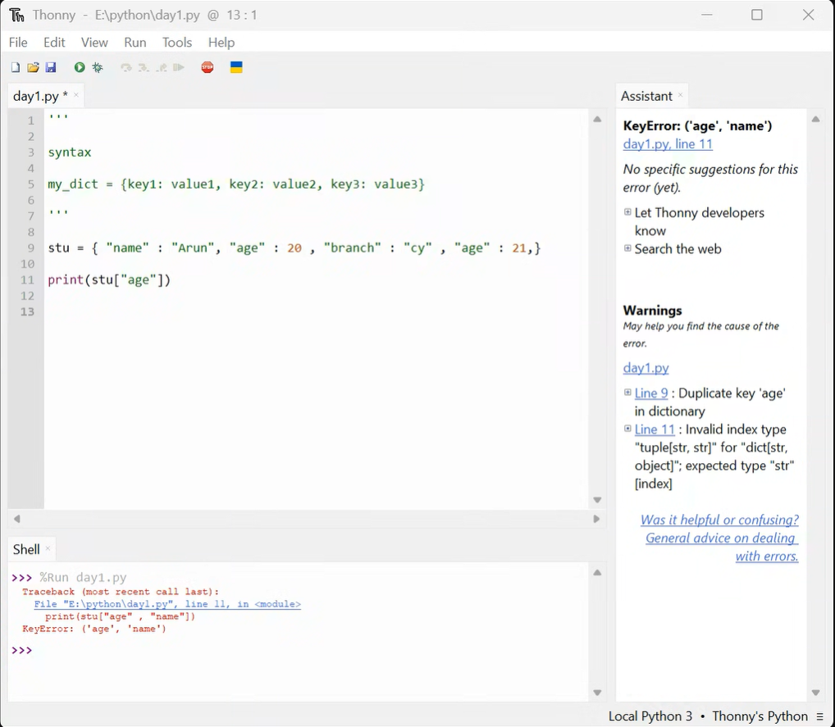

Syntax:-
Dict = {key1 : val1 , key2 : val2}
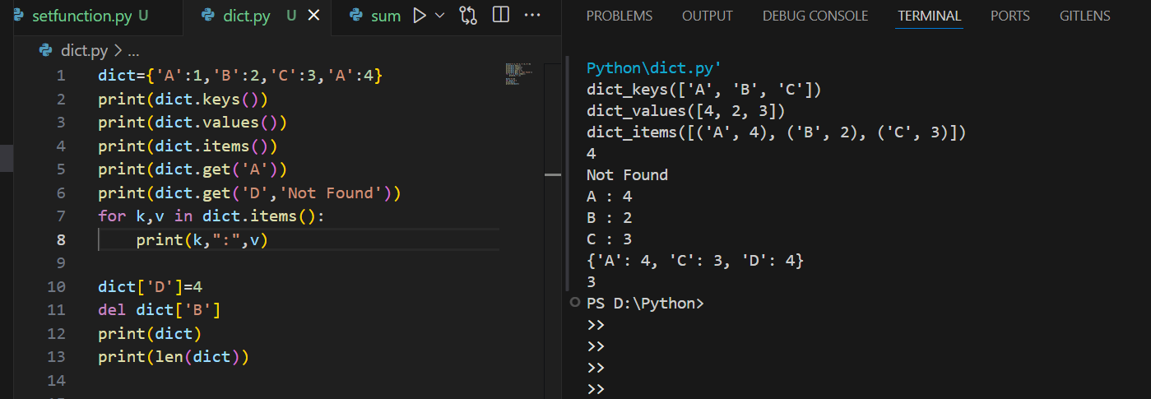
Operators
- Operators are used to perform tasks in python
- Operators are in special characters
Ex:
A=A+B

Types of operators
- Arithmetic operators
Addition , Subraction, Multiplication ,Exponential , Floor Division , Divison ,Modules
% used to take last digit
//,/used to remove last digit
** used to find power value
- Relational operators
<,>,==,!=,>=,<=
- Logical operator
and,or,not
- Bitwise operator
&,|,^,~,<<,>>
- Assignment operator
=,+=,-=,*=,**=,/=,//=,%=
- Membership operator
in,not in
- Identity operator
Is,is not
Logical Operator
If there are two conditions python will check first condition if it becomes True then it won’t check second condition

and
If both conditions becomes True then result will be True

or
If anyone conditions becomes True then result will be True

not
Swap the result

Truth Table
Op1 | Op2 | and |  | or |  | Op1=not
True | True | True | Op2 | True | Op1 | False
True | False | False | Op2 | True | Op1 | False
False | True | False | Op1 | True | Op2 | True
False | False | False | Op1 | False | Op2 | True

Membership Operator
It is used to check whether a value is present or not

in , not in
Identity Operator
It is used to check object belongs to same memory location or not

Is , is not

Bitwise Operator

XOR Truth Table
Op1 Op2 ^
True True False
True False True
False True True
False False False

NOT ~ Complement operator

A=5 #A = -(A+1)
print(~A) #-6
Conditional Statements
It is used to make decision in a statement
It check the condition True or False
According to result the blocks are executed

if if-else if-elif-else nested-if

Simple ‘if’
Execute a block of code only if the condition is True
if<condition>:
#if block True

‘if-else’
If condition is True if block is executed
If condition is False else block is
executed
Only one block will be executed
If<condition>:
#if block True
else:
#if block false

Nested if
Nested if means if statement inside another if statement
if<condition>:
#block of code
if<condition>:
#block of code
else:
#block of code
else:
#block of code

