UrbanFlow: Scalable Ensemble Learning Framework of Spatiotemporal Urban Mobility Forecasting

Mohammed Aswath M  Department of Information Technology  Kumaraguru College of Technology  Coimbatore, India  mohammedaswath.23it@kct.ac.in | Kharshavarthan N R  Department of Information Technology  Kumaraguru College of Technology  Coimbatore, India  kharshavarthan.23it@kct.ac.in | Jaya Kumar G  Department of Information Technology  Kumaraguru College of Technology  Coimbatore, India  jayakumar.23it@kct.ac.in

Abstract
To make Intelligent Transportation Systems (ITS) effective in routing, demand planning, and operational optimization, it is necessary to predict the exact trip duration. The data of urban mobility have nonlinear multifaceted dependencies subjected to the influence of spatial, time-based, environmental factors, which restrict the application of conventional statistical models. In this paper, UrbanFlow is introduced as a machine learning system to predict trip duration at scale with the use of large volumes of data.
Based on the analysis of one year of trip records (more than 30 million), memory-efficient preprocessing and stratified sampling pipeline has been used. Temporal decomposition, spatial encoding and environment context were also included in feature engineering. Baseline was Linear Regression and the comparison was done against LightGBM, CatBoost, and XGBoost.
The performance of XGBoost was the most optimal (RMSE = 4.05 minutes, MAE = 2.46 minutes, R² = 0.859). Importance analysis of features shows that trip distance and pickup time are the most important predictors whereas weather variables are marginally important. Findings prove that gradient boosting models optimized give high predictive accuracy at compute efficiency that is applicable in a real-world setting.
1. Introduction
1.1 Background
Depending on GPS-powered cars, e-metering devices, and transportation hailing services, the present-day urban transportation systems produce colossal amounts of trajectory data. Such streams of data offer high potential in modeling and comprehending dynamics of transportation. Precise trip time prediction will be of crucial importance in route optimization, dispatch planning, ETA prediction and congestion management.
Nonetheless, the travel time depends on multifactorial relationships between time-of-day and day-of-week, spatial, pickup and drop-off zones, trip characteristics (length) and traffic conditions. Such relationships are, by nature, of nonlinear and dynamic nature, which restricts the usefulness of the standard statistical methods to the large-scale forecasting of mobility.
1.2 Problem Statement
There are a number of issues that are interrelated in the urban trip duration forecasting. First, tens of millions of transportation records are often provided in datasets, which means that they need scalable processing approaches. Second, there is great temporal variability due to the fact that the patterns of traffic fluctuate on hourly, daily, and seasonal bases. Third, the presence of spatial heterogeneity in urban areas also leads to heterogenous traffic patterns. Besides, mobility patterns may be affected by the environmental conditions. Lastly, modeling trade-off, especially predictive accuracy Vs. computational efficiency exists especially in the application of models in the real world.

1.3 Objectives
The research objectives are the creation of a scalable data processing system that could process tens of millions of transportation records, identifying meaningful temporal, spatial, and contextual features of raw mobility data, comparing modern ensemble learning algorithms in a systematic manner, and a high predictive performance at a reasonable computational cost. The secondary objectives are to identify the most predictive factors that affect the trip duration, analyse the spatiotemporal traffic patterns, and prove the appropriateness of the framework in the implementation of a real-time prediction system.

1.4 Contributions
The contribution of this work is a large-scale transportation data preprocessing pipeline, a methodical feature engineering architecture on mobility forecasting, a thorough assessment of the current gradient boosting models, experimental evaluation on feature impact on trip duration, and a prediction architecture that can be applied to Intelligent Transportation Systems.
2. Literature Review
The travel time prediction sphere has evolved significantly in the past 30 years and has converted the parametric statistical schemes into complex deep learning models. This section explores the evolution of the techniques, the ignition of the ensemble learning and the critical component engineering in the process of big city mobility data management.
The chapter 2.1 provides methods of prediction by considering the travel time. The computation of travel time prediction has been a popular issue of study in the transportation research, computer science, and operations research communities offering a range of methodological frameworks, such as naive historical averages, up to sophisticated neural networks.

2.1 Prediction Methods
Initial research on travel time prediction used traditional statistical methods which were linear regression and time series [1]. On short routes, Chien and Kuchipudi (2003) used ARIMA models in bus arrival prediction and got a reasonable accuracy [1]. Nonlinear and stochastic dynamics of the urban transportation systems are, however, the assumption of these models and have a hard time in capturing them.
The development of data-driven methods meant that machine learning procedures substituted parametric assumptions. Zhang et al. (2018) revealed that Random Forests model represents an improvement over the conventional statistical models as it can model nonlinear relationships between traffic-travel time [2]. Wang et al. (2018) also demonstrated that, among various features, Gradient Boosting Decision Trees (GBDT) are especially recommended to be used with structured transportation data because they can capture the complex interactions between features with minimal pre-processing [3].
In more recent literature, deep learning-based models are used to represent spatiotemporal dependencies. Fu et al. exploited the LSTM networks to learn temporal dynamics in traffic sequence [4], whereas Yao et al. (2018) used Graph Convolutional Networks (GCNs) to learn spatial dependence in road networks [5]. The models are very accurate in their predictive performance but are costly in terms of computational capabilities and training requirements, which make them less practical in real-time or cost-constrained systems.

2.2 Transportation Ensemble Learning
Ensemble learning techniques have also become popular in the transportation analytics sector based on their strength, explainability, and performance in structured tabular data. XGBoost (Chen and Guestrin, 2016) is one of the boosting frameworks that proposed histogram-based splitting and regularization to regression scale [6]. The training was enhanced by LightGBM (Ke et al., 2017) which has a leaf-wise tree growth that is effective with large datasets [7]. To minimize the complexity of preprocessing and overfitting, CatBoost (Prokhorenkova et al., 2018) added native categorical handling [8].
The urban mobility problems have been addressed with these ensemble models. Petersen et al. (2019) used the technique of ride-sharing demand prediction with the help of Random Forest [9], whereas Zhao et al. (2020) proved that XGBoost could be used to achieve higher accuracy in the predictions of traffic flows, especially in the case of limited data availability [10]. Yet, scalability, as well as annual seasonality is not studied thoroughly because the majority of available studies employ short-term datasets or narrow geographic areas.

2.3 Transportation Data Feature Engineering
Good feature engineering is still the most important in predictive performance of transportation systems and can just dominates algorithm complexity.
Temporal Properties: The time of day effects are very influential on the travel time due to the human circadian rhythms. Williams and Hoel (2003) have noted that recurring congestion patterns can be represented using explicit features, hour-of-day and day-of-week features [11]. As it has been proved by Zheng et al. (2015), the existing models can be improved by additional planning of binary rush-hour indicators that distinguish between the peak time and free-flow traffic [12].
Spatial Features: Place of residence has a tremendous impact as far as travelling behaviour is concerned. Qi et al. (2013) accomplished the dimensionality reduction by spatial information using the zone-level aggregation process [13]. Yao et al. (2018) demonstrated that hierarchical geographic encoding (e.g., Neighborhood - Borough - City) is an effective way to encode multi-scale spatial patterns and this leads to models that can be further generalized in sparse areas [14].
Weather Integration: The effect of weather has had varied findings in the literature. A research conducted by Agarwal et al. (2005) found out that the lower capacity and the distance of braking on the precipitated roads worsen the travel time by an average of 5-15 percent [15]. Conversely, Hranac et al. (2006) have discovered that weather factor contributes to the negligence in large cities with a robust transportation system [16]. This kind of dissimilarity promotes further study on the concept of whether the Urban Stressors (congestion) overpower the environmental factors in big cities like New York.
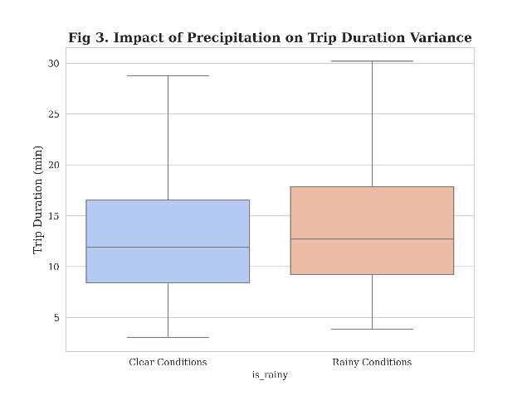
Fig. 1. Impact of precipitation on trip duration variance
2.4 Large-Scale Data Processing
The processing of datasets containing over 10 million records require special methods of processing in order to deliver a balanced ratio of statistics to memory.
Sampling Techniques:
Simple random sampling will lead to the risk of the insensitivity to the important patterns appearing infrequently (e.g., late-night airport trips). Stratified sampling was introduced by Neyman (1934), and it also has subgroup distributions [17]. Stratification of traffic data by time as demonstrated by Ali et al. (2021) revealed that the stratification of the hourly data maintains the representation of the peak a lot better as compared to the homogeneous sampling [18].
Memory Optimization:
Massive transportation data is prone to exceed the RAM. All that is needed is columnar storage (Parquet format), data type optimisations (e.g. downcasting float64 to float32), and categorical encoding. The Pandas development team has more or less documented these memory efficient practices as the necessary conditions in order to perform large scale manipulation of data with regular hardware [19].

2.5 Research Gap
The literature was useful, but there are a number of gaps, which will be addressed by the proposed study: Scale Limitations where it is less than 5 million records per study, Incomplete Feature Set where far fewer studies have combined temporal, hierarchical spatial and weather features in a single framework, Comparison of Algorithms where academic research has focused on ensuring the precision of a result, but not on its computational efficiency. UrbanFlow seals these holes, providing a systematically analyzed, scalable and comprehensive system, a design that can be produced.

3. Dataset Description
3.1 Scale and Coverage
There will be 30,904,308 records of a single trip occurrence that will be taken in a complete calendar year [20]. Large scale data is the wholesome representation of the real movement distribution in urban areas in the diverse time cycles like daily, weekly and seasonal. This long term cover can not only allow a model to follow the dynamic congestion pattern in the short-term, but also those structural changes in the long term such as holiday traffic surges, seasonal changes in tourism and changes in mobility as a result of climate.
The seasonal mobility behavior is also well identified by the difference in the number of trips provided per month which indicates that there is no steady demand throughout the year in traffic. This type of variation is required to create resilient predictive models, in which it applies the algorithms to different regimes of traffic and it does not overfit to a single temporal regime
Table I: Dataset - Monthly Distribution

Month | Trip Count
Jan | 1,369,769
Feb | 1,371,709
Mar | 1,925,152
Apr | 2,171,187
May | 2,507,109
Jun | 2,834,264
Jul | 2,821,746
Aug | 2,788,757
Sep | 2,963,793
Oct | 3,463,504
Nov | 3,472,949
Dec | 3,214,369

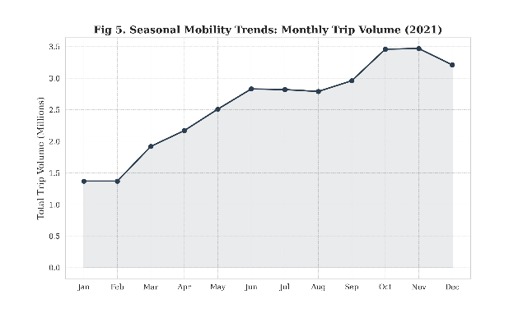
Fig. 2. Seasonal mobility trends (Monthly trip volume – 2021)
This monthly growth during the year up to the final quarter of the year is a veritable fact of the movement patterns of transportation, including high economic activity, tourism, and urban events. Such variability explains the utility of the dataset in the modeling of realistic transportation in the city.

3.2 Features Available
The trip records have particular attributes that have the temporal situation, spatial attributes, trip attributes, and environmental attributes. Pickup and drop-off times are considered as temporal features that allow to extract the patterns of rush-hours, and weekdays and weekends, as well as seasonality of mobility. Pickup and drop-off zone identifiers make up the spatial features that encode the geographic context, allowing the model to learn the congestion pattern, infrastructure constraints, and zone-specific traffic dynamics. The physical and transactional features of the trips include distance, number of passengers and fare that define the trip characteristics, distance has a direct connection with the time of travel, number of passengers and fare have an indirect connection with the purpose of trip or the choices of route. External contextual characteristics are temperature and rainfall indicators of NOAA National Centers of Environmental Information [21], which are indicators of potential changes in mobility due to weather conditions like slowing down by precipitation, behavioral changes during extreme weather.
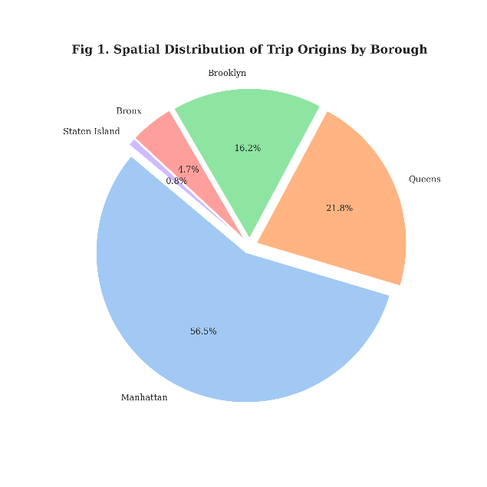
Fig. 3. Spatial distribution of trip origins by borough
3.3 Preprocessing Pipeline
The preprocessing pipeline will be designed in a way that it can be executed with a high level of computational feasibility and also statistical integrity due to the size of the data. To avoid overflowing memory, the loading of the data was done in monthly layers instead of loading it into one batch. It was necessary to maintain the stability of the process. Unrealistic measurements like impossible distances and times that had invalid records and records without any values were removed in a controlled way to remove noise and distort the model. Memory optimization tricks were used to downcast numeric types to reduced precision formats where feasible, and to reduce the use of memory with no analytical loss [19]. Thirty percent of the temporal sample kept hourly distributions that ensured that the infrequent events and common patterns represented proportionally [17]. This preprocessing led to the final working dataset of about nine million records that is statistically representative and at the same time computationally sensible to train the models.

4. Feature Engineering
In feature engineering, a natural data is transformed into a structured variable that improves the interpretability of a better model and foretelling capacity. It was the developed feature space that was designed to ensure that the space has the ability to compress the temporal, spatial, behavioral and environmental determinants of trip duration.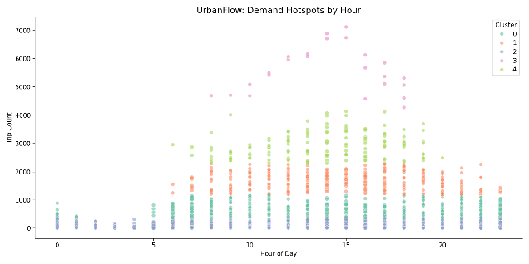
Fig. 4. Demand Hotspots by Hour

4.1 Target Variable

The target prediction will be the time (minutes) spent in a trip, which is determined as distance between the drop-off and pick up time. Duration will be the primary dependent variable because it is the variable which is directly connected to the efficiency of the transportation systems and congestion.

4.2 Temporal Features
Timestamps were broken down to understandable temporal features such as hour of day, day of week, month, flag of weekend and rush-hour indicator. These variables also allow the model to discover the regularity of traffic i.e. rush hours during commute, lazy traffic during weekends and seasonal changes. The rush-hour indicator specially recognizes peak time of congestion, enhancing the sensitivity of the model to nonlinear spikes in travel time at peak traffic times.

4.3 Spatial Features
Pickup zone identifiers, drop-off zone identifiers, and aggregated area types were the spatial context features that were encoded. Zone identifiers are local traffic characteristics that are specific to particular locations and aggregated regional categories are broader geographical structure. This hierarchy representation is the balance between detailed spatial data and the generalized data at specific regions to improve the model performance in sparse areas where finer data may be scarce.
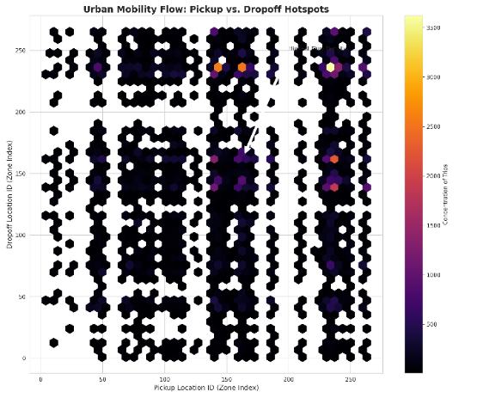
Fig. 5. Mobility – Pickup Vs. Drop Hotspots

4.4 Trip Attributes
The distance and the number of passengers characterize direct trip characteristics that describe each journey. Distance is the leading physical determinant of travel time and its time has a high level of correlation. Although this is less direct, passenger numbers could be a good indicator of trip purpose or route choice behavior.

4.5 Weather Features
The variables in the environmental context were temperature and rain indicator. The weather can affect speed of traffic, motorist behaviour and capacity. The inclusion of these variables allows the model to determine whether the environmental variables are a significant part of the travel time compared to the structural congestion variables like rush-hour traffic and spatial bottlenecks.

4.6 Feature Summary
The processed, transformed, and encoded modeling dataset had nineteen engineered features. The design of this feature set was to give enough coverage of every mobility dimension and at the same time reduce overlaps and still be suitable in tree based learning algorithms. The resulting feature space constitutes an information rich computational efficient balance that enables high-performance predictive modeling.

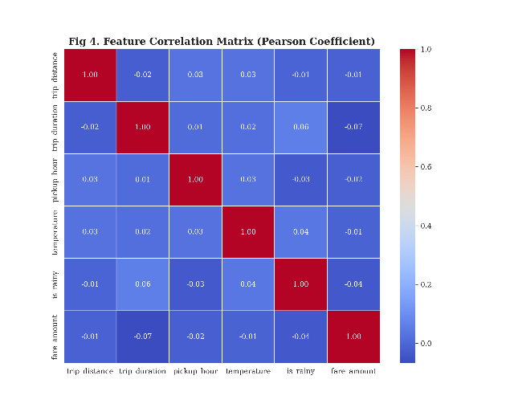
Fig. 6. Feature Correlation Matrix (Pearson Coefficient)
5. Methodology
5.1 Experimental Design
Fig. 7. Workflow overview
The preferred supervised learning protocol was applied to divide the dataset into training and test sets that comprised 80 percent and 20 percent training and testing data respectively. This division ensures that there is sufficient data to be learned on the model and still not discard a part of the data that would be learned without discrimination. Fixing a random seed was used to split the results so that the findings can be replicated between the successive experimental runs.

5.2 Preprocessing Pipeline

Before training a model, input features were processed based on the type of data. Numerical scaling was used to balance the ranges of values of continuous variables to stabilize model learning. One-hot encoding was used to encode categorical variables that were used to turn discrete values into binary vectors, which can be processed by machine learning algorithms. Ordinal variables were not manipulated with regard to any order. The standardization of feature representation through this preprocessing pipeline maintained semantic meaning in the feature representation, and all models used the well-formatted and consistent inputs.
5.3 Models Evaluated
The regression algorithms trained and tested were the following:
Table II: Regression Algorithms Used
Model | Type
Linear Regression | Baseline
LightGBM | Gradient Boosting
CatBoost | Gradient Boosting
XGBoost | Gradient Boosting
To measure the performance gain of the advanced machine learning models, there was the use of Linear Regression as a benchmark. Gradient boosting algorithms have been chosen because they have shown to be effective when applied to structured tabular data and they can be used to model nonlinear interactions between features. Hyperparameters were kept at default or by hand without a broad grid search so as to provide a fair comparison of the performance of intrinsic algorithms as opposed to tuning intensity.

5.3.1 Algorithm Descriptions
XGBoost: Extreme Gradient Boosting library with regularized objective function, histogram-based splitting, and level-wise tree growth [6].
LightGBM: Gradient boosting framework using leaf-wise growth strategy with GOSS (Gradient-based One-Side Sampling) and EFB (Exclusive Feature Bundling) optimizations [7].
CatBoost: Categorical boosting algorithm with ordered boosting technique and native categorical feature handling using symmetric trees [8].
5.4 Proposed Algorithm
Algorithm 1: UrbanFlow Trip Duration Prediction
Require: Trip_Records (T), Zone_Lookup (Z), Weather_Data (W)
1: Extracted_Data ← Load_Monthly_Parquet(T)
2: Sampled_Data ← Stratified_Sampling(Extracted_Data, rate=0.3, stratify='hour')
3: Merged_Data ← Join(Sampled_Data, Z, on='LocationID')
4: Enriched_Data ← Merge(Merged_Data, W, on='date')
5: Temporal_Features ← Extract_Time_Features(Enriched_Data)
6: Spatial_Features ← Encode_Zones(Enriched_Data)
7: Trip_Features ← Extract_Trip_Attributes(Enriched_Data)
8: Weather_Features ← Extract_Weather(Enriched_Data)
9: Target ← Calculate_Duration(Enriched_Data)
10: Cleaned_Data ← Remove_Outliers(Enriched_Data)
// distance > 0, duration ∈ [1, 180], fare > 0
11: Optimized_Data ← Downcast_Types(Cleaned_Data)
// float64 → float32, categorical encoding
12: X_train, X_test, y_train, y_test ← Split(Optimized_Data, test_size=0.2)
13: X_scaled ← Preprocess(X_train, X_test)
14: for model in [LightGBM, CatBoost, XGBoost] do
model.fit(X_scaled_train, y_train)
predictions ← model.predict(X_scaled_test)
metrics[model] ← Evaluate(y_test, predictions)
15: Best_Model ← Select_Best(metrics, criterion='R²')
16: Feature_Importance ← Analyze_Features(Best_Model)
17: return Best_Model, Feature_Importance, metrics

Output: Trained_Model, Performance_Metrics, Feature_Rankings

5.5 Evaluation Metrics

Three standard regression measures were used to determine model performance. Root Mean Squared Error (RMSE) is used to measure the mean value of the error of prediction, with a higher penalty on large values. Mean Absolute Error (MAE) is an understandable number that reports on the average error of the prediction in the original units. Coefficient of Determination (R² Score) is the measurement of the percentage of variance which is explained by the model. These complementary measures guarantee in-depth analysis of model accuracy, model robustness and model predictability.
6. Results
6.1 Model Performance
All the evaluated models are summarized in terms of predictive performance as shown below.
Table III: Model Metrics
Model | RMSE | MAE | R2
Linear Regression | 6.42 | 4.98 | 0.684
LightGBM | 4.76 | 2.95 | 0.805
CatBoost | 4.56 | 2.88 | 0.821
XGBoost | 4.05 | 2.46 | 0.859

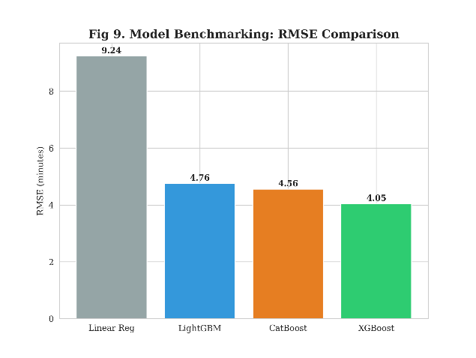
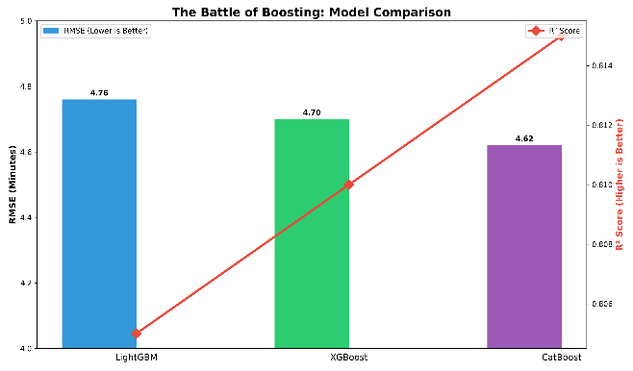
Fig. 8. Model Benchmarking (RMSE, RMSE Vs. R²)
The results show that there is clear stratification of performance of model classes. The fact that the ensemble methods are much better than the Linear Regression proves that the issue of the travel time prediction is non-linear and cannot be adequately modeled on the premises of the linear assumptions.
Gradient boosting models are all doing much better than the baseline in the ensemble techniques. XGBoost has the highest predictive accuracy on the measures, minimum RMSE and minimum MAE, and maximum coefficient of determination. This demonstrates that its tree construction and regularization programs which are based on histograms are useful in modeling complex interactions between spatial, temporal and trip level variables.
The magnitude of the error in prediction is also feasible. This is implied by the fact that RMSE is 4.05 minutes hence indicating that most predicted trip durations are only slightly different as compared to observed ones. Operationally reliable error in prediction in the estimation of ETA and dispatch optimization as in practice transportation entails prediction error of less than five minutes. As such, the model is both statistically right and useful in application.

6.2 Error Characteristics
Residual analysis further sheds light on the model reliability other than the aggregate measures of the model performance. Prediction error analysis indicates that there exist a number of critical properties. The model does not have any strong systematic bias meaning that it does not systematically over/underestimate travel times over the prediction range. The problem of underestimation is weakly exhibited with long trips, which is very frequent in regression models when long journeys have a small percentage of training examples. Trip duration slightly increases the residual variance and this suggests the existence of mild heteroscedasticity. Longer journeys are by nature, more erratic as they expose themselves to fluctuating traffic levels, unforeseen delays and route diversion. In general, it can be seen that the residual distribution suggests that the model has been able to capture most of the systematic relationships in the data, and the remaining prediction errors could be attributed to random or unobserved variables.
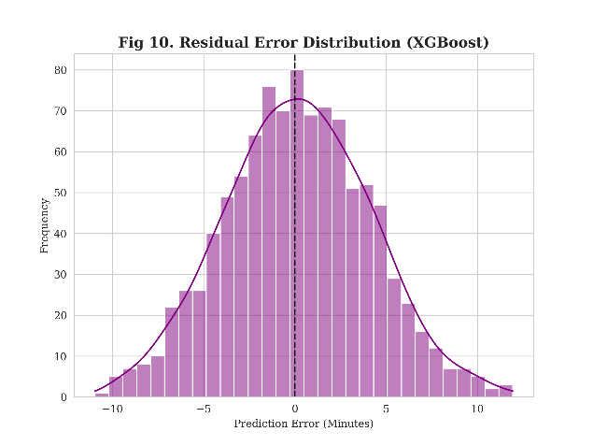
Fig. 9. Residual error distribution (XGBoost)
6.3 Feature Importance Ranking
The analysis of the importance of features indicates that the significant factors that predict the time of travel are the distance, pickup hour, pickup zone, drop-off zone, and rush-hour flag.
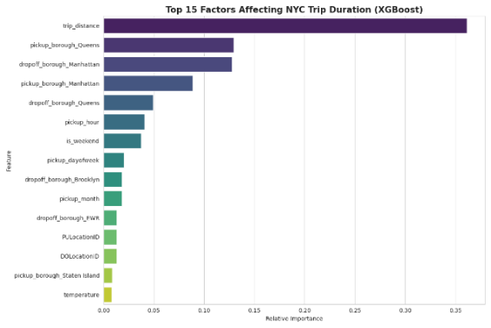
Fig. 10. Feature Importance (Gain Score)
This ranking shows that it is physical constraints and time context that are the main sources of accuracy of prediction. Distance stands out as the most important factor, which is compatible with the transportation theory that the time of travel is essentially limited by the spatial displacement. 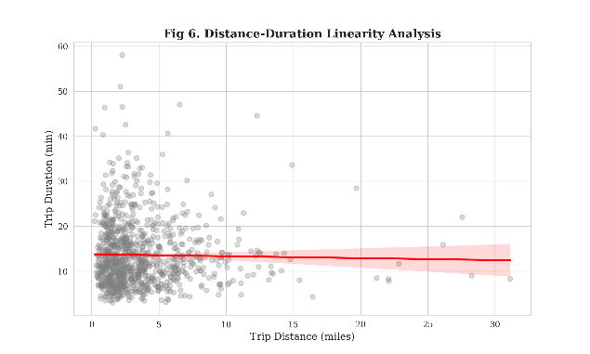
Fig. 11. Distance-Duration Linearity Analysis
Temporal variables such as pickup hour and rush-hour indicators address the dynamics of congestion proving that the state of traffic is significantly different at different times of the day. Spatial identifiers are also important contributors and it has been established that location specific variables like road infrastructure, traffic density and network connectivity are critical in influencing trip duration. The outstanding nature of these features justifies the success of the spatiotemporal feature engineering design.

6.4 Spatial Insights
The analysis of spatial aggregation indicates that patterns of geographic travels are unique. Ancient cities have lesser trip lengths yet slower travel because of traffic jam and density on the roads. Areas served by airports incur longer and costlier movements because of the distance and use of the highway system. The non-core urban areas exhibit low trip demands with an increase in the travel distance.
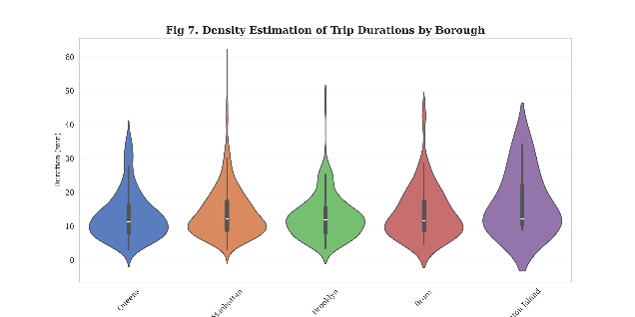
Fig. 12. Density estimation of Trip duration by Borough
These trends substantiate the fact that transportation dynamics are very locational and that centralities have more accessibility and are more densely populated whereas outer ones have more travel speed but have to be covered over a longer distance. These spatial heterogeneities are well defined by the model using location based features.

6.5 Temporal Patterns
Time analysis shows that there are discernible patterns in the urban mobility. The highest time taken on the trip is during evening narrow-hour periods meaning that there is the highest congestion during these times. Weekend trips normally have a short period which implies that there is less traffic of commuters. Minimal congestion rates are observed during the night hours when there is low demand of traffic. These time series patterns confirm the established transportation principles about the everyday travel patterns and show how the model can learn periodic movement patterns.

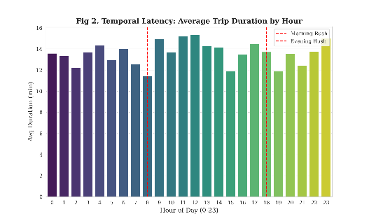
Fig. 13. Temporal Latency: Average Trip duration by hour

7. Conclusion

The present paper introduced UrbanFlow in the form of the scalable machine learning system developed to estimate the time of a trip in an urban environment based on the large-scale mobility data. This pipeline could handle more than thirty million records and be computational, indicating that big transportation data can be analyzed, and using appropriate preprocessing plans.
The framework combines systematic feature engineering strategy which involves time based and space based features, trip based variables and environment variables. Gradient boosting model was also experimented and actually showed the best results as compared with the traditional regressions, where XGBoost showed the best results (RMSE = 4.05 minutes, R² = 0.859). Such results confirm that nonlinear spatiotemporal relationships can be modeled using ensemble learning techniques in a very effective way.
The findings indicate that deep learning structures do not necessarily require computationally intensive computations to generate an accurate travel prediction. Instead, properly designed tabular machine learning pipelines may be efficient and deployable in addition to being capable of providing high predictive accuracy.
UrbanFlow thus provides a legitimate foundation of empirical contexts such as the development of routes, forecasting of demands, and the optimization of the processes in the present-day smart-city transportation systems. It can be implemented in real intelligent transportation systems as it is a scalable structure with high predictability.
References
[1]Chien, S. I., & Kuchipudi, C. M. (2003). Real-time and historic dynamic predictive travel time. J. Transportation Engineering, 129, 608-616.
[2]Zhang, D., Kabuka, M. R., & Zhang, X. (2018). Random forest regression of taxi travel time through feature selection. Intelligent Transport Systems Magazine, 10(3), 32-41.
[3]Wang, Z., Fu, K., & Ye, J. (2018). Training to understand how to estimate the travel time. ACM SIGKDD International Conference on Knowledge Discovery and Data Mining, 24th, 858-866.
[4]Fu, R., Zhang, Z., & Li, L. (2016). Predicting traffic flow with the help of LSTM and GRU methods of neural networks. 31st Youth Academic Annual Conference of Chinese Association of Automation (YAC), 2016, 324-328.
[5]Yao, H., Wu, F., Ke, J., Tang, X., Jia, Y., Lu, S., ... & Li, Z. (2018). Deep multi-view multi-temporal network of taxi demand prediction. Artificial Intelligence Conference of the AAAI, 32(1).
[6]Chen, T., & Guestrin, C. (2016). XGBoost: Tree boosting system which is scalable. ACM SIGKDD 22nd International conference on Knowledge Discovery and Data Mining, 785-794.
[7]Ke, G., Meng, Q., Finley, T., Wang, T., Chen, W., Ma, W., ... & Liu, T. Y. (2017). LightGBM: A high-performance gradient boosting decision tree. Neural Information Processing Systems (NeurIPS) progress, 30, 3146-3154.
[8]Prokharenkova, L., Gusev, G., Vorobev, A., Dorogush, A. V., and Gulin, A. (2018). CatBoost: unbiased categorical boosting. Neural Information Processing Systems (NeurIPS) advances, 31, 6638-6648.
[9]Petersen, N. C., Rodrigues, F., and Pereira, F. C., (2019). Prediction of multi-output bus travel time using convolutional LSTM neural network. Expert Systems with Applications, 120, 426-435.
[10]Zhao, L., Song, Y., Zhang, C., Liu, Y., Wang, P., Lin, T., etc. & Li, H. (2020). T-GCN: Temporal graph convolutional network: traffic prediction. IEEE Transactions on Intelligent Transportation Systems, 21(9), 3848-3858.
[11]Williams, B. M., & Hoel, L. A. (2003). Vehicular traffic flow Modeling and forecasting as a seasonal ARIMA process: Theoretical foundations and empirical findings. Journal of Transport Engineering, 129(6), 664-672.
[12]Zheng, F., van Zuylen, H., & Liu, X. (2015). Kalman filter based approach to precise and real time prediction of travel time. International Journal of Transportation Science and Technology, 4(2), 155-168.
[13]Qi, H., Shen, L., Chen, L., & Hu, J. (2013). Efficient taxi suggestion on the premise of pickup and drop points. 2013 IEEE International Conference on High Performance Computing and Communications, 1461-1466.
[14]Yao, Z., Fu, Y., Liu, B., Hu, W., & Xiong, H. (2018). Embedding of zone representation of human mobility patterns of urban functions. International Joint Conference on Artificial Intelligence Proceedings of the 27th international joint conference on artificial intelligence, 3919-3925.
[15]Agarwal, M., Maze, T. H., and Souleyrette, R. (2005). Weather effects on facility capacity and characteristics of traffic flow in urban freeways. Mid-Continent Transportation Research Symposium Proceedings, 2005.
[16]Hranac, R., Sterzin, E., Krechmer, D., Rakha, H., and Farzaneh, M. (2006). Experimental research on traffic commuting during rainy seasons. Federal Highway Administration Report FHWA-HOP-07-073.
[17]Neyman, J. (1934). In the two facets of the representative approach: the stratified sampling approach and the purposive selection approach. J. Royal Statistical Society, 97 (4): 558-625.
[18]Ali, A., Zhu, Y., & Zakarya, M. (2021). Crowd flows prediction of citywide predictions of dynamic spatio-temporal correlations using data aggregation method in cloud computing. Multimedia Tools and Applications, volume 80, issue 20, 31171-31197.
[19]pandas-dev/pandas: Pandas (Version 1.x). (2020). Zenodo. https://doi.org/10.5281/zenodo.3509134
[20]Taxi and Limousine Commission of NYC. (2021). TLC Trip Record Data. Accessed on 14 April, 2020 at; https://www1.nyc.gov/site/tlc/about/tlc-trip-record-data.page.
[21]NOAA National Centers of Environmental Information. (2021). Climate Data Online. Fetched by means of https://www.ncdc.noaa.gov/cdo-web/
[22]Breiman, L. (2001). Random forests. Machine Learning, 45(1), 5-32.
[23]Friedman, J. H. (2001). Greedy functional approximation: a gradient boosting machine. Annals of Statistics, 29(5), 1189-1232.
[24]Lundberg, S. M., & Lee, S. I. (2017). This is because of the unified approach towards interpretation of model predictions. Neural Information Processing Systems (NeurIPS) progress, 30, 4765-4774.
[25]Hochreiter, S., & Schmidhuber, J. (1997). Long short-term memory. Neural Computation, 9(8), 1735-1780.

