LOYOLA COLLEGE AUTONOMOUS
DEPARTMENT OF STATISTICS
NUNGAMBAKKAM, CHENNAI – 600034
STATISTICAL ANALYSIS OF THE RELATIONSHIP BETWEEN FREQUENCY OF AI TOOL USAGE AND ACADEMIC PERFORMANCE AMONG STUDENTS
A Comprehensive Research Report
Submitted by
MOHAMMED DHAQIB MH
Under the guidance of
Prof. Dr. Sumathy V
Department of Statistics
OCTOBER 2025

ACKNOWLEDGEMENT
We express our sincere gratitude to Prof. Dr. Sumathy V, Department of Statistics, Loyola College Autonomous, for guidance and academic support. We thank the students who completed the Google Forms questionnaire and contributed responses to the project. We acknowledge the researchers and institutions whose publications informed the literature review. The group should review this acknowledgement before submission.

ABSTRACT
This study describes students’ use of artificial intelligence (AI) tools for academic purposes, perceived benefits and risks, and the relationship between AI dependency and self-reported academic performance. The original project used a structured Google Forms questionnaire circulated among students from different institutions and departments. The supplied spreadsheet contains 105 response records and includes demographics, attendance and performance bands, arrears status, AI-use patterns, a five-point dependency item, five Likert statements, policy preferences, concerns, and an open-ended item. In the spreadsheet, 72 respondents (68.6%) were in second year, 53 (50.5%) had the department label Science, and 55 (52.4%) selected moderate dependency. Sixty-six respondents (62.9%) agreed or strongly agreed that AI improved assignment quality; 51 (48.6%) agreed or strongly agreed that AI positively affected examination performance. Seventy-seven respondents (73.3%) preferred allowing AI with restrictions. The original PDF reports a correlation of −0.11 between dependency and academic performance. However, a reproducible ordinal recoding of the supplied spreadsheet yields Pearson r = 0.074 and Spearman ρ = 0.104, both weak positive associations. The discrepancy requires reconciliation with the original analysis and coding. No significance or causal claim is made. The report concludes that respondents perceive useful academic support from AI while supporting safeguards and balanced learning. Important limitations include self-reported measures, undocumented sampling details, broad ordinal grade bands, incomplete factor-analysis diagnostics, and a mismatch between the original and spreadsheet-based correlation.
Keywords: artificial intelligence; generative AI; academic performance; AI dependency; college students; survey research; correlation; factor analysis

TABLE OF CONTENTS
Update the Table of Contents field in Word after opening this document. Chapter headings use Word heading styles.

List of Tables: Variable dictionary; respondent distributions; Likert responses; correlation comparison; limitations matrix.
List of Figures: Respondents by year; AI-use frequency; dependency ratings; Likert responses Q14–Q18.
Abbreviations: AI—Artificial Intelligence; GenAI—Generative Artificial Intelligence; CGPA—Cumulative Grade Point Average; KMO—Kaiser–Meyer–Olkin; UNESCO—United Nations Educational, Scientific and Cultural Organization.

CHAPTER 1: INTRODUCTION AND IDENTIFICATION OF THE RESEARCH PROBLEM

Step 1: Identifying the Research Problem

1.1 Background
Artificial intelligence has become increasingly visible in higher education through conversational systems, grammar assistants, coding tools, presentation generators, image tools, and AI-enabled study applications. Students may use these tools to clarify concepts, generate examples, plan assignments, improve writing, prepare for examinations, or obtain project support. These uses can make learning resources more accessible and provide rapid feedback. However, AI-generated responses may be inaccurate, biased, incomplete, or difficult to verify; uncritical use can blur the boundary between assistance and substitution for a student's own work.
The educational question is not simply whether students use AI. It is how they use it, how often they use it, whether they feel dependent on it, what benefits and risks they perceive, and whether usage patterns are associated with academic outcomes. Frequency and dependency are distinct constructs. Frequency describes how often a tool is used; dependency describes perceived reliance. A student may use AI frequently as a tutor while remaining intellectually independent, whereas another may use it less often but rely on it for tasks they could otherwise complete.

1.2 Statement of the research problem
The problem addressed by this project is the need to describe AI-use patterns among college students and examine whether reported AI dependency is associated with academic performance, while documenting perceived benefits, risks, and preferred institutional responses. The original project raises the possibility that AI can improve task efficiency but may also be associated with over-dependence, reduced self-study, plagiarism, and reduced originality.

1.3 Reasons for selecting the topic
- AI tools are increasingly accessible and used for a broad range of academic tasks.
- Students, teachers, and institutions need evidence-informed guidance rather than assumptions that AI is uniformly beneficial or harmful.
- Statistical methods can summarize use patterns and examine associations between dependency, perceptions, and academic indicators.
- The topic connects statistical analysis with a current issue in higher education and academic integrity.

1.4 Significance and necessity
The study is relevant to students who need to use AI without losing independent problem-solving skills; teachers who must design learning activities and assessments; and institutions developing fair, transparent policies. The study is descriptive and exploratory. It can describe respondents' reports and identify associations in the sample, but it cannot establish that AI use causes changes in marks.

1.5 Scope and delimitations
The supplied spreadsheet contains 105 response records dated in September 2025 and includes respondents reporting different colleges, years, and departments. The analysis focuses on self-reported AI use, dependency, academic-performance bands, arrears, attendance bands, Likert responses about study habits and perceived academic effects, policy preferences, concerns, and open-ended responses. Exact sampling-frame boundaries, recruitment channels, response rate, and eligibility rules are not documented and are marked for confirmation.

1.6 Operational definitions
Term | Operational meaning
AI tools | Applications respondents identify as AI, including conversational, writing, coding, presentation, and image tools.
AI-use frequency | Self-reported category such as Never, Rarely, Weekly, or Daily; distinct from dependency.
AI dependency | Self-rating from 1 (not at all dependent) to 5 (completely dependent), Q13.
Academic performance | Self-reported last-semester marks/CGPA band, Q6; exact metric is ambiguous.
Perceived benefit | Agreement that AI improved assignments, examination performance, or helped with arrears.
Independent learning | Represented by the Q14 statement that self-study time without AI has decreased.
Academic integrity concern | Concern such as reduced originality and risks related to over-dependence or misuse.
Arrears | Self-reported current arrears status, Yes/No.

The separate original Google Forms questionnaire was not supplied. Exact wording and response options should be verified against the original form.

CHAPTER 2: REVIEW OF LITERATURE AND RESEARCH GAP

Step 2: Reviewing the Literature
A targeted literature search was conducted using publisher pages and authoritative institutional sources, including ScienceDirect, Springer Nature, SAGE, MDPI, Taylor & Francis, PubMed/Heliyon, and UNESCO. The sources cover generative AI in higher education, academic achievement, student perceptions, assessment, and academic integrity. They differ in evidentiary strength: meta-analyses synthesize multiple studies, empirical surveys describe respondent perceptions, qualitative studies provide contextual detail, and policy papers recommend principles rather than estimate causal effects.

2.1 Kasneci et al. (2023)
“ChatGPT for good? On opportunities and challenges of large language models for education.” This peer-reviewed commentary reviews educational opportunities and challenges rather than reporting a single experiment. It discusses content generation, engagement, personalized support, output unreliability, bias, fact-checking, oversight, and AI literacy. It recommends pedagogical design and critical evaluation. This informs the present study's paired attention to benefits and dependency risks. Because it is a commentary, it does not estimate the relationship between student use frequency and grades.

2.2 Sun and Zhou (2024)
“Does Generative Artificial Intelligence Improve the Academic Achievement of College Students? A Meta-Analysis.” The authors synthesized 28 articles comprising 65 independent studies and 1,909 participants. They reported a medium positive pooled effect on college students’ achievement (Hedges’ g = 0.533, 95% CI [0.408, 0.659], p < .05). Moderator analyses considered activity category, sample size, generated content, intervention duration, discipline, and assessment type. This is stronger aggregated evidence for potential achievement benefits than a perception survey. Nevertheless, an intervention effect across included studies does not imply that self-reported dependency in a cross-sectional survey must correlate positively with grades.

2.3 Adewale et al. (2024)
“Impact of artificial intelligence adoption on students’ academic performance in open and distance learning: A systematic literature review.” The authors reviewed literature published from 2017 to 2023 and synthesized 64 papers from an initial pool of 700. They found a diverse methodological landscape, including machine-learning and classical statistical approaches, and noted that many papers were non-empirical. They emphasized the multifaceted determinants of AI adoption and called for better frameworks to forecast educational impact across contexts. Its open and distance learning focus differs from this survey, but it reinforces that AI adoption is not a single uniform exposure.

2.4 Chan (2023)
“A comprehensive AI policy education framework for university teaching and learning.” Chan used mixed methods with 457 students and 180 teachers/staff across disciplines in Hong Kong universities. The study proposed an AI Ecological Education Policy Framework with pedagogical, governance, and operational dimensions. It highlights assessment redesign, privacy, transparency, accountability, training, and stakeholder involvement. This supports the current respondents’ preference for allowing AI with restrictions. The setting and sampling approach differ from the present project.

2.5 Lo (2023)
“What Is the Impact of ChatGPT on Education? A Rapid Review of the Literature.” Lo analyzed 50 publications identified through literature searches covering the first months after ChatGPT’s release. The review found that performance varied across subject domains and identified opportunities for tutoring and instructional support alongside risks such as fabricated information and bypassing plagiarism detection. As a rapid review of an early literature base, it provides a useful map of emerging issues but reflects a rapidly changing technology and a short evidence window.

2.6 Tlili et al. (2023)
“What if the devil is my guardian angel: ChatGPT as a case study of using chatbots in education.” This qualitative instrumental case study examined ChatGPT through educational transformation, response quality, usefulness, user experience, and ethics. The authors identified both enthusiasm and caution in early public discourse. The work shows why student opinions are important but distinct from objective evidence of learning gains. Its qualitative design provides context but does not estimate population prevalence or a grade correlation.

2.7 Cotton et al. (2024; online 2023)
“Chatting and cheating: Ensuring academic integrity in the era of ChatGPT.” This scholarly discussion examines benefits and integrity risks and proposes institutional responses such as clear procedures, training, and appropriate approaches to misuse prevention. It is relevant to concerns about originality and over-dependence. It is principally a policy and practice discussion, not a controlled estimate of misconduct prevalence.

2.8 UNESCO (2023)
“Guidance for generative AI in education and research.” This authoritative guidance promotes a human-centred approach, including privacy protection, age-appropriate use, ethical validation, pedagogical design, and coherent policy frameworks. It is not an empirical study of student grades; it provides a policy basis for interpreting the survey’s preference for restricted AI use.

2.9 Zawacki-Richter et al. (2019)
“Systematic review of research on artificial intelligence applications in higher education—where are the educators?” This foundational review mapped AI applications in higher education and raised questions about the attention paid to educators and pedagogical perspectives. Although it predates the current generative-AI wave, it provides historical context: educational AI research existed before ChatGPT, while generative systems add questions about authorship, assessment, and independent work.

2.10 Critical comparison and synthesis
The literature does not support a simple conclusion that AI always improves or always harms academic performance. Sun and Zhou’s meta-analysis reports a positive average effect under the conditions of included studies, while the present project measures self-reported frequency and dependency in a naturalistic survey. These constructs and designs differ. Reviews and commentaries identify potential gains in explanation, feedback, and productivity alongside risks involving accuracy, privacy, integrity, and reduced cognitive effort when AI replaces rather than supports learning. Survey perceptions capture student experience but cannot establish objective improvement without verified outcomes and a suitable comparison design.

2.11 Research gap
The gap is not an absence of prior research. A narrower need remains for a context-specific descriptive account combining AI-use frequency, perceived dependency, self-reported performance bands, study-habit perceptions, arrears, and policy preferences in one student survey. This dataset can describe those dimensions and explore associations, but it cannot establish causality. Sampling and coding documentation also constrain generalization. The mismatch between the PDF’s reported correlation (−0.11) and the correlation recalculated from the supplied spreadsheet is an important data-verification issue.

2.12 Conceptual framework
Proposed framework: AI-use frequency and purpose may be associated with perceived dependency; dependency may be associated with self-study habits and academic performance; study habits may also be associated with performance. Perceived benefits, concerns, arrears, year, department, and attendance provide context.
Measured variables include frequency, extent, selected tools, purpose, dependency, self-study item, perceived assignment/exam/arrears effects, over-dependence concern, performance band, arrears, attendance, year, department, policy preference, and open responses. Not directly measured or not available as a validated scale are objectively verified grades, baseline achievement, prior AI proficiency, socioeconomic status, detailed study time, course difficulty, teaching quality, and a validated self-regulated-learning scale. These must not be represented as observed findings.

CHAPTER 3: OBJECTIVES, QUESTIONS, HYPOTHESES, AND FRAMEWORK

Step 3: Defining Objectives and Research Questions

3.1 General objective
To statistically describe AI-tool usage among college students and examine the association between self-reported AI dependency and academic performance, while documenting perceived benefits, risks, and opinions about AI integration in education.

3.2 Specific objectives
- Analyze the extent and frequency of AI usage among college students.
- Examine the relationship between AI dependency and self-reported academic performance.
- Identify perceived benefits for assignments, examination preparation, and clearing arrears.
- Examine perceived risks, including reduced self-study, academic difficulties, plagiarism, and reduced originality.
- Summarize student opinions about how colleges should integrate AI into academic practices.
- Recommend balanced and ethical AI usage based on the descriptive evidence and literature.

3.3 Research questions and analysis mapping
Research question | Objective | Variables | Suitable analysis
What are the reported AI-use patterns? | 1 | Q8–Q12 | Frequencies, percentages, multi-response counts
Is dependency associated with self-reported performance? | 2 | Q13, Q6 | Pearson/Spearman after documented coding; cross-tabulation
What benefits are perceived? | 3 | Q15–Q17 | Likert frequencies/percentages
What risks and concerns are reported? | 4 | Q14, Q18, Q20, Q22 | Likert distributions and qualitative themes
How should colleges handle AI? | 5 | Q19 | Frequency distribution
What balanced practices are appropriate? | 6 | Survey and literature | Evidence-informed recommendations

3.4 Hypotheses
For dependency and academic-performance category: H₀: There is no monotonic association between AI dependency rating and self-reported academic-performance category among the surveyed respondents. H₁: There is a monotonic association between these variables.
For a potential categorical comparison: H₀: AI-use frequency is independent of academic-performance category. H₁: the variables are associated. A chi-square test would require adequate expected cell counts and a documented treatment of ordinal categories.
The original PDF provides no sample size, p-value, confidence interval, or full coding for its correlation. The original significance status therefore cannot be verified. The workbook-based coefficients below are coding-dependent descriptive recalculations; they are not claimed as significant hypothesis tests.

CHAPTER 4: RESEARCH METHODOLOGY

Step 4: Describing the Research Methodology

4.1 Design and approach
The study is best described as a cross-sectional, questionnaire-based descriptive and exploratory survey. Quantitative variables include categorical academic and usage responses and Likert-type items; an open-ended question provides qualitative comments. The report does not document an experiment or repeated measurements. Thus, the design describes respondents at one period and explores associations rather than estimating causal effects.

4.2 Population, sampling unit, and sample
The target population is described as college students from different institutions and departments. The sampling unit is an individual student respondent. The supplied spreadsheet contains 105 response rows and is used as the available analysis file. The original PDF does not state sample size; 105 is therefore the count of supplied records, not proof of a representative sample or a known response rate.
Sampling frame: [DETAIL REQUIRED FROM RESEARCHERS]. Sampling technique: [DETAIL REQUIRED FROM RESEARCHERS]. Recruitment channel beyond circulation of the Google Form: [DETAIL REQUIRED FROM RESEARCHERS]. Inclusion/exclusion criteria: [DETAIL REQUIRED FROM RESEARCHERS]. Number invited and response rate: [DETAIL REQUIRED FROM RESEARCHERS]. Do not call the sample random or representative without documentation.

4.3 Data sources and questionnaire
The original report states that primary data were collected using a structured Google Forms questionnaire. The spreadsheet has 22 questionnaire fields plus a timestamp, covering demographics, attendance, performance bands, arrears, AI tools and frequency, purpose, dependency, five agreement statements, policy preference, concerns, non-academic AI use, and an open-ended response. Secondary data for the literature review were obtained from academic publications and UNESCO guidance.

4.4 Variables and scales
Nominal variables include college, department, device, arrears status, tools, and policy preference. Ordinal variables include year, attendance band, performance band, AI frequency, dependency, and Likert responses. Multi-select questions should be split into separate binary indicators for each option. Open-ended responses are qualitative text. Performance bands are ordinal and must not be treated as exact marks or CGPA.

4.5 Data collection procedure
The original report states that the Google Form was circulated among students from different institutions and departments and responses downloaded to Excel/Google Sheets. It states that incomplete or inconsistent records were removed and open-ended answers categorized, but the audit trail is unavailable. The supplied workbook contains 105 records; two device entries and one open-ended response are blank. Whether these blanks were present in the original form or arose during export is undocumented.

4.6 Statistical methods and justification
- Frequencies and percentages describe categorical variables and are suitable for usage and respondent profiles.
- Bar charts and stacked bars compare categories and Likert responses without implying causality.
- Pearson correlation measures linear association but assumes meaningful numeric spacing and is sensitive to ordinal coding.
- Spearman rank correlation is often more defensible for ordinal ratings because it assesses monotonic association using ranks.
- Cross-tabulation and chi-square tests may examine categorical association if expected cell counts are adequate.
- Factor analysis can summarize common item patterns but requires suitable inter-item correlations, sample adequacy, and diagnostics such as KMO and Bartlett’s test.

4.7 Software and hardware
The original report names Google Forms, MS Excel/Google Sheets, and Tableau. A basic laptop/desktop with internet access was sufficient. The supplied workbook is an Excel export. The software and version used for the original correlation and factor analysis are not documented and should be confirmed.

4.8 Reliability, validity, and ethics
No pilot-test results, expert validation record, internal-consistency coefficient, test–retest estimate, consent statement, ethics approval, or data-protection protocol appears in the available PDF. These should not be assumed. The dependency construct is represented by a single item, so reliability of a multi-item scale cannot be established. Future collection should include voluntary informed consent, purpose limitation, secure storage, and removal of names from analysis files. The raw spreadsheet contains direct identifiers, which should not appear in analytical tables or be shared unnecessarily.

4.9 Methodological limitations
The survey is observational and self-reported; the sample may be affected by self-selection; the exact sampling method is undocumented; performance is recorded in broad bands; and respondents come from different institutions and courses. The main-purpose item is labelled single-choice but contains multiple selections in some records. These issues are addressed in Chapter 8.

CHAPTER 5: DATA COLLECTION, ORGANIZATION, AND PREPARATION

Step 5: Collecting and Organizing the Data

5.1 Collection and organization
The original report describes a Google Forms survey circulated across institutions and departments. The supplied workbook contains 105 rows and 23 columns (timestamp plus 22 questionnaire fields). Timestamp values appear unique, but unique timestamps do not rule out duplicate submissions. No deletion log or exclusion history was supplied. The current workbook has two blank device entries and one blank open-ended response; therefore, it cannot be confirmed as the exact cleaned dataset used for the original PDF.

5.2 Coding and preparation
- Categorical responses were retained as labels for descriptive counts.
- The dependency response was parsed into numeric levels 1–5 for the exploratory correlation check.
- Performance bands were mapped to ordered ranks 1–6 (Below 50% through Above 90%) only for a sensitivity check. This assumes order, not equal spacing.
- Likert responses were summarized by category rather than assuming interval-level measurement.
- Multi-select answers were not treated as mutually exclusive. Q12 contains semicolon-separated multiple purposes despite its “Choose one” label.
- Names and college names were excluded from the report’s analytical tables; the group should anonymize the analysis copy.

5.3 Variable dictionary
Variable | Description | Type | Scale / coding
Timestamp | Submission date/time | Date-time | Timestamp string
Q2 College | Institution | Categorical | Nominal; spelling variants
Q3 Year | Year of study | Categorical | Ordinal, 1st–4th
Q4 Department | Department/programme | Categorical | Nominal; labels not harmonized
Q5 Attendance | Last-semester attendance | Categorical | Ordinal bands
Q6 Performance | Last-semester marks/CGPA | Categorical | Ordinal bands; exact metric ambiguous
Q7 Arrears | Current arrears | Categorical | Yes/No
Q8 Extent | Extent of academic AI use | Categorical | Ordinal labels
Q9 Tools | AI tools selected | Multi-response text | Semicolon-separated
Q10 Device | Device used | Categorical | Nominal; two missing
Q11 Frequency | How often AI used academically | Categorical | Ordinal; “Rarel” typo
Q12 Purpose | Main academic purpose | Multi-response text | Inconsistent with single-choice label
Q13 Dependency | Dependency rating | Ordinal | 1–5
Q14 Self-study | Self-study without AI decreased | Ordinal | 5-point Likert
Q15 Assignments | AI improved assignment quality | Ordinal | 5-point Likert
Q16 Exams | AI positively affected exams | Ordinal | 5-point Likert
Q17 Arrears help | AI helped clear arrears | Ordinal | 5-point Likert
Q18 Difficulties | Over-dependence caused difficulties | Ordinal | 5-point Likert
Q19 Policy | Preferred college approach | Categorical | Nominal
Q20 Concern | Main worry | Categorical | Nominal
Q21 Non-academic use | AI use outside academics | Multi-response text | Semicolon-separated
Q22 Open response | Biggest impact of AI | Text | Qualitative; one blank

CHAPTER 6: STATISTICAL ANALYSIS AND PRESENTATION OF RESULTS

Step 6: Analyzing the Data
The descriptive tables below use the 105 supplied records. Percentages use 105 as the denominator unless otherwise noted; minor differences may arise from rounding. The original PDF’s narrative findings are preserved where relevant. Any discrepancy between the PDF and spreadsheet is explicitly identified.

6.1 Descriptive statistics

Table 6.1. Respondents by year of study
Category | n | %
2nd year | 72 | 68.6
1st year | 22 | 21.0
3rd year | 9 | 8.6
4th year | 2 | 1.9

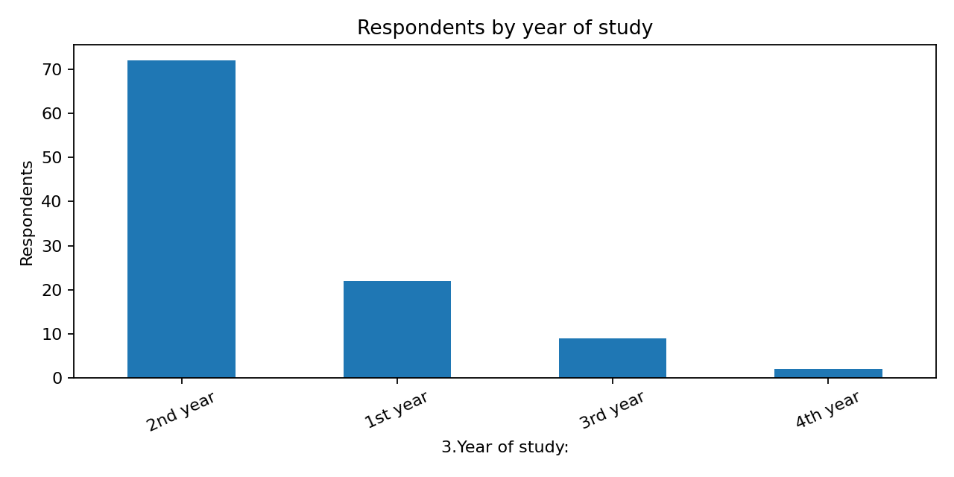
Figure 6.1. Respondents by year of study. Second-year students form the largest group (72/105, 68.6%). This describes sample composition, not population-level AI adoption.

Table 6.2. Department labels as recorded
Category | n | %
Science | 53 | 50.5
Arts | 24 | 22.9
B.Tech | 7 | 6.7
B.E | 7 | 6.7
B com | 2 | 1.9
Commerce | 2 | 1.9
M.tech | 1 | 1.0
Logistics | 1 | 1.0
Mtech cse | 1 | 1.0
MBBS | 1 | 1.0
logistics | 1 | 1.0
Maritime logistics | 1 | 1.0
BBA | 1 | 1.0
Bsc AIML | 1 | 1.0
Management studies | 1 | 1.0
B.com | 1 | 1.0

Department labels are heterogeneous: Science, Arts, Commerce variants, engineering programme labels, management, logistics, and other labels occur. The original PDF summarizes Science as the largest group, followed by Arts and Commerce. A valid department-wise comparison requires a documented harmonization rule before combining programme labels.

Table 6.3. Last-semester academic-performance band
Category | n | %
70-80% | 38 | 36.2
80-90% | 24 | 22.9
Above 90% | 16 | 15.2
60-70% | 16 | 15.2
50-60% | 8 | 7.6
Below 50% | 3 | 2.9

Table 6.4. Current arrears status
Category | n | %
No | 91 | 86.7
Yes | 14 | 13.3

Table 6.5. Frequency of AI use for academics
Category | n | %
Weekly | 41 | 39.0
Daily | 32 | 30.5
Rarely | 31 | 29.5
Never | 1 | 1.0

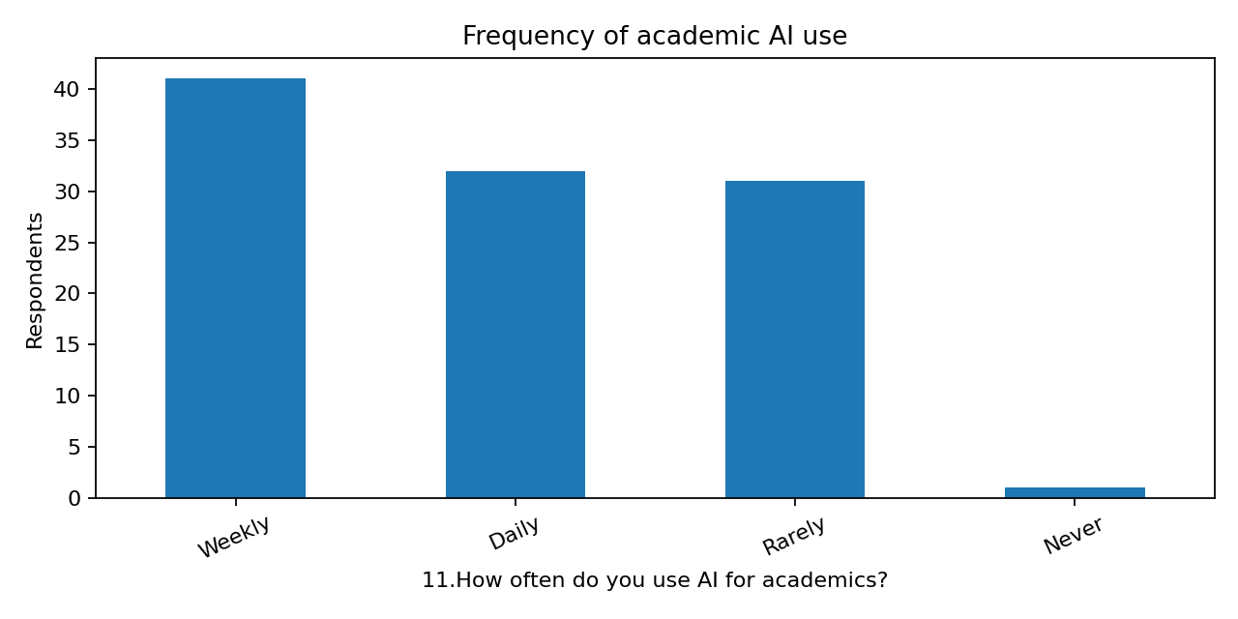
Figure 6.2. Frequency of academic AI use. The spreadsheet records 41 weekly users, 32 daily users, 22 “Rarely” after harmonizing the apparent typo “Rarel,” and one “Never.” The raw file has nine “Rarel” entries and should be cleaned transparently.

Table 6.6. AI dependency level (Q13)
Category | n | %
3 | 55 | 52.4
2 | 25 | 23.8
4 | 15 | 14.3
1 | 8 | 7.6
5 | 2 | 1.9

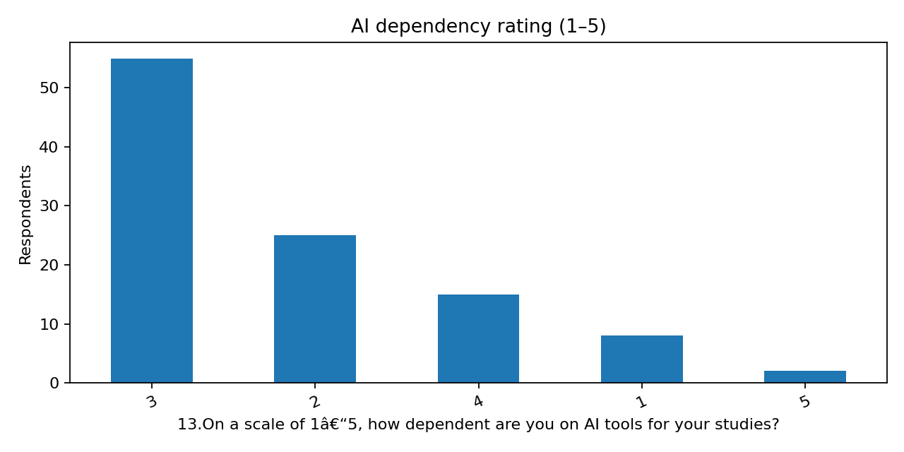
Figure 6.3. AI dependency ratings. The most common response is level 3, moderately dependent (55; 52.4%). Level 2 was selected by 25 (23.8%), level 4 by 15 (14.3%), level 1 by eight (7.6%), and level 5 by two (1.9%).

6.2 Perceived benefits and risks: Likert responses

Table 6.7. Q14: Self-study time without AI has decreased
Category | n | %
Neutral | 53 | 50.5
Agree | 22 | 21.0
Disagree | 20 | 19.0
Strongly disagree | 8 | 7.6
Strongly agree | 2 | 1.9

Table 6.8. Q15: AI improved assignment quality
Category | n | %
Agree | 55 | 52.4
Neutral | 30 | 28.6
Strongly agree | 11 | 10.5
Strongly disagree | 6 | 5.7
Disagree | 3 | 2.9

Table 6.9. Q16: AI positively affected examination performance
Category | n | %
Agree | 43 | 41.0
Neutral | 39 | 37.1
Disagree | 10 | 9.5
Strongly agree | 8 | 7.6
Strongly disagree | 5 | 4.8

Table 6.10. Q17: AI helped in clearing arrears
Category | n | %
Neutral | 45 | 42.9
Agree | 21 | 20.0
Disagree | 16 | 15.2
Strongly disagree | 16 | 15.2
Strongly agree | 7 | 6.7

Table 6.11. Q18: Over-dependence caused academic difficulties
Category | n | %
Neutral | 34 | 32.4
Disagree | 31 | 29.5
Strongly disagree | 18 | 17.1
Agree | 15 | 14.3
Strongly agree | 7 | 6.7

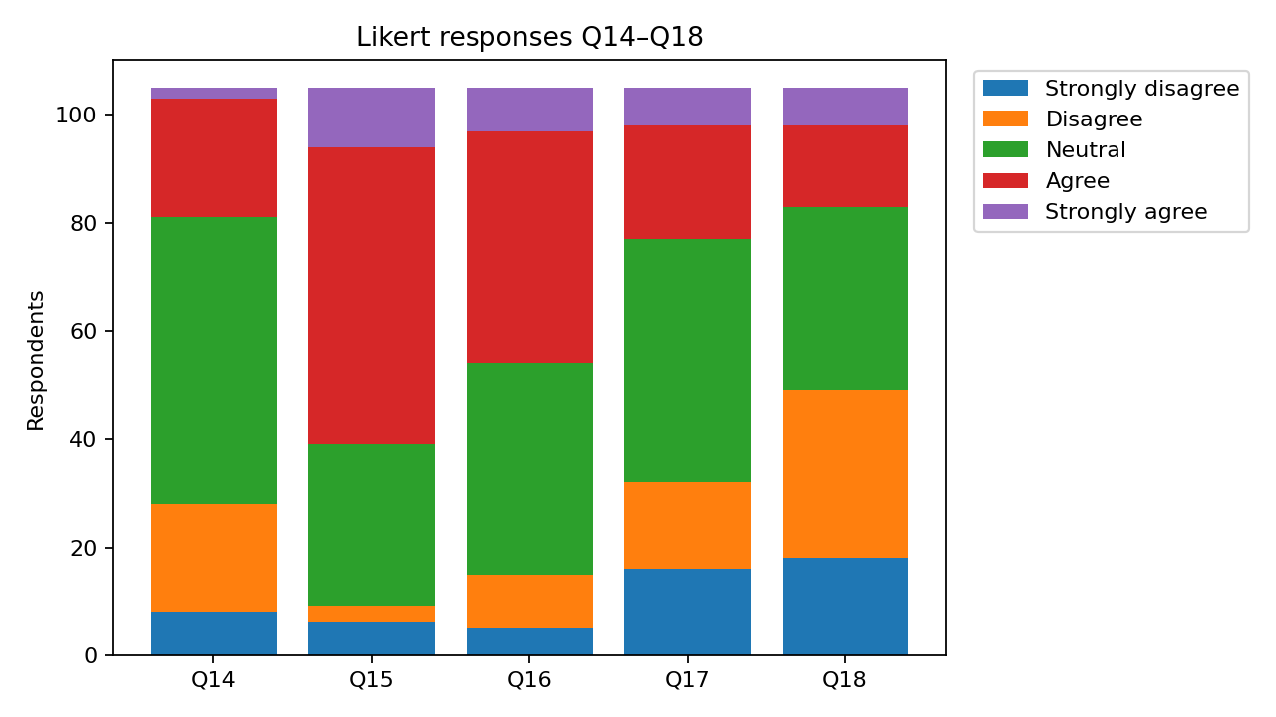
Figure 6.4. Likert responses to Q14–Q18.
For Q15, 66 respondents (62.9%) agreed or strongly agreed that AI improved assignment quality. For Q16, 51 (48.6%) agreed or strongly agreed that AI positively affected examination performance, while 39 (37.1%) were neutral. For Q14, 24 (22.9%) agreed/strongly agreed that self-study time without AI had decreased; 75 (71.4%) were neutral or disagreed/strongly disagreed. For Q18, 22 (21.0%) agreed/strongly agreed that over-dependence caused academic difficulties, 34 (32.4%) were neutral, and 49 (46.7%) disagreed/strongly disagreed.

6.3 Policy preferences and concerns

Table 6.12. Preferred college approach to AI
Category | n | %
Allowing AI with restrictions | 77 | 73.3
Encouraging AI freely | 22 | 21.0
Banning AI completely | 6 | 5.7

Table 6.13. Main concern about AI in academics
Category | n | %
Reduced originality | 40 | 38.1
Over-dependence / loss of self-learning | 31 | 29.5
Misuse / plagiarism issues | 20 | 19.0
Nothing, AI is only helpful | 14 | 13.3

In the supplied spreadsheet, 77 respondents (73.3%) selected allowing AI with restrictions, 22 (21.0%) selected encouraging AI freely, and six (5.7%) selected banning AI completely. This indicates a strong preference within this sample for managed use. The concern table reflects the exact recorded labels.

6.4 Purposes and tools
Q9 is multi-select, so each tool should be split into a binary indicator to estimate tool-specific prevalence. Q12 is labelled “Choose one,” but many records contain multiple semicolon-separated purposes; its raw category distribution is therefore not a valid mutually exclusive distribution. The original PDF identifies assignment writing, coding, exam preparation, project support, and content creation as common purposes. A corrected analysis should count each selected purpose separately and disclose the multi-response denominator.

6.5 Correlation analysis
Correlation describes the direction and strength of association. Pearson’s product–moment coefficient is r = Cov(X,Y)/(sₓsᵧ), where Cov(X,Y) is sample covariance and sₓ and sᵧ are sample standard deviations. It ranges from −1 to +1 and describes linear association. Spearman’s rank coefficient, ρ, is the Pearson correlation between ranks and is often preferable for ordinal variables or monotonic relationships. Neither coefficient implies causation.
Original reported result: the PDF reports r = −0.11 between Q13 (AI dependency) and Q6 (last-semester performance) and calls it a very weak negative relationship. The PDF does not provide the original coding, exact analysis sample, p-value, confidence interval, or full calculation output.
Workbook verification: all 105 supplied records were coded with dependency levels 1–5 and performance bands ranked 1 (Below 50%) to 6 (Above 90%). Under this explicitly stated coding, Pearson r = 0.074 and Spearman ρ = 0.104. These are weak positive associations, not the −0.11 reported in the PDF. This is a material discrepancy. Possible explanations include different data versions, different coding, transcription error, or a different variable pairing; the available evidence does not identify which explanation is correct. The original −0.11 is preserved as the originally reported result but is not independently verified.
Because performance is recorded in broad ordinal bands, Pearson correlation depends on numeric scoring. Spearman respects ordering more directly but is still limited by ties and self-reported data. No significance conclusion is made. The group should verify the original analysis workbook, exact variable pairing, and coding before final submission.

6.6 Factor analysis
Factor analysis summarizes common variation among observed items using a smaller number of latent dimensions. It requires meaningful inter-item correlations and suitable sample/measurement properties. A complete report typically includes extraction method, rotation, KMO, Bartlett’s test, communalities, eigenvalues, explained variance, loading matrix, and item-retention decisions.
The original PDF says Q14–Q18 were analyzed and describes Factor 1, “Academic benefits,” with loadings for assignments (−0.70), exam performance (−0.52), and arrears (−0.45); Factor 2, “Risks and over-dependence,” with arrears (+0.60) and academic difficulties (+0.37). It also describes a heatmap. These values and labels are retained as originally reported, but the complete loading matrix and extraction/rotation details are not available.
Factor signs can be reversed mathematically without changing the substantive solution, so negative loadings do not automatically mean negative importance. Q17 (arrears help) appears in both reported factors with different signs, which should be checked against the original output and item coding. The PDF does not provide enough evidence to confirm the labels or adequacy of the solution. KMO, Bartlett’s test, eigenvalues, explained variance, extraction, rotation, and sample adequacy remain [DETAIL REQUIRED FROM RESEARCHERS].

6.7 Additional suitable analyses (suggested, not claimed as completed)
- Spearman correlation between dependency and performance rank, with sample size, confidence interval or p-value after verification.
- Chi-square test between AI-frequency and performance categories if expected cell counts are adequate; use a justified alternative if sparse.
- Department-by-frequency cross-tabulation after documented department harmonization.
- Mann–Whitney U or Kruskal–Wallis tests for ordinal outcomes across suitable groups.
- Ordinal logistic regression for performance bands if sample size and assumptions permit, potentially adjusting for attendance, year, department, and arrears.
- Qualitative thematic analysis of Q22 using a codebook and anonymized examples.

6.8 Methods summary
Method | Purpose / variables | Appropriateness and limitation
Frequencies/percentages | Describe demographics, frequency, dependency, Likert items, arrears, policy | Appropriate for categories; label inconsistencies and multi-response strings affect counts.
Bar/stacked-bar charts | Show distributions and compare Likert categories | Useful for communication; visual patterns are not inferential evidence.
Pearson correlation | Linear association of coded dependency and performance | Sensitive to ordinal coding; equal spacing is not guaranteed.
Spearman correlation | Monotonic association of ordinal variables | More compatible with ranks; ties and self-report remain limitations.
Factor analysis | Summarize common patterns in Q14–Q18 | Cannot validate without full output and diagnostics.
Chi-square/group tests | Compare categorical variables | Suggested only; expected counts and multiple testing need attention.

CHAPTER 7: INTERPRETATION AND DISCUSSION OF FINDINGS

Step 7: Presenting the Results

7.1 Respondent characteristics
The supplied spreadsheet contains 105 response records. Second year is the largest group (72; 68.6%), followed by first year (22; 21.0%), third year (9; 8.6%), and fourth year (2; 1.9%). Science is the most common recorded department label (53; 50.5%), followed by Arts (24; 22.9%); other records are distributed across several programme labels. These are sample characteristics, not estimates for all students.

7.2 AI-use frequency and dependency
Weekly use is the most frequent category (41 records), followed by daily use (32). Dependency is concentrated at level 3, moderate dependence (55; 52.4%). Frequency and dependency must not be conflated: frequent use does not necessarily mean reliance, and moderate use does not guarantee independence.

7.3 Perceived benefits
A majority agreed or strongly agreed that AI improved assignment quality (66; 62.9%). The corresponding proportion for positive examination performance was lower (51; 48.6%), and 39 respondents (37.1%) were neutral. Respondents therefore report clearer perceived benefits for assignment quality than for examination outcomes. These are perceptions, not independently verified grade changes.

7.4 Study habits and risks
Only 24 respondents (22.9%) agreed or strongly agreed that self-study time without AI had decreased, while the majority were neutral or disagreed. On over-dependence causing academic difficulties, 22 (21.0%) agreed/strongly agreed, 34 (32.4%) were neutral, and 49 (46.7%) disagreed/strongly disagreed. The responses do not show a uniform perception that AI reduces self-study or causes difficulties. The survey does not objectively measure study time or critical thinking.

7.5 Arrears and policy
The spreadsheet records 14 respondents with current arrears and 91 without. Q17 responses are mixed: 28 agreed/strongly agreed that AI helped clear arrears, 45 were neutral, and 32 disagreed/strongly disagreed. Because the arrears group is small and Q17 measures perceived help, any subgroup comparison requires caution. Most respondents preferred allowing AI with restrictions (77; 73.3%).

Step 8: Interpreting the Findings
The descriptive evidence indicates that students use AI for academic purposes and often perceive assignment-related benefits. Perceived examination benefits are less clear, and responses about self-study and over-dependence are mixed. The evidence supports a balanced interpretation rather than a categorical claim that AI necessarily improves or damages performance.
If verified, the original r = −0.11 would indicate a very weak negative association. However, the supplied spreadsheet yields weak positive coefficients under the stated ordinal coding. Until reconciled, the direction of the association remains unverified. Neither the original nor workbook-based coefficient establishes causation.
Self-reported improvement in assignments or exam preparation is not equivalent to measured improvement in marks. Grades may also reflect prior achievement, attendance, subject difficulty, effort, and assessment design, which this study cannot isolate.

Step 9: Discussing the Findings
Perceived benefits align with opportunities discussed by Kasneci et al. (2023), Lo (2023), and Tlili et al. (2023), including explanation, feedback, and support for academic tasks. The assignment-quality responses are compatible with the positive average achievement effect reported by Sun and Zhou (2024), but direct comparison is limited: the meta-analysis synthesizes intervention studies, while this project records perceptions and observational associations.
Mixed responses about self-study and over-dependence are consistent with the balanced approach advocated by Kasneci et al. (2023) and UNESCO (2023): value depends partly on how tools are used, whether outputs are checked, and whether students remain actively engaged. This survey does not measure critical thinking objectively, so it cannot establish that AI has reduced those skills.
The strong preference for restricted AI use is consistent with Chan’s (2023) framework, which emphasizes pedagogy, governance, and operational support, and with Cotton et al.’s (2024) discussion of academic integrity. Institutions can state allowed/prohibited uses, require acknowledgement where appropriate, and redesign assessments to evaluate reasoning and process rather than relying only on detection tools.
The project contributes a context-specific dataset combining usage, dependency, performance bands, perceptions, and policy preferences. A central statistical issue is that the original −0.11 correlation is not reproduced from the supplied spreadsheet under straightforward ordinal coding. Resolving this discrepancy is essential before the correlation is finalized.

CHAPTER 8: LIMITATIONS OF THE STUDY

Step 10: Stating the Limitations
Limitation | Effect | Suggested improvement
Sampling method and response rate undocumented | Representativeness and selection bias cannot be evaluated. | Record frame, recruitment, number invited, response rate, and eligibility.
105 spreadsheet rows but no sample-size statement in PDF | Original denominator and analysis sample cannot be confirmed. | Reconcile final dataset and report exclusions.
Self-reported use, perceptions, attendance and grades | Recall/social-desirability bias may affect responses. | Use verified records with consent and validated measures where feasible.
Performance is a broad band; metric says marks/CGPA | Information is lost and intervals are unclear. | Specify marks or CGPA and use consistent bands or exact values.
Cross-sectional survey | Temporal order and causality cannot be established. | Use longitudinal or experimental/quasi-experimental designs.
Potential confounding by prior achievement, subject, attendance, effort | Associations may reflect other variables. | Collect pre-specified covariates and use appropriate models.
Inconsistent labels and Q12 multiple selections | Counts and comparisons may be misclassified. | Use a documented codebook and preserve raw/clean versions.
Correlation mismatch: PDF −0.11 vs workbook Pearson +0.074/Spearman +0.104 | Direction is not verified. | Reproduce the original calculation from original data and coding.
Incomplete factor-analysis output | Adequacy and factor labels cannot be assessed independently. | Obtain extraction, rotation, KMO, Bartlett, eigenvalues, variance, communalities and loadings.
Direct identifiers in raw workbook | Respondents may be identifiable. | Restrict access and anonymize analysis files.

Some limitations are directly evidenced in the supplied files; others, such as social-desirability bias and confounding, are potential limitations inherent in the survey design and are not asserted as proven defects.

CHAPTER 9: CONCLUSION, RECOMMENDATIONS, AND FUTURE RESEARCH

Step 11: Drawing Conclusions and Making Recommendations

9.1 Conclusion
The project aimed to describe AI-tool use among college students, examine the relationship between dependency and academic performance, document perceived benefits and risks, and identify preferred institutional approaches. The spreadsheet includes 105 records across years and departments. The largest group is second-year students, and the most common dependency response is moderate dependence. Respondents report stronger perceived benefits for assignment quality than examination performance. Views about reduced self-study and over-dependence are mixed, while nearly three-quarters prefer allowing AI with restrictions.
The correlation finding requires caution. The original PDF reports a very weak negative correlation of −0.11, but a fresh calculation from the spreadsheet using explicitly stated ordinal coding yields weak positive coefficients. This discrepancy cannot be resolved from the available evidence. The original coefficient must remain labelled as the original report’s result and the workbook-based coefficients as a verification check. No statistically significant or causal effect is established.
Overall, respondents perceive AI as useful for some academic tasks, but the survey does not demonstrate that AI use causes improved achievement or that dependency causes lower achievement. The value of the study is in documenting student perspectives, highlighting balanced use, and identifying the need for reproducible statistical reporting.

9.2 Recommendations

For students
- Use AI to explain concepts, generate practice questions, receive feedback, and identify gaps—not to replace reading, reasoning, or problem-solving.
- Verify important claims with textbooks, lecture materials, peer-reviewed sources, and official references.
- Write final submissions in your own words and disclose AI assistance where institutional rules require it.
- Practice solving problems without AI before examinations to check independent mastery.

For teachers and departments
- State which uses are permitted, restricted, or prohibited for each assignment and assessment.
- Design assessments with process evidence, oral explanation, drafts, in-class work, and reflection on AI-output evaluation.
- Teach students to verify hallucinations, identify bias, protect personal data, and cite sources accurately.
- Do not treat AI-detection scores alone as proof of misconduct; use transparent procedures and human review.

For the college
- Develop an AI policy covering pedagogy, governance, and operations, including privacy, accountability, disclosure, and equitable access.
- Offer AI-literacy workshops and discipline-specific examples of acceptable use.
- Encourage balanced use rather than blanket claims that AI is always beneficial or harmful.
- Protect survey data by removing identifiers from analysis copies and limiting access to raw files.

For future survey design and analysis
- Pilot-test the questionnaire and align response formats with labels (single choice versus multiple response).
- Define performance precisely and, with consent, use objective marks/CGPA or consistently specified bands.
- Document sampling, recruitment, eligibility, response rate, missing-data rules, and duplicate checks.
- Publish a codebook and reproducible output; report denominators, effect sizes, confidence intervals, and p-values when inferential tests are run.
- Use Spearman correlation for ordinal association as a primary or sensitivity analysis; use regression only when sample size and assumptions support it.

9.3 Future research
Future studies should recruit larger and more representative samples across colleges, disciplines, and regions; follow students over time; and use common assessment measures. Where feasible and ethical, research could compare AI-supported learning with well-defined alternatives. Studies should distinguish frequency, purpose, prompting quality, verification behaviour, dependency, self-regulated learning, and objective achievement rather than combining them into a single “AI use” measure. Interviews could explore why students choose tools and how they decide when to trust outputs.

Step 12: Providing References and Appendices

References (APA 7th edition)
Adewale, M. D., Azeta, A., Abayomi-Alli, A., & Sambo-Magaji, A. (2024). Impact of artificial intelligence adoption on students’ academic performance in open and distance learning: A systematic literature review. Heliyon, 10(22), e40025. https://doi.org/10.1016/j.heliyon.2024.e40025
Chan, C. K. Y. (2023). A comprehensive AI policy education framework for university teaching and learning. International Journal of Educational Technology in Higher Education, 20, Article 38. https://doi.org/10.1186/s41239-023-00408-3
Cotton, D. R. E., Cotton, P. A., & Shipway, J. R. (2024). Chatting and cheating: Ensuring academic integrity in the era of ChatGPT. Innovations in Education and Teaching International, 61(2), 228–239. https://doi.org/10.1080/14703297.2023.2190148
Kasneci, E., Sessler, K., Küchemann, S., Bannert, M., Dementieva, D., Fischer, F., Gasser, U., Groh, G., Günnemann, S., Hüllermeier, E., Krusche, S., Kutyniok, G., Michaeli, T., Nerdel, C., Pfeffer, J., Poquet, O., Sailer, M., Schmidt, A., Seidel, T., ... Kasneci, G. (2023). ChatGPT for good? On opportunities and challenges of large language models for education. Learning and Individual Differences, 103, 102274. https://doi.org/10.1016/j.lindif.2023.102274
Lo, C. K. (2023). What is the impact of ChatGPT on education? A rapid review of the literature. Education Sciences, 13(4), 410. https://doi.org/10.3390/educsci13040410
Sun, L., & Zhou, L. (2024). Does generative artificial intelligence improve the academic achievement of college students? A meta-analysis. Journal of Educational Computing Research, 62(7), 1676–1713. https://doi.org/10.1177/07356331241277937
Tlili, A., Shehata, B., Adarkwah, M. A., Bozkurt, A., Hickey, D. T., Huang, R., & Agyemang, B. (2023). What if the devil is my guardian angel: ChatGPT as a case study of using chatbots in education. Smart Learning Environments, 10, Article 15. https://doi.org/10.1186/s40561-023-00237-x
UNESCO. (2023). Guidance for generative AI in education and research. UNESCO. https://www.unesco.org/en/articles/guidance-generative-ai-education-and-research
Zawacki-Richter, O., Marín, V. I., Bond, M., & Gouverneur, F. (2019). Systematic review of research on artificial intelligence applications in higher education—Where are the educators? International Journal of Educational Technology in Higher Education, 16, Article 39. https://doi.org/10.1186/s41239-019-0171-0

APPENDICES

Appendix A: Original questionnaire
[APPENDIX REQUIRED FROM RESEARCHERS] The spreadsheet contains response fields for 22 questionnaire items, but a separate original Google Forms questionnaire/export was not provided. Insert the exact original questionnaire here; do not reconstruct it as though it were the original.

Appendix B: Variable dictionary and coding scheme
See Table 5.1 in Chapter 5. Add a complete codebook with response options, missing-value conventions, and multi-response splitting rules. Confirm the exact coding used in the original correlation.

Appendix C: Supplementary statistical tables
Descriptive distributions are provided in Chapter 6. Add an anonymized cross-tabulation of dependency by performance category after the original correlation discrepancy is resolved.

Appendix D: Detailed calculations and output
The workbook-based check codes dependency 1–5 and performance bands 1–6. Pearson r = 0.074; Spearman ρ = 0.104; n = 105 paired records. These are coding-dependent exploratory results. [APPENDIX REQUIRED FROM RESEARCHERS] Add the original software output that produced r = −0.11, including variable names, coding, sample size, and inferential statistics if calculated.

Appendix E: Additional graphs
Figures 6.1–6.4 were generated from the supplied spreadsheet and embedded in this report. Department-wise graphs should be finalized only after programme labels have been harmonized using a documented rule.

Appendix F: Methodological documentation
[DETAIL REQUIRED FROM RESEARCHERS] Add Google Forms export date, recruitment text, consent statement, inclusion/exclusion criteria, duplicate/missing-data audit, software versions, factor-analysis settings, and ethics or supervisor approval documentation.

MISSING-INFORMATION CHECKLIST FOR THE RESEARCH GROUP
- Confirm that the supplied spreadsheet is the final dataset used to produce the original PDF and explain any version differences.
- Provide sampling technique, sampling frame, recruitment channels, inclusion/exclusion criteria, number invited, and response rate.
- Provide the exact Google Forms questionnaire/export, including the wording and response options for Q1–Q22.
- Resolve the correlation discrepancy: PDF reports −0.11, but workbook-based ordinal coding gives Pearson r = 0.074 and Spearman ρ = 0.104. Confirm variable pairing, coding, missing-data handling, and original software output.
- Provide full factor-analysis output: extraction method, rotation, KMO, Bartlett’s test, eigenvalues, explained variance, communalities, complete loading matrix, and item coding.
- Confirm whether Q12 was single-select or multiple-select; the spreadsheet contains multiple selections in many records.
- Clarify whether Q6 records marks percentage, CGPA bands, or a mixture; define each band precisely.
- Document whether incomplete/duplicate records were removed and supply an exclusion log; the current workbook has two missing device entries and one missing open-ended response.
- Provide pilot testing, questionnaire validation, consent wording, and any ethics/supervisor approval information.
- Confirm software used for correlation, factor analysis, and original graphs, including versions where available.
- Remove direct identifiers from the analysis copy and confirm how respondent privacy was protected.
- Verify certificate wording and obtain supervisor/department signatures before submission.

CHANGE LOG
Area | Change made
Preserved | Original title, college/department, October 2025 date, five students and registration numbers, supervisor, six original objectives, Google Forms framing, PDF’s −0.11 correlation, reported factor labels/loadings, preventive measures, future scope, and broad conclusion.
Expanded | Research problem, operational definitions, literature review, research gap, conceptual framework, questions/hypotheses mapping, methodology, variable dictionary, data preparation, results, discussion, limitations, recommendations, references, and appendices.
Added from workbook | Used 105 response rows for descriptive distributions and charts; summarized year, department labels, performance bands, arrears, AI frequency, dependency, Likert items, policy preference, and concerns.
Statistical caution | Disclosed that workbook-based correlation under stated ordinal coding differs in direction from the PDF’s −0.11. No significance or causality claims were made. Factor-analysis output is marked incomplete.
Left unverified | Sampling technique, response rate, exact questionnaire, exclusion log, original coding, inferential output, factor diagnostics, consent/ethics documentation, and whether the spreadsheet exactly matches the PDF analysis dataset.

