LOYOLA COLLEGE AUTONOMOUS
DEPARTMENT OF STATISTICS

RESEARCH REPORT

ASSOCIATION OF SCREEN TIME AND SLEEP QUALITY WITH DIGITAL EYE STRAIN AND SELF-REPORTED HAIR LOSS AMONG COLLEGE STUDENTS: A CROSS-SECTIONAL STUDY

Submitted by
MOHAMMED DHAQIB MH
Register Number: 24-UST-046

Loyola College Autonomous, Chennai

ABSTRACT
This cross-sectional study examines the association of screen time and sleep-related measures with digital eye strain and self-reported hair loss among college students. The analysis uses a supplied Excel dataset containing 150 respondent records and 29 variables. The questionnaire covers demographic characteristics, daily screen exposure, device use before bedtime, screen breaks, sleep duration and perceived sleep quality, eye-strain frequency and symptoms, self-reported hair loss, family history, stress, exercise, diet, hydration, and opinions about possible effects.
Descriptive analysis showed that 60 respondents (40.0%) reported 4–6 hours of daily screen time, while 20 (13.3%) reported more than eight hours. The most common sleep-duration category was 6–7 hours (64; 42.7%). Digital eye strain was reported as “Often” by 84 respondents (56.0%); 52 (34.7%) selected moderate hair loss and 36 (24.0%) severe hair loss. These are self-reported categories, not clinical assessments.
Spearman rank correlation using explicitly defined ordinal coding showed a moderate positive association between screen-time category and eye-strain frequency (ρ = 0.504, p < .001). Sleep-duration category was weakly inversely associated with hair-loss category (ρ = -0.183, p = 0.025); screen time and hair-loss category were not associated in the rank analysis (ρ = 0.024, p = 0.770). Exploratory multiple linear regression with ordinal scores found screen-time category to be associated with the eye-strain score after adjustment for sleep duration (coefficient = 0.348, robust p < .001; R² = 0.219). The hair-loss model explained little variation (R² = 0.040); sleep duration had a small negative coefficient.
The findings are observational and coding-dependent. Several contingency tables contain sparse expected counts, and the dataset has four missing symptom entries—different from the 28 symptom values described in the presentation. These issues limit inference. The study supports cautious discussion of associations, not claims that screen time or sleep causes eye strain or hair loss.
Keywords: screen time; sleep quality; digital eye strain; self-reported hair loss; college students; cross-sectional study; Spearman correlation; regression.

TABLE OF CONTENTS
Section | Page
Abstract | 2
Chapter 1: Introduction and identification of the research problem | 4
Chapter 2: Review of literature and conceptual framework | 6
Chapter 3: Objectives, research questions and hypotheses | 8
Chapter 4: Research methodology | 9
Chapter 5: Data collection, organization and preparation | 10
Chapter 6: Descriptive and statistical analysis | 11–19
Chapter 7: Interpretation and discussion | 20
Chapter 8: Limitations of the study | 21
Chapter 9: Conclusion, recommendations and future research | 22
References | 23
Appendices | 24

List of Tables
Table 5.1 Data quality and missingness audit; Table 6.1 Respondent profile; Table 6.2 Screen-time and sleep distributions; Table 6.3 Eye-strain and hair-loss distributions; Table 6.4 Chi-square tests; Table 6.5 Spearman rank correlations; Table 6.6 Regression models.

List of Figures
Figure 1 Respondents by gender; Figure 2 Daily screen-time category; Figure 3 Nightly sleep duration; Figure 4 Reported digital eye strain; Figure 5 Self-reported hair-loss category; Figure 6 Screen-time category by eye-strain frequency.

Abbreviations
CGPA — Cumulative Grade Point Average; DES — Digital Eye Strain; OLS — Ordinary Least Squares; SD — Standard Deviation; χ² — Pearson chi-square statistic; ρ — Spearman rank correlation coefficient.

CHAPTER 1: INTRODUCTION AND IDENTIFICATION OF THE RESEARCH PROBLEM

1.1 Background
Digital devices are central to college learning, communication, entertainment and administration. Students may use smartphones, laptops, tablets and desktop computers for online classes, reading, assignments, research, social interaction and leisure. Screen exposure can be accompanied by visual discomfort, including tired eyes, dryness, burning, blurred vision and headache. The term digital eye strain (DES), also called computer vision syndrome in parts of the literature, describes a collection of symptoms associated with prolonged visual display use and viewing conditions.
Sleep is another important dimension of student well-being. Sleep duration, bedtime, perceived sleep quality and the feeling of being refreshed are related but distinct measures. Evening device use may displace time available for sleep or be associated with delayed bedtime. However, a questionnaire-based cross-sectional survey cannot determine whether screen exposure precedes a sleep problem or whether students with different routines use screens differently.
Hair loss is a complex, multifactorial concern. It can be influenced by hereditary patterns, health conditions, nutritional factors, medications, physiological changes and stress. Self-reported hair shedding or hair-loss severity is not equivalent to a dermatological diagnosis. In this project, hair loss is treated as a self-reported outcome and not as a condition caused by screen exposure.

1.2 Research problem
The study addresses the need to describe screen-use and sleep patterns among college students and to examine whether these reported patterns are associated with digital eye strain and self-reported hair loss. The research is exploratory: it summarizes the available sample and evaluates selected associations while acknowledging the limitations of self-report, categorical coding and cross-sectional design.

CHAPTER 1: RESEARCH PROBLEM (CONTINUED)

1.3 Rationale and significance
Understanding students’ everyday device habits and perceived symptoms can help identify topics for health education, ergonomic awareness and further research. Describing these responses may also show whether simple habits—such as regular breaks, avoiding device use immediately before bed, and maintaining consistent sleep routines—are worth discussing with students. The report does not assess clinical treatment or establish that any habit will prevent hair loss.

1.4 Aim
To investigate the association of screen time and sleep quality with digital eye strain and self-reported hair loss among college students.

1.5 Scope of the study
The analysis is restricted to the 150 records in the supplied workbook. It considers the questionnaire variables available in that file, with particular focus on daily screen-time category, sleep duration, perceived sleep quality, eye-strain frequency and self-reported hair-loss category. The results describe this dataset only; the sampling frame and recruitment process are not documented sufficiently to claim population representativeness.

1.6 Operational definitions
Term | Operational meaning in this report
Screen time | Ordinal category of reported daily digital-device use: <2, 2–4, 4–6, 6–8, or >8 hours.
Sleep duration | Ordinal category of reported nightly sleep: <5, 5–6, 6–7, 7–8, or >8 hours.
Sleep quality | Self-rating from Very Poor through Excellent; not a validated clinical sleep scale.
Digital eye strain | Self-reported frequency category recorded as Rarely, Sometimes, or Often in the workbook.
Hair loss | Self-reported category: No, Mild, Moderate, or Severe hair loss.
Cross-sectional | A single dataset snapshot; associations can be studied, but temporal order and causality cannot be established.

CHAPTER 2: REVIEW OF LITERATURE AND CONCEPTUAL FRAMEWORK

2.1 Digital eye strain and screen exposure
Digital eye strain is generally discussed as a group of visual and ocular symptoms related to digital-screen viewing. The literature distinguishes symptoms that may be associated with ocular surface dryness from those related to focusing demands, visual conditions, posture, viewing distance and duration. Because symptom definitions and measurement instruments differ between studies, prevalence estimates should not be transferred uncritically between populations.
Mataftsi and colleagues (2023) reviewed studies of digital eye strain among younger screen users. Their systematic review included ten studies and reported that screen use exceeding roughly four to five hours per day and poor ergonomic conditions were associated with higher symptom scores in some included studies. The authors also noted heterogeneity and limitations in the underlying evidence. This supports examining screen time and symptoms in student populations, while cautioning that duration alone may not explain all individual differences.
The present questionnaire includes eye-strain frequency, symptoms, headaches and tired eyes during or after online classes or study. It does not appear to use a validated diagnostic instrument, and the workbook’s eye-strain frequency variable contains only three observed categories. Findings therefore refer to the questionnaire response rather than a formal DES diagnosis.

2.2 Measurement considerations
Self-report can be useful for describing perceived discomfort, but it may be affected by recall, interpretation and response style. A single broad frequency question may not capture symptom intensity, duration, functional impact, screen distance, lighting, refractive error, contact-lens use or breaks. Future research should consider validated symptom scales and standardized questions about viewing conditions.

CHAPTER 2: REVIEW OF LITERATURE (CONTINUED)

2.3 Screen time and sleep
Screen use and sleep may be related through several pathways, including bedtime displacement, cognitive or emotional stimulation, notifications and light exposure. The relationship is not necessarily one-directional: students experiencing sleep difficulties may also spend more time on devices. The supplied study records nightly sleep duration, bedtime, perceived sleep quality, waking refreshed and use of digital devices within 30 minutes before bed. These indicators offer a broad description but do not constitute a validated sleep-quality instrument.
Li and colleagues (2020) synthesized studies of mobile-phone addiction and several mental-health outcomes among college students, including sleep quality. Their findings support the broader relevance of digital-device behaviours to student well-being, but mobile-phone addiction is not identical to total screen time and should not be treated as the same exposure. This distinction matters when interpreting the present project.

2.4 Hair loss and stress
Hair loss can have several causes and requires clinical assessment to determine type and cause. Reviews of telogen effluvium describe physiological and psychological stress among possible precipitants while emphasizing the complexity of diagnosis and causation. Asghar and colleagues (2020) review telogen effluvium and its multiple potential triggers. The present workbook includes perceived stress, family history and self-reported hair loss, but lacks clinical examination, medical history, laboratory information and a validated hair-loss assessment. It therefore cannot identify the cause of a respondent’s hair loss.

2.5 Research gap and conceptual framework
The practical gap addressed here is descriptive: how screen-time and sleep categories co-occur with reported eye strain and hair loss in the available student sample. The conceptual framework treats screen time and sleep measures as exposures or correlates, with eye-strain frequency and self-reported hair-loss category as outcomes. Stress, family history, device habits, breaks, exercise, diet and hydration are relevant contextual variables but are not all included in the main regression models.

CHAPTER 3: OBJECTIVES, RESEARCH QUESTIONS AND HYPOTHESES

3.1 General objective
To examine the association of screen time and sleep-related measures with digital eye strain and self-reported hair loss among college students using descriptive statistics and selected inferential methods.

3.2 Specific objectives
• Describe the demographic and academic profile of respondents.
• Summarize daily screen time, device use, screen breaks, bedtime habits, sleep duration and perceived sleep quality.
• Describe the distribution of self-reported digital eye strain, associated symptoms and hair-loss categories.
• Examine the association between screen-time category and eye-strain frequency.
• Examine the associations of sleep duration and screen time with self-reported hair-loss category.
• Use Spearman rank correlation to describe monotonic relationships between ordinal study variables.
• Fit exploratory multiple linear regression models for ordinal-coded eye-strain and hair-loss outcomes.
• Discuss limitations and make recommendations for improved measurement and future study.

3.3 Research questions
RQ1: What screen-time and sleep patterns are reported by the respondents? RQ2: Is screen-time category associated with reported eye-strain frequency? RQ3: Are sleep duration and screen-time categories associated with self-reported hair-loss category? RQ4: What monotonic relationships appear among screen time, sleep duration, sleep quality, eye strain and hair loss?

3.4 Hypotheses
For screen time and eye strain: H₀: the two categorical variables are independent. H₁: they are associated. For sleep duration and hair loss: H₀: the variables are independent. H₁: they are associated. Similar independence hypotheses can be formulated for screen time and hair loss and for sleep duration and eye strain. A significance level of 0.05 is used as a reference, but interpretation also considers sparse expected counts and coding limitations.
For ordinal correlation, the null hypothesis is that the population Spearman correlation is zero. For regression, the joint null is that both predictor coefficients are zero. These analyses are exploratory because ordinal categories are treated as scores and the outcome scales are not validated continuous measurements.

CHAPTER 4: RESEARCH METHODOLOGY

4.1 Research design
The study uses a quantitative, questionnaire-based, cross-sectional design. The supplied workbook contains 150 rows and 29 columns. The design supports description and association analysis but cannot establish temporal order, estimate causal effects or diagnose medical conditions.

4.2 Population and sample
The intended population is college students. The available analysis sample comprises 150 records in the Excel file. Respondents range in age from 17 to 25 years. The workbook lists multiple colleges and academic streams. The exact sampling frame, recruitment procedure, eligibility criteria, number invited and response rate were not provided; the sample should not be described as random or representative.

4.3 Instrument and variables
The questionnaire content in the project presentation is organized into demographic details, screen time, sleep quality, digital eye strain, hair loss, lifestyle and opinions. The workbook adds fields for college, stream, current study level, year and CGPA. Main analytical variables include ScreenHours, SleepHours, SleepQuality, EyeStrain and HairLoss.

4.4 Statistical methods
Frequencies and percentages summarize categorical variables. Pearson chi-square tests evaluate independence in contingency tables. Spearman rank correlation is used for monotonic associations among ordinal-coded variables. Two exploratory ordinary least-squares models predict ordinal-coded eye-strain and hair-loss scores from screen-time and sleep-duration scores. HC3 heteroskedasticity-robust standard errors are reported for the regression coefficients. The ordinal scores are analyst-defined and must not be interpreted as equal-interval clinical scales.

4.5 Ethics and confidentiality
No consent statement or ethics approval documentation was supplied. The report does not include individual-level records or direct identifiers. Before submission, the researcher should confirm the consent and data-protection process with the project guide and institution.

CHAPTER 5: DATA COLLECTION, ORGANIZATION AND PREPARATION

5.1 Dataset audit
The workbook was read as a single worksheet with 150 rows and 29 columns. A full-row duplicate check identified 0 exact duplicate rows. The dataset contains 4 blank cells, all in the Symptoms field. This differs from the project presentation, which states that 28 symptom values were missing and replaced with “None.” The supplied workbook therefore appears to be a different version or to have been processed differently; this discrepancy is retained as a data-quality note rather than silently reconciled.
Audit item | Finding | Action / interpretation
Rows / columns | 150 rows; 29 columns | All rows retained for the analyses shown.
Exact duplicate rows | 0 | No exact duplicate records detected.
Missing cells | 4 | All four blanks occur in Symptoms.
Gender labels | “Female ” appears with trailing spaces | Whitespace trimmed for frequency summaries.
Eye-strain categories | Rarely, Sometimes, Often | No Never or Always values appear in the workbook.
Symptoms field | Multiple symptom combinations; 4 blank entries | Not used in primary inferential models; blanks not imputed.

5.2 Data cleaning and coding
The original response labels were retained for descriptive tables. Trailing whitespace in the Gender field was standardized. For Spearman correlation and exploratory regression only, categories were assigned ordered scores: screen time <2=1, 2–4=2, 4–6=3, 6–8=4, >8=5; sleep duration <5=1, 5–6=2, 6–7=3, 7–8=4, >8=5; eye strain Rarely=1, Sometimes=2, Often=3; hair loss No=1, Mild=2, Moderate=3, Severe=4; sleep quality Very Poor=1 through Excellent=5.
These scores impose an ordering, not equal distances between categories. Regression results are consequently exploratory and should be interpreted alongside the categorical analysis. Symptoms are multi-response text and were not forced into a single category.

CHAPTER 6: DESCRIPTIVE AND STATISTICAL ANALYSIS

6.1 Respondent profile
The dataset includes 150 respondents. Ages range from 17 to 25 years (mean = 21.09; SD = 2.64; median = 21). There are 98 female respondents (65.3%) and 52 male respondents (34.7%) after trimming whitespace in the labels. Science students account for 89 respondents (59.3%), and Arts students account for 61 (40.7%).
Characteristic | Category | Frequency | Percentage
Gender | Female | 98 | 65.3%
 | Male | 52 | 34.7%
Stream | Science | 89 | 59.3%
 | Arts | 61 | 40.7%
Current study level | UG | 115 | 76.7%
 | PG | 29 | 19.3%
 | Others | 6 | 4.0%
Year | I Year | 35 | 23.3%
 | II Year | 40 | 26.7%
 | III Year | 39 | 26.0%
 | PG | 36 | 24.0%

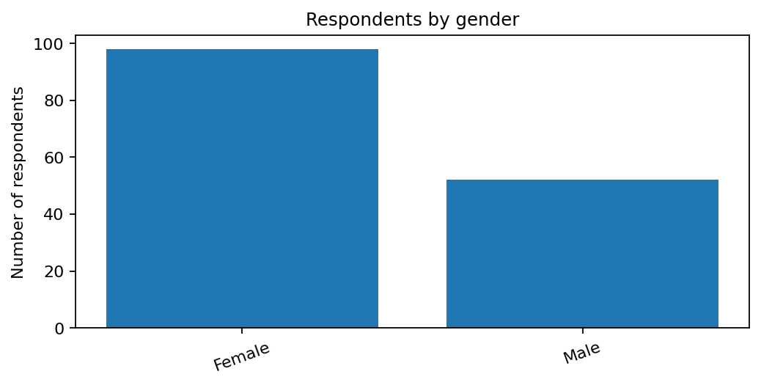
Figure 1. Respondents by gender (n = 150).
The largest study-level group is undergraduate (76.7%). The year variable uses “PG” as one of its categories, so its labels may not align exactly with a conventional year-of-study classification. This original label is retained rather than reclassified without confirmation.

CHAPTER 6: SCREEN TIME AND SLEEP PATTERNS

6.2 Daily screen time
Daily screen time | Frequency | Percentage
4-6 | 60 | 40.0%
2-4 | 31 | 20.7%
6-8 | 30 | 20.0%
>8 | 20 | 13.3%
<2 | 9 | 6.0%

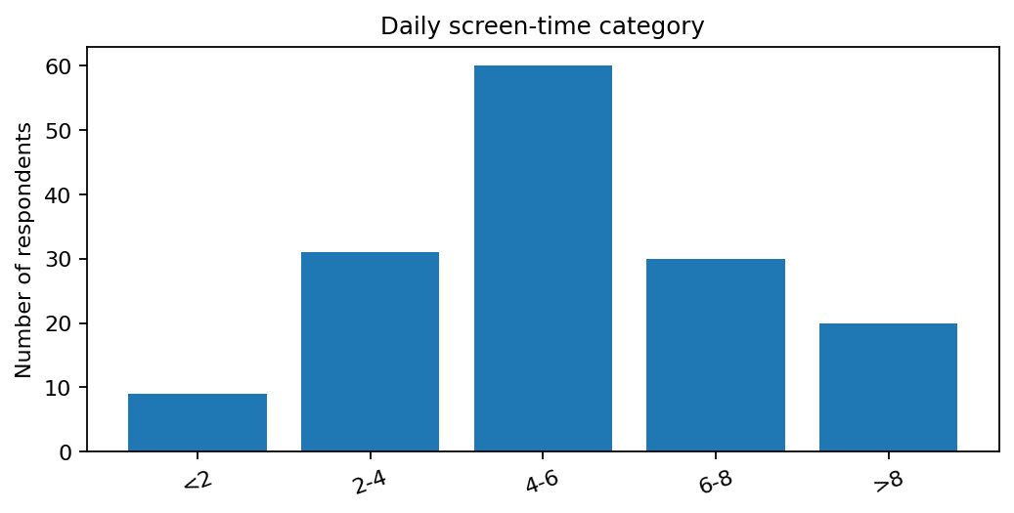
Figure 2. Distribution of daily screen-time categories.
The most frequent category is 4–6 hours (60 respondents; 40.0%). A further 50 respondents (33.3%) reported at least six hours per day, comprising 30 in the 6–8 hour category and 20 above eight hours. These are broad self-reported categories rather than device-logged exposure.

6.3 Nightly sleep duration
Sleep duration | Frequency | Percentage
6-7 | 64 | 42.7%
5-6 | 36 | 24.0%
7-8 | 29 | 19.3%
<5 | 15 | 10.0%
>8 | 6 | 4.0%

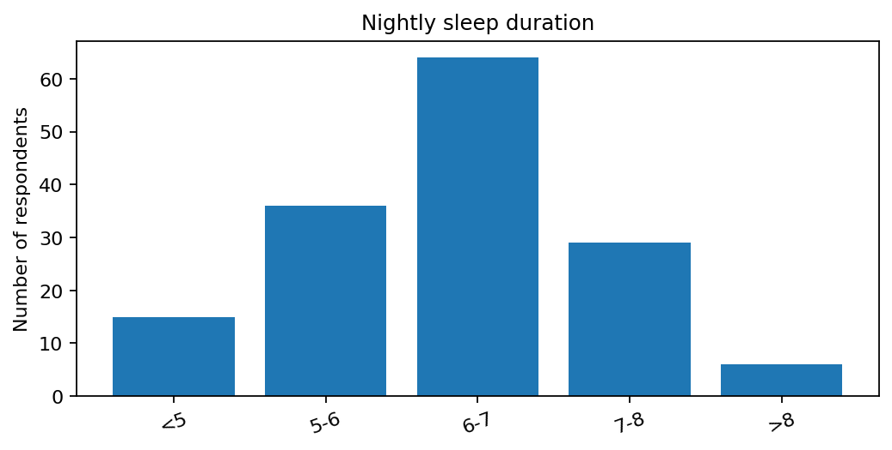
Figure 3. Distribution of reported nightly sleep duration.
The most common sleep-duration category is 6–7 hours (64; 42.7%). Fifteen respondents (10.0%) reported less than five hours, while six (4.0%) reported more than eight hours. The grouped response options prevent calculation of exact mean sleep duration.

CHAPTER 6: EYE STRAIN, HAIR LOSS AND LIFESTYLE

6.4 Digital eye strain
Eye-strain frequency | Frequency | Percentage
Often | 84 | 56.0%
Rarely | 38 | 25.3%
Sometimes | 28 | 18.7%

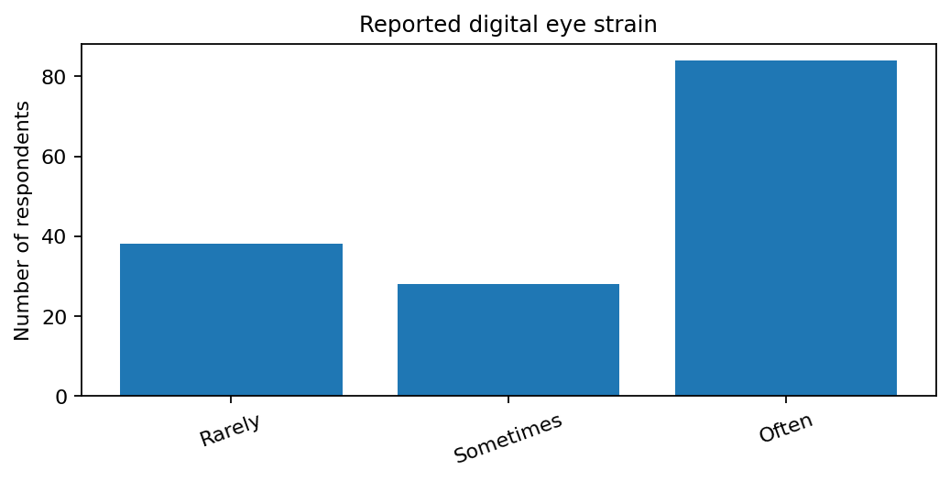
Figure 4. Reported digital eye-strain frequency.
“Often” is the most frequent response (84; 56.0%), followed by “Rarely” (38; 25.3%) and “Sometimes” (28; 18.7%). The workbook does not contain the “Never” or “Always” response categories described in the presentation. This is an important discrepancy in the source materials.

6.5 Self-reported hair loss
Hair-loss category | Frequency | Percentage
Moderate hair loss | 52 | 34.7%
Severe hair loss | 36 | 24.0%
Mild hair loss | 36 | 24.0%
No hair loss | 26 | 17.3%

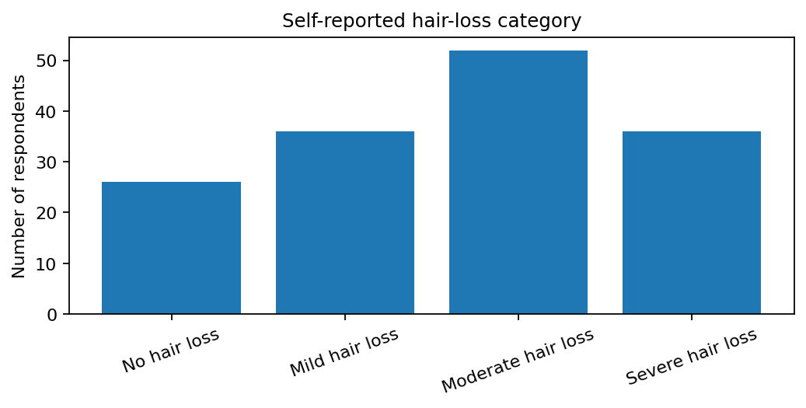
Figure 5. Distribution of self-reported hair-loss categories.
Moderate hair loss is the most common category (52; 34.7%). Mild and severe hair loss each account for 36 respondents (24.0%), and 26 (17.3%) reported no hair loss. These categories reflect respondents’ descriptions and are not clinically verified.

CHAPTER 6: CHI-SQUARE TESTS OF ASSOCIATION
Pearson chi-square tests were calculated from the workbook’s categorical labels. Because several contingency tables have small expected cell counts, p-values are exploratory and should be verified using a justified category-collapsing plan or an exact/Monte Carlo procedure before making strong inferential claims.
Association | χ² | df | p-value | Cramér’s V | Expected cells <5
Screen time × eye strain | 61.65 | 8 | <0.001 | 0.453 | 3/15
Sleep duration × hair loss | 49.96 | 12 | <0.001 | 0.333 | 7/20
Screen time × hair loss | 42.08 | 12 | <0.001 | 0.306 | 7/20
Sleep duration × eye strain | 14.16 | 8 | 0.078 | 0.217 | 5/15
Sleep quality × hair loss | 15.85 | 12 | 0.198 | 0.188 | 2/20

Interpretation
Screen-time category and eye-strain frequency showed a statistically detectable association in the Pearson test (χ² = 61.65, df = 8, p < .001; Cramér’s V = 0.453). However, the cross-tabulation is highly uneven: no respondents in the 6–8 hour and >8 hour groups selected Rarely or Sometimes. This may reflect the data structure and should be checked against the original form/export.
Sleep duration and hair-loss category also produced a small p-value (χ² = 49.96, df = 12, p < .001), but 7 of 20 expected counts were below five. Screen time and hair loss showed a similar sparse-table issue (p < .001). These results are not reported as robust confirmatory evidence; expected-count violations and possible data-entry/coding issues make the ordinary chi-square approximation unreliable.
Sleep duration and eye strain did not meet the conventional 0.05 threshold (p = 0.078); sleep quality and hair loss was also not statistically significant (p = 0.198).
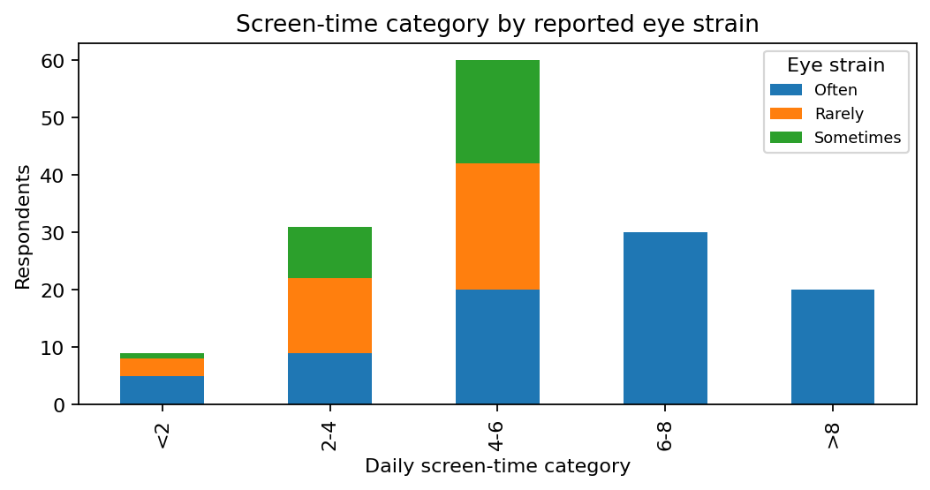
Figure 6. Screen-time category by eye-strain frequency; note the zero cells in higher exposure categories.

CHAPTER 6: SPEARMAN RANK CORRELATION
Spearman rank correlation was used because the principal variables are ordered categories. Scores were assigned in ascending order as documented in Chapter 5. The coefficients describe monotonic association under this coding and are not evidence of causation.
Variable pair | Spearman ρ | p-value | Direction
Screen time vs Eye-strain frequency | 0.504 | <0.001 | Positive
Sleep duration vs Hair-loss category | -0.183 | 0.025 | Negative
Screen time vs Hair-loss category | 0.024 | 0.770 | Positive
Sleep duration vs Eye-strain frequency | -0.194 | 0.017 | Negative
Sleep duration vs Perceived sleep quality | 0.271 | <0.001 | Positive
Screen time vs Sleep duration | -0.293 | <0.001 | Negative
Sleep quality vs Hair-loss category | -0.110 | 0.179 | Negative

Interpretation
The strongest relationship in the selected pairs was between screen-time category and eye-strain frequency (ρ = 0.504, p < .001), consistent with higher screen-time categories tending to coincide with more frequent reported eye strain.
Sleep duration had a weak negative relationship with hair-loss category (ρ = -0.183, p = 0.025) and with eye-strain frequency (ρ = -0.194, p = 0.017). Screen time and hair-loss category were essentially uncorrelated in this coding (ρ = 0.024, p = 0.770).
The direction and size of a rank correlation depend on the stated ordering. The results should be interpreted as exploratory summaries, especially because the survey measures are not validated scales and the category spacing is unknown.

CHAPTER 6: MULTIPLE LINEAR REGRESSION — DIGITAL EYE STRAIN

6.7 Model 1: Eye-strain score
The exploratory OLS model used eye-strain score (Rarely=1, Sometimes=2, Often=3) as the outcome and ordinal screen-time and sleep-duration scores as predictors. HC3 robust standard errors were used for coefficient inference.
Regression equation: Eye-strain score = 1.379 + 0.348(Screen-time score) -0.058(Sleep-duration score).
Predictor | Coefficient | Robust p-value | 95% CI (approx.)
Intercept | 1.379 | 0.0000 | [0.734, 2.023]
Screen-time score | 0.348 | <0.001 | [0.231, 0.465]
Sleep-duration score | -0.058 | 0.354 | [-0.181, 0.065]

Model fit: R² = 0.219; adjusted R² = 0.209; overall robust-model F-test p = 1.49e-09.

Interpretation
With sleep-duration score held constant, each one-category increase in screen-time score was associated with a 0.348-point increase in the eye-strain score (robust p < .001). Sleep-duration score had a small negative coefficient (-0.058) that was not statistically significant (p = 0.354). The model explains about 21.9% of the variation in the ordinal-coded outcome.
Because the outcome is ordinal and only three response categories appear in the workbook, an ordinal logistic model may be more appropriate than OLS. The current regression is included to match the analytical approach in the project presentation, but its coefficient interpretation assumes an approximate equal step between categories.

CHAPTER 6: MULTIPLE LINEAR REGRESSION — HAIR LOSS

6.8 Model 2: Hair-loss score
The second exploratory OLS model used hair-loss score (No hair loss=1, Mild=2, Moderate=3, Severe=4) as the outcome, with screen-time and sleep-duration scores as predictors.
Regression equation: Hair-loss score = 3.401 -0.040(Screen-time score) -0.219(Sleep-duration score).
Predictor | Coefficient | Robust p-value | 95% CI (approx.)
Intercept | 3.401 | 0.0000 | [2.424, 4.378]
Screen-time score | -0.040 | 0.645 | [-0.211, 0.131]
Sleep-duration score | -0.219 | 0.021 | [-0.406, -0.033]

Model fit: R² = 0.040; adjusted R² = 0.027; overall model p = 0.045.

Interpretation
Screen-time score had a small negative coefficient (-0.040) and was not statistically significant (p = 0.645). Sleep-duration score had a negative coefficient (-0.219) and was statistically significant in this exploratory model (robust p = 0.021). The R² of 0.040 indicates that the model explains about 4.0% of score variation.
This does not establish that longer sleep prevents hair loss. The result is based on self-reported categories and a simple ordinal coding, with potential confounding from family history, stress, diet, health conditions and other factors. An ordinal regression and prespecified adjustment for relevant confounders would be preferable in a follow-up analysis.

CHAPTER 7: INTERPRETATION AND DISCUSSION

7.1 Summary of principal findings
The supplied dataset shows that screen exposure is common: 40.0% reported 4–6 hours per day, and one-third reported at least six hours. The largest sleep-duration category was 6–7 hours. More than half of respondents selected “Often” for eye strain, while the most common hair-loss category was moderate self-reported loss. These results describe the surveyed respondents and should not be generalized without information about sampling.

7.2 Screen time and eye strain
Both the Spearman analysis and the ordinal-coded regression show a positive relationship between screen-time category and eye-strain frequency. The chi-square test also indicates a strong categorical association, but the cross-tabulation has zero cells for some higher screen-time groups and symptom categories. Such a pattern may reflect a genuine association, response coding, or a data-entry issue. The original form and export should be checked before this is treated as a stable inferential result.

7.3 Sleep and hair loss
The rank analysis indicates a weak negative association between sleep duration and hair-loss category, and the exploratory regression gives a negative sleep-duration coefficient. Yet the model explains only a small proportion of the variation and cannot account for hereditary, clinical, nutritional or stress-related factors. The chi-square result for sleep duration and hair loss is affected by sparse expected counts. It should therefore be treated cautiously rather than as proof of an association.

7.4 Integrating the evidence
Screen time was not meaningfully correlated with hair-loss category in the ordinal analysis. This is consistent with avoiding a direct causal claim that digital-device use causes hair loss. The data include potentially relevant contextual measures—stress, family history, hydration, exercise and fruit/vegetable intake—but these variables require careful coding and a larger, prespecified modelling plan before causal pathways can be explored.

CHAPTER 8: LIMITATIONS OF THE STUDY
Limitation | Implication | Suggested improvement
Cross-sectional design | Temporal order and causation cannot be established. | Use longitudinal measurements or a prospective cohort.
Self-reported exposure/outcomes | Recall and interpretation may affect responses; hair loss is not clinically verified. | Use device logs where feasible and validated symptom measures; clinical assessment only with consent.
Sampling method undocumented | Representativeness and response rate cannot be evaluated. | Document recruitment, eligibility, invitations and response rate.
Dataset/presentation discrepancy | Workbook has 4 missing symptom cells and 3 eye-strain levels; presentation states 28 missing values and five eye-strain levels. | Confirm the final dataset and retain a versioned data-cleaning log.
Sparse contingency tables | Several expected cell counts are below five, weakening the chi-square approximation. | Predefine defensible category grouping or use exact/Monte Carlo methods.
Ordinal coding in regression | Assumes category steps can be treated as approximately equal. | Use ordinal logistic regression and report coding clearly.
Potential confounding | Stress, family history, health, nutrition and device ergonomics may affect outcomes. | Collect and adjust for prespecified covariates.
No validated scales documented | Sleep quality and eye strain may not be measured comprehensively. | Use validated questionnaires and document scoring.
Ethics/consent records not supplied | Approval and consent status cannot be confirmed from available files. | Confirm with the supervisor and document consent and data protection.

The limitations above distinguish problems directly observed in the files from general risks inherent in cross-sectional self-report studies. No unprovided sampling or ethics details have been assumed.

CHAPTER 9: CONCLUSION, RECOMMENDATIONS AND FUTURE RESEARCH

9.1 Conclusion
This study described screen-time habits, sleep duration and quality, digital eye-strain frequency, and self-reported hair loss among 150 college-student respondents. The most common daily screen-time category was 4–6 hours; the most common sleep-duration category was 6–7 hours; “Often” was the most frequently selected eye-strain response; and moderate hair loss was the most frequent self-reported hair-loss category.
Screen-time category showed a positive monotonic association with reported eye-strain frequency, and the exploratory regression indicated a positive screen-time coefficient. In contrast, screen time and hair-loss category were essentially uncorrelated in the rank analysis. Sleep duration showed a weak negative relationship with hair-loss category, but sparse contingency tables, self-reported measures and the low explanatory power of the regression mean that this should not be interpreted as a causal effect.
The main methodological finding is the need to reconcile the Excel workbook with the presentation before final submission. The discrepancy in missing symptom values and eye-strain response categories could materially affect analysis. Conclusions should remain limited to the available dataset until that audit is completed.

9.2 Recommendations
• Encourage students to take regular visual breaks and review screen ergonomics; this report does not test an intervention.
• Promote consistent sleep routines and mindful use of devices close to bedtime without presenting this survey as proof of causation.
• Advise students concerned about persistent hair loss to seek qualified clinical assessment rather than attributing it to screen time alone.
• Retain a raw dataset, a cleaned analysis copy, a codebook and a reproducible analysis log.
• Verify the response options and missing-value handling against the original questionnaire/export before interpreting the chi-square results.
• Use validated eye-strain and sleep-quality instruments and a justified ordinal model in future work.

9.3 Future research
A larger study with documented sampling, standardized measurement, a clear consent procedure, and prespecified statistical methods could investigate screen exposure, sleep, eye symptoms and hair concerns more reliably. Future analysis should consider confounders and report effect sizes with confidence intervals alongside p-values.

REFERENCES
1. Mataftsi, A., Seliniotaki, A. K., Moutzouri, S., Prousali, E., Darusman, K. R., Adio, A. O., Haidich, A.-B., & Nischal, K. K. (2023). Digital eye strain in young screen users: A systematic review. Preventive Medicine, 170, 107493. https://doi.org/10.1016/j.ypmed.2023.107493
2. Li, Y., Li, G., Liu, L., & Wu, H. (2020). Correlations between mobile phone addiction and anxiety, depression, impulsivity, and poor sleep quality among college students: A systematic review and meta-analysis. Journal of Behavioral Addictions, 9(3), 551–571. https://doi.org/10.1556/2006.2020.00057
3. Asghar, F., Shamim, N., Farooque, U., Sheikh, H., & Aqeel, R. (2020). Telogen effluvium: A review of the literature. Cureus, 12(5), e8320. https://doi.org/10.7759/cureus.8320
4. Malkud, S. (2015). Telogen effluvium: A review. Journal of Clinical and Diagnostic Research, 9(9), WE01–WE03. https://doi.org/10.7860/JCDR/2015/15219.6492
5. Project presentation supplied by the researcher. (2026). Impact of screen time and sleep quality on digital eye strain and hair loss among college students [Unpublished project presentation, PDF].
6. Research dataset supplied by the researcher. (2026). Biostats.data.xlsx [Unpublished questionnaire dataset].
Note: Literature references above are bibliographic sources used to frame the topic. The dataset and presentation are primary project materials and are not published studies. All data-derived numerical findings in this report are recalculated from the supplied workbook.

APPENDICES

Appendix A: Questionnaire domains recorded in the supplied materials
Domain | Variables / question topics
Demographic and academic | Age, gender, college, stream, current study level, year, CGPA.
Screen time | Daily hours, main device, device use within 30 minutes before bed, regular breaks.
Sleep | Nightly sleep duration, usual bedtime, perceived sleep quality, waking refreshed.
Digital eye strain | Frequency of eye strain, symptoms, headache frequency, tired eyes during/after study.
Hair loss | Increased hair fall in past six months, current self-reported hair-loss category, family history.
Lifestyle | Stress frequency, exercise days, fruit/vegetable frequency, daily water intake.
Opinions | Views on screen time and sleep, poor sleep and hair loss, screen time and eye strain.

Appendix B: Analysis coding notes
Ordinal coding used for exploratory analyses: screen time (<2, 2–4, 4–6, 6–8, >8) = 1–5; sleep duration (<5, 5–6, 6–7, 7–8, >8) = 1–5; sleep quality (Very Poor, Poor, Average, Good, Excellent) = 1–5; eye strain (Rarely, Sometimes, Often) = 1–3; hair loss (No, Mild, Moderate, Severe) = 1–4. These mappings are analytical conventions, not original numeric fields.

Appendix C: Items to confirm before final submission
1. Confirm that this Excel workbook is the final dataset used for the project presentation. 2. Resolve the difference between four blank Symptoms cells in the workbook and 28 missing values described in the presentation. 3. Confirm why the workbook records only Rarely, Sometimes and Often for EyeStrain, whereas the presentation mentions five categories. 4. Insert the project guide’s name and academic year. 5. Confirm consent and ethics documentation with the supervisor. 6. If possible, provide the exact original questionnaire export and the software output used for the presentation.

Appendix D: Reproducibility statement
The descriptive counts, percentages, chi-square tests, Spearman correlations, and exploratory OLS models in this report were recalculated from the supplied workbook. Ordinal mappings and sparse-table limitations are stated explicitly. No respondent-level records are reproduced in the report.

