A Simple Http server docker image with node express

Step1: create a docker file with command “touch Dockerfile”

Add the following contents to it.

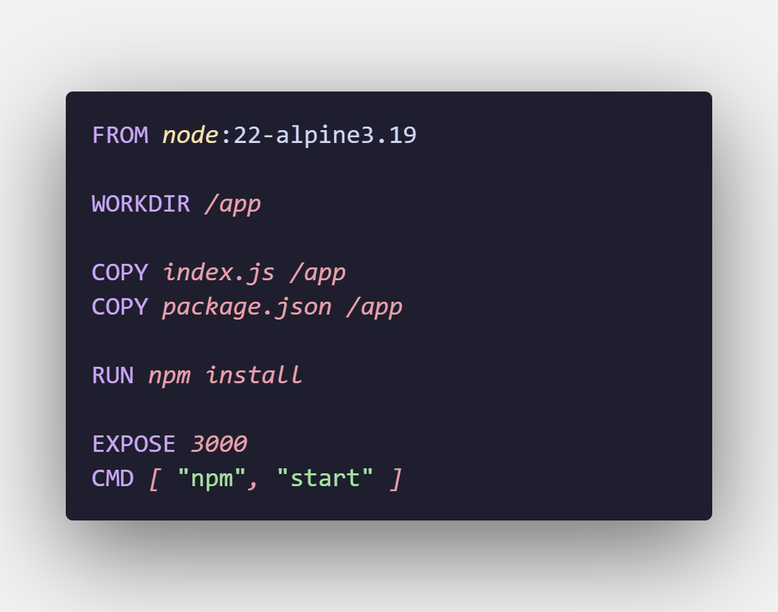

Step2: build the docker image.

“docker image build –tag node-app:v1 .”

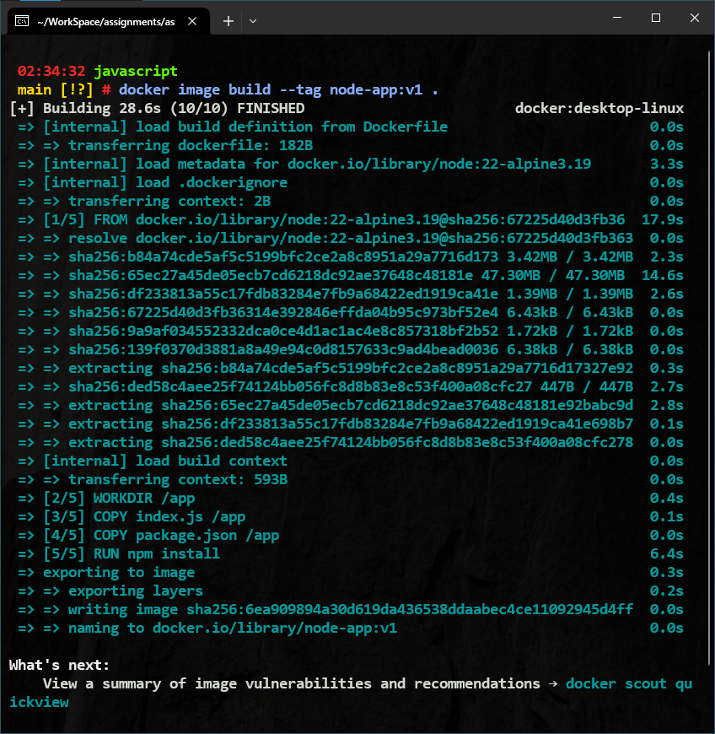

Step3: run the image in container

“docker container run –p 8080:3000 --name express-server node-app:v1”

