Building a simple flask app image.

Step 1: Create a Dockerfile with command “touch Dockerfile”

And add the following contents to it.

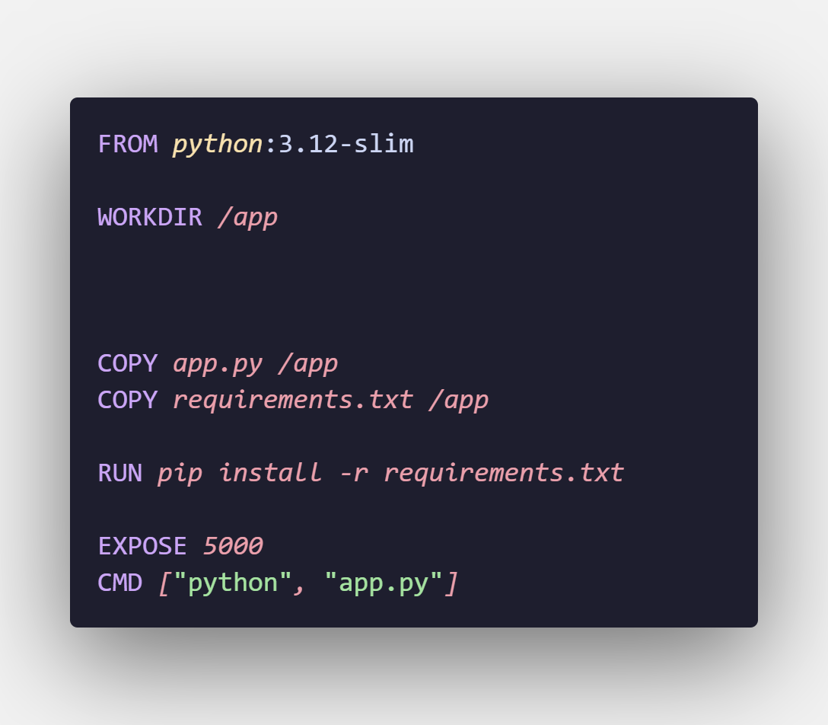

Setp2: build the docker image with the following command

“docker image build –tag python-app:v1 .”

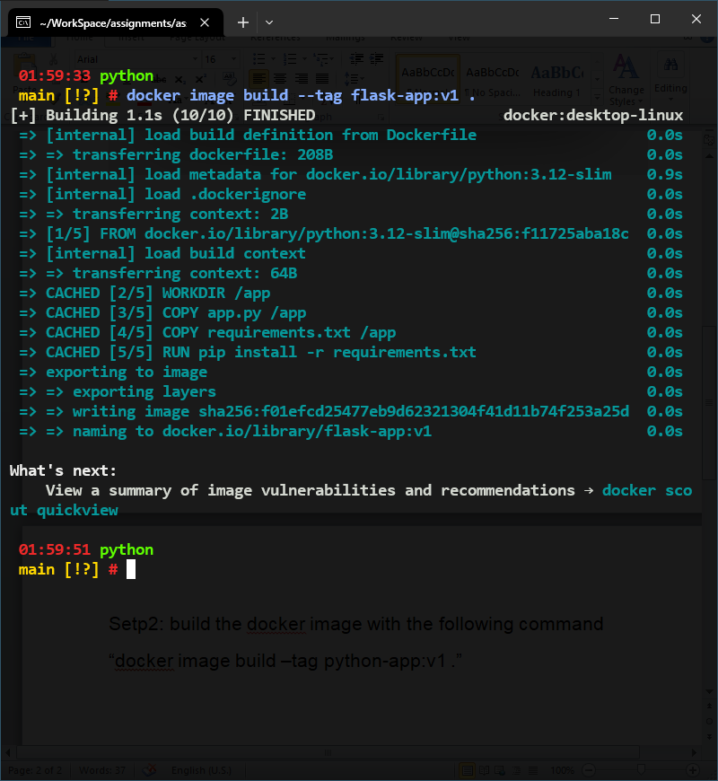

Setp 3: Run the container with the build image.

“docker container run –p 8080:5000 –name flask-server flask-app:v1”

