A simple python web application

Setp 1:

Create a new virtual environment by following commands

“python –m install virtualenv”

“python –m virtualenv env”

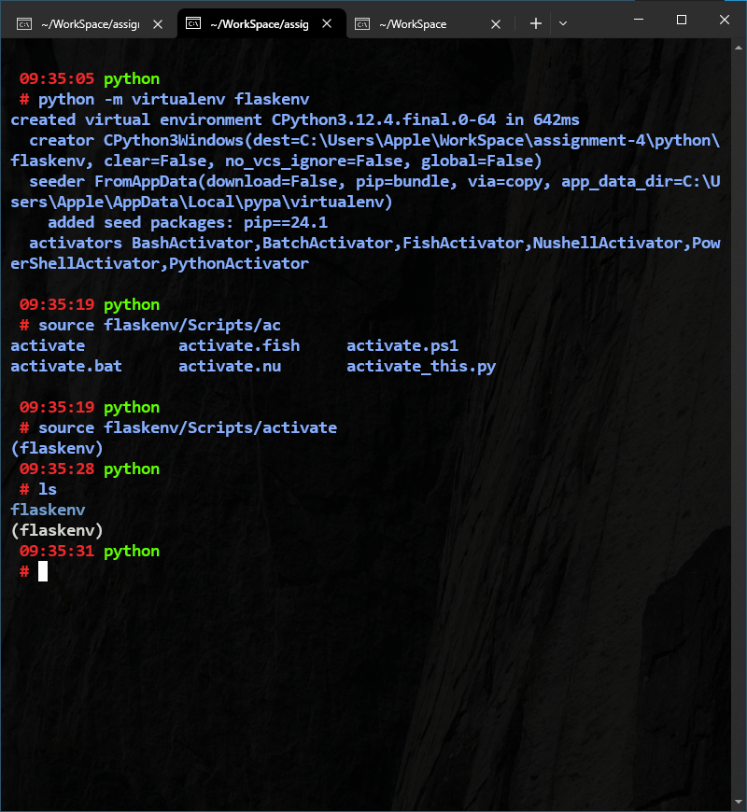

Step 2:

Install required library Flask by running command

“pip install Flask”

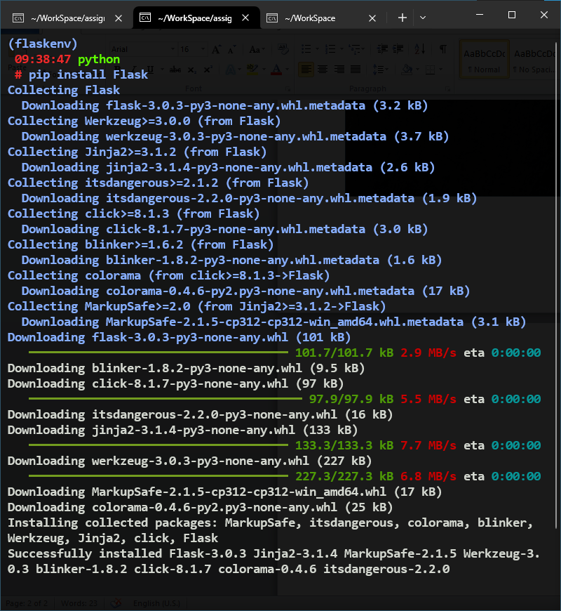

Step 3:

Write a simple flask application.

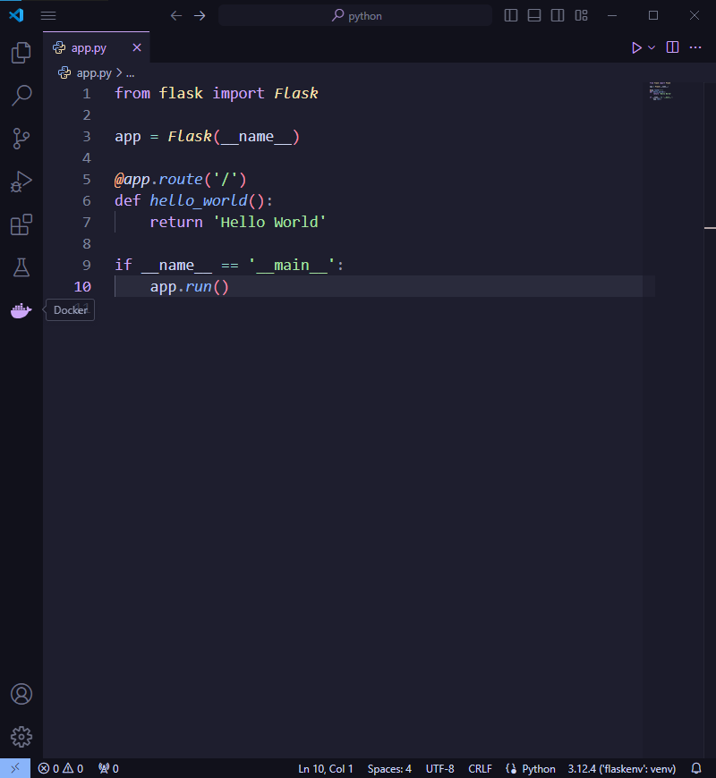

Step 4:

Start the server “python app.py”

