**Air Traffic scaling, delay- analysis and prediction using PySpark on Hadoop Cluster**

Scaling, Simulation, delay analysis and delay prediction of 2019 US domestic air flights

Mohammed Zoher Guniem Megh Raj Upreti

University of Stavanger, Norway University of Stavanger, Norway

m.guniem@stud.uis.no mr.upreti@stud.uis.no

# ABSTRACT

As more commercial airplanes take off to the sky, data generated from air traffic is rapidly increasing in both size and complexity. According to the International Air Transport Association (IATA), Air travel industry is anticipated to annually grow by 3.5% in the next 2 decades (IATA, 2018). This growth raises big questions on how to gather, store, analyze and use the data generated from those flying cities in the sky. In this research we start by using flight route information to produce a scalable and realistic simulation model for air traffic, and in the second phase we analyze the delay distribution and then evaluate some machine learning algorithms so we can have a better scientific foundation on which machine learning algorithm can produce better and more accurate prediction on flight delays.

# KEYWORDS

Hadoop, Spark, PySpark, Power BI, Python, Aviation, Air-traffic, Scaling, Simulation, delay, Prediction, Machine learning, Random forest, Logistic Regression, Decision Trees.

# 1 INTRODUCTION

Over the last few decades, air transport is increasing in popularity because of its speed and comfort which eventually increases the traffic in the airspace. With the great increase in air traffic comes a large increase in the demand for capacity in airports and airspace. However, the capacity in the aviation industry is often a tight constraint and it cannot keep increasing at the rate necessary to match the rising demand.

During peak hours, the demand for resources in both airports and airspace is at its highest. Some of the most important resources are:

* Good trained human resources.
* Take-off and landing slots.
* Spacious airspace.
* Available Gates at airports.
* Available taxiways and runways.
* Many other factors.

Airspace congestion and flight delays are two of the most important bottlenecks factors that limit the available resources and causes multiple unhealthy side effects on both the operation of air industry and thus the growth of the economy.

It is therefore crucial to have a good trained human resource to manage the airspace and ground operations to avoid any leak of capacity. In this paper we shall investigate the possibilities of using big data technologies to solve such challenges and limitations. Some of these cutting-edge technologies are:

* Apache Hadoop Clustering, which uses the MapReduce programming model and a network distribution to help solving problems related to big data and its demanding computation (Wikipedia, 2020).
* Apache Spark framework is a cluster-computing framework that offers an interface to program entire clusters with implicit data parallelism and fault-tolerance. In this project we use the powerful python language to work with spark by its popular library PySpark (Wikipedia, 2020).
* We will also be using some other python libraries and software’s like “basemap”, “matplotlib” and Power BI to further help and assist our research (matplotlib.org, 2020).

# 2 BACKGROUND AND MOTIVATION

# 2.1 Air Traffic Scaling and Simulation

Today’s modern aircrafts are equipped with numerous sensors which measures the performance and different states of each part and system of the aircraft. From the very basic of flying parameters like speed, altitude and location to more detailed data like temperature and pressure from the airplane’s engines and cabin. Data from each airplane is often sent to datacenters on the ground for use in maintenance and troubleshooting. Most airlines also store this same data about each aircraft for later use in analysis and simulation.

Through the age of aviation, Simulation has had great benefits in training staff to handle the routines, procedures and challenges of the aviation industry. All trainee pilots and airspace controllers must spend a big amount of their training in simulation environments. Such simulations enable them to be prepared for daily handling of air traffic that never stops around the clock. Unfortunately, making a realistic simulation model is a challenge for all software engineers. Simulation software’s can either generate air traffic randomly or by using data from realistic flights. And because the simulation must be as realistic as possible, the first option is hard to consider. This makes any simulation software very dependent on data from real life.

The simulation algorithms must have a normal uncomplicated flow and low running time, which means that data must be easily scalable with low overhead. In this research, we take advantage of the known capabilities of Apache Hadoop and Spark to design a scaling algorithm that uses data from earlier US domestic flights to provide realistic data for general use in air traffic simulation and analysis.

# 2.2 Delay analysis

Another problem the aviation industry faces is in the delays caused on arrival and departure, these delays cost both the airlines, and passengers billions of dollars every year. A report about the effects of flight delays on economy was given by the United States Joint Economic Committee (JEC) (Schumer & Maloney, May 2008, p. 3) and it has estimated that delayed domestic passenger flights costed the U.S. economy close to $41 billion in 2007 alone. The table in figure 1 below shows the distribution of delay costs between airlines, passengers and other related businesses. Understanding and predicting such delays should help all involved parts to be prepared and thus minimizing the effect of such delays on the economy.

|  |  |  |  |
| --- | --- | --- | --- |
| **Airline Operating Cost** | **Value of Passenger Time** | **Spillover Costs to the Economy** | **Total** |
| $19.1 Billion | $12.0 Billion | $9.6 Billion | $40.7 Billion |

Table 2. Flight delays cost passengers, airlines, and the US economy billions. (https://www.jec.senate.gov/public/_cache/files/47e8d8a7-661d-4e6b-ae72-0f1831dd1207/yourflighthasbeendelayed0.pdf). Page 3

Different analysis software’s can be used to draw a picture on how and what might cause the delays. Since Microsoft launched its first public version of Power BI in 2015, the interests have grown around it because of it is user-friendly and flexibility in performing data analysis. Although Power BI has a relatively big collections of different visualization tools, loading a big dataset into Power BI will produce a very heavy and slow visualization model with degraded user experience.

This is where we can take advantage of the computational power of a Hadoop Cluster and PySpark methods to easily extract target information about delays from big datasets and use it to build fast and flexible power BI models.

# 2.3 Delay Prediction

To take the research in flight delays to the next level, we shall later apply machine learning to predict and expect such delays before they occur based on what we already know. Hadoop PySpark has some great built-in libraries that helps runs the most popular and efficient machine learning algorithms on our datasets, and based on related work we should then test the accuracy of some popular machine learning algorithms on our dataset like random forest, decision trees and logistic regression.

An accurate machine learning algorithm can be helpful when working with big datasets and trying to understand the hidden relations between attributes. But as we already know a machine learning algorithm can be highly accurate with one dataset but very much less accurate with another. Therefore, we should run tests where we compare different machine learning algorithms based on earlier related work and calculate their accuracy before moving on and selecting one machine algorithm to work with in the future.

We should also keep in mind that even though a prediction algorithm works with high accuracy today, this does not mean the same algorithm will necessary give high accuracy prediction in the future, this is why it is important to keep a continuous evaluation of the performance of any available machine learning algorithm on our an updated dataset.

# 2.4 Dataset

For this research, we had the need of a dataset that is realistic, includes detailed information about flights and covers the geographical size of nearly a continent. Therefore, the choice has fallen on the United States of America. Since the airspace over the mainland USA is known to be heavily loaded with commercial airplanes around the clock, most of them are on domestic routes.

We are using an open source dataset which includes all the domestic flights on both mainland USA and overseas territories from the year of 2019. The dataset is downloaded from the website of the United States Bureau of Transportation Statistics. It is contained in 12 CSV files, one file per month. Its size can vary according to research need, because it is possible to only select the needed data parameters on each flight. In our case the initial size of the dataset is about 1.88 GB.

The most important advantages of this dataset are:

* Provides detailed information about the flight route from taxing into the runway until final arrival at the terminal, like actual and scheduled clock of taxi out, wheels off, wheels on, and taxi in.
* Reasons for flight delays are given in 5 clear and reasonable categories. Which gives us a clear picture on the actual causes of each delayed flight.

But the dataset is not perfect and has some issues that was discovered and dealt with under this research. Some of these issues are:

* Clock time like wheels off and wheels on is given in local time, which makes it essential to convert these into UTC times.
* Delay categories are numeric and needs to be converted into suitable interval categories for prediction.
* No airport coordinates included in the main dataset. Which makes it necessary to use some support dataset to provide this information.

The support dataset comes from the same bureau and enables us to gain more information about the geographic coordinates of the departure and arrival airports, along with UTC time variation. This support dataset is of size 1.17 MB for our needs, but it comes in a separate CSV file and includes data from almost all airports inside and outside the USA, which is very useful in case of a global extension of our research.

# 2.5 Tools & Setup

The following highlights some of the tools and technologies used in this research:

* Apache Hadoop, version 3.1.1

Using a distributed cluster consisting of one master node and 3 slave nodes.

* Apache Spark, version 2.4.5

Installed on top of the Hadoop cluster and utilizes its resources.

* PySpark

A powerful library that enables us to use its effective functions to write a consistent and god structured code using python. The PySpark library takes care of translating the python code into Scala which is the native programming language of Spark.

* Power BI

A popular visualization tool introduced by Microsoft. it has the main advantage in analyzing data in a user-friendly, and reactive way. It also has multiple visualization tools and models that makes the analysis model more flexible to changes in the future.

* mpl_toolkits.basemap

An open-source python library that enables us to retrieve the flight path using the method of great circle calculation. The library also helps with the actual simulation on the client side by plotting the results in a geographic map.

* matplotlib

A popular open source library that is helpful for making simulation and statistical plots.

* Another helpful open-source libraries

datetime, argparse, sys, imageio, json, time, os, shutil, and cv2.

# 2.6 Related Work

There are several works in the literature that focus on air-traffic and airport delays. Airline operations are highly complicated processes that are intended to regulate expenses, constraints, and interdependent resources, such as the crew, aircrafts, airports, and maintenance facilities. Myriads of research have been carried out on aviation planning problems such as delays, but only a few have been performed on the characteristics of flight scaling, airspace simulation, airline delays and the use of machine learning to predict flight delays. Following are some useful researches that we used as an inspiration and foundation for our research:

* Agent-based Modelling and Simulation of Air Transport Technology in 2013 by Grether and Nagel.

Researchers used scaling and simulation software for flight data. They normalized the data, performed pre-processing and simulated the results between inbound and outbound flights. They also converted local times to UTC (Coordinated Universal Time) for consistency.

* Predicting Flight Delays in 2012 by Dieterich Lawson and William Castillo.

This research used a dataset of flights including several years, which resulted in 135 million flights. However, work on weather data only obtaining 40% recall. They used algorithms like support vector machines, Naïve Bayes, and Random forest.

* Application of Machine Learning Algorithms to predict flight arrival delays in 2017 by Nathalie Kuhn and Navaneeth Jamadagni.

The contributors to this project used machine Learning algorithms like decision trees, Neural Network and Logistic regression algorithms and concluded that the departure delays are the main factor in flight delays. They also performed some statistical analysis like average delays of flights and basic summary statistics.

* Predicting flight delays and cancellations using weather as a feature in 2016 by Movva, N. and Menon, S.

The report of this research has compared algorithms like Random forest, XGboost (Extreme Gradient), Linear regression, and SVM and finally concluded with AUC (Area Under Curve) 0.81 highest among all algorithms.

# 3 AIR TRAFFIC SIMULATION

# 3.1 Design

The main goal of this part of the project is to provide simulation applications with easily scalable data that has the following properties:

* The geographic position of an aircraft at each minute in a route.
* The route information of each aircraft.

The data should also be easily scalable between a time interval in the day, and according to which geographic area the simulation view is based on.

Based on the requirements above we decided to split the solution into 3 main steps which are explained in figure 1 below.

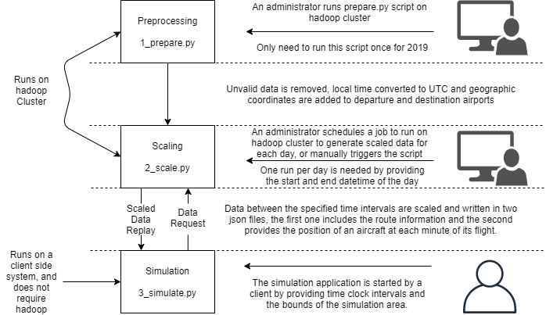

Figure 1. The overall design architecture of scaling and simulation for air-traffic.

# 3.2 Analysis

The 3-step divided design in figure 1 should improve the running time and flow of the simulation application, this is because much of the preparing and scaling steps are performed on the distributed cluster of Hadoop which is expected to be much powerful than the client computer.

For instance, the preprocessing step takes care of cleaning data, converting to UTC time and adding the needed coordinates for scaling. The scaling on its side filters out those rows that does not fit into the user specified time frame and generates the full path of a flight in geographic points. This leaves the client with

the only need to check if a flight is inside or outside the bounds of the simulation area.

On further examination, we found out that the preparing script takes about 13 minutes to finish for the entire dataset, and the scaling script takes only 5 minutes for a one-day time frame. These running times durations can off course change to be shorter or higher based on multiple factors like background processes in the operating system and other Hadoop jobs executed on the same cluster, but we could assume having a dedicated cluster to service the preparing and scaling scripts. However, the running time of the most critical script which is “2_scale.py” is not expected to exceed 30 minutes per day. Which is considered a good result when considering the massive size of our initial dataset.

# 3.3 Optimization

To optimize our solution and make it run faster, we decided to isolate the preprocessing in the “1_prepare.py” script, this relaxes the scaling script from needing a local time conversion to UTC, adding coordinates and other data validation steps.

The Scaling script “2_script.py” can then focus on finding out which flight belong to the given time frame and calculating the great circle route path. In addition, this script is made more robust by enabling the administrator to choose any different time interval according to his need and can be run as a scheduled job for each day or week, etc. in the future.

Replacing the scaled data into json files, makes it easier for the client application to retrieve and process data which in turn improves the running time of the client application.

For further details on the final experimental phase on the application level see section 6.2 on Air Traffic Simulation, but first let’s dive into the details of out implementation.

# 3.4 Implementation

To match the design that was mentioned in 3.1, this implementation has been divided into 3 steps, these steps are explained below:

* Preparing the dataset

As mentioned earlier it is essential to deal with the weaknesses and deficiencies in the dataset before moving on with designing a scaling algorithm. To help us overcome this we design a preprocessing script that runs on the Apache Hadoop cluster using PySpark. The script does the following on the entire dataset:

- Some minority number of the flights in the dataset does not have any airtime, wheels off and/or wheels on time due to cancelation or some other reasons. It is then essential to remove these rows before proceeding on.

- Because flights can often connect two regions located in different time zones, It is difficult to use local time when considering the position of an aircraft in respect to time, its is then better to convert all times from local time to Coordinated Universal Time (UTC).

- Our original dataset does contain the sequential ID of the departure and arrival airports, but it does not contain their geographic coordinates that are needed to calculate the flight path later in the scaling step. This is solved by joining our dataset with a support dataset that provide geographic coordinates of each airport.

All the above steps are performed using PySpark functions and the script is meant to run only once on the entire dataset with no command line input arguments. The script is to be found under the following path and name in the project code folder. “.../1_scaling_and_simulation/1_prepare.py”.

* Scaling the dataset

The output of the preparing algorithm is written on the Hadoop file system in csv format and will be used by the next step which scales the dataset to produce a useful route information and location at each time in json format which can be used by a simulation application. The following steps explains the general structure of the scaling algorithm:

- A start and end datetime, along with a folder name where the output should be stored is provided by the user using command line arguments.

- After reading the prepared data, PySpark functions are used to filter the dataset according to the provided start and end datetimes. By keeping the rows that have a wheels off and wheels on time before, during or after the provided datetime bounds, we ensure that we do not miss flights that started and/or ended before the start and end time bounds. Figure 2.3 explains this stage.

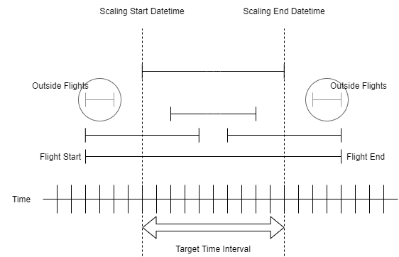

- To be able to provide a location of the aircraft at each minute of the flight we rely on great circle calculations. The spherical shape of the earth makes it looks like pilots want to take a circle shape route from source to destination which seems longer on a traditional 2-dimensional map, but it is indeed the shortest path between source and destination. In addition to this pilots has to take into account the wind directions along the path and they do also fly according to established non-physical traffic checkpoints on the map, but often these checkpoints are placed in a path that is very much similar to a great circle.

To calculate the great circle of each flight, we take advantage of the python open-source library “mpl_toolkits.basemap” which takes in the coordinates of the source and destination as an argument along with the number of points to be generated along the path, by letting the airtime in minute represents the number of points to be generated by the method “gcpoints” we can make sure that the average speed is taking into consideration. Average speed lays very much near the cruising speed of a flight. Which is the speed that the flight is having most of the time during its duration.

All of the scaling steps are performed using PySpark function, except the great circle calculation which we experienced to be faster if done by iterating over the remaining scaled routes using the “rdd.collect()” PySpark function.

The script is designed to produce 2 json files, one that contains the information of each different flight and the other that provide the geographic position of each flight between the given time interval.

Although it is possible to change the time intervals, it is recommended to run the script for one day at a time, either in advance or a week before. The output can then be served to the client simulation application by using ftp or by giving access to a NoSQL database like mongoDB. The json structure makes it easy to establish a NoSQL database for this purpose, but for our project we feel it is enough to try to save some time and use the scp command to be able to use and test the scaled data on the client side.

The scaling script is to be found under the following path and name in the project code folder. “.../1_scaling_and_simulation/2_scale.py”.

* Simulation

In this step, we decided to develop a small simulation application that uses the scaled data from the scaling step above, the results of this step should determine the reliability and efficiency of our implementation. Further details on the experimental setup and result is described in the section of experimental evaluation for air traffic simulation 3.5

The simulation application is to be found under the following path and name in the project code folder “.../1_scaling_and_simulation/3_simulate.py”.

And following is an example of its output images

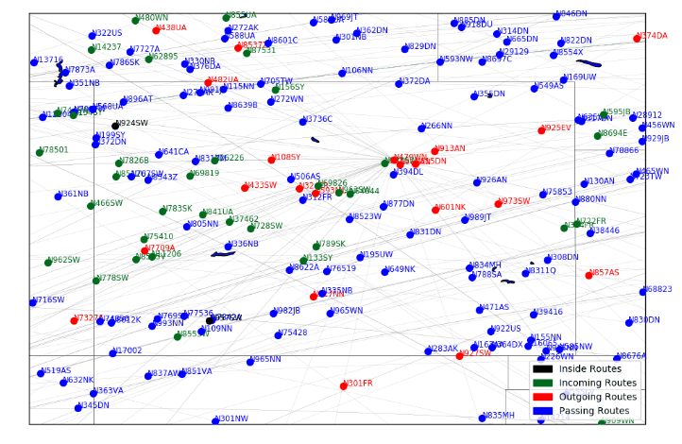

# 3.5 Experimental evaluation of air traffic scaling and simulation

1. **Experimental setup**

We have developed a simulation application for general use purposes that uses the ouput of the Hadoop scaling step and takes in the following command line argument from a user:

* North-, south-, east- and west bounds.
* Tag of the aircraft whether it is the tail number of the aircraft or route between airports, cities or states.
* Start and end clock of the simulation.
* The name of the folder where the output should be stored.
* Whether to keep snapchat images or not
* The gif duration of each minute interval in the output.

We randomly select a day, run the scaling script on Hadoop for this day and then use the scaled results to test this simulation application. And measure its running time by dividing the day into 8 intervals each interval containing 3 distinct hours of that day. Also, for this task we select the entire airspace of the state of Colorado as a simulation area because of its strategic location in the middle of the United State, and its busy airspace. We will also be running the client simulation on a normal PC with RAM equals to 32 Gb. Which is much lower than must machines that are dedicated to simulation can offer in modern days. The simulations are also executed concurrently at the same on the same machine and operating system.

1. **Results**

The running time results of our experimental setup is giving in the table below

|  |  |
| --- | --- |
| ***Time interval in the 10th of April*** | ***Simulation running time to produce output, hh:mm:ss*** |
| 00:00 – 03:00 | 0:06:55.823885 |
| 03:01 – 06:00 | 0:06:19.043982 |
| 06:01 – 09:00 | 0:04:18.139255 |
| 09:01 – 12:00 | 0:04:18.947238 |
| 12:01 – 15:00 | 0:05:17.992771 |
| 15:01 – 18:00 | 0:06:41.680611 |
| 18:01 – 21:00 | 0:06:21.062542 |
| 21:01 – 23:59 | 0:05:57.069641 |
| Total Running time | 0:46:6 |
| Average per simulated minute in running seconds |  |

The sum of running times in the table above is around 46 minutes and 6 seconds for all 8 simulations. If we divide this sum on the number of seconds in a day, we get the amount of running time spent on each minute of simulation.

(46*60)+6 / 24*60*60 ~ 0,08 running time per minute of simulation.

As we see from the calculations above, it takes a client machine around 0,08 seconds to retrieve simulation data from one minute of airspace traffic above the State of Colorado.

# 4 FLIGHT DELAY ANALYSIS

# 4.1 Design

There exist 5 different types of delays in our dataset, they are categorized according to their main operation area where the delay was caused, it is also possible for a flight to have multiple delays at the same time. These delays are specified in the following table:

|  |  |
| --- | --- |
| Type of delay | Explanation |
| Carrier delay | related to the maintenance and condition of an aircraft |
| Weather delay | caused by weather conditions |
| NAS delay | related to the national airspace system |
| Security delay | caused by any security breach |
| Late aircraft delay | arrival delay at an airport due to the late arrival of the same aircraft at a previous airport |

The aim of this part of our research is to help improving the speed and efficiency of a power BI model that visualized the distribution of different delays across multiple other features from the same dataset.

To help achieve a better power BI model, we have designed a PySpark script that aggregate and groups the rows in our datasets in terms of a given feature column like an airport, city or state. The script then calculates some basic statistics like the sum, mean, minimum and maximum of each delay grouped by a given feature category.

The script is designed in a way that a user can use a json config file which is found under the path “2_delay_statistics\analyze_config.json” to be able to enter instructions to what feature category(s) the script should use to produce the different delay statistics.

The output is then written to one or more csv files on both the local file system and the Hadoop file system for distributed use. This output will serve as a csv data feed by loading each generated csv to a power BI model, for more information about the experimentation and testing of the power bi model, please see section 4.5

# 4.2 Analysis

The main generator script is to be found under the following path and name “2_delay_statistics\analyze.py” and it loops through the array of “analyze_targets” in the previously mentioned json configuration file. During every loop similar operations are performed on different features using PySpark functions.

Thus, the running time of the script is

F(n) = O (n * P),

where n is the size of “analyze_targets”, and P represents the unknown cost of running built-in PySpark functions.

But in case the target feature is built from single features as it is possible, the running time of the script will be

F(n) = O (n * M * P),

where M is the size of the array of “target_components”. But “M” can also change in length between different merged configuration according to the need of a user on how many features he/she wishes to merge. Therefore, we should write the final running time of our script as

f(n) = O(N1 * M1 * P1) + O(N2 * M2 * P2) + … + O( N1(n-1) * M(n-1) * P(n-1) ),

where

n = N1 + N2 + N3 + …

M = M1 + M2 + M3 + …

P = P1 + P2 + P3 + …

As we see from the time analysis, the running time is highly dependent on the user input from in the configuration file. Which makes it necessary to setup an experiment and take a close look at actual performance under production.

# 4.3 Optimization

To make the PySpark script more dynamic and easier to use, we have decided to use a configuration file that enables the user to specify different parameter settings. An example that shows the structure of the json configuration file is given in the figure 2.2 below

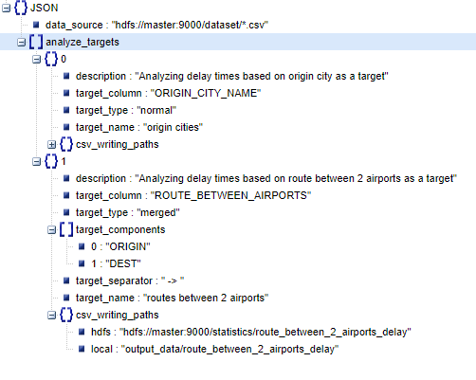

A user can also use the opportunity of declaring some group of feature data columns as one target feature, an example would be if a user wants to analyze based on the route from destination to arrival airport, this is shown in the seconds element of the configuration in figure 2.2 above. And makes the script event more helpful in analyzing different correlations between data features and their impact on delays.

# 4.4 Implementation

Based on the design constraints and possible optimization, which was discussed earlier, the pseudo-code for the analyze script is given below.

- Read “analyze_config.json”

- Read dataset

- For N in length(«analyze_targets»):

- read configuration parameters

- if target_type == “merged”:

- merged_features = target_components[0]

- for M in “target_components”:

- merged features = merge(merged_features, M)

- target_column = merged_features

- else:

- target_column = “target_column”

- aggregate and group delays according to merged_features.

- compute sum, mean, minimum and maximum for each feature or feature merged group.

- Write to csv and Hadoop file system.

Under development we did notice that most of flights has been without any delays and therefore, we know that calculating the minimum, mode and median of the delays will most probably equals 0, and results in slowing down the analysis script. This why we decided to illuminate the calculations of the mode and median and just calculating the minimum of each delay. Later on and under analysis can a minimum value of higher than 0 trigger the alarm on any selected filtering effect of any category features.

We also had to perform some data cleaning to replace all delays that were not registered with a value of 0, this is because the dataset wanted to save size and therefore had no value what so ever when there was no delays and Spark automatically assumes that the value there is null and not 0, calculating statistics with a value of null using PySpark functions gives us the wrong calculations, an example is given below:

Data = [3,3,null]

Average = 3+3/2 = 3

Data = [3,3,0] // replacing null with 0

Average = 3+3+0/3 = 2

# 4.5 Delay Analysis

1. **Experimental setup**

The experimental setup consists of to stages, the first is regarding the pyspark script that runs on Hadoop cluster and produce the csv feed files to by used by the Power BI model, and the second stage is to use the csv file to produce a working Power BI model.

We start off by running the “analyze.py” on Hadoop cluster with 11 configured analyze targets. 8 of these targets are single features about origin, destination, month and aircraft and 3 others are merged to represent the route between state, city and airports.

1. **Results**

The table below shows the running time of each configured section in “analyze_targets”

|  |  |  |  |
| --- | --- | --- | --- |
| **Feature** | **type** | **#of merged features** | **Running time in seconds** |
| Tail_number | Single | 1 | 43 |
| Destination state | Single | 1 | 30 |
| Destination city | Single | 1 | 29 |
| Destination airport | Single | 1 | 29 |
| Origin state | Single | 1 | 31 |
| Origin city | Single | 1 | 30 |
| Origin airport | Single | 1 | 28 |
| State route | Merged | 2 | 33 |
| City route | Merged | 2 | 34 |
| Airport route | Merged | 2 | 32 |
| month | Single | 1 | 28 |

We notice here that the highest running time was registered not in merging as we would expect but it is under categorizing by the tail number of different aircrafts. The reason for that is the total sum of generated categories would be highest by using the tail number, which proves that the expensive part is computing statistics for each category using PySpark functions and not by merging feature columns together.

Following is some basic statistics approximately measured in seconds about the observed running times in table 2.2

|  |  |
| --- | --- |
| **Statistic Variable** | **Estimated value** |
| Mean or average | 32 |
| Mode | 28, 29, and 30 |
| Median | 30 |
| Standard deviation | 4 |
| 25% percentile | 29 |
| 75% percentile | 33 |
| Minimum | 28 |
| Maximum | 43 |

We notice that it is possible to locate 3 different mode values and they all together represent more than 50% of the measured running times. Which means that there exist a 50% possibility that the running time will be one of these 3 mode values.

The standard deviation tells us that most of the running times are within the range of 4 seconds from the mean value of 32 seconds.

Further on, we locate the 25-percentile to be at 29 seconds and the 75-percentile to be at 33 seconds, the differentiation between these 2 percentiles is equal to the standard deviation of 4 seconds. Which give us a good confidence to conclude that statistically there exist a high probability that the running time of each target component will be fall within 29 and 33 seconds, especially when observing that the 3 observed modes are all within or close to range from 29 to 33 seconds.

We now has analyzed the running time of our script, but what about the main goal of this script, and it was to make power BI run faster and more user-friendly with minimal delay when processed by the visualization tools. There is no better way to test this than building a Power BI model that uses all the csv outputs from the “analyze.py” script that has been running on Hadoop cluster. After building a model using all the output data and many of the available visualization tools, we can conclude that the power BI model is working in much more effective way than just loading the whole dataset into the model, the model has also become light weight with a total size of 1,83 MB and include detailed information about different type of delays according to different feature categories. In addition to this the model is easily scalable giving the user the opportunity to focus on isolated incidents and features and extract useful information.

The model is available in the project files at the following path and name “2_delay_statistics\delay_analysis_power_bi_model.pbix”

After installing Power BI, feel free to open the model and test it capabilities, with no actual need to rerun the “analyze.py” script on Hadoop cluster.

# 5 FLIGHT DELAY PREDICTION

# 5.1 Design

How is code executed? Where? Which input parameters are used? What is the output?...

# 5.2 Analysis

Highlight some advantages and disadvantages of you design above!

Evaluate your design and argue about it!

What can we do better? And how?

Also highlight some advantages of your design.

# 5.3 Optimization

What did you do to make your script go faster, better and why it does that? This is based on your statement and observation above

# 5.4 Implementation

What are the major and critical steps in the scripts? Explain any important calculations, or lines of code?

Write only pseudo code, or in descriptive brief words.

# 6 EXPERIMENTAL EVALUATION

# Delay Prediction

1. **Experimental setup**

Explain how you plan on proving the capabilities of your design? What measurements did you use and How will you plot the result?

1. **Results**

Now explain the result with nice plots? And comment them? What can we say about the result? Are we satisfied and what could be done better in the future?

# CONCLUSION

# 8 FURTHER WORK

# REFERENCES

[1] IATA. (2018, 24 October). IATA Forecast Predicts 8.2 billion Air Travelers in 2037. Obtained from <https://www.iata.org/en/pressroom/pr/2018-10-24-02/>

[2] Wikipedia, (2020, 26 March). Apache Hadoop. Obtained from <https://en.wikipedia.org/wiki/Apache_Hadoop>

[3] Wikipedia. (2020, 20 April). Apache Spark. Obtained from <https://en.wikipedia.org/wiki/Apache_Spark>

[4] Matplotlib Basemap Toolkit documentation. (2020). Matplot and basemap documentation. Obtained from <https://matplotlib.org/basemap/>

[5] Schumer C. E. & Maloney C. B., (May 2008). Flight delays cost passengers, airlines, and the US economy billions. United States Joint Economic Committee (JEC). Obtained from <https://www.jec.senate.gov/public/_cache/files/47e8d8a7-661d-4e6b-ae72-0f1831dd1207/yourflighthasbeendelayed0.pdf>

[6] Grether D., Furbas S. & Nagel K., (2013). *Agent-based Modelling and Simulation of Air Transport Technology. Procedia Computer Science. Obtained from* <https://www.sciencedirect.com/science/article/pii/S1877050913007175>

[7] Lawson D. & Castillo W., (2012). Predicting Flight Delays. Stanford Education. Obtained from <http://cs229.stanford.edu/proj2012/CastilloLawson-PredictingFlightDelays.pdf>

[8] Kuhn N. & Jamadagni N., (2017). Application of Machine Learning Algorithms to predict flight arrival delays. Stanford Education. Obtained from <http://cs229.stanford.edu/proj2017/final-reports/5243248.pdf>

[9] Movva N. & Menon, S., (2016). Predicting flight delays and cancellations using weather as a feature. Stanford Education. Obtained from <http://cs229.stanford.edu/proj2016/report/MenonMovva-PredictingFlightDelays-report.pdf>

[10]