Simulation of Mass Vaccination Programs using GPenSIM in Matlab

A Practical and Experimental approach between centralized and mobile vaccination programs

Mohammed Z. Guniem   
*Department of Electrical Engineering and Computer Science*  
*University of Stavanger*Stavanger, Norway  
m.guniem@stud.uis.no

Abstract

Abstract comes here.

Keywords

Vaccination-Programs, Simulation, Petri-Nets, GPenSIM, Matlab.

Motivation

Vaccination has long been a powerful tool in providing immunity against infectious diseases, which have otherwise been far more deadly without the mass production and distribution of effective vaccines to provide immunity against such deadly diseases.

Figure 1 below shows the fatality rate of major virus outbreaks worldwide in the last 50 years as of January 2020 provided by “statista.com” [1], a clear decrease of the fatality rate from 80% of the Marburg disease in 1967 to 9.6% of the SARS virus disease in 2002 highlights the importance and benefits of vaccination in the fight against new viruses and diseases.

This paper describes a practical project that aims to measure the effectiveness of a traditional centralized vaccination program in comparison with a more mobile vaccination program. The main goal of this project is to utilize the capabilities of the GPenSIM simulation package in MATLAB to establish a scientific proof of the strengths and weaknesses of the mentioned vaccination programs and their potentials in mass vaccination of the human population.

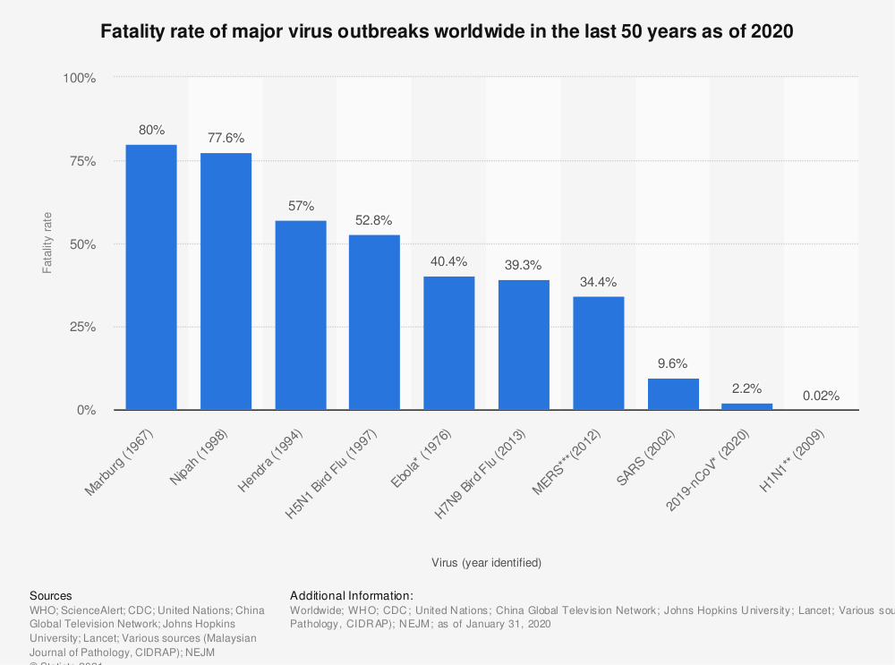

Figure 1, Fatality rate of some major virus outbreaks since 1976, [1].

# **Introduction**

The experienced history of vaccination has proven its effectiveness in protecting both human and animal populations against various diseases since its introduction in 900 CE [2]. However, most of the research has since then been focusing on developing the right vaccine against new outbreaks of diseases, with little effort to investigate how to distribute the developed vaccines across societies in an efficient and agile approach. The speed and effectiveness in which vaccine doses are distributed to society members is an important factor to limit and prevent the outbreaks of diseases across the human population, especially in tight urban environments where individuals are dependent on daily physical contact to keep the society functioning as desired.

This research takes on the challenge of comparing the two main types of vaccination programs; the first type of these programs provides the vaccine doses in a centralized fashion by asking residents to visit a vaccination center, while on the other hand a decentralized vaccination program can be mobile by letting the health crew visit residents at their residential address to provide the vaccine doses.

Each vaccination program has its combination of advantages and disadvantages in term of speed, quality and environmental cost along with some other factors. The centralized vaccination has the advantage of being easy to setup and manage, with the disadvantage of being a contributing factor in spreading infectious diseases as people rush to the vaccination centers and wait in long queues to receive the vaccine, which increases the physical contact of society members and therefore the risk of a higher rate of infections. This physical contact can be minimized when a trained health crew visit residents at their homes to provide the vaccine, but this mobile vaccination program still comes at a cost of more management and coordination of the operations during the vaccination process.

This research will put each vaccination program under the magnifying glass to try revealing their hidden effects and establish a better understanding of their efficiency. We start by building a ground foundation of the process that each individual society member must go through to get a dose of the vaccine in both of the centralized and mobile vaccination programs. Then move on into constructing two petri nets[1] that will be used to implement two separate technical simulations of both vaccination programs using the GPenSIM package tool in MATLAB. The interpretation of these GPenSIM simulations can help achieve the goal of this research by establishing an understanding of the strengths and weaknesses in each vaccination program during various conditions and situations. But at first lets dive into some related work in this field that has been contributed in previous research.

# **Related Work**

Intoduction comes here.

# **Centralized vs. Mobile Vaccination Programs**

The process that each vaccine receiver must go through is described as the workflow of the vaccination program, these workflows can vary in small and big details across environments and up to many factors. In this research we will propose two simplified common approaches of such processes for both centralized and mobile vaccination programs.

Starting with the centralized vaccination program, we assume that visitors arrive at the vaccination center after booking an appointment and that the rate of arrival is known to us, for example 1 visitor per minute. Upon arrival the visitor should be registered at a registration desk before queueing up to receive the vaccine from a trained health personal, then hold in another queue to occupy a waiting room for observation of any unexpected side effects and reactions that might show within half an hour after receiving the vaccine. The process of registering a new visitor is estimated to take 5 minutes on average and requires the help of one staff member at duty. similarly, the vaccination process is expected to take 10 minutes on average and requires the help of one trained health personal to inject the vaccine into the receiver’s body in a safe way. At last, vaccine receivers are required to wait for 30 minutes in isolated waiting rooms available at the vaccination center before leaving. This workflow is visualized below on the left side of figure 2.

The previously proposed workflow of a centralized vaccination program is said to be visitor oriented, as visitors are moving from one stage to another through the vaccination center. This is different for a mobile vaccination program where health personnel are dispatched from one street to another to visit residents at their homes and provide them with the vaccine, making this workflow more oriented to health personal than for the vaccine receivers.

The proposed mobile workflow of this research is provided on the right side of figure 2. It starts by dispatching a vaccination bus with one driver and one health personal to the start street, which is a process that is expected to take 15 minutes on average. After arriving at the target street, the vaccination process can start by visiting residents at their homes in this street, or by letting the residents of the street queue up to receive their dose in the vaccination bus, either way it is estimated to take 10 minutes to provide one dose of vaccine as in the centralized vaccination program. After vaccinating the residents of the targeted street, the vaccination bus needs a turnaround time that is expected to take 1 minute before starting to drive to the next target street.

To keep focus on the main operations of vaccine distribution, we assume that we have an available response team that have sufficient capacity to response to any side effects experienced by any of the vaccine receivers. For this reason, we will not include the details of the intervention from this response team in the main workflows of this research. But it is indeed recommended to extend this research by integrating this response operation into the main workflow as it would make the simulation more realistic and reliable in the future.

Figure 2, The proposed workflows of both centralized(left) and mobile(right) vaccination programs in this research.

# **Simulation Setup of A Centralized Vaccination Program**

Text comes here.

# **Experimental Simulation of a Centralized Vaccination Program using GPenSIM in Matlab**

Text comes here.

# **Simulation Setup of A Mobile Vaccination Program**

Text comes here.

# **Experimental Simulation of a Mobile Vaccination Program using GPenSIM in Matlab**

Text comes here.

# **A Performance Comparsion between the centralized and mobile vaccination programs.**

Text comes here.

*Conclusion*

Text comes here.

##### **Acknowledgment**

Remember to thank the teacher here.

##### **References**

References comes here.

[1] Statista, Fatality rate of major virus outbreaks worldwide in the last 50 years as of 2020, 2021. Available: <https://www.statista.com/statistics/1095129/worldwide-fatality-rate-of-major-virus-outbreaks-in-the-last-50-years/>. Accessed on: 06.10.2021.

[2] The College of Physicians of Philadelphia, History of Vaccines, an educational resource by the college of physicians of Philadelphia, 2021. Available: <https://www.historyofvaccines.org/timeline/all>. Accessed on: 06.10.2021.

[3] James Lyle Peterson. 1981. Petri Net Theory and the Modeling of Systems. Prentice Hall PTR, USA. page 7.

[1] remove this

1. A Petri net is composed of four parts: a set of places P, a set of transitions T, an input function I, and an output function O. [3]