

KONERU LAKSHMAIAH EDUCATIONAL FOUNDATION
Department of Experiential Learning and Global Engagement

PROJECT
BY
REGISTERED NUMBER
2300100006
STUDENT NAME
Md Habib Qureshi

Startup / Team Name: _______________________________________________________________________________
Project Title: IoT-Based Environmental Sensor Network
Mentor Emp ID / Name: 3914 sir /P.Gopi Krishna

Table of Contents
S.No. | Contents | Page No.
1 | Declaration
2 | Abstract
3 | Objectives
4 | Problem Statement
5 | Learning Resources
6 | Methodology / Implementation
7 | Tools and Technologies Used
8 | Results / Output
9 | Challenges Faced
10 | Learning Outcomes and CO Mapping  (Course Code, Course Name, CO Number, CO Description, Project Mapping)
11 | Achievements and Proof of Outcomes  (Patent, Copyright / IP Registered, Consultancy Project, Article / Paper Published, Startup / Product Created, Revenue Generated, Awards / Recognitions, Any Other Proof)
12 | Summary of Self Learning
13 | Appendix  (Few Screen Shots)

Declaration

We, the undersigned, declare that the Self-Learning Project entitled “IoT-Based Environmental Sensor Network” submitted to the Department of Experiential Learning and Global Engagement, K. L. University, is the result of our independent work carried out under the guidance of our project mentor. This project has not been submitted elsewhere.

S.No. | Students Register No. | Students Name | Signature
1. | 2300100045 | GHADGE MAYUR
2. | 2300100006 | MD HABIB QURESHI
3. | 2300100029 | KAREEM PATHAN
4. | 2300100061 | CHARAN SAI
5. | 2300100036 | P HARSH VARDHAN

Project Mentor Emp ID: 3914
Project Mentor Emp Name: P.Gopi Krishna

Signature:
Date:

ABSTRACT:
Monitoring the environment is very important for protecting nature and helping people prepare for changes in weather or pollution. This project is about building a simple and affordable system that uses IoT (Internet of Things) to measure things like temperature, humidity, air quality, light intensity, and rainfall. The system collects data using sensors and shares it online so people can easily access and understand the information. The goal of this project is to create a system that can continuously monitor these environmental factors in real time. The sensors are connected to a microcontroller, which sends the data through Wi-Fi to an online (Thinkspeak). On this platform, users can see the information displayed in an easy-to-read format like charts or graphs. This way, they can keep track of changes and take action if something unusual happens, like bad air quality or heavy rainfall. The results show that the system works well in recording accurate information and providing real-time updates. It can also alert users when something unusual is detected, like sudden changes in weather or pollution levels. In summary, this project provides an affordable and reliable way to monitor the environment using IoT technology. It can be used for things like farming, planning cities, or helping people prepare for bad weather.
Keywords: IoT (Internet of Things) , Environmental Monitoring, Sensors, Real-Time Data, Microcontroller, Wi-Fi.

Introduction:

The Internet of Things (IoT) is an emerging technology that connects physical devices to the internet, enabling them to collect, share, and analyze data in real time. It bridges the gap between the physical and digital worlds by integrating sensors, microcontrollers, communication modules, and cloud computing platforms. This interconnection of smart devices has transformed industries such as healthcare, transportation, agriculture, and environmental monitoring.
Among its numerous applications, environmental monitoring is one of the most impactful domains of IoT. Traditional methods of environmental data collection often require manual measurement and observation, which are time-consuming, less accurate, and limited to specific locations. However, IoT-based environmental sensor networks (ESNs) provide automated, continuous, and scalable monitoring capabilities that significantly enhance accuracy and efficiency.
In an IoT-based environmental sensor network, multiple distributed sensing nodes are deployed across different geographical regions. Each node is equipped with sensors capable of measuring various environmental parameters such as temperature, humidity, air quality (CO₂, PM2.5, VOCs), pressure, light intensity, and sound levels. These nodes transmit the collected data wirelessly to a centralized cloud platform using communication technologies such as Wi-Fi, Zigbee, LoRa, or GSM.
Once the data reaches the cloud, it can be processed, analyzed, and visualized through dashboards or mobile applications. The use of real-time analytics and visualization tools allows users to observe environmental trends, detect anomalies, and generate automatic alerts when any parameter exceeds safe thresholds. This facilitates data-driven decision-making, which is essential for sustainable development, pollution control, and climate change analysis.
The significance of IoT-based environmental sensor networks lies in their ability to collect and manage large volumes of environmental data efficiently, enabling governments, researchers, and industries to take proactive measures. These systems are especially useful in urban environments for monitoring air pollution, agricultural zones for optimizing crop growth conditions, and industrial regions for ensuring compliance with environmental safety standards.
Furthermore, the integration of machine learning (ML) and artificial intelligence (AI) with IoT systems has opened new possibilities for predictive environmental analysis. These technologies can forecast air quality index levels, detect pollution sources, and suggest corrective measures automatically.

Problem Statement:

Environmental changes, like poor air quality and unpredictable weather, affect agriculture, health, and planning. Traditional monitoring methods are costly and lack real-time updates. This project aims to create an affordable IoT-based system to monitor temperature, humidity, air quality, light, and rainfall, providing real-time data for better decision-making and sustainability
Objective:
1. To develop a cost-effective and energy-efficient system using IoT technology and sensors.
2. To collect accurate and continuous data on environmental factors such as temperature, humidity, air quality, light intensity, and rainfall.
3. To transmit and display the collected data on a user-friendly online platform for realtime monitoring.
4. To enable alerts and notifications for unusual changes or critical environmental conditions
5. To support applications in agriculture, urban planning, disaster management, and environmental sustainability.

System Architecture:

The IoT-based environmental sensor network consists of three major components:
1. Embedded System Layer (Sensor Nodes): These are small, battery-powered devices equipped with sensors for measuring
temperature, humidity, air quality (e.g., CO₂, PM2.5), and atmospheric pressure. Microcontrollers such as ESP32 or
Arduino boards are used for processing and wireless communication.
2. Cloud Infrastructure Layer: Data collected from the sensor nodes is transmitted to the cloud using protocols like MQTT
or HTTP. Cloud platforms such as AWS IoT Core, ThingSpeak, or Firebase can be used for data aggregation and storage.
3. User Interface Layer: A web or mobile dashboard visualizes environmental data in real-time. It includes graphical charts,
statistical analysis tools, and alert mechanisms for threshold violations

Working Principle:

1. Sensor nodes continuously collect environmental data.
2. The data is processed and converted into digital form by the microcontroller.
3. The data is transmitted wirelessly (Wi-Fi, LoRa, or Zigbee) to the cloud platform.
4. The cloud stores and organizes data for visualization and analysis.
5. The dashboard displays real-time sensor readings and alerts users when critical limits are reached.

Block Diagram:
ESP32 MCU
DHT Sensor
MQ Sensor
Cloud/ThingSpeak
BMP Sensor
Dashboard

Hardware Components:

- Microcontroller: ESP32
- Temperature and Humidity Sensor: DHT11 or DHT22
- Air Quality Sensor: MQ135 or CCS811
- Pressure Sensor: BMP180 or BME280
- Power Supply: Rechargeable Li-ion battery with solar charging
- Connectivity Module: Built-in Wi-Fi or external GSM/LoRa module

Software Components:

- Firmware Development: Arduino IDE and Visual Studio code
- Communication Protocols: MQTT, HTTP, or CoAP
- Cloud Services: ThingSpeak
- Dashboard Design: HTML, CSS

Applications:
- Smart Cities: Continuous monitoring of air and noise pollution
- Agriculture: Optimization of irrigation and crop growth conditions
- Industrial Zones: Monitoring hazardous emissions and maintaining worker safety
- Healthcare: Tracking environmental conditions in hospitals and labs
- Disaster Management: Early detection of forest fires or toxic gas leaks

Advantages and Limitations:

Advantages:
- Real-time monitoring and analysis
- Low power consumption and cost-effectiveness
- Scalable and adaptable for different environments
Limitations:
- Dependence on network connectivity
- Limited battery life for sensor nodes
- Sensor calibration and maintenance required periodically
Hardware Screenshot
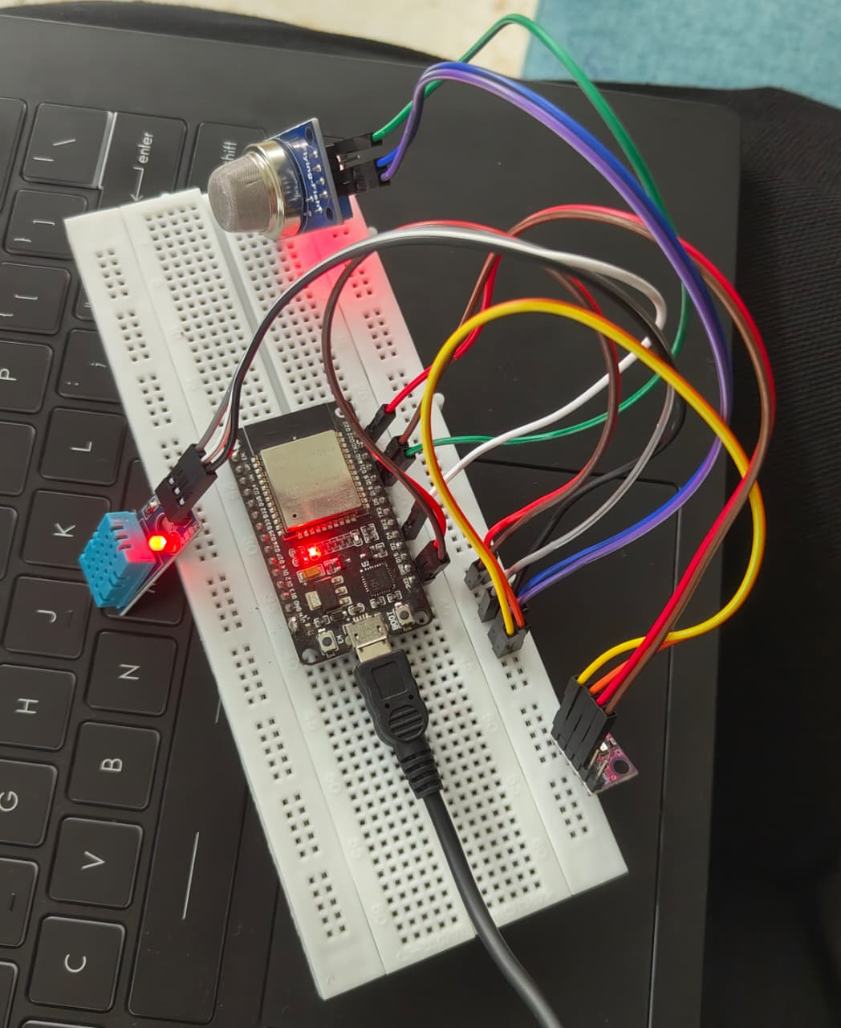

Software Screenshot

Arduino IDE:
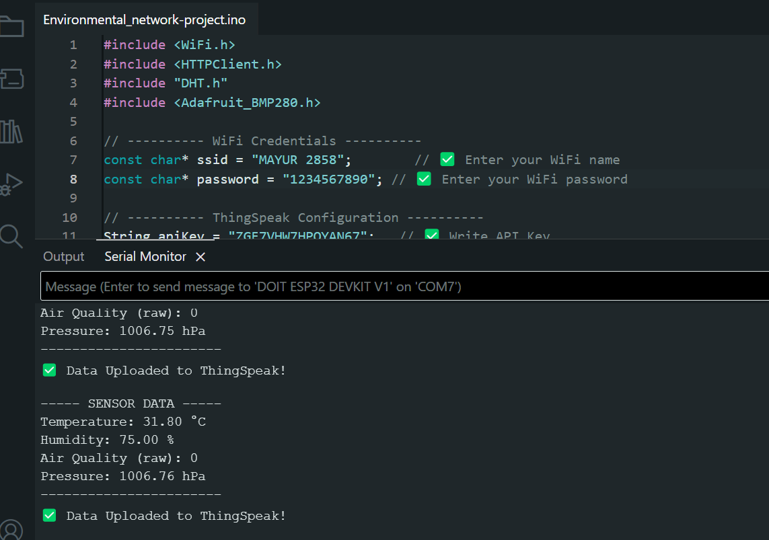

DashBoard:
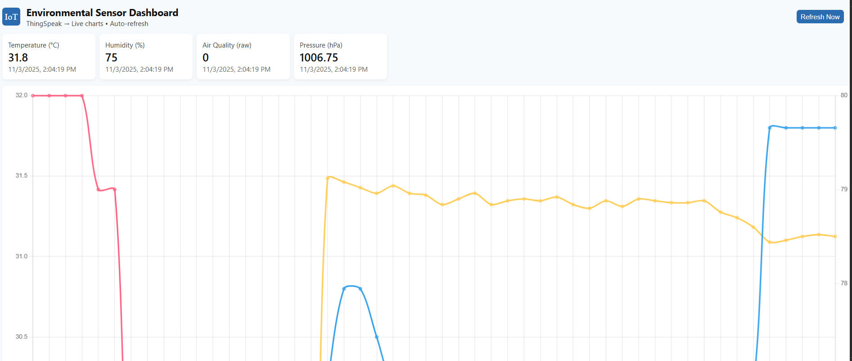
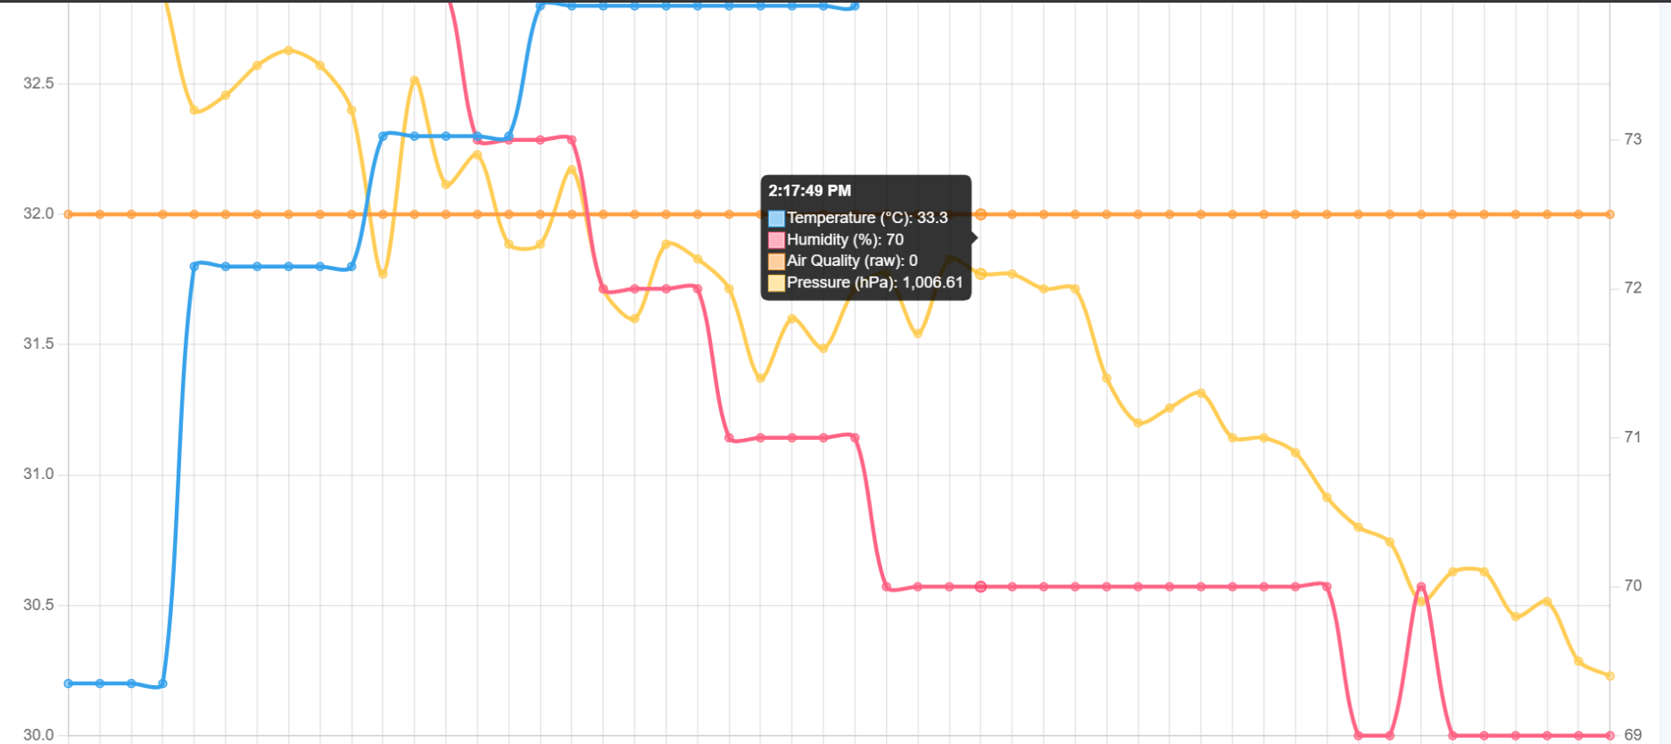
Conclusion:

The IoT-based environmental sensor network is a vital tool for sustainable environmental management.
It combines embedded systems, cloud computing, and data analytics to provide real-time insights into environmental parameters.
This system helps governments, industries, and individuals make informed decisions to improve environmental quality and ensure
public health and safety. The future of this technology lies in integrating artificial intelligence for predictive analytics
and adaptive control mechanisms to respond proactively to environmental changes.

Learning Outcomes:

After studying this project, learners will be able to:
- Understand how IoT systems are applied in environmental monitoring.
- Identify key hardware and software components required for IoT projects.
- Develop and deploy basic IoT applications using cloud platforms.
- Visualize and interpret environmental data effectively.

References:

1. Internet of Things: Principles and Paradigms – Elsevier, 2016
2. AWS IoT Core Documentation – Amazon Web Services
3. ThingSpeak IoT Platform – MathWorks
4. ESP32 Technical Reference Manual – Espressif Systems

