SE432

University Management System (UMS)

Software Requirements Specification

Document

Version: (1) Date: (2/9/2026)

Table of Contents
Chapter 1 – Introduction 5
1.1 Background 5
1.2 Problem Statement 6
1.3 Project Objectives 8
Chapter 2 – System Overview and Architecture 11
2.1 System Vision 11
2.2 High-Level System Architecture 12
2.2.1 Core University Management System (UMS Core) 12
2.2.2 Learning Management System (LMS) 13
2.2.3 Intelligent Chatbot System 13
2.2.4 External Systems and Services 14
2.3 Actors and User Roles 14
2.4 System Context Diagram (DFD Level 0) 15
2.5 Major Business Processes Overview 15
2.6 Architectural Principles 17
2.7 Summary 17
Chapter 3 – Business Processes and Data Flow 18
3.1 Introduction 18
3.2 Context-Level Data Flow (DFD Level 0) 18
3.3 Level 1 Data Flow Overview 19
3.4 Authentication and Authorization Process 19
3.5 Academic Structure Management Process 19
3.6 Course Offering and Scheduling Process 20
3.7 Course Registration Process 20
3.8 Learning and Assessment Process (LMS) 20
3.9 Grading and Academic Evaluation Process 21
3.10 Financial Management Process 21
3.11 Academic Regulation Support Process (Chatbot) 21
3.12 Data Stores Overview 22
3.13 Summary 22
Chapter 4 – Data Design and Class Structure 23
4.1 Introduction 23
4.2 Data Modeling Approach 23
4.3 Identity and Authorization Data Model 24
4.4 Academic Structure Data Model 24
4.5 Student and Academic Staff Data Model 25
4.6 Registration and Enrollment Data Model 26
4.7 Learning and Assessment Data Model (LMS) 27
4.8 Grading and Academic Evaluation Data Model 28
4.9 Financial Management Data Model 28
4.10 Chatbot Knowledge Data Model 29
4.11 Class Diagram Overview 29
4.12 Summary 30
Chapter 5 – System Requirements 31
5.1 Introduction 31
5.2 Functional Requirements 31
5.3 Non-Functional Requirements 44
5.4 Summary 48
Chapter 6 – System Functional Requirements and Use Cases 48
6.1 Introduction 48
6.2 Actors Overview 49
6.3 Authentication and Authorization Use Cases 49
Use Case: User Login 49
6.4 Academic Structure Management Use Cases 50
Use Case: Manage Academic Structure 50
6.5 Course Offering and Scheduling Use Cases 50
Use Case: Create Course Offering 50
6.6 Course Registration Use Cases 51
Use Case: Register for Course 51
6.7 Learning and Assessment Use Cases (LMS) 51
Use Case: Define Assessment Components 51
Use Case: Submit Assessment 52
6.8 Attendance Management Use Cases 52
Use Case: Record Attendance 52
6.9 Grading and Academic Evaluation Use Cases 53
Use Case: Submit Grades 53
6.10 Financial Management Use Cases 53
Use Case: Manage Payments 53
6.11 Academic Regulation Support Use Cases (Chatbot) 54
Use Case: Query Academic Regulations 54
6.12 Use Case Relationships 54
6.13 Summary 54
Chapter 7 – Intelligent Chatbot Subsystem 56
7.1 Introduction 56
7.2 Purpose and Role of the Chatbot 56
7.3 Chatbot Scope and Limitations 57
7.4 Chatbot Architecture Overview 57
7.5 Knowledge Base Design 58
7.6 Query Processing Workflow 58
7.7 Integration with the UMS 58
7.8 Security and Governance Considerations 59
7.9 Use Cases of the Chatbot Subsystem 59
7.10 Benefits of the Chatbot Subsystem 59
7.11 Summary 59
7.12 Abstract 60
7.13 List of Diagrams 60
Chapter 8 – Conclusion and Future Work 70
8.1 Conclusion 70
8.2 Project Contributions 70
8.3 Limitations 70
8.4 Future Work 70
8.5 Final Remarks 71

Chapter 1 – Introduction

1.1 Background
Modern universities operate as complex organizations that manage academic, administrative, financial, and learning processes involving a wide range of stakeholders. These stakeholders include students, instructors, teaching assistants, department leadership, faculty leadership, financial officers, and administrative staff. In many institutions, these processes are still supported by fragmented systems or semi-manual workflows that rely on disconnected applications, spreadsheets, or paper-based procedures. Such fragmentation leads to duplicated data entry, inconsistent records, delayed processing, and increased administrative workload.

In a university environment that follows a credit-hour system with GPA calculation out of 4.0, these challenges become more critical. Academic decisions such as course registration, prerequisite validation, academic standing, grade calculation, and graduation eligibility depend on accurate, synchronized, and timely data. Additionally, modern universities frequently allow cross-departmental and cross-faculty course offerings, where students belong to one department while enrolling in courses taught by instructors from other departments or faculties. This academic flexibility significantly increases the complexity of coordination, data management, and rule enforcement within the university system.

At the same time, learning activities are no longer limited to classroom scheduling and final examinations. Universities increasingly rely on Learning Management Systems (LMS) to support continuous assessment through assignments, quizzes, projects, and attendance tracking. These learning-related activities directly contribute to official academic records and grade computation. As a result, the LMS must be deeply integrated into the overall university management platform rather than treated as an isolated or supplementary tool.

Furthermore, students and staff frequently need access to official university regulations, academic policies, grading rules, attendance requirements, and administrative procedures. When such information is only available through lengthy documents or static PDF files, users experience confusion, delays, and repeated reliance on administrative offices. This situation highlights the need for an intelligent, always-available advisory system that can provide accurate, authoritative, and regulation-based answers using natural language interaction.
These challenges collectively emphasize the necessity of a unified, process-driven University Management System that integrates academic operations, learning activities, financial control, governance mechanisms, and intelligent user support into a single coherent platform.

1.2 Problem Statement

The primary problem addressed by this project is the absence of a centralized and integrated system that manages the full academic, learning, and administrative lifecycle of a single university in a consistent, rule-driven, and transparent manner.
Without such a system, universities commonly face the following issues:
- Inconsistent management of academic structures such as faculties, departments, programs, and courses, leading to data duplication and ambiguity in academic responsibility.

- Course registration errors caused by missing or improperly enforced rules related to prerequisites, GPA conditions, credit-hour limits, and registration windows.

- Weak integration between financial status and academic operations, particularly in cases where unpaid fees should block or restrict course registration.

- Fragmented grading and assessment processes when continuous evaluation components (assignments, quizzes, projects, attendance) are managed outside the official academic system.

- Difficulty enforcing diverse attendance policies that vary by course and affect grades in different ways.

- Challenges in handling exceptional academic periods such as the Summer semester, where enrollment and evaluation rules differ from the regular academic term.

- Limited visibility for academic leadership (Heads of Departments, Deans, and University President/Chancellor) to monitor academic performance, operational efficiency, and policy compliance.

- Lack of immediate and reliable access to official academic regulations and policies, resulting in repeated inquiries and increased administrative burden.

As a result, academic accuracy, operational efficiency, and user satisfaction are negatively affected. The absence of an integrated platform also increases the risk of data inconsistency, delays in academic decision-making, disputes regarding grades and eligibility, and administrative errors.

1.3 Project Objectives

The main objective of this project is to design and document a comprehensive University Management System (UMS) that supports academic, administrative, financial, and learning processes through clearly defined workflows and enforced business rules.
The specific objectives of this project are:
- To develop a centralized system for a single university that manages all core academic and administrative operations.
- To implement a secure Role-Based Access Control (RBAC) model that supports users with multiple roles (e.g., Instructor and Head of Department).
- To support the complete student academic lifecycle, including:
  - Admissions
  - Course registration
  - Course offerings and scheduling
  - Attendance tracking
  - Grading and assessment
  - Examination management
- To enforce course registration rules automatically, including:
  - Registration availability within a defined time window
  - Maximum credit-hour limits
  - Course prerequisite validation
  - GPA-based eligibility conditions
  - Blocking registration based on financial status

- To integrate a Learning Management System (LMS) as a core subsystem responsible for:
  - Managing continuous assessment activities
  - Supporting optional grading components
  - Contributing directly to final grade computation

- To design a financial management process that:
  - Applications for fixed program-based fees per semester
  - Supports scholarships, discounts, and fines
  - Controls academic access based on payment status

- To provide an intelligent chatbot system that offers real-time access to official university regulations and policies using natural language interaction in Arabic.

- To model the system using industry-standard techniques, including DFD, ERD, class diagrams, use case diagrams, activity diagrams, and sequence diagrams, ensuring academic rigor and clarity.

  - Project Scope
In-Scope Features
- The scope of the system includes:
  - Management of university academic structure (faculties, departments, programs, courses).
  - User and role management with administrator-controlled account creation.
  - Admissions and student record management.
  - Course offerings and instructor assignment.
  - Course registration with rule-based validation.
  - Timetable and classroom scheduling.
  - Attendance management with configurable policies.
  - Grading and assessment management through LMS integration.
  - Examination management.
  - Financial management including semester-based program fees.
  - Blocking and unblocking academic actions based on payment status.
  - Reporting and dashboards for academic leadership.
  - Integration with:
  - National ID systems
  - University email services
  - Internal LMS
  - Intelligent chatbot for academic regulation and policy inquiry.
Out-of-Scope Features
- The following features are explicitly excluded from the current scope:
  - Multi-university or federated university support.
  - Public self-registration of user accounts.
  - External online payment gateways (unless added in future work).
  - Mobile application support (considered a future enhancement).

  - Stakeholders and User Roles
- The system serves multiple stakeholders, each with clearly defined responsibilities:
  - Students: Register courses, view schedules, attendance, grades, and financial status.
  - Instructors (Professors/Doctors): Manage course content, assessments, grading, and attendance policies.
  - Teaching Assistants (TAS): Assist in attendance recording and assessment-related tasks.
  - Head of Department: Monitor departmental academic performance and course offerings.
  - Dean: Oversee faculty-level academic and operational activities.
  - University President / Chancellor: Access university-wide reports and performance indicators.
  - Finance Officers: Manage fees, payments, scholarships, discounts, and registration blocking.
  - System Administrators / Registrars: Manage users, roles, academic structures, and system configuration.

  - Assumptions and Constraints
- The system is designed under the following assumptions and constraints:
  - The university follows a two-semester academic calendar, with the Winter semester as the primary term.
  - The Summer semester is reserved for remedial and exceptional academic cases.
  - Academic evaluation is based on a credit-hour system with GPA calculated out of 4.0.
  - Each student belongs to one department but may enroll in courses offered by other departments or faculties.
  - Course registration is fully automatic but strictly limited to a defined registration window.
  - Attendance and grading policies vary by course and must be configurable.
  - Financial status directly affects academic access.
  - The chatbot operates in a read-only advisory role and does not modify transactional data.

  - Methodology
- The project follows a structured methodology consisting of:
  - Requirements analysis and business rule identification.
  - Process modeling using Data Flow Diagrams.
  - Data modeling using Entity-Relationship Diagrams.
  - Structural modeling using class diagrams.
  - Behavioral modeling using case, activity, and sequence diagrams.
  - System validation through consistency checks between models and requirements.
  - Documentation and academic presentation.

Chapter 2 – System Overview and Architecture

2.1 System Vision

The proposed University Management System (UMS) is designed as a unified, process-driven platform that supports the academic, learning, administrative, and financial operations of a single university. The system is not limited to basic data management; instead, it enforces university policies, academic rules, and governance constraints through well-defined workflows and controlled interactions between subsystems.
The vision of the system is to provide a single source of truth for academic and administrative data while ensuring that all critical operations—such as registration, grading, attendance, and financial control—are executed consistently, transparently, and in accordance with official university regulations. The system is intended to serve both operational users (students, instructors, TAS, finance officers, administrators) and decision-making authorities (Heads of Departments, Deans, and the University President/Chancellor).
To achieve this vision, the system adopts a separation-of-concerns approach, where responsibilities are distributed across clearly defined subsystems that interact through controlled data flows and shared business rules.

2.2 High-Level System Architecture
- At a high level, the system architecture consists of three primary subsystems, supported by external integrations:
  - Core University Management System (UMS Core)
  - Learning Management System (LMS)
  - Intelligent Chatbot System
  - External Systems and Services

Each subsystem has a distinct responsibility and authority, and no subsystem overlaps another’s core role.

2.2.1 Core University Management System (UMS Core)
The UMS Core represents the transactional backbone of the platform. It is responsible for managing official academic and administrative records and enforcing university rules that govern student progression and academic eligibility.
- The UMS Core handles the following responsibilities:
  - Management of academic structures, including faculties, departments, programs, and courses.
  - Student admissions and maintenance of official student records.
  - Course offerings and instructor assignments.
  - Course registration, including validation of registration windows, credit-hour limits, prerequisites, GPA-based eligibility, and financial clearance.
  - Timetable and classroom scheduling.
  - Integration with financial processes to block or allow academic actions.
  - Generation of official academic reports and dashboards for leadership roles.
All data managed by the UMS Core is considered authoritative and official, and any changes to this data are strictly controlled through role-based access and validated processes.

2.2.2 Learning Management System (LMS)
- The Learning Management System (LMS) is a core academic subsystem, not a supplementary feature. It is responsible for managing learning activities and continuous assessment that directly contribute to official academic outcomes.
- The LMS subsystem handles:
  - Definition and management of assessment components for each course, including assignments, quizzes, projects, and attendance-based evaluation.
  - Support for optional assessment components, where instructors are required to select at least one optional component in addition to mandatory components (such as midterm and final examinations).
  - Collection of student submissions and assessment results.
  - Participation in grade computation by providing validated assessment data to the UMS Core.
  - Support for diverse attendance policies, where attendance may be mandatory, grade-impacting, or informational only.
The LMS does not operate independently of the UMS Core. Instead, it collaborates with the UMS Core, where the LMS manages learning activities and raw assessment data, while the UMS Core maintains official enrollment records and final grade registration. This separation ensures flexibility in learning design while preserving academic integrity and centralized control of official records.
2.2.3 Intelligent Chatbot System

The intelligent chatbot system is designed as a read-only advisory subsystem that provides instant access to official university regulations, academic policies, and procedural guidelines.
- Key characteristics of the chatbot subsystem include:
  - Natural language interaction in Arabic.
  - Retrieval of answers from official university documents and structured academic data.
  - Use of Retrieval-Augmented Generation (RAG) techniques to ensure accuracy and source traceability.
  - Context-aware conversation handling for follow-up questions.
  - Explicit restriction from modifying any transactional or academic data.

The chatbot does not participate in operational workflows such as registration, grading, or payments. Its role is to support users’ understanding of rules and procedures, reduce administrative workload, and improve user experience by providing authoritative answers at any time.

2.2.4 External Systems and Services
- The UMS integrates with several external systems to support identity verification and communication:
  - National ID System: Used for identity validation and consistency of official records.
  - University Email System: Used for notifications, announcements, and system-generated communications.
These integrations enhance reliability and compliance while keeping the UMS as the central control point for academic operations.

2.3 Actors and User Roles
- The system serves multiple actors, each interacting with the system according to clearly defined responsibilities and privileges:
  - Student: Registers courses, accesses LMS activities, views schedules, attendance, grades, and financial status.
  - Instructor (Professor/Doctor): Manages course content, defines assessment components, evaluates students, and oversees attendance policies.
  - Teaching Assistant (TA): Assists instructors in attendance recording and assessment-related tasks.
  - Head of Department: Oversees departmental academic activities and monitors performance indicators.
  - Dean: Supervises faculty-level academic and operational activities.
  - University President / Chancellor: Accesses university-wide reports and strategic indicators.
  - Finance Officer: Manages fees, payments, scholarships, discounts, and registration blocking.
  - System Administrator / Registrar: Manages users, roles, academic structures, and system configuration.
A single user may possess multiple roles simultaneously, and the system enforces access control using Role-Based Access Control (RBAC).
2.4 System Context Diagram (DFD Level 0)

At the highest level, the system can be viewed as a single process that interacts with external entities such as students, academic staff, administrative staff, finance departments, and external identity and communication services.
The DFD Level 0 illustrates how data flows between these external entities and the UMS as a whole, establishing the system boundary and identifying the main inputs and outputs without exposing internal process details.
This context-level view confirms that all academic and administrative interactions are mediated through the UMS, while external systems provide supporting services without controlling academic processes.
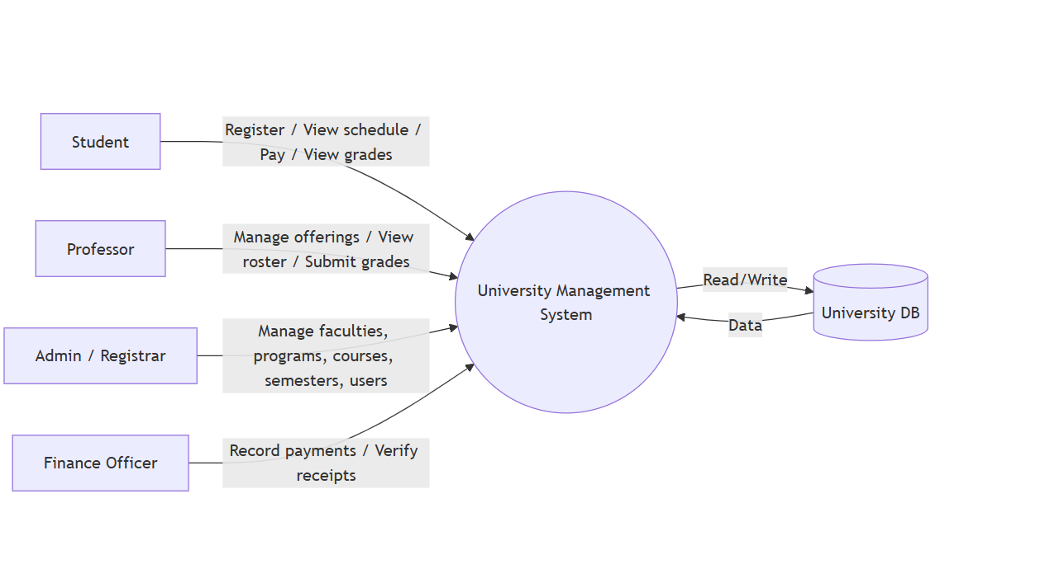
2.5 Major Business Processes Overview
Based on the detailed Data Flow Diagrams (DFDs) and sequence diagrams, the system supports several major business processes:
Authentication and Authorization
User authentication, role resolution, and establishment of authorization context for system interactions.

Academic Structure Management
Creation and maintenance of faculties, departments, programs, and courses, along with assignment of instructors and academic responsibilities.

Course Offering and Scheduling
Creation of course offerings per semester and allocation of classrooms and schedules.

Course Registration
Validation of registration window availability, enforcement of academic and financial rules, and automatic approval or rejection of registration requests.

Learning and Assessment
Management of assessments through the LMS, including continuous evaluation and attendance tracking.

Grading and Academic Evaluation
Collection of assessment data, calculation of final grades, and publication of official academic results.

Financial Management
Recording of fees and payments, application of scholarships, discounts, and fines, and blocking or unblocking academic actions based on financial status.

Academic Regulation Support
Provision of regulation-based answers through the intelligent chatbot subsystem.

2.6 Architectural Principles
- The design of the system is guided by the following principles:
  - Separation of Concerns: Each subsystem has a clearly defined responsibility.
  - Process-Driven Design: Business rules are enforced through workflows rather than isolated functions.
  - Centralized Authority: Official academic records are managed by the UMS Core.
  - Flexibility in Learning: The LMS supports diverse assessment and attendance policies.
  - Security and Governance: Access is controlled through RBAC and validated processes.
  - Scalability and Maintainability: Modular design supports future expansion.

2.7 Summary

This chapter presented an overview of the proposed University Management System and its architecture. The system is composed of a transactional core (UMS Core), a learning-focused subsystem (LMS), and an intelligent advisory subsystem (chatbot), supported by external integrations. Together, these components form a cohesive platform that enforces academic rules, supports learning activities, ensures financial control, and provides reliable regulatory guidance.
The following chapters will describe the system’s internal processes, data models, and functional behavior in greater detail, supported by formal diagrams and structured analysis.

Chapter 3 – Business Processes and Data Flow

3.1 Introduction

This chapter describes the core business processes of the University Management System (UMS) and explains how data flows between system components, users, and subsystems. The objective of this chapter is to translate the system architecture presented in Chapter 2 into executable operational workflows that reflect how academic, learning, and administrative activities are actually performed.
- The system is modeled using Data Flow Diagrams (DFD) to represent:
  - The flow of information between external entities and the system
  - The internal processes that transform data
  - The data stores that maintain persistent system state
The business processes described in this chapter are aligned with the DFD Level 0 (Context Diagram) and DFD Level 1, as well as the detailed process-level DFDs for registration, grading, payments, scheduling, and authentication.

3.2 Context-Level Data Flow (DFD Level 0)
At the context level, the University Management System is represented as a single high-level process that interacts with multiple external entities. This diagram establishes the system boundary and clarifies what lies inside and outside the scope of the UMS.
- External Entities:
  - Students
  - Instructors and Teaching Assistants
  - Academic Leadership (Heads of Departments, Deans, President/Chancellor)
  - Finance Department
  - System Administrators
  - External Systems (National ID System, University Email System)

Primary Data Exchanges include academic requests, learning interactions, financial information, and identity and communication data.

3.3 Level 1 Data Flow Overview
The DFD Level 1 decomposes the system into major internal processes that collectively implement university operations. These processes represent functional workflows, not software modules.
- The main processes include:
  - Authentication and Authorization
  - Academic Structure Management
  - Course Offering and Scheduling
  - Course Registration
  - Learning and Assessment (LMS)
  - Grading and Academic Evaluation
  - Financial Management
  - Academic Regulation Support (Chatbot)

3.4 Authentication and Authorization Process
This process is responsible for verifying user identity and establishing an authorization context based on assigned roles.
- Data Flow:
  - Users submit login credentials.
  - The system validates credentials against the user data store.
  - Assigned roles are retrieved and evaluated.
  - An authorization context is created and attached to the user session.

3.5 Academic Structure Management Process

This process manages the academic hierarchy of the university, including faculties, departments, programs, and courses.
- Data Flow:
  - Administrators define or update academic structures.
  - Changes are validated and stored in academic data stores.
  - Academic leadership accesses structure data for monitoring and reporting.

3.6 Course Offering and Scheduling Process

This process handles the preparation of courses for a specific academic term, including the Winter semester and the remedial Summer semester.
- Data Flow:
  - Courses are offered for a specific semester.
  - Instructors are assigned to course offerings.
  - Classrooms and time slots are allocated.
  - Scheduling data is stored and made available to students and staff.

3.7 Course Registration Process

This process allows students to enroll in courses while enforcing academic and administrative rules.
- Data Flow:
  - Student initiates a registration request.
  - The system verifies registration window availability, course capacity, prerequisite fulfillment, GPA eligibility, and financial clearance.
  - Registration is approved or rejected.
  - Enrollment data is stored and forwarded to relevant subsystems.

3.8 Learning and Assessment Process (LMS)

This process is managed by the Learning Management System (LMS) and supports continuous evaluation of students.
- Data Flow:
  - Instructors define assessment components.
  - Students submit assignments and complete quizzes.
  - Attendance is recorded according to course policy.
  - Assessment data is stored and validated.

3.9 Grading and Academic Evaluation Process

This process computes final academic results based on LMS assessment data and official enrollment records.
- Data Flow:
  - Assessment data is retrieved from the LMS.
  - Weighting rules are applied.
  - Final grades, letter grades, and grade points are calculated.
  - Results are stored as official academic records.

3.10 Financial Management Process

This process handles student fees and controls academic access based on payment status.
- Data Flow:
  - Fees are calculated per program and semester.
  - Payments, scholarships, discounts, and fines are recorded.
  - Financial status is evaluated.
  - Academic actions are blocked or unblocked accordingly.

3.11 Academic Regulation Support Process (Chatbot)

This process provides regulation-based academic support through an intelligent chatbot.
- Data Flow:
  - Users submit natural language questions.
  - The chatbot retrieves relevant information from official sources.
  - Responses are generated and returned with source attribution.

3.12 Data Stores Overview
- The system relies on persistent data stores including:
  - User and Role Data
  - Academic Structure Data
  - Enrollment and Registration Data
  - LMS Assessment Data
  - Grades and Academic Records
  - Financial Records
  - Regulation Documents and Knowledge Base

3.13 Summary

This chapter presented a detailed description of the University Management System’s business processes and data flows using Data Flow Diagrams. The system is designed around process-driven workflows that enforce academic, learning, and financial rules through controlled data transformations.
The next chapter focuses on the data design and class structure, explaining how system entities and relationships support the processes described in this chapter.

Chapter 4 – Data Design and Class Structure

4.1 Introduction

This chapter describes the data design and structural model of the University Management System (UMS). While the previous chapter focused on business processes and data flow, this chapter explains how the system’s data is structured, stored, and organized to support those processes.
- The system data design is represented using:
  - Entity-Relationship Diagrams (ERD) to model persistent data entities and their relationships.
  - Class Diagrams to describe the object-oriented structure of the system and the interaction between core classes.
The data model is designed to ensure data consistency, integrity, scalability, and alignment with academic and administrative rules enforced by the system.

4.2 Data Modeling Approach

The data model follows a domain-based separation, where entities are grouped according to their functional responsibility. This approach improves clarity, maintainability, and alignment with system processes.
- The major data domains include:
  - Identity and Authorization
  - Academic Structure
  - Registration and Enrollment
  - Learning and Assessment (LMS)
  - Financial Management
  - Academic Records and Evaluation
  - Regulatory Knowledge (Chatbot)
Each domain is represented by a dedicated ERD or a logical grouping of entities within the overall data model.

4.3 Identity and Authorization Data Model

Description
The identity and authorization domain is responsible for managing system users, their credentials, and their access privileges. This domain supports multirole users and enforces Role-Based Access Control (RBAC).
Core Entities
- User
  - Stores personal and authentication-related information.
  - Represents a system account, not a specific academic role.

- Role
  - Defines a specific system role (e.g., Student, Instructor, Admin).
  - Used to control access to system functions.

- User Role
  - Represents a many-to-many relationship between users and roles.
  - Allows a single user to hold multiple roles simultaneously.

Key Relationships
- A user can be assigned multiple roles.
- Each role can be assigned to multiple users.
- Access to system processes is determined by role assignments.

4.4 Academic Structure Data Model

Description
The academic structure domain defines the hierarchical organization of the university and forms the foundation for registration, scheduling, and evaluation processes.
Core Entities
- Faculty
  - Represents a high-level academic division.
- Department
  - Represents an academic unit within a faculty.
- Program
  - Represents an academic program that may belong to one or more departments or faculties.
- Course
  - Represents an academic subject offered by the university.
  - Courses may be shared across departments and faculties.
Key Relationships
- Faculties contain departments.
- Departments offer programs.
- Programs include multiple courses.
- Courses may be associated with multiple departments.
- This flexible structure supports cross-departmental and cross-faculty teaching, as required by the university model.

4.5 Student and Academic Staff Data Model
Student Entity
- The Student entity represents enrolled students and stores academic attributes such as:
  - Student number
  - Enrollment year
  - Academic status
  - Current GPA
  - Department and program affiliation
Each student is linked to a user account for authentication purposes.

Instructor and Teaching Assistant Entities

- Instructor
  - Represents academic staff responsible for course delivery and evaluation.

- Teaching Assistant (TA)
  - Supports instructors in attendance tracking and assessment activities.

Academic staff entities are linked to user accounts and may be associated with multiple courses across departments.

4.6 Registration and Enrollment Data Model

Description
This domain manages student enrollment in courses and enforces academic and administrative constraints.

Core Entities
Semester
- Represents an academic term (Winter or Summer).
- Stores registration windows and term-specific rules.

Course Offering
- Represents the availability of a course in a specific semester.
- Links courses, instructors, schedules, and capacity.

Registration
- Represents a student’s enrollment record in a course offering.
- Stores registration status and timestamps.

Key Relationships
- A semester contains multiple course offerings.
- A course offering can have multiple student registrations.
- Each registration links a student to a course offering.

This model supports both regular registration and exception-based enrollment during the Summer semester.

4.7 Learning and Assessment Data Model (LMS)

Description
The LMS data model supports continuous assessment and learning activities that directly contribute to academic evaluation.

Core Entities
- Assessment Component
  - Defines assessment types such as assignments, quizzes, projects, and attendance.

- Assessment Submission
  - Stores student submissions and results for assessment components.

- Attendance Record
  - Stores attendance data according to course-specific policies.

Key Relationships
- Each course offering may define multiple assessment components.
- Students submit assessments linked to course offerings.
- Attendance records contribute to grading when applicable.
The LMS model ensures flexibility while maintaining consistency with grading rules.

4.8 Grading and Academic Evaluation Data Model

Description
This domain represents the official academic evaluation results produced by the system.

Core Entities

- Grade
  - Stores final numeric grades, letter grades, and grade points.
  - Linked to student registrations and course offerings.

Key Characteristics
- Grades are computed using LMS assessment data.
- Final grades are stored as official academic records.
- Grade modification is strictly controlled.

4.9 Financial Management Data Model

Description

The financial domain manages fees and payments and controls academic access based on financial status.

Core Entities

- Fee
  - Represents program-based and semester-based fees.

- Payment
  - Stores payment transactions, including scholarships, discounts, and fines.

Key Relationships

  - Payments are linked to students and semesters.
  - Financial status affects registration eligibility.

4.10 Chatbot Knowledge Data Model

- The chatbot subsystem relies on a read-only knowledge base that includes:
  - University regulations
  - Academic policies
  - Procedural documents
This data is stored separately from transactional data to ensure safety and consistency.

4.11 Class Diagram Overview

- The class diagram provides an object-oriented representation of the system and complements the ERD by:
  - Defining class attributes and methods.
  - Showing inheritance and associations.
  - Representing interactions between UMS Core, LMS, and chatbot components.
The class structure reflects the domain separation defined in the ERD and supports modular development.

4.12 Summary
This chapter presented the data design and class structure of the University Management System. The ERD and class diagram collectively define how system data is organized to support academic, learning, and administrative processes.
The next chapter focuses on system functionality and user interactions, described through detailed use case specifications.

Chapter 5 – System Requirements

5.1 Introduction

This chapter defines the system requirements of the University Management System (UMS). The requirements specify what the system must do (functional requirements) and how well the system must perform (non-functional requirements).
Together, these requirements provide a clear and testable specification that can guide system implementation and validation.

5.2 Functional Requirements

Functional requirements describe the services, behaviors, and operations that the system must provide. These requirements are grouped by functional domain.

Authentication and Authorization Requirements
FR-1 The system shall authenticate users using unique credentials.
- Acceptance Criteria
  - Given a registered user, when valid username and password are submitted, then the system shall grant access and create an authenticated session.
  - Given invalid credentials, when the user attempts to login, then the system shall deny access and display an error message.
  - Given an inactive/deactivated account, when the user attempts to login, then the system shall deny access.

FR-2 The system shall support Role-Based Access Control (RBAC).
- Acceptance Criteria
  - Given a user with role(s), when the user accesses a protected feature, then the system shall allow access only if the role has permission.
  - Given a user without permission, when accessing a protected feature, then the system shall block access and return “Access Denied”.

FR-3 The system shall allow a single user to be assigned multiple roles.
- Acceptance Criteria
  - Given an admin, when assigning multiple roles to one user, then the system shall persist all assigned roles.
  - Given a multi-role user, when permissions are evaluated, then the system shall combine permissions according to assigned roles.

FR-4 The system shall restrict access to system functions based on assigned roles.
- Acceptance Criteria
  - Given any protected function, when accessed by a user lacking required role permissions, then the system shall deny access.
  - Given role permissions are updated, when the user retries access, then the new permissions shall take effect immediately (next authorization check).

FR-5 The system shall prevent unauthenticated users from accessing protected system resources.
- Acceptance Criteria
  - Given a non-authenticated request to a protected resource, when accessed, then the system shall redirect to login (or return HTTP 401/403).
  - Given an expired session, when a user accesses a protected resource, then the system shall require re-authentication.
User and Role Management Requirements

FR-6 The system shall allow system administrators to create, update, and deactivate user accounts.
- Acceptance Criteria
  - Given an admin, when creating a user with required fields, then the account shall be created and visible in the user list.
  - Given an admin, when updating user details, then changes shall be saved and reflected in subsequent reads.
  - Given an admin, when deactivating a user, then the user shall be unable to authenticate.
FR-7 The system shall allow administrators to assign and revoke roles for users.
- Acceptance Criteria
  - Given an admin, when a role is assigned to a user, then the user’s authorization shall reflect that role.
  - Given an admin, when a role is revoked, then access dependent on that role shall be denied immediately (next check).
  - Given an invalid role, when admin attempts assignment, then the system shall reject with a validation error.

FR-8 The system shall maintain an association between user accounts and academic or administrative entities.
- Acceptance Criteria
  - Given a staff user, when linking the user to a faculty/department/unit, then the link shall be stored and retrievable.
  - Given a user is linked to an entity, when that entity changes, then the system shall maintain referential integrity (no broken links).

Academic Structure Management Requirements

FR-9 The system shall manage academic structures including faculties, departments, programs, and courses.
- Acceptance Criteria
  - Given an authorized admin, when creating/updating/deleting (or deactivating) a faculty/department/program/course, then changes shall persist.
  - Given unauthorized user, when attempting management operations, then access shall be denied.

FR-10 The system shall allow programs to belong to one or more departments or faculties.
- Acceptance Criteria
  - Given an authorized admin, when assigning a program to multiple departments/faculties, then all relationships shall be saved.
  - Given a program has multiple associations, when viewing program details, then all linked departments/faculties shall be displayed.

FR-11 The system shall allow courses to be shared across departments.
- Acceptance Criteria
  - Given an authorized admin, when linking a course to multiple departments, then all links shall be stored.
  - Given a shared course, when generating department course lists, then the course shall appear in each linked department list.

FR-12 The system shall ensure consistency of academic structure relationships.
- Acceptance Criteria
  - Given a relationship rule (e.g., valid foreign keys), when an admin attempts an invalid link, then the system shall reject it with a clear message.
  - Given an entity is removed/deactivated, when it is referenced, then the system shall prevent orphaned relationships (enforce constraints).

Admissions and Student Management Requirements

FR-13 The system shall store and manage official student records.
- Acceptance Criteria
  - Given an authorized staff member, when creating a student record with mandatory fields, then the system shall save it as an official record.
  - Given a student record exists, when searching by ID/name, then the correct record shall be returned.

FR-14 The system shall associate each student with a department and program.
- Acceptance Criteria
  - Given a student record, when assigning department and program, then the system shall validate they exist and save the association.
  - Given missing department/program, when saving the student record, then the system shall block saving and show validation errors.

FR-15 The system shall track academic status and GPA for each student.
- Acceptance Criteria
  - Given completed grades exist, when GPA is requested, then the system shall calculate and display GPA based on configured rules.
  - Given no grades yet, when GPA is requested, then the system shall show GPA as “N/A” (or 0.00 per policy) without errors.
  - Given status rules exist, when GPA/credits change, then the academic status shall update accordingly.
Semester and Course Offering Requirements

FR-16 The system shall support multiple academic semesters.
- Acceptance Criteria
  - Given an admin, when creating semesters with start/end dates, then multiple semesters shall coexist without overlap rule violations (if enforced).
  - Given a semester is active, when querying current semester, then the system shall return the correct one.
FR-17 The system shall treat the Winter semester as the primary academic term.
- Acceptance Criteria
  - Given semesters include Winter, when the system needs a default/primary term, then Winter shall be selected as primary.
  - Given reporting across academic year, when “primary term” is referenced, then Winter data shall be used by default unless overridden.

FR-18 The system shall support a remedial Summer semester with special enrollment rules.
- Acceptance Criteria
  - Given Summer is marked remedial, when a student attempts Summer registration, then remedial rules shall be applied.
  - Given a student violates Summer rules, when registering, then the system shall reject with a specific reason.

FR-19 The system shall allow administrators to create course offerings per semester.
- Acceptance Criteria
  - Given an admin, when creating a course offering with course + semester + capacity, then it shall be saved and listed for that semester.
  - Given duplicate offering rules, when creating an invalid duplicate, then the system shall prevent it (if policy requires uniqueness).

FR-20 The system shall allow instructors to be assigned to course offerings.
- Acceptance Criteria
  - Given an admin, when assigning an instructor to an offering, then the assignment shall be stored and visible to instructor and students.
  - Given an offering has no instructor, when viewed, then it shall show “Unassigned” (or equivalent) without failure.

Course Registration Requirements

FR-21 The system shall allow students to register for course offerings during a defined registration window.
- Acceptance Criteria
  - Given registration is open, when a student submits registration, then the request shall be accepted for processing.
  - Given registration is closed, when a student submits registration, then the system shall reject with “Registration window closed”.

FR-22 The system shall automatically validate registration eligibility.
- Acceptance Criteria
  - Given a student submits a registration request, when processed, then the system shall validate prerequisites, GPA rules, credit limits, and financial clearance.
  - Given any rule fails, when processed, then the system shall return a rejection reason.

FR-23 The system shall enforce maximum credit-hour limits.
- Acceptance Criteria
  - Given a student’s current registered credits, when adding a course exceeds the max limit, then the system shall reject the registration.
  - Given adding a course remains within limit, then the system shall allow continuation.

FR-24 The system shall enforce course prerequisite requirements.
- Acceptance Criteria
  - Given a course has prerequisites, when the student has not completed them, then the system shall reject registration.
  - Given prerequisites are satisfied, then the system shall allow registration (subject to other validations).
FR-25 The system shall enforce GPA-based eligibility conditions.
- Acceptance Criteria
  - Given a course or semester has GPA conditions, when student GPA is below threshold, then registration shall be rejected.
  - Given student meets GPA threshold, then registration shall pass this check.

FR-26 The system shall block course registration when financial obligations are unmet.
- Acceptance Criteria
  - Given a student is not financially cleared, when attempting registration, then the system shall block it and show “Financial hold”.
  - Given the student becomes cleared, when retrying registration, then the hold shall no longer block registration.

FR-27 The system shall automatically approve or reject registration requests.
- Acceptance Criteria
  - Given all validations pass, when the request is processed, then the system shall approve and enroll the student automatically.
  - Given any validation fails, then the system shall reject automatically with a stored reason.
  - Given the decision is made, then the system shall store the outcome (approved/rejected) with timestamp.

Learning Management System (LMS) Requirements

FR-28 The system shall integrate an LMS as a core academic subsystem.
- Acceptance Criteria
  - Given an authenticated user, when accessing LMS features, then the system shall provide access without separate login (SSO or unified session, if configured).
  - Given LMS is unavailable, when accessed, then the system shall show a clear service error and not crash.
FR-29 The system shall allow instructors to define assessment components for each course.
- Acceptance Criteria
  - Given an instructor of a course offering, when creating assessment components (type, weight, due date), then they shall be saved and visible to enrolled students.
  - Given invalid weights, when saving, then the system shall reject with validation errors.

FR-30 The system shall require at least one optional assessment component per course when applicable.
- Acceptance Criteria
  - Given a course policy requires optional component(s), when the instructor finalizes assessment structure, then at least one optional component must exist.
  - Given none exist, when attempting to finalize, then the system shall block finalization with a clear message.

FR-31 The system shall support assignments, quizzes, projects, and attendance-based evaluation.
- Acceptance Criteria
  - Given an instructor, when creating each supported assessment type, then the system shall store it and allow student participation/submission.
  - Given a student, when viewing assessments, then all assessment types shall appear correctly.

FR-32 The system shall store assessment submissions and results.
- Acceptance Criteria
  - Given a student submits work, when submitted successfully, then the system shall store submission content/metadata and timestamp.
  - Given an instructor grades a submission, when saved, then results shall be stored and viewable according to permissions.

Attendance Management Requirements

FR-33 The system shall allow attendance to be recorded per course session.
- Acceptance Criteria
  - Given an instructor, when marking attendance for a session, then attendance status shall be saved per student per session.
  - Given attendance already recorded, when updating (if allowed), then the updated record shall replace the previous one with audit info (if enabled).

FR-34 The system shall support different attendance policies per course.
- Acceptance Criteria
  - Given an admin/instructor with permission, when setting an attendance policy for a course, then it shall be saved and applied to that course only.
  - Given multiple courses, when policies differ, then each course shall enforce its own policy.

FR-35 The system shall apply attendance rules during grade computation when required.
- Acceptance Criteria
  - Given a course uses attendance in grading, when final grade is computed, then attendance contribution/penalties shall be included.
  - Given attendance rule triggers failure/penalty thresholds, when thresholds are met, then the system shall apply the configured outcome.

Grading and Academic Evaluation Requirements

FR-36 The system shall calculate final grades based on defined assessment weights.
- Acceptance Criteria
  - Given defined assessment weights totaling 100% (or configured total), when computing grades, then the final grade shall be calculated correctly.
  - Given weights do not meet validation rules, when attempting computation/finalization, then the system shall block with an error.

FR-37 The system shall support numeric grades, letter grades, and grade points.
- Acceptance Criteria
  - Given a numeric final grade, when grade mapping rules apply, then the system shall derive the correct letter grade and grade points.
  - Given grade scheme changes (admin-controlled), when applied, then new computations shall follow the updated scheme.

FR-38 The system shall store final grades as official academic records.
- Acceptance Criteria
  - Given grades are finalized, when stored, then they shall be persisted as official records and included in transcripts/reports.
  - Given a finalized grade exists, when queried later, then it shall match the stored official value.

FR-39 The system shall restrict grade modification to authorized roles.
- Acceptance Criteria
  - Given a non-authorized user, when attempting to change a grade, then the system shall deny access.
  - Given an authorized role, when modifying (if allowed), then the system shall log the change (old value, new value, who, when).

Financial Management Requirements

FR-40 The system shall apply fixed program-based fees per semester.
- Acceptance Criteria
  - Given a student is enrolled in a program, when a semester is created/activated, then the system shall generate the semester fee based on program rules.
  - Given program fee configuration changes, when applied, then future semesters shall use updated fees (past invoices remain unchanged unless policy says otherwise).

FR-41 The system shall record payments, scholarships, discounts, and fines.
- Acceptance Criteria
  - Given a financial officer, when recording a transaction type (payment/scholarship/discount/fine), then the ledger shall update correctly.
  - Given invalid amounts, when submitted, then the system shall reject with validation errors.

FR-42 The system shall determine financial clearance status for each student.
- Acceptance Criteria
  - Given student balance is fully settled (or meets clearance policy), when status is checked, then it shall show “Cleared”.
  - Given an outstanding balance, when status is checked, then it shall show “Not Cleared” and show the reason (e.g., unpaid fees).

FR-43 The system shall block or unblock academic actions based on financial status.
- Acceptance Criteria
  - Given “Not Cleared”, when student attempts blocked actions (e.g., registration), then the system shall prevent the action.
  - Given status changes to “Cleared”, when the student retries, then the action shall be allowed.

Reporting and Monitoring Requirements

FR-44 The system shall provide academic reports for Heads of Departments.
- Acceptance Criteria
  - Given a Head of Department, when generating department reports, then the system shall include only data within that department’s scope.
  - Given export is enabled, when exporting, then the report shall download successfully (e.g., PDF/Excel).

FR-45 The system shall provide faculty-level reports for Deans.
- Acceptance Criteria
  - Given a Dean, when generating faculty reports, then the system shall aggregate all departments within the faculty.
  - Given access control, when a non-dean user tries to access these reports, then access shall be denied.

FR-46 The system shall provide university-wide reports for the President or Chancellor.
- Acceptance Criteria
  - Given President/Chancellor role, when generating university reports, then the system shall include cross-faculty data.
  - Given filters (semester, faculty, program), when applied, then results shall update accordingly.

Chatbot Functional Requirements

FR-47 The system shall provide an intelligent chatbot for academic regulation support.
- Acceptance Criteria
  - Given a user opens the chatbot, when asking a regulation-related question, then the chatbot shall respond with a relevant answer or a fallback message.
  - Given the chatbot cannot answer confidently, then it shall respond with “I don’t have enough information” (or similar) and suggest official references.

FR-48 The chatbot shall accept natural language queries in Arabic.
- Acceptance Criteria
  - Given an Arabic question, when submitted, then the chatbot shall process it and respond in Arabic.
  - Given mixed Arabic/English input, when submitted, then the chatbot shall still produce a meaningful response (Arabic preferred).

FR-49 The chatbot shall retrieve answers from official university documents.
- Acceptance Criteria
  - Given a query related to a documented rule, when answered, then the chatbot shall base the answer on approved document content.
  - Given citations are enabled, when responding, then the chatbot shall reference the document/section used (e.g., doc title + section).

FR-50 The chatbot shall operate in a read-only advisory mode.
- Acceptance Criteria
  - Given any request to perform an action (register, pay, change grade), when asked, then the chatbot shall refuse transactional execution and provide guidance only.
  - Given the user asks “how to”, then the chatbot shall provide steps without triggering system actions.

FR-51 The chatbot shall not modify any transactional system data.
- Acceptance Criteria
  - Given any chatbot interaction, when auditing system logs, then no database write operations for transactional entities shall be attributed to the chatbot.
  - Given a user requests data changes, then the chatbot shall not perform them and shall direct the user to the correct system module/role.

5.3 Non-Functional Requirements

Security Requirements

NFR-1 The system shall enforce authentication for all users.
- Acceptance Criteria
  - Any request to a protected page/API without a valid login session/token shall be denied (redirect to login or return 401).
  - After logout or session expiration, the user shall not be able to access protected resources without re-authentication.
  - Multiple failed login attempts shall not result in authentication bypass.

NFR-2 The system shall ensure role-based authorization for all operations.
- Acceptance Criteria
  - For each protected operation, the system shall verify the user’s role permissions before execution.
  - A user without required permission shall receive an “Access Denied” response and the action shall not be executed.
  - Permission changes (role assigned/revoked) shall take effect on the next authorization check.

NFR-3 The system shall protect sensitive academic and financial data.
- Acceptance Criteria
  - All sensitive data exchanged between client and server shall be transmitted over TLS (HTTPS).
  - Sensitive data shall only be accessible to authorized roles and shall not be exposed in UI/API responses to unauthorized users.
  - Sensitive fields shall not appear in application logs (unless masked/anonymized).

NFR-4 The system shall log critical system actions for audit purposes.
- Acceptance Criteria
  - The system shall log critical events (login attempts, role changes, grade changes, financial transactions, configuration changes).
  - Each audit log entry shall include: actor (user ID), action, target, timestamp, and outcome (success/failure).
  - Audit logs shall be accessible only to authorized roles and protected from unauthorized modification.
Performance Requirements

NFR-5 The system shall respond to user requests within acceptable time limits under normal load.
- Acceptance Criteria
  - Under normal load, common user operations (login, view profile, search, registration view) shall meet the defined response-time SLA (e.g., 95% ≤ X seconds).
  - If an operation exceeds the SLA (e.g., reporting), the system shall still respond without errors and show a loading indicator where applicable.

NFR-6 The system shall support concurrent access by multiple users.
- Acceptance Criteria
  - Under target concurrency, the system shall remain available and responsive without functional failures.
  - Concurrent operations (e.g., multiple students registering) shall not cause data corruption or duplicate/invalid records.

Reliability and Availability Requirements

NFR-7 The system shall ensure data consistency across subsystems.
- Acceptance Criteria
  - For cross-module transactions (e.g., registration + finance clearance), the system shall maintain consistent state or roll back on failure.
  - Data retrieved from different subsystems for the same entity (e.g., student status) shall match according to defined consistency rules.
NFR-8 The system shall recover gracefully from system failures.
- Acceptance Criteria
  - After a service failure/restart, the system shall resume operation without manual data fixes for standard failure cases.
  - Incomplete transactions caused by failure shall not leave the system in a partial/inconsistent state.
  - The system shall display a clear error message when a service is temporarily unavailable.

Scalability Requirements

NFR-9 The system shall support future growth in number of users and courses.
- Acceptance Criteria
  - The system shall handle increased numbers of users/courses/records without requiring architectural redesign.
  - Performance under increased dataset size shall remain within acceptable limits based on scaling strategy (e.g., indexing/caching).

NFR-10 The system architecture shall allow addition of new modules without major redesign.
- Acceptance Criteria
  - New modules shall integrate through defined interfaces (APIs/events) without changing existing modules’ core logic significantly.
  - Adding a module shall not require breaking changes to existing modules’ interfaces (or shall follow versioning/deprecation rules if applicable).

Usability Requirements

NFR-11 The system shall provide a user-friendly interface.

- Acceptance Criteria
  - Core workflows (login, course registration, grade viewing, fee status) shall be discoverable via clear navigation.
  - The UI shall use consistent labels, layout, and interactions across modules.
  - First-time users shall be able to complete key tasks without external assistance (validated via usability testing checklist).

NFR-12 The system shall present clear error messages and guidance.
- Acceptance Criteria
  - Error messages shall be human-readable, specific, and actionable (what went wrong + next step).
  - Validation errors shall indicate the exact field(s) causing the issue.
  - The system shall not expose technical stack traces or internal details to end users.

NFR-13 The chatbot shall provide understandable and accurate responses.
- Acceptance Criteria
  - For supported questions, the chatbot shall return answers in clear Arabic with correct intent coverage.
  - If the chatbot cannot answer confidently, it shall provide a safe fallback response and suggest official sources or next steps.
  - Chatbot responses shall not contradict documented regulations (as validated against a test set).

Maintainability Requirements

NFR-14 The system shall follow modular design principles.
- Acceptance Criteria
  - The system shall be organized into modules with clear responsibilities and minimal coupling.
  - Changes in one module shall not require changes in unrelated modules (validated via impact analysis during updates).
  - Each module shall expose clear interfaces and documentation for integration.

NFR-15 The system shall allow administrators to update academic rules without code changes where possible.
- Acceptance Criteria
  - Authorized admins shall be able to update configurable rules (e.g., credit limits, registration windows, GPA thresholds) via configuration/UI.
  - Updated rules shall take effect without code modification and without breaking existing workflows.
  - All rule changes shall be logged with who changed what and when.

5.4 Summary

This chapter defined the functional and non-functional requirements of the University Management System. The requirements provide a complete and testable specification that supports system implementation, validation, and future enhancement.

Chapter 6 – System Functional Requirements and Use Cases

6.1 Introduction

This chapter describes the functional behavior of the University Management System (UMS) through detailed use case definitions. While previous chapters focused on architecture, data, and process flows, this chapter specifies what the system does from the users’ perspective.
- Use cases are employed to:
  - Capture system functionality in a user-oriented manner
  - Define interactions between actors and the system
  - Clarify system responsibilities and boundaries
  - Serve as a bridge between requirements and implementation
The use cases presented in this chapter are aligned with the use case diagram, activity diagrams, sequence diagrams, and business processes described in Chapter 3.

6.2 Actors Overview
- The following actors interact with the system:
  - Student
  - Instructor (Professor/Doctor)
  - Teaching Assistant (TA)
  - Head of Department
  - Dean
  - University President / Chancellor
  - Finance Officer
  - System Administrator / Registrar
  - External Systems (National ID System, Email System)
Each actor may have one or more roles, and access to system functionality is controlled using Role-Based Access Control (RBAC).

6.3 Authentication and Authorization Use Cases
Use Case: User Login
Primary Actor: All system users
Description:
Allows a user to authenticate into the system and establish an authorized session.
- Preconditions:
  - User account exists
  - User is active
- Main Flow:
  - User enters login credentials.
  - System validates credentials.
  - System retrieves assigned roles.
  - System establishes user session.
- Postconditions:
  - User is authenticated.
  - Authorized system access is granted.
6.4 Academic Structure Management Use Cases

Use Case: Manage Academic Structure
Primary Actor: System Administrator / Registrar
Description:
Allows administrators to create, update, or deactivate faculties, departments, programs, and courses.
- Preconditions:
  - Administrator is authenticated.
  - Administrator has sufficient privileges.
- Main Flow:
  - 1. Administrator selects academic entity type.
  - 2. Administrator creates or updates entity details.
  - 3. System validates relationships.
  - 4. System stores changes.
- Postconditions:
  - Academic structure is updated.

6.5 Course Offering and Scheduling Use Cases

Use Case: Create Course Offering
Primary Actor: System Administrator / Registrar
Description:
Defines course offerings for a specific semester.
- Preconditions:
  - Semester is active.
  - Course exists.
- Main Flow:
  - Administrator selects course and semester.
  - Instructor is assigned.
  - Capacity and schedule are defined.
  - System saves course offering.
- Post conditions:
  - Course offering becomes available for registration.

6.6 Course Registration Use Cases

Use Case: Register for Course
Primary Actor: Student
Description:
Allows a student to register for an available course offering.
- Preconditions:
  - Registration window is open.
  - Student is academically active.
- Main Flow:
  - Student selects course offering.
  - System validates registration window, credit-hour limit, prerequisites, GPA eligibility, and financial clearance.
  - System approves or rejects registration.
- Alternative Flows:
  - Registration blocked due to unpaid fees.
  - Registration rejected due to unmet prerequisites.
- Postconditions:
  - Student is registered or notified of rejection.
6.7 Learning and Assessment Use Cases (LMS)

Use Case: Define Assessment Components
Primary Actor: Instructor
Description:
Allows instructors to define assessment components for a course.
- Preconditions:
  - Course offering exists.
  - Instructor is assigned.
- Main Flow:
  - Instructor defines assessment components.
  - System validates weighting rules.
  - Components are saved.
- Postconditions:
  - Assessment structure is finalized.

Use Case: Submit Assessment
Primary Actor: Student
Description:
Allows students to submit assignments or complete assessments.
- Preconditions:
  - Student is enrolled.
  - Assessment is active.

- Main Flow:
  - Student submits assessment.
  - System validates submission.
  - Submission is stored.
  - Postconditions:
  - Submission is recorded.

6.8 Attendance Management Use Cases

Use Case: Record Attendance
Primary Actor: Instructor / Teaching Assistant
Description:
Records student attendance according to course policy.
- Preconditions:
  - Course session exists.
- Main Flow:
  - Attendance is recorded.
  - System evaluates attendance policy.
  - Attendance data is stored.

- Postconditions:
  - Attendance record is updated.
6.9 Grading and Academic Evaluation Use Cases

Use Case: Submit Grades
Primary Actor: Instructor
Description:
Allows instructors to submit final grades.
- Preconditions:
  - Assessment data exists.
  - Grading window is open.
- Main Flow:
  - Instructor submits grades.
  - System validates grade completeness.
  - Final grades are stored.
- Postconditions:
  - Grades become official.

6.10 Financial Management Use Cases

Use Case: Manage Payments
Primary Actor: Finance Officer
Description:
Manages student financial transactions.
- Preconditions:
  - Student record exists.

- Main Flow:
  - Finance officer records payment.
  - System updates financial status.
  - Registration blocks are updated.
- Postconditions:
  - Financial status reflects latest payment.

6.11 Academic Regulation Support Use Cases (Chatbot)

Use Case: Query Academic Regulations
Primary Actor: Any authenticated user
Description:
Allows users to query academic regulations using natural language.
- Preconditions:
  - User is authenticated.
- Main Flow:
  - User submits question.
  - Chatbot retrieves relevant regulation.
  - Response is returned.
- Postconditions:
  - User receives authoritative information.

6.12 Use Case Relationships
The use cases exhibit include relationships for validation and authentication, extend relationships for exceptional cases, and shared preconditions across related use cases.

6.13 Summary

This chapter defined the functional behavior of the University Management System using cases. The use cases describe system responsibilities from the perspective of different actors and provide a clear specification of user interactions.
The next chapter focuses on the intelligent chatbot subsystem, detailing its architecture, data sources, and interaction model.

Chapter 7 – Intelligent Chatbot Subsystem

7.1 Introduction

This chapter focuses on the intelligent chatbot subsystem of the University Management System (UMS). While previous chapters addressed academic, administrative, and learning processes, this chapter describes how the system provides intelligent, regulation-based support to users through natural language interaction.
The chatbot is designed as a supportive advisory component, not as a transactional system. Its primary role is to improve accessibility to official university regulations, academic policies, and procedural guidelines while reducing administrative workload and repetitive inquiries.

7.2 Purpose and Role of the Chatbot
- Universities typically maintain extensive academic regulations covering topics such as:
  - Course registration rules
  - Attendance policies
  - Grading and evaluation criteria
  - Examination regulations
  - Academic standing and probation
  - Financial and administrative procedures
These regulations are often distributed as static documents, which makes it difficult for students and staff to quickly find accurate and relevant information.

- The chatbot addresses this problem by:
  - Providing instant access to official regulations
  - Interpreting user questions in natural language
  - Returning authoritative and traceable answers
  - Operating continuously without administrative intervention
The chatbot enhances user experience while ensuring that all responses remain consistent with official university policies.

7.3 Chatbot Scope and Limitations

In-Scope Responsibilities
- The chatbot subsystem is responsible for:
  - Answering questions related to:
  - Academic regulations
  - Registration rules
  - Attendance requirements
  - Grading and evaluation policies
  - General academic procedures
  - Supporting natural language interaction in Arabic
  - Providing clarification and follow-up responses based on conversation context
  - Retrieving answers from officially approved university documents

Out-of-Scope Responsibilities
- The chatbot explicitly does not perform the following actions:
  - Modifying academic records
  - Registering students for courses
  - Submitting grades
  - Processing payments
  - Making academic decisions
This strict limitation ensures that the chatbot remains a read-only advisory system and does not compromise data integrity or governance rules.

7.4 Chatbot Architecture Overview

The chatbot subsystem follows a Retrieval-Augmented Generation (RAG) architecture to ensure both flexibility and accuracy.
- The high-level architecture consists of the following components:
  - User Interface Layer
  - Natural Language Processing (NLP) Engine
  - Retrieval Component
  - Knowledge Base
  - Response Generation Module
Each component plays a distinct role in processing user queries.
7.5 Knowledge Base Design
- The knowledge base is the foundation of the chatbot subsystem. It contains official and authoritative sources, including:
  - University by laws and regulations
  - Academic policy documents
  - Procedural guidelines issued by university administration
  - Approved FAQs derived from official sources
- The knowledge base is:
  - Maintained by authorized administrators
  - Version-controlled
  - Updated in accordance with official policy changes
This ensures that chatbot responses remain accurate and aligned with current regulations.

7.6 Query Processing Workflow
- The chatbot interaction follows a structured workflow:
  - The user submits a question using natural language.
  - The NLP engine analyzes the intent and key terms.
  - The retrieval component searches the knowledge base for relevant documents.
  - Relevant content is extracted and ranked.
  - The response generation module formulates a coherent answer.
  - The response is returned to the user, optionally with source references.
This workflow ensures consistency, traceability, and relevance of responses.

7.7 Integration with the UMS

The chatbot subsystem is integrated with the UMS at a logical and informational level, not at a transactional level.
- Integration Characteristics:
  - Read-only access to selected academic metadata
  - No direct access to transactional databases
  - No write operations on UMS or LMS data
  - Secure authentication context inherited from the UMS session
This integration allows the chatbot to provide context-aware answers without affecting system operations.
7.8 Security and Governance Considerations
- To ensure safe operation, the chatbot subsystem enforces several security and governance controls:
  - Authentication required for access
  - Role-aware response filtering
  - Controlled knowledge base updates
  - Logging of chatbot interactions for auditing purposes
These measures ensure that the chatbot remains compliant with institutional governance policies.

7.9 Use Cases of the Chatbot Subsystem
- The chatbot supports multiple use cases, including:
  - Students asking about registration rules or attendance requirements
  - Instructors querying grading policies
  - Staff seeking clarification on administrative procedures
  - Academic leadership reviewing policy-related questions
All interactions are informational and advisory in nature.

7.10 Benefits of the Chatbot Subsystem
- The chatbot subsystem provides several benefits:
  - Reduced administrative workload
  - Faster access to accurate information
  - Improved user satisfaction
  - Consistent interpretation of regulations
  - Support for large user populations
By centralizing regulatory knowledge, the chatbot enhances transparency and operational efficiency.

7.11 Summary
This chapter described the intelligent chatbot subsystem, its purpose, scope, architecture, and integration within the University Management System. The chatbot serves as a reliable, regulation-based advisory tool that complements academic and administrative operations without interfering with transactional workflows.
The next chapter concludes the project and discusses potential future enhancements.

7.12 Abstract
This project presents the analysis and design of a comprehensive University Management System (UMS) intended to support academic, administrative, financial, learning, and regulatory processes within a single university. Modern universities operate in complex environments that require strict enforcement of academic rules, accurate data management, and efficient coordination between multiple stakeholders. Fragmented systems and manual procedures often lead to inconsistencies, delays, and administrative burden.
The proposed system adopts a process-driven approach to manage the complete academic lifecycle, including admissions, course offerings, registration, attendance tracking, grading, examinations, and financial management. A Learning Management System (LMS) is integrated as a core subsystem responsible for continuous assessment and attendance, ensuring that learning activities directly contribute to official academic records. In addition, an intelligent chatbot subsystem is introduced to provide real-time, regulation-based support to users through natural language interaction in Arabic.
The system is modeled using industry-standard techniques, including Data Flow Diagrams (DFD), Entity-Relationship Diagrams (ERD), class diagrams, use case diagrams, activity diagrams, and sequence diagrams. The resulting documentation provides a complete and coherent specification that can serve as a foundation for system implementation and future enhncement.

7.13 List of Diagrams

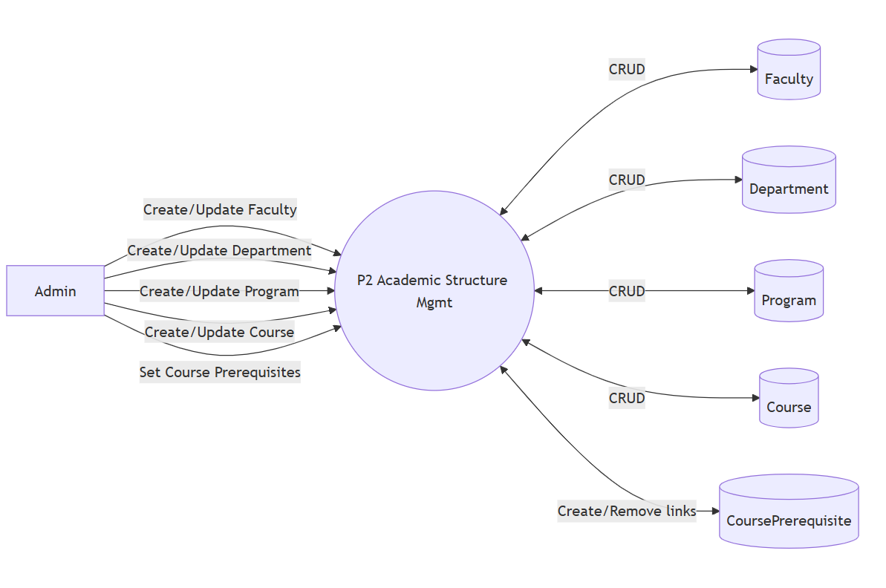
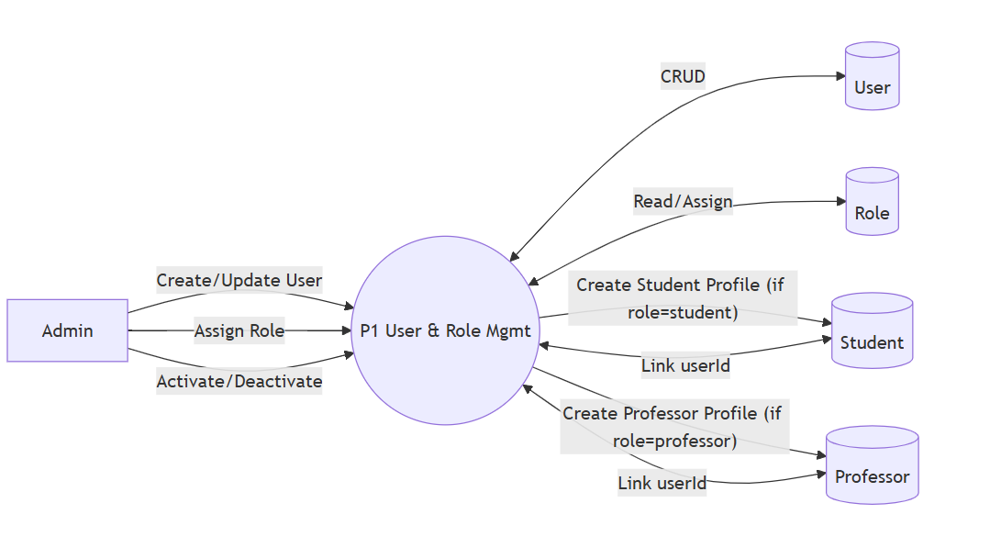
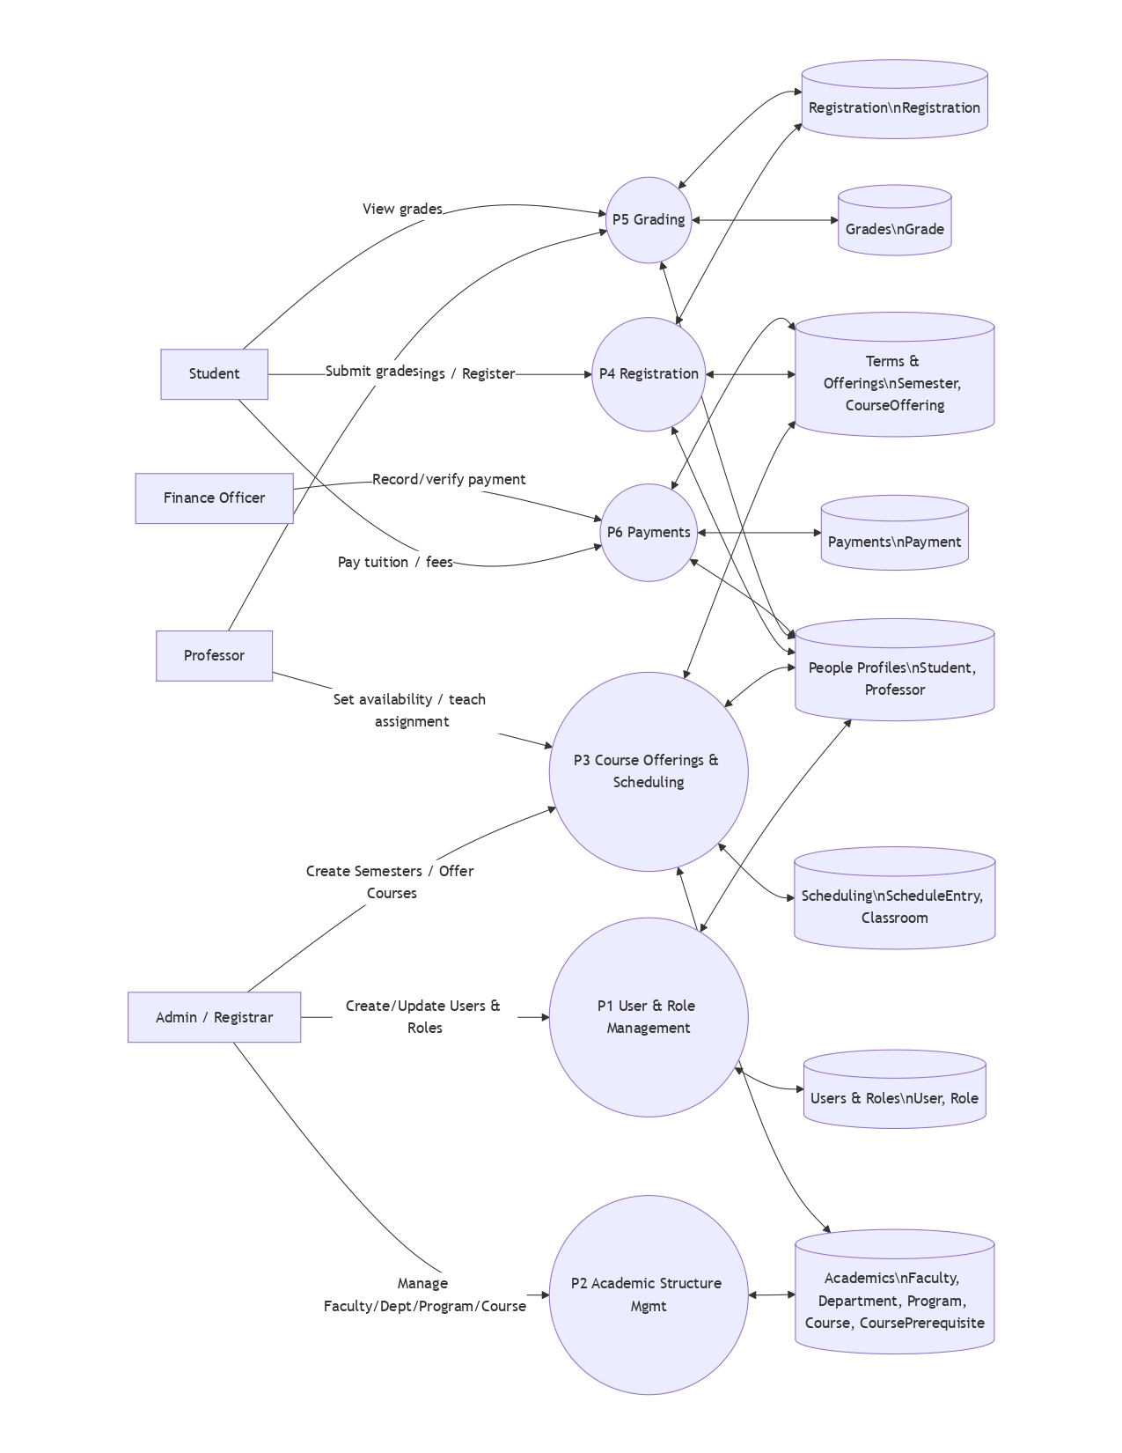
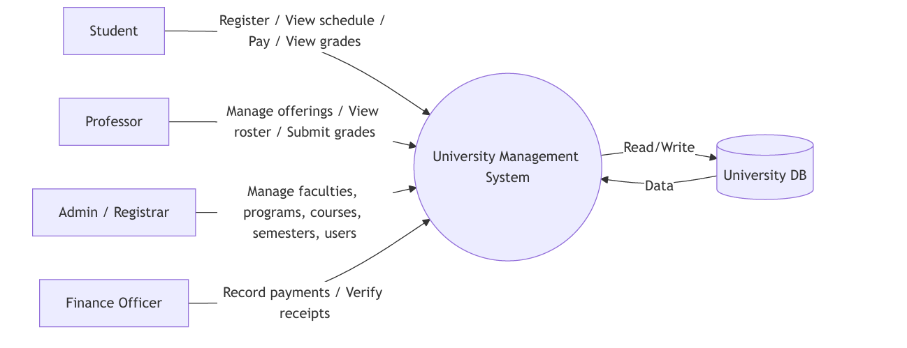
Figure 1 DFD LEVEL 0 (Context Diagram)
Figure 4 DFD LEVEL 2 academics

Figure 3 DFD LEVEL 2 authentication

Figure 2 DFD LEVEL 1

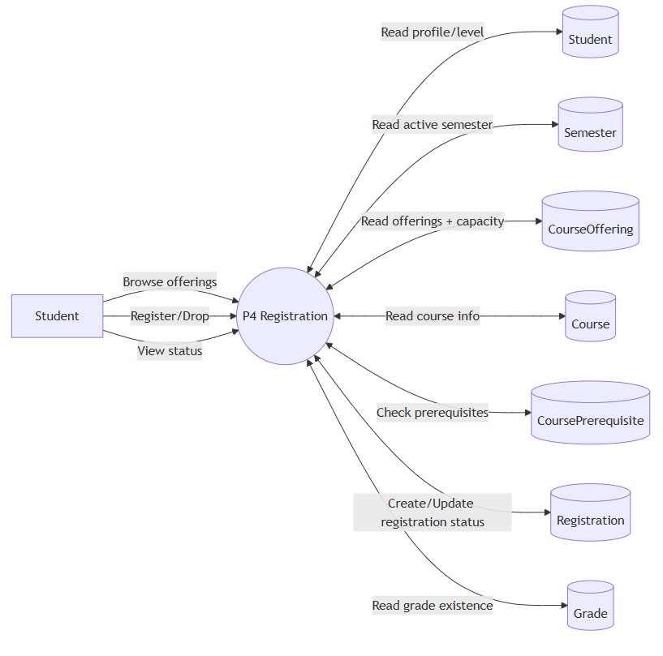
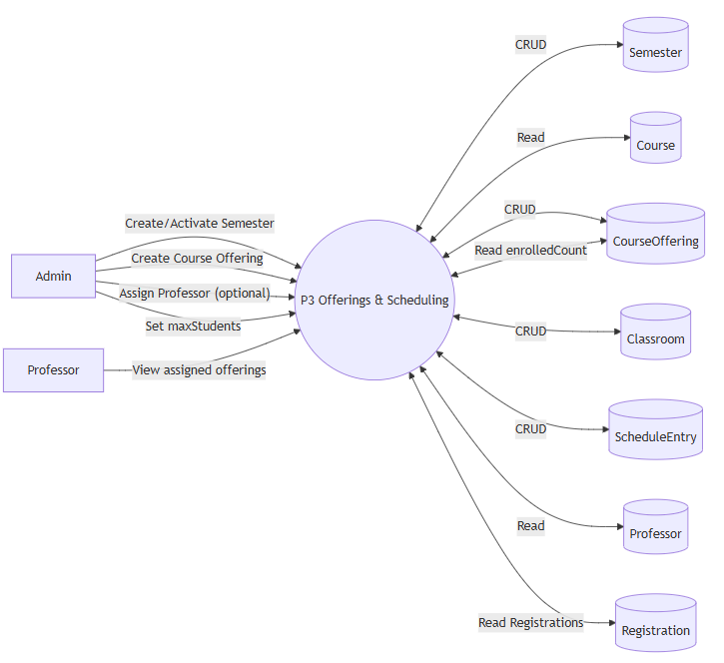
Figure 5 DFD LEVEL 2 offerings & schedule

Figure 6 DFD LEVEL 2 registration

Figure 7 DFD LEVEL 2 grading

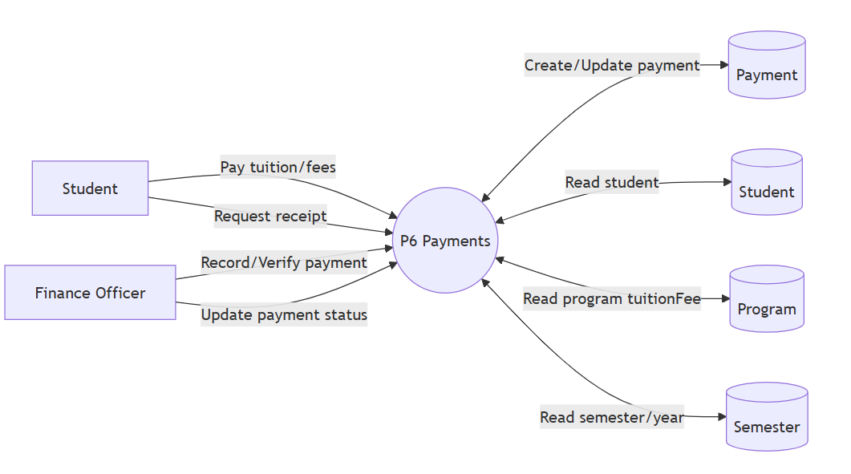
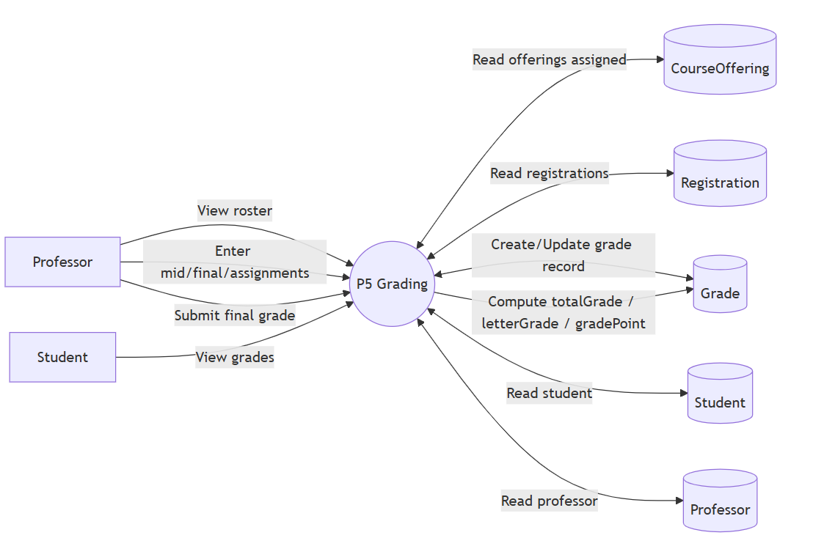
Figure 9 Activity Authentication & Access
Figure 8 DFD LEVEL 2 payments

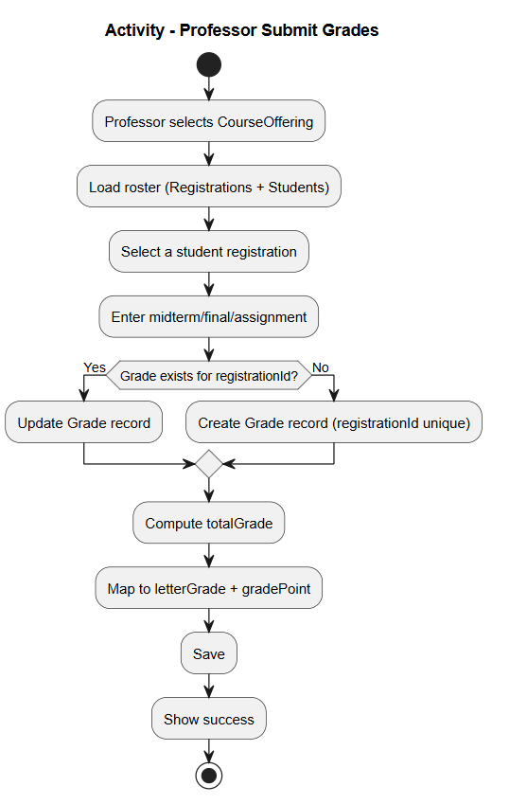
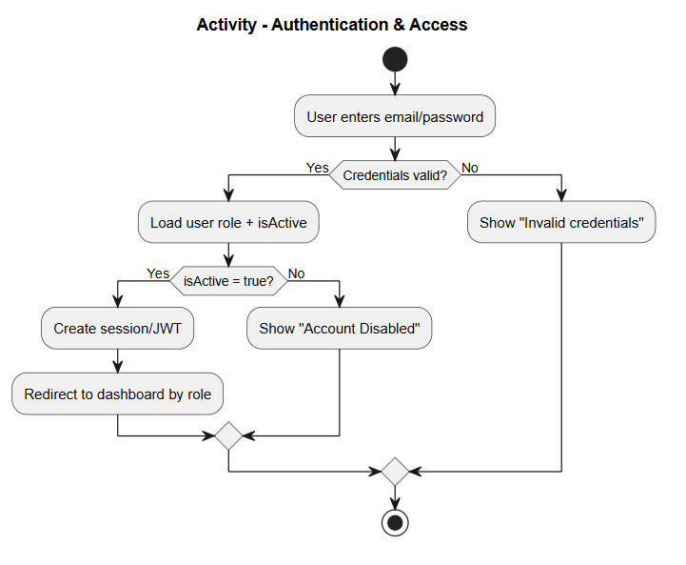
Figure 10 Activity grading

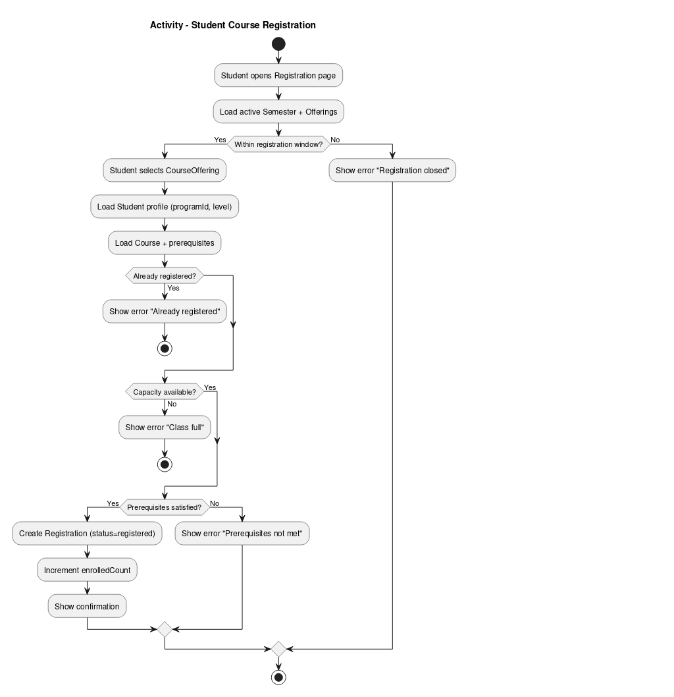
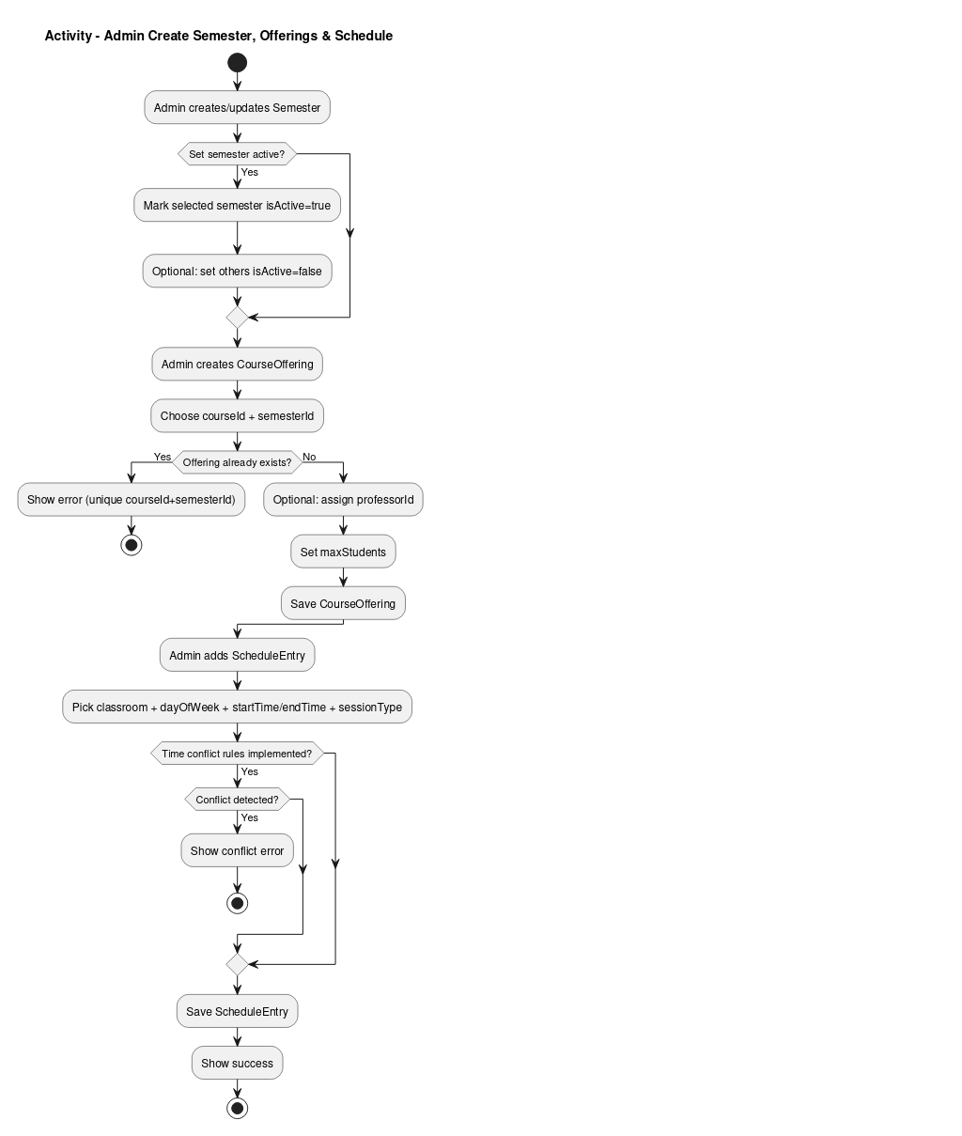
Figure 13 Activity registration
Figure 12 Activity payments
Figure 11 Activity offerings & schedule
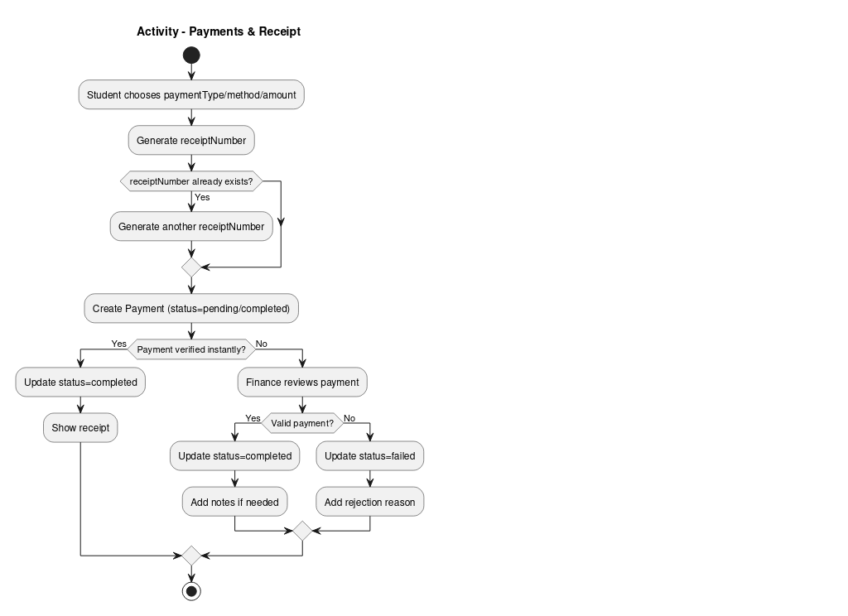

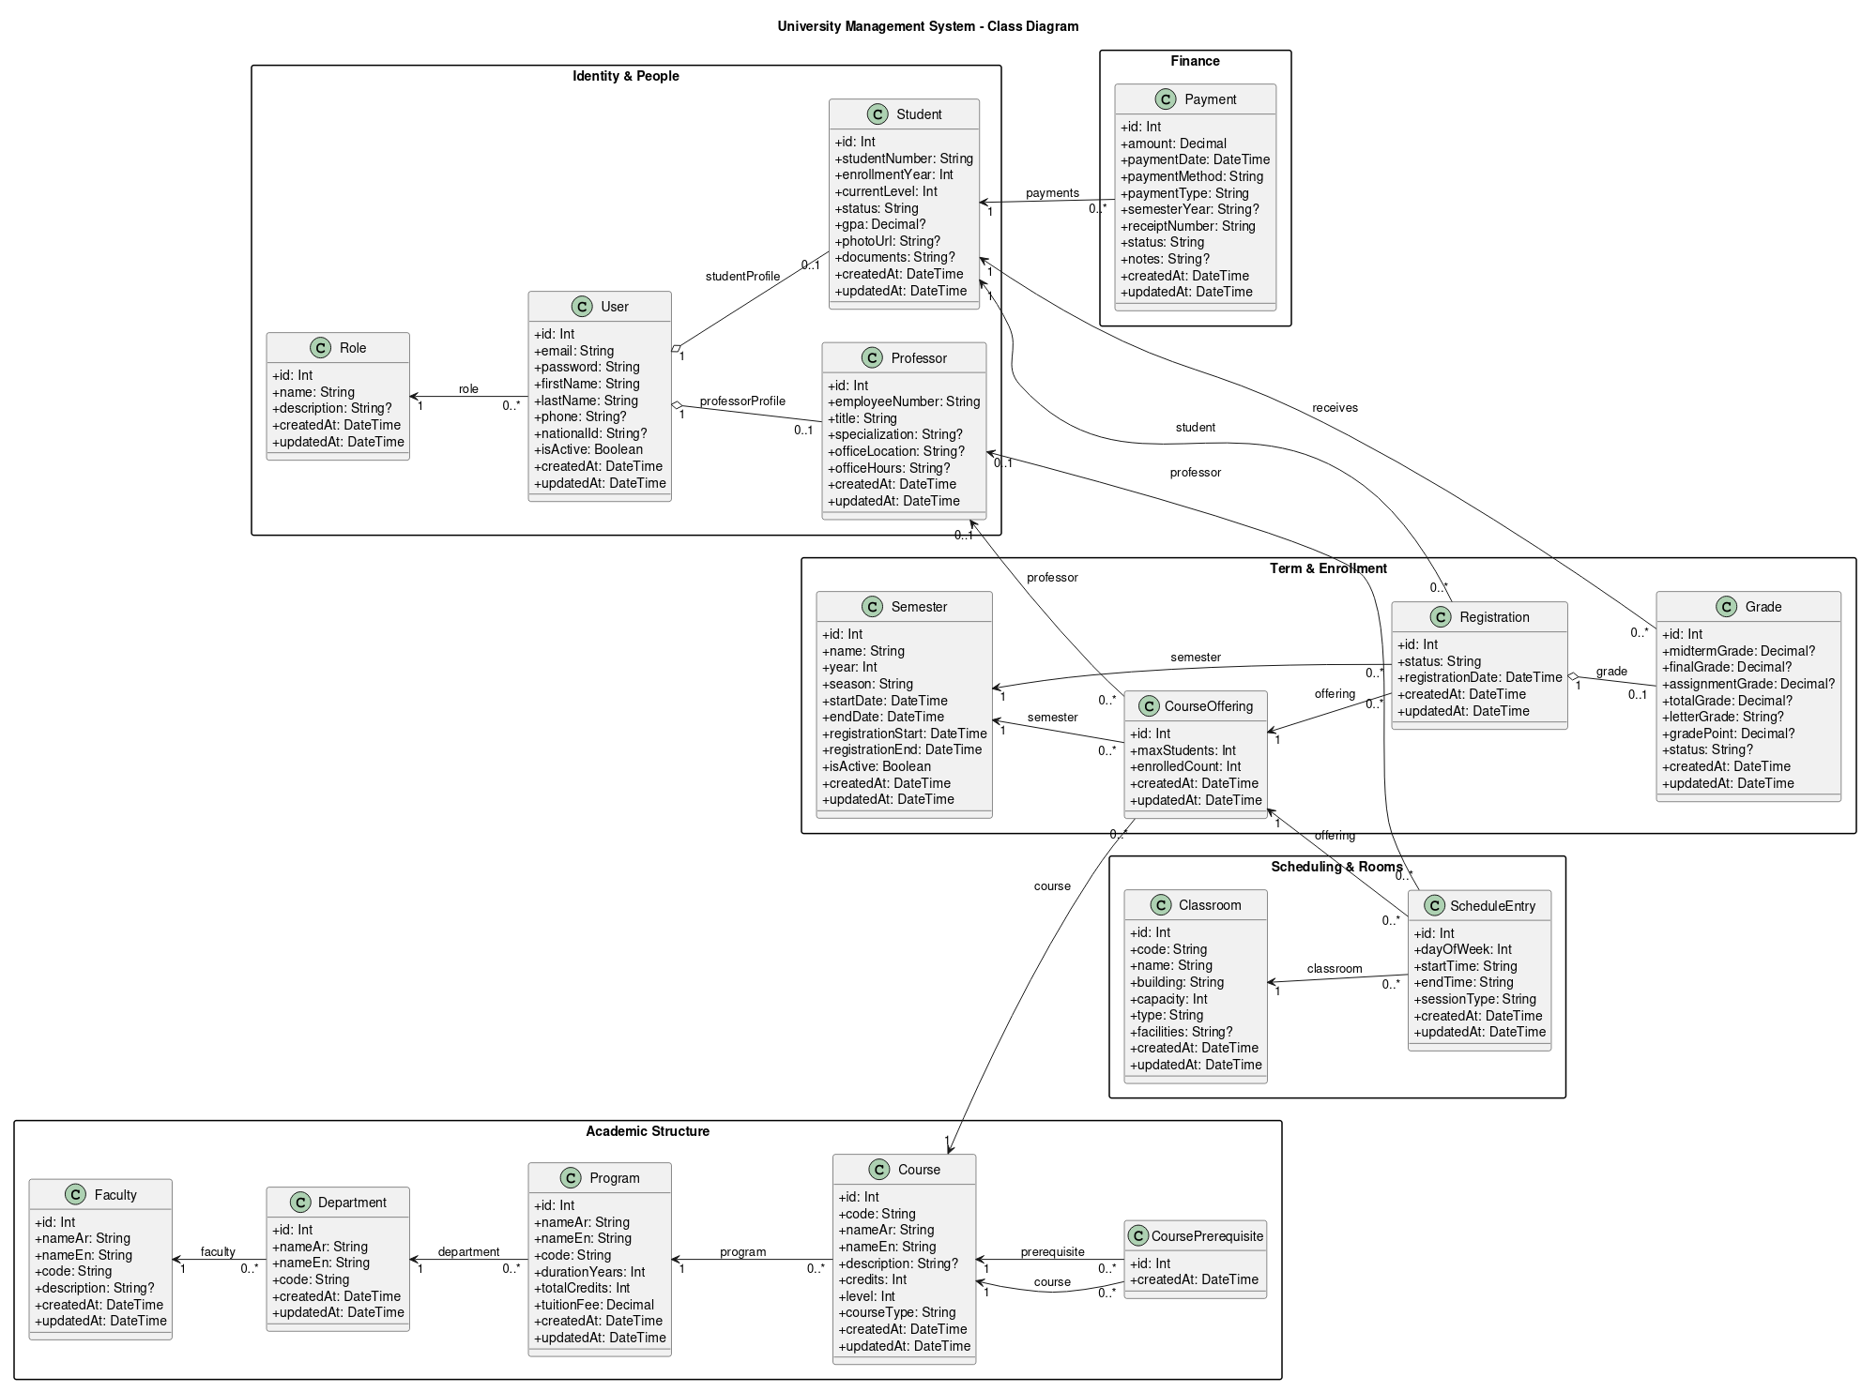
Figure 14 Class Diagram

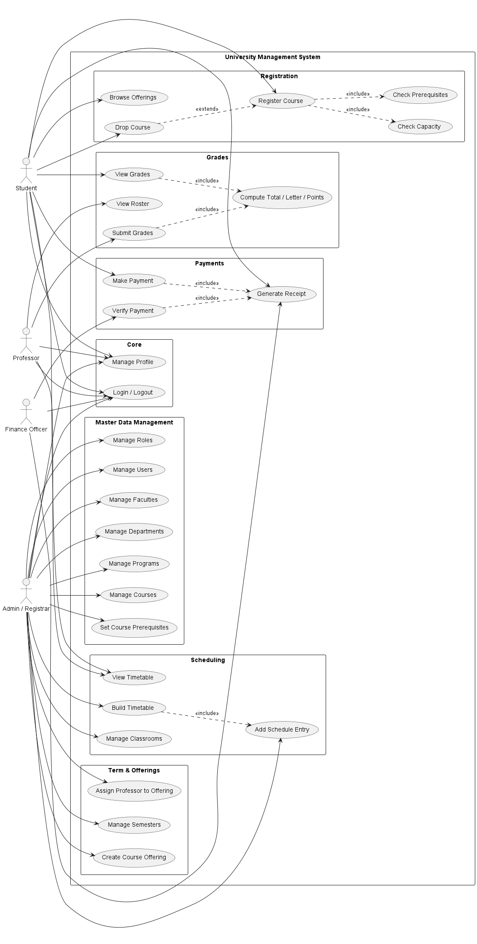
Figure 15 Use Cases Diagram
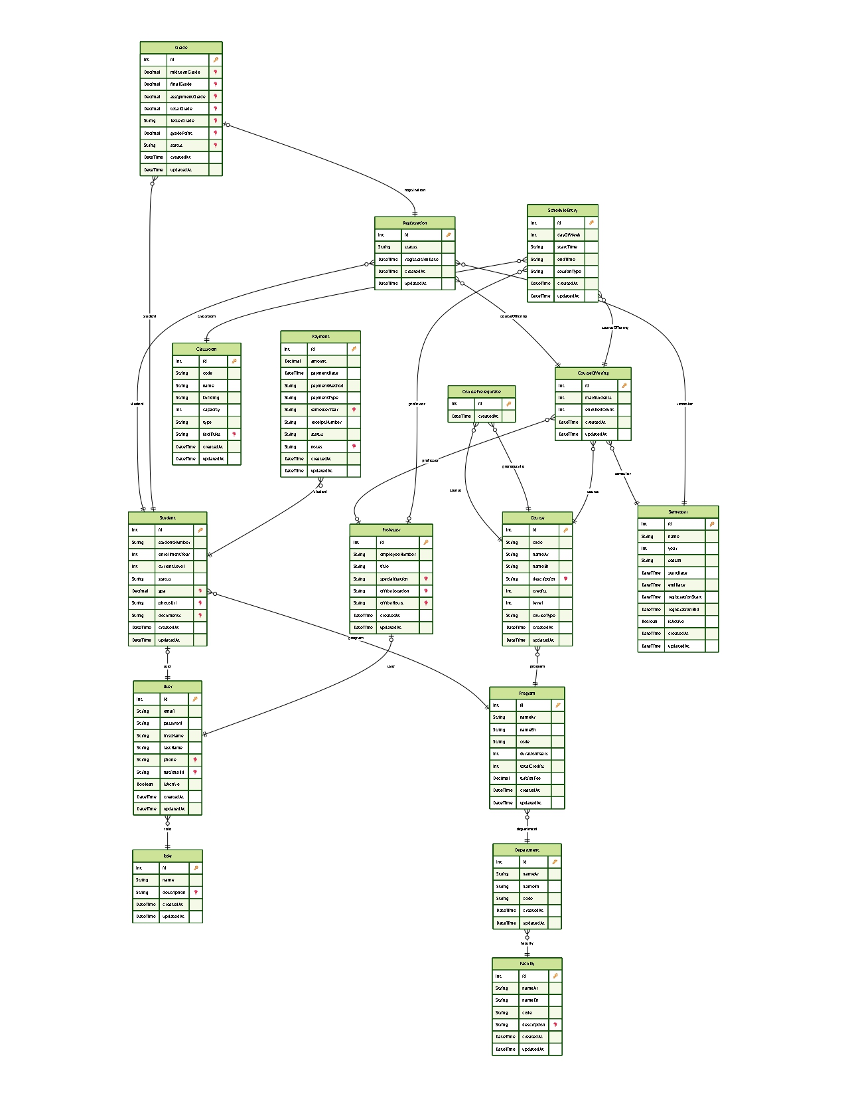
Figure 16 ERD

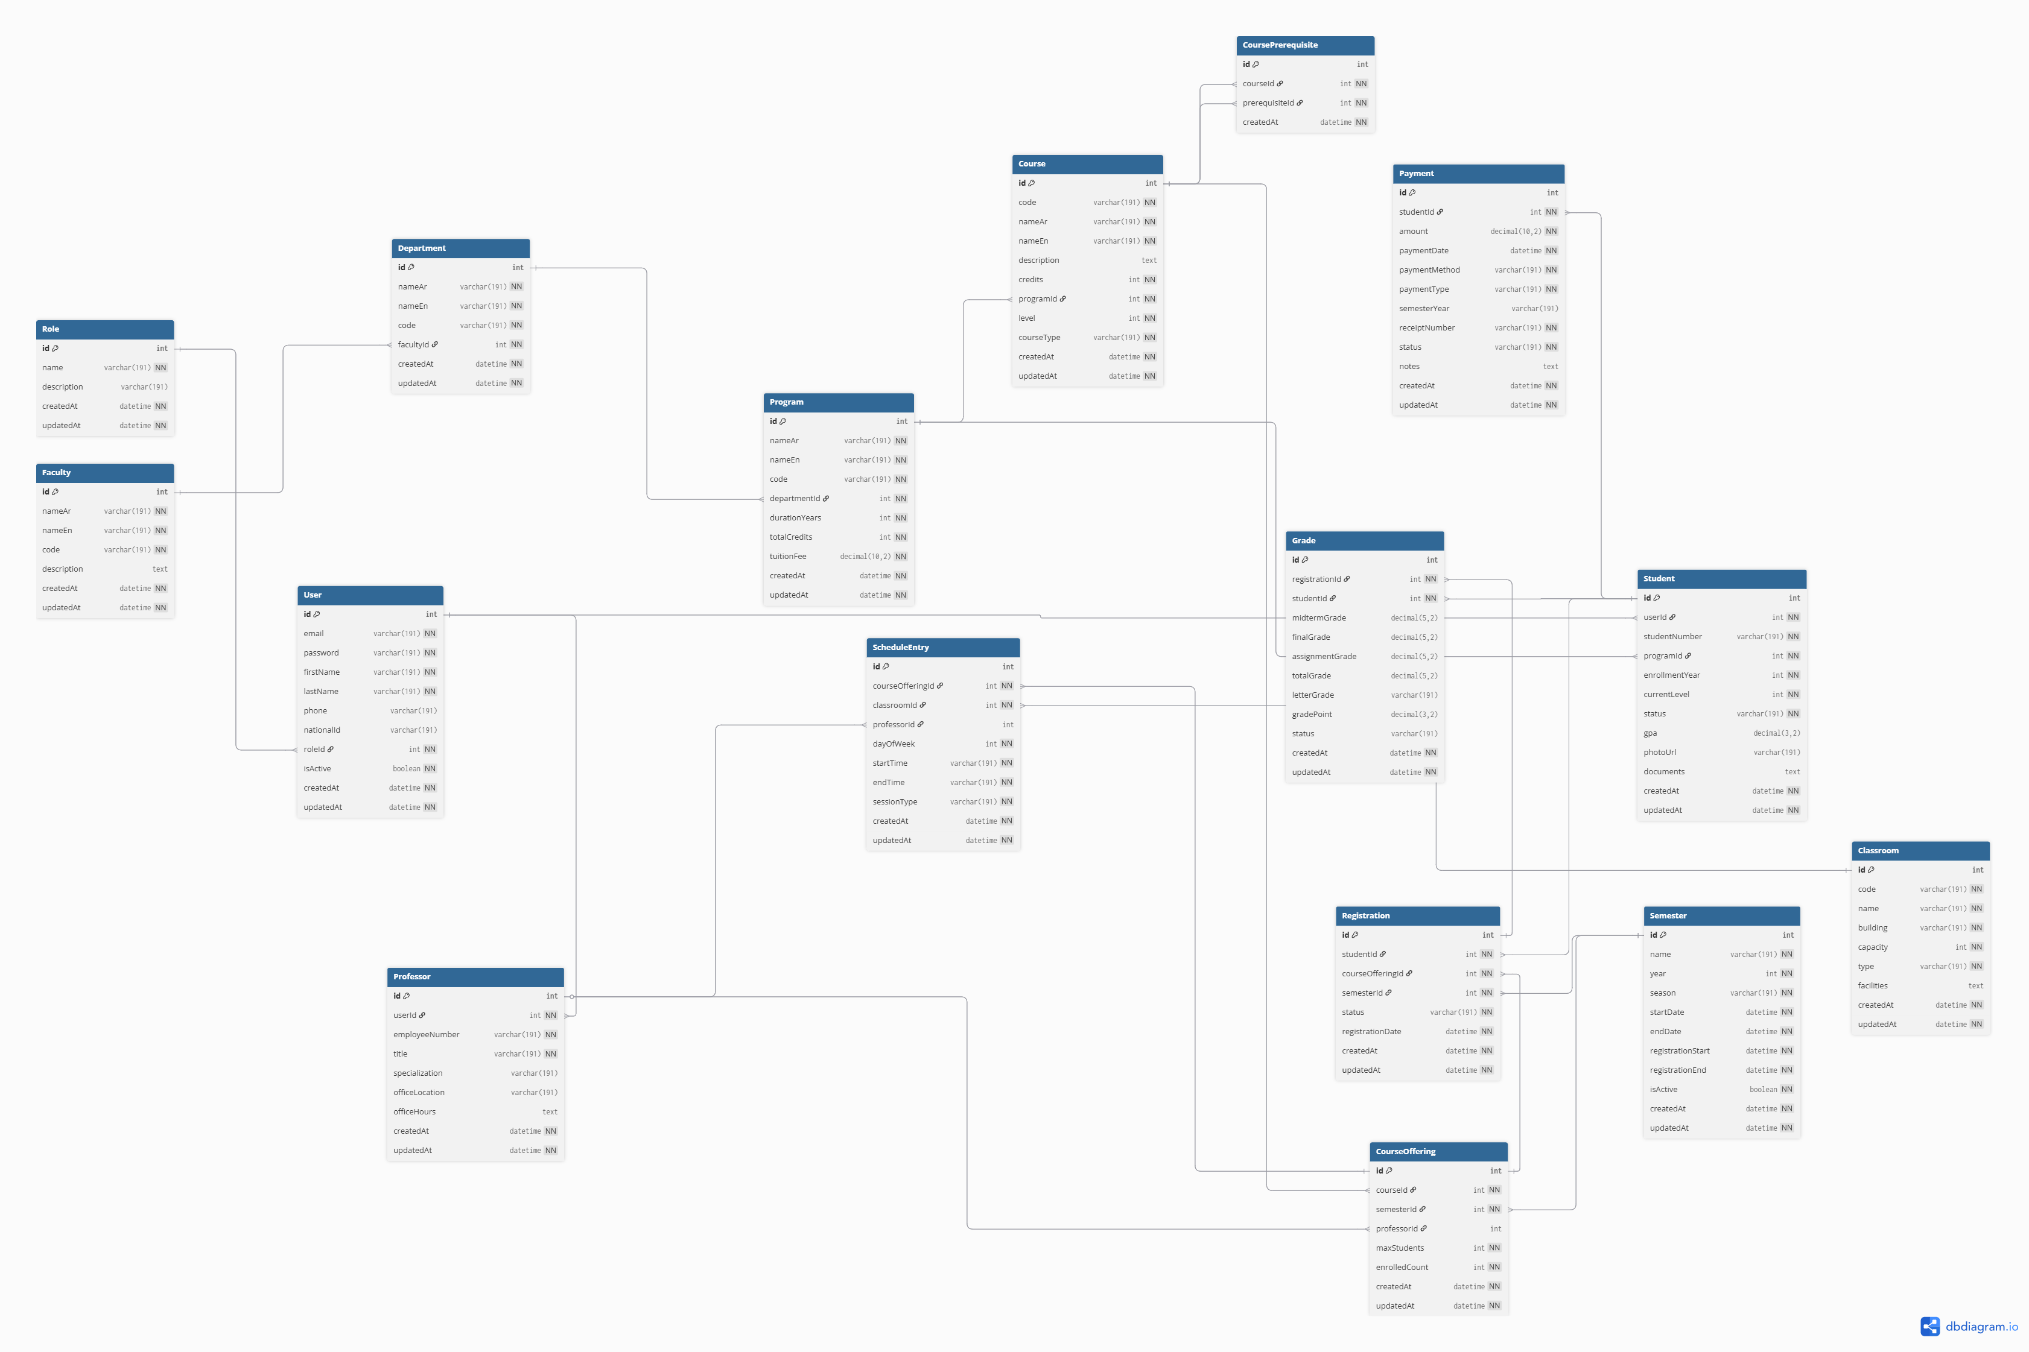
Figure 17 ERD

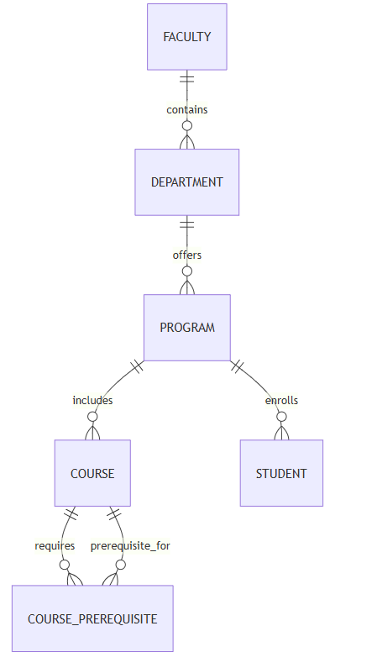
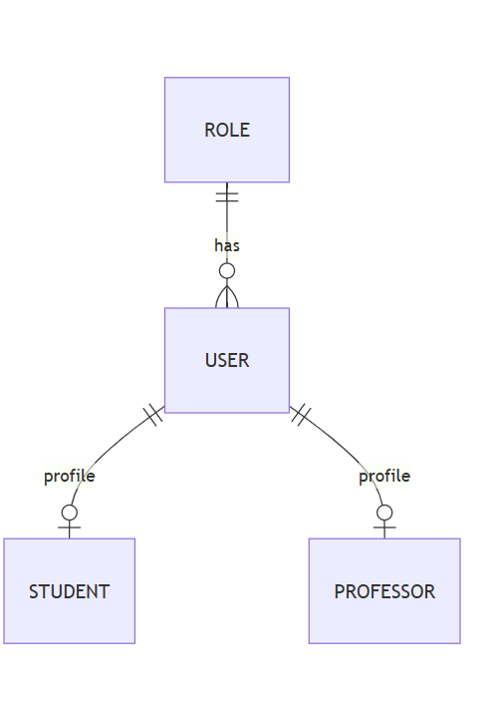
Figure 18 Logical ERD academics
Figure 19 Logical ERD identity

Figure 20 Logical ERD registration

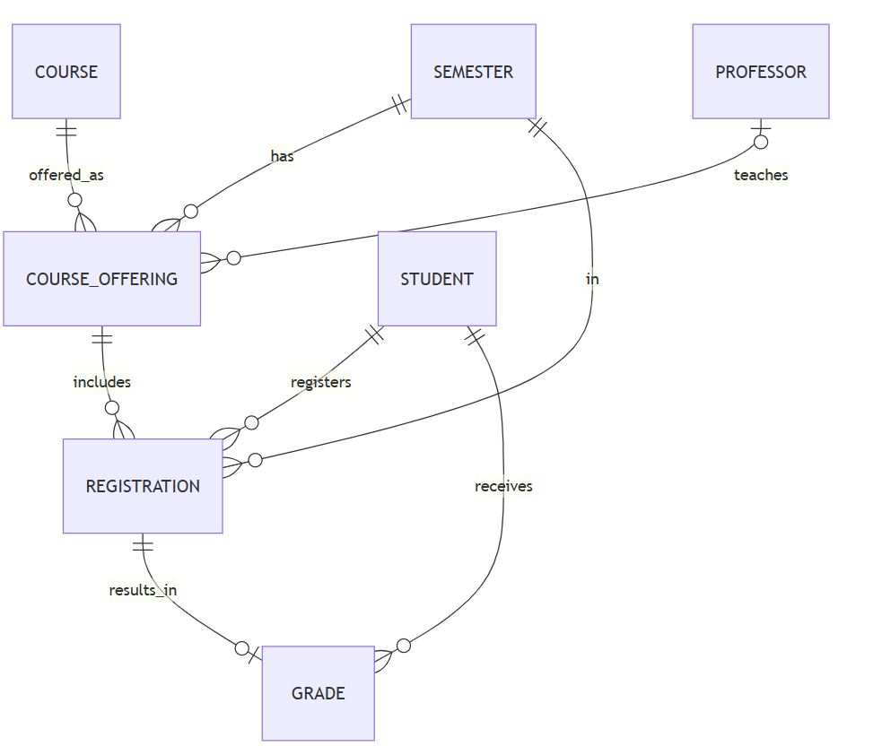

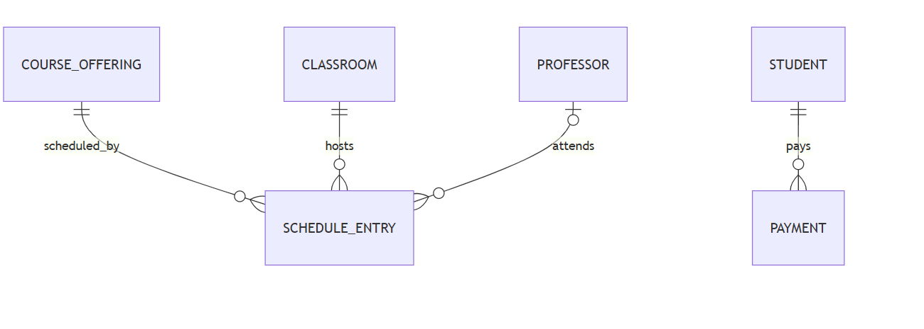
Figure 21 Sequence Diagram offering & schedule
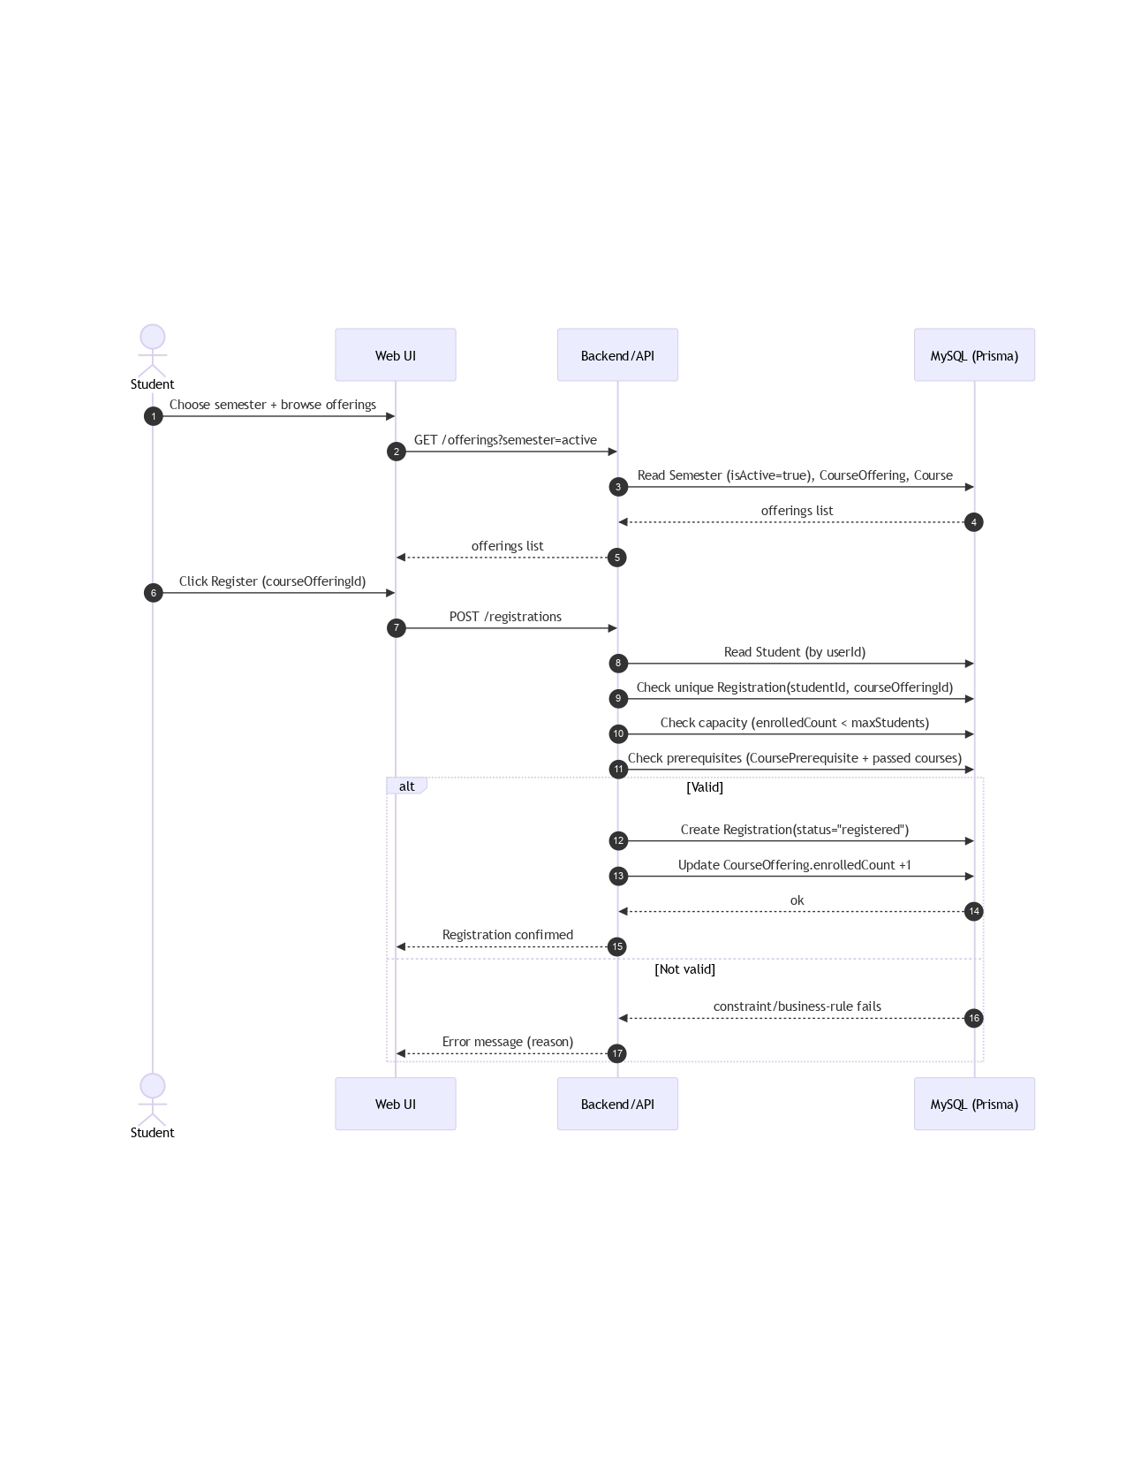
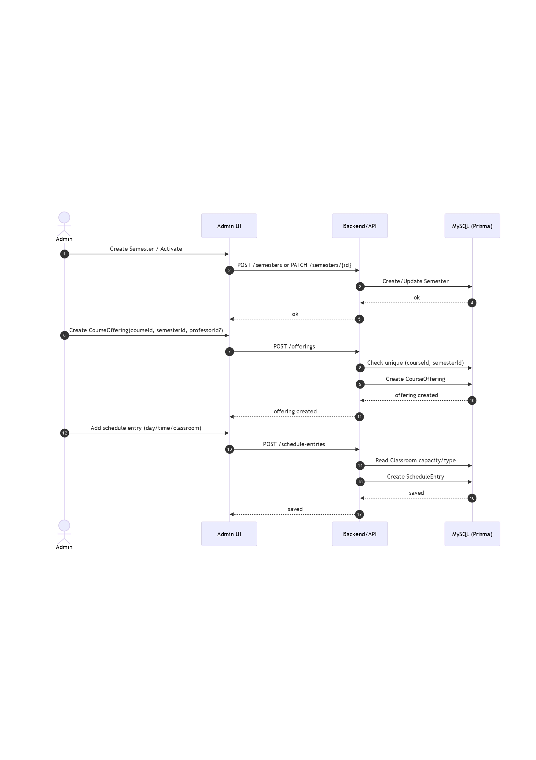
Figure 23 Sequence Diagram register course
Figure 22 Sequence Diagram payment
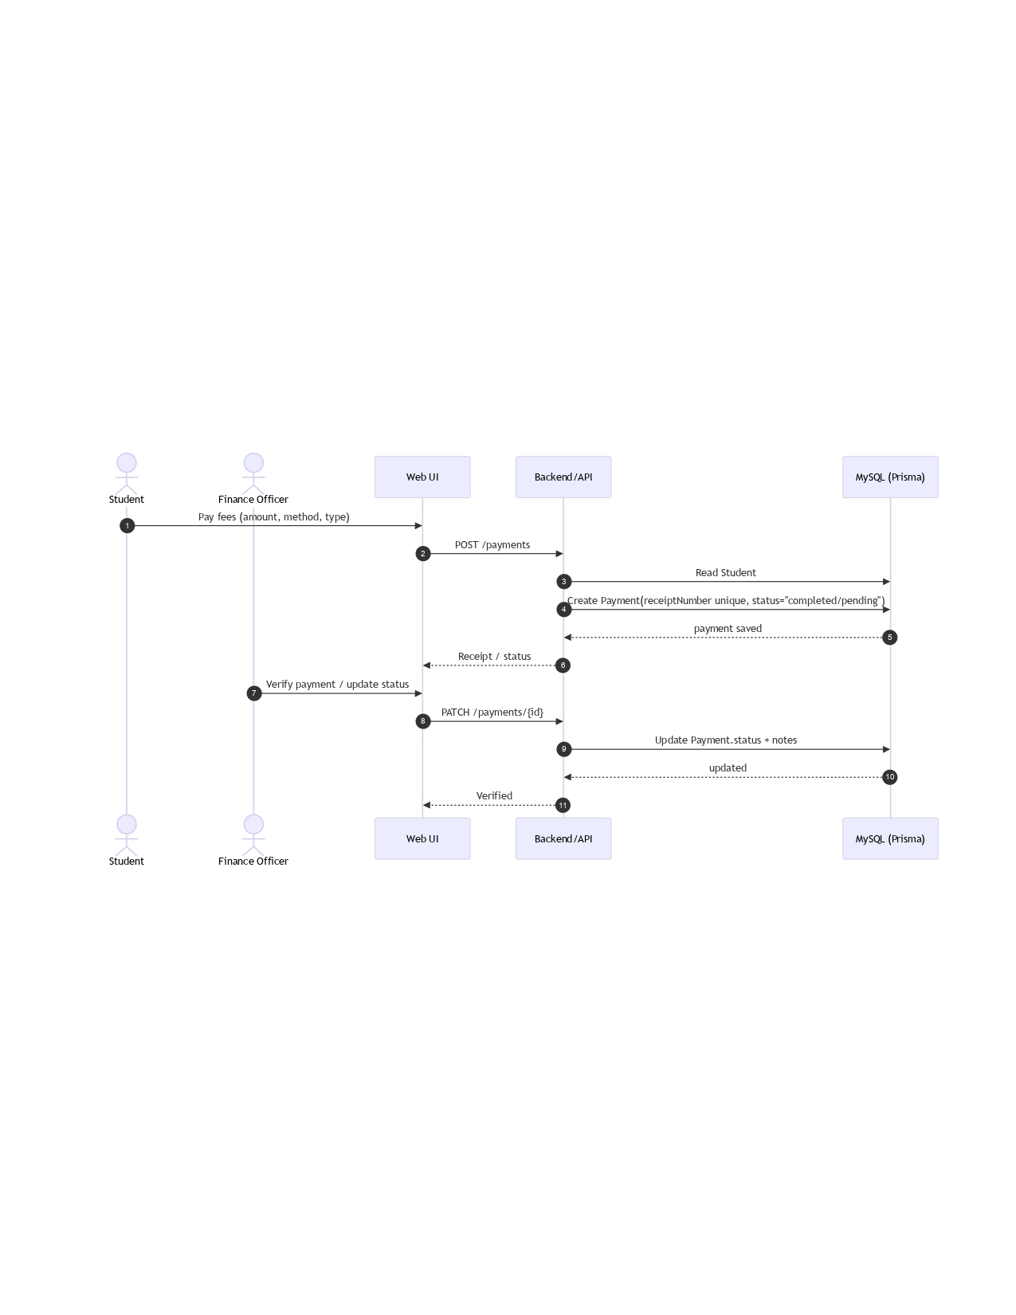

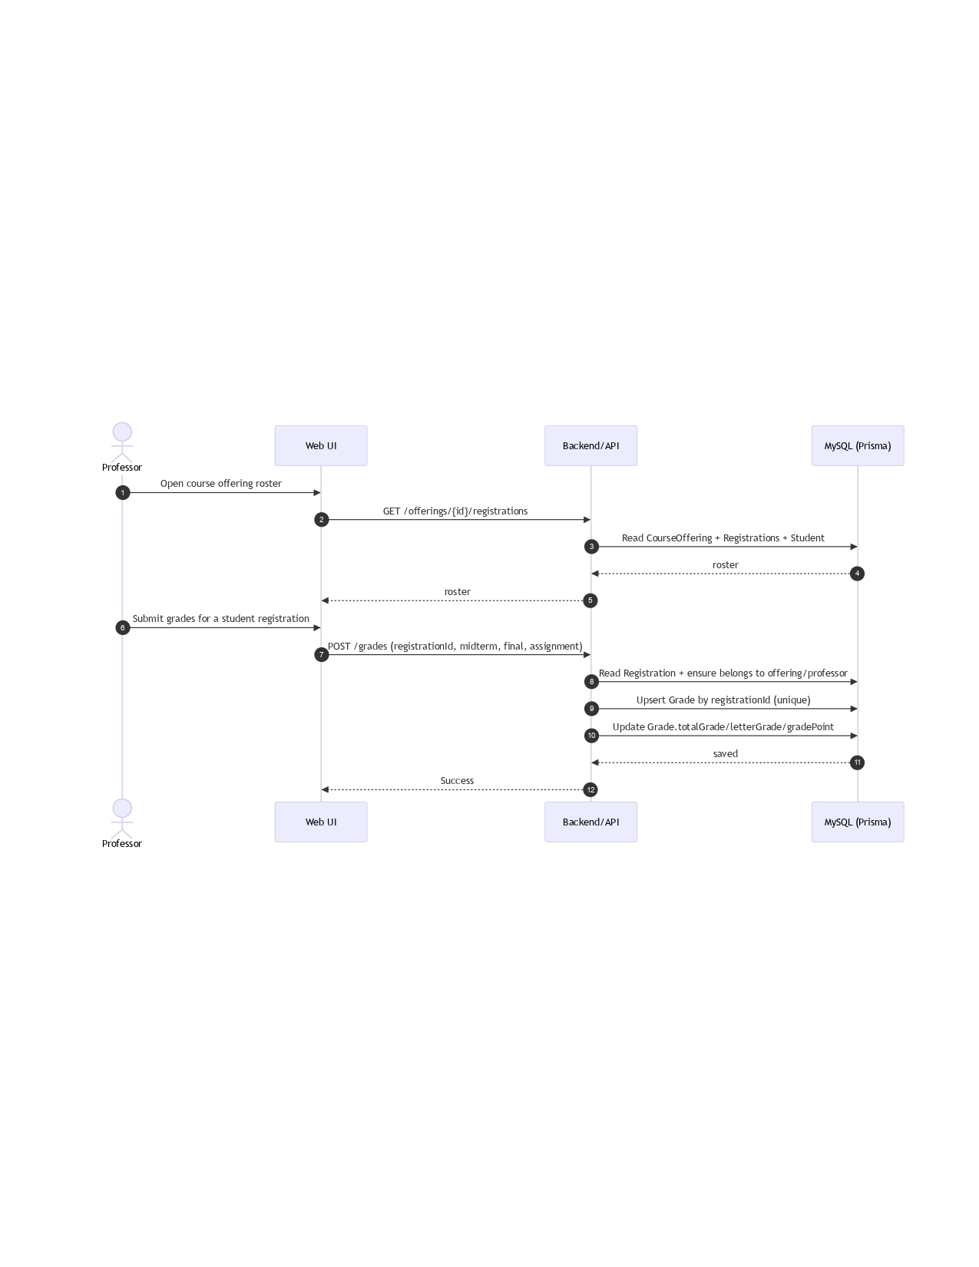
Figure 24 Sequence Diagram submit grades

Chapter 8 – Conclusion and Future Work
8.1 Conclusion
This project presented the analysis, design, and documentation of a comprehensive University Management System (UMS) for a single university environment. The system was designed to address the complexity of modern academic institutions by integrating academic, administrative, financial, learning, and regulatory support processes into a unified, process-driven platform.
Throughout the project, the system was analyzed and modeled using a structured and systematic approach. Special attention was given to real-world academic requirements such as credit-hour–based evaluation, GPA calculation, cross-departmental course enrollment, rule-based registration, and exceptional academic periods such as the remedial Summer semester.
The system architecture was designed around a clear separation of concerns. The UMS Core acts as the authoritative source for academic and administrative records, while the LMS supports continuous assessment and attendance tracking. The intelligent chatbot subsystem provides regulation-based advisory support without interfering with transactional workflows.
Business processes were modeled using Data Flow Diagrams (DFD), and data structures were defined using Entity-Relationship Diagrams (ERD) and class diagrams. Functional behavior was specified using case, activity, and sequence diagrams. Together, these models form a coherent and academically rigorous system specification.
8.2 Project Contributions
The project contributes a unified academic management model, formal process definitions, integrated LMS support, automated rule enforcement, and an intelligent advisory chatbot. The documentation produced can serve as a foundation for real-world system implementation.
8.3 Limitations
The system is limited to a single university context and does not include mobile applications or external payment gateways. The chatbot operates in a read-only advisory role. These limitations were defined to maintain focus and feasibility within a bachelor-level project.
8.4 Future Work
Future work may include full system implementation, mobile application support, learning analytics, external payment integration, advanced chatbot capabilities, and support for multi-university environments.
8.5 Final Remarks
This project demonstrates that a well-designed, process-driven University Management System can significantly enhance academic accuracy, operational efficiency, and regulatory transparency.

