ReactJS problem statement :

1. Create the below screen with ReactJS and handle the event when button is pressed

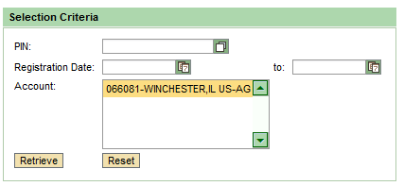

1. In the above screen create two functions which will change the state of the component when the button is clicked.
2. When Retrieve button is clicked display some data in account details in text area
3. When the retrieve button is clicked refresh the account text area