Git and GitHub Advance concepts – Chapter II
Command
Local Tags
Result:

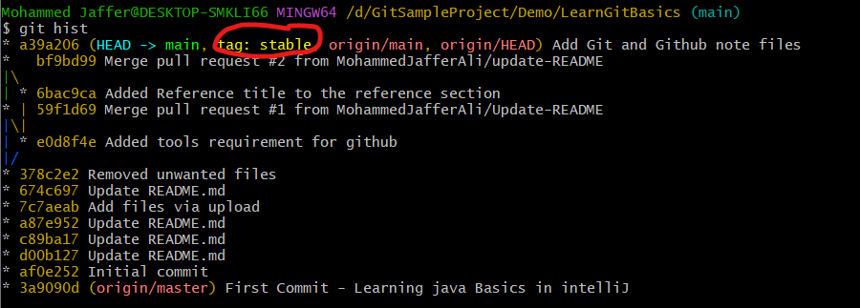
Annotate Tag:
git tag -a v0.1-alpha -m “Release 0.1 Alpha” <specificCommitID>
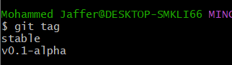

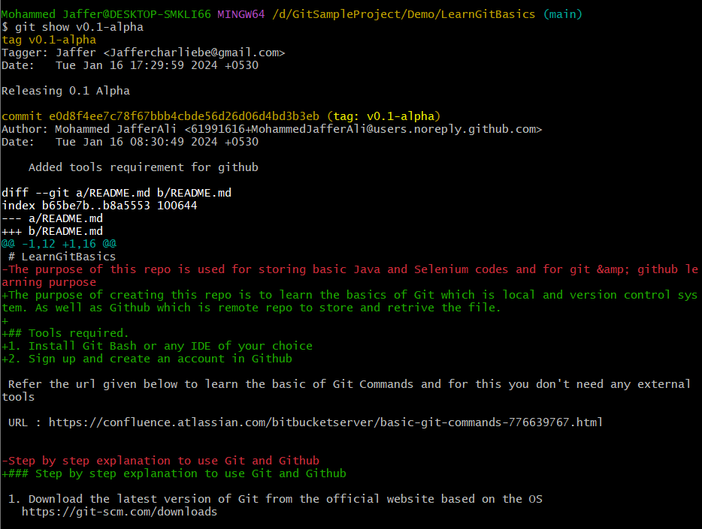
Result
Push tags to Remote Repo
Releases in github and tags in local git are similar but exactly

In order to push the tags to Github use
git push origin stable (stable is the tag name)
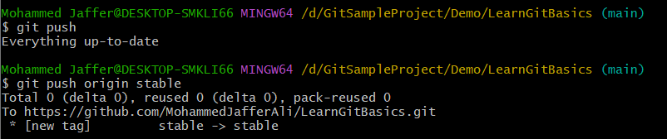
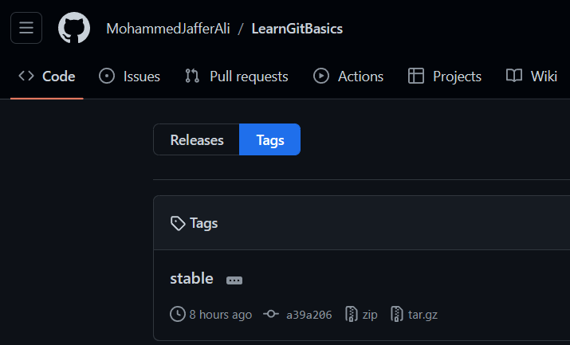

Push all tags
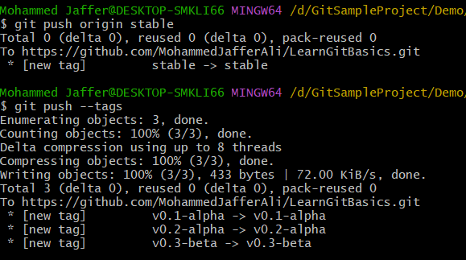

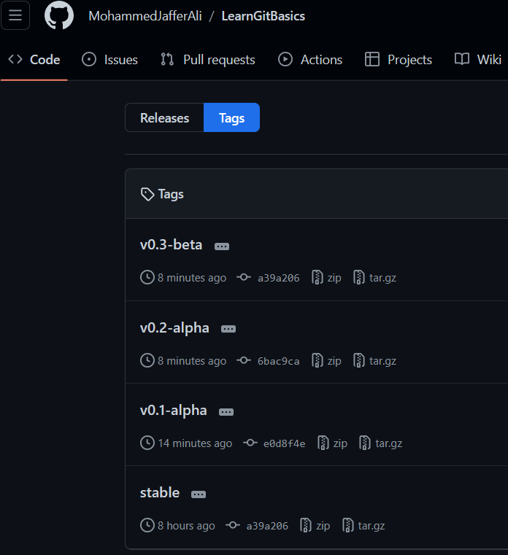

Delete tags from git hub is UI level - > Go to that tag and select Delete and confirm deletion. But the changes won’t update in local. To achieve that,

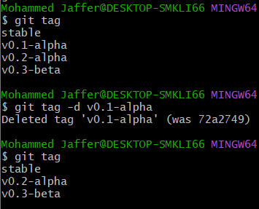

to delete from local
git tag -d <tagname> and to push the changes use git push origin :<tagname>
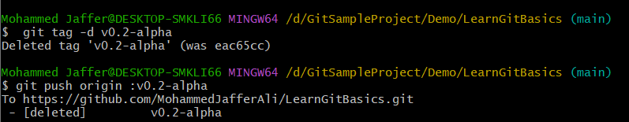

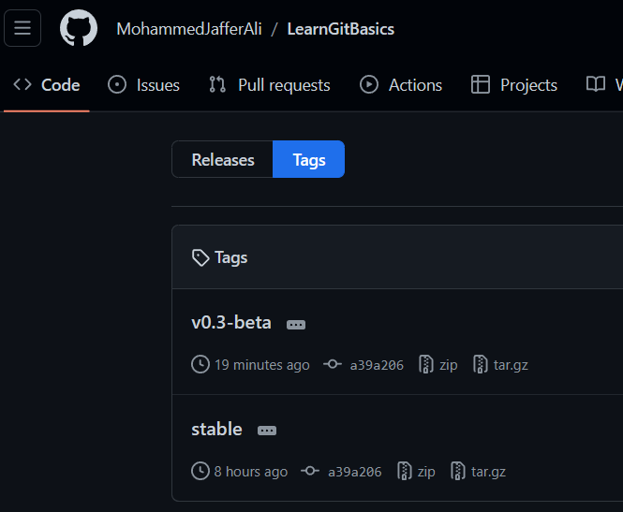

Update the tags change the commit to the latest commits
git tag -f <tagName> <commitID> (-f represent the updating tags)

Tags vs Releases

Release and tags may look similar but releases are used to enter the comments for the specific tag/release.
And release format is .md(markdown).

