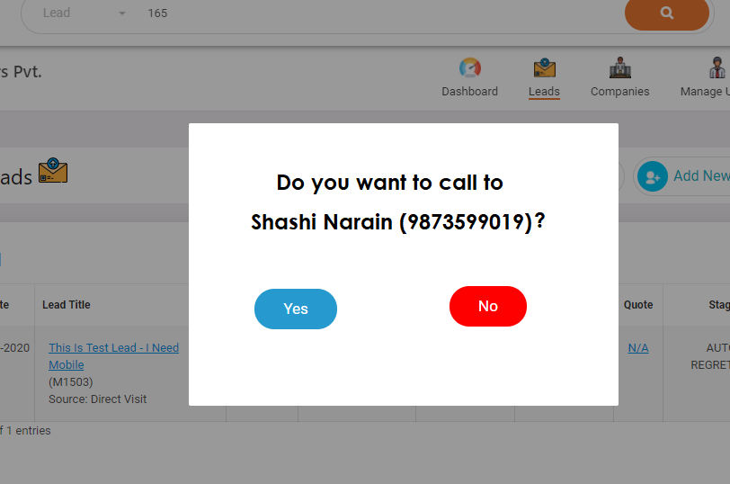

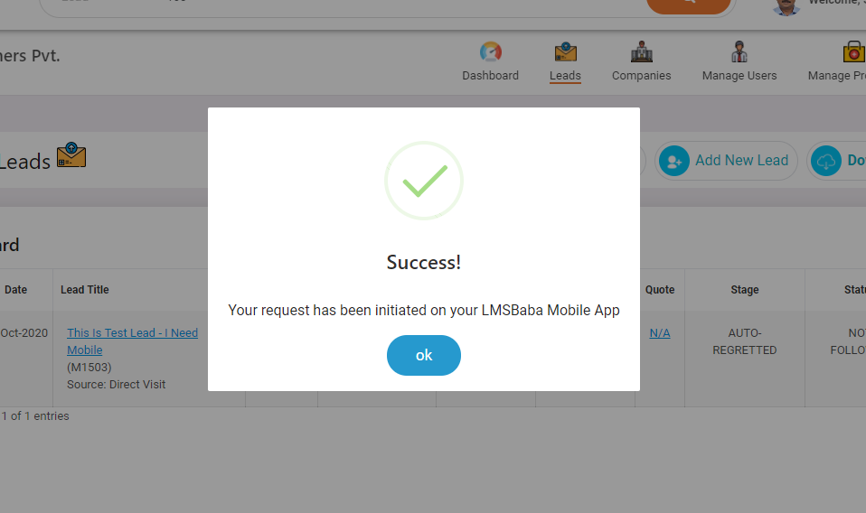

App got hanged in between

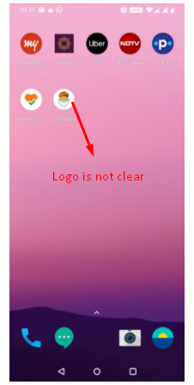LMSbaba logo is not clear.. pl. make it more clear

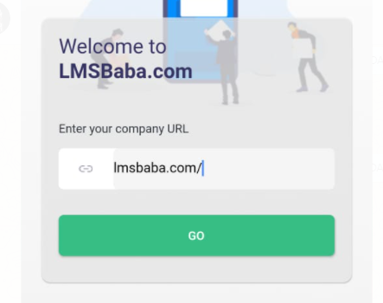

By default lmsbaba.com/ will be printed. Give a space before text.. Change Enter your company url to **Enter Your LMSBaba Login URL**

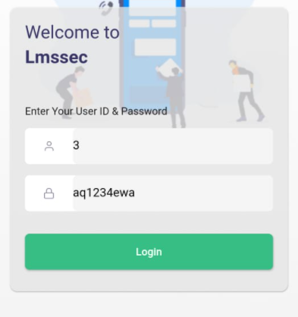

**Welcome to <Company Name> instead of <folder name>. Password should be bydefault password type (******). Give a space before User ID and Password**

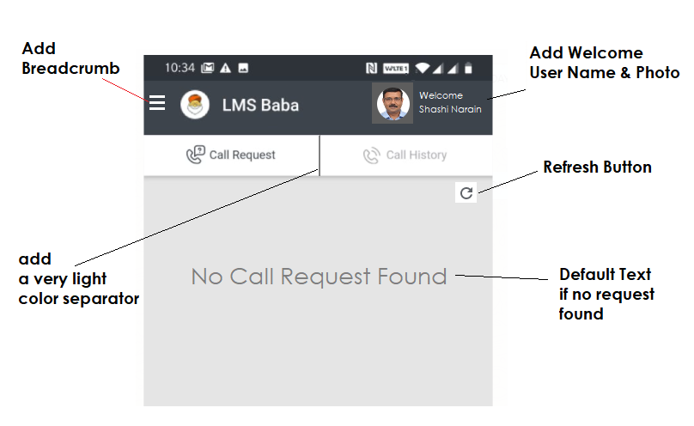

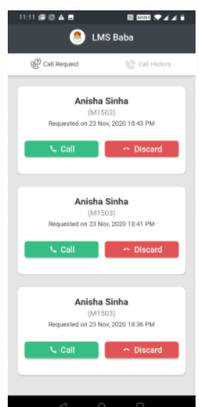

Should we display a client multiple times if request received multiple times for a client? Think!

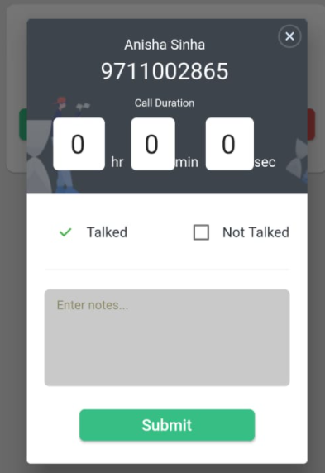

This screen is perfect.. but timing is coming

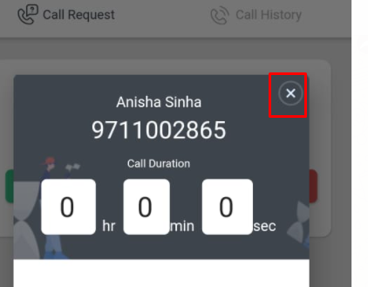Remove Close button

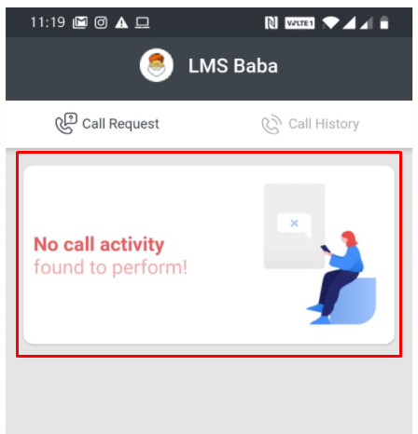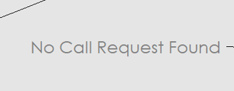

This screen will be same as above default screen..

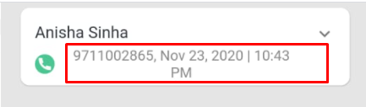

this should come in one line.. if required, reduce font size

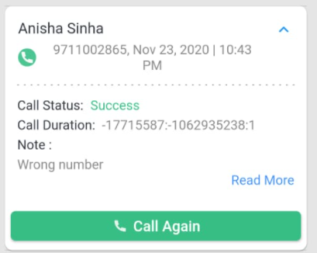

**Call Status & respective logo** will be

1. **Talked** 
2. **Not Talked** 
3. **Discard** 

**Call Duration is not coming in proper way**

**Read More color in very highlighted, reduce it..**

**Read More should only come if there is text more then the display limit**

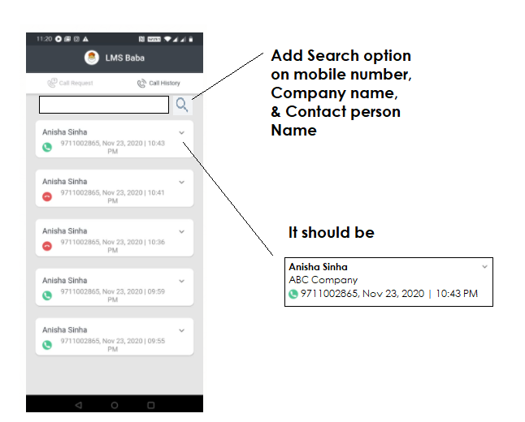

* One issue notices.. app is getting hanged for some time if you leave it open for sometime Screen gets black.. Need to check this.. The APP should not get hanged, should heat the mobile device,
* If re-login after Uninstalling the, old data should there.. currently its getting removed.
* **Call status & comment is not getting saved in history.**
* **Arup – all action will be recorded in history under Call History so that we can display call history for a Lead separately. History will be as below**
  1. **Call initiated -** 
     + **Message: A call has need initiated through LMS Baba Mobile App (Date/Time)**
  2. **Call Discarded –**
     + **Message: A call to client through LMS baba App has been discarded**
  3. **Call Success (Talked)**
     + **Message: A call has been successfully initialed to Shashi Narain (9873599019). Call Time/ Date/ Comment**
  4. **Call Failed ( Not Talked)**
     + **Message: Call Failed | Not Talked | Reason: Asked call back**