**Explanation of Parameters:**

**1. min_support (Minimum Support)**

* **Definition**: Support measures how frequently an item or itemset (group of items) appears in the dataset. It is calculated as the proportion of transactions that contain the itemset compared to the total number of transactions.

**Formula**:

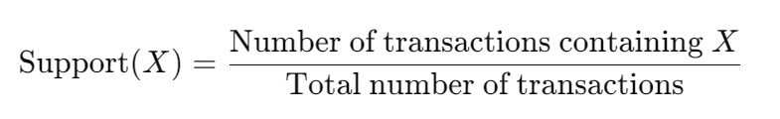

* + **Example**: If min_support = 0.01, the itemset must appear in at least 1% of the total transactions to be considered for the association rules.
* **Real-World Guidance**:
  + **Higher Support**: Use a higher value (e.g., 0.05 or 0.1) when you are only interested in rules for frequently purchased items.
  + **Lower Support**: Use a lower value (e.g., 0.001 or 0.01) when you want to find less common but still significant itemsets.

**Suggested Value**: Start with 0.01 (1%) for a balanced approach, and adjust depending on the data.

**2. min_confidence (Minimum Confidence)**

* **Definition**: Confidence measures how often the rule's consequent is true when the antecedent is true. It indicates the reliability of the rule.

**Formula**:

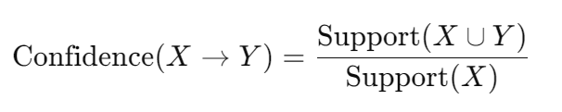

* + **Example**: If min_confidence = 0.2, then at least 20% of the transactions that contain the antecedent must also contain the consequent for the rule to be considered.
* **Real-World Guidance**:
  + **Higher Confidence**: Use a higher value (e.g., 0.5 or 0.7) if you want more reliable rules where the consequent is very likely to occur when the antecedent occurs.
  + **Lower Confidence**: Use a lower value (e.g., 0.2 or 0.3) if you're open to discovering weaker, but potentially still useful, rules.

**Suggested Value**: 0.2 to 0.3 is a good starting point, but it depends on how confident you need the rules to be in your specific application.

**3. min_lift (Minimum Lift)**

* **Definition**: Lift measures how much more likely the consequent is, given the antecedent, compared to the likelihood of the consequent occurring at random. A lift greater than 1 indicates a strong positive association between the antecedent and consequent.

**Formula**:

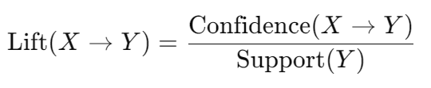

* + **Example**: If min_lift = 3, it means that the consequent is at least 3 times more likely to occur given the antecedent compared to its random occurrence.
* **Real-World Guidance**:
  + **Higher Lift**: A higher lift value (e.g., 3 or 4) ensures that only strong associations (items that are bought together much more often than by random chance) are included.
  + **Lower Lift**: A lower value (e.g., 1 or 1.5) allows weaker associations but may lead to more rules being found.

**Suggested Value**: Start with min_lift = 3 for a strong association. If few rules are found, try lowering it to 2 or 1.5.

**4. min_length (Minimum Length of the Rule)**

* **Definition**: min_length specifies the minimum number of items in the rule, including both the antecedent and the consequent.
  + **Example**: If min_length = 2, the rule must contain at least 2 items (e.g., 1 item in the antecedent and 1 item in the consequent).
* **Real-World Guidance**:
  + Set this based on your interest in multi-item rules. In most cases, a minimum length of 2 makes sense (1 item in the antecedent, 1 item in the consequent), but you can adjust it if you want to focus on more complex rules with multiple antecedents.

**Suggested Value**: min_length = 2 is common and works well in most scenarios.

**Real-World Tuning of These Parameters**

The choice of these parameter values depends on the specific dataset and the kind of rules you’re trying to discover. Here are some tips:

**1. Start with Conservative Values:**

* **min_support = 0.01**: This ensures that only itemsets occurring in at least 1% of transactions are considered.
* **min_confidence = 0.2**: Rules should be at least 20% reliable.
* **min_lift = 3**: You're only interested in rules where the consequent is at least 3 times more likely to happen, given the antecedent.
* **min_length = 2**: You're focusing on simple rules with at least 2 items.

**2. Tuning the Parameters:**

* **If Too Few Rules Are Found**: Lower min_support, min_confidence, or min_lift. Lowering these values will include more rules, but they might be weaker.
* **If Too Many Rules Are Found**: Increase min_support, min_confidence, or min_lift to focus on stronger and more reliable rules.

**3. Application-Specific Example:**

* **E-commerce**: If you’re analyzing an e-commerce site where there are many transactions but only a few products frequently bought together, you might use:
  + min_support = 0.001 (to catch low-frequency but important associations)
  + min_confidence = 0.3 (you want rules that are somewhat reliable)
  + min_lift = 2 (you still want the association to be stronger than random chance).
* **Supermarket Data**: If you have thousands of transactions but only a few products that are frequently bought together (e.g., bread and butter), use:
  + min_support = 0.05 (focus on more frequent patterns),
  + min_confidence = 0.4 or higher (to ensure more reliable rules),
  + min_lift = 3 (for strong associations).