**King Fahd University of Petroleum & Minerals**

**College of Computer Sciences and Engineering**Information and Computer Science Department  
**SWE 316: Software Design and Architecture (Term 161)**

Assignment # 1 Weight 6%

Handed : Monday Oct 10, 2016  
Due : Monday Oct 17, 2016 @ 8:00 pm

# Objectives

* Practice designing a real software example
* Programming skills:
  + Global shortcuts in Java
  + Control other applications from your Java application

# Instructions

1. Calculate the time you spend in this assignment using the table below

– any activity should be considered including

1. Reading the requirement of the homework
2. The design of your implementation, including drawing UML diagrams
3. Coding
4. Testing
5. Other activities where you spent some time on (e.g., reading a book or a website).

|  |  |  |  |  |
| --- | --- | --- | --- | --- |
|  | **Start** | **End** | **Duration** | **Comments** |
| Task 1 |  |  |  |  |
| Task 2 |  |  |  |  |
| : |  |  |  |  |
| Task n |  |  |  |  |
| Total | | |  |  |

1. Answers have to be typed; **handwritten solutions will not be accepted**.
2. Submission:
   1. through BlackBoard
   2. **Softcopy** (ZIP or RAR file) including:
      1. your report in PDF  format (**WORD format is NOT acceptable**).  
         (CutePDF is a simple and free utility to convert documents to PDF format)  
         (NOTE: it should be a self-contained report – i.e, when I read the report I should not need to open any other file)
      2. Your source code: Java files
      3. Your compiled classes (.class files)
      4. configuration files and other related resources (if any)
3. The report should include a **cover page** showing: course name, assignment number, date of submission, your name and ID
4. Include the question text and then put your answer

IMPORTANT

1. The file name should be in the following format:  
    HW<#> - <YOUR ID> - <YOUR NAME>
2. **Diagrams**, **program text**, and **output** should all be included in the report
3. You should use Java as your programming language
4. Code should be formatted properly
   1. Write the code in Notepad++
   2. Code should be in **“Courier New”** font
   3. To format the code choose Menu 🡪 Language 🡪Java
   4. Click Plugins 🡪 NppExport 🡪Copy RTF to clipboard
   5. Paste it in Word
5. Correct solutions earn full mark. **However, not following the previous points will reduce your mark.**
6. Include the following table in your cover page

|  |  |  |  |
| --- | --- | --- | --- |
| **Task** | **Grade** | **Your Grade** | **Comments** |
| UML Diagrams | 20 |  |  |
| Implementation | 30 |  |  |
| Reverse Engineering | 10 |  |  |
| Check list  Cover page 🞎  File name 🞎  Code format 🞎  Time log 🞎  Self contained report 🞎  PDF format 🞎  Java files 🞎  Class files 🞎 | |  |  |
|  |  |  |  |
| Total | 60 |  |  |

# Software Description

This is the software that we discussed in our class activity in Week # 2. The idea of this software is to simplify the process of inserting citations into LaTeX documents. I usually insert citations using the command \cite{bib_key} where bib_key is an identifier of one of the bib entries in my library: library.bib file (attached with the assignment). I would like you to design and implement software by which I can ***easily*** insert citations while I am typing without switching to other applications. I don’t want to use the mouse in this application at ALL. While typing, I like to press a hotkey (e.g., CTRL + SHIFT + B) or a hot string (e.g., b\) to activate the software. Actually the software is something that I already implemented and looks like this:

Whether you like it or not, you have to live in my DOMAIN. If you can’t understand “LaTeX” or “BibEntry”, it is not my problem ☺



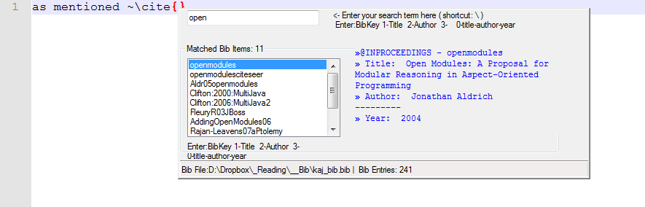

Status bar

Bib info

Hotkeys

Bib list

Search box

As you see in the image above, there are 5 main areas:

* + Search box: an area where you can type the words you are searching for
  + Bib list: in this area, you are supposed to list all bib entries matching the term in the “Search box”. If the search box is empty, you should list all bib items.
  + Hotkeys: just an info section telling the user what hotkeys he can use while one of the items in the “Bib list” is selected:
    - Enter: insert the bibkey
    - 1 (Number): title of the bibitem
    - 2 (Number): author of the bibitem
    - 3 (Number): title-author-year of the bibitem

NOTE: when you press one of these hotkeys, you should insert the required info in the background program. For example: if I am using Notepad++ to write my document, your program should insert the text into Noatepad++

* + Bib Info: another panel showing some info about the selected bib item
  + Status bar: showing the path to the currently BIB file and the number of bib items in it.

# UML diagrams [20 marks]

Start by designing your software using UML.

1. **[10 marks]** Sketch an initial class diagram for your application (some of you might do it in a single class). Make sure to include the main required methods in your application (I am not interested in getters and setters in the time being)
2. **[10 marks]** reading the bib file is a critical function is this software. Draw a detailed activity diagram or flow chart showing the steps required in this function. (this is a continuation of our class activity)

# Implement the software [40 marks]

1. You have to provide a complete implementation for this software.
2. Your implementation should be in Java
3. You have to follow proper program construction techniques
   1. Formatting
   2. Indentation
   3. Variable names
   4. etc.

<<<<<<<<<<<<<<<<<<<<<<<<<<<<<< END >>>>>>>>>>>>>>>>>>>>>>>>>>>>>>