**King Fahd University of Petroleum & Minerals**

**College of Computer Sciences and Engineering**Information and Computer Science Department  
**SWE 316: Software Design and Architecture (Term 161)**

Assignment # 2 - Weight 8% (80 marks)

Submitted : Saturday Nov 05, 2016  
Due : Saturday Nov 26, 2016 @ 11:59pm

## Objectives

The main goals of this assignment are:

1. to practice with two design principles discussed in the class: Efficiency and Flexibility
2. to learn how to automate and write programs for office applications (Excel)
3. Learn a new programming environment: Greenfoot

## Instructions

1. Calculate the time you spend in this assignment using the table below

– any activity should be considered including

1. Reading the requirement of the homework
2. The design of your implementation, including drawing UML diagrams
3. Coding
4. Testing
5. Other activities where you spent some time on (e.g., reading a book or a website).

|  |  |  |  |  |
| --- | --- | --- | --- | --- |
|  | **Start** | **End** | **Duration** | **Comments** |
| Task 1 |  |  |  |  |
| Task 2 |  |  |  |  |
| : |  |  |  |  |
| Task n |  |  |  |  |
| Total | | |  |  |

1. Answers have to be typed; **handwritten solutions will not be accepted**.
2. Submission:
   1. through BlackBoard
   2. **Softcopy** (ZIP or RAR file) including:
      1. your report in PDF  format (**WORD format is NOT acceptable**).  
         (CutePDF is a simple and free utility to convert documents to PDF format)  
         (NOTE: it should be a self-contained report – i.e, when I read the report I should not need to open any other file)
      2. Your source code: Java files
      3. Your compiled classes (.class files)
      4. configuration files and other related resources (if any)
3. The report should include a **cover page** showing: course name, assignment number, date of submission, your name and ID
4. Include the question text and then put your answer
5. The file name should be in the following format:  
    HW<#> - <YOUR ID> - <YOUR NAME>
6. Your solution should be in a SINGLE document.
7. Include the question text and then put your answer
8. The file name should be in the following format:  
    HW<#>-<YOUR ID>-<YOUR NAME>
9. Code should be formatted properly (as in the code next page)
   1. Write the code in Notepad++
   2. To format the code choose Menu 🡪 Language 🡪 Your language (VB or Java)

Try to use some callouts (like this one) to illustrate the code

* 1. NOTE: You don’t have to copy ALL your code.   
     Just copy the parts that need to be illustrated.

1. Correct solutions earn full mark. However, not following the previous points will reduce your mark.
2. Include the following table in your cover page

|  |  |  |  |
| --- | --- | --- | --- |
| **Task** | **Grade** | **Your Grade** | **Comments** |
| Problem # 1 |  |  |  |
| Efficiency | 30 |  |  |
| Flexibility | 10 |  |  |
| Problem # 2 |  |  |  |
| Reading file | 5 |  |  |
| GUI | 10 |  |  |
| Randomization and  Movement | 25 |  |  |
|  |  |  |  |
| Check list and penalties  Cover page with grade table -10 🞎  File name -5 🞎  Code format and color -10 🞎  Time log -5 🞎  Self contained report -10 🞎  PDF format -10 🞎  Source Code files -20 🞎  demos (youtube) -40 🞎 | | |  |
| Total | 80 |  |  |

## Problem 1 Description:

Data analysis and manipulation plays a great role in current IT projects. Most clients use spreadsheet programs such as Microsoft Excel to store their data as shown in the figure below.

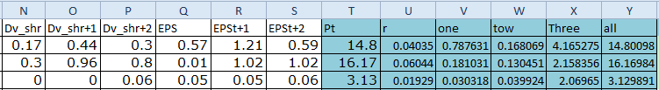

The client of this application would like to have the value of column Y to be as close to column T as possible. You can only change the ***r*** value (column U).

The formula to calculate column Y is:

resAll = cH + (cR - (cU * cH)) / (1 + cU) + (cS - (cU * cI)) / (1 + cU ^ 2)+ (cS - (cU * cI)) / (cU * (1 + cU ^ 2))

where c**X** means the value of column **X**. Calculating this formula in Excel is straight forward but we need to alter the ***r***-value to achieve the required results. This should be done for all rows in the file (thousands of rows)

To do this, I wrote a program to loop the value of ***r*** from 0 to 1 with increment of 0.00001. The code that accomplishes this functionality is shown below.

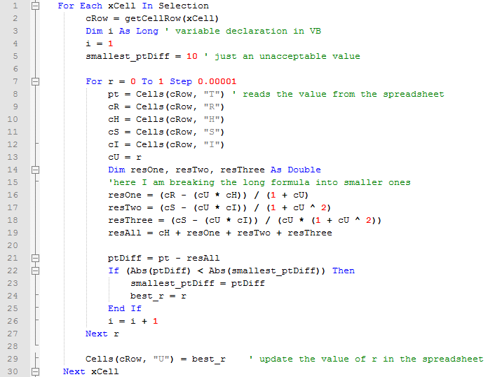

# Task 1: Experimenting with the application

Try to understand the problem and the given code. Open the attached Excel file “DataForm.xlsm”. To run the program, follow these steps:

1. Select any row (or rows) that contains data in the sheet (Don’t select many rows as it will take time to process - I suggest 3 rows)
2. Run the program by pressing Alt+F8.
3. When you see the dialog – select **Find-R** and click the Run button.
4. The (best) r-value will be inserted in Column **U**

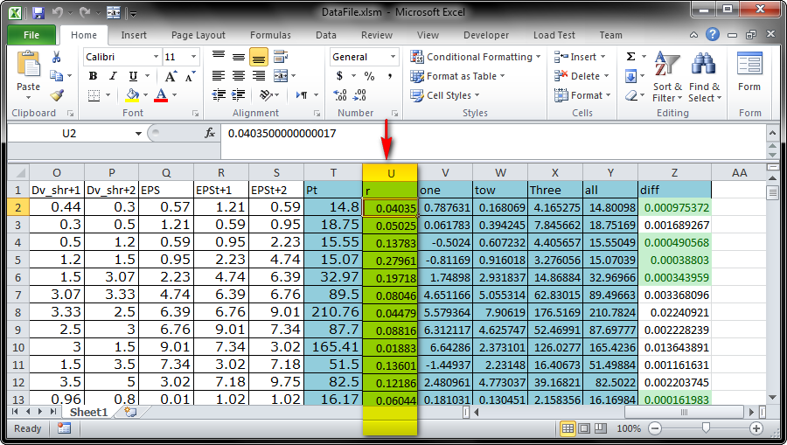

If you face difficulties trying this, just type “Excel Macro” in Google and you will have plenty of documentations.

# Task 2: Efficiency [30 marks]

As we will be running our code on huge tables (thousands of rows), it is crucial to consider efficiency in this application (running the program on a set of 600 rows takes about 3 hours – on a fast machine).

1. [10 marks] Modify the code to include a profiling functionality i.e., calculate the time needed to calculate the r-value
   1. The time required for each row should be inserter in column AA in the sheet
2. [15 marks] modify the code so that it can perform better than its current state.
   1. In a paragraph, describe your modifications and reason about them.
   2. Indicate if your changes are affecting other quality attributes (correctness, reusability, usability, etc.)
3. Again, measure the time that your **new** code consumes.
   1. Again, The time required for each row (after the modification) should be inserter in column AB in the sheet
4. [5 marks] In a table, show the comparison results that you got before and after modifying the code

|  |
| --- |
| Note:  You should provide a **short** demo of your work in step 1 and 3.  The demo should be uploaded to youtube.com (you can make it private and share the link with me). If you don’t have a google account, create one. |

# Task 3: Flexibility [10 marks]

Identify 2 flexibility issues in this code and **identify how to resolve them.**

# Problem 2: Student Group generator (using Greenfoot)

## Description

You are required to create a utility that generate random groups from a list of students in a text file.

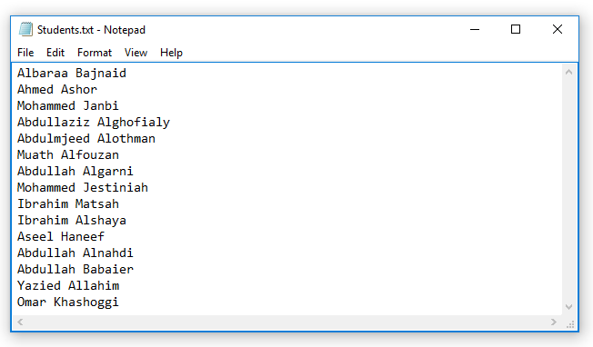

Creating groups from an array of students is not difficult at all (you can achieve it with few loops and an if-statement). The main idea of this utility is to create a **visual representation** of the process of assigning groups:

* The program should be implemented using Greenfoot (<http://www.greenfoot.org/>) – **no other choice**
* **[5 marks]** The program should start by loading all students from a text file. Each student should be shown in as an icon on the screen with his name underneath it.
* **[10 marks]** The program should give the user a way of choosing the number of groups (you can select whatever suits you e.g., text field, up-down button, etc..)
* After selecting the number of groups, the program should show a screen containing the students and the groups represented as tables.
  + Note: you can make this interactive by including the number of groups control inside the same screen
  + Tables do not have to be circles, they can be rectangles or squares (or even triangles)

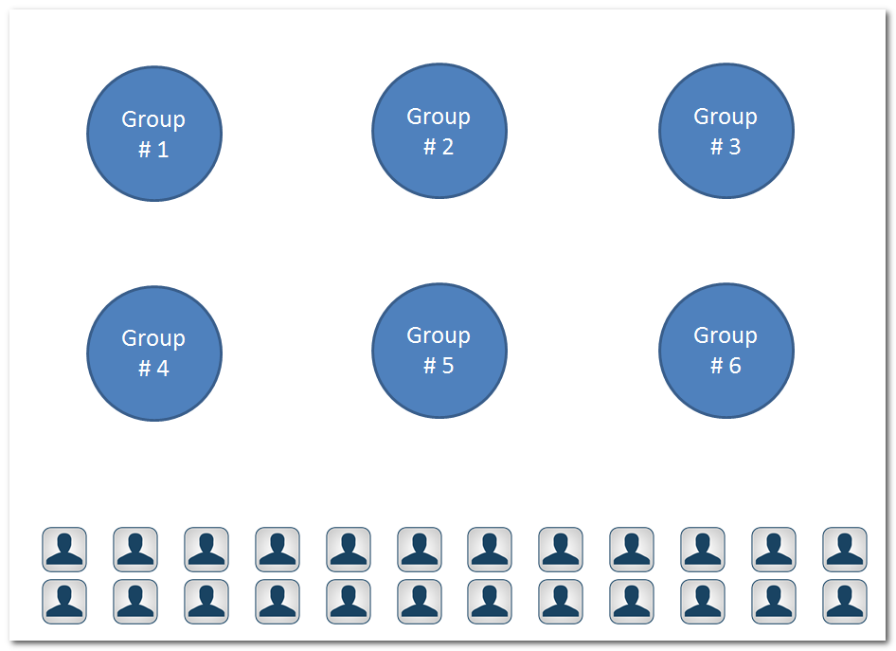

* You should have a button labeled: generate. When pressed, the actual process of students assignment to groups should start
* Students’ icons should **move** (step by step – not jump) from their original location to one of the empty slots around the table.
  + You can allow student to move one by one – However, I prefer to make them move together.
  + Movement algorithm is your own – choose any way of movement (passing over the table or going around the table)
* After finishing randomization, you should have students shown like this (**Note the angle of students**):



|  |
| --- |
| Note:  You should provide a **short** demo of your work showing the randomization process.  The demo should be uploaded to youtube.com (you can make **public** or **unlisted** and share the link with me). If you don’t have a google account, create one. |

# Task 4: Document your work (you will find this very beneficial later)

* Identify any resources you have used (e.g. websites)
* List all tools you have used in this assignment