**King Fahd University of Petroleum & Minerals**

**Information and Computer Science Department**

**SWE 205: Introduction to Software Engineering (151)**

**Term Project – Problem Description**

Hi there,,,, My name is Mr. Researcher. And since you are a programmer, I would like you to develop me software to help me with my daily life. I regularly read a lot of research papers to know the latest advances in my field. Every time I read a paper, I take notes that might help me when I write my own papers or articles.

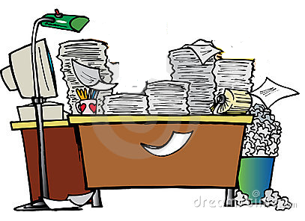My office is a mess,,, I really don’t know how many papers I have in my shelves and this is getting me crazy. Usually, I download papers from sources like google scholar, IEEE, ACM, ScienceDirect, ResearchGate, and many others.

Have you seen a paper before??? It looks like this:

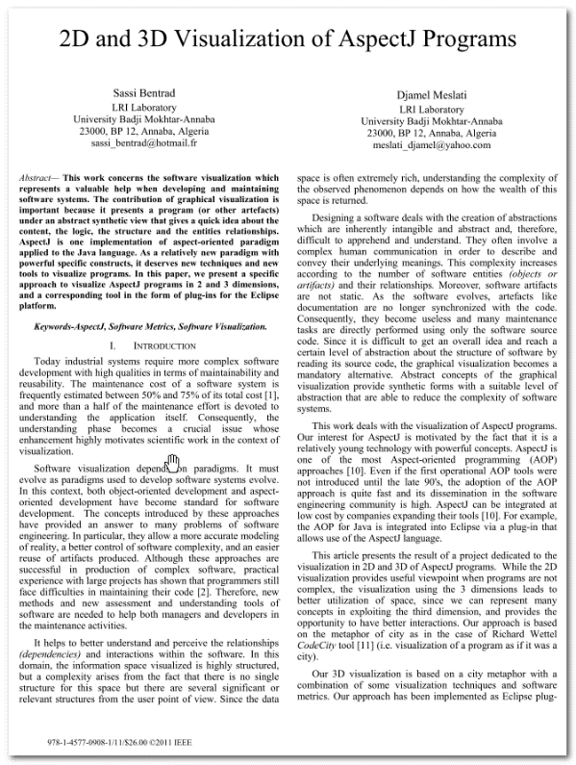

Whenever I want save a file, it comes with a strange name!! Something like

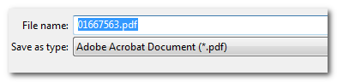

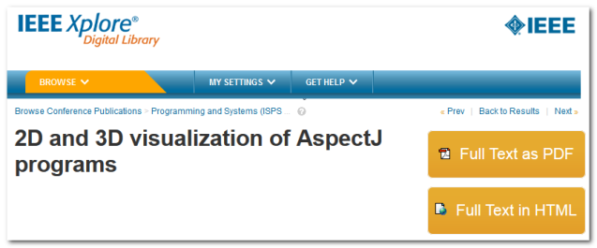And I have to type the file name myself or copy it and paste it from the page source:

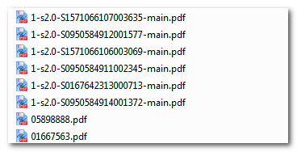

As you can imagine, the files will appear like this in my machine and searching for a certain paper takes forever. I don’t know how you will do it!! But I want you to find an ***easy*** way to rename my files to meaningful names. Currently, I do this manual-renaming to my files:



First part (0350) is a counter that keeps increasing for each paper I download. After that, I put five empty spaces. Then, I enter the date in which I downloaded the paper. I follow that with a space and then the title of the paper. Finally, I put the year in which the paper was published.

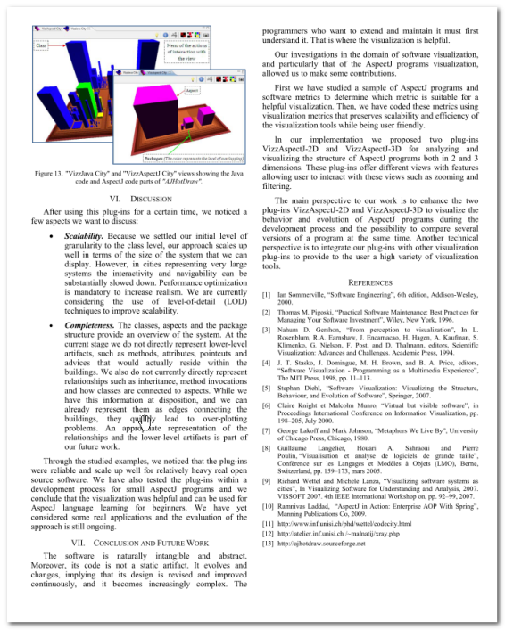The other issue, it is difficult for me to find the relation of the various papers in my library. Every paper has a list of references that usually appear in the last page of the paper.

It would be very nice to see the relation between the various papers. For example, paper A refers to paper B. Also paper C refers to paper B. I am just thinking here, it would be very informative to have a graphical representation of this relation. Something similar to this:

Keep in mind; papers are published in different years. Putting A and C in this representation is ok if they appear in the same year. However, if they are published in different years, they should appear with different horizontal alignment. I really don’t know how difficult is this but, hey,, you are the clever computer-guy who can do everything. Aren’t you???

By the way, the year will not appear in the paper itself. Also, the journal or conference in which the paper was published will not appear in the paper. I usually get this information from the BibTeX entry. Are you familiar with that? I download the BibTeX entry from many sources but it is usually available from the same source where I get the paper. It has the following format (this example is for the paper shown above):

@INPROCEEDINGS{5898888,   
 author={Bentrad, S. and Meslati, D.},   
 booktitle={Programming and Systems (ISPS), 2011 10th International Symposium on},   
 title={2D and 3D visualization of AspectJ programs},   
 year={2011},   
 month={April},   
 pages={183-190},   
 keywords={Java;aspect-oriented programming;data visualisation;2D visualization;3D   
 visualization;AspectJ programs;Eclipse platform;Java language;aspect-oriented   
 paradigm;graphical visualization;software systems;software visualization;   
 Color;Complexity theory;Data visualization; Java;Measurement; Software;   
 Visualization; AspectJ;Software Metrics;Software Visualization},   
 doi={10.1109/ISPS.2011.5898888},   
}

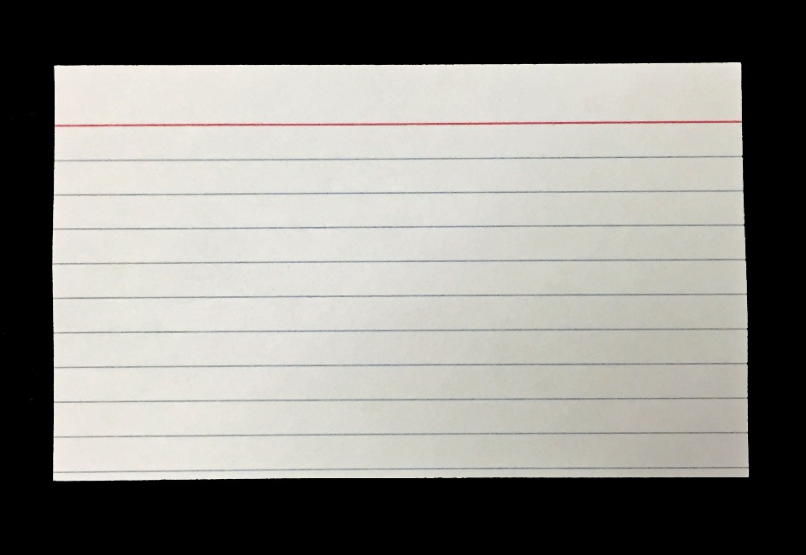Another thing, I do take notes when I read papers. I hope you can facilitate this for me as I am doing this manually right now. I take notes on what is called index-card.

Every index-card has one idea from one source. On the top of the index-card, I put the reference and the idea category (e.g, software reusability, advantages of aspect oriented languages). In the middle of the card, I write those interesting points that I found in the paper. It would be nice if you can facilitate this also in your software. One main feature that I am looking for is searching the pile of index-cards. I hope you can facilitate searching by words, by category, or by reference. Also, I know it is a computer application but I hope you can make in a way that appear as natural looking index-card with, maybe, hand-written fonts.

That’s all my friend… I guess everything is clear right now. If you have any questions, you can set a meeting with me next week (Oct 11 – Oct 15).

See you later…….

# Paper Sample

