# MJ-MART (E-COMMERCE)

**MJ-MART** is a **React-based** e-commerce web application built using **Vite**.  
It allows users to **browse books, filter by category, view details, and add new books** to the library.

## Installation & Setup:

### ****1. Create Project using Vite****

Vite is used as the project bundler

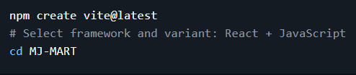

### 2. Install Dependencies:

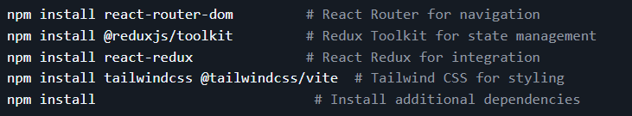

## 3. Start the development server:

C:\Users\JUNAID\AppData\Local\Packages\MicrosoftWindows.Client.Core_cw5n1h2txyewy\TempState\ScreenClip\{A3A397B7-3A50-4806-B962-CFFAD1D51BE9}.png

# Project Overview:

### ****Components****

* **Header** – Contains the logo and navigation links.



* **Home** – Displays a welcome message, product categories, and top-rated books.

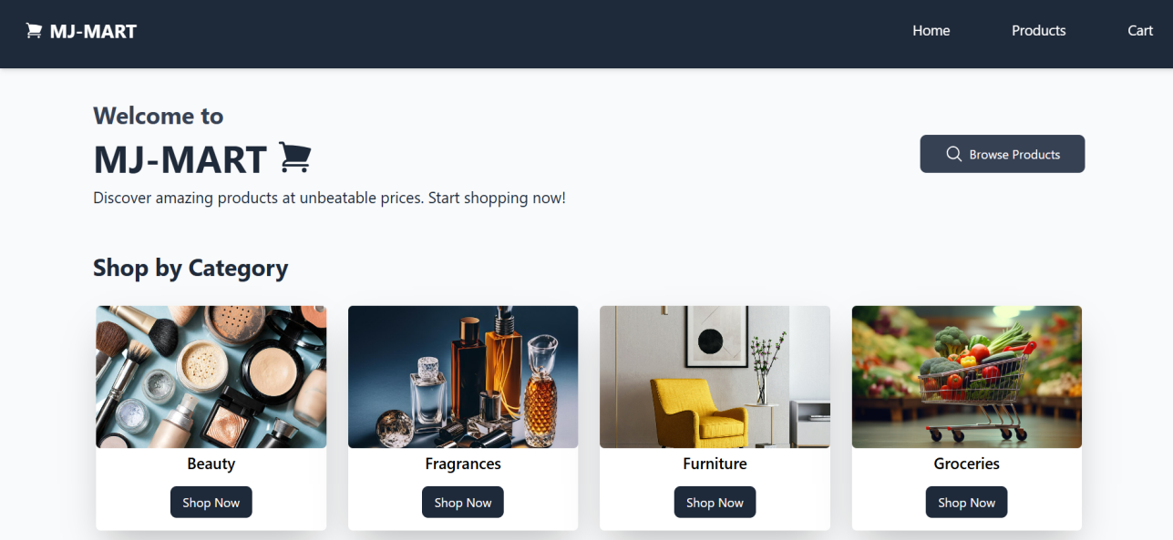

* **ProductItem** – Shows metadata of a single item.

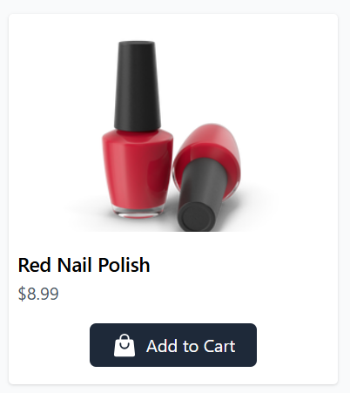

* **ProductList** – Displays all products.

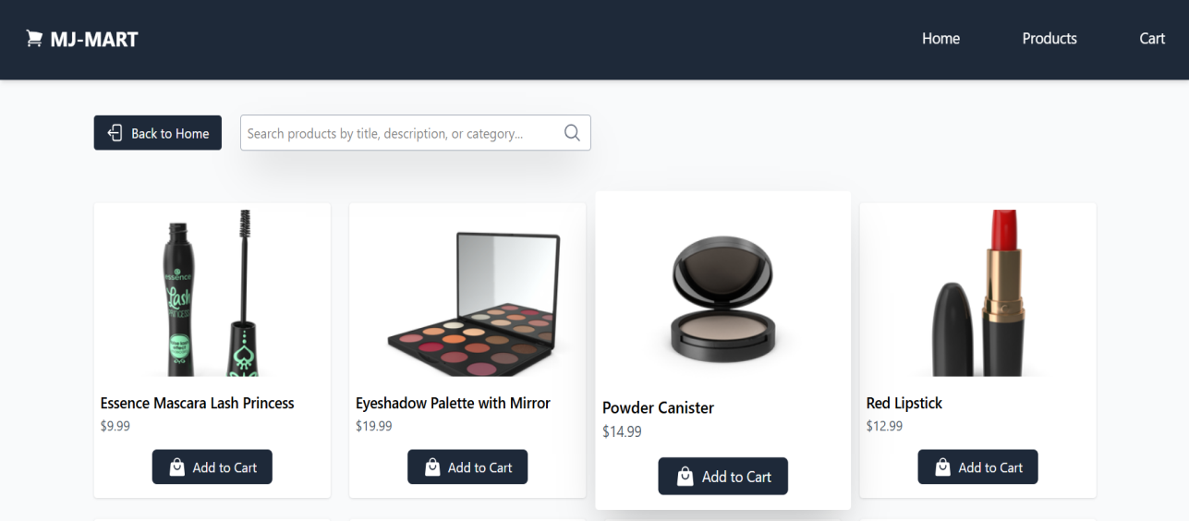

* **ProductCategory** – Filters and displays products by category.



* **TopRated** – Highlights the most popular books.

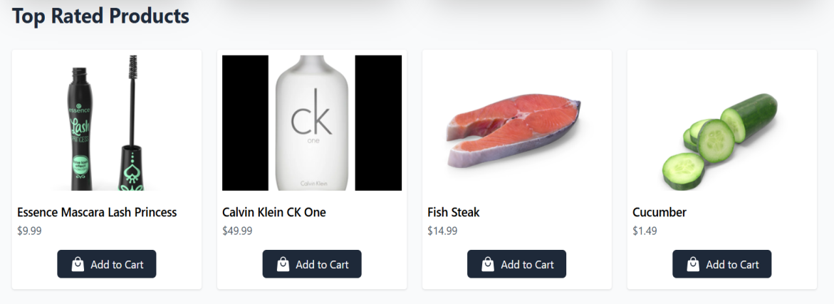

* **ProductDetail** – Shows detailed information about a book.

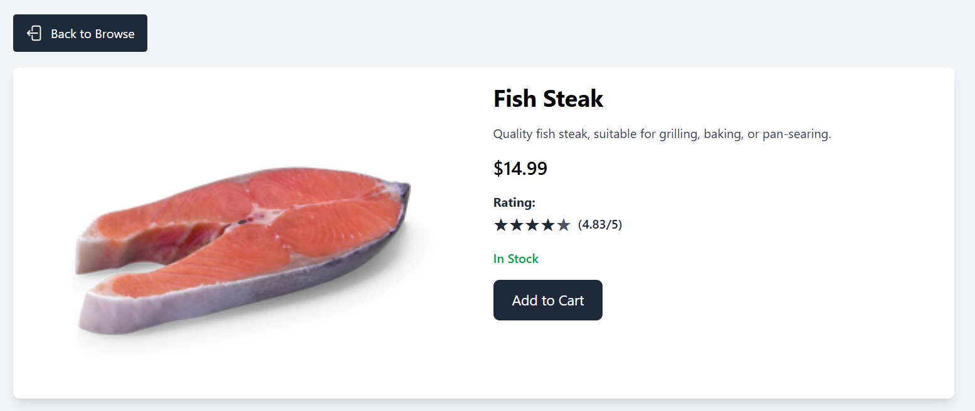

* **Cart** – Displays items added to the cart.



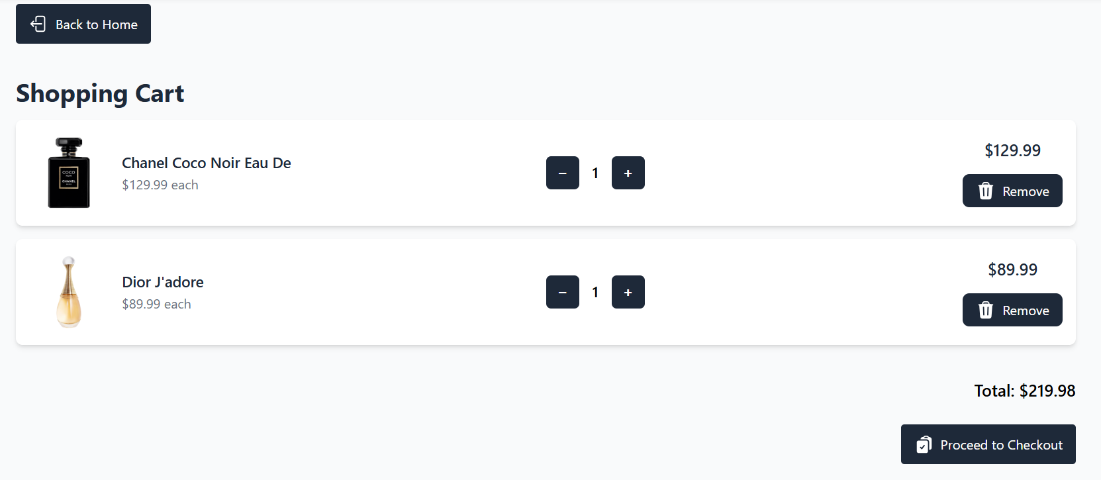

* **CartItem** – Represents a single item in the cart.

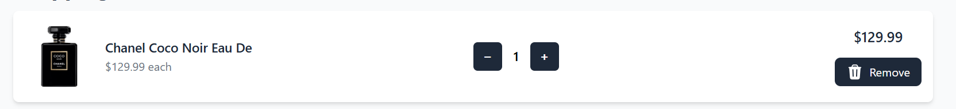

* **Checkout** – Displays order summary and checkout details.

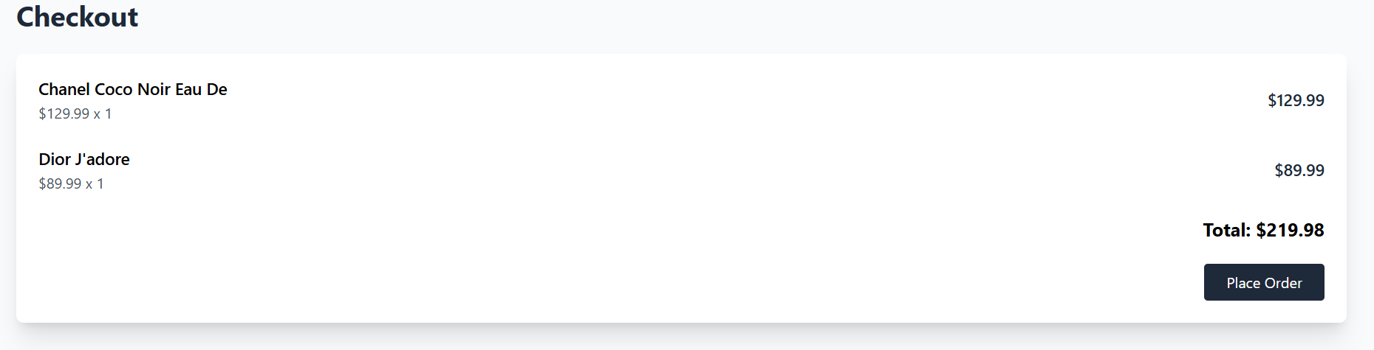

* **NotFound** – Handles undefined routes with an error message.

****

* **Hooks (useProduct) – Fetches product data.**
* **Used redux to manage the state of the books list.**

MY GITHUB REPOSITORY LINK:

<https://github.com/MohammedJunaidKhan18/MJ-MART-E-COMMERCE.git>