ACME PORTAL
Acme Portal Order Export Guide
Export orders for reporting and finance
User Guide
Product version 3.2
Document version 1.0
October 3, 2026

Acme Corporation
Copyright © 2026 Acme Corporation. All rights reserved.
Information in this document is subject to change without notice. Screens shown are representative and can differ slightly from your version of the product.

Contents
Introduction
Who should read this guide
What this guide covers
Before you begin
Document conventions
Order export
Go to Order export
Export limits
Export flow
Screen elements
Export orders to a file
Appendix
Contact information
Troubleshooting
Glossary
Related documents

Introduction
Acme Portal is the web application that order managers use to track and manage customer orders.
This guide explains how to export orders from the Orders page so you can share order data with finance and reporting teams.
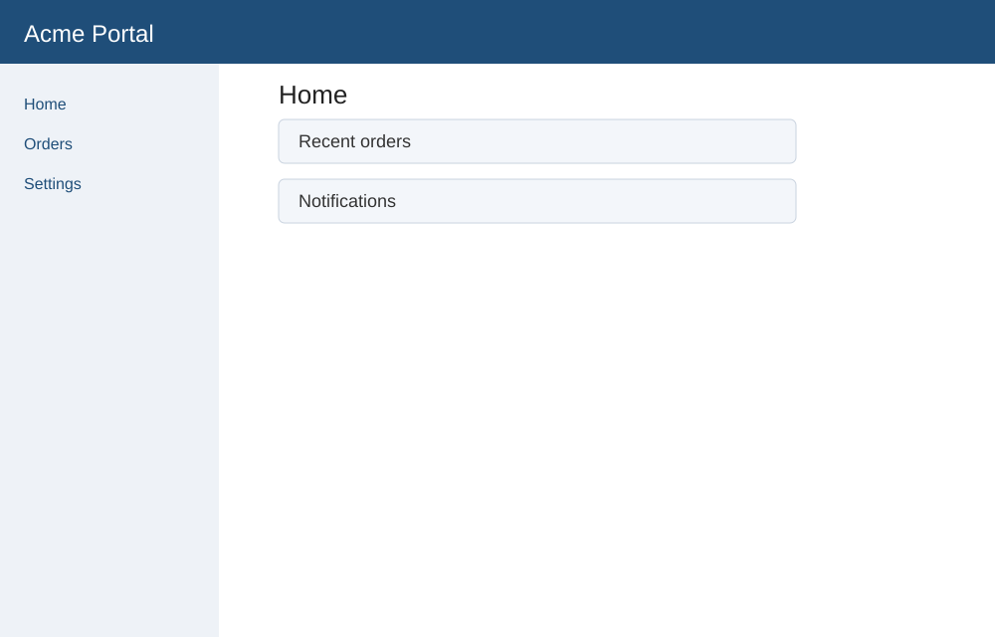
Figure 1. Acme Portal home screen

Who should read this guide
Order managers who have the Order Manager role in Acme Portal.

What this guide covers
This guide describes the following features:
- Order export

Before you begin
- An Acme Portal account with the Order Manager role.
- A supported web browser.

Document conventions
This guide uses the following conventions:
Convention | Meaning
Bold | Names of buttons, menus, fields, tabs, and other elements you select or see on the screen.
Italic | New terms, and placeholders that you replace with your own value.
Monospace | Text that you type, file names, and codes.
Numbered steps | Procedures. Complete the steps in order.
Note, Tip, Important, Caution | Supporting information. A caution or warning describes an action that can cause loss of data or an error.

Order export
Order export lets you download the orders that match your current filter as a CSV or XLSX file. You can open the file in a spreadsheet application or load it into reporting tools.
Only users with the Order Manager role see the Export button. Each export can contain up to 10,000 rows.

Go to Order export
To open Order export from the home screen, do the following:
- Sign in to Acme Portal.
The home screen appears.
- In the left pane, select Orders.
The Orders page appears.
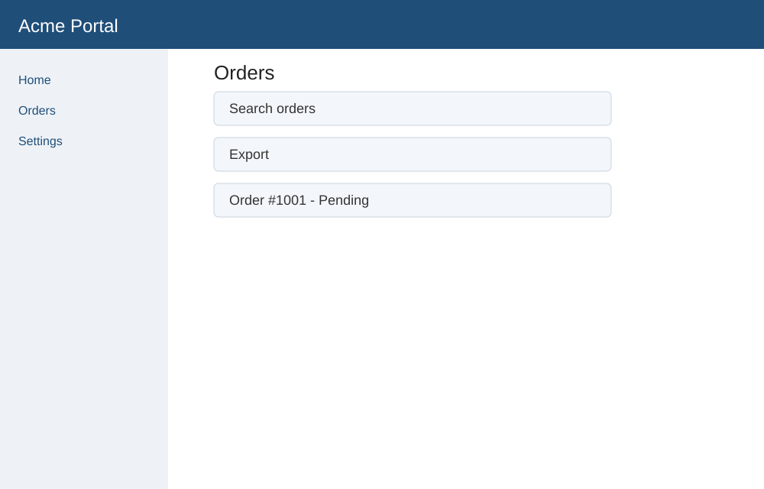
Figure 2. Orders page
- Select Export.
The Export orders dialog box appears.
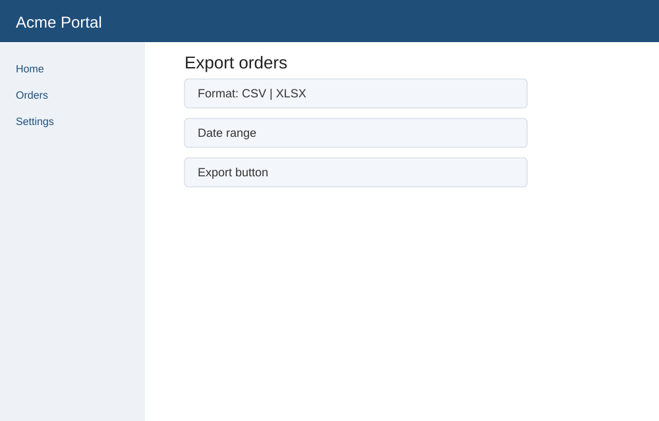
Figure 3. Export orders dialog box

Export limits
An export can contain up to 10,000 rows. If your filter returns more rows, Acme Portal shows the message Narrow your filter. Add filter criteria and try again.

Export flow
The following diagram shows the export flow defined in the specification.
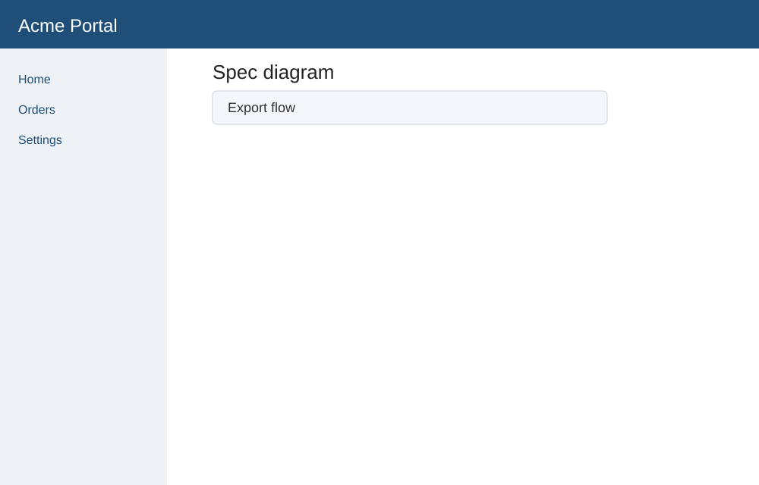
Figure 4. Order export flow

Screen elements
The following table describes the elements on the Order export screen.
Element | Description
Format | File type for the export: CSV or XLSX.
Date range | Limits the export to orders created within the selected dates.
Export | Creates the file and downloads it to your computer.

Export orders to a file
Before you begin
- You have the Order Manager role.
- On the Orders page, filter the list to the orders you want.
- Select Export.
The Export orders dialog box appears.
- In the Format list, select CSV or XLSX.
- In Date range, select the start and end dates.
- Select Export.
The file downloads to your computer.
Note: Large exports can take up to a minute.
Important: If you do not see the Export button, ask your administrator to assign the Order Manager role to your account.

Appendix

Contact information
Use the following contacts for help with the product or this guide.
Product owner
Name: Priya
Technical support
Email: support@acme.example
Hours: Monday to Friday, 9:00 AM to 6:00 PM IST

Troubleshooting
Problem | Solution
The message Narrow your filter appears. | Your filter returns more than 10,000 rows. Add filter criteria and export again.

Glossary
Term | Definition
CSV | Comma-separated values, a plain-text table format.
XLSX | Microsoft Excel workbook file format.

Related documents
- Order Export Spec: https://kashiftwtai.atlassian.net/wiki/spaces/AP/pages/555
- Portal designs: https://www.figma.com/design/AbCdEfGhIjKlMnOpQrStUv/Portal

