
المملكة العربية السعودية
وزارة التعليم
الجامعة الإسلامية
كلية الحاسب الآلي ونظم المعلومات
KINGDOM OF SAUDI ARABIA
Ministry of Education
Islamic University
College of Computing and Information Systems

Frequent Itemsets and Association Rules in Online Retail

Supervised by:
Prof. Rashid Mehmood
1st Semester - Academic Year 1448–1449 AH (2026)
Table of Content
Abstract 1
1 Mini Project Description 2
1.1 Objective and problem 2
1.2 Dataset and basket model 2
1.3 Why frequent itemset mining is suitable 2
2 Selected Concepts from Chapter 6 3
2.1 Support and frequent itemsets 3
2.2 Association rules and rule strength 3
2.3 Apriori and monotonicity 4
2.4 Pair counters and memory 4
2.5 PCY and hashing refinements 4
2.6 Maximal and closed frequent itemsets 5
3 Mini Project Design and Algorithms 6
3.1 Pipeline and implementation 6
3.2 Data preparation 6
3.3 Candidate generation and counting 7
3.4 Thresholds and experimental controls 7
4 Demonstration of Concepts 8
4.1 A small example with exact answers 8
4.2 Apriori levels on the retail data 8
4.3 Threshold effects on individual patterns 9
4.4 PCY preserves the exact frequent pairs 9
5 Evaluation of the Mini Project 10
5.1 Minimum support 10
5.2 Minimum confidence 11
5.3 Scalability 12
5.4 Pair storage and hashing tradeoffs 13
5.5 Compact output and rule interest 14
5.6 Interpretation and limitations 14
6 Appendix Project Structure 16
7 References 17

Abstract
This project investigates products purchased together in the UCI Online Retail dataset. A manually implemented Apriori algorithm mines 19,766 cleaned invoice baskets. At 1% minimum support and 50% minimum confidence, it finds 2,013 frequent itemsets and 962 association rules. PCY, Multistage, and Multihash preserve the exact frequent pairs while reducing candidate counts at suitable bucket capacities.
The experiments demonstrate threshold sensitivity, subset pruning, pair-counter storage, and compact frequent-itemset output. Matching product families produce strong associations, but their commercial usefulness requires validation on future transactions. The report explains the algorithms, demonstrates their behavior with exact examples, and evaluates the saved experimental results.
Keywords
Frequent itemsets, association rules, Apriori, PCY, Online Retail, market baskets

1 Mini Project Description

1.1 Objective and problem
The project discovers frequent product groups and interpretable association rules from invoices. It converts individual invoice lines into baskets, mines recurring itemsets, and measures how algorithm parameters affect the results. Applications include product bundles, catalogue grouping, and related-product suggestions.
The project demonstrates Chapter 6 concepts: frequent-item candidate generation, pruning larger candidates with infrequent subsets, and eliminating pairs through hash-bucket counts.

1.2 Dataset and basket model
The Online Retail dataset was donated by Daqing Chen to the UCI Machine Learning Repository in 2015. It contains 541,909 invoice lines from a UK online retailer between 1 December 2010 and 9 December 2011. The eight fields are InvoiceNo, StockCode, Description, Quantity, InvoiceDate, UnitPrice, CustomerID, and Country. The dataset is licensed under CC BY 4.0. [1]
A basket is the set of distinct product descriptions on one cleaned InvoiceNo. Repeated lines and multiple units of a product contribute one presence per basket. Invoice identity is sufficient, so missing CustomerID does not require removing an otherwise valid purchase. Single-item invoices remain in the denominator of support.
An item is a canonical product description. Preprocessing selects the most frequent normalised description per StockCode, then builds baskets from descriptions and assigns sorted integer IDs. StockCodes sharing a canonical description become one item; the report follows this implemented representation.
Property after preprocessing | Value
Baskets | 19,766
Distinct description items | 3,749
Total item occurrences | 513,563
Mean and median basket size | 25.98 and 15
Largest basket | 1,100 items
Single-item baskets | 1,508
Pair occurrences across all baskets | 28,002,911

1.3 Why frequent itemset mining is suitable
Each invoice is a subset of the product universe, so the data fits the market-basket model. Support measures recurrence across invoices and confidence measures a conditional co-purchase proportion. No class labels are required. The matrix is sparse overall: only about 0.69% of basket–item positions are occupied. Yet 3,749 items allow 7,025,626 possible pairs and about 8.78 billion triples, making exhaustive enumeration unattractive. Apriori and PCY reduce the combinations requiring exact counts.

2 Selected Concepts from Chapter 6
The project demonstrates six related concepts from Chapter 6 of Mining of Massive Datasets: support and frequent itemsets, association rules, Apriori and monotonicity, pair-counter storage, hash-based candidate reduction, and maximal and closed itemsets. [2]

2.1 Support and frequent itemsets
An itemset is a set of items. Its support count is the number of baskets containing every item in that set; relative support divides this count by the total number of baskets. The distinction matters because experiments use percentage thresholds but the implementation compares integer counts.
σ(I) = |{b ∈ B : I ⊆ b}| support(I) = σ(I) / N
minCount = ⌈sN⌉ I is frequent ⇔ σ(I) ≥ minCount
For N = 19,766 and s = 0.01, the minimum count is 198. The pair JUMBO BAG PINK POLKADOT and JUMBO BAG RED RETROSPOT occurs in 825 baskets, so its support is 825 / 19,766 = 4.17%. It is frequent at 1% and 4%, but fails at 5%. The implementation counts item presence once per invoice, rather than adding purchased quantities.

2.2 Association rules and rule strength
A rule X → Y has non-empty, disjoint antecedent and consequent sets. Confidence estimates the proportion of baskets containing X that also contain Y. High confidence can partly reflect a popular consequent. Interest subtracts the consequent’s baseline support; lift divides by it. For multi-item consequents, support(Y) means joint support of all consequent items.
support(X → Y) = σ(X ∪ Y) / N
confidence(X → Y) = σ(X ∪ Y) / σ(X)
interest(X → Y) = confidence(X → Y) − support(Y)
lift(X → Y) = confidence(X → Y) / support(Y)
Interest equal to zero and lift equal to one indicate independence at the empirical frequencies. Positive interest or lift above one indicates more co-occurrence than the baseline, but does not establish causation or statistical significance. A cutoff of 0.5 for interest is used as an illustrative threshold in the experiment, not as a universal significance test.
For the pink and red jumbo bags, the individual counts are 1,218 and 2,089, and the pair count is 825. PINK → RED has confidence 67.73%, interest 0.572, and lift 6.41. RED → PINK has confidence 39.49% and interest 0.333. Confidence depends on direction; lift is symmetric for this pair.
The rule generator enumerates every non-empty proper subset X of each frequent itemset I and sets Y = I \ X. All required subset counts are already known by monotonicity, so rule generation needs no new basket scan.

2.3 Apriori and monotonicity
Apriori discovers frequent sets one size at a time. A basket containing a set necessarily contains each of its subsets. Therefore support cannot increase when items are added. If even one subset is infrequent, a candidate containing that subset cannot be frequent. Apriori applies this rejection before counting candidates. [3]
J ⊆ I ⇒ σ(J) ≥ σ(I)
If a (k − 1)-subset of candidate C is absent from Lₖ₋₁, reject C.
The algorithm counts all items to obtain L₁, joins frequent sets sharing a prefix to generate candidates Cₖ, prunes candidates with infrequent subsets, counts the survivors, and retains counts at least minCount as Lₖ. It stops when no frequent sets remain. The join guarantees two subsets are frequent, so the implementation only checks the remaining subsets.

2.4 Pair counters and memory
A triangular array stores one counter for each unordered pair of m frequent items. A table of triples stores item IDs i and j plus a count for each occurring pair. Under a textbook model of four bytes per integer, the triangular representation needs 4 × m(m − 1)/2 bytes and triples need 12 × Pocc bytes. Triples save space only when fewer than one third of possible pairs occur.
position(i, j) = (i − 1)(m − i/2) + j − i, 1 ≤ i < j ≤ m
The formula uses one-based positions. Renumbering only frequent items reduces the array size. These are theoretical storage estimates: the Python implementation uses NumPy int64 counters, Boolean arrays, dictionaries, and temporary pair arrays. Its actual peak memory exceeds the textbook estimates and is not measured in this project.

2.5 PCY and hashing refinements
PCY counts items and hashes pair occurrences to buckets during its first conceptual pass. Bucket counts below minCount cannot contain a frequent pair, because a bucket count includes all occurrences of each pair hashing to it. The final pass counts only pairs whose items are both frequent and whose bucket qualifies. Hash collisions can retain infrequent pairs, but cannot remove a truly frequent pair. [4]
hₜ(i, j) = ((aₜi + bₜj + cₜ) mod p) mod B, p = 2³¹ − 1
Multistage adds another pass that hashes only occurrences of pairs surviving the first filter into an independent second table. The last pass requires both bucket checks. Multihash instead hashes every pair into two tables during the first pass, splitting the total bucket budget in half; the final pass also requires both checks. Smaller individual tables increase collision pressure, so Multihash can perform poorly when the budget is too small.
The code keeps baskets in memory and implements the item and pair scans separately. The reported two- or three-pass counts describe the textbook algorithms. Diagnostics perform extra scans outside the timed mining portion. The Boolean bucket filters are not physically packed into one-bit storage.

2.6 Maximal and closed frequent itemsets
A frequent set is maximal when no proper superset is frequent. It is closed when no proper superset has the same support count. Immediate supersets suffice for these checks because of monotonicity. Maximal sets preserve which sets are frequent through their subsets, but do not preserve all counts needed to generate rules. Closed frequent sets can preserve support information. [2]
I maximal ⇔ I ∈ F and no frequent proper superset exists
I closed ⇔ no proper superset J has σ(J) = σ(I)
For example, if A has count 4, AB has count 4, B has count 5, C has count 3, and BC has count 3, then maximal sets are AB and BC. Closed frequent sets are B, AB, and BC. A and C are not closed because supersets preserve their counts.

3 Mini Project Design and Algorithms

3.1 Pipeline and implementation
The pipeline is raw Excel → data-quality checks → cleaned invoice baskets → integer encoding → Apriori → rule generation → experiment tables and figures → Flask dashboard. The hashing and triangular-counter modules separately mine pairs and check them against Apriori. Compact-output analysis uses the complete Apriori result. The mining logic is implemented directly; pandas handles cleaning and NumPy accelerates pair-array operations.
Module | Purpose
src/preprocessing.py | Clean lines and build baskets
src/apriori.py | Join, prune, count, and filter itemsets
src/association_rules.py | Generate rules and compute strength measures
src/pcy.py | Triangular counts, PCY, Multistage, Multihash
src/compact_output.py | Identify maximal and closed sets
src/experiments.py | Support, confidence, pruning, scalability
src/chapter6_experiments.py | Toy examples, memory estimates, hashing, compact output, interest
app.py and front end | Display results through the dashboard
tests/ | Toy examples and brute-force cross-checks

3.2 Data preparation
Cleaning is sequential, so removal counts below are conditional on earlier steps and must not be added to raw data-quality totals that overlap. Descriptions are normalised before basket construction. The project also excludes 22 alcohol- or smoking-themed products under its scope filter; these results describe the filtered product universe.
No. | Action | Lines removed | Values changed
1 | Exact duplicate lines | 5,268 | 0
2 | Cancelled invoices | 9,251 | 0
3 | Nonstandard invoice numbers | 3 | 0
4 | Missing descriptions | 1,454 | 0
5 | Nonpositive quantity | 474 | 0
6 | Nonpositive unit price | 582 | 0
7 | Non-product codes | 2,337 | 0
8 | Normalise description text | 0 | 126,548
9 | Canonical description per StockCode | 0 | 6,555
10 | Project scope keyword filter | 3,442 | 0
11 | Repeated item within an invoice | 5,535 | 0
The 541,909 raw lines become 519,098 cleaned lines, then 513,563 distinct invoice–description occurrences. These form 19,766 baskets. Missing CustomerID values remain because this analysis is invoice based. Removing nonpositive prices is a project choice; it may also exclude legitimate free promotional items, so the findings apply to positive-price purchases.

3.3 Candidate generation and counting
Item names are alphabetically sorted and encoded as integers. Baskets and itemsets are sorted tuples, which support prefix joins and dictionary lookup. C₂ contains all pairs of L₁. For k ≥ 3, itemsets sharing their first k − 2 IDs are joined. For example, AB and AC generate ABC; the code then checks BC. If BC is absent from L₂, ABC is removed.
For each counting level, the code drops basket items absent from every candidate. It compares the number of basket k-subsets with the candidate count. For ordinary baskets it enumerates subsets and looks them up; for unusually large baskets it checks candidates for containment. Both strategies give the same support, while avoiding the combinatorial expansion of large wholesale invoices.
The pair-mining extensions generate pair arrays in chunks of 2,000 baskets. However, final counting collects retained pair codes across chunks and uses NumPy unique counts. It is not a bounded-memory disk-streaming implementation. This distinction is relevant when interpreting its memory estimates.

3.4 Thresholds and experimental controls
The support sweep uses 0.5%, 0.75%, 1%, 1.5%, 2%, 3%, 4%, and 5%. The reference setting is 1%, corresponding to 198 baskets. The most common item appears in 11.46% of baskets, and no pair survives at 5%; these values provide useful variation in this dataset. Confidence ranges from 30% to 90% in steps of 10%, with 50% as the reference.
The saved timing environment is an Apple M2 Max with 32 GB RAM, macOS, and Python 3.13.3. Timings use time.perf_counter and the median of three runs. Scalability uses nested shuffled samples with seed 42, holding relative support at 1%. Sampling measures behavior at different data sizes; it does not implement a corrected sample-based mining algorithm such as Toivonen or distributed SON. No distributed processing is used.

4 Demonstration of Concepts

4.1 A small example with exact answers
The test baskets are {m,c,b}, {m,p,j}, {m,b}, {c,j}, {m,p,b}, {m,c,b,j}, {c,b,j}, and {b,c}. At minimum count 3, L₁ = {b,c,j,m}; L₂ = {bc,bm,cj}; and L₃ is empty. Joining bc and bm proposes bcm, but it is pruned because cm has count 2 and is absent from L₂. The example exposes candidate generation and subset pruning with answers that can be checked by hand.
For the rule {m,b} → c, the antecedent count is 4 and the union count is 2. At a reduced minimum count of 2, the union is frequent and the rule can be generated. Confidence is 2/4 = 0.5. Since c occurs in 5/8 baskets, interest is 0.5 − 0.625 = −0.125. The test checks these exact values, illustrating why a moderate-confidence rule need not have positive interest.

4.2 Apriori levels on the retail data
Size k | Joined | Pruned | Counted | Frequent
1 | 3,749 | 0 | 3,749 | 824
2 | 339,076 | 0 | 339,076 | 902
3 | 5,795 | 2,770 | 3,025 | 261
4 | 284 | 165 | 119 | 25
5 | 5 | 4 | 1 | 1
At 1% support, the 824 frequent items reduce candidate pairs from all 7,025,626 possibilities to 339,076, or 4.83%. At k = 3, subset pruning removes 2,770 of 5,795 joined candidates, or 47.8%. It removes 58.1% at k = 4 and 80% at k = 5. The result contains 824 + 902 + 261 + 25 + 1 = 2,013 frequent sets. The pair level remains the largest counting problem.
For example, the triple containing 6 RIBBONS RUSTIC CHARM, JAM MAKING SET PRINTED, and SCANDINAVIAN REDS RIBBONS is pruned because the last two products occur together in only 138 baskets. The triple cannot occur more often than that pair and therefore cannot reach 198.
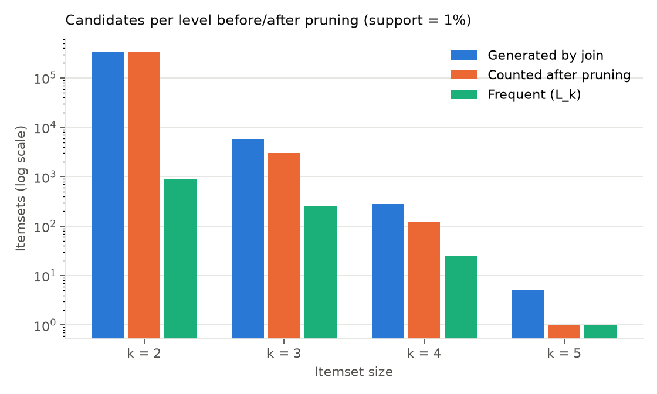
Figure 1 Candidate reduction by Apriori level at 1% support

4.3 Threshold effects on individual patterns
The GREEN, PINK, and ROSES REGENCY TEACUP AND SAUCER trio occurs in 541 baskets, or 2.74%. It survives at 1% and 2%, but fails at 3%, where minCount = 593. Its pairs still qualify, so Apriori generates the trio and rejects it only after counting. This distinguishes pruning by an infrequent subset from rejection by a candidate’s own support.
The pink and red jumbo-bag pair produces different directional rules. PINK → RED, at 67.73% confidence, survives thresholds of 30% and 50% but fails at 70%. RED → PINK, at 39.49%, survives 30% but fails 50%. Changing confidence leaves the frequent itemsets unchanged.

4.4 PCY preserves the exact frequent pairs
At 1% support and one million buckets, PCY hashes 28,002,911 pair occurrences, averaging 28.0 occurrences per bucket compared with minCount = 198. Only 0.16% of buckets qualify. The final pass counts 2,352 observed candidate pairs, of which 902 are frequent and 1,450 are false positives. The frequent-pair dictionary matches Apriori exactly. The candidate reduction is 99.31% relative to Apriori’s 339,076 theoretical candidates, or 99.30% relative to its 337,984 occurring pairs.

5 Evaluation of the Mini Project

5.1 Minimum support
Support | Min count | L₁ | L₂ | L₃₊ | Total | Time s
0.5% | 99 | 1,544 | 8,191 | 7,500 | 17,235 | 7.974
0.75% | 149 | 1,091 | 2,290 | 1,137 | 4,518 | 2.964
1% | 198 | 824 | 902 | 287 | 2,013 | 1.575
1.5% | 297 | 479 | 240 | 39 | 758 | 0.663
2% | 396 | 299 | 90 | 3 | 392 | 0.353
3% | 593 | 131 | 10 | 0 | 141 | 0.144
4% | 791 | 70 | 1 | 0 | 71 | 0.075
5% | 989 | 36 | 0 | 0 | 36 | 0.045
Increasing support from 0.5% to 5% reduces frequent itemsets from 17,235 to 36 and the largest size from six to one. Larger itemsets disappear first because every added item imposes another joint-presence condition. Runtime falls from 7.974 to 0.045 seconds, about 177 times, as fewer items survive and candidate pairs decline quadratically with |L₁|. These saved timings describe this machine and implementation, not a universal speed guarantee.
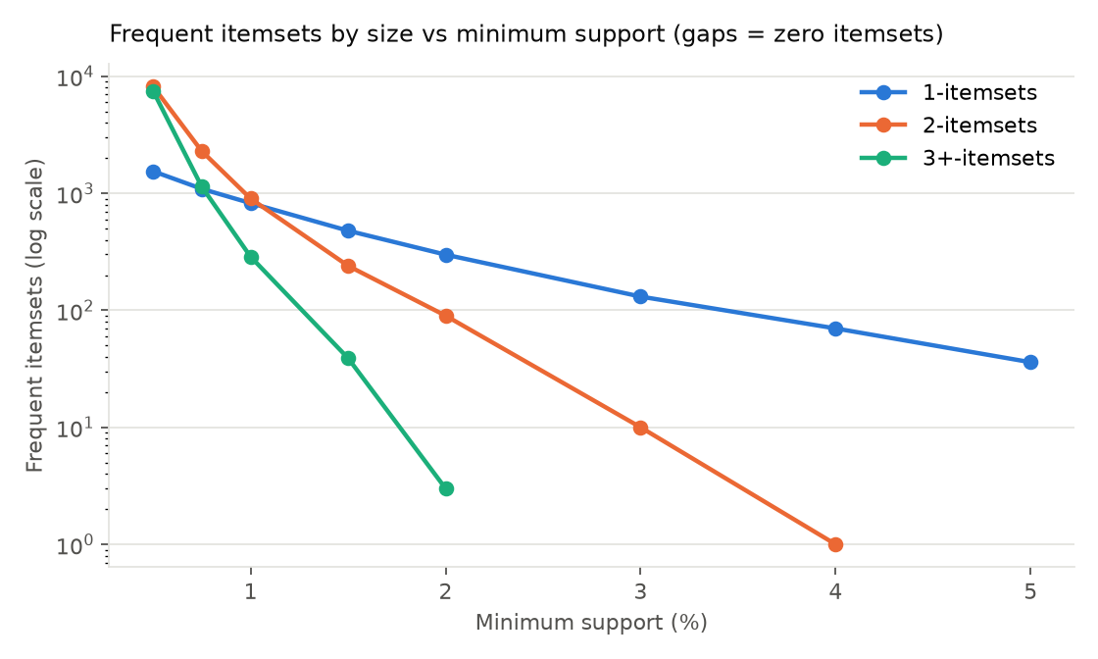
Figure 2 Frequent itemsets by size at different support thresholds
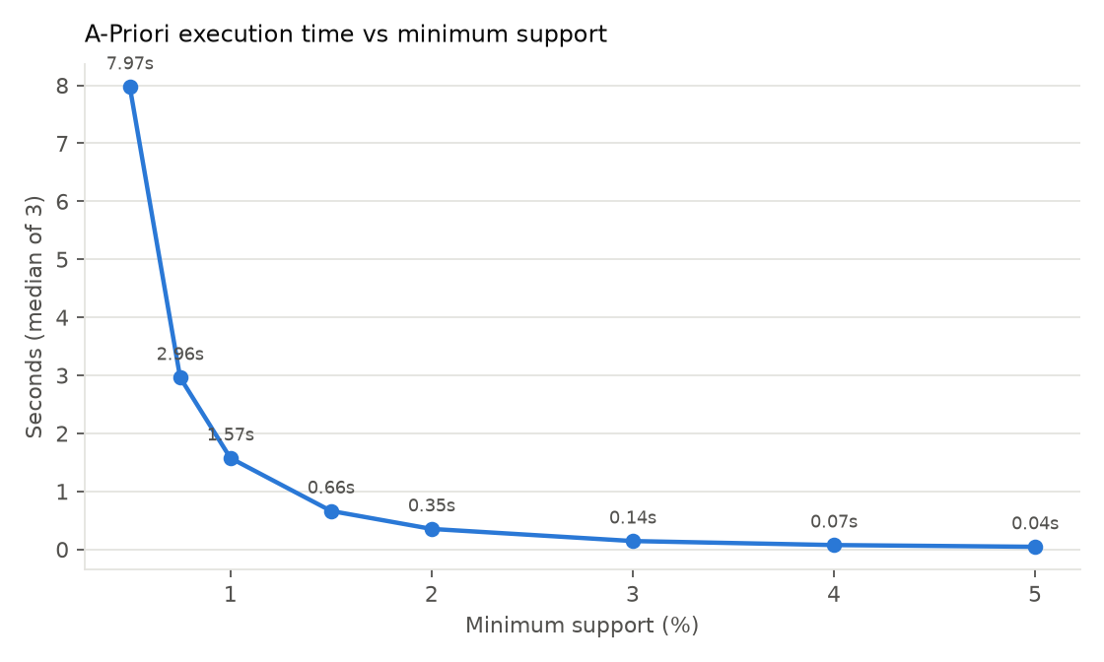
Figure 3 Saved median Apriori runtime at different support thresholds

5.2 Minimum confidence
Confidence | Rules | Average confidence | Average lift
30% | 1,938 | 52.1% | 13.7
40% | 1,402 | 58.6% | 15.2
50% | 962 | 65.0% | 17.0
60% | 574 | 71.7% | 19.3
70% | 289 | 78.8% | 23.3
80% | 109 | 85.9% | 35.7
90% | 20 | 92.2% | 50.5
Raising confidence removes rules after mining; all 2,013 frequent itemsets remain. The rule count falls by 98.97% from 1,938 at 30% to 20 at 90%. Tight product families account for the strongest retained rules. Average lift rises in this dataset, but confidence filtering does not mathematically guarantee that lift will rise for other data. Sixteen of the 20 rules at 90% arise from itemsets of size at least three.
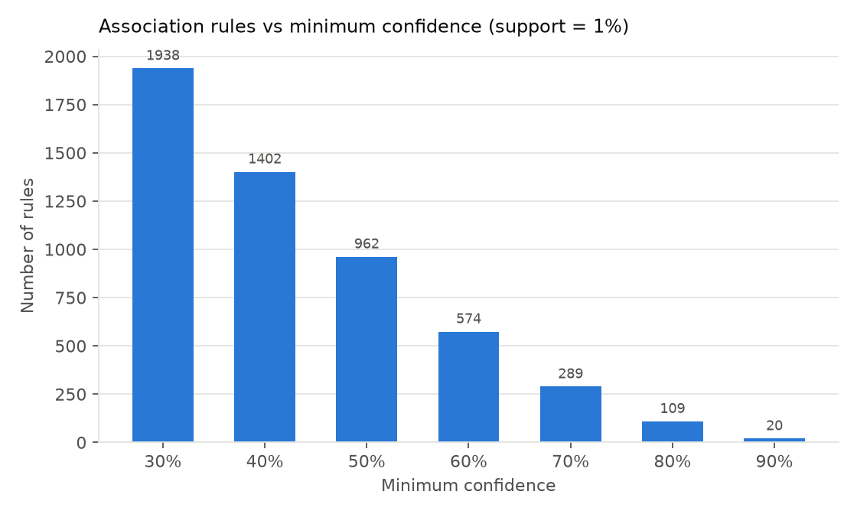
Figure 4 Rules retained at different confidence thresholds with support fixed at 1%

5.3 Scalability
Nested samples of 2,500, 5,000, 10,000, 15,000, and 19,766 baskets were mined at 1% relative support. Candidate counts remain close to 340,000 while the minimum count grows from 25 to 198. Frequent sets are 2,801, 2,312, 2,029, 2,072, and 2,013 respectively. The count is not monotonic across nested samples because a fixed percentage threshold and changing empirical frequencies can add or remove patterns.
Runtime increases approximately linearly over the measured range. Per 1,000 baskets, the saved cost decreases from 126.6 to 81.1 milliseconds as fixed costs are spread across more data. The smaller sample’s additional patterns may reflect sampling variability, but were not tested against full-data support as false positives. This is a limited within-dataset experiment, not evidence of distributed or out-of-memory scalability.
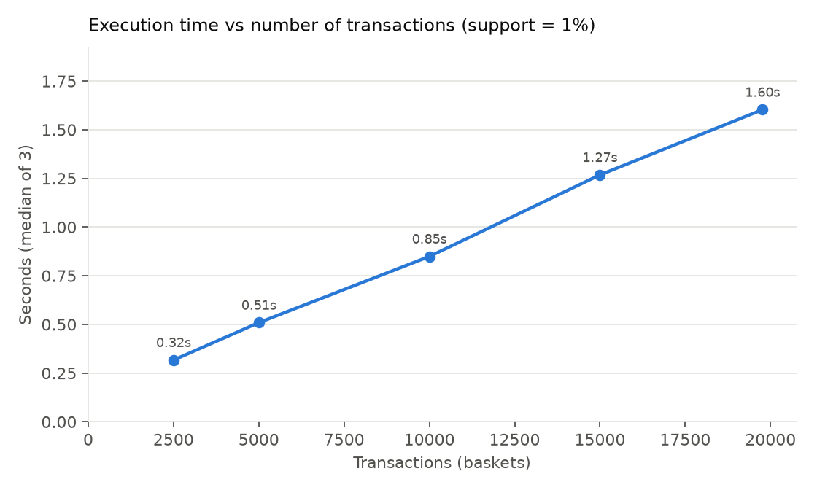
Figure 5 Apriori runtime over nested basket samples at 1% support

5.4 Pair storage and hashing tradeoffs
Support | Frequent items | Triangular estimate MB | Triples estimate MB | Occurring pairs
0.5% | 1544 | 4.765 | 13.850 | 1,154,145
1% | 824 | 1.356 | 4.056 | 337,984
2% | 299 | 0.178 | 0.534 | 44,539
Almost every pair of frequent items occurs at least once: 96.9% to nearly 100%. Thus the triangular estimate is smaller than triples at these settings. At 1% support, renumbering 824 frequent items reduces the four-byte model from 28.103 MB for all products to 1.356 MB. The actual NumPy int64 counter array alone uses twice this estimate.
Bucket budget B | PCY candidates | Multistage candidates | Multihash candidates
10,000 | 337,984 | 337,984 | 337,984
100,000 | 311,700 | 41,973 | 337,984
300,000 | 27,364 | 1,129 | 95,948
1,000,000 | 2,352 | 904 | 1,970
4,000,000 | 1,065 | 902 | 1,017
B is the size of each PCY or Multistage table; Multistage therefore allocates two B-sized tables. Multihash divides total B into two B/2 tables. This experiment does not give Multistage the same total table capacity as PCY. Every configuration returns the same 902 frequent pairs.
At 10,000 buckets, the average PCY bucket count is 2,800, well above 198; all buckets qualify and hashing offers no additional filtering. At one million, PCY leaves 1,450 false positives, Multistage leaves two, and Multihash leaves 1,068. Multistage’s second filter is effective because it receives only occurrences of surviving pairs, but it requires another pass. Multihash suffers when its half-sized tables become saturated.
The idealised final storage for PCY is 153,224 bytes at one million buckets and 512,780 bytes at four million. The larger bitmap eventually outweighs further candidate reductions. These estimates exclude Python overhead, retained int64 bucket counters, unpacked Boolean arrays, input baskets, and temporary pair arrays. They must not be presented as measured peak memory. Hashing is vectorised while Apriori uses Python counting loops, so timing differences do not isolate the algorithms themselves.
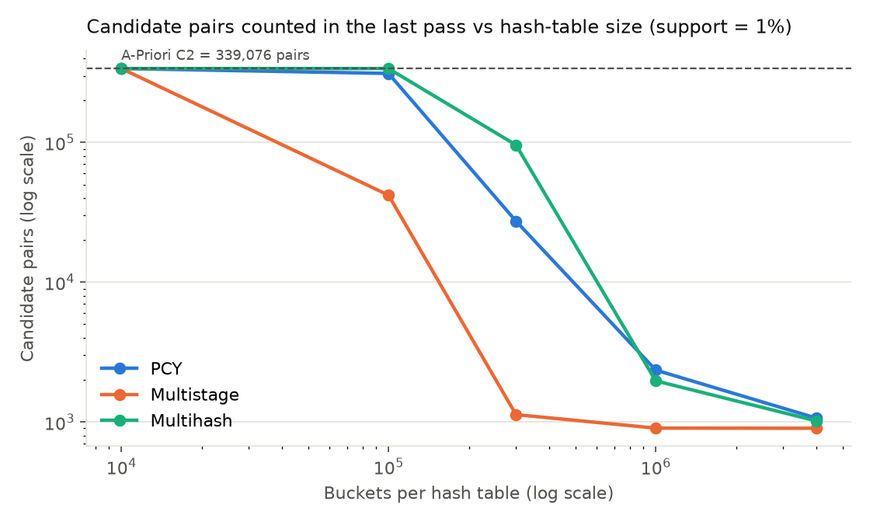
Figure 6 Hash-bucket capacity and final candidate counts at 1% support

5.5 Compact output and rule interest
At 1% support, all 2,013 frequent sets are closed and 1,446 are maximal, reducing the output by 28.2% if only maximal sets are displayed. This equality of frequent and closed sets is an observed result: no frequent immediate superset has exactly equal support. It is not guaranteed by retail data in general. At 0.5% support, maximal sets reduce 17,235 sets to 11,259; at 2%, they reduce 392 to 323.
Among the 962 rules at 50% confidence, 201 have interest between 0.3 and 0.5, 597 between 0.5 and 0.7, and 164 between 0.7 and 1.0. Thus 761 meet the experiment’s 0.5 interest cutoff. The most common item has support 0.1146, so interest differs from confidence by at most 0.1146 for these consequents. Similar values do not guarantee identical rankings.

5.6 Interpretation and limitations
The rule {HERB MARKER PARSLEY, HERB MARKER THYME} → {HERB MARKER ROSEMARY} has 95.3% confidence and lift about 78.5. Rosemary markers occur in only about 1.2% of baskets overall. This indicates a concentrated product-family association. The pink-to-red jumbo-bag rule has lower confidence, 67.7%, but its pair appears in 825 invoices and may be a more broadly applicable suggestion. Both coverage and strength should guide which patterns to inspect.
The project meets its algorithmic objectives: it exposes per-level candidate reduction, threshold sensitivity, hashing tradeoffs, and interpretable patterns. All 35 tests pass, including toy examples, brute-force comparisons, rule measures, and equality of pair counts across algorithms. The saved extension experiments also assert exact agreement with Apriori’s pair dictionary.
The findings are descriptive and in-sample. There is no temporal holdout, statistical-significance correction, recommendation evaluation, or measurement of incremental revenue. Large wholesale invoices can create many co-occurrences; every invoice has equal weight regardless of quantity or value. Description merging and the scope filter can alter patterns. Future work could retain StockCode as identity, validate rules on later invoices, compare separate retail and wholesale segments, and measure actual peak memory before making deployment claims.

6 Appendix Project Structure
The implementation is organised as follows. The repository contains the complete source code, tests, datasets or dataset instructions, and reproducible experiment outputs.
GitHub repository: [Add GitHub repository URL here]
Assignment 1/
README.md
requirements.txt
app.py Flask dashboard application
src/
preprocessing.py Cleaning and invoice baskets
apriori.py Candidate generation and counting
association_rules.py Support confidence lift and interest
pcy.py PCY Multistage Multihash and counters
compact_output.py Maximal and closed itemsets
experiments.py Core experimental comparisons
chapter6_experiments.py Chapter 6 extensions
utils.py Shared paths and output helpers
templates/index.html Dashboard page
static/ JavaScript and CSS
tests/ Algorithm correctness tests
data/raw/ Original Online Retail workbook
data/processed/ Cleaned baskets and summaries
results/ Tables figures and JSON outputs
references/ Reference library
report/ Report files

7 References
[1] D. Chen, “Online Retail,” 2015. doi: 10.24432/C5BW33.
[2] J. Leskovec, A. Rajaraman, and J. D. Ullman, Mining of Massive Datasets, 3rd ed. Cambridge, UK: Cambridge University Press, 2020. doi: 10.1017/9781108684163.
[3] R. Agrawal and R. Srikant, “Fast algorithms for mining association rules in large databases,” in Proceedings of the 20th International Conference on Very Large Data Bases (VLDB ’94), San Francisco, CA, USA: Morgan Kaufmann, 1994, pp. 487–499. [Online]. Available: https://dl.acm.org/doi/10.5555/645920.672836
[4] J. S. Park, M.-S. Chen, and P. S. Yu, “An effective hash-based algorithm for mining association rules,” in Proceedings of the 1995 ACM SIGMOD International Conference on Management of Data, 1995, pp. 175–186. doi: 10.1145/223784.223813.

