
المملكة العربية السعودية
وزارة التعليم
الجامعة الإسلامية
كلية الحاسب الآلي ونظم المعلومات
KINGDOM OF SAUDI ARABIA
Ministry of Education
Islamic University
College of Computing and Information Systems

Efficient Monitoring of Website Activity Using Data Stream Algorithms

Supervised by:
Prof. Rashid Mehmood
1st Semester - Academic Year 1448–1449 AH (2026)
Table of Contents

Abstract 1
1 Mini Project Description 2
2 Selected Concepts from Chapter 4 4
2.1 Bloom Filtering 4
2.2 Flajolet Martin 5
2.3 DGIM and Sliding Windows 5
3 Mini Project Design and Algorithms 7
4 Demonstration of Concepts 9
4.1 Interactive Web Application 10
5 Evaluation 12
Bloom Filter Parameters 12
FM Variability 13
DGIM Window Size 14
Memory and Processing Cost 15
Scalability and Reproducibility 16
6 Code Repository 18
7 References 19

Abstract
This mini project processes 1,891,714 real HTTP requests from NASA Kennedy Space Center as a sequential data stream. It implements Bloom filtering for prior-host membership, the Flajolet-Martin maximum-trailing-zero teaching estimator for distinct hosts, and DGIM for recent error counts. Exact baselines evaluate accuracy, maintained memory and processing cost. StreamLab provides a responsive browser interface with replay controls, request inspection, charts and actual algorithm-state visualizations.
The source contains 81,982 different host strings and 10,980 HTTP errors. At the end of the default replay, Bloom produces 27 false positives and no false negatives; FM estimates 442,368 distinct hosts against 81,982 exact hosts; and DGIM estimates 28 errors against 30 exact errors in the last 10,000 requests. The results demonstrate compact summaries while exposing accuracy and implementation trade-offs. The experiments include 63 parameter cases, nine full replays and reproducible correctness checks.

1 Mini Project Description
A website operator may need a quick repeat-host check, a running estimate of distinct hosts, and a recent error count. Keeping every request makes memory grow with the stream. A summary can preserve selected information while discarding individual events. The objective here is to measure the resulting accuracy, state size and processing cost.
Observed dataset property | Value
Origin | NASA Kennedy Space Center WWW server, Internet Traffic Archive [1]
Valid requests / distinct hosts | 1,891,714 / 81,982
Actual first / last timestamps | 01/Jul/1995:00:00:01 -0400 / 28/Jul/1995:13:32:25 -0400
HTTP errors (400-599) | 10,980 (0.580% of requests)
Rejected / unknown-byte records | 1 trailing fragment / 19,726 unknown response sizes
Compressed file size | 20,676,672 bytes
The archive description labels this file as July 1995, but inspection finds valid records only through 28 July at 13:32:25. The final raw line is the incomplete fragment 'alyssa.p'. It is counted as rejected; no missing events are synthesized. The gzip file was read through EOF with its integrity check, and no timestamp inversions were found among valid records.
One stream element is one HTTP request, including asset requests and repeated requests. A host is an IP address or hostname; it is not a verified person. Missing response size '-' is kept as None because size is not needed by these algorithms. Raw order and duplicate requests are preserved. Only general traffic patterns are studied, following the archive's request, and redistribution is permitted [1].
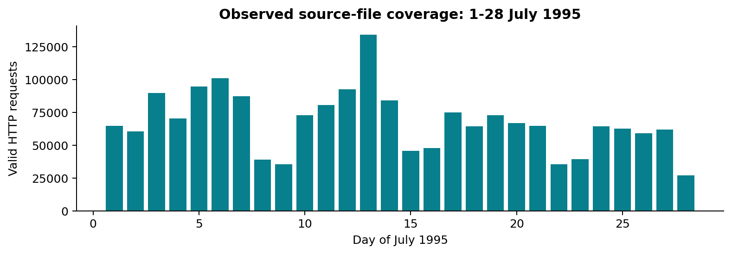
Figure 1. Counts calculated directly from valid source records. Days after 28 July are not represented as zero traffic.

2 Selected Concepts from Chapter 4

2.1 Bloom Filtering

Purpose and mathematical model
The filter answers whether a host may have appeared earlier in the stream. It stores m bits and uses k hash positions per host. A zero in any queried position proves absence; all queried bits being one gives only possible membership. Collisions can make an unseen host appear present. Insertions never clear bits, so previously inserted hosts have no false negatives [2, 3].
P(bit stays 0 after d distinct inserts) = (1 - 1/m)^(k*d)
p_FP(d) ~= (1 - exp(-k*d/m))^k
k_opt ~= (m/d) * ln(2)
Online FPR = false positives / queries for truly unseen hosts
The probability expression assumes approximately independent uniform hash positions. Keyed 64-bit BLAKE2b hashes provide deterministic, well-distributed positions for this experiment; distinct keys are used for the k functions. The implementation packs eight bits per byte using masks, rather than allocating a Python Boolean per bit.

Processing steps
The query is evaluated against prior state, before insertion. A false positive therefore means a first-ever host request was incorrectly classified as a repeat. Each first-seen host contributes one negative query. Later requests from that host are positive queries. The exact set is an evaluation instrument and is not part of the Bloom state.

Trade-off and limitations
State payload is ceil(m/8) bytes and each fused query/insertion costs O(k) hashes. Increasing m reduces saturation for fixed d and k. Increasing k helps only up to an appropriate occupancy-dependent range and always adds hashing work. This filter cannot list hosts or delete an individual host. It represents all previous history, not a sliding window.
The saved final_theoretical_fpr column describes occupancy at the end. The measured online FPR averages queries over a filter that starts empty. They are different quantities; the endpoint formula should not be interpreted as the expected cumulative observed rate.

2.2 Flajolet Martin

Purpose and estimator
Distinct counting asks for the number of different host identifiers seen so far. Repeated requests should not increase that count. Hashing maps each host to a reproducible 64-bit string, so repeats produce the same evidence. Let rho(h(x)) be the number of trailing zero bits. Long zero runs are rare and become more likely as distinct hosts accumulate [3, 4].
P(rho(h(x)) >= r) = 2^(-r) [uniform-hash model]
R_j = max over observed x of rho(h_j(x))
Single estimate E_j = 2^(R_j)
Group mean A_g = mean(E_j for j in group g)
Final estimate = median(A_1, ..., A_G)
This project implements the chapter's maximum-trailing-zero teaching variant. It does not implement the original first-zero bitmap estimator or HyperLogLog. In particular, the bitmap correction constant 0.77351 is not attached to a maximum-zero statistic. The versions use 1 hash; 16 hashes split into four groups of four; and 64 hashes split into eight groups of eight. For an even group count, the median is the average of the two middle group means.

Processing steps
The all-zero 64-bit hash has a defined trailing-zero count of 64. Each register uses one byte, so H registers have H bytes of payload plus keys and Python object overhead. An update costs O(H), and a query costs O(H) plus sorting the few group means.

Limitations to investigate
The estimate changes in jumps. A rare hash with many trailing zeros can create a very large value of 2^R. Arithmetic group means retain sensitivity to such outliers; taking their median reduces some instability but supplies no small-error guarantee here. Five predetermined seeds expose that variation. More hashes can improve some runs without improving every seed or removing this variant's bias. No empirical correction is fitted to the NASA answers.

2.3 DGIM and Sliding Windows

Purpose and binary representation
For request t, set b_t to one for HTTP status 400-599 and zero otherwise. The requested answer is the sum of these bits in the last N valid requests. A request-count window does not represent a fixed number of seconds when traffic rates change. DGIM summarizes the ones using buckets whose sizes are powers of two [3, 5].
C_t(N) = sum b_i for max(1,t-N+1) <= i <= t
bucket = (number of ones, timestamp of newest one)
at most two buckets of each size
estimate = sum(bucket sizes) - half the oldest retained size
A timestamp here is the integer event index t. On every bit, including zero, time advances and buckets whose newest timestamp is at most t-N expire. A one creates a size-one bucket. If three buckets share a size, merge the two oldest and keep the newer of their endpoint timestamps; repeat if the larger size now has three buckets.
When t is at most N, no prior observations have expired, so the implementation returns the sum exactly. A retained size-one oldest bucket is also exact because its single one is known to be inside the window. An empty bucket list returns zero. Otherwise half-weighting approximates the uncertain contribution of the oldest bucket.
The basic two-bucket rule gives the standard coarse relative-error bound of at most 50% for a positive true count. Zero-count windows are evaluated separately and should return zero. There are O(log N) buckets. Classical modulo-N timestamps use O(log N) bits each, giving O(log-squared N) bits overall. This readable Python version uses absolute event indices and Python tuples, so its actual overhead is measured separately.
The exact baseline is a circular bytearray with a running total: O(N) bytes and constant-time updates and queries. A packed exact bit ring could use only ceil(N/8) payload bytes; that theoretical alternative is shown alongside the implemented baseline.

3 Mini Project Design and Algorithms
Stage | Behavior
Source and parser | Read gzip line by line; validate the timestamp and HTTP fields; retain valid requests in original order.
Bounded replay | Collect at most 1,000 parsed events per batch. Stream speed is simulated without real-time sleeps.
Approximate branches | Host -> Bloom; host -> FM; error bit -> DGIM. Each branch has independent state.
Exact validation | Prior-host set for Bloom; distinct-host set for FM; byte ring and sum for DGIM.
Measurement | Time updates/queries separately; compare answers outside timing; measure final reachable state.
Outputs | CSV rows and checkpoints -> seven figures -> report; preserve raw repetitions and provenance.
Each replay is one forward traversal. Experiments reopen the file for independent runs; algorithms do not revisit previous events within a run. The profiler and exact sets deliberately use more memory to establish ground truth. Shared parsing buffers, validation state and plots are excluded from sketch-state comparisons.
The web implementation adds a responsive HTML/CSS interface, a JavaScript Web Worker, and lossless compact browser inputs. The worker incrementally decompresses 20-byte records and updates the three summaries plus exact validation. The catalog preserves host and request strings. Prepared BLAKE2b hash words and zero counts reproduce the Python hashes without millions of slow browser hash operations; summary states and answers are calculated on every event, rather than loaded as prepared results.
Experiment | Settings
Bloom parameter sweep | m = 65,536; 262,144; 1,048,576 bits; k = 2, 4, 7 (9 combinations)
FM parameter sweep | H = 1, 16, 64; fixed grouping described in Section 2
DGIM parameter sweep | N = 1,000; 10,000; 100,000 requests
Sweep stream and seeds | First 100,000 valid requests; seeds 7, 19, 42, 73, 101; deterministic DGIM run once
Default full-stream settings | Bloom m=1,048,576 and k=7; FM H=16; DGIM N=10,000; seed 42
Scaling and timing | 10,000; 100,000; 500,000; EOF snapshots within three full replays per algorithm
The 1,000-event batch is also the FM/DGIM query interval. Bloom requires one membership query per event. Timed blocks include their updates and queries; parsing, comparison, CSV writing and memory inspection are outside those blocks. Approximate/exact comparisons are made within a task, rather than claiming the three different tasks have identical costs.

4 Demonstration of Concepts
At EOF, 1,891,714 valid requests have been processed. The same source-file order is used for both approximate and exact calculations. The table reports the first full replay with seed 42; repeated-run timing is reported separately.
Concept | Observed result | Exact comparison
Bloom prior-host membership | 27 false positives; online FPR 0.03% | 81,982 genuinely unseen-host queries; 0 false negatives
FM distinct hosts | Estimate 442,368.0; relative error 439.59% | 81,982 distinct host strings
DGIM recent errors | Estimate 28.0; relative error 6.67% | 30 errors in the final 10,000 requests
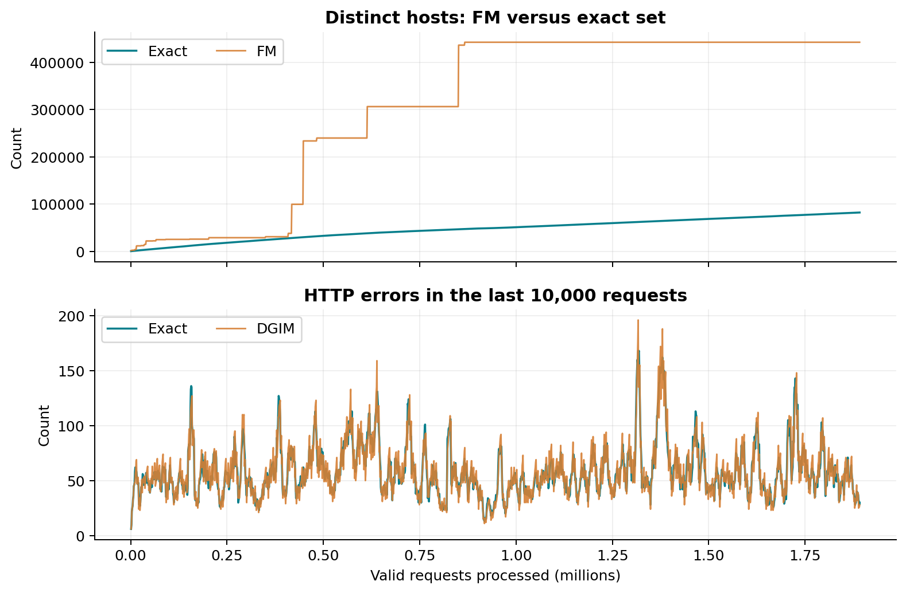
Figure 2. Checkpoints every 1,000 requests plus EOF. FM is cumulative; DGIM describes a moving request-count window.
Bloom's uncertain positive result is visible as a measured false-positive rate. FM's stepwise changes and possible overestimation are visible against exact cardinality. DGIM follows changes in recent errors with a much smaller summary than the full request history. The checkpoint CSVs retain the plotted numbers for inspection.

4.1 Interactive Web Application
The web application turns the mini project into a working visual lab. It offers historical replay of the first 10,000, 100,000, 500,000 or all 1,891,714 valid requests. This is live computation on historical records, not a connection to current NASA traffic.
Interface | What it demonstrates
Overview | Current counts, exact-versus-approximate curves, source timestamps, recent real requests and logical summary payload.
Replay controls | Start, pause, resume, reset, and exactly one event per Step. Speed ranges from one to 100,000 requested events per second; compute capacity can limit it.
Bloom state | 128 actual bit positions at a time, paging and jump-to-hash; current membership decision, prior exact membership and false positives.
FM state | The actual maximum-zero registers, powers-of-two evidence, group means, current estimate and relative error.
DGIM state | Power-of-two buckets ordered by recency; current merges/expirations and last 128 actual binary request events.
Experiments | The 63 recorded Python parameter cases, memory and throughput comparisons, CSV export and transparent FM error.
Dataset and source | Provenance, actual dates, response distribution, checksum, original request inspection, complete source explorer and project ZIP download.
Changing a sketch parameter or hash seed restarts the replay. This prevents an existing state from being labeled with settings that did not produce it. Changing speed affects only pacing. Work is done in a worker so the controls and layout can remain responsive. The sidebar becomes a mobile menu; cards and charts stack, while wide data tables scroll inside their panels. Keyboard focus, accessible labels and reduced-motion behavior are included.
Eight web tests include a full replay of every real event and the actual worker's initialization, step, playback and one-event-per-second pacing. The JavaScript implementation matches Python exactly: 81,982 distinct hosts, 27 Bloom false positives, FM estimate 442,368, DGIM estimate 28 versus 30 exact recent errors, and 10,980 total HTTP errors. Browser checks also verified initial loading, one-step processing and a 100,000-event replay.
Live memory badges show logical payload only. The browser has additional input/hash caches, JavaScript overhead and exact state. In particular, the standalone HTML embeds compressed inputs and is larger than the sketch state. The Experiments view labels measured Python state separately. A hosting source push was blocked by DNS restrictions in the task environment; the delivered app works locally and offline.

5 Evaluation

Bloom Filter Parameters
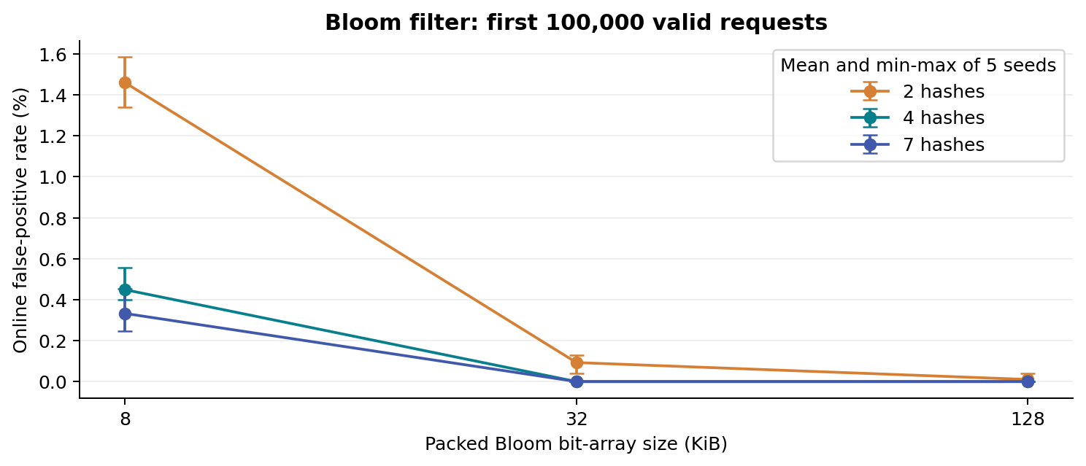
Figure 3. Online FPR across nine settings. Error bars span the five fixed seeds; they are not confidence intervals.
Bit payload | Hashes | Mean online FPR | Min-max FPR
8 KiB | 2 | 1.46% | 1.34% - 1.59%
8 KiB | 4 | 0.45% | 0.40% - 0.55%
8 KiB | 7 | 0.33% | 0.25% - 0.45%
32 KiB | 2 | 0.09% | 0.04% - 0.13%
32 KiB | 4 | 0.00% | 0.00% - 0.00%
32 KiB | 7 | 0.00% | 0.00% - 0.00%
128 KiB | 2 | 0.01% | 0.00% - 0.04%
128 KiB | 4 | 0.00% | 0.00% - 0.00%
128 KiB | 7 | 0.00% | 0.00% - 0.00%
At fixed k, the larger array spreads the inserted hosts over more bits and reduces collisions. Hash count is not a universal accuracy knob: the best k depends on m/d. If the filter becomes crowded, setting more positions can increase saturation. When the array is very large relative to the 7,752 distinct hosts in this prefix, some observed rates are zero. That means no false positives were observed in these finite tests; it does not prove a zero underlying probability.
The prefix sweep should not be mistaken for the full-month occupancy. The default full-stream filter receives many more distinct hosts. Its memory stays fixed while the risk of false positives grows. No false negatives were observed in the evaluated runs, consistent with the insertion-only design.

FM Variability
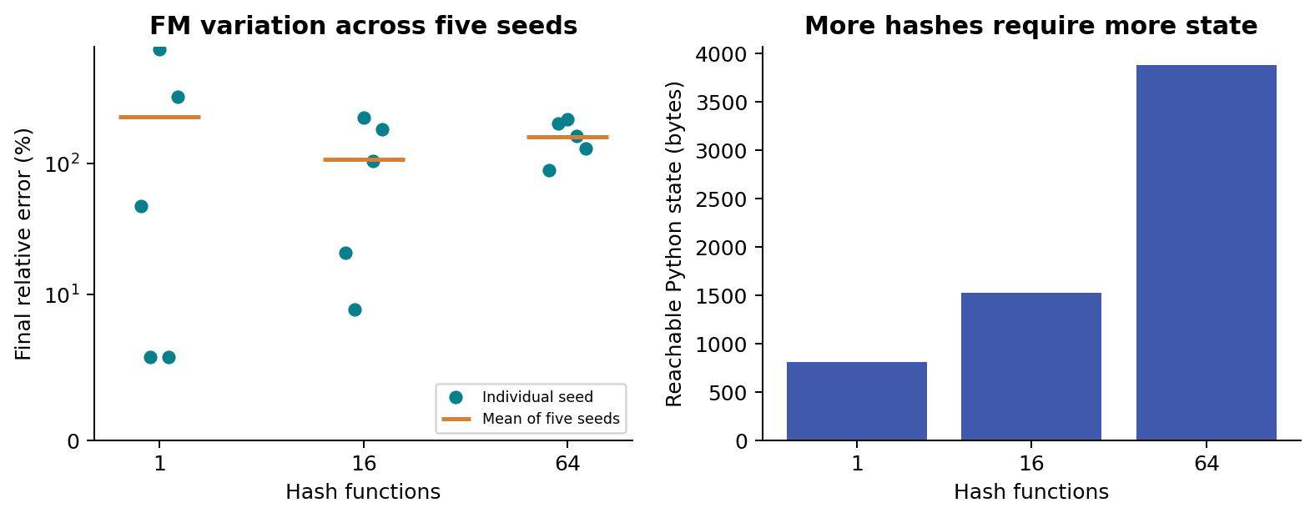
Figure 4. Per-seed final errors and maintained state on the first 100,000 requests. The nonlinear error scale preserves outliers.
Hashes | Mean error | Minimum | Maximum | State bytes
1 | 225.33% | 5.68% | 745.41% | 809
16 | 107.76% | 8.98% | 223.63% | 1,523
64 | 159.57% | 88.24% | 217.03% | 3,883
A single unusually long zero run can dominate 2^R, which explains the large variation for a single hash. Grouping multiple estimates changes the distribution but arithmetic means remain sensitive to extreme estimates. The results show the actual errors rather than claiming that increasing H guarantees improvement. These groups and seeds were fixed before inspecting outcomes; no seed was selected to make a favorable plot.
The default full-stream estimate is 442,368.0 against 81,982 exact hosts. Its error is 439.59%. This is an important practical limitation of the uncalibrated teaching estimator. It demonstrates how a tiny hash summary operates, but this experiment does not support using it for a strict-accuracy production counter. A separately evaluated bitmap FM or a modern cardinality sketch would be a useful extension, not a result claimed here.

DGIM Window Size
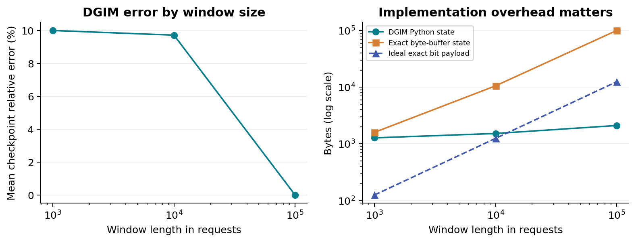
Figure 5. Mean checkpoint error and final state at the 100,000-request prefix. The ideal packed exact line is payload only.
Window | Mean rel. error | Final exact / est. | DGIM bytes | Exact bytes
1,000 | 10.00% | 17 / 17.0 | 1276 | 1598
10,000 | 9.71% | 55 / 57.0 | 1524 | 10590
100,000 | 0.00% | 505 / 505.0 | 2108 | 100582
A larger window includes more old events and can require buckets at more scales. Its exact byte buffer grows linearly with N, while the bucket count grows slowly. Error does not have to grow monotonically with the window: it depends on how recent ones fall around the oldest bucket boundary. The N=100,000 run at this prefix is a startup case with no expired data, so its zero error is expected and is not evidence of exact behavior after the window starts sliding.
Mean relative error is the unweighted mean across the 1,000-request checkpoints, including zero-error empty windows. Absolute errors are also stored. For a zero true count, a zero estimate is recorded as zero error; a nonzero estimate would have an undefined relative error and would not silently be divided by zero. Small true counts can turn a small absolute error into a large percentage.
At small N, Python tuple/list overhead can outweigh the theoretical saving compared with an efficiently packed exact ring. This is why the figure includes the ideal N/8 exact payload. Claims of space efficiency must state which representation is used.

Memory and Processing Cost
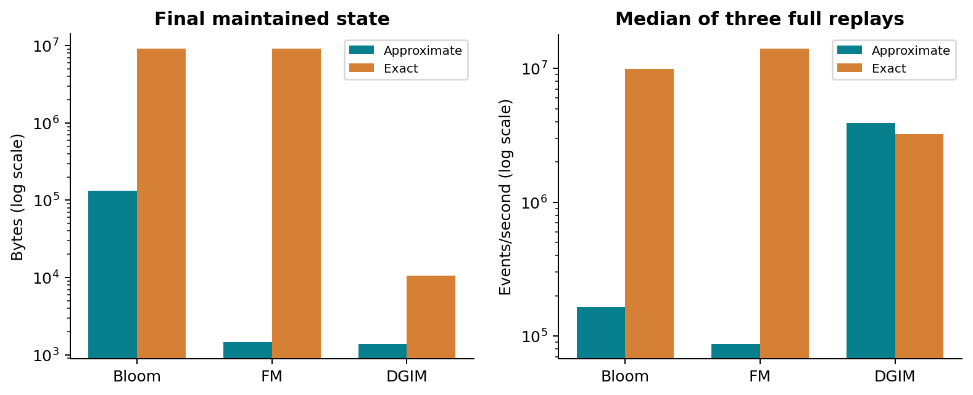
Figure 6. Default parameters at EOF. Timing excludes parsing and validation; throughput uses the median of three full replays.
Task | Approx. state | Exact state | Approx. events/s | Exact events/s
BLOOM | 131,927 | 9,086,764 | 164,793 | 9,941,799
FM | 1,459 | 9,086,764 | 87,774 | 13,993,327
DGIM | 1,396 | 10,574 | 3,902,897 | 3,212,609
Memory is the recursively measured reachable state using sys.getsizeof, with each object counted once per algorithm. It includes arrays, keys, containers and Python overhead. It is final maintained state, not peak process RSS or a claim about total application memory. Temporary allocations, interpreter code and the shared input batch are excluded consistently. Exact states are measured independently.
Python's exact set uses an optimized built-in hash table. Bloom and FM perform several BLAKE2b calculations per event and execute their loops in Python, so their smaller state need not lead to higher throughput. DGIM processes zeros cheaply, and only about 0.58% of requests are errors; that sparsity helps this implementation. Results are workload- and machine-dependent, rather than a general ranking of the concepts.
Measured environment: Python 3.12.7; macOS-27.0.1-arm64-arm-64bit; architecture arm64. Raw timings, minimum/maximum cumulative durations and all repetitions are included in scaling_raw.csv and scaling_summary.csv.

Scalability and Reproducibility
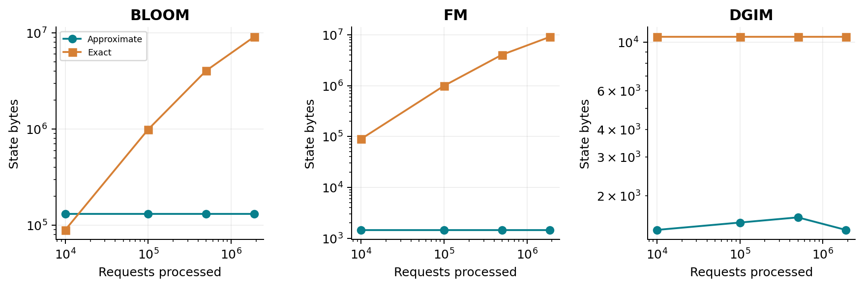
Figure 7. Prefix snapshots within three full replays. Window size stays fixed; distinct-host exact state grows as new hosts appear.
Bloom state is fixed by m and k, and FM state by H. They summarize all history. DGIM depends on its fixed recent window and the current bucket pattern. The exact distinct set grows with distinct hosts, not directly with request count; many repeated requests can arrive without adding any keys. The exact circular buffer remains fixed once N is chosen.

Validation
Fifteen unittest cases cover Bloom membership and saturation; query-before-insert; FM empty streams, duplicate/order invariance and an independent trailing-zero calculation; parser failures and valid-row limits; and DGIM invariants, expiry, alternation, sparse input and randomized streams. DGIM is also checked exhaustively on every 9-bit sequence for six window lengths, against an independently summed history. The tests verify the 50% positive-count error bound on these fixtures. Artificial fixtures are used only for tests, not for the experimental results.

Reproduction and limitations
The ZIP includes the compressed real dataset, exact parameter choices, five seeds, raw results and plotting/report scripts. Deterministic estimates reproduce on the same input, whereas timings and Python object sizes can vary across systems. Only one historical server workload is evaluated. Error sparsity, repeated hosts, the capture's partial-month coverage and Python implementation overhead limit generalization.
The evidence supports compact summary states, while exposing their task-specific costs: Bloom can misclassify new hosts, this FM variant can be substantially inaccurate, and DGIM trades exact recent counts for bucket-based estimates. None of the three summaries replaces the full log when individual request retrieval is required.

6 Code Repository
GitHub repository: ________________________________________________

7 References
[1] Internet Traffic Archive. NASA-HTTP: Two Months of HTTP Logs from the KSC-NASA WWW Server. Collected by Jim Dumoulin; contributed by Martin Arlitt and Carey Williamson. https://ita.ee.lbl.gov/html/contrib/NASA-HTTP.html (accessed 23 October 2026).
[2] Bloom, B. H. (1970). Space/time trade-offs in hash coding with allowable errors. Communications of the ACM, 13(7), 422-426. https://doi.org/10.1145/362686.362692.
[3] Leskovec, J., Rajaraman, A., and Ullman, J. D. Mining of Massive Datasets, Chapter 4: Mining Data Streams. Author-hosted materials: https://www.mmds.org/; chapter: https://infolab.stanford.edu/~ullman/mmds/ch4.pdf.
[4] Flajolet, P., and Martin, G. N. (1985). Probabilistic counting algorithms for data base applications. Journal of Computer and System Sciences, 31(2), 182-209. https://doi.org/10.1016/0022-0000(85)90041-8.
[5] Datar, M., Gionis, A., Indyk, P., and Motwani, R. (2002). Maintaining stream statistics over sliding windows. SIAM Journal on Computing, 31(6), 1794-1813. https://doi.org/10.1137/S0097539701398363.

Data provenance and integrity
Original download: https://ita.ee.lbl.gov/traces/NASA_access_log_Jul95.gz
SHA-256 (compressed source file):
199109ed0f273e095da6ccd5fc9dc4cd
8bb58daa06d62135e62090fea9d27488
The included references.bib provides a reusable bibliography. Results and narrative are specific to this project's measured runs; external sources provide the dataset provenance and algorithm foundations.

