VFJ Brief
For Foundation day Celebration of Armoured Vehicle Nigam Limited (AVNL) on 1st Oct’2022

Since inception in the early 1900’s, Indian Ordnance Factories Traditionally manufactured military hardware 1959 witnessed a significant departure from this trend with the introduction of military vehicles into the product range. This venture was undertaken to boost the Army’s programme for modernising its fleet of World-War-II vintage vehicles as only trickle supplies could be expected from an infant indigenous automotive industry.
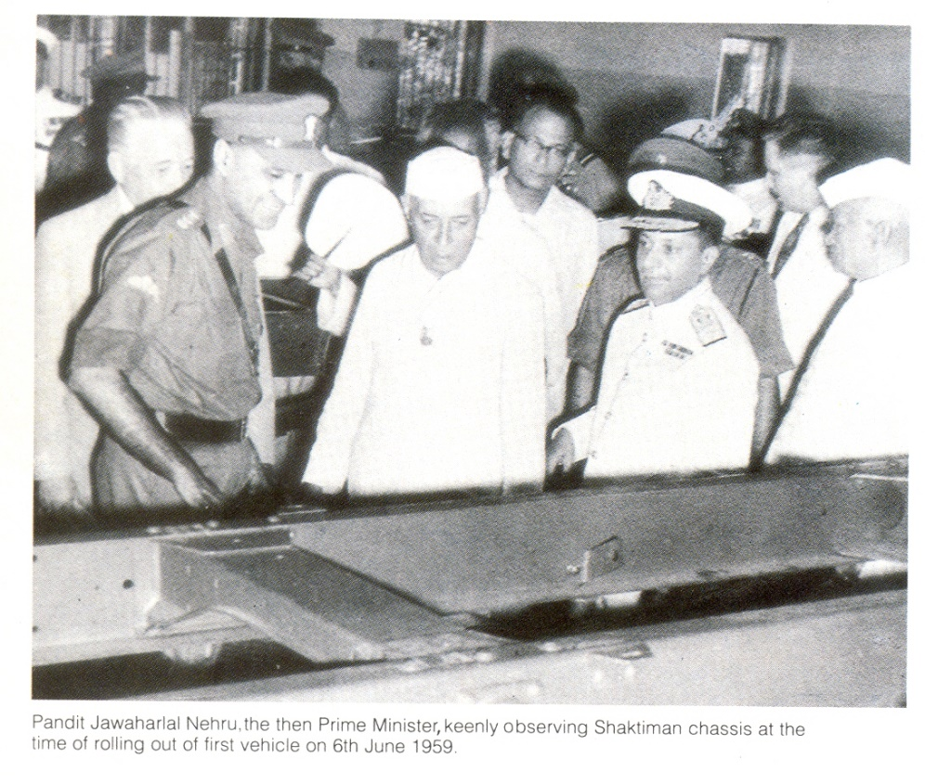
Initially, vehicle manufacture was spread over a heterogeneous and far-flung network of production sites. In spite of this constraint, production picked up fast. In a few years time, the entire vehicle requirements were being met by the Ordnance Factories. To capitalise on this favourable beginning, all manufacturing activities were integrated into a single facility at Vehicle Factory, Jabalpur in 1969.

Thus, Vehicle Factory Jabalpur serves the nation’s defence and looks forward to meet future challenges.

Previous VFJ Products
VFJ’s products were rugged work-horses that have proved their mettle on glacial heights, in scorching deserts and swampy jungles. Boulder strewn mountain tracks, clinging desert and water logged forest paths are some of the obstacles encountered and surmounted by these four-wheel drive vehicles specially made to suit military applications.
VFJ has been the main source of supply of “B” vehicles to the Armed Forces and has successfully manufactured and supplied the following upto 1998:-
- 1Ton Nissan
- 0.25Ton Jonga
- 3Ton Shaktiman
- Light Recovery Vehicle on Shaktiman
- Bulk Petroleum Lorry on Shaktiman Chassis
- 1KL Water Bowser on Shaktiman Chassis
- Civil Jonga
- Jonga Karn – Bullet Proof

Shaktiman :
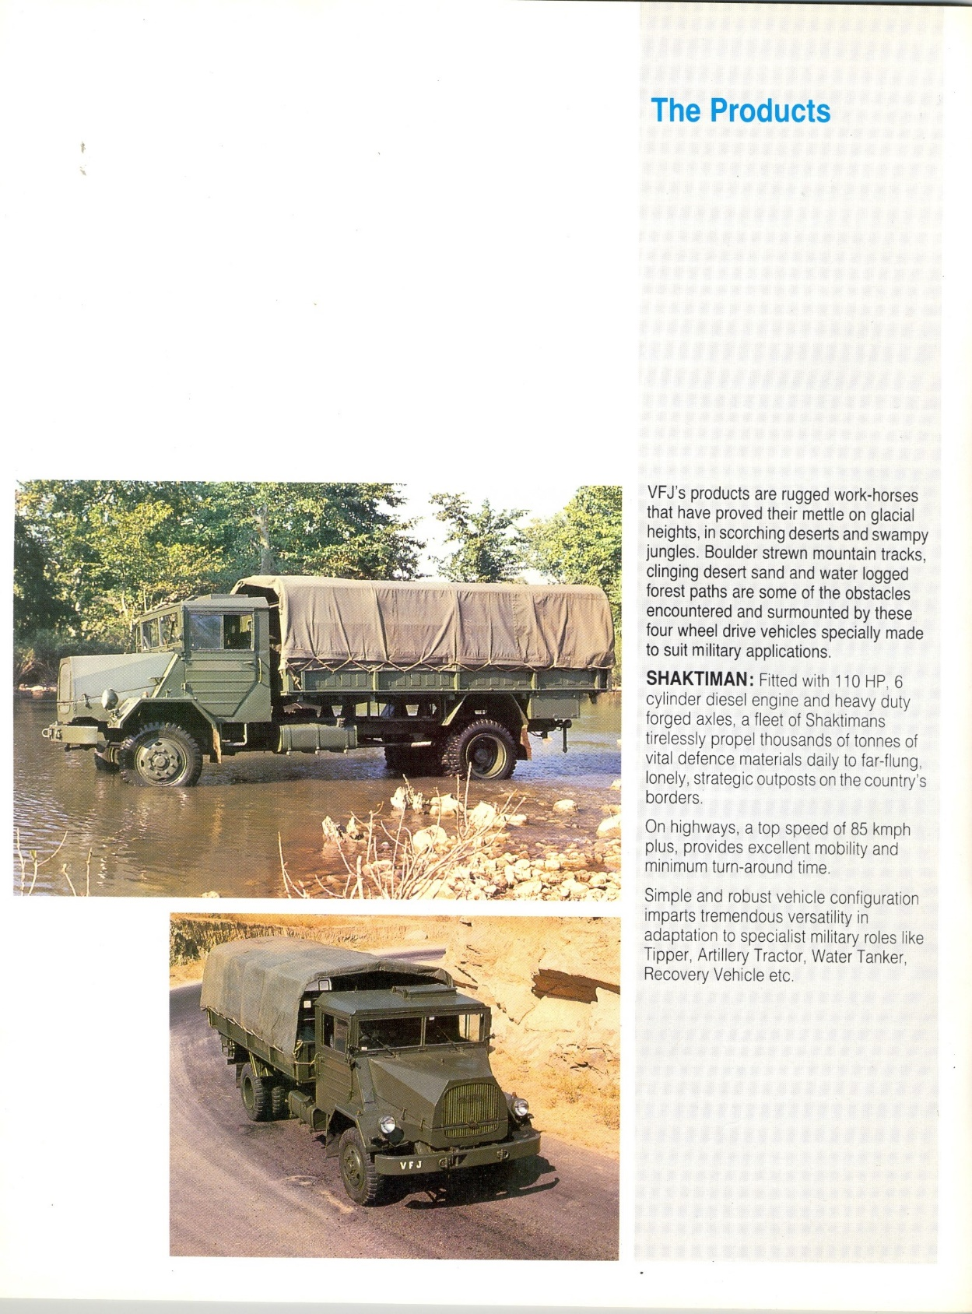 | Fitted with 110 HP, 6 cylinder diesel engine and heavy duty forged axles, a fleet of Shaktimans tirelessly propel thousands of tonnes of vital defence materials daily to far-flung, lonely, strategic outposts on the country’s borders.  On Highways, a top speed of 85 kmph plus, provides excellent mobility and minimum turn-around time.  Simple and robust vehicle configuration imparts tremendous versatility in adaptation to specialist military roles like Tipper, Artillery Tractor, Water Tanker, Recovery vehicle etc.
Jonga:
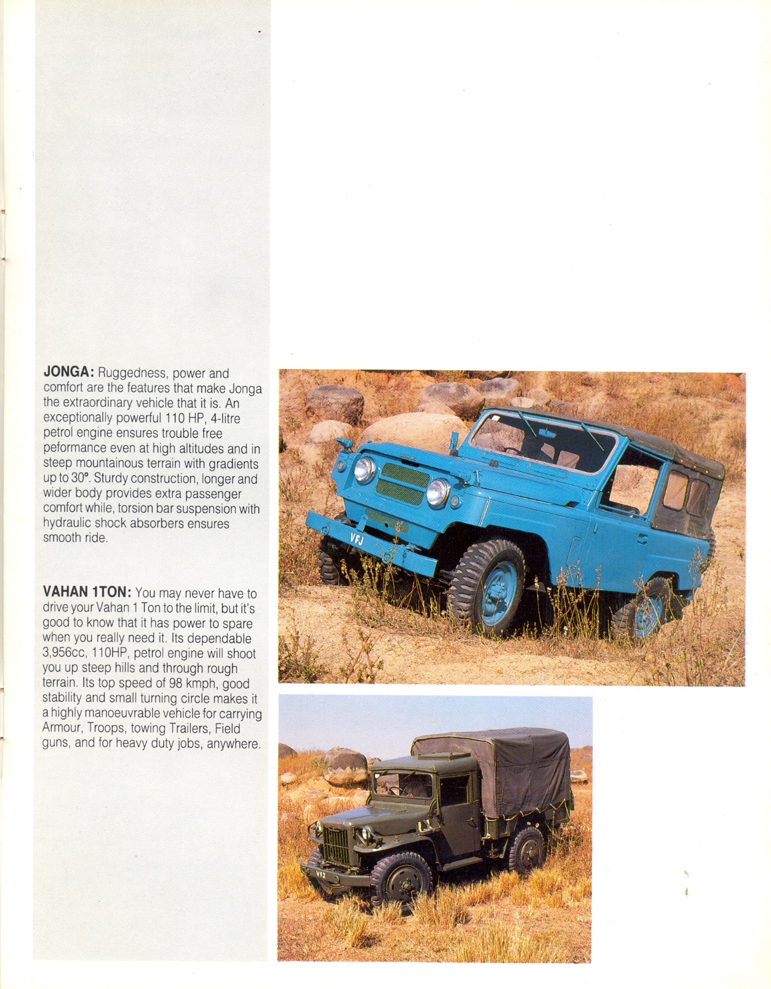 | Ruggedness, power and comfort are the features that make Jonga the extraordinary vehicle that it is. An exceptionally powerful 110 HP, 4-Litre petrol engine ensures trouble free performance even at high altitudes and in steep mountainous terrain with gradients up to 30°. Sturdy construction, longer and wider body provides extra passenger comfort while, torsion bar suspension with hydraulic shock absorbers ensures smooth ride.

Vahan 1Ton:
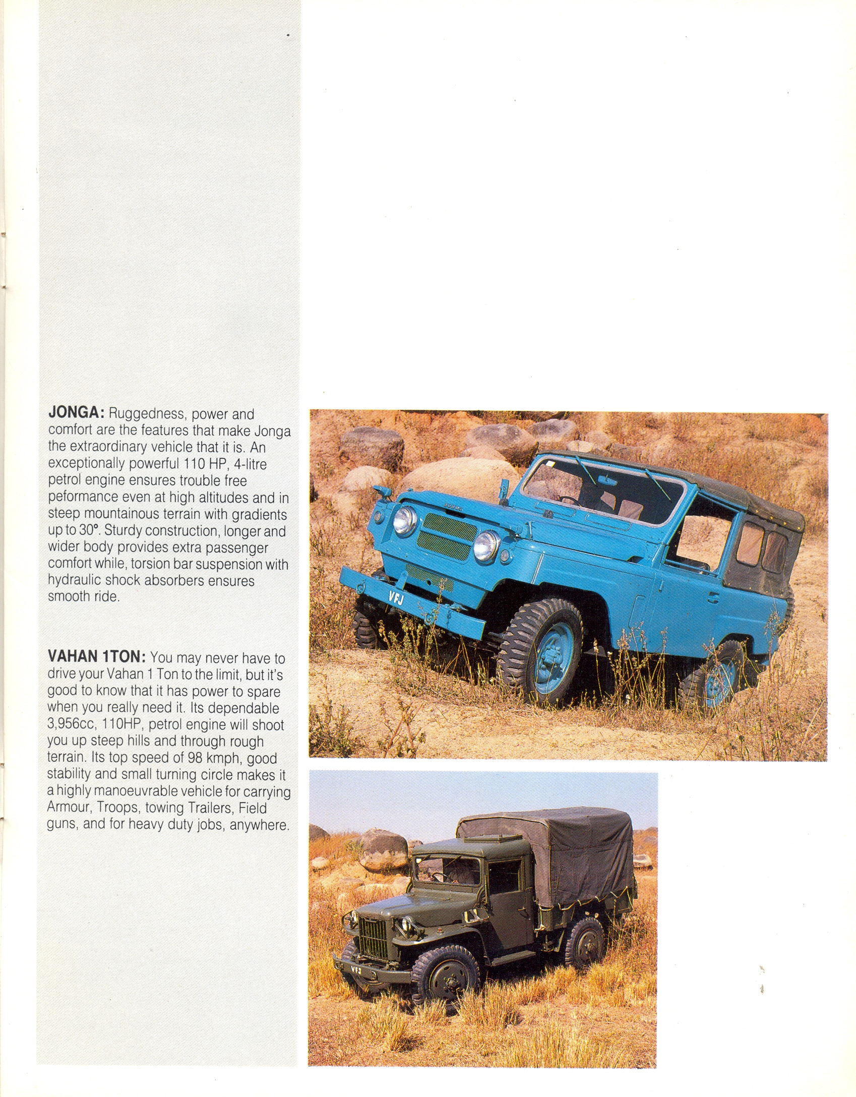 | You may never have to drive your Vahan 1 Ton to the limit, but its good to know that it has power to spare when you really need it. Its dependable 3,956cc, 110 HP, petrol engine will shoot you up steep hills and through rough terrain,. Its top speed of 98 kmph, good stability and small turning circle makes it a highly manoeuvrable vehicle for carrying Armour, Troops, towing Trailers, Field Guns and for heavy duty jobs, anywhere.

Current Product Range
With the induction of new automobile technology, the following vehicles are being currently manufactured and supplied to Indian Army since 1998:-
- 2.5 Ton LPTA-715/32TC BS-III
- 5/7.5 Ton Stallion MK-IV BS-III
- 2KL Water Bowser on LPTA 715 Chassis
- Mine Protected Vehicles
- Bullet Proof Maruti Gypsy
- Bullet Proof LPTA 715
- Bullet Proof Tata 407
- UTD-20 overhauling for BMP Engines

The manufacture of new generation vehicles - 2.5 Ton LPTA-713/32 and 5/7.5 Ton Stallion MK-III was started in 1997-98 in collaboration with M/s Tata Motors and M/s Ashok Leyland respectively. VFJ is now making BS-III version of these vehicles from Oct’2010.

5/7.5 Ton Stallion MK-IV

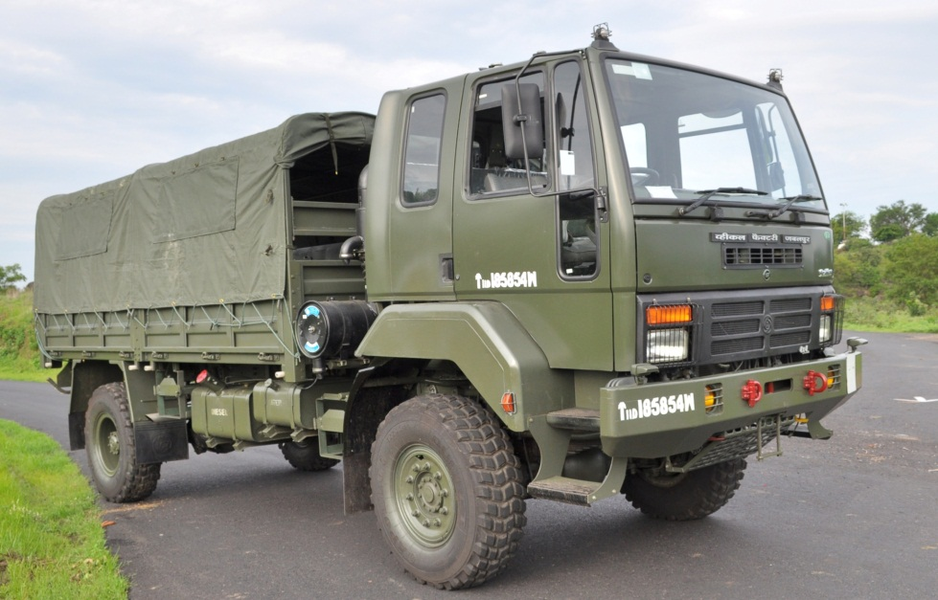 | 5 Ton – Cross Country (CC)  7.5Ton – Sand-cum-Highway (SCH)
Supplied till FY 2018-19 :- 67,304 Nos.
  - First Agreements were signed during 1998 which was valid for 7 years i.e. upto 2005. Agreement extended for another seven years upto 2012. Further again Agreement extended for 7 years upto 2019. Further, again agreement extended up to March’2024.
  - Engine & Cabin from M/s AL
  - Other items from:
    - In-house manufacture, or
    - AL at IPL (Itemised Price List) rate as per TOT agreement, or
    - Other trade sources
Parameter | Stallion MK-IV
Engine | HA57L135 BS-III
Power | 135 Kw @ 2400rpm
Gear Box –Input Torque | 680 Nm.
Gear Box Casing | Additional Ribs for strength.
Transfer Case | Increased strength 30% with wider Gear width
Power to weight Ratio | 10.8 kW /T (5T Payload)
Cabin Mounting | 3 Points mounting.
Brake Circuit | With Load Sensing Valve.
Electrical Sockets | Water proof design.
Parking Brake | Both Rear & Front.
Tyres | Wider Tyres
Suspension | 3 Stage Rear & 2 Stage Front Leaf spring.
Frame | Strengthened – Improved.
Water Tank | 100 Litres.

2.5 Ton LPTA-715
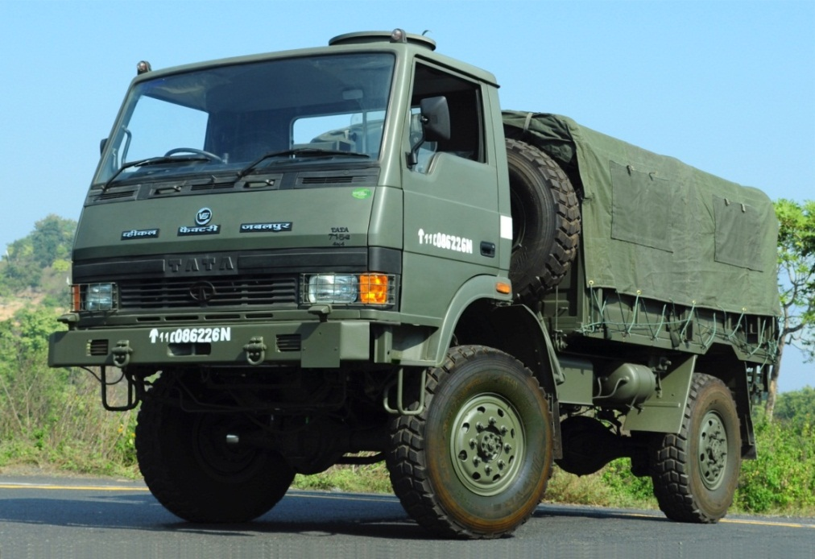
2.5 Ton - Cross Country (CC)
- Sand Cum Highway (SCH)
Supplied till FY 2018-19 :- 49,374 Nos.
  - First Agreements were signed during 1998 which was valid for 7 years i.e. upto 2005. Agreement extended for another seven years upto 2012. Further again Agreement extended for 7 years upto 2019. Further, again agreement extended up to March’2024.
  - Engine & Cabin from M/s TML
  - Other items from:
    - In-house manufacture, or
    - TML at IPL(Itemised Price List) rate as per TOT agreement, or
    - Other trade sources
PARAMETER | LPTA715TC/32 BS-III
Engine | B5.9 155 30 BSIII
Power | 115 kw (155 HP)  @ 2500 rpm
Max. Torque | 590 Nm (60.2 Kgf-m)  @ 1500 rpm
Power to Weight Ratio | 14.90 (KW / Ton)
Oil Sump Capacity | Min.13.30 Litres & Max.15.30 Litres
Radiator Heat dissipation | 92.50 kW with fan shroud
Front Axle wt. (unladen) -Kg | 3200 (with load body)
Rear Axle wt. (unladen) -Kg | 2050 (with load body)
GVW | 5250 (with load body)
Gear Box | 6 Forward & 1 Reverse

2KL Water Bowser
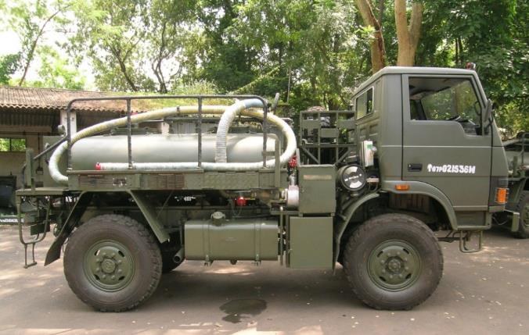
2.5 Ton - Cross Country (CC)
- Sand Cum Highway (SCH)
Variant of LPTA 715

  - Engine & Cabin from M/s TML
  - Other items from:
    - In-house manufacture, or
    - TML at IPL(Itemised Price List) rate as per TOT agreement, or
    - Other trade sources

Features of 2 KL WB :
- Variant developed by VFJ on LPTA 2.5 Ton Chassis.
- Can carry upto 2000 ltrs of water over all kind of roads, terrains and high altitude
- Inner & Outer wall shell made of Special Grade Stainless Steel.
- Temp variation not more than 5ºC in 24 Hrs in extreme Temp Range of +50ºC to -10ºC.
- No bacterial presence up to 72 hrs.

Mines Protected Vehicles (MPV)
Manufacture of Mine Protected Vehicles (both Army version as well as MHA version) – designed & developed by Ordnance Development Centre (ODC) Medak – with modified Stallion Engine has been undertaken by VFJ during 2008-09.
Blast & Ballistic protection:
- Mine Blast under Hull 10 kg TNT Mine Blast under Tyre 14 kg
- Side Mine Blast 10 kg explosive & ½ kg shrapnel from a distance of 5 m and a height of 1.5 m above ground level
- Bullet firing from side Direct fire of 3 rounds from 7.62 SLR from a distance of 10 m.
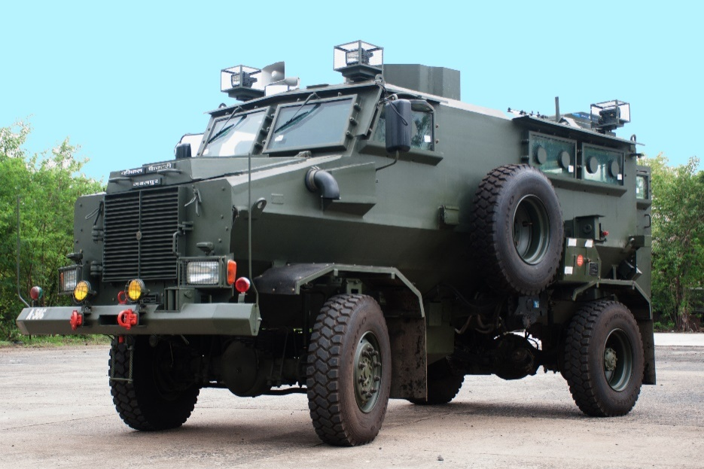
- Engine power :220HP BS-III Diesel Engine
- Ventilation system for expunging of gases
- Space / Bracket for stacking Armt./ Ammn.
- First Aid kit size is increased
- Rear View Camera with night vision
- GPS based navigation system
- Self Recovery Winch (10 Ton)
- Door opening Pneumatic system (2 switchs near Dandaman)
- Radiator grill hinge type provided for maint.
- 4 nos search lights operated individually
- Mounting arrangement for Arial of radio set
- 12 nos Ball Type Firing Ports
(a)Two in each side glass (Four sided glasses)
(b)One in each driver and co-driver glass
(c)One each in two rear door

13. AC -2.85 Ton

PERFORMANCE:
- ACCELERATION : 0-75 km/h in 60 Seconds
- MAX.SPEED : 85 km/h
- PATROL SPEED : 50 km/h
- GRADABILITY : 30 deg.
- RANGE : 750 km
- FORDABILITY : 1000 mm.
- PAY LOAD : 1500 kg

Bullet Proofing of Tata-407 & SML
VFJ has fully taken up bullet proofing of all types of TATA-407, SML, Maruti Gypsy & LPTA-715 etc to cater the requirement of Army, MHA, Central Police and State Police Departments.
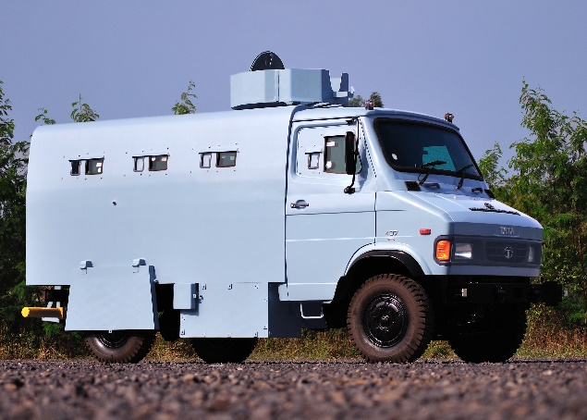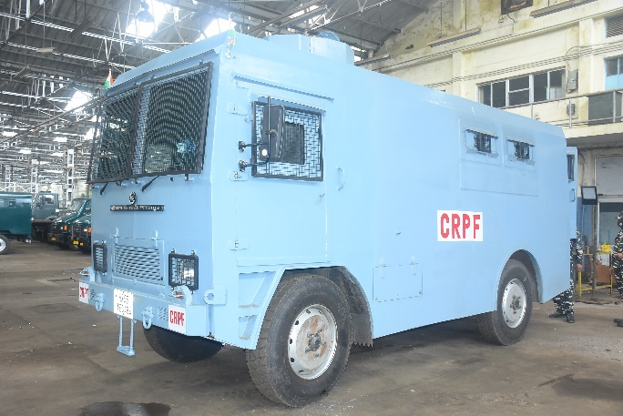
Up-Gunning 130mm (m-46) to 155mm/45 Cal Gun System (Sharang Gun)
VFJ has started Up-Gunning of Sharang M-46 Gun from 130mm to 155mm from 2019-20. A contract of Up-Gunning of Sharang Gun has been signed between MoD & OFB during on 18 Oct’2018 for 300 Nos. Guns.
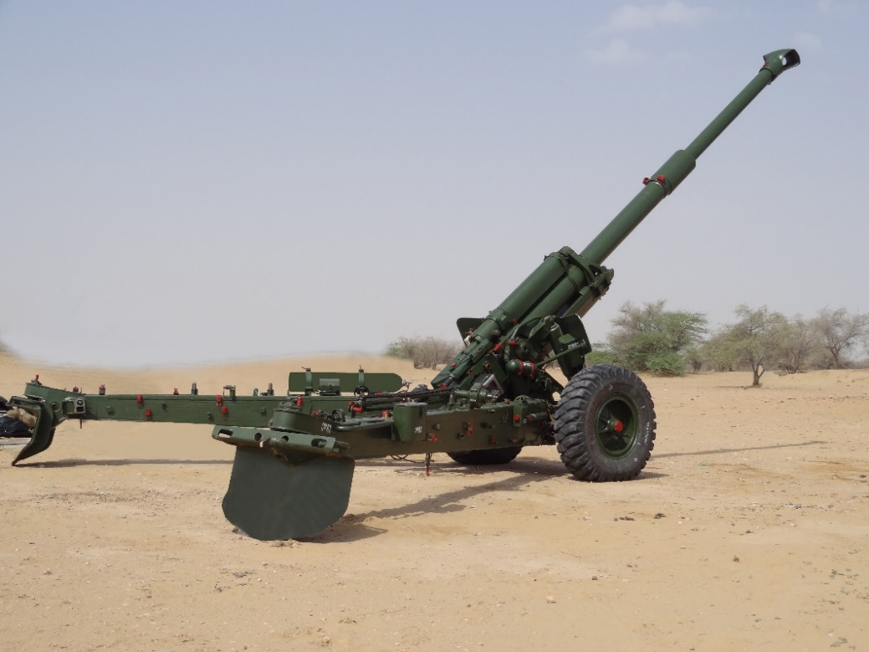
Ammunition Systems:

a. Type of Shell:
Should be able to fire 155mm projectiles in current prod indigenously.

b. Charges:
Should be able to fire in service Bi-modular charge system with 155mm

c. Fuzes :
In service fuzes with 155mm family of ammunition

Barrel life: Min 1500 EFCs with highest charge at 21ºC temp

Ammunition Handling: Manual Loading & pneumatic ramming.

Technological Capabilities
VFJ is equipped with state of art manufacturing facilities comprising of conventional as well as CNC turning, milling, grinding, gear cutting and grinding machines, heat treatment and surface treatment etc for production of gears and other automotive components. There are well developed Tool Room facilities to manufacture special tools, jigs and fixtures. In addition, it has got manual as well as semi-automatic facilities to assemble and test vehicle sub-assemblies and vehicles. VFJ also possess modern fabrication facilities comprising of Plasma cutting, Laser cutting and water jet cutting machines; presses and armor plates welding machines.
VFJ is well equipped with NABL accredited state of art laboratories to test chemical, metallurgical and mechanical properties of ferrous and non-ferrous input material, and NABL accredited calibration lab with well trained manpower. It also has full fledged Test Track to test the dynamic performance of vehicles comprehensively.
Quality system of VFJ has been accredited with ISO-9002 Certification since 1994 and IS/ISO-9001:2015 certification since 2017. VFJ has been accredited with ISO(EMS) 14001-2004 Environmental Management System from BIS, New Delhi since 2014.

VFJ has developed following specialist role vehicles for Indian Army:
- Kitchen Container on Stallion
- 5KL Water Bowser on Stallion
- Battery Command Post (BCP) on Stallion
- Battery Command Post (BCP) on LPTA
- Caravan Office Containerized Vehicle on Stallion
- SATA( Surveillance & Acquisition) Containerized Vehicle on Stallion

Certifications
- ISO:9001-2015 certified.
- EMS : ISO 14001:2004 since 2014
- NABL accredited Physical, Metallurgical & Metrology Labs.

Core Competencies
Over a period of its operations, VFJ has developed core competence in the following area:
  - Manufacturing of Transmission Assemblies & Components
  - Manufacture of Chassis Frame & Assembly of Automobiles
  - Design & Production of Press Tools, Jigs & Fixtures
  - Heat Treatment
  - Armour Plate Cutting

Technology available
The production facilities consists of
- Manufacture of Precision Machining,
- All types of Gear Manufacture,
- Heat Treatment & Surface Treatment of large components.
- Fabrication
- Plasma Cutting
- Laser Cutting
- Water Jet Cutting
- Armour Welding
- Vehicle Assembly
- Semi-Automatic Transfer-Line.
- Inspection & Testing
- Multi-Gauging & CMM
- Test Track

CUSTOMER SERVICE & SUPPORT
- Warranty Spares Support.
- Single Point Agency to address Customer Complaints for defect investigation and rectification.
- Customer feedback – for rating Level of Satisfaction.
- In-situ Customer Training as well as at VFJ
- User Interaction Meeting (Annual)
- Periodical publication of technical literature and compendium on defect reports

