Course Work Project Description and Rubric
Semester | 202520 |  | Division |  | CIS
Assessment title in Syllabus | Final Project |  | Program |  | BASWE,BADSC,BACYB
1
Course Code | CIS2213
Course Title | Full-Stack Web Applications Development
Course Instructor |  |  | CRN
Assessment Weight | 40% |  | Submission Date |  | Week 11
For Group Work submissions an additional individual assessment will be conducted.
Grades for the students in one group will vary based on the individual performance in the additional assessment.
Student Declaration:
Academic Integrity Statement
In accordance with the HCT Academic Integrity Policy
• Students are required to refrain from all forms of academic integrity breaches as defined and explained by HCT.
• A student found guilty of having committed acts of academic integrity breach(es) will be subject to the relevant sanctions as outlined by HCT.
إفادة النزاهة الأكاديمية
وفقًا لسياسة كليات التقنية العليا للنزاهة الأكاديمية
• على الطلبة الإلتزام بلوائح وقواعد النزاهة الأكاديمية، كما هو مبيّن وموضح في السياسات والإجراءات الخاصة بكليات التقنية العليا.
• في حالة ارتكاب الطالب أي شكل من أشكال الإخلال بالنزاهة الأكاديمية، سيتعرض الى العقوبات الموضحة في السياسات ذات الصلة.
This assignment is entirely my own work except where I have duly acknowledged other sources in the text and listed those sources at the end of the assignment. I have not previously submitted this work to the HCT, or any other entity. I understand that I may be orally examined on my submission.
Student (s) Signature: _____________________________________
_____________________________________
_____________________________________

Student Name(s):
Student HCT ID(s): | H00 | H00 |  | H00

For Examiner’s Use Only
Section | Project Proposal | Deliverable 1 | Deliverable 2 | Final Deliverable | Oral Defense | Total | %
Marks Allocated | 5 | 10 | 20 | 15 | 50 | 100 | 40
Marks Obtained

Chatbot ( e.g. ChatGPT ) statement
This submission does not allow you to use any AI tool to complete. Any breach of this requirement will be treated as a plagiarism attempt and shall be subject to the HCT Academic Integrity Policy.
Update the table of content before submitting your work.
TABLE OF CONTENTS
1. PROJECT PROPOSAL 3
1.1 Project Title and Description 3
1.2 Project Scope and Features 3
1.3 Proposed Web Application Structure 3
2. FRONT-END DEVELOPMENT 3
2.1 Title of Web Page 1 3
2.2 Title of Web Page 2 3
CONCLUSION 3
REFERENCES 4
RUBRIC 5

1. PROJECT PROPOSAL

1.1 Project Title and Description

Project Title: CarZone – A Comprehensive Full-Stack Online Car Showroom.

Description: CarZone is a modern web application designed to bridge the gap between automobile showrooms and potential buyers. It serves as a digital catalog where administrators can manage vehicle listings dynamically. Unlike static mockups, this project utilizes a robust back-end architecture to handle user authentication, persistent data storage, and real-time inventory management. The application focuses on a user-centric experience, providing detailed insights into each vehicle while maintaining a high level of administrative control through a dedicated dashboard.

1.2 Project Scope and Features

The project was developed to move beyond a simple visual interface into a working system. Its scope includes:

Persistent Data Management: Moving from temporary arrays to a permanent JSON-based database for both users and car listings.

Full CRUD Functionality: The ability to Create, Read, Update, and Delete vehicle listings directly from the user interface.

Secure Authentication: A registration and login system that validates users against stored server data.

Advanced Media Handling: A local image upload system (via Multer) allowing users to select photos from their own devices instead of relying on external URLs.

Live Search & Filtering: Instant feedback for users searching for specific brands or models using jQuery.

1.3 Proposed Web Application Structure
- The application follows a modular structure for scalability:
- Client-Side (Front-End): HTML5 for structure, CSS3 (Bootstrap 5) for aesthetics, and JavaScript/jQuery for dynamic logic.
- Server-Side (Back-End): Node.js with Express.js handling API routing and file operations.
- Storage Layer: data/cars.json and data/users.json act as a lightweight, efficient database.
- Assets: A dedicated images/ directory for locally uploaded vehicle photographs.

2. FRONT-END DEVELOPMENT
For each web page developed, create a separate subsection using the structure below.

2.1 HOME PAGE (index.html)

Brief Description: The landing page serves as the public face of the showroom. It fetches all available car listings from the server and displays them in a responsive grid.

Responsiveness: Utilizes Bootstrap’s grid system (col-md-4) to transition from a 3-column layout on desktops to a single-column layout on smartphones, ensuring a seamless experience across all devices.

Interactive Elements: Uses $.get() to fetch data asynchronously. A live search bar is implemented using the keyup event in jQuery to filter the visible car cards instantly without page reloads.

Screenshots:


2.2 LOGIN & REGISTER PAGES (login.html / register.html)
- Brief Description: These pages manage user access. The register page creates new user profiles, while the login page verifies credentials to grant access to the Management Dashboard.
- Interactive Elements: AJAX POST requests are used to send credentials to the server. The localStorage API is utilized to store session tokens, allowing the website to "remember" the user as they navigate different pages.
- Client-side Form Validation: Implemented via HTML5 required attributes and custom jQuery logic to check for empty fields, valid email formats, and matching passwords during registration.
- Screenshots:
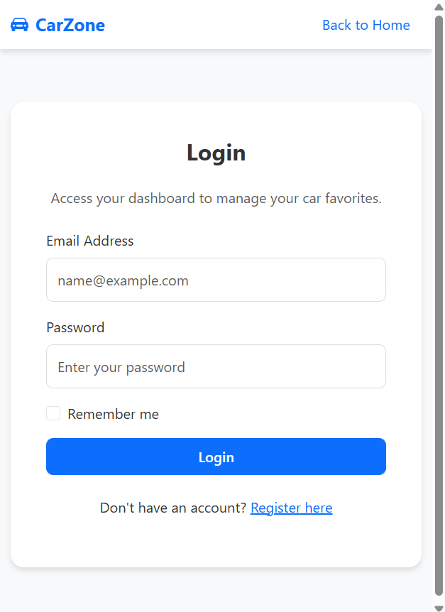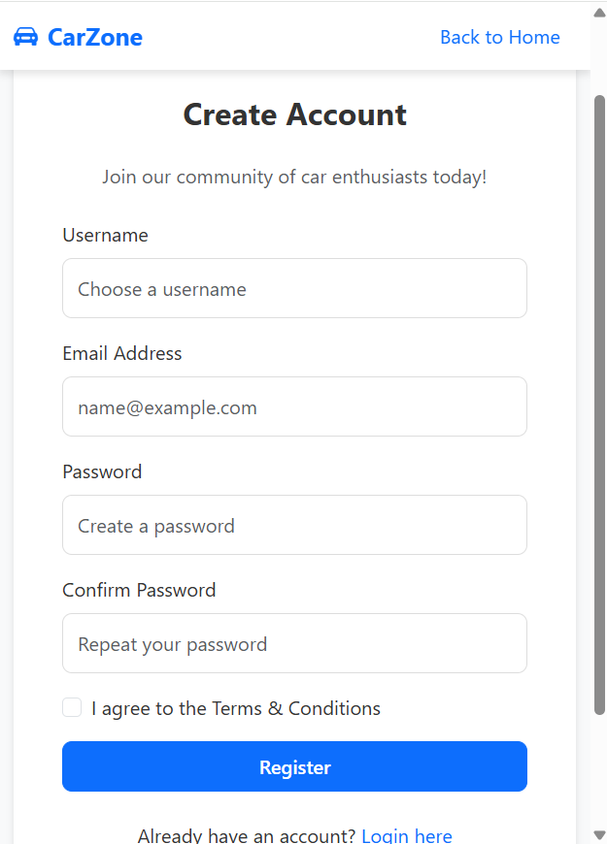

2.3 MANAGEMENT DASHBOARD (dashboard.html)
- Brief Description: An administrative hub available only to logged-in users. It provides a specialized view of the inventory with tools to Modify or Remove listings.
- Responsiveness: Features a dynamic navigation bar that toggles based on authentication status and cards that scale appropriately to fit small screens while maintaining the "Edit/Delete" button accessibility.
- Interactive Elements: Heavy use of Event Delegation in jQuery to handle clicks on dynamically generated "Delete" buttons. The confirm() dialog is used for safe data removal.
- Screenshots:
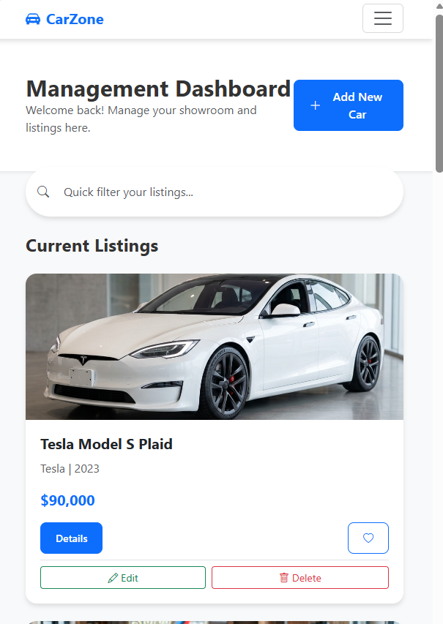

2.4 ADD & EDIT CAR PAGES (add-car.html / edit-car.html)
- Brief Description: Functional forms for inventory expansion. The Add page creates new entries, while the Edit page pre-fills existing data for modification.
- Interactive Elements: Integration with the Multer library. Users can upload images from their local machine. When a file is selected, the script first uploads the file to the /api/upload endpoint and then uses the resulting path to save the car listing.
- Client-side Form Validation: Numeric inputs (Price/Year) are validated to prevent incorrect data types from being sent to the JSON database.
- Screenshots:
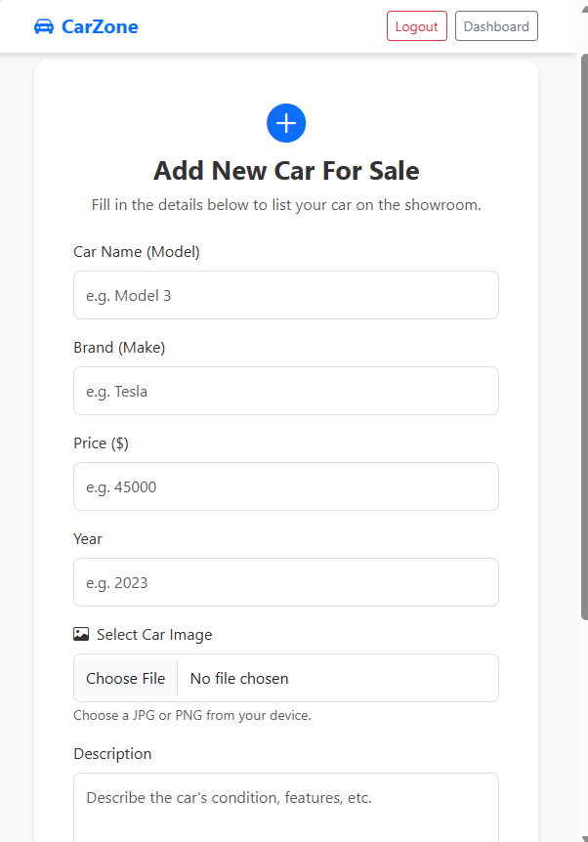

CONCLUSION
- The development of CarZone successfully demonstrates the integration of modern front-end technologies with a functional Node.js backend. We transitioned from a basic UI concept to a fully operational CRUD system with image upload capabilities and secure user sessions.
- Challenges Faced:
- State Persistence: Initially, user sessions were lost upon page refresh. We addressed this by implementing localStorage to synchronize the authentication state across all project pages.
- Image Accessibility: External URLs often proved unreliable. We overcame this by building a dedicated upload pipeline using Multer, allowing for local asset management.
- Next Steps:
- Implementing password hashing (Bcrypt) for enhanced security.
- Migrating the JSON files to a relational database like MongoDB or MySQL for better performance with larger datasets.

REFERENCES
- Node.js Documentation – API handling and File System interactions.
- Bootstrap 5 Guidelines – Responsive grid systems and UI components.
- Multer Documentation – Middleware for handling multipart/form-data.

RUBRIC

 |  | No Attempt | Insufficient | Emerging | Satisfactory | Competent | Mastering
Front-End Development Deliverable [10 Marks] | Front-End Structure and Styling | [0]  No meaningful HTML or CSS implementation is provided. | [0.01 – 0.25]  - Poorly structured HTML with missing or incorrect tags.  - Minimal or no use of CSS.  - No external CSS or JavaScript files included. | [0.26 – 0.50]  - Basic HTML structure with some semantic elements.  - Limited use of CSS, but lacks consistency.  - External CSS or JavaScript files may be missing or improperly linked. | [0.51 – 0.70]  - Proper HTML structure with appropriate semantic elements.  - CSS applied for styling with some inconsistencies.  - External CSS and JavaScript files included but not effectively utilized. | [0.71 – 0.90]  - Well-structured HTML with correct semantic elements.  - Consistent and well-organized CSS styling.  - External CSS and JavaScript files effectively included and utilized for reusable code. | [0.91 – 1.00]  - Excellent HTML structure with proper semantic elements.  - CSS is well-structured, consistent, and follows best practices.  - External CSS and JavaScript files are efficiently used for reusable and maintainable code.
 | Responsive Layout and Design | [0]  No responsive design is implemented. | [0.01 – 0.25]  - Pages do not adapt to different screen sizes.  - No use of Bootstrap or responsive techniques. | [0.26 – 0.50]  - Basic responsiveness with some media queries but lacks consistency.  - Limited use of Bootstrap classes. | [0.51 – 0.70]  - Moderate responsiveness using media queries and Bootstrap.  - Most elements adapt to screen size, but some layout or scaling issues remain. | [0.71 – 0.90]  - Good responsiveness using media queries, Bootstrap classes, and the Bootstrap grid system.  - Layout, images, and text adapt well across common screen sizes. | [0.91 – 1.00]  - Excellent responsiveness with a well-structured layout using the Bootstrap grid system.  - Images, text, and components scale smoothly, providing a consistent user experience across devices.
 | Client-Side Interactivity and DOM Manipulation | [0]  No JavaScript or jQuery interactivity is implemented. | [0.01 – 1.25]  - Very limited or no interactivity.  - No meaningful event handling or jQuery usage. | [1.26 – 2.50]  - Basic interactivity using a small number of events.  - Limited use of jQuery for simple effects or actions. | [2.51 – 3.50]  - Several interactive elements implemented using JavaScript and jQuery.  - Handles a limited range of event types.  - Basic DOM manipulation is present. | [3.51 – 4.50]  - Good interactivity with multiple event types handled correctly.  - Effective use of JavaScript and jQuery for DOM manipulation, animations, or UI feedback. | [4.51 – 5.00]  - Advanced interactivity with well-organized event handling logic.  - Extensive and appropriate use of JavaScript and jQuery for complex UI behaviour and dynamic DOM updates.
 | Client-Side Input Validation | [0]  No client-side validation is implemented. | [0.01 – 0.75]  Forms accept input without validation or user feedback. | [0.76 – 1.50]  Basic validation is implemented, but checks are limited to a small number of fields and feedback is minimal. | [1.51 – 2.10]  Form validation implemented using JavaScript, including required field checks and some feedback. | [2.11 – 2.70]  Client-side validation implemented using JavaScript, including required field checks and basic user feedback. | [2.71 – 3.00]  Strong client-side validation with multiple field checks, immediate user feedback, and partial use of JavaScript regular expressions.

