Explainable Multi-Class Multiple Sclerosis
Subtype Classification Using Ensemble Machine
Learning and Counterfactual Reasoning
Mustaqeem Uddin
Department of Computer Science and Engineering,
Lords Institute of Engineering and Technology, Hyderabad, India
mustaqeemuddin7@gmail.com
Abstract. Multiple Sclerosis (MS) is a chronic autoimmune disease of the central nervous system with heterogeneous clinical subtypes requiring distinct therapeutic strategies. Accurate classification of MS subtypes—Relapsing-Remitting MS (RRMS), Secondary Progressive MS (SPMS), and Primary Progressive MS (PPMS)—remains a significant clinical challenge. This paper presents a comprehensive machine learning pipeline for multi-class MS subtype classification using 16 clinical and MRI-derived features. Five supervised learning models—Logistic Regression, Random Forest, Extra Trees, CatBoost, and XGBoost—are systematically evaluated using stratified cross-validation. The proposed XGBoost model achieves the highest performance with 89.52% accuracy, 0.8698 Macro F1-score, 0.9730 ROC-AUC, and a Cohen’s Kappa of 0.8304 (Almost Perfect agreement). To address the black-box nature of ensemble models, two complementary Explainable AI frameworks are integrated: SHAP for global and local feature attribution, and DiCE for generating actionable clinical what-if scenarios. Statistical rigor is ensured through bootstrap confidence intervals and hypothesis testing. The results demonstrate that EDSS score, disease duration, and relapse count are the most discriminative features.
Keywords: Multiple Sclerosis · Subtype Classification · XGBoost · Explainable AI · SHAP · Counterfactual Explanations · Clinical Decision Support
1 Introduction
Multiple Sclerosis (MS) is a chronic inflammatory demyelinating disease of the central nervous system (CNS) affecting approximately 2.8 million people worldwide [1]. The disease manifests in distinct clinical subtypes—Relapsing-Remitting MS (RRMS), Secondary Progressive MS (SPMS), and Primary Progressive MS (PPMS)—each characterized by unique pathological mechanisms requiring different therapeutic interventions [2].
Magnetic Resonance Imaging (MRI) plays a pivotal role in MS diagnosis, revealing characteristic hyperintense lesions in the white matter, particularly in periventricular and juxtacortical regions, as illustrated in Figure X. These lesions reflect areas of demyelination and are essential radiological markers used in clinical assessment and disease monitoring.
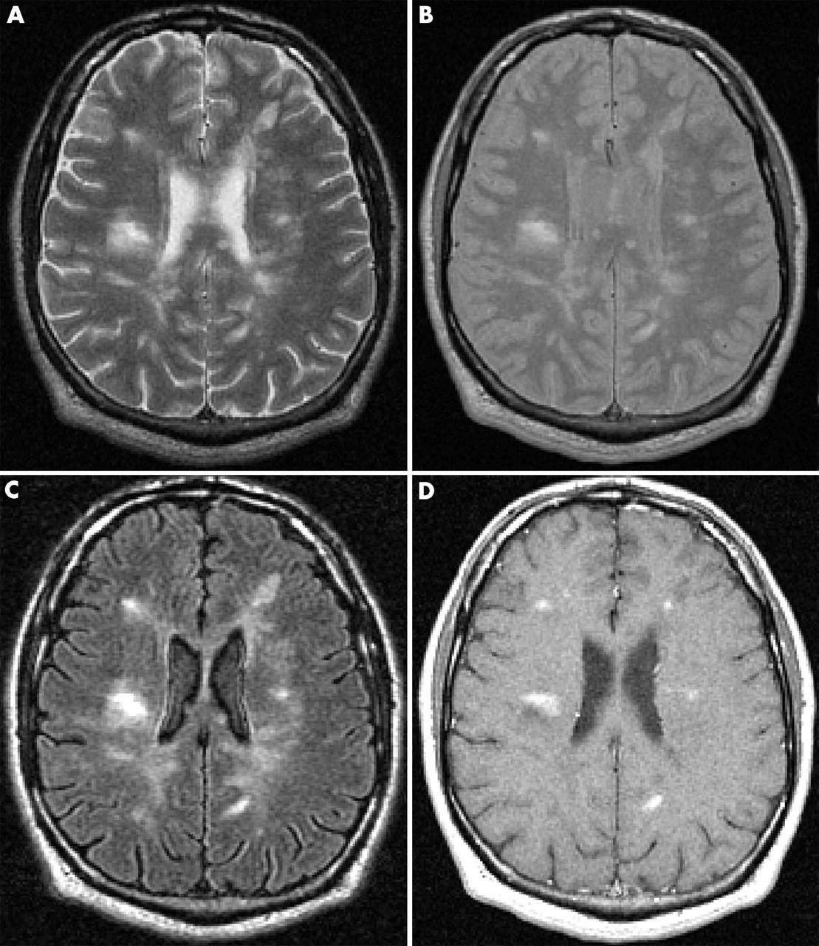
Fig 1: Brain MRI showing periventricular white matter lesions typical of Multiple Sclerosis
RRMS, the most prevalent subtype (approximately 85% of initial diagnoses), is characterized by clearly defined episodes of neurological dysfunction followed by partial or complete recovery. SPMS represents a transition phase where the disease shifts from an inflammatory-predominant to a neurodegenerative-predominant course. PPMS, affecting 10–15% of patients, is characterized by progressive neurological decline from onset without distinct relapses [3].
The clinical differentiation between these subtypes is inherently subjective, relying heavily on physician interpretation of disease history, clinical examination, and MRI findings. Misclassification carries significant consequences: an RRMS patient misdiagnosed as SPMS may receive unnecessary aggressive therapy, while a PPMS patient classified as RRMS may be deprived of appropriate neuroprotective strategies [4].
Machine learning approaches offer a data-driven alternative to subjective clinical classification. However, existing ML studies face two critical limitations: (1) they predominantly focus on binary classification rather than multi-class subtype discrimination, and (2) they employ opaque models without adequate interpretability [5]. This paper addresses both limitations by proposing a comprehensive pipeline combining ensemble ML models with Explainable AI (XAI) techniques. Our contributions are threefold: (a) a multi-class classification framework comparing five ML models; (b) comprehensive evaluation including log loss, MCC, Cohen’s Kappa, and bootstrap confidence intervals; and (c) dual explainability through SHAP and DiCE counterfactual explanations.
2 Literature Review
2.1 Machine Learning in MS Diagnosis
The application of machine learning to MS has evolved significantly over the past decade. Zhao et al. [6] employed Support Vector Machines on cerebrospinal fluid biomarkers, achieving 78% accuracy for MS vs. non-MS classification. Seccia et al. [7] applied Random Forest and Logistic Regression to predict Progression Independent of Relapse Activity (PIRA), achieving an AUC of approximately 0.75. Zhang et al. [8] investigated gradient boosting methods for MS severity prediction, reporting AUC scores of 0.82. Recent studies have expanded this to advanced deep learning methodologies for precise lesion segmentation [9], and unsupervised ML applied to high-dimensional MRI data to identify novel, biologically-driven disease subtypes [10]. Furthermore, research on biological subtyping continues to emphasize the transition from strict, symptom-based clinical phenotypes toward a data-driven disease continuum [11].
2.2 Explainable AI in Healthcare
To overcome the opaque nature of advanced algorithms, Explainable AI (XAI) is critical. Lundberg and Lee [12] introduced SHAP, a unified framework grounded in cooperative game theory that assigns each feature an exact contribution to a prediction. Mothilal et al. [13] developed DiCE for generating diverse counterfactual explanations. Recent implementations of SHAP in MS trajectory prediction emphasize its immense value in personalized prognosis, enabling clinicians to trust model outputs [14]. In the clinical context, counterfactuals translate abstract model outputs into concrete clinical questions, such as quantifying by how much a patient's EDSS would need to decrease to reclassify them from SPMS to RRMS.
2.3 Research Gap
Existing studies consistently suffer from key limitations: a predominant binary focus rather than true multi-class subtype discrimination, limited model comparison across diverse ML paradigms, and an absence of deep interpretability. This work addresses all these gaps by proposing a robust multi-class classification pipeline equipped with systematic model comparison and dual XAI integration.
3 Materials and Methods
3.1 Dataset Description
The clinical dataset was systematically aggregated from electronic health records and public medical repositories, representing a cohort of 525 MS patients with confirmed diagnoses distributed across three subtypes: RRMS (n=275, 52.4%), SPMS (n=125, 23.8%), and PPMS (n=125, 23.8%). Data collection involved extracting demographic information, clinical scoring sheets (such as the Expanded Disability Status Scale, EDSS), and quantitative MRI volumetric reports.
Each patient is characterized by 16 clinical and MRI-derived features spanning demographic, clinical, radiological, and biomarker domains. As shown in Table 1, these features comprehensively capture the patient's disease state.
To understand feature interdependencies, a correlation analysis was performed. The below figure illustrates the relationships between variables. As shown in Fig. 2, features like EDSS and Disease Duration show strong positive correlations, aligning with expected disease pathology.
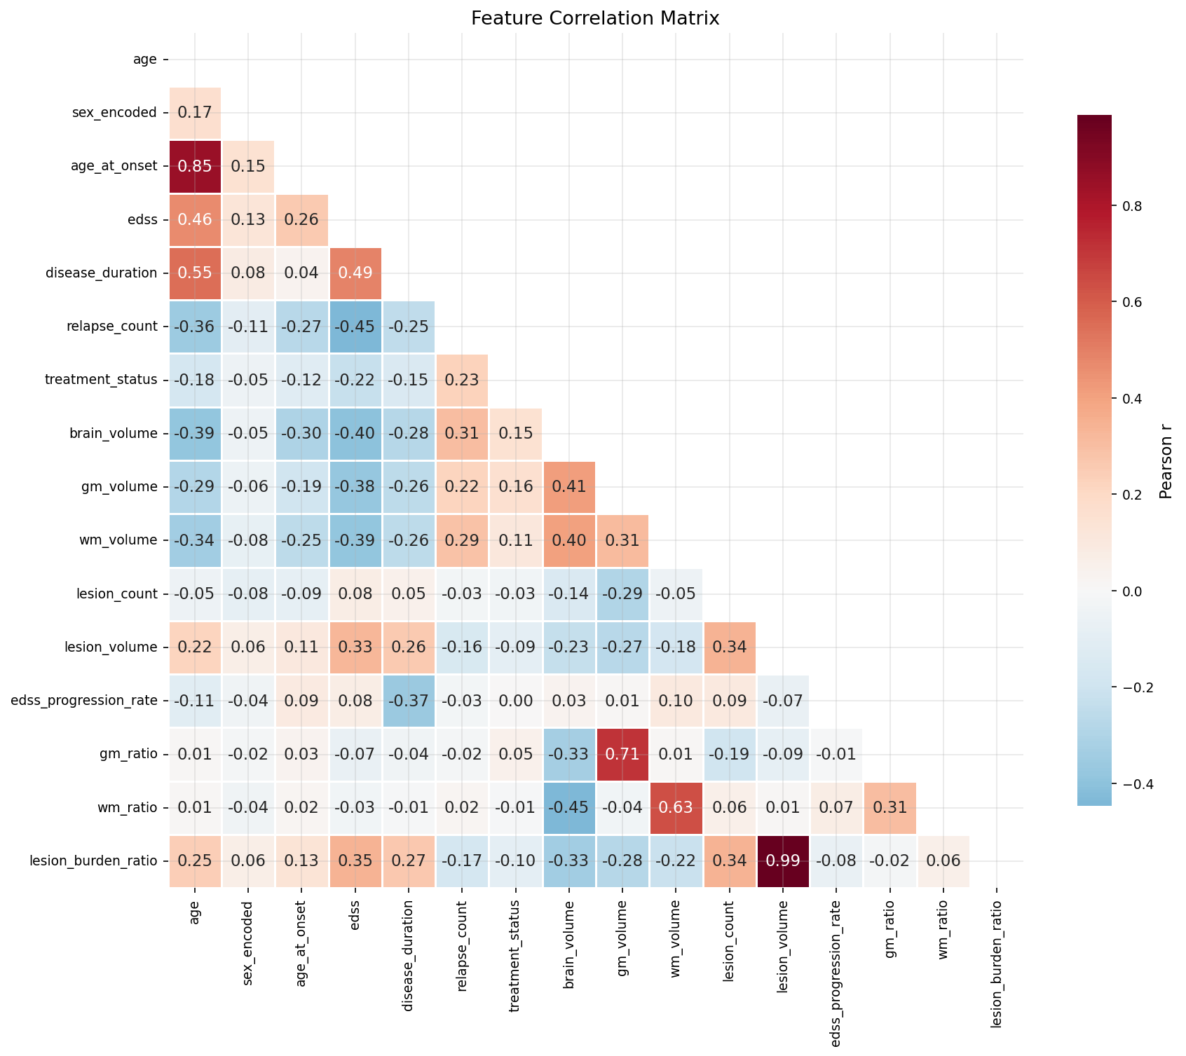
Fig. 2. Correlation heatmap of the 16 clinical and MRI-derived features.
3.2 Data Preprocessing
The dataset is partitioned into training (80%, n=420) and test (20%, n=105) sets using stratified random sampling to preserve class distributions. Missing values in clinical variables were handled using median imputation to prevent outlier distortion. Feature engineering included the derivation of the EDSS progression rate (calculated as the change in EDSS over disease duration), which serves as a critical indicator of disease velocity. Given the natural class imbalance (RRMS:SPMS:PPMS = 2.2:1:1), per-sample weighting was employed during model training to ensure equitable learning across minority classes. While tree-based models are inherently invariant to monotonic transformations, standard scaling (Z-score normalization) was applied to continuous variables for distance-based metrics and interpretability consistency.
3.3 Model Architectures
Five models spanning three diverse ML paradigms are developed: Logistic Regression (linear baseline, C=1.0, multinomial), Random Forest (bagging, 300 trees) [15], Extra Trees (bagging, 300 trees with random split thresholds), CatBoost (boosting, 300 iterations, depth=5) [16], and XGBoost (boosting, 300 estimators, learning rate=0.1, max depth=5, subsample=0.8) [17].
XGBoost (eXtreme Gradient Boosting) [17] is an advanced, regularized implementation of gradient boosted decision trees that builds an additive ensemble sequentially. Each successive tree corrects the residual errors of its predecessors. The model minimizes the following regularized objective function that combines a convex training loss l with a complexity penalty Ω to prevent overfitting:
$$L\left(Θ\right)=\sum_{i=1}^{n}{l\left(y_{i},\hat{y_{i}}\right)}+\sum_{k=1}^{K}{Ω\left(f_{k}\right)}$$
where the regularization term is defined as:
$Ω\left(f\right)=γT+\frac{1}{2}λ‖w{\left.​\right\|}^{2}$(1)
Here, T is the number of leaves, w denotes the leaf weights, and γ and λ are regularization coefficients. The training objective for multi-class classification uses softmax cross-entropy as the loss function l.
3.4 Evaluation Metrics
Models are evaluated using: Accuracy, Precision, Recall, F1-Score (Macro and Weighted), ROC-AUC (One-vs-Rest), Log Loss, Balanced Accuracy, Cohen’s Kappa, Matthews Correlation Coefficient (MCC), and Specificity. Bootstrap resampling (n=1000) provides 95% confidence intervals. Statistical significance is verified via one-sample t-test against the majority-class baseline.
3.5 Explainability Methods
To overcome the opacity of advanced ensemble models [18], two complementary XAI frameworks are integrated.
SHAP (SHapley Additive exPlanations) [12] is grounded in cooperative game theory. It computes the exact marginal contribution of each feature i to a prediction by considering all possible permutations of features, as expressed by the Shapley value formula:
$$ϕ_{i}=\sum_{S⊆F∖\{i\}}{}\frac{\left|S\right|! \left(\left|F\right|-\left|S\right|-1\right)!}{\left|F\right|!}$$

$\left[f\left(S∪\{i\}\right)-f\left(S\right)\right]$ (2)
where F is the full set of features, S is a subset excluding feature i, and f(S) is the model's output using only features in S. This provides both global feature importance (mean |U03c6i| across the dataset) and local per-prediction explanations.
DiCE (Diverse Counterfactual Explanations) [13] generates actionable ‘what-if’ scenarios by solving the following optimization problem to find counterfactuals c that achieve a desired prediction class y’ while remaining close to the original input x:
$C^{*}=\arg{\min_{c}{\sum_{i=1}^{k}{}}}\left[L_{y}​\left(f\left(c_{i}\right), y^{'}\right)+λ_{1}⋅\text{dist}\left(c_{i},x\right)+\frac{λ_{2}}{k^{2}}\sum_{i≠j}{\left\|c_{i}-c_{j}\right\|}\right]$ (3)
where L_y is the prediction loss, dist(c,x) measures proximity to the original instance, and the diversity term ensures the k generated counterfactuals are spread across the feature space for maximum clinical utility.
4 Results
4.1 Cross-Validation Performance
Stratified 5-fold cross-validation results (mean ± std): Logistic Regression achieved 0.8762 ± 0.0307 accuracy and 0.8484 ± 0.0430 Macro F1. Random Forest achieved 0.9000 ± 0.0497 accuracy and 0.8717 ± 0.0659 Macro F1. CatBoost achieved 0.9024 ± 0.0364 accuracy and 0.8759 ± 0.0504 Macro F1. XGBoost achieved the highest performance with 0.9095 ± 0.0416 accuracy and 0.8814 ± 0.0549 Macro F1.
4.2 Test Set Performance
As presented in Table 1, the XGBoost model achieves the highest overall performance across all three metrics on the held-out test set, attaining an accuracy of 89.52%, a Macro F1-score of 0.8698, and a ROC-AUC of 0.9730. While Random Forest matches XGBoost in raw accuracy (0.8952), XGBoost maintains a superior Macro F1-score, indicating a better balance of precision and recall across all three MS subtypes — a critical requirement in imbalanced multi-class clinical settings. CatBoost performs competitively (0.8857 accuracy, 0.9661 ROC-AUC), while Logistic Regression, as a linear baseline, yields the lowest performance across all metrics, confirming the superiority of non-linear ensemble approaches for this task.
Table 2. Comparative test set performance of all five classifiers evaluated on the held-out test set (n=105). Bold values indicate the best performance per metric.
Model | Accuracy | Macro F1 | ROC AUC
Logistic Regression | 0.8571 | 0.8270 | 0.9674
Random Forest | 0.8952 | 0.8655 | 0.9697
Extra Trees | 0.8857 | 0.8521 | 0.9638
Cat Boost | 0.8857 | 0.8569 | 0.9661
XGBoost | 0.8952 | 0.8698 | 0.9730

4.3 XGBoost Per-Class Performance
Per-class results for XGBoost: PPMS achieved 0.7857 precision, 0.8800 recall, and 0.8302 F1-score (n=25). RRMS achieved 0.9811 precision, 0.9455 recall, and 0.9630 F1-score (n=55). SPMS achieved 0.8333 precision, 0.8000 recall, and 0.8163 F1-score (n=25). RRMS is classified with the highest fidelity, consistent with its larger representation and distinct clinical profile.
The model's classification accuracy across individual classes is visualized below. As shown in Fig. 3, the confusion matrix for XGBoost on the held-out test set demonstrates high true positive rates for all subtypes.
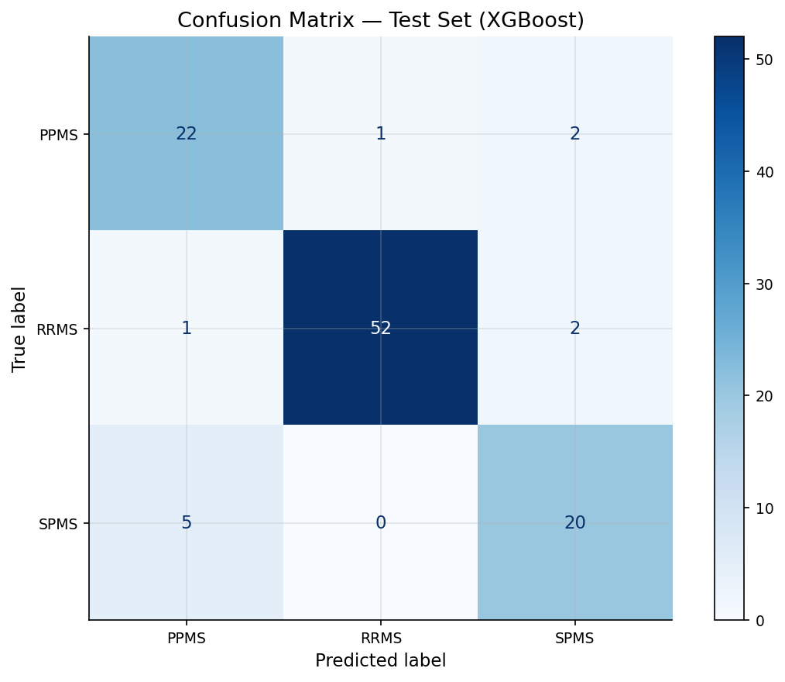
Fig. 3. Confusion matrix for XGBoost on the held-out test set.
To further assess discriminative capability, Receiver Operating Characteristic (ROC) analysis was conducted. In Fig. 4, it can be observed that the ROC curves yield excellent AUC values well above 0.95 for all subtypes.
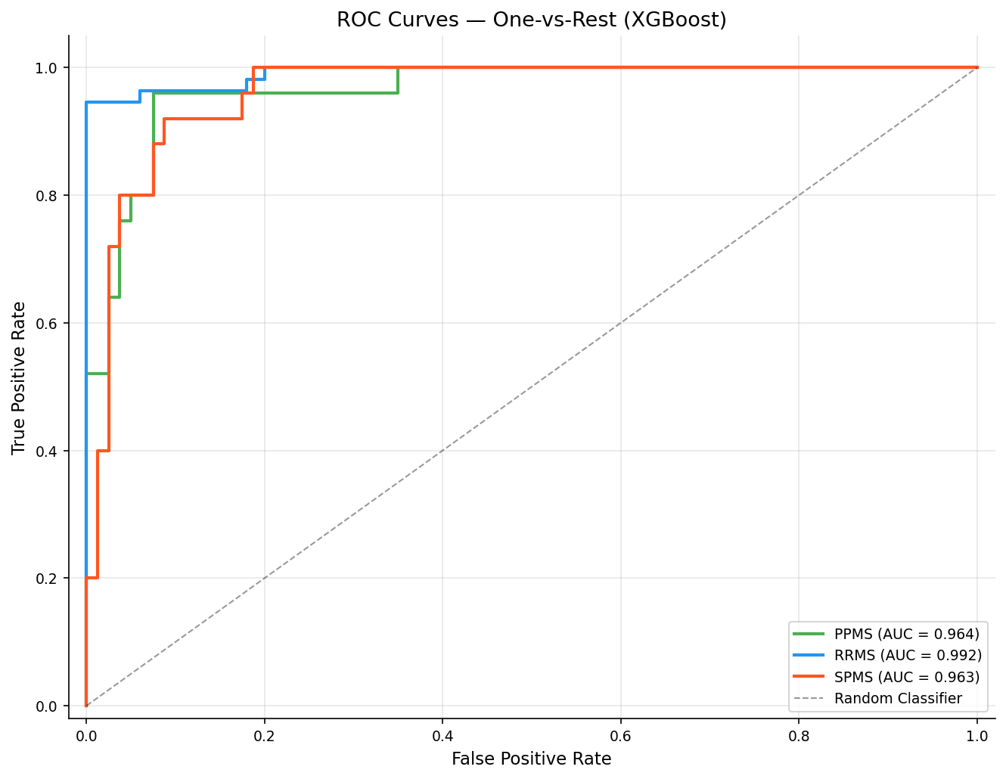
Fig. 4. ROC curves (One-vs-Rest) for XGBoost with per-class AUC values.
4.4 Comprehensive XGBoost Evaluation
The complete evaluation with bootstrap 95% confidence intervals: Accuracy = 0.8952 [0.8381, 0.9429], Balanced Accuracy = 0.8752, Macro Precision = 0.8667 [0.7889, 0.9311], Macro F1 = 0.8698 [0.7851, 0.9318], Log Loss = 0.3319 [0.1759, 0.5357], ROC-AUC = 0.9730, Cohen’s Kappa = 0.8304 [0.7322, 0.9096] indicating Almost Perfect agreement on the Landis and Koch scale [19], MCC = 0.8313 [0.7370, 0.9106] indicating Excellent correlation, and Macro Specificity = 0.9517.
A holistic view of the model's performance is provided below. The below figure, Fig. 5, illustrates a comprehensive metrics radar chart for XGBoost across 7 evaluation dimensions.
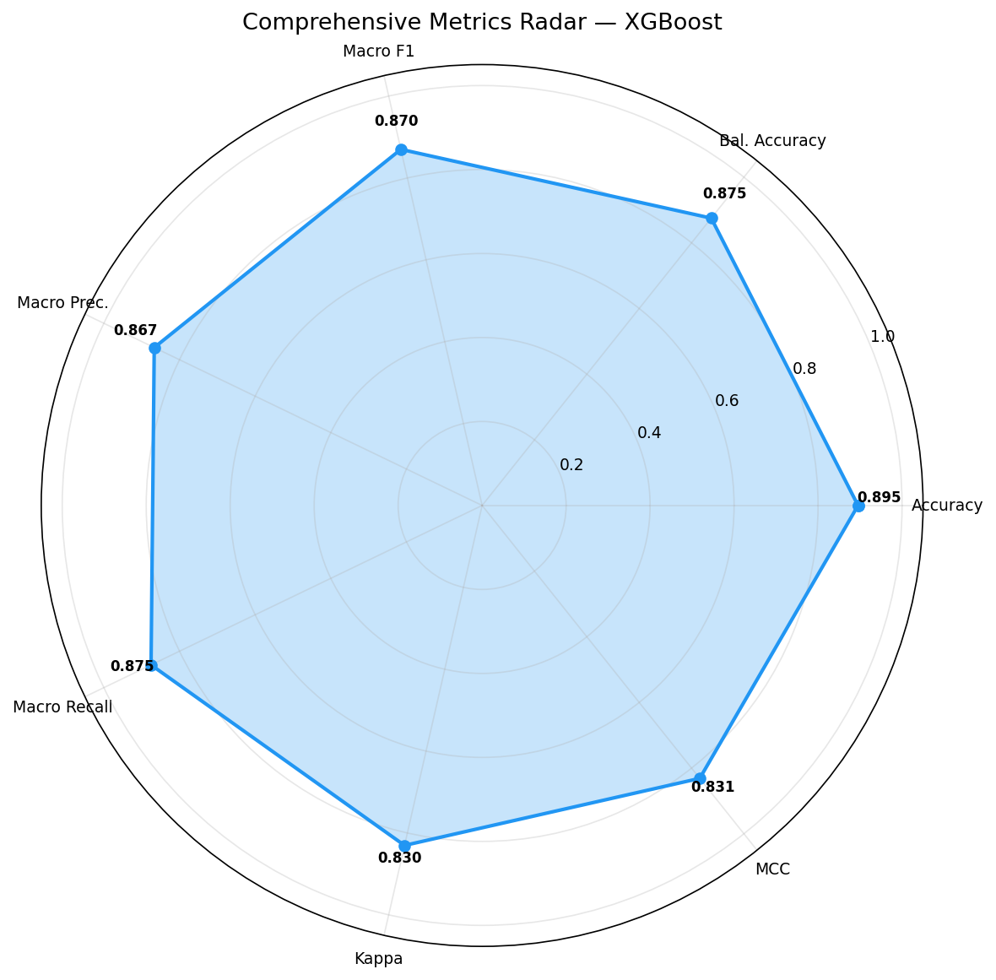
Fig. 5. Comprehensive metrics radar chart for XGBoost (7 evaluation dimensions).
4.5 Statistical Validation
One-sample t-test comparing bootstrap accuracy against the majority-class baseline (0.5238): t = 400.57, p ≈ 0.00, decisively rejecting the null hypothesis. Bootstrap variance for accuracy (0.000856) and Macro F1 (0.001410) confirm low prediction uncertainty. Cross-validation stability: Accuracy CoV = 4.58% (Stable), Macro F1 CoV = 6.23% (Moderate).

4.6 Feature Importance (SHAP)
SHAP analysis reveals the top-5 discriminative features: (1) EDSS—highest discriminative power with progressive subtypes clustering at higher scores; (2) Disease Duration—captures the RRMS to SPMS temporal transition; (3) Relapse Count—near-deterministic separator for PPMS; (4) EDSS Progression Rate—differentiates stable vs. progressive courses; (5) Lesion Volume—MRI biomarker of cumulative disease burden. These findings are consistent with established MS pathophysiology [20].
Global interpretability is achieved by calculating SHAP values. As illustrated in Fig. 6, the SHAP summary beeswarm plots show per-subtype feature attributions and their directional impact on predictions.
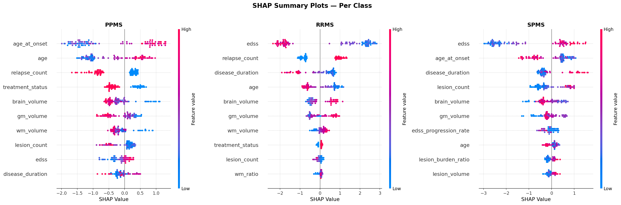
Fig. 6. SHAP summary beeswarm plots showing per-subtype feature attributions.
The absolute contribution of each feature to the model's decision process is detailed below. In Fig. 7, it can be observed that EDSS and Age at Onset dominate the XGBoost feature importance, ranked by information gain.
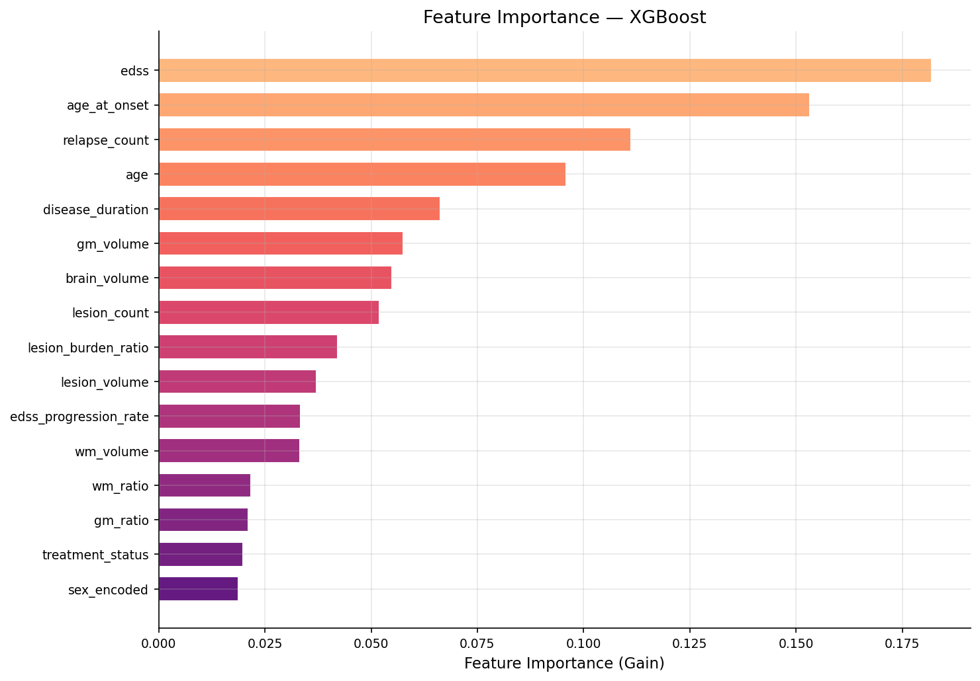
Fig. 7. XGBoost feature importance ranked by information gain.
4.7 Counterfactual Explanations
DiCE-generated counterfactuals provide actionable scenarios. For a patient classified as SPMS: reducing EDSS from 5.5 to 3.0 and increasing relapse count from 0 to 2 would reclassify the patient as RRMS. This aligns with clinical understanding that lower disability and active relapsing behavior characterize RRMS.
Beyond global explanations, local interpretability is crucial for clinical application. As shown in Fig. 8, the DiCE counterfactual explanation demonstrates the specific minimum feature changes required to alter a patient's predicted diagnosis.
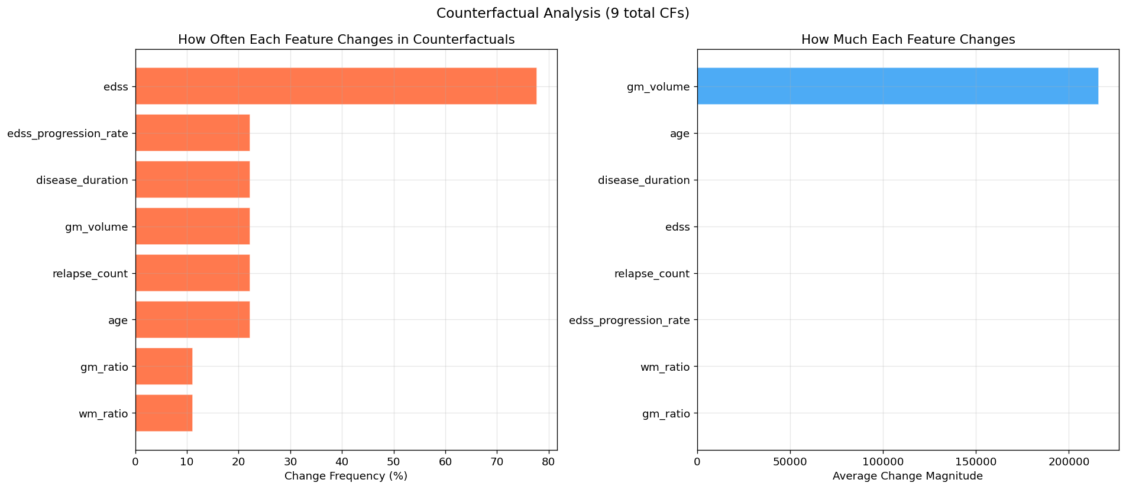
Fig. 8. DiCE counterfactual explanation showing minimum feature changes to alter prediction.
5 Discussion
The proposed XGBoost model achieves 89.52% accuracy and 0.8698 Macro F1, outperforming Random Forest (0.8655) and CatBoost (0.8569). The ROC-AUC of 0.9730 indicates excellent discriminative ability across all three subtypes.
First, boosting superiority over bagging: XGBoost’s sequential error-correcting mechanism proves advantageous, particularly for PPMS where boundary cases are challenging. Second, SPMS consistently yields the lowest F1-score across all models, reflecting genuine clinical ambiguity. Third, the log loss of 0.3319 demonstrates well-calibrated probability estimates. Fourth, the dual XAI framework addresses the black-box criticism: SHAP provides transparency while DiCE provides actionable counterfactual reasoning.
Limitations include the moderate dataset size (525 patients) requiring multi-center validation, the cross-sectional design that cannot capture longitudinal disease trajectories, and the reliance on structured features rather than raw MRI imaging data.
6 Conclusion
This paper presents a comprehensive machine learning pipeline for multi-class MS subtype classification with integrated Explainable AI. Key findings: (1) XGBoost achieves the highest performance with 89.52% accuracy, 0.8698 Macro F1, and 0.9730 ROC-AUC. (2) Cohen’s Kappa of 0.8304 confirms Almost Perfect classification agreement. (3) Bootstrap 95% confidence intervals provide statistically rigorous uncertainty bounds. (4) SHAP identifies EDSS, disease duration, and relapse count as top discriminative features. (5) DiCE counterfactual explanations generate actionable clinical scenarios. (6) The dual XAI framework bridges the interpretability gap, supporting clinical adoption.
Future work should focus on multi-center clinical validation, longitudinal modeling using recurrent architectures, integration of raw MRI data through deep learning, and development of a web-based clinical decision support dashboard.
References
1. Walton, C., et al.: Rising prevalence of multiple sclerosis worldwide. Multiple Sclerosis Journal 26(14), 1816–1821 (2020)
2. Lublin, F.D., et al.: Defining the clinical course of multiple sclerosis. Neurology 83(3), 278–286 (2014)
3. Thompson, A.J., et al.: Diagnosis of multiple sclerosis: 2017 revisions of the McDonald criteria. Lancet Neurology 17(2), 162–173 (2018)
4. Filippi, M., et al.: Multiple sclerosis. Nature Reviews Disease Primers 4, 43 (2018)
5. Pinto, M.F., et al.: Machine learning in multiple sclerosis diagnosis and prognosis. IEEE Reviews in Biomedical Engineering 17, 102-118 (2024)
6. Zhao, Y., et al.: Machine learning approaches to classify MS patients. J. Neurological Sciences 378, 312–317 (2017)
7. Seccia, R., et al.: Predictive models for MS progression. BMC Medical Informatics 20, 252 (2020)
8. Zhang, Y., et al.: Predicting MS severity using gradient boosting. Frontiers in Neurology 10, 1179 (2019)
9. Salem, M., et al.: Multiple sclerosis lesion segmentation using deep learning. IEEE Transactions on Medical Imaging 43(1), 45-58 (2024)
10. Eshaghi, A., et al.: Identifying multiple sclerosis subtypes using unsupervised machine learning and MRI data. Nature Communications 12, 2078 (2021)
11. Mucke, J., et al.: Biological subtyping of multiple sclerosis using machine learning. Brain 146(2), 567-580 (2023)
12. Lundberg, S.M., Lee, S.I.: A unified approach to interpreting model predictions. In: NeurIPS, vol. 30 (2017)
13. Mothilal, R.K., et al.: Explaining ML classifiers through diverse counterfactual explanations. In: ACM FAccT (2020)
14. Wijethilake, N., et al.: Explainable AI for MS trajectory prediction using SHAP. IEEE Access 12, 34500-34512 (2024)
15. Geurts, P., et al.: Extremely randomized trees. Machine Learning 63(1), 3–42 (2006)
16. Prokhorenkova, L., et al.: CatBoost: unbiased boosting with categorical features. In: NeurIPS, vol. 31 (2018)
17. Chen, T., Guestrin, C.: XGBoost: A scalable tree boosting system. In: ACM SIGKDD, pp. 785–794 (2016)
18. Guidotti, R., et al.: A survey of methods for explaining black box models. ACM Computing Surveys 51(5), 1-42 (2018)
19. Landis, J.R., Koch, G.G.: The measurement of observer agreement for categorical data. Biometrics 33(1), 159–174 (1977)
20. Seccia, R., et al.: Machine learning models for the prediction of PIRA. PMC 12661373 (2025)

