**3/14/2023**

**Differentiating Between TCP and UDP in Respect to Distributed Systems**

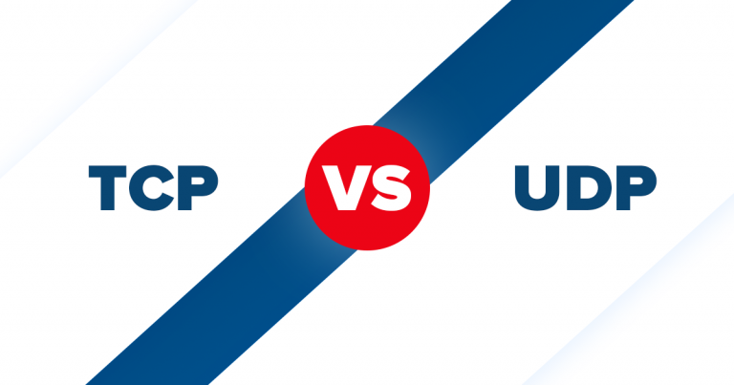

**Done By : Osama Abdulwahed Alathwari**

**Software Enginnering , Level 04**

**Supervised By : Dr. Ali H Shamsan**

**Introduction:**

**In distributed systems**, communication is an essential aspect to ensure that different nodes in the system can interact and exchange data with each other. Two popular communication protocols used in distributed systems are **Transmission Control Protocol (TCP)** and **User Datagram Protocol (UDP)**. In this assignment I will **differentiate between TCP and UDP communication in respect to distributed systems.**

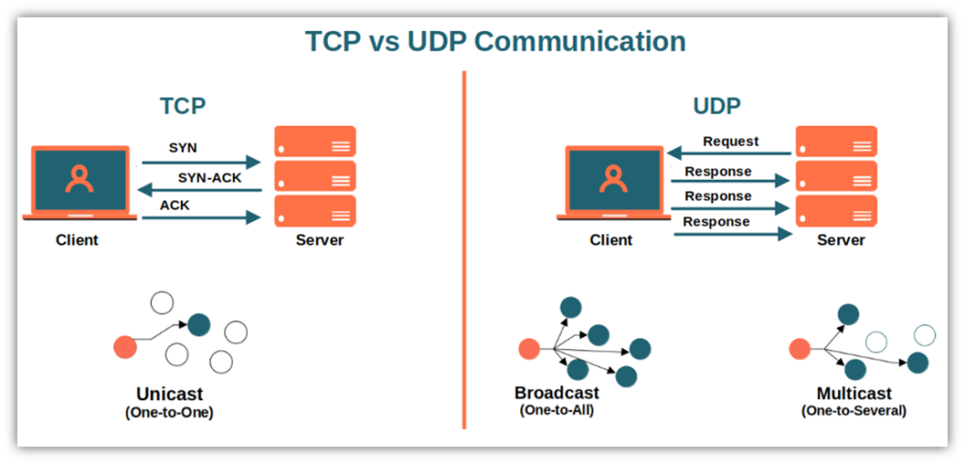

**Definition:**

**TCP** and **UDP** are protocols used in computer networks to transmit data between different devices.

**TCP:** is a connection-oriented protocol that establishes a reliable, ordered, and error-checked communication channel between two devices.

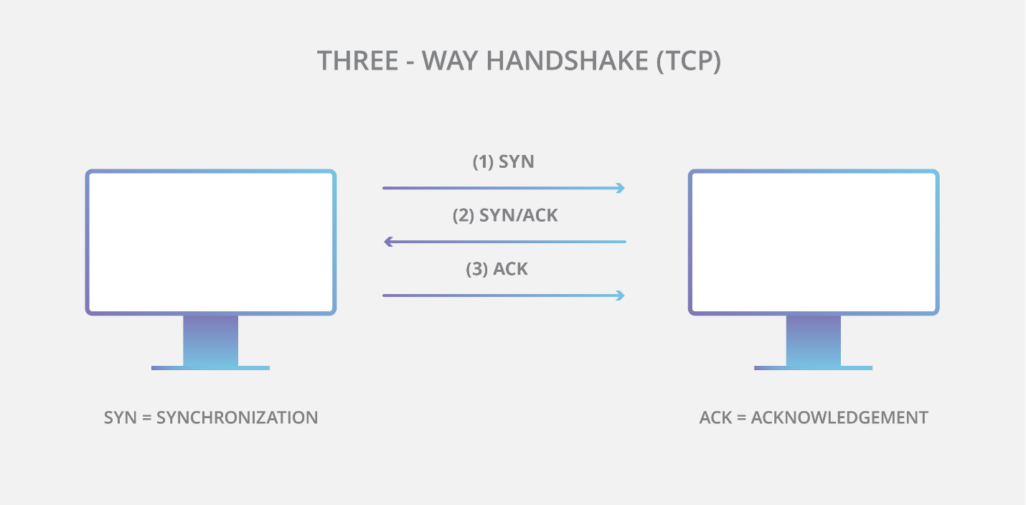

In contrast, **UDP:** is a connectionless protocol that does not establish a dedicated end-to-end connection between two devices.

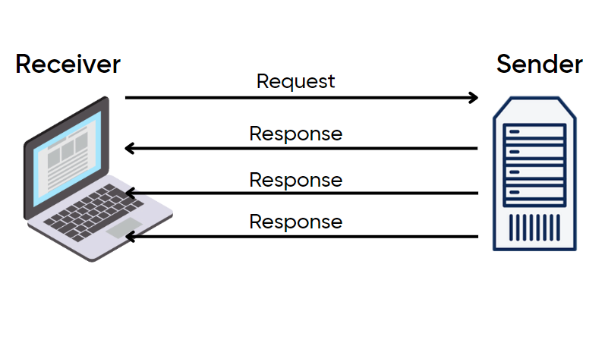

**Examples:**

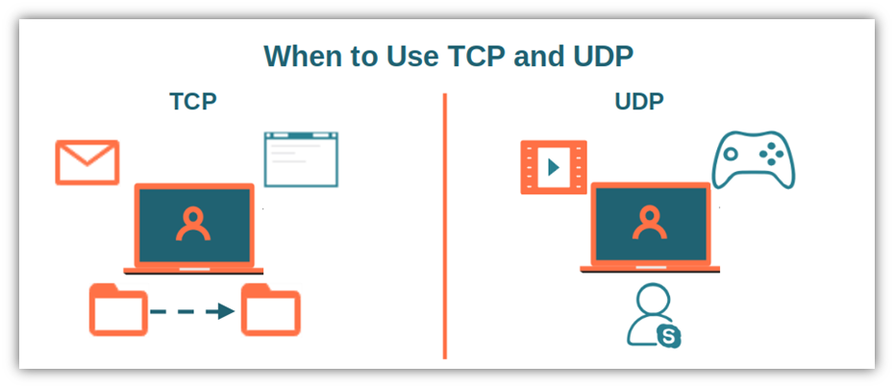

**TCP** is used in applications that require **high reliability**, such as

1. **web browsing (HTTP)**
2. **email file transfer (SMTP)**
3. **file transfer (FTP)**
4. **remote desktop connections**.

**UDP** is used in applications that require **real-time communication**, such as

1. **video streaming**
2. **online gaming**
3. **VoIP**

**Advantages and Disadvantages of TCP :**

|  |  |
| --- | --- |
| Advantages | Disadvantages |
| Reliable: TCP ensures that all data packets are received in the correct order, and any lost or corrupted packets are retransmitted | **Slower: TCP is slower than UDP as it establishes a connection between two devices and checks for errors and retransmits any lost or corrupted packets.** |
| Ordered: TCP maintains the order of data packets, which is essential in applications such as file transfer and email. | **Resource-intensive: TCP requires more resources, such as memory and processing power, to establish and maintain a connection.** |
| Error-checked: TCP uses checksums to detect any errors in the data packets and retransmits any corrupted packets. | **Overhead : TCP incurs overhead for connection establishment, maintenance and termination** |

**Advantages and Disadvantages of UDP:**

|  |  |
| --- | --- |
| Advantages | Disadvantages |
| Faster: UDP is faster than TCP as it does not establish a connection or perform error-checking | **Unreliable: UDP does not guarantee the delivery of data packets, which can result in lost or corrupted packets.** |
| Simple: UDP is simple and requires less processing power and memory than TCP. | **No order: UDP does not maintain the order of data packets, which can result in data packets arriving out of order.** |
| Real-time: UDP is ideal for real-time applications such as online gaming and video streaming. | **No error-checking: UDP does not perform error-checking, which can result in corrupted data packets.** |

**Conclusion:**

In conclusion, **TCP** and **UDP** are protocols used in distributed systems to transmit data between different devices. **TCP** is a connection-oriented protocol that is reliable, ordered, and error-checked, while **UDP** is a connectionless protocol that is faster, simpler, and ideal for real-time applications. **The choice** between TCP and UDP **depends on the application's requirements**, and developers must carefully evaluate the advantages and disadvantages of each protocol before making a decision.