**Project Details**

|  |  |
| --- | --- |
| Project number | *Project 1* |
| Project title | *Mega Store* |
| Corresponding TA\LA | *1* |
| Deliverable | *Phase 3* |

**Team Details**

**Team 8**

|  |  |  |
| --- | --- | --- |
| **Student ID** | **Student name** | **Lab Group** |
| 20200403 | Loay Mohamed Hussien | S3-S4 |
| 20200490 | Mahmoud Ahmed Abdo | S1-S2 |
| 20200687 | Ibrahim Rashid Ibrahim | S1-S2 |
| 20200479 | Mohammed Nasser Abdel-Samea | S1-S2 |
| 20200125 | Ganna Allah Khaled Fouad | S3-S4 |
| 20201185 | Nadeen Medhat Assem Abdel-Latif | S3-S4 |
| 20200143 | Habiba Adel Lotfy ELbatrawy | S3-S4 |

**Phase 3: DESIGN THE ENVIRONMENT and THE USER & SYSTEM INTERFACES**

**DESIGN THE ENVIRONMENT**

1. ***Using the project description then answer the following questions:***
2. **With what external systems and databases will the system under development interact?**

**Note:**

* **Write all external systems that will deal with your system.**
* **Write all the table names and columns in your database either internally [your system] or externally [ external system].**
* **No need to answer the questions in lectures, just identify the above.**

🡪The frequency of the interaction between system and database will be high When the

customer wants to buy a product the system checks the availability of the products in

the product database, also when the customer/admin sign-in, the system goes to the

database to check the validity of the information

Data content of input to: customer selects the products he wants to buy, Customer

checks offers of the products, Customer selects the payment method (Cash/Credit card)

Customer selects item to return, Admin add products and offers on the products

🡪Data content of output from: System show offers and products System asks for the

payment method System displays the state of the item that has been returned

🡪HTTP: The Hypertext Transfer Protocol is a widely used protocol for transferring data

on the internet. It is commonly used to transfer data between web servers and clients

(such as browsers) and can be used to transfer data in a variety of formats including

HTML, XML and JSON.

🡪Encryption: Encrypting data before it is transmitted can help to protect it from being

intercepted and read by unauthorized parties.

Authentication: Ensuring that only authorized parties can access the data can help to

prevent unauthorized access This can be achieved using authentication protocols such

as passwords and tokens,

1. **What devices will be used for automated inputs and outputs?**

**Note:**

* **Write all devices needed as input devices and output devices**
* **Example: Bar code reader, keyboard,....**

**Devices:**

Automated Input devices:

Barcode Reader- Magnetic Strip on Credit card

Automated Output devices:

Receipt Printer

1. What user-interface technology will be used?

**Note:**

**Answer first 2 questions for this part:**

1. **Where users will be located?**

**Everywhere around the world**

1. **What hardware devices will users use?**

**Mobile – tablet – desktop**

**THE USER & SYSTEM INTERFACES**

1. **Using the system sequence diagrams developed during the analysis phase of your project:**
2. **Identify the various screens and forms that may be needed for the user interface.**

**Note: Write all screens and forms for the previous 3 sequence diagrams**

-Input screen for searching for product by customer

-Output screen for viewing customer’s search result

-Input screen for add product to cart by customer

-Output screen for viewing customer’s added product

-Input screen for buy product by customer and enter credit card information

-Output screen for checking customer’s credit card validation

-Input screen for applying checkout by customer

-Output screen for viewing customer’s checkout status

-Check customer validation for return product input screen

-Output screen for viewing customer’s validation return status

-Input screen for buy product by customer and put an option to buy special bags

-Output screen for viewing customer’s points

-Input screen for add product information by manager

-Output screen for show added status

-Input screen for detect country by manager

-Output screen for show country detected by manager

Input screen for detect payment method by manager

-Output screen for show detected payment method by manager

-Input screen to show if there are offers on not and if there is an offer, enter its information

-Output screen to show offers status

1. **From use case diagrams developed during the analysis phase of your project which related to the screens and forms identified in (2.a):**
2. **Create a good menu design by following the principles you studied. This should start by defining how use case are grouped inside a menu in a tabular format, which is followed by the actual menu design and define which menu style will be used?**

**Note: Design your menu.**

Menu design (tabular form)

|  |  |  |
| --- | --- | --- |
| Menu description | Choices (use caser) | Intended Users |
| product | 1.add product  2.add product information  3.remove product  4.return product  5.check return policy  6.buy product  7.gain points  8.buy special bag  9.chechout  10.check discount by point  11.add product to cart  12.search for product  13.get offers | -Manager  -Customer |
| services | 1.provide services  2.Enhance services  3.view search history  4.make a financial report  5.view purchase history  6.detect location  7.change language automatically  8.provide special bags  9.provide different categories | -Manager |
| offers | 1.make offers  2.affected by local events  3.affected by global events  4.get offers | -Manager  -Customer |
| operation | 1.operate different stores  2.deal with suppliers | -Manager |
| warehouses | 1.Has warehouses | -Manager |

**which menu style will be used?🡪RMO CSMS use cases grouped into first-cut menus by similar function and user**

🡪Menu design and hierarchy

1. For the screens and forms identified in (2.a) create a **Storyboard** that captures the sequences of event. Storyboards may be designed using **wireframe tool or any low-fidelity** paper sketches, e.g. pencil tool, power points, etc.

**Note: Create one storyboard for one of the complex screens and forms**

-Dialogue (1.1):

🡪 System: what would you like to do?

🡪Customer: I want to check out.

🡪 System: Please, enter the product name.

🡪Customer: ok, here it is.

🡪 System: here is your product (product 1).

🡪Customer: I want to add product 1 to my cart.

🡪 System: Please, enter your credit card information.

🡪Customer: ok, this is my credit card information.

🡪 System: valid credit card information and are you sure you want to add this product to your cart

🡪Customer: yes, I’m sure  
 🡪 System: ok, checkout is done successfully!

-Dialogue (1.2):

🡪 System: what would you like to do?

🡪Customer: I want to return product.

🡪 System: Please, enter the product name.

🡪Customer: ok, here it is.

🡪 System: you can return your product successfully according to our policy

-Dialogue (1.3):

🡪 System: what would you like to do?

🡪Customer: I want to gain points.

🡪 System: OK, this is the products in your cart, do you want to buy special bags?

🡪Customer: YES, I want.

🡪 System: ok, your operation is done successfully! and you have gained some points.

-Dialogue (2.1):

🡪 System: what would you like to do?

🡪Manager: I want to add product information.

🡪 System: Please, enter your product information.

🡪Manager: ok, here it is.

🡪 System: ok, your warehouse in free enough to hold this product and it is added successfully.

-Dialogue (2.2):

🡪 System: what would you like to do?

🡪Manager: I want to make offers.

🡪 System: Please, detect the country.

🡪Manager: ok, here it is

🡪 System: Please, detect the payment method.

🡪Manager: ok, here it is

🡪 System: Please, select the offer type if exist and if EXIST, ENTER the offer information.

🡪Manager: ok, here it is

🡪 System: the offer is added successfully

Storyboard

**🡪As a customer**

**1-Checkout**

**3-Gain points**

**🡪As a manager**

**1-Add product information**

**2-Make offers**

1. Design a web-based user interface (screen) and mobile/tablet interface for one of the screens from (2.a).

**Note:**

* **Design a web interface**
* **Design Mobile/ Tablet interface**

1.**Web**

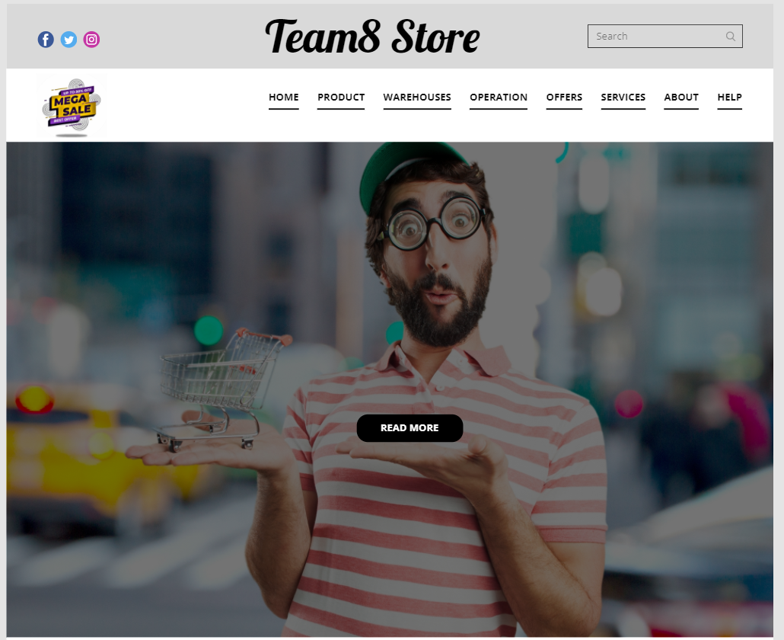

2.**Tablet**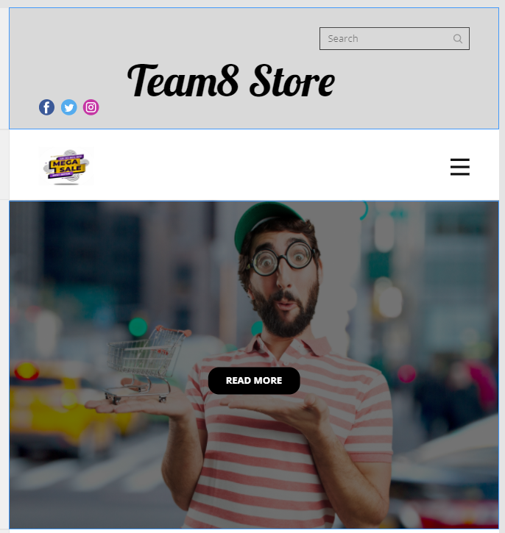

3.**Mobile**

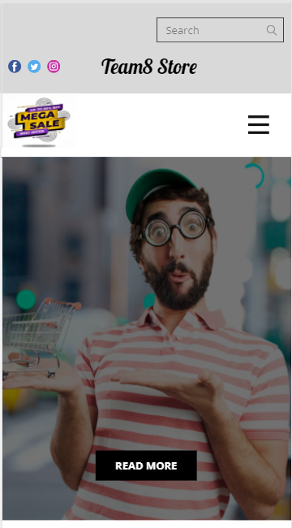

1. **Consider all User Interface Design Guidelines you studied and show how they addressed in your screens**

Reports:

* Design One electronic internal output reports of your choice.
* Design One electronic external output reports of your choice.
* **Warehouse report:**

* 4a) Internal Detailed Report

* 4B) External Detailed Report

