
Department of Computers and Informatics (PROGRAMMING)
My Django Project
Assignment - 1
Mohammed Niaz Khaleel Jameel


CONTENTS.

- Project Overview…………………………… 3
- Endpoints…………………………………… 4


Project Overview


This project is designed to provide a simple web application with a variety of features. These features include the handling of API endpoints and views to manage Http requests and display HTML templates. The functionalities encompass rendering a a homepage that displays the current date. It also allows the management of to-do-list data through endpoints and allows the user to download files.
Django URL configuration defines the routing for various HTTP requests in the application. It maps specific URL patterns to corresponding view functions, allowing users to access different features of the web application.

Endpoints.
- Views:

- home_page_view(request): This view renders a simple HTML page displaying the current date. It uses the datetime module to retrieve the current date and formats it as dd-mm-yy.
- to_do_list(request): This view handles POST requests to store to-do list data received in JSON format. It expects data including name, email, ID, title, and due date. If the data is valid, it prints the received name and email and returns a JSON response indicating success. It also handles GET requests and responds with a success message.
- download_data(request): This view handles requests to download a file named "documentation.pdf". If the file exists, it returns the file as an attachment. Otherwise, it returns a "File not found" error.
- res(request): This view renders the home.html template.
- welcome(request): This view renders the welcome page for authenticated users. It uses GET Method and requires user authentication @login_required.
- Task List View (task_list): URL: /task_list/
Description: Renders a list of all tasks.
Method: GET
Permissions: Requires user authentication (@login_required decorator).
Template: task_list.html
Context:
'tasks': Queryset containing all tasks.
- Add Task View (add_task):
URL: /add_task/
Description: Renders a form to add a new task and processes form submission.
Method: GET (to render form), POST (to process form submission)
Permissions: Requires user authentication (@login_required decorator).
Template: task_list.html
Context:
'form': Form for adding a new task.
- Edit Task View (edit_task):

URL: /edit_task/<task_id>/
Description: Renders a form to edit an existing task and processes form submission.
Method: GET (to render form), POST (to process form submission)
Permissions: Requires user authentication (@login_required decorator).
Template: task_list.html
Context:
'form': Form for editing the specified task.
- Delete Task View (delete_task):

URL: /delete_task/<task_id>/
Description: Deletes the specified task.
Method: GET (to render form), POST (to process form submission)
Permissions: Requires user authentication (@login_required decorator).
Redirects to: Task list page (task_list view).
Authentication Endpoint:
- Login Endpoint (login):
URL: /login/
Description: Authenticates users and generates a token for authentication.
Method: POST
Parameters:
'username': Username of the user.
'password': Password of the user.
Returns:
Redirects to: Task list page (task_list view) upon successful authentication.
- Error response (HTTP status 401) with message "Invalid credentials" for unsuccessful authentication.

2. Dependencies:
- Django: The web framework used for building the project.
3. HTML Templates
- home.html: This template is rendered by the res view. It contains the structure for the home page, including placeholders for dynamic content.
Usage:
1.Installation: Ensure Django is installed. If not, install it using pip install django.
- Run the Development Server: Navigate to the project directory and run python manage.py runserver.
3.Accessing Endpoints: The endpoints are accessible at the following URLs:
- Home Page: http://localhost:8000/
- To-Do List API: http://localhost:8000/todo/
- FileDownload: http://localhost:8000/download/
4.Interacting with the Application:
- Visit the home page to see the current date.
- Use the To-Do List API to store and retrieve to-do list items.
- Download the file using the provided endpoint.
- Configuration
- No additional configuration is required for this project beyond the standard Django settings.
- Maintenance
- Ensure that the file paths for templates and static files are correctly configured.
- Regularly review and update the code to maintain compatibility with newer versions of Django or dependencies.

The following code looks like this:

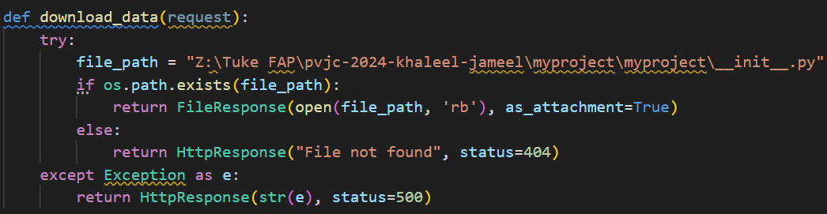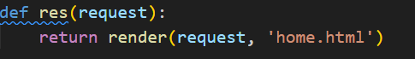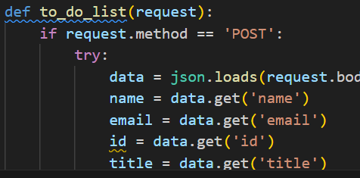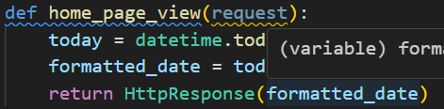

URLS PATTERNS OF DJANGO.

Components:
1. urlpatterns List:
- The urlpatterns list is a collection of URL patterns that map URLs to view functions within the Django application.
2.URL Patterns:
- This URL pattern corresponds to the root URL of the application. It directs users to the home_page_view view function, which renders the home page of the application. The name assigned to this URL pattern is 'home'.

'todo/': This URL pattern corresponds to the /todo/ endpoint of the application. It directs users to the to_do_list view function, which handles requests related to managing a to-do list. The name assigned to this URL pattern is 'todo'.

'download/': This URL pattern corresponds to the /download/ endpoint of the application. It directs users to the download_data view function, which handles requests to download a file. The name assigned to this URL pattern is 'download'.

'res/': This URL pattern corresponds to the /res/ endpoint of the application. It directs users to the res view function, which renders a specific template or performs an action associated with the /res/ endpoint. The name assigned to this URL pattern is 'res'.

Usage:
Accessing URLs: Users can access different features of the web application by navigating to the corresponding URLs defined in the url patterns list.

Home Page: http://example.com/
To-Do List: http://example.com/todo/
File Download: http://example.com/download/
Additional Endpoint: http://example.com/res/

Maintenance:

Ensure that the URL patterns are correctly defined and mapped to the appropriate view functions.
Regularly review and update the URL configuration to accommodate any changes or additions to the application's features.

