**Answer to the question no. 1**

The use case diagrams of the system are given below:

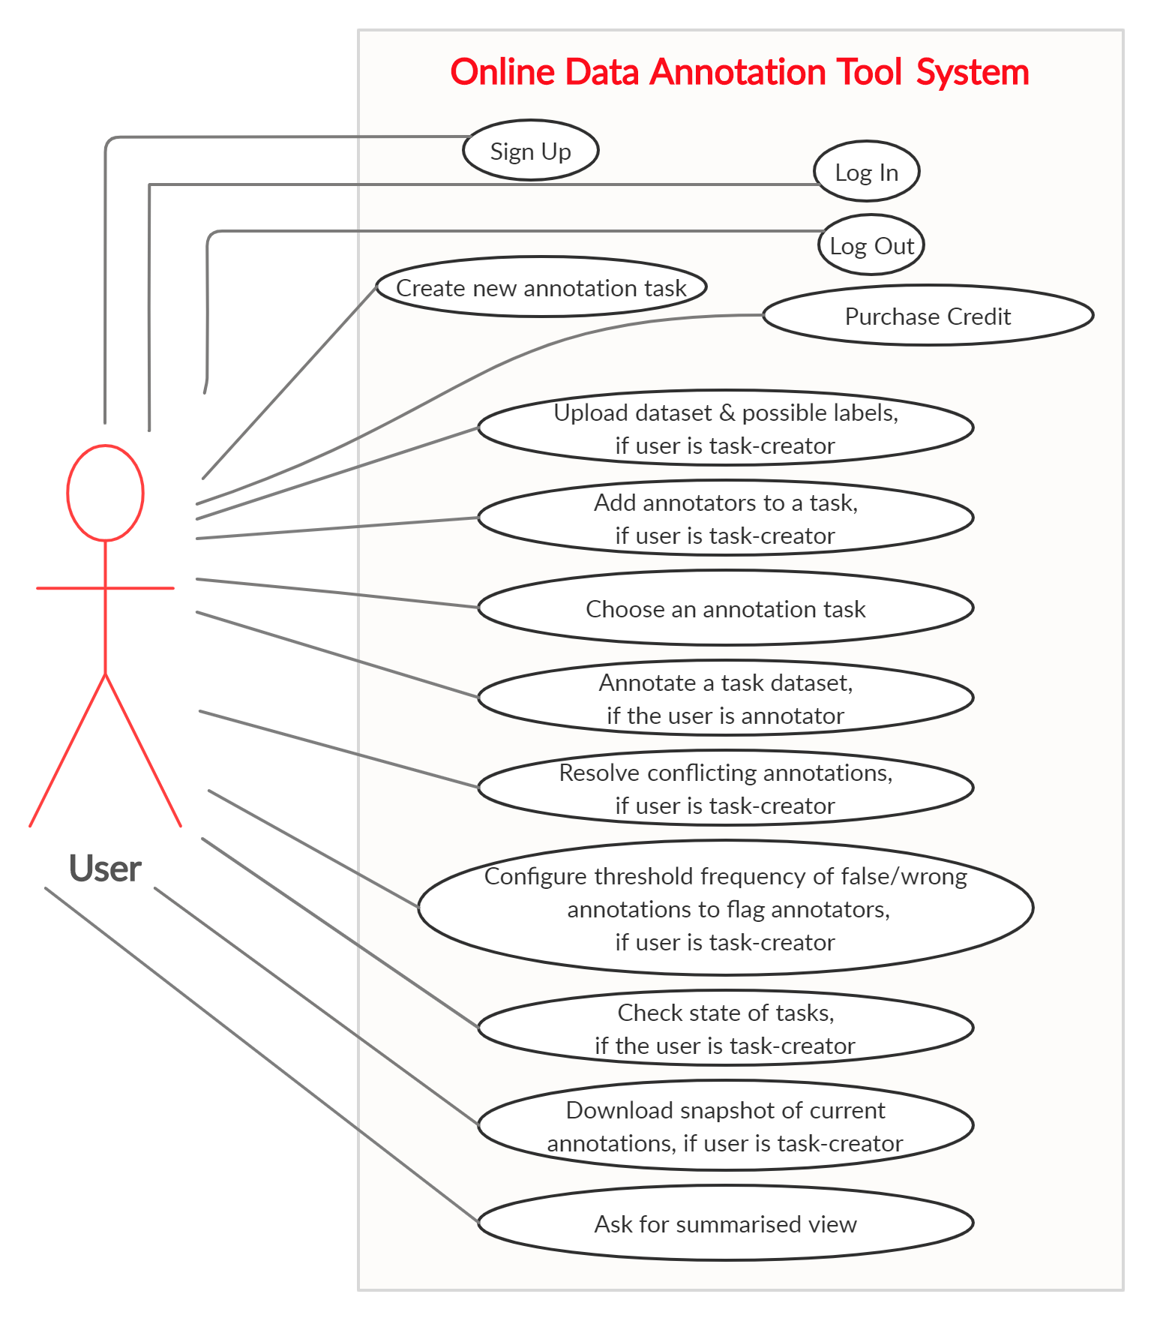

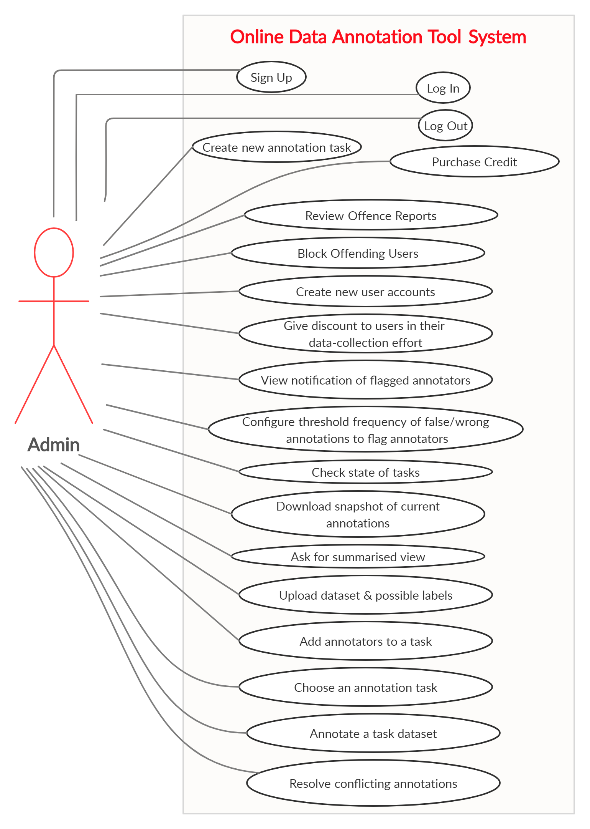

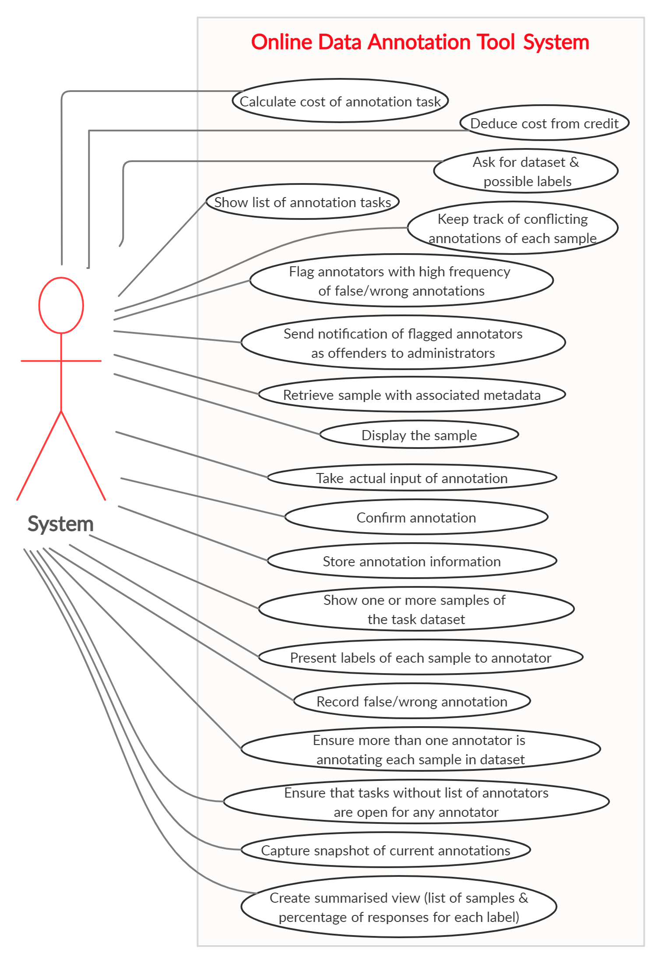

**Answer to the question no. 2**

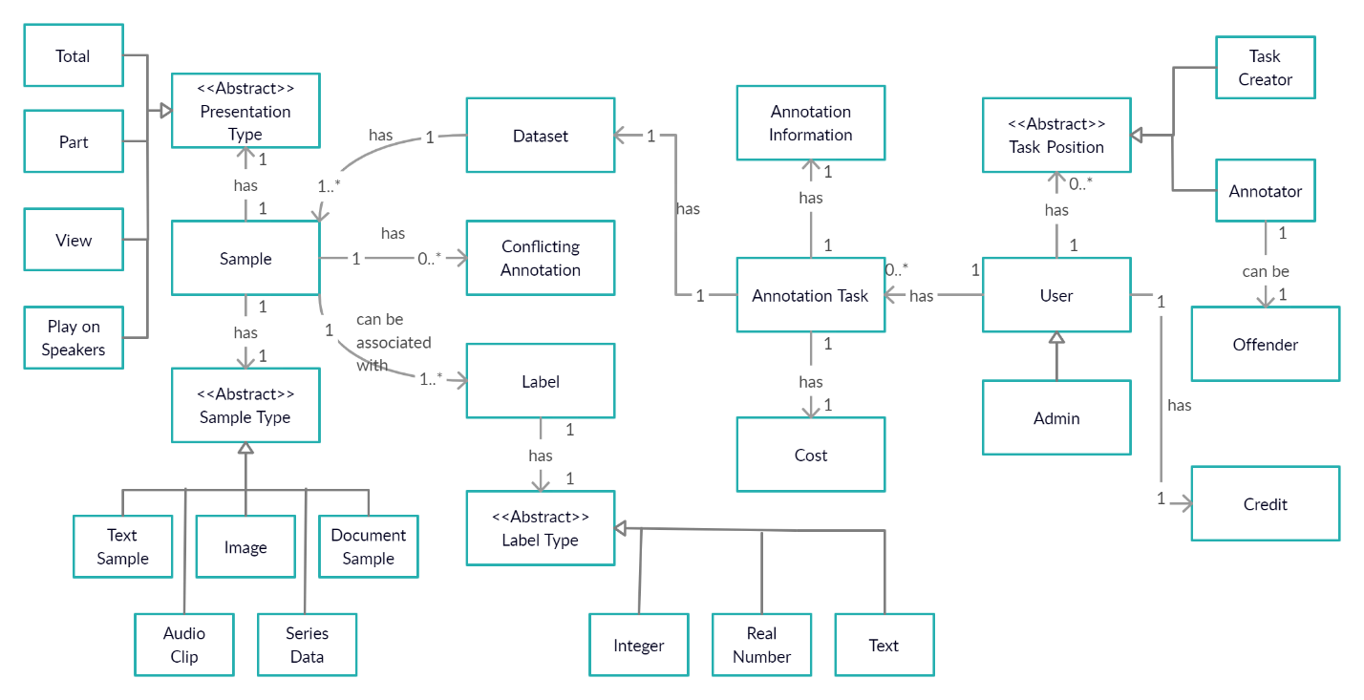**High-level Class Diagram of Model Classes of Online Data Annotation Tool System**

**Answer to the question no. 3**

**High-level UML Class Diagram depicting the design of solution to P4.**

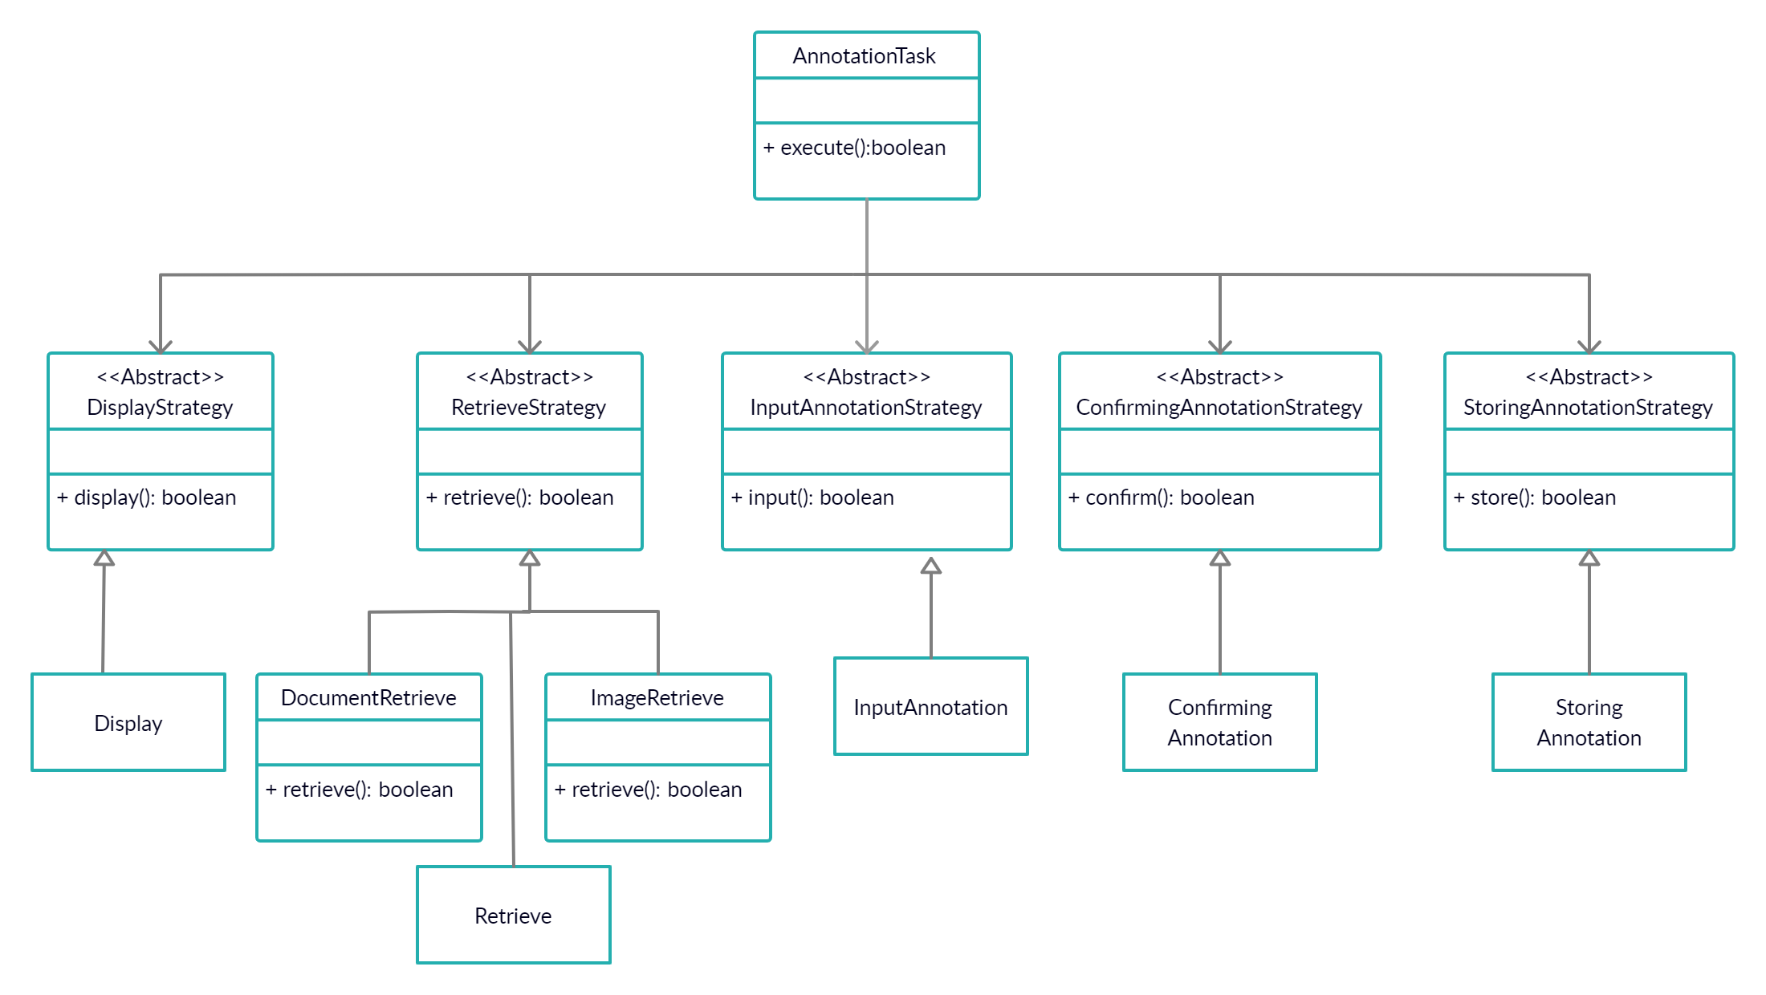**I have used Strategy Design Pattern**

**Answer to the question no. 4**

***Code for annotating an image sample:***

**public** **class** AnnotationTask {

RetrieveStrategy rs;

DisplayStrategy ds;

InputAnnotationStrategy ias;

ConfirmingAnnotationStrategy cas;

StoringAnnotationStrategy sas;

**public** AnnotationTask(RetrieveStrategy rs, DisplayStrategy ds,

InputAnnotationStrategy ias, ConfirmingAnnotationStrategy cas,

StoringAnnotationStrategy sas) {

**this**.rs = rs;

**this**.ds = ds;

**this**.ias = ias;

**this**.cas = cas;

**this**.sas = sas;

}

**public** **boolean** execute()

{

**if**(**this**.rs.retrieve())

{

**if**(**this**.ds.display())

{

**if**(**this**.ias.input())

{

**if**(**this**.cas.confirm())

{

**return** **this**.sas.store();

}

}

}

}

**return** **false**;

}

}

**public** **class** Main {

**public** **static** **void** main(String[] args) {

AnnotationTask at = **new** AnnotationTask(**new** ImageRetrieve(),

**new** Display(), **new** InputAnnotation(), **new** ConfirmingAnnotation(),

**new** StoringAnnotation());

at.execute();

}

}

THE -END