Fragments Service
Mohammed Sultan Shaikh - 178900239
BTI535 NBB – Assignment 1

1. Intro
The Fragments Microservice Project is a cloud-based web system that enables users to securely create, store, and manage small pieces of data called fragments. Each fragment can be plain text, with support for additional formats planned in future updates. Every user's data is private and accessible only after secure authentication.
The system consists of two main components: a backend API service and a frontend web application. The backend is developed using Node.js and Express, deployed as a microservice on an AWS EC2 instance. It implements secure development practices, including authentication and authorization through Amazon Cognito and comprehensive unit testing using Jest and Supertest. The API handles all core functionality such as creating, retrieving, listing, and deleting user fragments while enforcing access control and data isolation.

2. GitHub Repos
https://github.com/MohammedSShaikh/fragments
https://github.com/MohammedSShaikh/fragments-ui

3. GitHub Actions CI Workflow
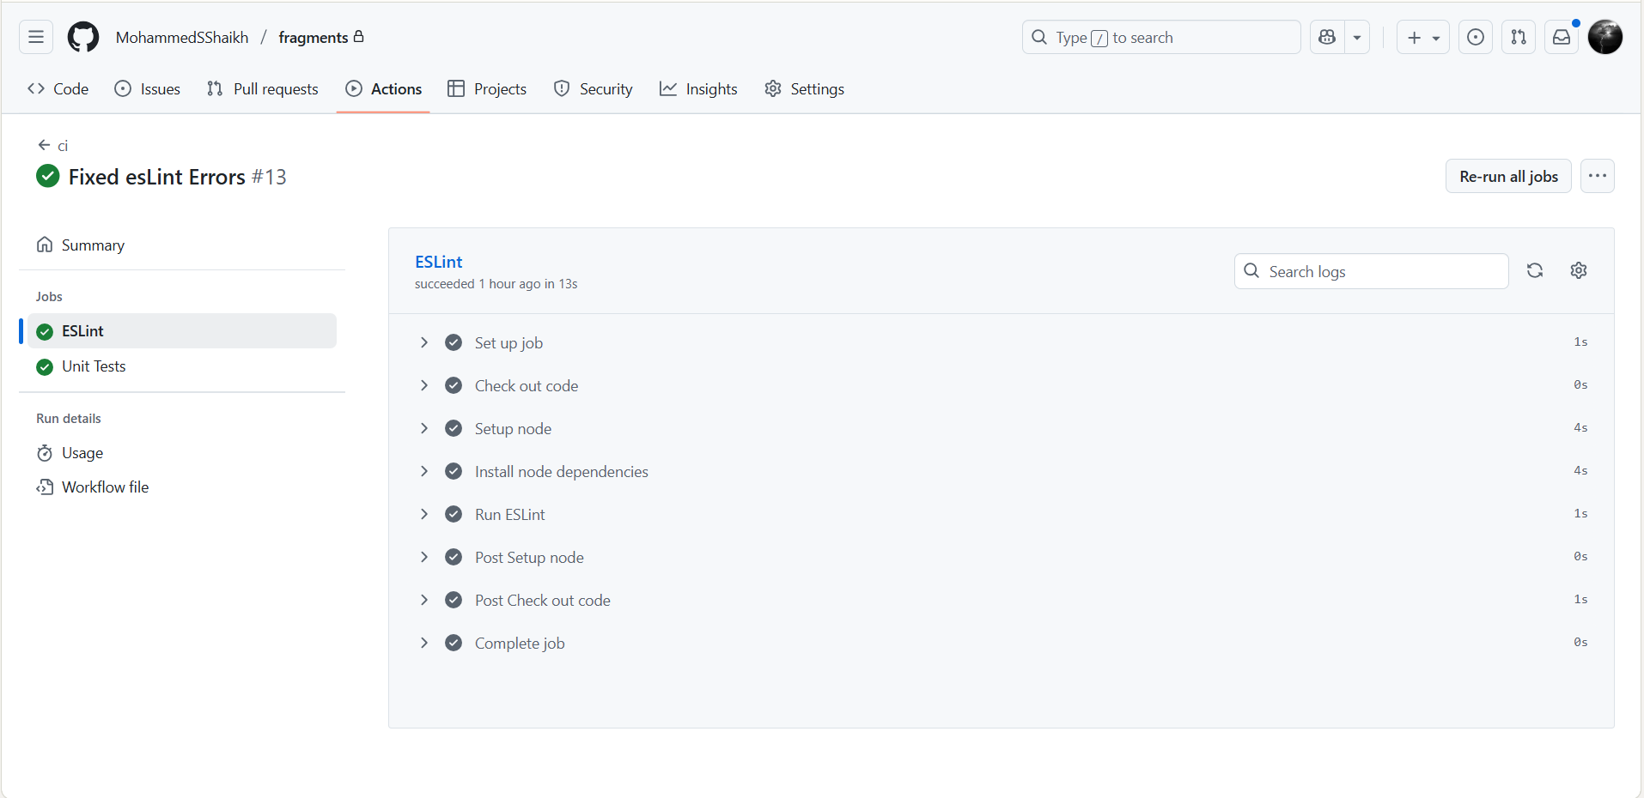
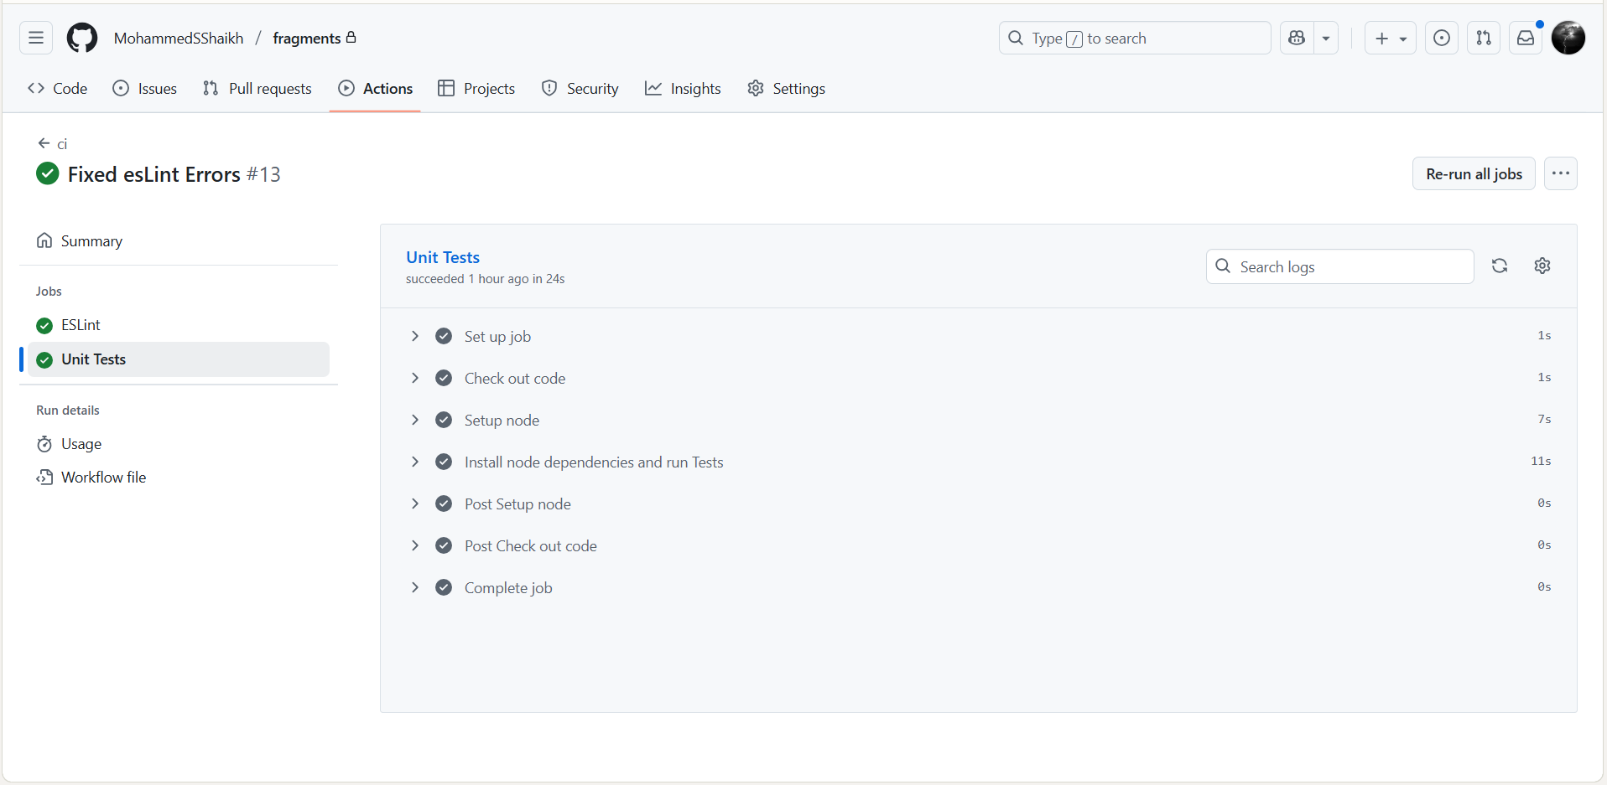
I have successfully implemented continuous integration (CI) using GitHub Actions for my repositories. My CI workflow automatically runs whenever I push code changes or create pull requests, ensuring code quality and functionality are maintained throughout development. The first screenshot shows my GitHub Actions dashboard with successful workflow runs. I can see that all my recent commits have triggered the CI pipeline, and they are all passing with green checkmarks. The second one shows my code passes all linting rules, ensuring consistent code style and catching potential errors.

4. API server running on an EC2 instance + Health Check JSON response
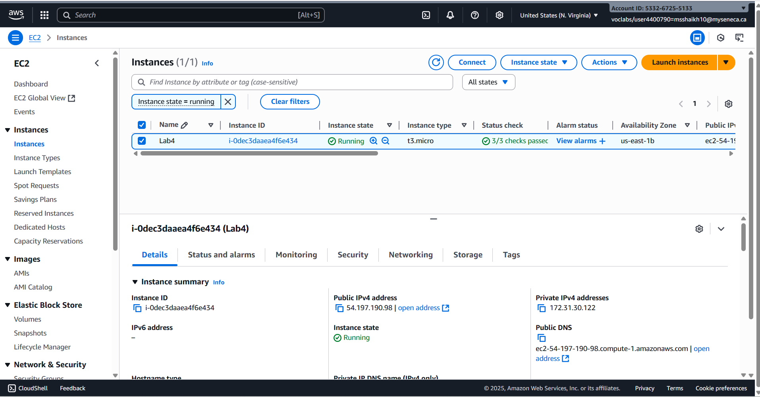
I have successfully deployed my fragments API server to an AWS EC2 instance. This cloud deployment demonstrates that my microservice can run reliably in a production-like environment. The screenshot shows my AWS EC2 instance running successfully which is in the "running" state.
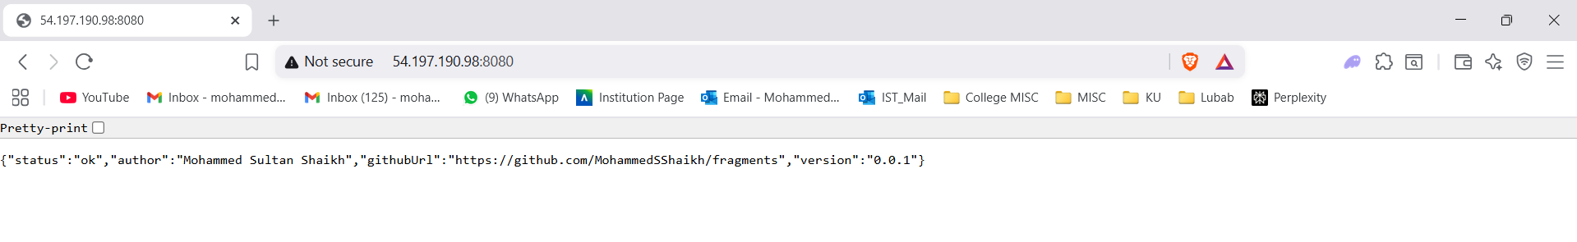
The visible AWS EC2 URL in the browser address bar proves that my fragments service is successfully hosted on Amazon Web Services and can be accessed publicly. My server returns a JSON response confirming that the service is running and accessible.

5. Fragments-UI Authentication
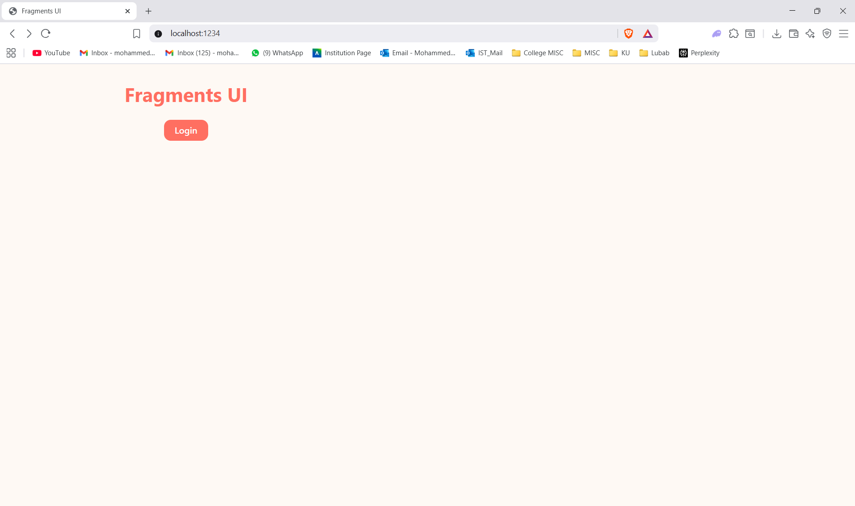
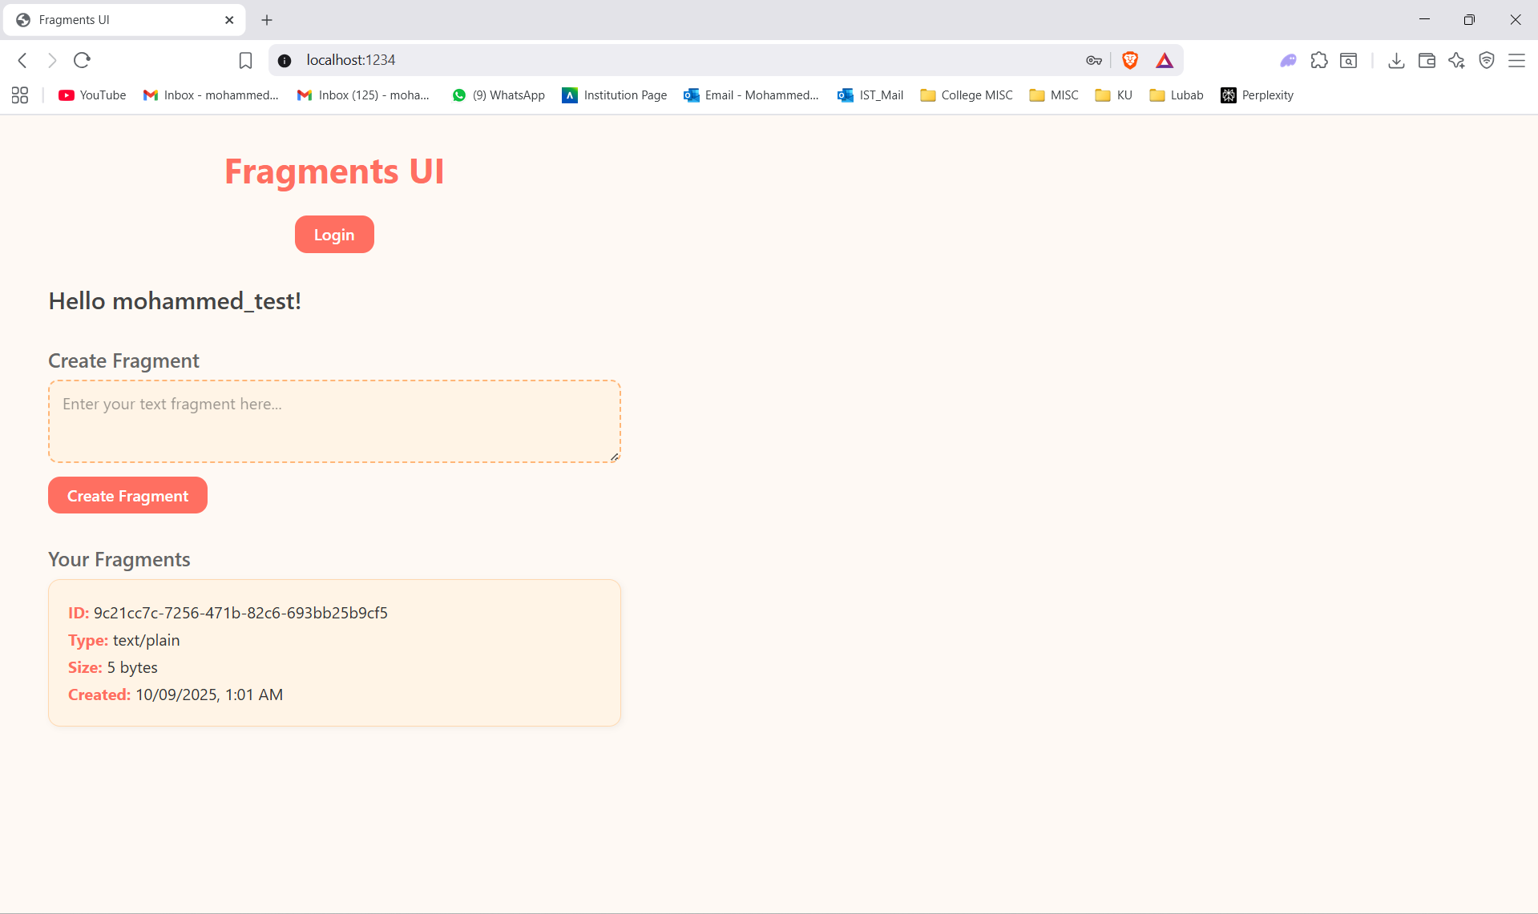
I have implemented user authentication in my fragments-ui application using Amazon Cognito's Hosted UI.

6. Fragment Creation Testing
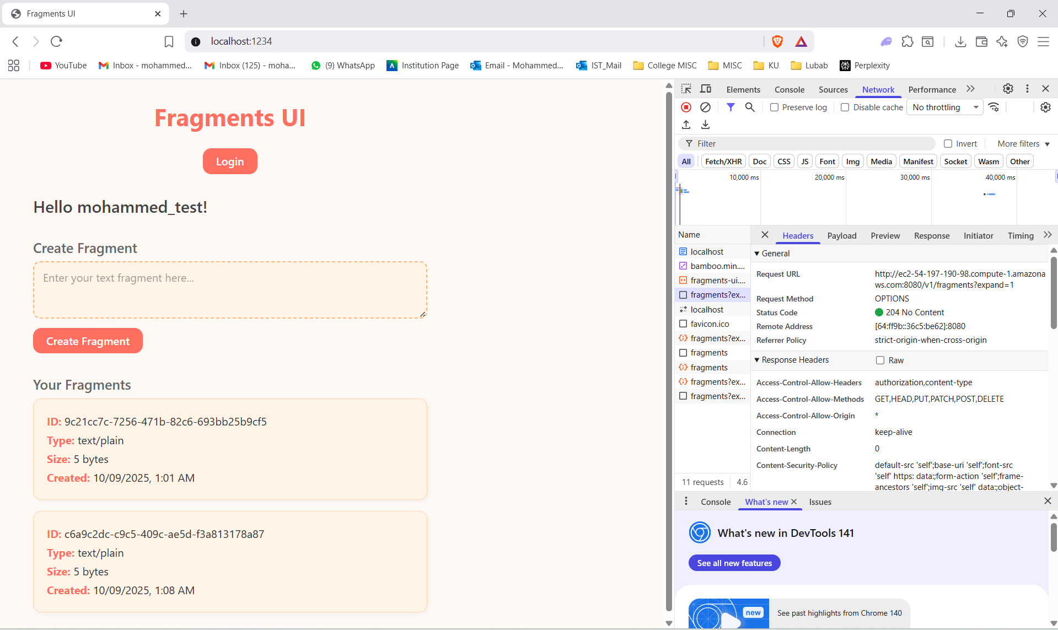
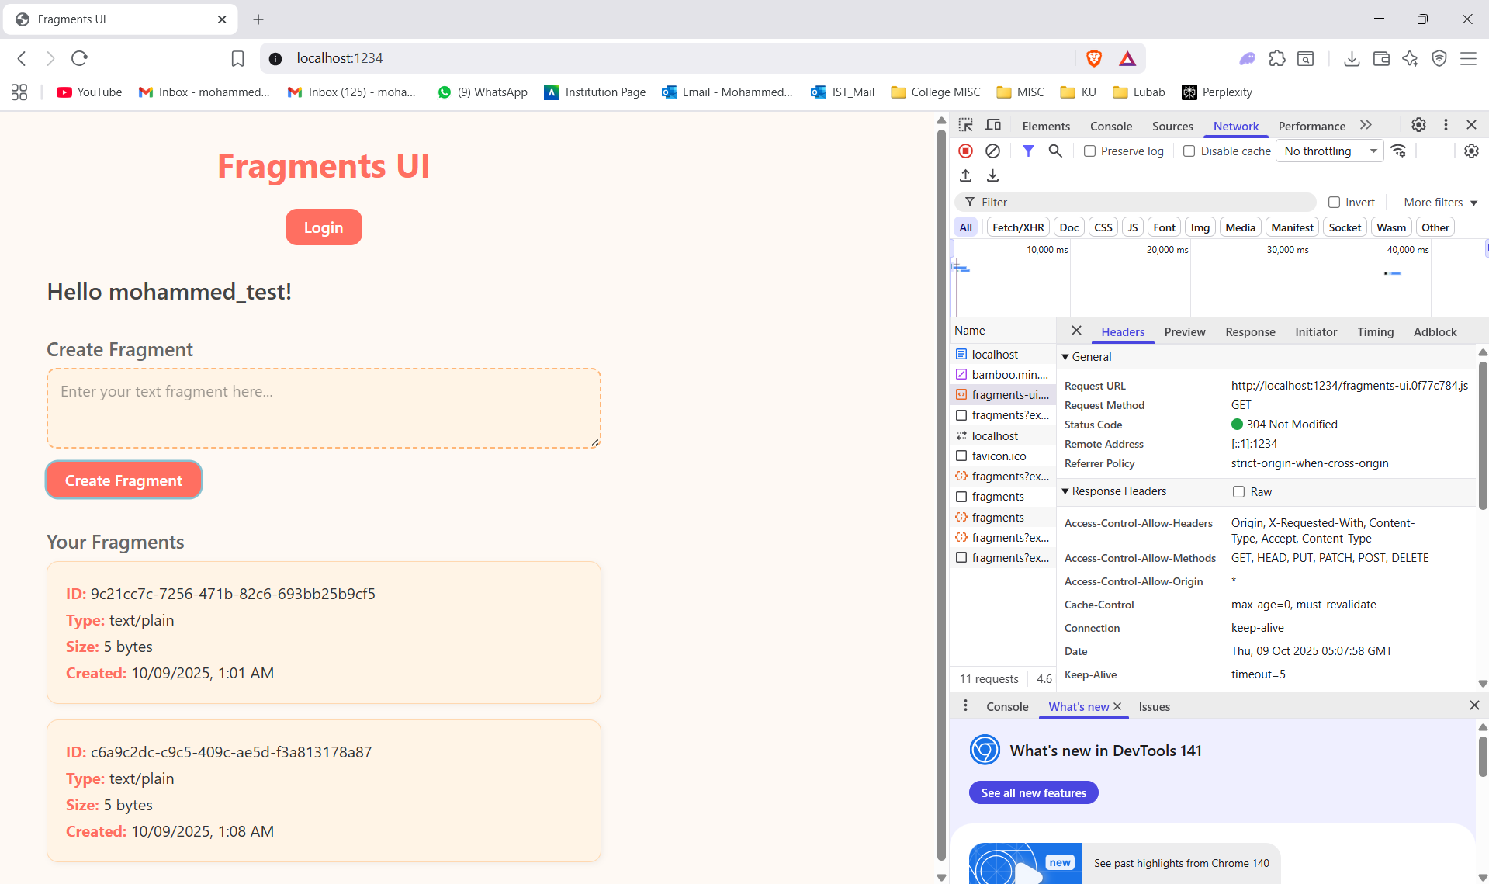
This screenshot shows the Developer Tools Network tab displaying the HTTP POST request to my EC2-hosted fragments API server. I can clearly see:
- Location Header: The response includes the Location header pointing to the newly created fragment's URL on my EC2 instance
- Request URL: The POST request is being sent to my AWS EC2 instance
- Authentication: The request includes proper authorization headers from my Cognito authentication

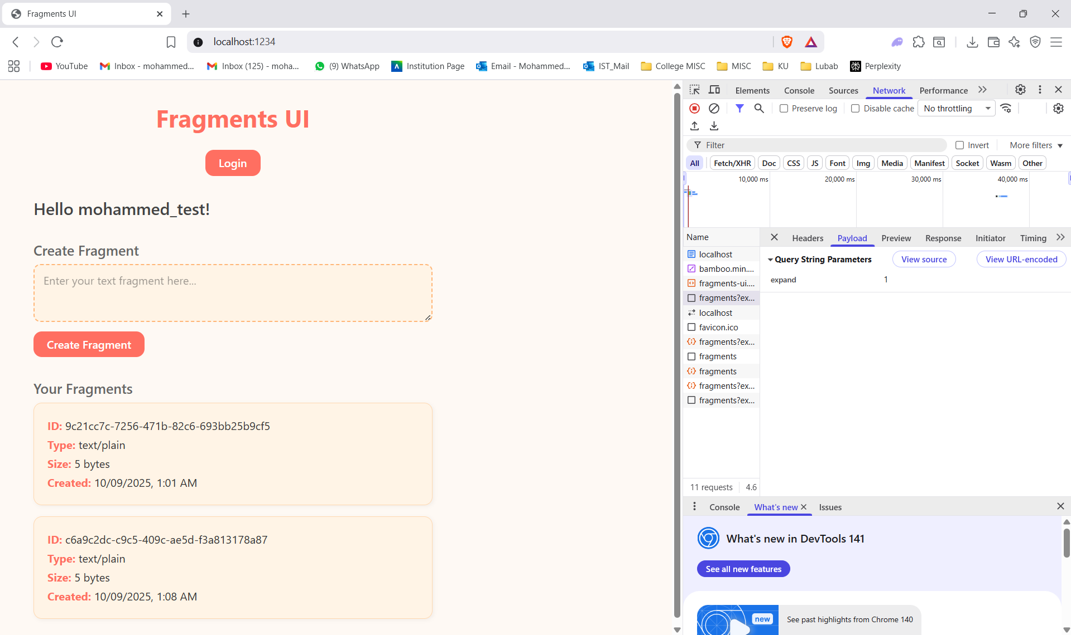
Showing the payload.
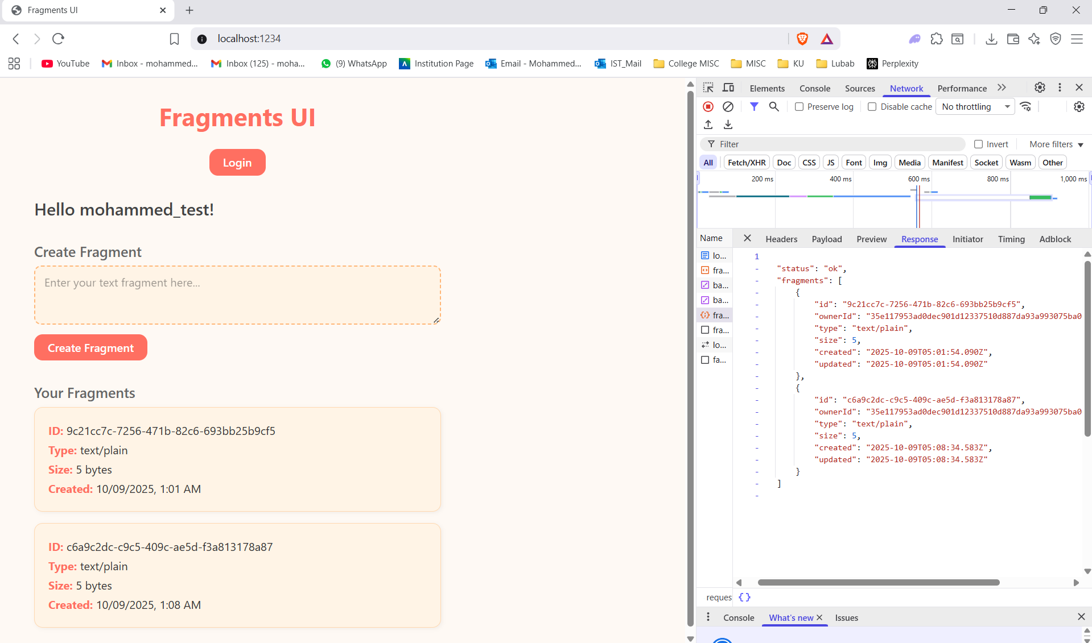
This screenshot displays the JSON response body containing the fragment's metadata.

7. Code Coverage
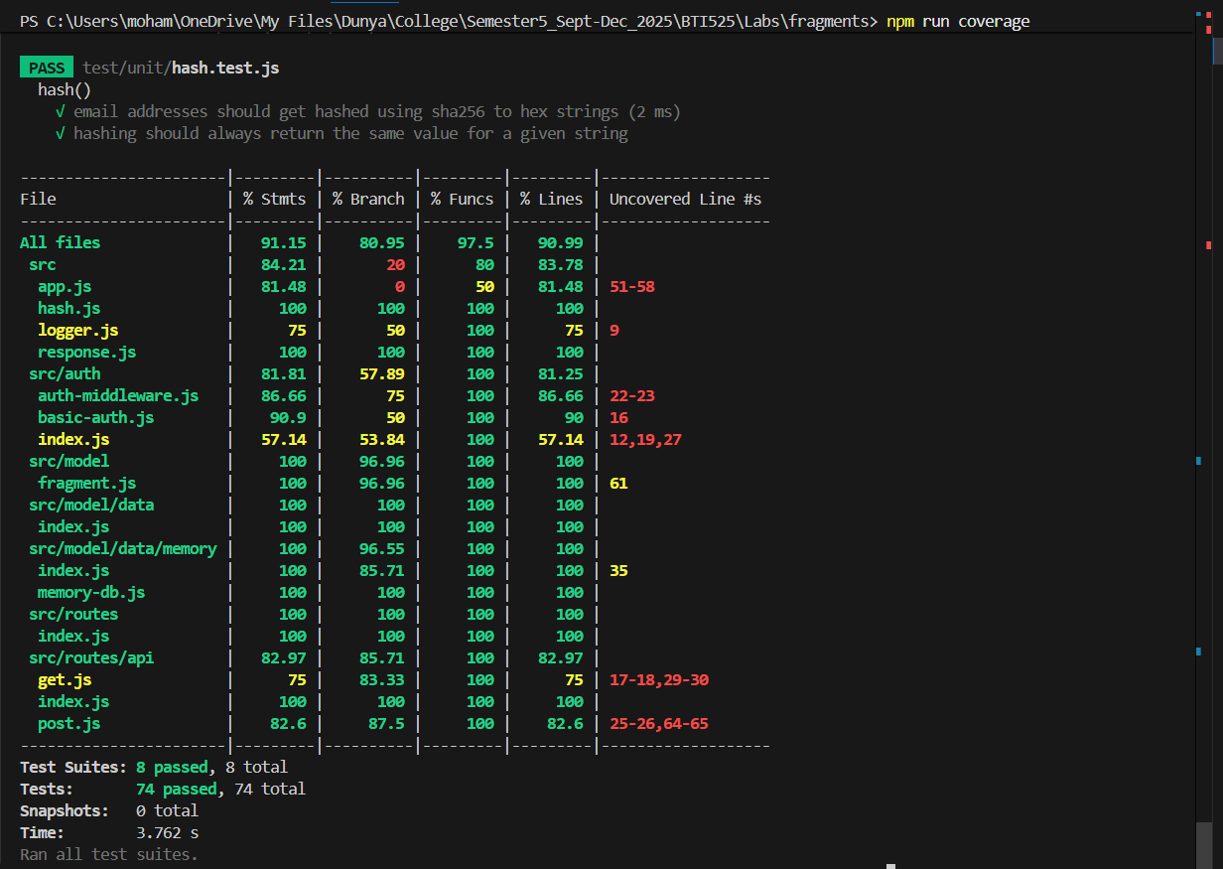
This screenshot shows the results of running npm run coverage in my fragments API project. The coverage report proves my tests cover over 85% of all code statements, ensuring that the majority of my code execution paths are validated.

8. Conclusion
Overall, this assignment was a huge milestone in successfully building and deploying the Fragments microservice and its companion UI. My system now runs smoothly on AWS EC2, integrates securely with Amazon Cognito, and communicates reliably between the backend API and frontend interface. I created strong unit testing and with over 85% coverage, I have proven that my service is stable and dependable.
There are still a few small areas I need to polish in future updates, such as improving how I handle edge cases in my fragment.js model, adding more detailed error handling, and tightening up the remaining test coverage gaps. Moving forward, I will focus on refining performance, enhancing the user experience, and preparing my system for even larger-scale deployments.

