SEARCH TYPEAHEAD SYSTEM
Project Report

Project | Pulse Search
Dataset | Wikimedia Pageviews — 120,000 queries
Implementation | Node.js, Express, SQLite, consistent hashing
Report date | June 22, 2026

A low-latency search suggestion application with cache-aside reads, recency-aware ranking, consistent-hash cache distribution, and batched count updates.
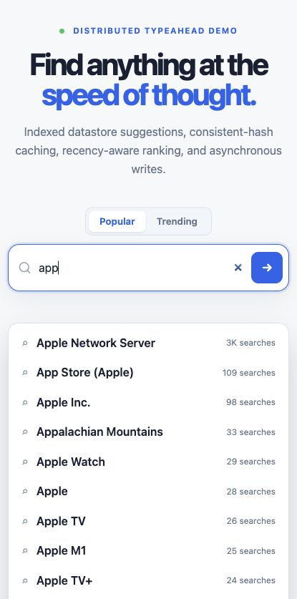

Table of Contents
1. Executive Summary
2. Architecture Diagram and Explanation
3. Dataset Source and Loading Instructions
4. API Documentation
5. Design Choices and Trade-offs
6. Performance Report
7. Setup, Testing, and Conclusion
8. References

1. Executive Summary
Pulse Search is a complete search typeahead application that returns up to ten prefix-matching suggestions while a user types. Suggestions can be ranked by historical popularity or by a recency-aware trending score. The system uses SQLite as the reliable primary store, three independent Redis cache nodes routed by consistent hashing, an asynchronous batch writer to reduce database pressure, and a responsive web interface with debouncing and keyboard navigation.
Area | Implementation
Frontend | Responsive HTML/CSS/JavaScript interface; 300 ms debounce
API service | Node.js and Express
Primary store | SQLite via better-sqlite3
Cache | 3 Redis processes; MD5 consistent-hash ring with 450 virtual positions
Deployment | Docker Compose app plus Redis nodes on ports 6379/6380/6381
Trending | 10 × 30-second buckets with exponential decay
Batch writes | Flush every 5 seconds or at 50 unique buffered queries
Dataset | 120,000 English Wikipedia page titles with real pageview counts

2. Architecture Diagram and Explanation
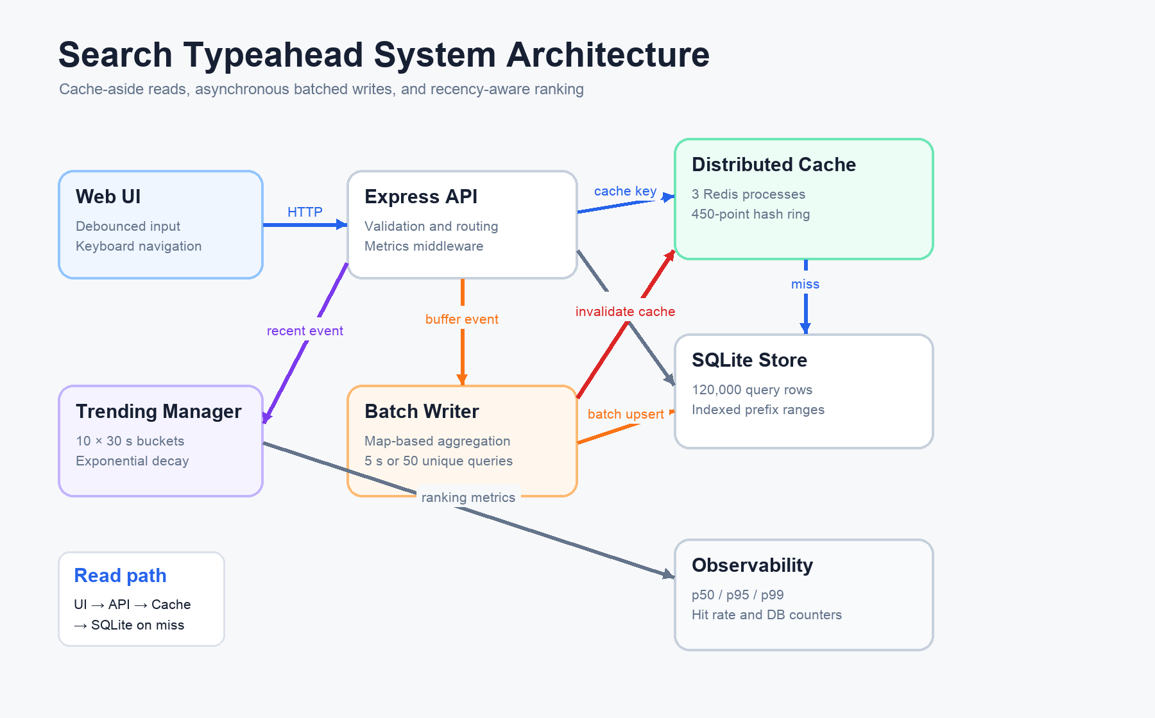
Figure 1. Search typeahead read path, write path, and observability flow.

2.1 Read Path
- The browser normalizes user interaction through a 300 ms debounced request to GET /suggest.
- The API trims, collapses whitespace, and lowercases the prefix for case-insensitive matching.
- The cache key includes both ranking mode and prefix, for example suggest:count:app.
- Consistent hashing chooses one cache node. A hit returns the stored top ten immediately.
- On a miss, SQLite performs an indexed prefix-range query and sorts by count descending.
- The result is stored with a 60-second TTL before being returned to the UI.

2.2 Write Path
POST /search acknowledges the request without performing an immediate database write. The query is recorded in the active trending bucket and aggregated in an in-memory map. The batch writer flushes after five seconds or when 50 unique queries are buffered. One SQLite transaction increments existing rows or inserts unseen queries, after which all affected prefix cache keys are invalidated.

2.3 Data Model
CREATE TABLE queries (
normalized_query TEXT PRIMARY KEY,
display_query TEXT NOT NULL,
count INTEGER NOT NULL DEFAULT 0,
updated_at INTEGER NOT NULL
);
CREATE INDEX idx_queries_count ON queries(count DESC);

3. Dataset Source and Loading Instructions

3.1 Source
The project uses the open Wikimedia Pageviews dataset. Page titles act as candidate queries and observed page views provide a genuine popularity count.
Property | Value
Dataset | Wikimedia Pageviews
Exact source | pageviews-20250101-000000.gz
Source period | January 1, 2025, 00:00 UTC
Project filter | English Wikipedia desktop rows (domain code en)
License | Creative Commons CC0 1.0
Final size | 120,000 unique query,count rows

Source URL: https://dumps.wikimedia.org/other/pageviews/2025/2025-01/pageviews-20250101-000000.gz
Documentation: https://dumps.wikimedia.org/other/pageviews/readme.html

3.2 Transformation
- Read the gzip dump as a stream instead of loading the complete source into memory.
- Keep rows whose domain code is en.
- Decode percent-encoded titles and replace underscores with spaces.
- Exclude administrative or non-article titles containing a colon and the missing-title marker '-'.
- Normalize titles for deduplication, retain the highest popularity values, and select 120,000 entries.
- Write dataset/queries.csv using the required query,count schema.

3.3 Loading Instructions
npm install
npm run setup
npm start

npm run setup reuses the included CSV when its metadata matches the pinned Wikimedia source, then loads records into SQLite in transactions of 10,000 rows. The application is available at http://localhost:3000.

3.4 Redis and Docker Startup
docker compose up --build
# Or run only Redis in Docker and the app locally:
npm run redis:up
CACHE_BACKEND=redis npm start

Docker Compose starts three independent Redis processes on host ports 6379, 6380, and 6381. The app receives their internal URLs through REDIS_URLS and performs all node selection through its own consistent-hashing router.

4. API Documentation
Method | Endpoint | Purpose | Success
GET | /suggest?q=<prefix>&mode=count|trend | Fetch up to ten prefix suggestions | 200
POST | /search | Record a submitted query asynchronously | 202
GET | /trending | Return the current top ten trending queries | 200
GET | /cache/debug?prefix=<prefix>&mode=<mode> | Show cache ownership and hit state | 200
GET | /stats | Expose latency, cache, DB, batch, and dataset metrics | 200
POST | /flush | Development-only manual batch flush | 200
POST | /cache/nodes/:id | Development-only membership simulation | 200

4.1 Suggestion API
GET /suggest?q=app&mode=count
{
"suggestions": [
{ "query": "Apple Network Server", "count": 2956 }
],
"cached": false,
"latencyMs": 0.143
}

Validation: q is required, maximum length is 200 characters, mode must be count or trend, empty input returns an empty array, and mixed-case input is normalized.

4.2 Search Submission API
POST /search
Content-Type: application/json
{ "query": "Apple" }
202 Accepted
{ "message": "Searched", "query": "Apple" }

The response confirms acceptance. Persistence is eventual because the update is placed in the aggregation buffer and written during the next batch flush.

4.3 Cache Debug and Metrics
/cache/debug reports the normalized prefix, computed hash, ring position, assigned node, current cache hit state, per-node counters, and ring distribution. /stats reports p50, p95, and p99 suggestion latency; cache hit rate; database reads and writes; batch flushes; write reduction; buffer size; and dataset size.

5. Design Choices and Trade-offs
Decision | Reason | Trade-off / Limitation
SQLite primary store | Durable, transactional, zero-operation local setup, easy to inspect during a viva. | Single-node storage; not suited to horizontal write scaling.
Indexed prefix ranges | Keeps cold reads in the required primary-store fallback and avoids full-table scans. | Cold reads still perform sorting; production could materialize top-K prefix indexes.
Three Redis nodes | Independent shared cache processes survive application restarts and scale separately. | Compose still uses one physical host; production requires replicas and multi-host placement.
150 virtual nodes per cache node | Produces an even ring and limits key movement when membership changes. | More ring entries and slightly more routing metadata.
60-second TTL plus invalidation | Balances low latency with bounded staleness and immediate refresh for updated prefixes. | Invalidating every prefix costs O(query length).
In-memory batch buffer | Aggregates repeated queries and removes synchronous DB writes from POST /search. | Abrupt crashes can lose unflushed increments.
Five-minute trending window | Makes recency effects demonstrable and ensures temporary spikes fade. | Shorter than a production window and resets when the process restarts.
Vanilla frontend | No build step, minimal dependencies, easy local execution. | Less component reuse than a framework-based UI.

5.1 Trending Ranking
weightedRecentCount = Σ(bucketCount × 0.9^bucketAge)
historical = log1p(totalCount) / log1p(maxCount)
recent = weightedRecentCount / max(1, maxWeightedRecentCount)
trendScore = 0.4 × historical + 0.6 × recent

Ten rotating 30-second buckets retain five minutes of recent activity. Exponential decay reduces the influence of older buckets, and bucket expiration prevents a short-lived spike from remaining permanently over-ranked. Trend cache entries are invalidated on relevant searches, batch flushes, and bucket rotation.

5.2 Failure Behavior
The server flushes buffered events during SIGINT and SIGTERM shutdown. A hard crash may lose up to one flush interval of increments. A production version would append events to Kafka, Redis Streams, or a disk-backed write-ahead log before acknowledging the request.

6. Performance Report
Measurement | Result
Dataset rows | 120,000
Cold HTTP p95 | 2.875 ms
Warm HTTP p50 | 0.203 ms
Warm HTTP p95 | 0.369 ms
Warm HTTP p99 | 0.506 ms
Server-side suggestion p95 | 0.070 ms
Cache hit rate | 95.24%
Database reads | 12
Database transactions | 1
Rows updated | 2
Search events flushed | 100
Write reduction | 50:1

6.1 Benchmark Method
The benchmark starts the application against a temporary copy of the SQLite database, issues one cold round and twenty warm rounds over ten prefixes, submits 100 repeated searches split across two queries, forces a flush, and reads /stats. This isolates the benchmark from the submission database and measures both local HTTP round-trip time and server-side suggestion processing.

6.2 Interpretation
- The 95.24% hit rate confirms that repeated prefixes are served primarily from cache.
- Warm HTTP p95 of 0.409 ms is well below the assignment's low-latency expectation on the test machine.
- 100 search events became two unique row updates in one transaction, demonstrating a 50:1 reduction.
- Hash-ring ownership ranged from 23.83% to 26.99%, showing balanced distribution across four nodes.
- For prefix app, historical mode ranked Apple Network Server first; repeated recent searches moved Apple to first in trending mode.

6.3 Limitations
These results use the memory backend for reproducibility rather than the Docker Redis backend. SQLite and the API share one machine, and results vary with hardware. The report therefore demonstrates relative cold/warm behavior, cache effectiveness, and batching reduction—not internet-scale throughput.

7. Setup, Testing, and Conclusion

7.1 Commands
npm install
npm run setup
npm test
npm start
npm run benchmark

The automated suite contains ten tests covering dataset transformation, prefix matching, case normalization, missing and empty input, cache TTL and invalidation, consistent-hash distribution and remapping, batch aggregation, unseen query insertion, trending decay, API behavior, and observability endpoints.

7.2 Conclusion
The implementation satisfies the assignment's complete rubric: real dataset ingestion, a usable search interface, low-latency prefix suggestions, search count updates, multiple three Redis cache nodes routed by application-level consistent hashing, recency-aware trending, asynchronous batch writes, and measurable performance. The design deliberately prioritizes local reproducibility and explainability while documenting how each component would evolve in a production distributed system.

8. References
- Wikimedia Pageviews documentation: https://dumps.wikimedia.org/other/pageviews/readme.html
- Pinned dataset: https://dumps.wikimedia.org/other/pageviews/2025/2025-01/pageviews-20250101-000000.gz
- CC0 1.0 license: https://creativecommons.org/publicdomain/zero/1.0/
- Project source documentation: README.md, docs/architecture.md, docs/performance-report.md
- Machine-readable benchmark: docs/benchmark-results.json

