
Blue Sand
Design Documentation

Version 2.1
August 2024
Table of Contents

Design Overview 4
Counter Unit 5
Enabling and disabling the counter block 5
Changing the Number of cycles for the counter block 6
Counter block modes 6
Change the count direction. 8
Loading main load value 8
Counter programming flow 8
Pulse Width Modulation Block 10
Pulse Width Modulation (PWM) 10
Sinusoidal Pulse Width Modulation (SPWM) 11
Configuring the Modulation block 13
Adjusting the frequency of the PWM signal 14
Adjusting the duty cycle of the PWM signal 14
Adjusting the frequency of the SPWM signal 14
Configuring the Fixed Range 15
Configuring the Phase shift 16
Multi level arbitration Block 17
Weighted Round Robin block 18
Regions 18
Choosing a source 19
Random block 19
Weighted Random block 20
Clock Muxing Unit 20
Clock muxing configuration 21
Fatal error 21
Signals description 22
APB Interface 22
Counter Block Interface 22
Pulse Width Modulation block signals 22
Multi level arbitration block 22
Weighted round robin block 23
Rand arbitration block 24
Weighted random block 24

List of Figures
Figure 1 : block diagram of the Blue-Sand designFunctional description 4
Figure 2 : the basic flow of the Counter 9
Figure 3 : The modulation block 10
Figure 4 : block diagram of the Blue-Sand design 17
Figure 5 : block diagram of the weighted round robin design 18
Figure 6 : Weights distribution 18
Figure 7 : block diagram of the random design 19
Figure 8 : block diagram of the weighted random design 20
Figure 9 block diagram of clock muxing unit 20

List of Tables
Table 1 : the single wrap point change direction actions 6
Table 3 Weights values 19
Table 4 Clock muxing config 21
Table 5 : counter output signals details 22
Table 6 : Modulation output signals details 22
Table 8 Multi level arbitration block signals 23
Table 9 Weighted round robin block 23
Table 10 Rand arbitration block 24
Table 11 Weighted random block 25

Design Overview
B
lue sand is an APB-controlled design. This design uses the Advanced peripheral bus (APB) protocol for accessing the internal programmable register control unit. Blue Sand includes several programmable units: The counter unit generates a count output that can operate in various modes, the pulse-modulation unit generates pulse-width modulation (PWM) and sinusoidal PWM (SPWM) signals with various features, Multi level arbitration unit consisting of three arbitration levels, Clk Muxing unit controls the operating frequency of the other blocks. All the units are controlled by an internal register control unit. Figure 1 shows the block diagram and the input/output signals of the full design.
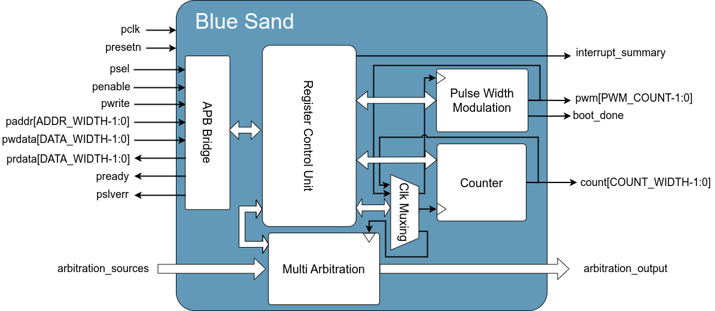
Figure 1: block diagram of the Blue-Sand design
Functional description
The design consists of 6 blocks as described below:
- The APB bridge, reads read and write requests from APB master and transform it to a simple inner protocol and passes it to the register control unit that gives the appropriate response which is transformed back to the APB protocol by the APB bridge.
- The register control block, includes the internal registers that control and monitor the design behavior.
- The counter block, generates the count of width of COUNT_WIDTH which is configured to be 8.
- The pulse width modulation block, generates a PWM or a SPWM signal on PWM_COUNT ports.
- The multi arbitration block, takes requests from 16 sources and arbitrate the requests then outputs it.
- The clk muxing block, generates an operating clock for the pwm block, counter block, and multi arbitration block according to the value of counter output, pwm output, and the configuration in the register control.

Counter Unit
The counter unit is an N-bit counter that is controlled by the register control unit. The counter can count up or down at the rising edge of the clock according to the specified count mode. The counter width can be configured using COUNT_WIDTH parameter (Default value = 8).

Enabling and disabling the counter block
      - Enabling the counter:
- The counter block is enabled by writing 1 on bit [0] of the counter_en_config_reg register.
- When the counter is enabled, it counts up or down according to the configured direction and mode.
      - Disabling the counter
- The counter is disabled by writing 0 on bit [0] of the counter_en_config_reg register.
- When the counter is disabled, it will stop on the last value that was reached.

Changing the Number of cycles for the counter block
The counter_number_of_cycles_config_reg register controls the needed rising edges of the clock to get to the next count value. The register value is mapped to [1:$2^{COUNT_WIDTH}$]. The register value can be only changed if the counter is disabled.

Counter block modes
The mode bits [1:0] of the counter_mode_control_config_reg register controls the mode of the counter block. There are four modes for the counter block:

  - Free running, bits [1:0] = 2’b00
  - Single wrap point, bits [1:0] = 2’b01
  - Double wrap, bits [1:0] = 2’b10
  - Special single wrap point, bits [1:0] = 2’b11
- Free running mode
- The count will wrap to ‘0’ if it reached the maximum value (2^{DATA_WIDTH -1}).
- The count will wrap to the maximum value (2^{DATA_WIDTH -1}) if reached ‘0’.
- Region: 0 - 2^{DATA_WIDTH-1}.
- Single wrap point mode
- The count will wrap to the main load value if reached the maximum value ‘2^{DATA_WIDTH -1}’.
- The count will wrap to the main load value if reached ‘0’.
- The count will wrap to ‘0’ if reached the main load value when counting up.
- The count will wrap to the maximum value ‘2^{DATA_WIDTH -1}’ if reached the main load value when counting down.
- Regions:
    - (0-Main load)
    - (Main load- 2^{DATA_WIDTH-1})
- Changing the counting region:
A switch between the 2 regions happens when the counter mode (up/down direction) is changed so that the counting direction points to a new region while you are at the wrap point (Main load). The following table clarify the switching operation:
Table 1: the single wrap point change direction actions
Current Region | Count Mode | Action to switch to the other region
0 – Main Load | Up | Cannot be switched directly
 | Down | Changing the mode to ‘Up’ at the (Main load) value
Main load – 2^{DATA_WIDTH-1} | Up | Changing the mode to ‘Down’ at the (Main load) value
 | Down | Cannot be switched directly
- Double wrap point mode
- The count will wrap to the main load value if it reaches the secondary load value.
- The count will wrap to the secondary load value if it reaches the main load value.
- Regions:
    - Inner Region: between Secondary Load and Main Load values.
    - Outer Region: Outside the inner region

Secondary
Load
Main Load
Region 1
Region 2
- A switch between the 2 regions happens when:
            - The counter mode (up/down direction) is changed so that the counting direction points to a new region while you are at the wrap points (Main and Secondary points).
            - If the Secondary Load value is changed so that the current count value is out of the assumed region.
- special single wrap point mode
- The counter will wrap to the main load value if it reached the maximum value ‘2^{DATA_WIDTH -1}’.
- The counter will wrap to the main load value if reached ‘0’.
- Region: 0 - 2^{DATA_WIDTH-1}

Change the count direction.
The counter direction can be controlled by writing on counter_direction (bit [2]) of the counter_mode_control_config_reg register.
- Counting UP: by writing 1 to bit [2] of the counter_mode_control_config_reg register.
- Counting DOWN: by writing 0 to bit [2] of the counter_mode_control_config_reg register.

Loading main load value
The counter value changes by writing the new value on the counter_main_load_config_reg register.

Counter programming flow
The procedure illustrated in Fig.2 is the initial programming flow of the Counter block.
- Disable the counter.
- Load the (Number of cycles).
- Program the counter modes.
- Load the main value.
- If the counter mode is set to (double wrap point), load the second wrap point value by writing on the counter_secondary_load_config_reg register.
- Enable the counter.
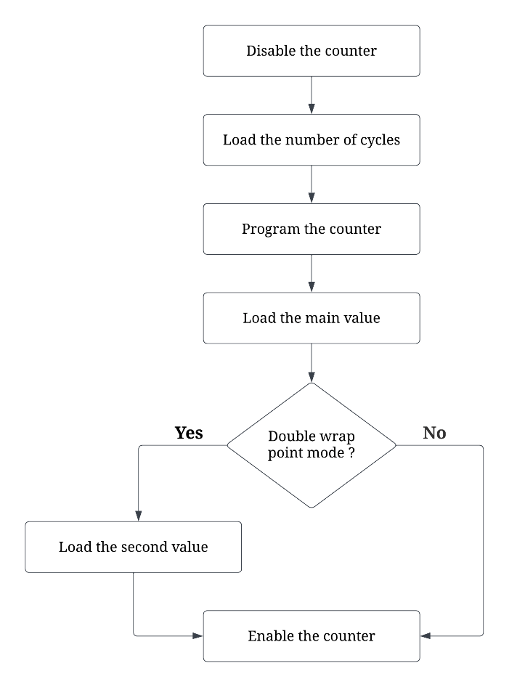
Figure 2: the basic flow of the Counter

Pulse Width Modulation Block
Pulse width modulation block produces pulse width modulation (PWM) and sinusoidal pulse width modulation (SPWM) signals. A signal is said to be pulse width modulated if the size of the pulses in its output can be adjusted.
The block contains PWM_COUNT generation units each can generate independent pulse width modulation (PWM and SPWM) signals. The following figure shows a general view of the pulse width modulation block.
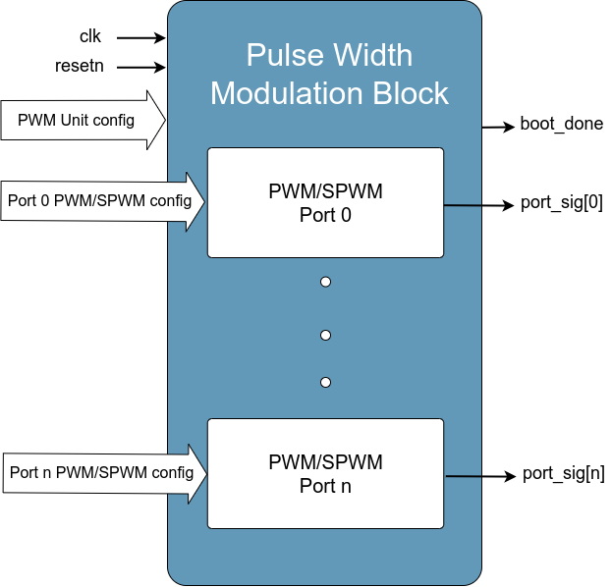
Figure 3: The modulation block

Pulse Width Modulation (PWM)
Pulse Width Modulation (PWM) is a DC voltage controlling method that depends on controlling the average value of a train of pulses signal. The two main characteristics of PWM signal are the frequency and the duty cycle. The frequency determines the period of the pulse, while the duty cycle can be defined as the percentage of the ON period from the whole period. It controls the average power of the output signal, the higher it is the higher the average power is.
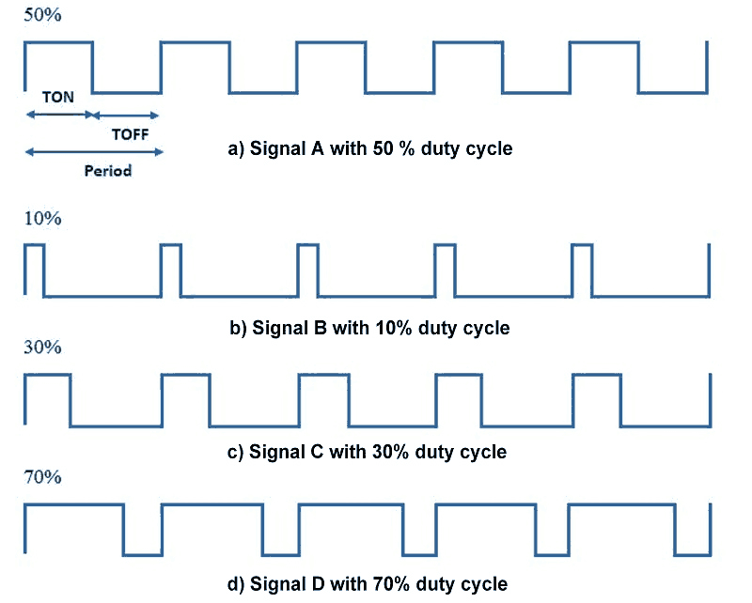
PWM signal is generated according to the PWM port frequency and its duty cycle. they are used for calculating the ON and OFF time periods of the PWM signal. The frequency of the PWM signal depends on the clock frequency, frequency resolution, and the prescaler using the following equation:
$$PWM_{freq}=\left(\frac{1}{Freq_{resolution}∙2^{prescaler}}\right)Clock_{freq}$$
Calculating the ON and OFF times of the PWM period is done as follows:
ON time:
$$T_{on}=\left\lfloor \frac{Duty_Cycle.{PWM}_{period}}{256}\right\rfloor$$
OFF time:
$$T_{off}=\left({PWM}_{period}−T_{on}\right)$$

Sinusoidal Pulse Width Modulation (SPWM)
Sinusoidal Pulse Width Modulation (SPWM) is another pulse modulation technique. In this modulation, pulses are produced by comparing a reference signal with a carrier signal thus the SPWM signal are ON if and only if the carrier signal is strictly less than the generated sinusoidal. The general behavior of the pulses in the SPWM is that the pulses close to the ends of the half cycle are narrower than the pulses close to the center of the half cycle such that the pulse widths are comparative to the amplitude of a sine wave at that part of the cycle. To change the efficient output voltage, the widths of all pulses are amplified or reduced while keeping the sinusoidal proportionality. The main parameters of SPWM signal are the frequency of the reference (Sinusoidal) and the carrier (triangle) waves. The carrier wave frequency has to be higher than that for the reference wave in order to generate a sinusoidal modulation process.
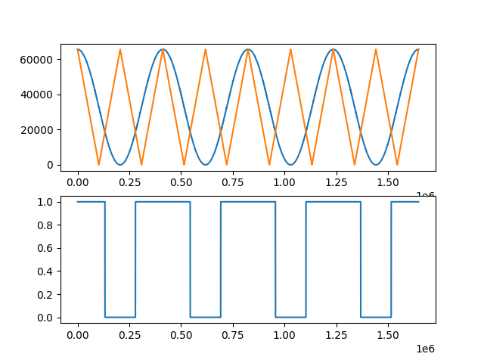
SPWM generation
Spwm S(x) function is generated according to the following equation.
$$S\left(x\right)=cos(x)≥trng(x) \{0≤x≤\frac{π}{2}2^{16},x:int\}\{S(x)∈\{0,1\}\}\{\frac{π}{2}2^{16}≈102944\}$$
A 3rd order Cosine power series were used to generate the first quarter of the sinusoidal signal:
$$cos\left(x\right)≅1−\frac{x^{2}}{2!}+\frac{x^{4}}{4!}−\frac{x^{6}}{6!}\{0≤x≤\frac{π}{2},x:float\}\{−1≤cos(x) ≤1\}$$
The equation were mapped to integers. The following enhancement has been added to the equation of the first quarter:
$$f\left(x\right)≅\frac{\left\{2^{16}.\left[cos(\frac{x}{2^{16}})+1\right]\right\}}{2}\{0≤x≤\frac{π}{2}2^{16},x:int\}\{0≤f(x)≤2^{16}\}$$

$$f\left(x\right)≅\left\{2^{16}−\left\lfloor \frac{x^{2}}{2^{18}}\right\rfloor +\left\lfloor \frac{\frac{x^{4}}{2^{52}}}{3}\right\rfloor −\left\lfloor \frac{\frac{x^{6}}{2^{85}}}{3^{2}.5}\right\rfloor \right\}\{0≤x≤\frac{π}{2}2^{16},x:int\}\{0≤f(x)≤2^{16}\}$$
This enhancement will make the sinusoidal wave applicable on integers without the need of float calculations.
The remaining three quarters are generated by shifting and rotating the first quarter values. This is done to reduce the mathematical operation and memory size needed to create the full wave.
It is generated as following by:
$$Second phase f\left(x\right)≅2^{16}−f(π2^{16}−x)\{\frac{π}{2}2^{16}≤x≤π2^{16},x:int\}\{0≤f(x)≤2^{16}\}$$
$Third phase f\left(x\right)≅2^{16}−f(x−π2^{16})\{π2^{16}≤x≤\frac{3π}{2}2^{16},x:int\}\{0≤f(x)≤2^{16}$}
$Forth phase f\left(x\right)≅f(2π2^{16}−x)\{\frac{3π}{2}2^{16}≤x≤π2^{16},x:int\}\{0≤f(x)≤2^{16}$}
Illustration: https://www.desmos.com/calculator/knk3zofp42
Controlling and configuring the pulse width modulation block
The modulation block has PWM_COUNT output signals, each one is independent from the other (PWM_COUNT default =3). however, they are controlled (enabled and configured) using the same register ‘pwm_en_config_reg’

Configuring the Modulation block
- Port i is disabled by writing 0 and enabled by writing 1 on bit [4i] of the ‘pwm_en_config_reg’ register. Disabling a port results an output of 0. Enabling the port results in generating a PWM/SPWM.
- Port i polarity is controlled by bit [4i +1]. Setting this bit to 0 means that the ON-period will be represented by logic LOW (0), and the OFF-period will be represented by logic HIGH (1). While setting them to 1 will represent the ON-period with logic HIGH (1) and the OFF-period with logic LOW (0).
- Port i modulation type is controlled by bit [4i +2]. Setting this bit to 0 generates an PWM signal. While setting it to 1 will generate an SPWM signal.
- Port i SPWM phase shift activation is controlled by bit [4i +3]. When the modulation type is PWM this bit is inactive. Setting this bit to 0 will disable the SPWM phase shift while setting them to 1 will enable it.

Adjusting the frequency of the PWM signal
For each port, two parameters are responsible for adjusting the frequency of the port’s PWM signal. The frequency resolution is set in a separate register for each port pwm_freq_rsl_config_reg[i], while the pwm prescaler parameters for the ports are in one register pwm_prescaler_config_reg. Port i pwm_prescaler is on pwm_prescaler_config_reg[4i:4i+3] . The pwm_prescaler value for each port should be in the 0 – 10 range. The frequency resolution register value is mapped to (1-256).

Adjusting the duty cycle of the PWM signal
The duty cycle of for port i can be adjusted using pwm_duty_cycle_config_reg[i], it represents the percentage that the PWM signal will stay High within one period. This value is represented as shown:
$$dut{y cycle}_{port[i]}=\frac{T_{on}}{T_{period}}=\frac{pwm_duty_cycle_config_reg[i]}{256}$$

Adjusting the frequency of the SPWM signal
SPWM signal is generated by comparing a sinusoidal signal with a triangle signal. The frequency of these two signals can be adjusted using the following general equation:

$$signal_{freq}=Default_{freq}\frac{Multiplier}{Divider}$$
where the default frequency is the following equation:
$${Default}_{sinusuidal freq}=\frac{clock_{freq}}{2π.2^{16}}$$
$${Default}_{triangle freq}=2\frac{clock_{freq}}{2π.2^{16}}$$

Each signal has two parameters that control the frequency, the numerator and the denominator. Each parameter is controlled by a specific register. For each port, 4 registers control the sinusoidal and the triangle signals frequency as follows:
Sinusoidal signal:
- spwm_m_step_config_reg[i]
- spwm_d_step_config_reg[i]
Triangle signal:
- trng_m_step_config_reg[i]
- trng_d_step_config_reg[i]
Therefore, port n equations can be represented by:
$$Sinusoidal signal_{freq}={Default}_{sinusuidal freq}\frac{spwm_m_step_config_reg[i]}{spwm_d_step_config_reg[i]}$$
$$Triangle signal_{freq}={Default}_{triangle freq}\frac{trng_m_step_config_reg[i]}{trng_d_step_config_reg[i]}$$

Note that theses registers values are mapped from (0-255) to (1-256).

Configuring the Fixed Range
The SPWM can be fixed for a range (Fixed logic 0 or Fixed logic 1 according to polarity). For each port [i], the spwm_fixed_range_qrtr_en_config_reg[4i+3:4i] controls the enable for the port, each bit is responsible for enabling the fixed range feature for the corresponding quarter.
For each port i, a starting angle and range can be configured in the spwm_fixed_range_starting_angle_config_reg[i] and spwm_fixed_range_config_reg[i] respectively. The value of the spwm_fixed_range_starting_angle_config_reg[i] will specify the starting angle (range 0-180, mapped to 0-90°) in the quarter that the fixed range will be applied at, while the spwm_fixed_range_config_reg[i] value will specify the width that the fixed range (range 0-180, mapped to 0-90°).
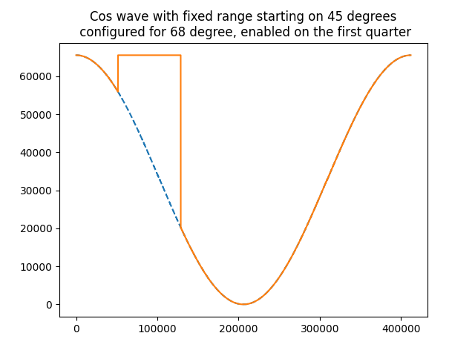

Configuring the Phase shift
When SPWM phase shift is enabled for port i, it can be configured using phase shift register. The spwm_phase_shift_config_reg[i] controls the phase shift (range 0 - 2880 mapped to 0-360°). The phase shift represents the sin shifted to the left by the phase shift value.

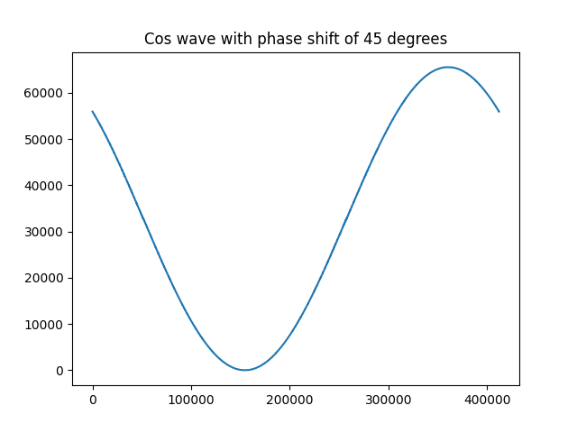

Multi level arbitration Block
Multi level arbitration design includes three arbitration levels: The weighted round robin arbitration, the random arbitration, and the weighted random arbitration. The following figure shows the block diagram and the input/output signals of the full design.
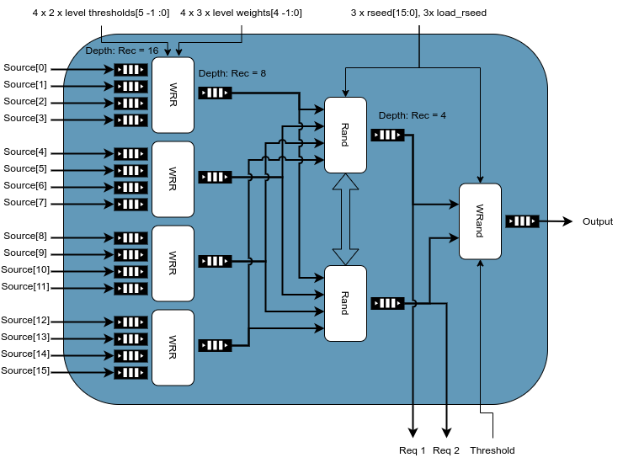
Figure 4: block diagram of the Blue-Sand design
The illustration in Fig.1 shows the internal units (blocks) of the design. The design takes input from 16 sources numbered 0 to 15, each source pushes requests to a queue with depth of 16 requests. Each weighted round robin arbitration block takes input from 4 queue sources, level thresholds configuration, and level weights configuration, then chooses a source request from the inputs and store it in the WRR queue with depth of 8 requests. The 2 random arbitration blocks take inputs from the 4 WRR queues then each choose one request from the queues without choosing the same requests, then each block stores the chosen requests in a queue with depth of 4 requests . The weighted random block takes inputs from the 2 Rand queues then chooses one of them and then put as an output. Each random and weighted random take a seed for randomization.
The design consists of 4 blocks types as described below:
- The queue block, which pushes and pulls requests.
- The weighted round robin block, takes 4 inputs and chooses one of them and put it as an output.
- The random block, takes 4 inputs and chooses one of them and put it as an output.
- The weighted random block, takes 2 inputs and chooses one of them and put it as an output.

Weighted Round Robin block
The weighted round robin block uses weighted round robin arbitration scheme to choose a request from 4 sources, with weights representing the current state of the input queues. It uses the occupancy of each source to calculate the weight/priority using level thresholds and level weights configurations. The level thresholds are used to determine the current region of the source and the level weights are used to determine the weight of each region.
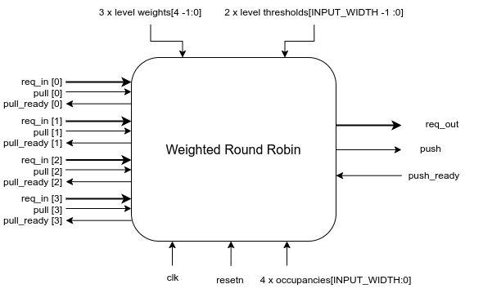
Figure 5: block diagram of the weighted round robin design

Regions
The regions are split into three regions using the level thresholds, the current weight of the queue can be in 4 states as the following figure shows.
Weight possible states.
0 | Occupancy = 0
level_weights[0] | no condition above applies and Occupancy<level_thresholds[0]
level_weights[1] | no condition above applies and Occupancy<level_thresholds[1]
level_weights[2] | no condition above applies
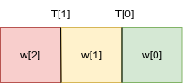
Figure 6: Weights distribution

Table 2 Weights values

Choosing a source
The WRR block uses pocket counters to determine the current source to choose. The WRR chooses the source with the highest counter value then the lower index. If a source doesn’t have a ready request then the counter source is not chosen and the counter will be reset. When a source is chosen the value of it’s counter is decreased by one. If all the counters are zero a new round begins by loading the current weight of the queues to the counter.

Random block
The random block uses random arbitration scheme to choose a request from 4 sources, using lfsr to generate the random number to choose from available inputs with equal probabilities according to the available requests. Random block takes an input called not_chosen which takes an input and asserts that the chosen value doesn’t equal the not_chosen by adding 1 if equals. Random block outputs chosen_i which represents the value chosen by the random block.
The not_chosen and chosen_i are used to assure that the chosen values in the second level of the arbitration block aren’t equal, thus if lfsr resulted choosing the same value as not_chosen, the chosen_i will change to chosen_i+1.
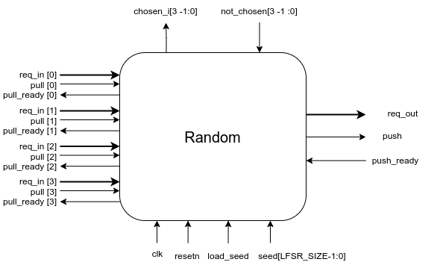
Figure 7: block diagram of the random design

Weighted Random block
The weight random block uses a weighted random arbitration scheme to choose a request from 2 sources, using lfsr to generate the random number to choose from available inputs with probability according to the threshold_val. If there is 2 available inputs the first value is chosen if and only if the random output of the lfsr is less than the threshold_val.
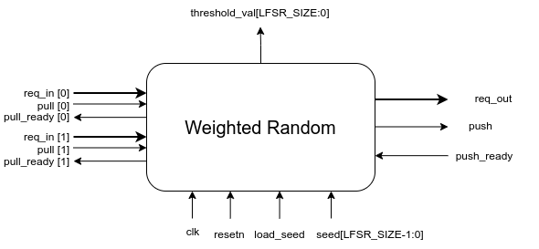
Figure 8: block diagram of the weighted random design

Clock Muxing Unit
Clock muxing unit controls the operating frequency of each functional block in the system.
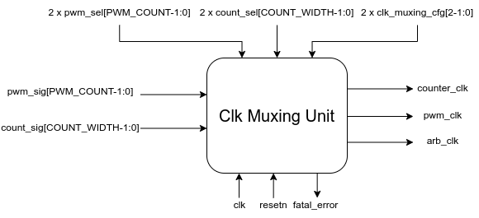
Figure 9 block diagram of clock muxing unit

Clock muxing configuration
The configuration clk_muxing_cfg, count_sel, and pwm_sel has two values for each, the first value with the index 0 is to configure the pwm - counter clock muxing, and the second value with index 1 is to configure the arbitration clock muxing. The following table explains the configuration.
Value of clk_muxing_cfg | Behaviour of pwm unit  - counter unit | Behaviour of multi arbitration unit.
0 | System clock is controls both. | System clock connection.
1 | pwm unit will be controlled by count_val masked by count_sel[0] | arbitration unit will be controlled by count_vall masked by count_sel[1]
2 | counter unit will be controlled by pwm_val masked by pwm_sel[0] | arbitration unit will be controlled by pwm_val masked by pwm_sel[0]
3 | Don’t Care | Don’t Care
Table 4 Clock muxing config

Fatal error
fatal error happens in response of wrong configuration that may cause the blue sand to enter an unknown state. Fatal error can be resolved by resetting the system and returning it to the default configuration. Fatal error is triggered when an out of range error happens causing an unknown state for the clock of a unit thus the block behaviour becomes unknown.

Signals description
This chapter details all the I/O signals in the Blue Sand design.
General signals:
- pclk: oscillating between high and low state and synchronizing actions in the circuit.
- presetn: which sets all the values to a predetermined state.
- main_interrupt: The value is one if any unmasked interrupts are toggled.

APB Interface
APB signals can be studied from AMBA 3 APB PROTOCOL Specification.

Counter Block Interface
Table 5: counter output signals details
Port Name | Size | I/O | Description
count | COUNT_WIDTH | O | Output signal describes the count of the counter.

Pulse Width Modulation block signals
Table 6: Modulation output signals details
Port Name | Size | I/O | Description
boot_done | 1 | O | Active high signal indicates that the boot phase is done in the SPWM mode
pwm_port_sig | PWM_COUNT | O | Ports output signals that will hold the PWM/SPWM signals

Multi level arbitration block
Port Name | Size | I/O | Description
req_sources | 16 request | I | Request input from 16 sources
req_output | 1 request | O | Request output chosen from the arbitration
pull | 1 | I | Pull signal for the output queue, used in pull operation
pull_ready | 1 | O | Pull ready signal for the output queue, used in pull operation
push | 16 | I | Push signal for the 16 input queues, used in push operation
push_ready | 16 | O | Push ready signal for the 16 input queues, used in push operation
size_exceeded_intr | 23 | O | Size exceeded interrupt for all the queues in the block, with 16 queues in the input stage, 4 queues at the output of the first stage, 2 queues at the output of the second stage, and 1 output queue.
threshold_val | 17 | I | Threshold value for the weighted random block in the third stages.
stage3_input_requests | 2 request | O | Third stage input requests which are second stage outputs.
Table 8 Multi level arbitration block signals

Weighted round robin block
Port Name | Size | I/O | Description
req_in | 1 request | I | Request input from the queue.
req_out | 1 request | O | Request output chosen from the arbitration.
push | 1 | I | Push signal used in push operation for output.
push_ready | 1 | O | Push ready signal used in push operation for output.
pull | 4 | I | Pull signal used in pull operation for inputs.
pull_ready | 4 | O | Pull ready signal used in pull operation for inputs.
Table 9 Weighted round robin block

Rand arbitration block
Port Name | Size | I/O | Description
req_in | 1 request | I | Request input from the queue.
req_out | 1 request | O | Request output chosen from the arbitration.
rseed | LFSR_SIZE | I | Seed for the lfsr.
load_rseed | 1 | I | Load seed for the lfsr.
push | 1 | I | Push signal used in push operation for output.
push_ready | 1 | O | Push ready signal used in push operation for output.
pull | 4 | I | Pull signal used in pull operation for inputs.
pull_ready | 4 | O | Pull ready signal used in pull operation for inputs.
chosen_i | 3 | O | chosen index from inputs with available requests.
not_chosen | 3 | I | the value that the block aren’t allowed to choose.
Table 10 Rand arbitration block

Weighted random block
Port Name | Size | I/O | Description
req_in | 1 request | I | Request input from the queue.
req_out | 1 request | O | Request output chosen from the arbitration.
rseed | LFSR_SIZE | I | Seed for the lfsr.
load_rseed | 1 | I | Load seed for the lfsr.
push | 1 | I | Push signal used in push operation for output.
push_ready | 1 | O | Push ready signal used in push operation for output.
pull | 2 | I | Pull signal used in pull operation for inputs.
pull_ready | 2 | O | Pull ready signal used in pull operation for inputs.
threshold_val | LFSR_SIZE | I | Used in choosing the output request.
Table 11 Weighted random block

