

**North South University**

Department of Electrical and Computer Engineering

Summer 2021

**Project Report**

**CSE499A - Senior Design Project**

Section – 12

Group – 11

**Submitted To**

Dr. Mohammad Ashrafuzzaman Khan (Azk)

**Submitted By**

| Group Member | NSU ID |
| --- | --- |
| Mohammad Sajedul Islam  [mohammed.islam1@northsouth.edu](mailto:mohammed.islam1@northsouth.edu) | 1531177042 |
| A. S. M. Sabiqul Hassan  ([sabiqul.hassan@northsouth.edu](mailto:sabiqul.hassan@northsouth.edu)) | 1812442042 |

**Table of Contents**

Introduction 3

Keywords 3

Initial Project Idea 3

Idea-1: Graph Embedding 3

Idea-2: Mobile Sensor Data Processing 3

Work Progress 3

New Project Idea 4

New Project Work-flow 4

New Project Required Tools & Technology 5

Contribution 5

Acknowledgement & Conclusion 5

Reference List 6

**Introduction**

CSE499A is a senior design project course for doing research or creating projects on advanced topics. Our initial plan was to write a paper on a machine learning topic.

As it is a senior design project, we had to choose more progressive topics like Graph Embedding, Mobile Sensor Data processing with deep learning.

**Keywords**

Machine Learning, Deep Learning, Graph Embedding, Image Processing

**Initial Project Ideas**

At First, we choose two project ideas to finalize our topic to write a research paper.

**Idea-1: Graph Embedding**

For the graph embedding topic, we have reviewed few problems from the site [1] and found a problem called “node2vec” that initially matched with our interest.

We found some datasets and related papers on it. Then, we selected a dataset of Facebook [2] which was collected using the official Facebook app and it is about circles or friends list from Facebook. The collected data was replaced with an anonymous value for each user id.

For example, it helped us to find whether two people contain the same value against a particular feature of the feature vectors from the dataset but not their affiliation with a feature.

**Idea-2: Mobile Sensor Data Processing**

For the mobile sensor data processing topic, we chose a problem on “Traffic Vehicle Detection”.

The idea was to train the model using datasets from Kaggle and use mobile phones to detect traffic vehicles on the road for testing purposes. We got a reference paper [3] that matches our idea.

We thought to pick an open-source sensor data stream processing engine called `Global Sensor Network (GSN)' with the Android platform to capture our sensor data. Then we can test vehicle detection using our trained model based on the collected Kaggle dataset.

**Work Progress**

After reviewing some related papers, we were failed to get a solid grasp of Graph embedding and Mobile sensor data processing.

Due to the lack of prior knowledge on these topics, the mathematical and statistical terms used in those papers were too difficult for us to work with.

Then, we have decided to come up with a new web-based project work instead of paper writing on Deep Learning or Graph Embedding field.

**New Project Idea**

In our new project, we planned to create a web application for image classification using an ML algorithm with the help of the TensorFlow.js library.

**New Project Work-flow**

Only the registered users will be able to use that application for testing purposes.

Initially, a user can upload an image from the given 10 categories and choose an algorithm from some given algorithms (ml5.js, etc) to process the image testing.

When we send our data to the backend it will apply the Tensorflow.js library to use their API server against submitted form data. Then it will return a response to our backend with one of the two states success or error.

As a result, our application will show the correct name of the image that has been uploaded. If it fails then it will show the error result on the frontend part.

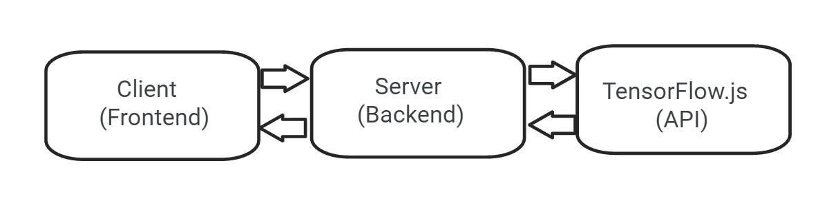

**New Project Required Tools & Technology**

We planned to pick some frameworks to implement our new project idea.

* Node JS (For frontend and backend)
* Tailwind CSS (For Design Part)
* TensorFlow.js (To use ML API)

Now you may think that Node JS is used as backend technology, how can we use it for the frontend (UI – User Interface) part? No need to be worried. There are some popular template engines (for example, EJS, pug, handlebars, etc) used with Node JS to provide support of view layer in a server-side rendering (SSR) project. Initially, we planned to pick the EJS template engine package for that project.

As we know Tailwind CSS, a utility-based CSS framework has a growing demand in the current market. We will try to apply it instead of Vanilla CSS or other frameworks like Bootstrap, Material UI, etc which require more customization.

TensorFlow.js is a library for machine learning in JavaScript. It helps us to develop ML models in JavaScript, and use ML directly in the browser or Node.js. We will use it on our backend part to apply different ML algorithms against our submitted form data.

We will add the authentication to our application. We will apply JWT (JSON Web Token) for the authentication part of the project. It will keep track of our service users.

For the database part, our initial plan is to use Mongo DB, a no-SQL database for simplicity and to store user information of our application.

**Contribution**

Due to the COVID situation, we could not work on a particular topic for writing a research paper. It is difficult for us to define the contribution part of the group members individually, as our research work badly failed.

But we conducted discussion sessions regularly at the Google Meet platform. There we discussed paper review, paper-related concepts, etc. We tried to contribute equally in the project work section as well as the work of presentation & report submission.

**Acknowledgement & Conclusion**

We would like to thank our faculty Dr. Ashrafuzzaman Khan (Azk) for providing an extra office hour to fix a new project idea as we failed in our research paper writing.

We will try to implement our new ML-based web application project in the next semester on the CSE499B course.

**Reference List**

1. <http://snap.stanford.edu>
2. J. McAuley and J. Leskovec. Learning to Discover Social Circles in Ego Networks. NIPS, 2012. (<http://snap.stanford.edu/data/egonets-Facebook.html>)
3. C. Perera, A. Zaslavsky, P. Christen, A. Salehi and D. Georgakopoulos, "Capturing sensor data from mobile phones using Global Sensor Network middleware," 2012 IEEE 23rd International Symposium on Personal, Indoor and Mobile Radio Communications - (PIMRC), 2012, pp. 24-29, doi: 10.1109/PIMRC.2012.6362778.